MediLink AI — Proof of PoC
Connected Ambulance Triage System
1. Project Snapshot
Field | Details
Project name | MediLink AI
Hackathon theme | Crisis Management, HealthTech & Emergency Response
Present stage | TRL 3 — Proof of concept demonstrated
Core AI | AI-assisted triage, urgency classification, and hospital recommendation
User benefit | Faster emergency response, clearer prioritization, and smarter coordination
Deployment type | Web prototype ready for demo and public hosting

2. What the PoC Demonstrates
- The prototype accepts a patient/emergency intake form and analyzes symptom signals in real time.
- The AI layer classifies the urgency level as Low, Moderate, High, or Critical using symptom and age-risk cues.
- It recommends the most suitable hospital type based on the emergency profile.
- It estimates ambulance ETA using location distance and priority level.
- It shows dispatch progress, live status updates, and a history of recent triage runs for repeatability.

3. End-to-End Workflow
- Step 1: User enters patient details, symptoms, and incident type.
- Step 2: AI engine scores risk signals such as chest pain, breathing trouble, bleeding, stroke symptoms, and unconsciousness.
- Step 3: System outputs urgency, ETA, recommended facility, and escalation instructions.
- Step 4: Dispatcher/hospital summary is generated for quick coordination.
- Step 5: Response timeline and case history help the jury verify functionality instantly.

4. Key Functionalities Visible in the Demo
- AI symptom triage
- Urgency classification
- Nearest hospital recommendation
- Ambulance ETA estimation
- Dispatch simulation with live updates
- Scenario presets for cardiac, stroke, trauma, breathing distress, and fever

5. Proof / Screenshot Placeholders
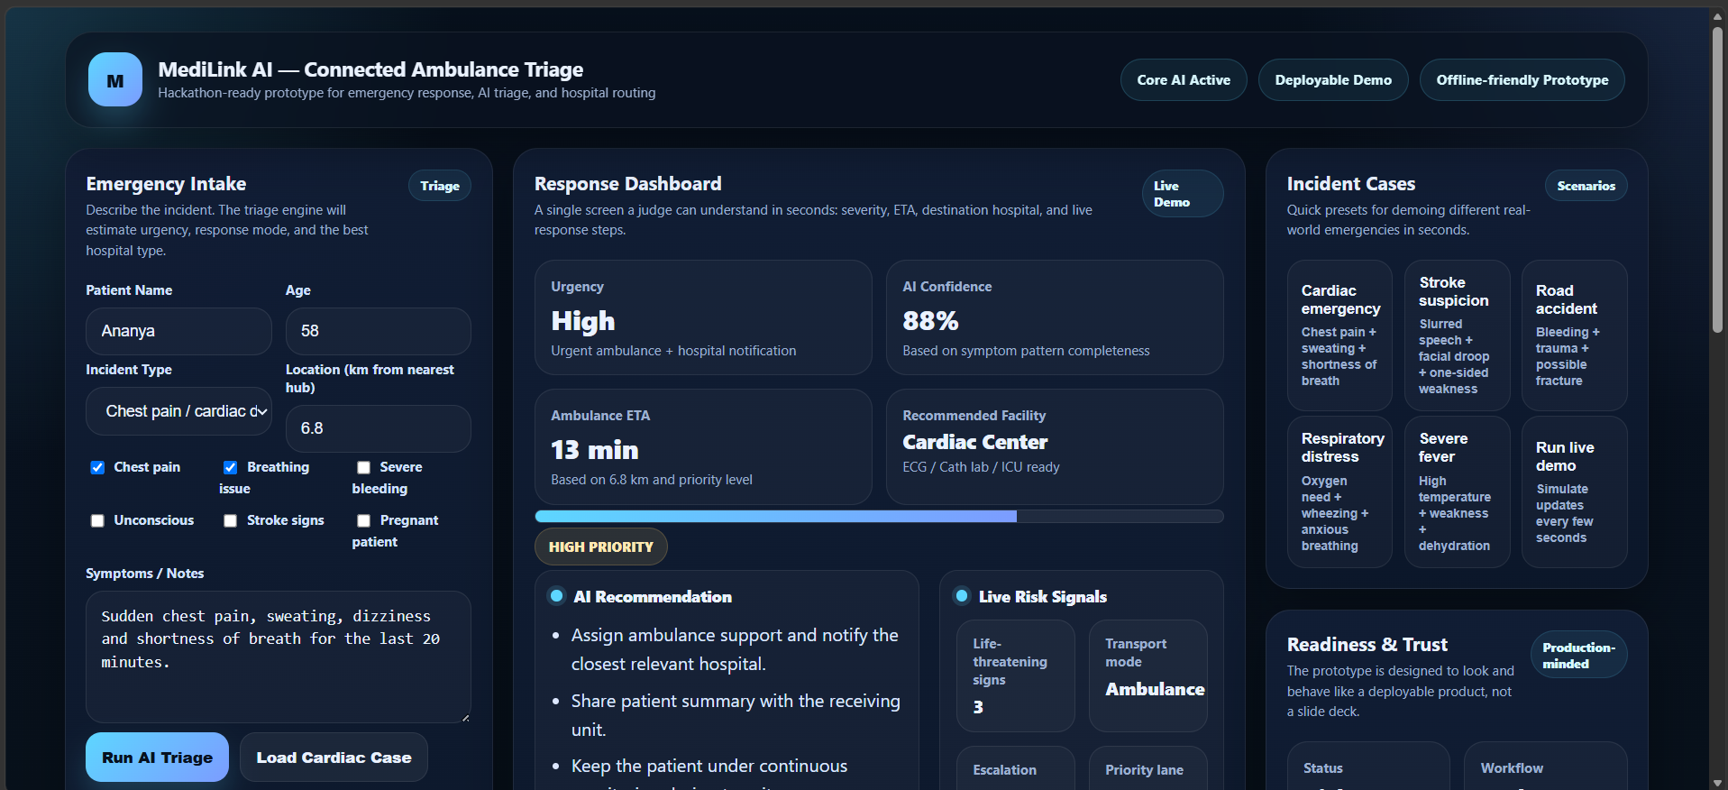

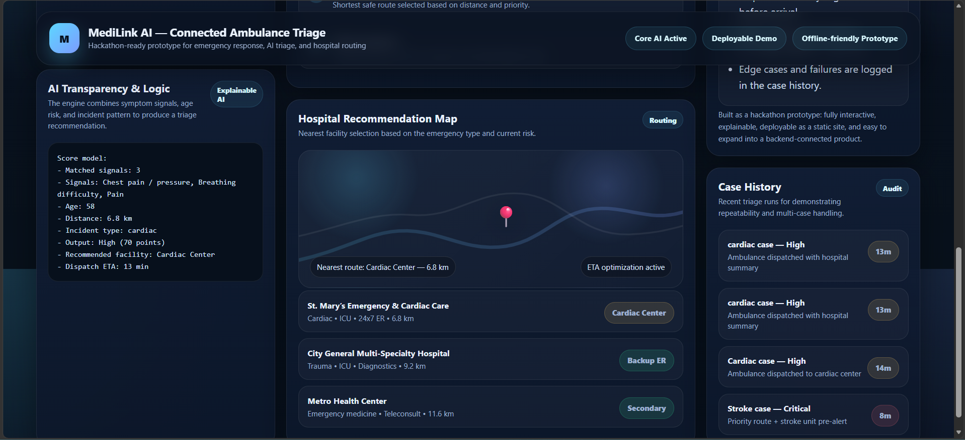

6. Validation Notes
- Prototype is fully interactive and can be run locally or deployed as a web app.
- The design is intentionally narrow and demo-friendly to match hackathon judging criteria.
- The AI logic is explainable, so the jury can clearly understand why a case is marked critical or high.
- The solution is suitable for expansion into real-time ambulance and hospital integrations.

7. References & Links
GitHub repository | Pranav-Mahesh-Palled/MediLink_AI
Deployed link | MediLink AI — Connected Ambulance Triage
Demo video | Pranav_Mahesh_Palled_MediLink_AI_ScreenCast.mp4 - Google Drive

