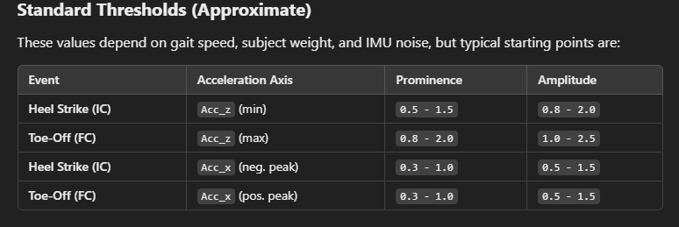

Filename: imu_data_20250322_195308.csv

First step taken: Right

Number of steps: 5

* Left: 2
* Right: 3

Step width: approximately 13 cm

Step length: 60cm

* Left: 60cm
* Right: 60cm

Recording duration:

Filename: imu_data_20250322_200459.csv

First step taken: Left

Number of steps: 6

* Left: 3
* Right: 3

Step width: ~13cm

Step length:

* Left: 30cm
* Right: 60cm

Recording duration:

Filename: imu_data_20250322_200607.csv

First step taken: right

Number of steps: 6

* Left: 3
* Right: 3

Step width: ~13cm

Step length:

* Left: 60cm
* Right: 30cm

Recording duration:

Filename: imu_data_20250322_200857.csv

First step taken: Left

Number of steps:

* Left: 3
* Right: 2

Step width: ~13cm

Step length:

* Left: 60cm
* Right: 60cm

Recording duration:

Filename:

First step taken: Right

Number of steps:

* Left:
* Right:

Step width: ~13cm

Step length:

* Left: 30cm
* Right: 30cm

Recording duration:

Filename:

First step taken:

Number of steps:

* Left:
* Right:

Step width:

Step length:

* Left:
* Right:

Recording duration: