
LAB ASSIGNMENT-1
Submitted by:
Pranav Mishra
1024150203
2O23
- Write a program (WAP) to display "Hello World" on console display.
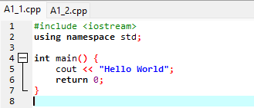
OUTPUT:
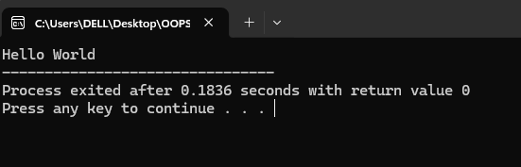
- WAP to that reads two values from keyboard and displays the larger value on the screen.
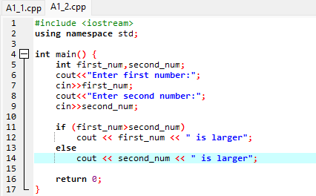
OUTPUT:
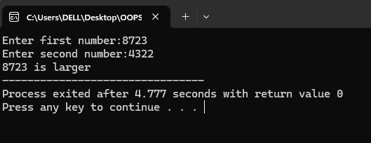
3. WAP to read three values a, b, c from keyboard and display the value
of x = a/b-c.
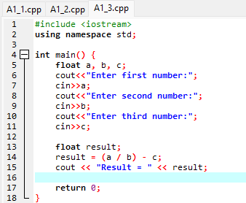
OUTPUT:
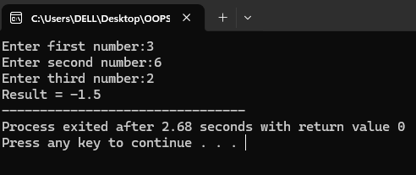
4.WAP to implement the following control characters:
- ‘\n’ is for new line, or you can use endl – cout<<endl<<“message”;
- ‘\t’ is for tab
- ‘\a’ is an alarm sound
- ‘\r’ is carriage return to go to the beginning of the current line
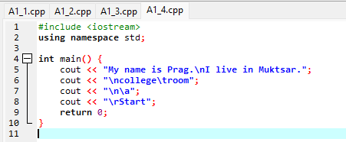
OUTPUT:
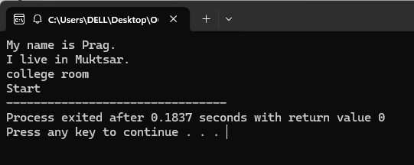
5. Implement namespace in a program to illustrate the use of same name variables and functions in different sections/libraries of the code.
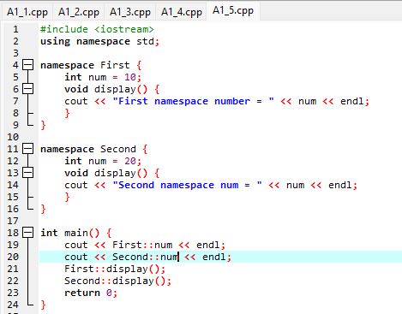
OUTPUT:
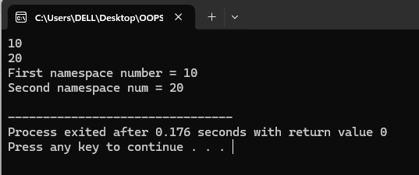
6. Write a program to define a structure Student that contains 3 variables and 2 functions:
- Variables: (a) name (b) roll (c) marks
- Functions: (1) setStudentData() (2) getStudentData()
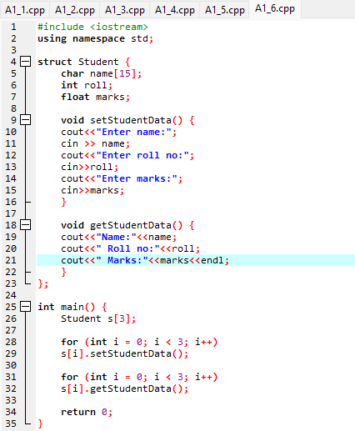
OUTPUT:
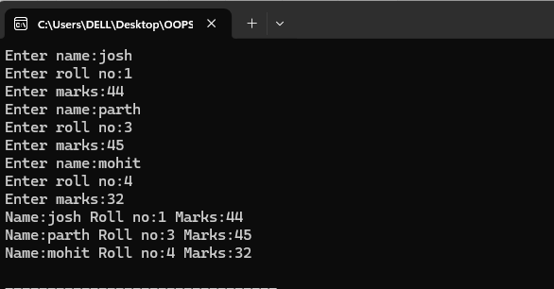

7.In the previous program make the data private, and functions public.
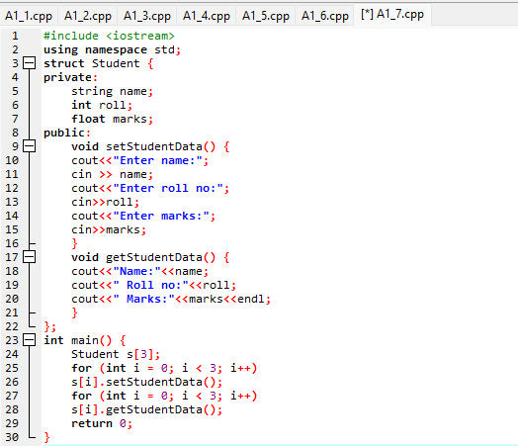
OUTPUT:
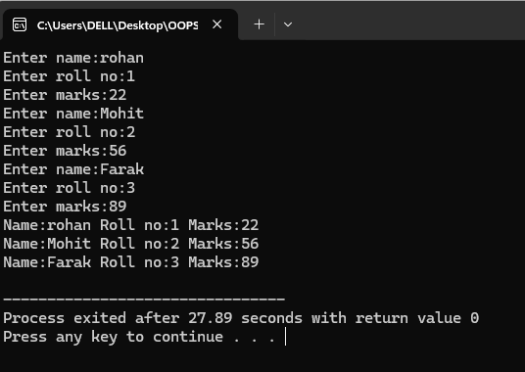
8. Convert program #4 from struct to class.
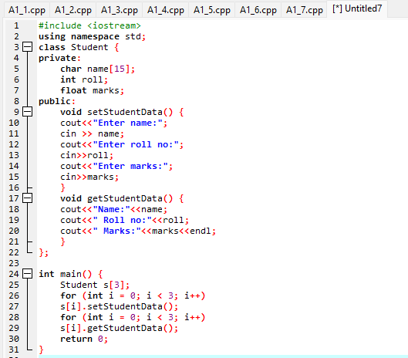
OUTPUT:
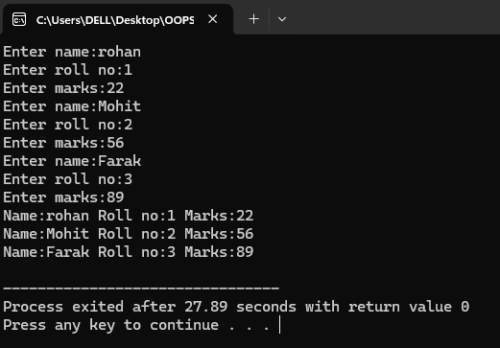
9. Discuss the differences of structures in C and structures in C++ during
the lab with other students or your instructor.
Structure in C
- Structures in C are used only to store data; they cannot have functions inside them.
- C structures do not have access specifiers, so all data members are openly accessible.
- Since there is no access control, data hiding is not possible in C structures.
- C structures do not support constructors or destructors for automatic initialization and cleanup.
- Overall, C structures do not support object-oriented programming concepts.
Structure in C++
- In C++, structures can contain both data members and functions.
- C++ structures allow the use of access specifiers like public and private to control access.
- Because of access control, data hiding is supported in C++ structures.
- C++ structures support constructors and destructors, making object initialization easier.
- C++ structures support object-oriented programming concepts such as encapsulation and inheritance.
10. WAP to read an integer value from the keyboard and display on screen “WELL DONE” that many times.
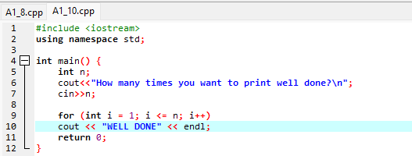
OUTPUT:
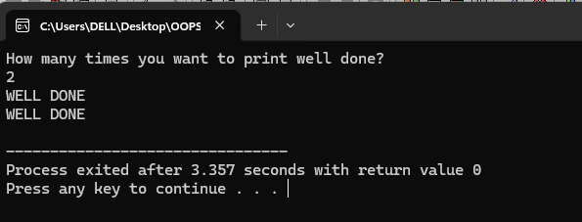
11.WAP to utilize assignment += and -= operators.
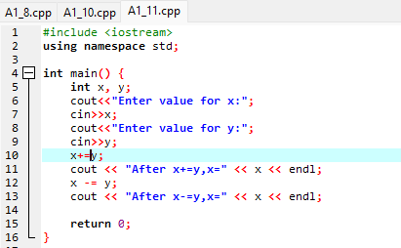
OUTPUT:
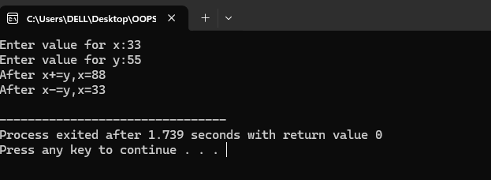
12.Swap two numbers using bitwise operator.
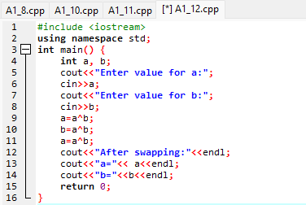
OUTPUT:
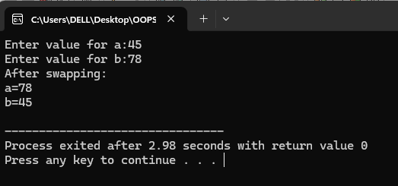

13. Write a program to solve the following problem:
A library charges a fine for every book return late. For first 5 days the fine is 50 paise, for 6–10 days fine is one rupee and above 10 days fine is 5 rupees. If you return the book after 30 days your membership will be cancelled. WAP to accept number of days the member is late to return the book and display the fine or appropriate message.

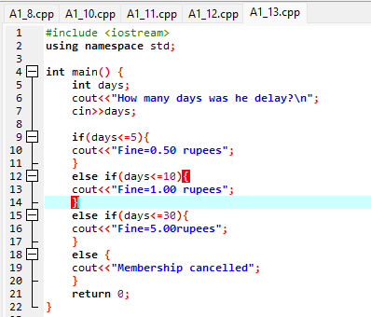
OUTPUT:
