**Assignment No.-2**

**Name of Student: Pranav Kishor Patel**

**Batch: 2 Branch: IT Roll No: 55**

**Problem Statement:**

There is a class Adder which has two data members of type 1D int array and int variable. It has two functions: getdata and numsum. Function getdata accepts non-empty array of distinct integers from user in 1D int array data member and a targetsum in another data member. The function numsum adds any two elements from an input array which is equal to targetsum and return an array of resulting two elements, in any order. If no two numbers sum up to the target sum, the function should return an empty array. Note that the target sum is to be obtained by summing two different integers in the array; you can’t add a single integer to itself in order to obtain the target sum. You can assume that there will be at most one pair of numbers summing up to the target sum. Use constructor. Use extra variables if needed.

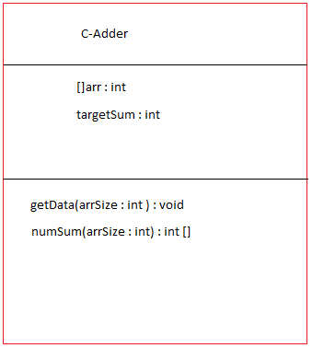

**Sample Input and Output**

**Test Case 1**

|  |  |  |
| --- | --- | --- |
| **Input Parameters** | **Values** | **Expected Output** |
| 1D Array | [3,5,-4,8,11,1,-1,7] | [8,7] |
| targetsum | 15 |

**Test Case 2**

|  |  |  |
| --- | --- | --- |
| **Input Parameters** | **Values** | **Expected Output** |
| 1D Array | [3,5,-4,8,11,1,-1,6] | [ ] |
| targetsum | 15 |

import java.util.Scanner;

import java.util.Arrays;

public class Assignment2 {

private int[] dataArray;

private int targetSum;

// Constructor

public Assignment2() {

// Initialize data members in the constructor

dataArray = null;

targetSum = 0;

}

// Function to get data from the user

public void getData() {

Scanner scanner = new Scanner(System.in);

// Input the size of the array

System.out.print("Enter the size of the array: ");

int size = scanner.nextInt();

// Input array elements

dataArray = new int[size];

System.out.println("Enter distinct integers for the array:");

for (int i = 0; i < size; i++) {

dataArray[i] = scanner.nextInt();

}

// Input the target sum

System.out.print("Enter the target sum: ");

targetSum = scanner.nextInt();

}

// Function to find and return two elements that sum up to the target sum

public int[] numSum() {

int[] result = new int[2];

// Check each pair of elements in the array

for (int i = 0; i < dataArray.length; i++) {

for (int j = i + 1; j < dataArray.length; j++) {

if (dataArray[i] + dataArray[j] == targetSum) {

// Found a pair with the target sum

result[0] = dataArray[i];

result[1] = dataArray[j];

return result;

}

}

}

// No pair found, return an empty array

return new int[0];

}

public static void main(String[] args) {

Scanner scanner = new Scanner(System.in);

while (true) {

// Create an instance of the Assignment2 class

Assignment2 assignment2 = new Assignment2();

// Get data from the user

assignment2.getData();

// Find and display the result

int[] result = assignment2.numSum();

System.out.println("Result: " + Arrays.toString(result));

// Ask whether to continue

System.out.print("Do you want to continue? (Y/N): ");

String choice = scanner.next().toUpperCase();

if (!choice.equals("Y")) {

break; // Exit the loop if the user enters anything other than 'Y'

}

}

}

}

**Results:**

**Actual Output**

