SENTIMENT ANALYSIS OF IMDB MOVIE REVIEWS USING MODERNBERT WITH ATTENTION POOLING
PROJECT REPORT [Phase-I]
Submitted in partial fulfillment for the award of the degree of
BACHELOR OF TECHNOLOGY
Department of Computer Science and Engineering
Submitted to
INDIAN INSTITUTE OF INFORMATION TECHNOLOGY
BHOPAL (M.P.)

Submitted by
Polawar Pranav Shirish (24U020088)
Satyam Raj (24U020098)
Under the supervision of
Dr. Amit Kumar Nandanwar
Assistant Professor
Computer Science and Engineering
October 2026

INDIAN INSTITUTE OF INFORMATION TECHNOLOGY
BHOPAL (M.P.)
CERTIFICATE
This is to certify that the project report entitled “Sentiment Analysis of IMDb Movie Reviews Using ModernBERT with Attention Pooling” has been completed satisfactorily by Polawar Pranav Shirish (24U020088) and Satyam Raj (24U020098) under the guidance of the Department of Computer Science and Engineering, Indian Institute of Information Technology, Bhopal. The work is submitted in partial fulfillment of the requirements for the award of the Bachelor of Technology degree in Computer Science and Engineering.
Date:
Dr.Amit Kumar Nandanwar  Assistant Professor,  Computer Science and Engineering,  IIIT Bhopal (M.P.) | Dr.Rahul Chaurasia,  Department of CSE,  IIIT Bhopal (M.P.)

INDIAN INSTITUTE OF INFORMATION TECHNOLOGY
BHOPAL (M.P.)
DECLARATION
We hereby declare that the project report entitled “Sentiment Analysis of IMDb Movie Reviews Using ModernBERT with Attention Pooling” is submitted in partial fulfillment of the requirements for the award of the Bachelor of Technology degree in Computer Science and Engineering. The report documents the work carried out by us under the guidance of Dr. Amit Kumar Nandanwar. To the best of our knowledge, the information presented here is accurate. We accept responsibility for any errors or discrepancies that may be identified.
We, the undersigned, declare that the information stated above is true to the best of our knowledge.
Polawar Pranav Shirish (24U020088) sign of student 1
Satyam Raj (24U020098)
ACKNOWLEDGEMENT
We, Polawar Pranav Shirish and Satyam Raj, would like to thank everyone who supported us during the completion of our project, “Sentiment Analysis of IMDb Movie Reviews Using ModernBERT with Attention Pooling.”
We express our sincere gratitude to our Director, Prof. (Dr.) Ashutosh Kumar Singh, for providing the resources and facilities required to carry out this project. His encouragement and leadership helped us complete the work.
We are especially grateful to our project guide, Dr. Amit Kumar Nandanwar, for his guidance, constructive feedback, and technical suggestions throughout the project. His input helped us refine the methodology and improve the report.
We also thank the Department Coordinator, Dr. Rahul Chaurasia, and the faculty members of the Department of Computer Science and Engineering for their support and for helping us resolve questions during the project.
We appreciate the encouragement and suggestions provided by our friends. We are equally thankful to our parents and family members for their patience, understanding, and continued moral support.
Finally, we thank everyone who contributed directly or indirectly to this work.
Polawar Pranav Shirish (24U020088)
Satyam Raj (24U020098)

TABLE OF CONTENT
S. no Title Page No.
Certificate ii
Declaration iii
Acknowledgement iv
Abstract 1
1. Introduction 2
2. Literature Review 5
3. Problem Definition and Objectives 11
4. Proposed Methodology and Work Description 13
5. Proposed Algorithms 18
6. Proposed Flowchart / Block Diagram / DFD 20
7. Implementation (Tools and Technology Used) 23
8. Result, Discussion and Analysis 27
9. Conclusion and Future Scope 31
10. References 32
List of Publication 34
Plag Report (Turnitin) 35

LIST OF FIGURES
Fig. 1. Architecture of the ModernBERT-base encoder 14
Fig. 2. Block diagram of the proposed ModernBERT with attention-pooling classifier 20
Fig. 3. Level-1 data flow diagram of the sentiment classification system 20
Fig. 4. Flowchart of data preparation, training, validation, and testing 20
Fig. 5. Confusion matrix of the proposed model on the IMDb test set (4,959 reviews) 27
Fig. 6. Comparison of IMDb test accuracy of the reviewed and proposed models 29
LIST OF TABLES
Table 1. Summary of reviewed approaches and reported IMDb accuracy 8
Table 2. Dataset subsets used in the experiments 13
Table 3. Blocks of the proposed ModernBERT with attention-pooling classifier 22
Table 4. Role of each tool in the implementation 23
Table 5. Experimental configuration 24
Table 6. Performance of the proposed model on the IMDb dataset 27
Table 7. Class-wise precision, recall, and F1-score on the test set 27
Table 8. Confusion matrix counts on the test set (4,959 reviews) 28
Table 9. Comparison with the reference RoBERTa-BiLSTM model on IMDb 28
Table 10. Accuracy of the proposed model relative to the reviewed approaches 29

ABSTRACT
This project studies ModernBERT-base with attention pooling for binary sentiment classification on the IMDb dataset. The encoder produces contextual representations for the input tokens. A learned attention mechanism which combines these representations into a weighted review summary which is concatenated with the [CLS] representation and passed to fully connected classification layers. The architecture does not Include a recurrent layer. Hugging face / python implementation. Transformers. From 50,000 human labelled IMDb reviews, we discarded 418 exact duplicates, leaving 49,582 reviews for the experiment. Following three iterations over the data, which lasted for 162 minutes, the model was able to. 95.93% test accuracy, weighted F1-score of 95.93%. References for example of RoBERTa-BiLSTM Table 3: Model performance on the test set. Results of 92.36% accuracy and 92.35% weighted F1-score [3]. Accuracy difference between the Is 3.57 percentage points but should not be ascribed toattention pooling alonethe. Encoder, data set, training setup and computing environment were not controlled Ir this point across the two experiments. The training times to has not proved an. Computational-efficiency advantage. Are reproduced baseline and controlled ablation studies. There are three factors to separate the influences of each component. I am going to be able to train several samples to run it on minimal texts.
Keywords: sentiment analysis, imdb, ModernBERT, attention pooling, Transformer, text 1 Introduction up until now, most of the research has been performed by using the linguistically motivated features. For instance, Biber (1987) lists a series of contextualized features that set apart various text types.

1. Introduction

1.1 Background and Motivation
Sentiment analysis (also known as opinion mining) is a technique from computer linguistics which automatically determines, extracts and analyzes subjective information expressed in text [1], [2]. The internet has seen an explosion of user-generated content including comments, ratings and reviews. An obvious example can be seen in IMDb reviews, which are the opinions of a user towards a film, with review scores having an influence on other viewers' choices, what few reviews they actually read. Automated sentiments for reviews may save us time by summarising the users' opinions; and in the same way, applying to other writing based submissions and feedbacks may save time by not having to read every one manually.
The classifer can be applied at document level, sentence level and aspect level [2]. In our paper we are going to talk about document level classication, where the label is assigned to the whole review to fall into one of two classes (positive or negative). It is not always that easy to classify movie reviews. They might have plot summaries, comparisons, transcribed dialogue, factual description as well as subjective comments..
These could also be applied in extra textual content fields similar to product evaluations, supportcenter messages, survey solutions, and social media posts, the place labeled knowledge may be of course-together with-value. At that point, even a modest good thing about accuracy - 3.6 levels, for instance - could mean loads of predictions. For example, if that was a similar shift in that inhabitants, it will be about 36,000 labels per 1 million examples.

1.2 Existing Approaches and Their Limitations
Recurrent architectures such as Long Short-Term Memory (LSTM) networks [5] and Bidirectional LSTMs (BiLSTMs) [6] model sequential information, but process positions in sequence. Transformer architectures [7] use self-attention to model relationships among tokens and compute token representations in parallel within each layer. Even with these advances, classifying long reviews remains challenging because sentiment can be expressed across multiple sentences.
Rahman et al. [3] introduced a RoBERTa-BiLSTM model that passes RoBERTa token representations through a BiLSTM and dense classification layers. Their reported IMDb results were 92.36% accuracy and a 92.35% weighted F1-score. The additional recurrent layer introduces sequential computation after the Transformer encoder, motivating the investigation of alternative classification heads.
Pretrained language models reduce the need to design text features manually. A Transformer encoder is first pretrained on a large collection of unlabelled text and then fine-tuned on labelled examples for a task such as sentiment classification [8], [10]. This transfer-learning approach has become common in text classification. However, an encoder returns a representation for each token, whereas a classifier generally needs a single vector for the full review. The choice of aggregation method—such as the [CLS] representation, mean pooling, or a learned weighted sum—may therefore affect classification performance.

1.3 Proposed Work
ModernBERT-base [11] is used with attention pooling for binary sentiment classification. The [CLS] vector obtained from the pooling layer is then fed into fully-connected layers to obtain the sentiment class label. The reference architecture makes use of a RoBERTa-BiLSTM architecture, while our architecture does not use a recurrent layer.
The same dataset included 50,000 labeled reviews with a total of 418 exact duplicate reviews, which were taken out to leave 49,582 reviews for training, validation, and testing. But this comparison does not definitively prove that the change in architecture was the only factor behind these results, since the encoders, training hyperparameters, and even computers used may have been different.
Therefore, controlled experiments are needed to evaluate the individual contributions of attention pooling, backpropagation, and parameter updates. Model performance and computational cost should be assessed separately.
ModernBERT[11] is also an encoder-only Transformer where the full way of training models are bidirectional representations of the models have been kept, but the changes applied there are the rotary positional embeddings, the gated feed-forward network, local and global attentions and the better calculation for attention. In our project, we choose the ModernBERT-base and try to verify its result with an attention-pooling classification head on a standard sentiment benchmark. The model was trained on Google colab with Tesla T4 GPU for 3 epochs. The holdback test set, which is used for training and checkpointing was preserved and only tested at the end.

1.4 Objectives and Contributions
The main contributions of this project are summarized below.
1. Model design: a ModernBERT-base classifier that concatenates the [CLS] representation with an attention-pooled summary of all tokens and classifies the result with fully connected layers, without any recurrent layer.
2. Data preparation: a cleaned IMDb dataset in which 418 exact duplicates are removed and the remaining 49,582 reviews are divided into training, validation, and test subsets.
3. Evaluation: a measured test accuracy of 95.93% and a weighted F1-score of 95.93%, supported by class-wise precision and recall and a confusion matrix.
4. Critical comparison: a comparison with the published RoBERTa-BiLSTM result that states clearly what the comparison does and does not show, and a list of controlled experiments needed to isolate the contribution of each component.

1.5 Organization of the Report
The remainder of the report is organized as follows. Section 2 reviews related work on traditional, recurrent, Transformer-based, and hybrid sentiment models. Section 3 defines the problem and lists the objectives. Section 4 describes the proposed methodology, including the dataset, the ModernBERT encoder, the attention-pooling design, and the training and evaluation procedure.

2. Literature Review

Standard algorithms for sentiment classification, (Naive Bayes, SVMs, Logistic Regression, KNN) all use Bag-of-Words or TF-IDF features. Pang et al. [4] have investigated these algorithms, and they were extensively surveyed for accuracy (for classifying movie reviews) [1], [2]. They are useful as standard baselines for comparison, but will probably be very sensitive to the feature construction, and has difficulty with negation and contextual models. Based on [3], these algorithms got an IMDb classification accuracy of 87.12% with Logistic Regression.

2.1 Traditional Machine Learning and Recurrent Models
Pang et al. [4] applied such classifiers to movie reviews, and surveys [1, 2] describe their use. They are efficient baselines but depend heavily on feature design and handle context and negation poorly; the reference study [3] reports 87.12% IMDb accuracy for Logistic Regression.
Deep learning. Recurrent networks keep hidden states.A token sequence, but plain RNNs do vanish gradients. LSTM [5] gets around it.On either side of the gated memory cell, the sequence walks in both directions with the BiLSTM [6].The compositional models learned on the sentiment treebanks [14] also illustrate the power of modelling:And cover how the nature of sentence of the deeps off the beginning and end.Lengthens training for long inputs.Besides supervised classifiers they early systems also used sentiment lexicon, which is a list of:Polarity and (sometimes) strength of words. A review is scored by summing all the word scores.
It gives the sentiment orientation of words it contains[1], [2]. The techniques which are based on lexicons don't need any labelled training data.Data but a fixed word list is still not able to show how a word is used, eg. The word:'Unpredictable' can be great in a thriller, not so much in a review of a car. Supervised processesThis is avoided by the fact that they are trained on labelled examples, which as we saw earlier Pang et al. [4] actually did when they ran their various models on the training data.
Classifiers directly on movie reviews.
Naive Bayes assumes independence of words given the class, and uses class posterior probabilities based on word counts. Naive Bayes is very fast to learn and make predictions with, and requires very little data, but clearly misses the point in natural language.SVMs find the maximum-margin hyper-plane between classes. KNN uses the class labels of the most similar training reviews to classify new reviews. KNN is computationally expensive and less accurate with increasing its feature sizes. All these algorithms use a fixed feature vector, the accuracy of which is entirely dependent on quality of input features.

Bag of Words / TF-IDF description also suffers from two other drawbacks. The first, of course, is that it doesn't take order into account, so "not good" and "good, not" will have nearly the same feature vectors, requiring a rule for every negation These problems likely motivated the rise of neural models that encode contextual, dense vectors as function of data.

Recurrent networks attempted to alleviate these problems with a hidden state that carries through a review one word at a time. Recurrent nets, however, run into three practical issues with long reviews: 1) don't drop the information accumulated in the review's beginning in order to address the vanishing gradients problem, 2) don't delay positional parallelization by sequentially reading, 3) do all the read words somehow get compressed into one hidden state? Long short term memory (LSTM) gates and bidirectional reading alleviate the first problem, and attention over the hidden state alleviates the second. The third cost of sequential reading is still, however, a concern.

2.2 Transformer-Based Language Models
The output is a weighted combination of the input representations for each position in the sequence, where the weight assigned to each of the input tokens is computed by a function of the other input tokens. Work indicates that direct interaction of all pairs of positions enables a word at the beginning of a review to affect the representation of a word at the end without having to go through many intermediate states, and all positions are processed simultaneously. Positional encodings are probably added separately, as attention is order-agnostic.

BERT is pretrained with a masked language modelling objective, in which some input tokens are hidden and must be predicted from both left and right context, and with a next-sentence prediction objective [8]. A special [CLS] token is placed at the start of every input; after fine-tuning, its final representation is commonly fed to a classifier. Sun et al. [10] studied how to fine-tune BERT for text classification and examined choices such as which layers to use, learning rates, and further pretraining, showing that these choices affect the result. RoBERTa keeps the BERT architecture but trains longer on more data with larger batches, uses dynamic masking, and removes next-sentence prediction [9]. DeBERTa [28] further modifies the attention mechanism by representing content and position separately.

The pretrain-then-fine-tune paradigm is the main reason why Transformers dominate text classification. Pretraining: Trained with a very large amount (unlabelled) data during pretraining and Most of the data for grammar, definitions and general world knowledge is highly limited and has been included during pretraining. Pretraining enables definitions, word meanings and large general knowledge about the world. In few shot, a task specific head is included and then all the parameters are finetuned for the labelled data with an extremely small learning rate. This allows the long term memory to come from the batch rather than having to fine tune with many parameter. It allows the finetuning of a full recurrent network at the start which is probably going to require less labelled data and less time to get to a reasonable high. It is common to use finishing tools to speed up accuracy such as pretraining encoder as in refs [8] and [10]. The data structure and quality is probably the biggest factor in final results.
It was to use the ModernBERT encoder - which we assume to be a simple thing for most people. Most models like BERT have a maximum input length ( for example 512 tokens). The explicit restriction of input length is often one that is not discussed in reviews. This very restriction requires newer encoder designs, as this problem of the length of sequences is one that is still very relevant.

2.3 Hybrid RoBERTa-BiLSTM Architecture
Rahman et al. [3] the text of each review is tokenized and fed into a pretrained RoBERTa model and encoded. This encoding is fed into dropout, BiLSTM, and dense layers to make a sentiment prediction. The authors state that this model gets 92.36% accuracy and 92.35% weighted F1 score on IMDb, training for a total of 170.98 minutes over 5 epochs.The recurrent layer may improve sequence modelling, but it also adds computation.
The idea behind the hybrid design is that the Transformer supplies rich contextual token vectors and the BiLSTM then reads these vectors in both directions to model how the sentiment evolves across the sentence. The cost is the extra recurrent computation after the encoder, which is sequential in the sequence length, and the additional parameters that must be trained. The reference study reports that this model outperformed the plain RoBERTa-base baseline (91.32%) and the classical baselines on IMDb [3], which shows that adding a sequence-aware layer on top of an encoder is useful, but it does not show that a recurrent layer is the only or the best way to do so.
Regularization is a further element of this type of design. The reference model applies dropout between the encoder and the BiLSTM layer, a standard technique that randomly sets a fraction of the activations to zero during training so that the layers cannot rely on individual features [3]. Dropout reduces overfitting when a large pretrained network is fine-tuned on a comparatively small labelled dataset, and the same idea is applicable to the head of the proposed model.

2.4 Attention Pooling and ModernBERT
Attention mechanisms allow models to assign different importance to different parts of an input [15]. Attention pooling learns a score for each token representation and combines the representations into a weighted summary. A similar principle appears in hierarchical attention networks for document classification [16]. In sentiment analysis, evaluative phrases may contribute more to the prediction than neutral text. Nevertheless, attention weights should not be treated as definitive explanations of model decisions [17], [18].
There are several common ways to turn token vectors into one review vector. Using the [CLS] vector relies on the encoder to have gathered the relevant information into one position. Mean pooling averages all token vectors, which treats every token as equally important, and max pooling keeps the strongest value of each feature. Attention pooling instead learns a score for every token and weights the tokens by the normalized scores, so that opinion-bearing words can contribute more than filler words. In the proposed model the [CLS] vector and the attention-pooled vector are concatenated, so the classifier receives both the global summary prepared by the encoder and a learned, token-level summary.
ModernBERT-base [11] is an encoder-only model with rotary positional embeddings [19], gated linear unit activations [20], efficient attention [21], and support for much longer sequences than BERT. In this project its token representations are combined through attention pooling and the [CLS] vector. The implementation reached 95.93% test accuracy, above the 92.36% published for RoBERTa-BiLSTM, but this compares a project result with a published one and does not show that ModernBERT or attention pooling alone caused the gain. Table 1 summarizes the reviewed approaches.
Table 1. Summary of reviewed approaches and reported IMDb accuracy
Approach | Main idea | IMDb accuracy
Logistic Regression [3] | TF-IDF features with a linear classifier | 87.12%
RoBERTa-base [3] | Fine-tuned pretrained encoder | 91.32%
RoBERTa-BiLSTM [3] | RoBERTa, BiLSTM layer, dense layers | 92.36%
ModernBERT + attention pooling (this work) | ModernBERT-base, attention pooling with [CLS] | 95.93%

The first three rows are reported in [3]; the last row comes from this work under a different setup.

2.5 Architectural Features of ModernBERT
ModernBERT [11] was designed as a drop-in replacement for BERT-style encoders that is faster and more memory-efficient and can process much longer inputs. It was pretrained on approximate 2 trillion tokens and supports sequences of up to 8,192 tokens. The base version has 22 encoder layers, a hidden size of 768, and 12 attention heads (Fig. 1). Its main changes with respect to BERT and RoBERTa are described below.
1. Rotary positional embeddings (RoPE): instead of adding learned absolute position vectors, RoPE rotates the query and key vectors according to position, so attention depends on the relative distance between tokens [19]. This supports longer sequences and is applied inside the attention block shown in Fig. 1.
2. GeGLU feed-forward layers: the feed-forward network uses a gated linear unit with a GELU activation, in which one projection of the input is passed through GELU and multiplied element-wise with a second projection before the down projection [20].
3. Alternating local and global attention: most layers use attention restricted to a sliding window of nearby tokens, and every third layer attends over the whole sequence. This lowers the cost of long inputs while preserving long-range information.
4. Efficient attention and unpadding: FlashAttention-style kernels [21] reduce memory traffic, and padding tokens are removed before the encoder layers so that no computation is spent on them.
5. Pre-normalization: layer normalization is applied before the attention and feed-forward blocks, with residual connections around each block, which stabilizes training of the 22-layer stack.

2.6 Evaluation Metrics and the IMDb Benchmark
The original set used was the IMDb data set (dataset 25K) (Maas et al. [12]) there were no other feature extraction other than those in the sets. It is a set of labelled positive and negative reviews, originally, the total set consisting of 25000 reviews in the training set, containing an equal number of negative and positive reviews, as well as 25000 within the test set containing roughly equal numbers of negative and positive reviews, with the Polar opposites left for the Ratings- avoiding the slightly more ambiguous midrange of reviews. As a common, publicly available, and balanced set, results may be more directly comparable than other implementations (which may not have the same division of training and validation, and test sets). Our implementation combines the set of 50,000, leaveless reviews, and recreates a training and validation set as well as an independent test set, so results are roughly comparable but not directly comparable.
The 4 metrics on IMDb [22] were accuracy, precision, recall, F1-score (accuracy 8, false positive 9, false negative 10, and true positive 11 components of the confusion matrix were defined as follows: Accuracy: reviews which were correctly labelled. Precision: reviews labelled to be part of a class that were indeed in that class. Recall: reviews which were in a class that were labelled to be part of that class. This is the measure used on unbalanced classes. The confusion matrix indicates what sort of error the classifier makes. 8 9 10 11

2.7 Comparative Analysis of the Reviewed Approaches
On IMDb, the accuracy of reported on Table 1 increases significantly when the models are.Model Building. Logistic Regression wifh TFIDF Features=87.12%,In the data set; the value for the bottom -fined roberta-base is 91.32; the value of adding a BiLSTM layer is 92.36%.[3]. Pre trained encoder will become the largest shift from classical baseline, and it will be Different shows that pretraining has the maximum contribution to the increase with the recurrent layer giving .A compromise between calculations of the value that are not incremental and more sequential calculations.First and foremost if no task specific training is done from pretrained,Encoders can always surpass hand-crafted features. The second one, another.
The above would be equally applicable, but unfortunately, not the paper which provide the RoBERTa-BiLSTM.See if this could be sourced from a lesser weight element as attentive pooling.Potential. Thirdly, ModernBERT, and some other encoders, were left out of on the.IV. Conclutions: Conclutions were took, when the same conditons were used on the paper´s model, RoBERTa- BiLSTM. The paper we are dealing with is the second.And third points by the applying ModernBERT using attention pooling and auditing its.Performance on the IMDb, and at the same time, we are acutely aware that a strict comparison pre is still to come Work.

2.8 Research Gap
Pretrained transformers, hybrid recurrent models are also effective for sentiment analysis, however the recurrent layer increases the training time. Here we explore ModernBERT-base with attention pooling as an alternative candidate along with combined [CLS] representation. A controlled comparison with a reproduced RoBERTa-BiLSTM and ablations that remove attention pooling are still needed to show the contribution of each component.

2.9 Summary of the Review
The literature shows a steady move from hand-designed features, through recurrent models, to pretrained Transformers, with each step improving the accuracy of sentiment classification on IMDb. Hybrid models such as RoBERTa-BiLSTM show that further processing of the encoder output can add accuracy, but at the price of sequential computation. Attention pooling offers a lighter way to aggregate token information, and ModernBERT offers a more efficient and more capable encoder.

3. Problem Definition and Objectives

3.1 Problem Definition
In movie review classification our the task is to decide whether a review expresses positive or negative sentiment to be decided. Long reviews are hard to classify because of contextual dependencies, negation, and mixed positive and negative expressions. Traditional methods depend on hand designed features and Transformer models such as BERT and RoBERTa generate strong contextual representations [8, 9] . Hybrid models like RoBERTa-BiLSTM add a recurrent layer, which increases computation because of sequential processing.
The reference paper reports 92.36% accuracy and 92.35% weighted F1-score on IMDb dataset [3]. This project investigates whether ModernBERT-base with attention pooling, it is combining the [CLS] vector with an attention-weighted review representation, can classify sentiment well without recurrent processing.

3.2 Objectives
- To understand the idea behind the paper RoBERTa-BiLSTM To learn about the approach, training setup, results and limitations.
- For the IMDb data: Deduplication, label encoding, and train/val/test splits.
- To use ModernBERT-base (attention pooling + [CLS] aggregating method) for binary classification.
- To test the accuracy, precision, recall, weighted F1-score, loss and the confusion matrix and contrast with the reference results.
- To record training time and (when possible) inference latency and GPU memory usage, and to run ablations with a [CLS]-only head and a reimplementation of RoBERTa-BiLSTM.

3.3 Scope of the Work
The study covers binary sentiment classification of IMDb reviews with ModernBERT-base and attention pooling. Conclusions are limited to this dataset and these experimental conditions; testing on other datasets is needed to show generalizability.

3.4 Research Questions and Challenges
The above objectives lead to following research questions.
1. RQ1: Can a ModernBERT-base encoder with attention pooling and a [CLS] representation classify IMDb reviews with accuracy at least as high as the published RoBERTa-BiLSTM model?
2. RQ2: It is a recurrent layer necessary for strong sentiment classification when the encoder is combined with learned attention pooling layer?
3. RQ3: How should be the comparison be reported so that the evidence is stated honestly, given that the encoders and training setups differ?
There are three factors to the design of a review. Length of the review: a review canA list of the sentences in which the model has to locate the parts of the opinion. The secondIs also a duplicated review which exists in both train and test set. (also) label noise and duplication:For the numbers: we need not data as will add accuracy readings as our device does not have that high of a measuring capability, so we ignore it.Splitting. And number three: single-hand-cloud-notebooks-t4-gpu-computer-cost.Which limits the number of experiments tht can be made finally decide thebatch sizeandtheepochscan Be run.

4. Proposed Methodology and Work Description

4.1 Overview
The reference RoBERTa-BiLSTM [3] passes RoBERTa outputs through dropout, a BiLSTM, a dense layer, and Softmax. The proposed model instead uses ModernBERT-base for contextual token representations and attention pooling for a weighted review representation, which is combined with the [CLS] vector and passed to fully connected layers.
The work flows through seven stages: (1) loading the IMDb reviews and removing exact duplicates; (2) encoding the labels and splitting the data into training, validation, and test sets; (3) tokenizing and padding each review to 512 tokens; (4) encoding the tokens with ModernBERT-base; (5) combining the [CLS] vector with the attention-pooled vector and classifying the result; (6) training with validation-based checkpoint selection; and (7) evaluating the best checkpoint once on the test set and comparing it with the reference.

4.2 Dataset and Preprocessing
IMDB dataset [12] 50,000 positive/negative labels for reviews. After that we removing 418 duplicate review, we have 49,582 reviews. We splitted by 49,582 reviews training (39,665 reviews), validation (4,958 reviews for selecting the best checkpoint), and testing (4,959 reviews). Tokenized by ModernBERT tokenizer with 512 padding or truncate the tokens with attention mask to make the BERT aware that those are padding or not.
Table 2. Dataset subsets used in the experiments
Subset | Reviews | Share | Purpose
Training | 39,665 | ≈ 80% | Updating model parameters
Validation | 4,958 | ≈ 10% | Monitoring and checkpoint selection
Test | 4,959 | ≈ 10% | Final, one-time evaluation
Total | 49,582 | 100% | After removing 418 duplicates

No duplicates. And, it isalso that a report has been in many groups.Test accuracy would be very high, and could be a model of overfitting.We exclude 418 duplicates before training/validation split.This is why this type of leakage is being avoided. Test data subset is 2,470 so some of the data is on hold until the very end for testing.Almost equal in size with negatives and 2,489 positives, the classes are balanced.Accuracy is a meaningful measure.
Tokenization for this task was done with the byte-pair-encoding (BPE) tokenizer from ModernBERT.Which breaks down the unusual words and gets them in parts so that nothing is missed. EverySequence of tokens indexs of the Review is obtained. If the length of the Review is longer than 512 tokens, then cut to 512.All tokens, if the number of tokens is less than the length mentioned then we can just normally add the padding tokens to make it of the length so, the special padding token has been added. And, the attention_mask has value 1.
This time they are stored as an integer, one integer value per class negative and positive. Repeat the same procedures of cleaning, splitting then tokenising, so that these experiments can be replicated: the same cleaned data, and then the same split, can be used on the tests later on as detailed in the ablations of Section 9 with all variants being compared on the same test reviews.

4.3 ModernBERT-base Encoder
The new model's encoder is ModernBERT-base [11] (see Fig. 1). Input sequence of tokens is divided into subword units by BPE tokenizer and subsequently linearly embedded into vectors of H=768 dimension by token embedding layer. Further, token vectors sequence passes for a stack of 22 identical encoder layers, and then gets normalized with the help of the final layer normalization, providing a contextual word representation.
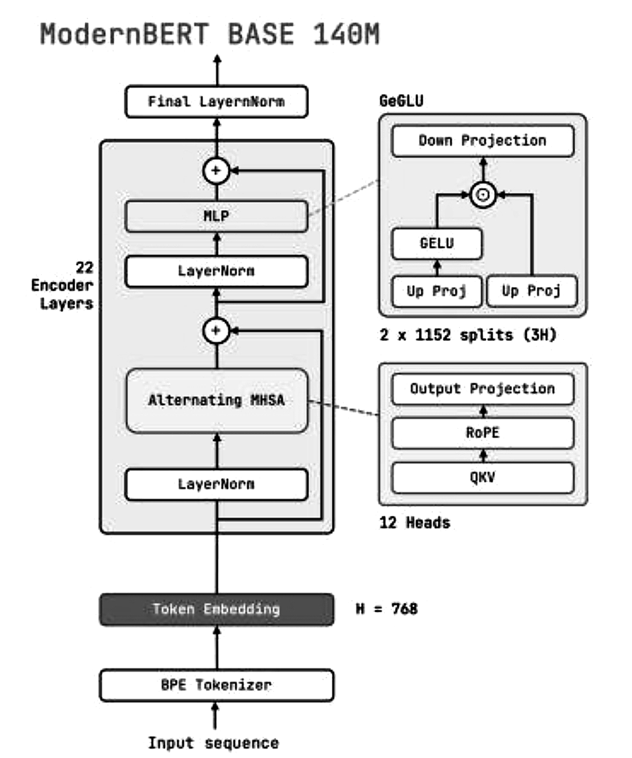
Fig. 1. Architecture of the ModernBERT-base encoder: 22 encoder layers, hidden size H = 768, 12 attention heads, rotary position embeddings (RoPE), and a GeGLU feed-forward block [11].
Each encoder layer contains two sub-blocks with residual (skip) connections drawn as the ⊕ nodes in the figure. In the first sub-block layer normalization is followed by alternating multi-head self-attention (MHSA). The query, key, and value (QKV) projections are computed for 12 attention heads, rotary position embeddings are applied to the queries and keys, and an output projection combines the heads. The word "alternating" refers to the pattern in which most layers use local attention and every third layer uses global attention. In the second sub-block, layer normalization is followed by a feed-forward network (MLP) of the GeGLU type. The input is expanded by two parallel up projections; one branch passes through the GELU activation, the two branches are multiplied element-wise, and a down projection returns the result to size H. The figure indicates that the up projection is split into two parts of size 1,152 each (3H in total).
The gated feed-forward layer increases the expressive power of each layer at a similar cost to a standard feed-forward layer. Rotary embeddings encode the relative position without fixed maximum length .The pretrained weights are fine-tuned together with the new layers described in Section 4.4, so the encoder adapts its representations to sentiment rather than remaining a fixed feature extractor.

4.4 Proposed Model Architecture
The model has four parts: a pretrained ModernBERT encoder, an attention-pooling layer, a combined feature vector, and a classification head (Fig. 2). The fine-tuned encoder outputs contextual representations
H = [h₁, h₂, …, h_{n}] (1)
where h_{i} is the representation of the i-th token and n is the sequence length. Attention pooling learns a weight for each token, in the spirit of additive attention [15, 16]. The score and normalized weight of token i are
e_{i} = w^{T} tanh(W_{h} h_{i} + b_{h}) (2)
α_{i} = exp(e_{i}) / Σ_{j=1}^{n} exp(e_{j}) (3)
where W_{h}, w, and b_{h} are learnable parameters, and padding tokens are masked out. The pooled vector and the final feature vector are
h_{att} = Σ_{i=1}^{n} α_{i} h_{i} (4)
h_{combined} = [h_{CLS} ; h_{att}] (5)
The [CLS] vector gives a dedicated sequence-level feature, while attention pooling aggregates information from all tokens. The combined vector passes through fully connected layers that output two logits for the positive and negative classes; Softmax gives class probabilities at inference. No BiLSTM layer is used.
The sizes of the vectors follow directly from the encoder. The [CLS] vector and the attention-pooled vector each have H = 768 values, so the combined vector has 1,536 values. In the attention-pooling layer, padding positions are excluded by assigning them a very low score before the Softmax, which makes their weights zero and ensures that the weights of the real tokens sum to one. The weights α are also useful for inspection: a large weight on a token indicates that it contributed strongly to the pooled vector, although such weights should be interpreted with caution and not taken as a complete explanation of the prediction [17], [18].
The design rests on two ideas.First attention pooling gives it a second view that is computed from all tokens and is learned for this task, so that strongly polarized words and phrases can be emphasized even when they appear far from the beginning of a long review. Concatenating the two vectors lets the classifier use both sources of information. The additional parameters of the pooling layer are very few compared with the encoder, so the extra computational cost is small, and there is no recurrent computation.
For a single review, the forward pass can be followed through the tensor shapes. The tokenizer produces a sequence of 512 token identifiers and a mask of the same length. The embedding layer maps them to a matrix of shape 512 × 768, and the 22 encoder layers transform it into another matrix of the same shape, so every token has a contextual vector. The first row of this matrix is the [CLS] vector (768 values). The scoring function gives one value per token (512 values), the masked Softmax turns these into weights that sum to one, and the weighted sum of the rows gives the pooled vector (768 values). The concatenation has 1,536 values, and the fully connected layers reduce it to two logits, from which the Softmax produces the probabilities of the negative and positive classes. In a mini-batch, all these operations are applied to many reviews at the same time by adding a batch dimension.

4.5 Training and Optimization
The model is implemented with Python, PyTorch, and Hugging Face Transformers in Google Colab and trained on a Tesla T4 GPU for three epochs.Learning rate 3×105 for the pretrained encoder 2×104 for the new classification layers, max length 512 tokens, 4-5 hours per epoch run the dev set after each epoch and save best. Transformer uses tokens in parallel at each layer but training cost is still proportional to the encoder, the sequence length the batch size the number of epochs, and the device.
The learning rates differ for the two sets of parameters since they are in different situations: The encoder has already learned much during pretraining, so the parameters can be learned with a low learning rate (3×10⁵) so as to not lose the learnt information [10]. The parameters of the pooling layer and classification layer are randomly initialized, so they are learned from scratch at high learning rate (2×10⁴). The loss is the cross-entropy between the two class probabilities for the prediction and the true label.
At the end of each epoch the model is evaluated on the validation set and the best validation checkpoint is stored. Using the validation set as the comparison on the checkpoints in contrast to the test set results in an unbiased comparison. If the validation accuracy had stopped improving as the training accuracy was continually improving this would be over-fitting and the best generalising checkpoint would still have been stored.
Training proceeds in mini-batches. For every batch the token identifiers and masks are moved to the GPU the model produces logits the loss is computed against the true labels and the gradients of all trainable parameters are obtained by backpropagation. The training set is shuffled at the beginning of each epoch so that the batches differ from epoch to epoch and the number of epochs is limited to three because fine-tuning a pretrained encoder normally converges within a few passes over the data and more epochs increase the risk of overfitting as well as the cost.

4.6 Evaluation
The model is evaluated on the held-out test set with accuracy, precision, recall, and F1-score [22], where
Accuracy = (TP + TN) / (TP + TN + FP + FN), Precision = TP / (TP + FP) (6)
Reca ll = TP / (TP + FN), F1 = 2 × Precision × Recall / (Precision + Recall) (7)
Training and validation loss and accuracy are plotted across epochs to detect overfitting, and training time is recorded.Accuracy alone can hide differences between the classes, so class-wise precision, recall, and F1-score are also reported. The F1-score combines both. Because the two classes have nearly the same size, the weighted averages are almost identical to the simple averages, and a large difference between the classes would indicate a bias of the model. The confusion matrix reports the numbers of correct and incorrect predictions for each class and is the basis for the error analysis in Section 8.3.

4.7 Experimental Design and Fair Comparison
On the experiments, we have: a static split, one 3 epoch train run, a by validation checkpoint selection and a test set score. We compare against the reported scores of RoBERTa-BiLSTM [3]. Since the other work used a different encoder, number of epochs and setting the numbers indicate that the two systems perform well relative to each other, but little to none of the variance explained. A fully controlled comparison would train RoBERTa-BiLSTM on the same split with the same hardware, and would add ablations in which attention pooling is removed so that only the [CLS] vector is used, and in which the encoder is replaced while the head is kept. These experiments are listed as future work in Section 9.

5. Proposed Algorithms

5.1 Algorithm 1: IMDb Dataset Preprocessing
Input: IMDb reviews and labels. Output: tokenized training, validation, and test sets.
1. Load the dataset and remove exact duplicate reviews.
2. Encode sentiment labels as positive or negative.
3. Split the data into training, validation, and test subsets.
4. Tokenize each review with the ModernBERT tokenizer, using padding and truncation to 512 tokens.
5. Generate attention masks for valid tokens and return the prepared datasets.

5.2 Algorithm 2: ModernBERT with Attention Pooling
Input: tokenized review and attention mask. Output: predicted sentiment class.
1. Pass the tokens through the pretrained ModernBERT encoder to obtain contextual representations.
2. Extract the [CLS] representation.
3. Compute attention scores for all token representations and apply Softmax, excluding padding, to obtain weights.
4. Compute the weighted sum of token representations as the attention-pooled vector.
5. Concatenate the pooled vector with the [CLS] representation.
6. Pass the result through fully connected layers to obtain two logits and predict the class with the highest score.

5.3 Algorithm 3: Model Training and Evaluation
Input: training, validation, and test sets. Output: best checkpoint and test metrics.
1. Initialize the model and optimizer with learning rates of 3×10⁻⁵ (encoder) and 2×10⁻⁴ (classification layers).
2. For each of three epochs, train on batches: compute the loss, backpropagate, and update the parameters.
3. Evaluate on the validation set after each epoch and save the best-performing checkpoint.
4. Load the best checkpoint and evaluate it on the held-out test set.
5. Compute accuracy, precision, recall, weighted F1-score, and the confusion matrix; record training time and compare with RoBERTa-BiLSTM.
Result: the implemented model achieved 95.93% test accuracy and a 95.93% weighted F1-score on the IMDb dataset.

5.4 Complexity and Design Notes
The preprocessing algorithm makes one pass over the dataset for duplicate removal and one pass for tokenization, so its cost grows linearly with the number of reviews. The cost of the model in Algorithm 2 is dominated by the encoder. In every encoder layer the cost of attention grows with the sequence length n, and the feed-forward network grows linearly with n; ModernBERT lowers the attention cost by using local attention in most layers [11]. The attention-pooling step adds only one scoring operation per token and one weighted sum, which is linear in n and has a number of parameters of the order of H² for the scoring matrix. This is small compared with the roughly 150 million parameters of the encoder, so the pooling layer does not change the overall cost noticeably.
The training algorithm uses early checkpointing rather than a fixed final model. The best checkpoint according to the validation subset is retained, and the test subset is read only once, in the last step. This ordering is essential: if the test subset were used to choose between checkpoints, the reported accuracy would no longer be an unbiased estimate of performance on new reviews.

6. Proposed Flowchart / Block Diagram / DFD

6.1 Block Diagram of the Proposed Architecture
As shown in Fig. 2, the input review is tokenized and processed by the fine-tuned ModernBERT-base encoder. Its token representations feed two branches: one selects the [CLS] representation, while the other scores the tokens, applies a masked Softmax, and calculates an attention-weighted sum. The two vectors are concatenated and passed through fully connected layers that produce two class logits. No recurrent layer is used.
The encoder shown in Fig. 1 returns token representations with a hidden size of 768 for the configured sequence length of up to 512 tokens. The [CLS] branch selects the first token vector. The attention branch computes a score for each token and uses normalized scores to form another 768-dimensional vector. Concatenating the two vectors produces a 1,536-dimensional representation for classification. Table 3 describes the role of each component.
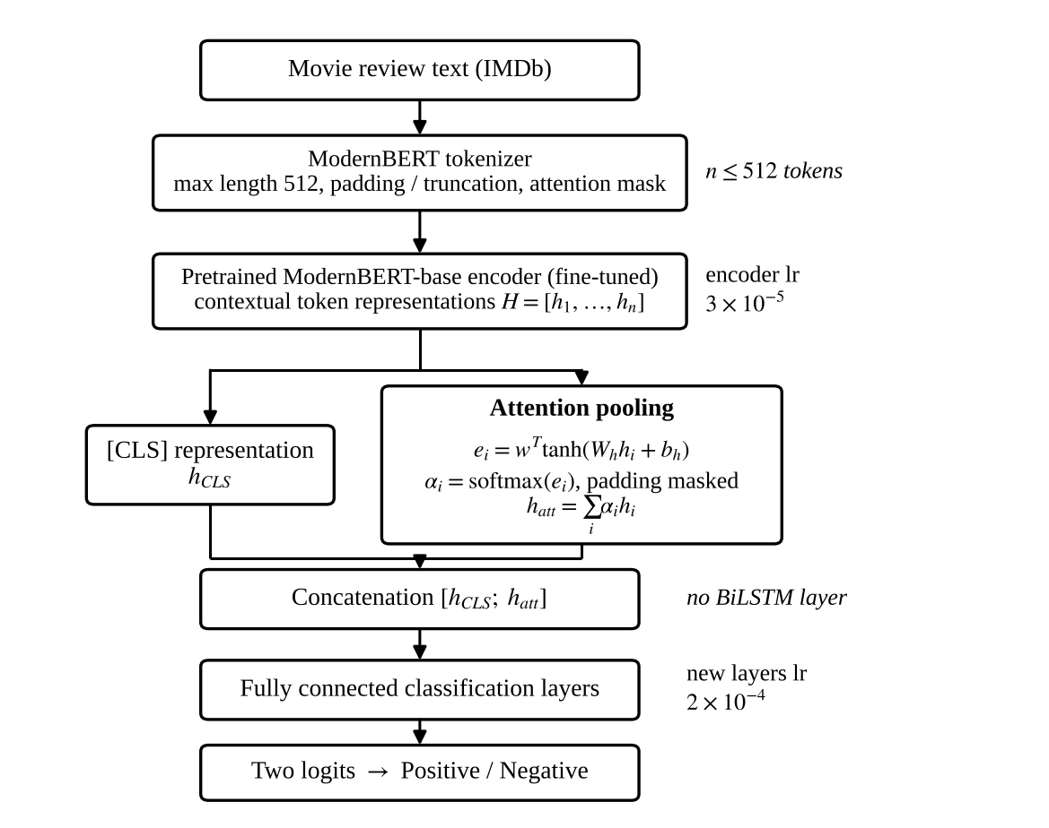
Fig. 2. Block diagram of the proposed ModernBERT with attention-pooling classifier.

6.2 Data Flow Diagram
Fig. 3 shows the data flow between the dataset, the three main processes, and the two data stores. The test split is read only by the evaluation process, which keeps final evaluation separate from training and checkpoint selection.
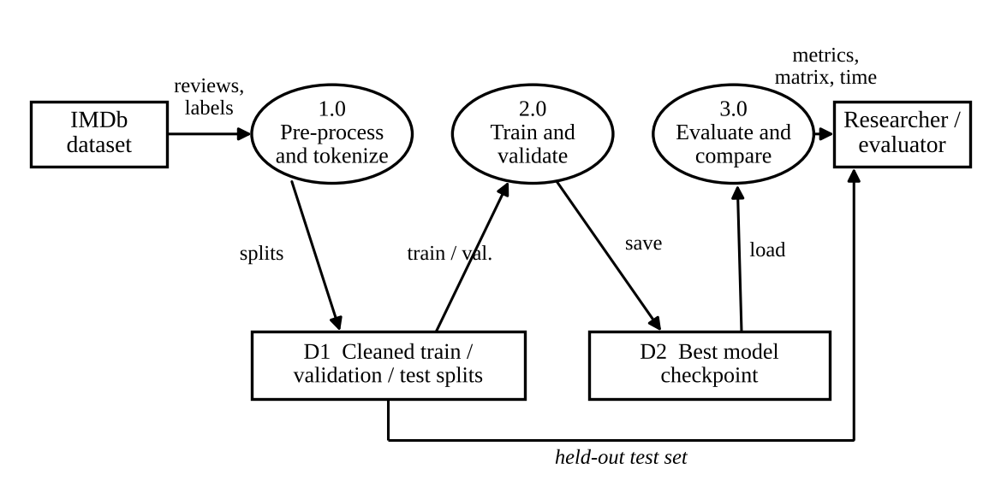
Fig. 3. Level-1 data flow diagram of the sentiment classification system.

6.3 Flowchart of the Training and Evaluation Pipeline
Fig. 4 summarizes the pipeline: data preparation, three epochs of training with validation and checkpointing, and a single evaluation of the best checkpoint on the test set followed by comparison with the published RoBERTa-BiLSTM figures.
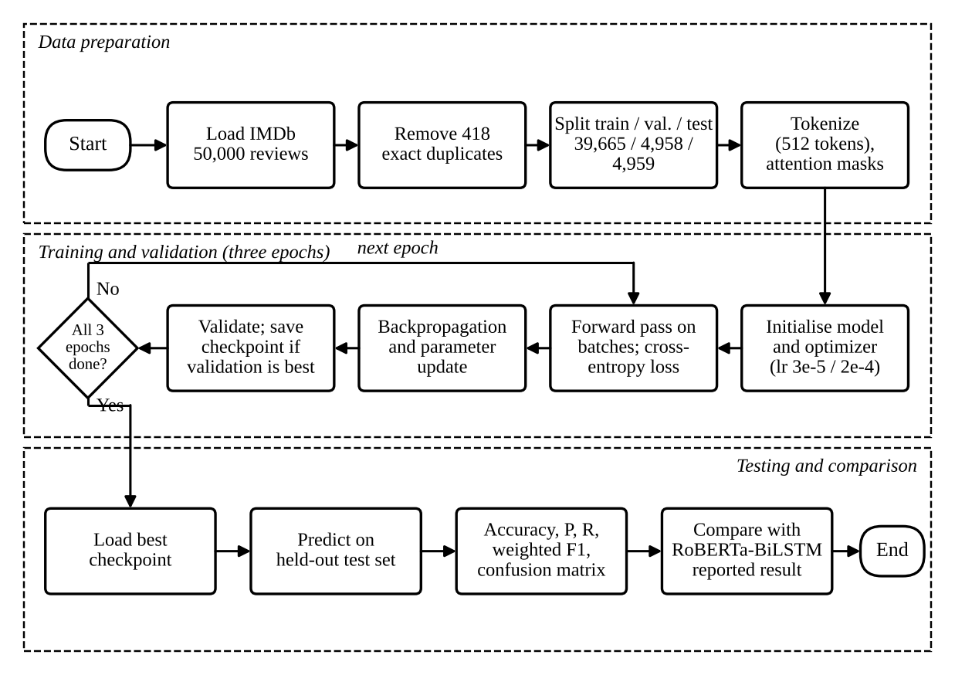
Fig. 4. Flowchart of data preparation, training, validation, and testing.

6.4 Component-wise Description
Table 3 summarizes each block of the proposed architecture, its input, its output, and its function. The shapes assume a review that has been padded to n = 512 tokens and an encoder with hidden size H = 768.
Table 3. Blocks of the proposed ModernBERT with attention-pooling classifier
Block | Input | Output | Function
BPE tokenizer | Review text | n token IDs, mask | Splits text into sub-words; pads or truncates to 512
ModernBERT-base | Token IDs, mask | n × 768 matrix | Produces contextual vector for every token
[CLS] selector | n × 768 matrix | 768 vector | Takes the sequence-level vector at position 1
Attention pooling | n × 768 matrix, mask | 768 vector | Scores tokens, masked Softmax, weighted sum
Concatenation | Two 768 vectors | 1,536 vector | Joins global and token-level summaries
Fully connected layers | 1,536 vector | 2 logits | Maps features to the two classes
Softmax | 2 logits | 2 probabilities | Gives class probabilities at inference

The data flow diagram (Fig. 3) and the training flowchart (Fig. 4) complement the architecture diagram. At the top from the review through model is the architecture diagram, showing the concept model architecture; second is the data flow diagram indicating the data and process flow of the system below are flow chart, demonstrating the order of training, validation and testing of the model. These depict the model structure, system-level data flow and experimental process respectively.

7. Implementation (Tools and Technology Used)

7.1 Programming Language
Python is primary language because of its overall support for ML,DL and NLP is very good.Python is also the language in which PyTorch, Hugging Face Transformers, and the scientific libraries used in this project are written , so the entire pipeline from data loading to evaluation can be expressed in single language and one notebook. Its simple syntax reduces development time and its large community provides documentation and tested implementations of the components needed for NLP experiments. Heavy computations run in compiled code on the GPU, so the use of Python does not limit or cap the training speed.

7.2 Tools and Technologies
The following tools and technologies implement the proposed model:
1. Google Colab: It provide cloud environment for running Python code and training with the GPU acceleration.
2. PyTorch:It implements the attention-pooling layer, classification layers, loss, backpropagation, and optimization [23].
3. Hugging Face Transformers: It provides the pretrained ModernBERT-base model and its tokenizer [24].
4. Pandas and NumPy: The dataset loading, duplicate removal, and numerical operations [25, 26] it will be handled.
5. Matplotlib: The plots of training and validation accuracy and loss across epochs are handled [27].
6. Google Drive: The storage of model checkpoints and training results.
Table 4. Role of each tool in implementation
Tool | Category | Role in this project
Python | Language | Implements data preparation, model, training, and evaluation
Google Colab | Environment | Hosts the notebook and provides the Tesla T4 GPU
PyTorch | Deep learning | Tensors, attention-pooling layer, loss, backpropagation, optimizer
Hugging Face Transformers | Model library | Pretrained ModernBERT-base weights and its tokenizer
Pandas, NumPy | Data handling | Loading reviews, removing duplicates, numerical operations
Scikit-learn | Evaluation | Data splitting; accuracy, precision, recall, F1, confusion matrix
Matplotlib | Visualization | Training curves and confusion-matrix plot
Google Drive | Storage | Keeps checkpoints and results between sessions

Google Colab and the GPU.
Google colab contains browser based notebook with free GPU and no setup that makes these experiment reproducible on any computer. The training of a transformer on 512 token inputs would be prohibitively slow, so we need GPU speedups. Is set to make sure we do not go over our limit, so checkpoints are saved to Google Drive.
Hugging Face Transformers. By use of the tokenizer that belongs to the pretrained model is important because the token identifiers must match those seen during pretraining of the model.
Pandas, NumPy, Scikit-learn, and Matplotlib. Pandas [25] and NumPy [26] are used to read the dataset, find and remove exact duplicates, and handle arrays. Scikit-learn [22] provides the routines for splitting the data and for computing the metrics, including the confusion matrix. Matplotlib [27] draws the training and validation curves and the confusion-matrix figure.

7.3 Hardware and Experimental Environment
The model is trained in Google Colab on a Tesla T4 GPU for three epochs with a maximum sequence length of 512 tokens. The learning rate is 3×10⁻⁵ for the pretrained encoder and 2×10⁻⁴ for the classification layers.
Table 5. Experimental configuration
Item | Setting
Dataset | IMDb movie reviews, 50,000 (49,582 after removing 418 duplicates)
Train / validation / test split | 39,665 / 4,958 / 4,959 reviews
Pretrained encoder | ModernBERT-base
Maximum sequence length | 512 tokens
Epochs | 3
Learning rate (encoder / new layers) | 3×10⁻⁵ / 2×10⁻⁴
Hardware and platform | Tesla T4 GPU, Google Colab

The NVIDIA Tesla T4 is a data-centre GPU with 16 GB of memory, 2,560 CUDA cores, and 320 Tensor Cores that accelerate mixed-precision matrix multiplication. Its memory is the main constraint on the batch size when 512-token sequences are used, because the memory needed for activations grows with both the batch size and the sequence length. For this reason the maximum sequence length of 512 tokens and the choice of the model size (the base version with about 150 million parameters, rather than the large version) were matched to the available hardware.

7.4 Implementation Workflow
The implementation follows the sequence of steps below. Each step corresponds to a block of the flowchart in Fig. 4.
1. Environment setup: open a Colab notebook with a GPU runtime, install or import the required libraries, and mount Google Drive for checkpoints.
2. Data loading and cleaning: read the 50,000 reviews into a table, remove the 418 exact duplicates, and encode the sentiment labels as numbers.
3. Splitting: divide the 49,582 reviews into training (39,665), validation (4,958), and test (4,959) subsets.
4. Tokenization: apply the ModernBERT tokenizer with padding and truncation to 512 tokens and create the attention masks; wrap the tensors in a dataset and data loaders that supply mini-batches.
5. Model definition: load the pretrained ModernBERT-base encoder and add the attention-pooling layer, the concatenation of the [CLS] and pooled vectors, and the fully connected classification layers.
6. Optimizer setup: assign the learning rate of 3×10⁻⁵ to the encoder and 2×10⁻⁴ to the new layers.
7. Testing: reload the best checkpoint, predict the labels of the test subset, and compute accuracy, precision, recall, weighted F1-score, and the confusion matrix.
8. Reporting: plot the training curves and the confusion matrix, record the training time, and tabulate the comparison with the reference model.

7.5 Code Organization
The code is organized into a small number of logical components each with one responsibility so that individual parts can be modified without affecting the rest componenets.
1. Dataset component: stores the tokenized reviews, the attention masks and the labels and returns one example at a time to the data loader which groups examples into shuffled mini-batches.
2. Pooling component: A pytorch module that hold the parameters of the scoring function that applies the padding mask computes the softmax weights and returns the weighted sum of the token vectors.
3. Model component: a module that wraps the pretrained ModernBERT encoder, calls the pooling component, concatenates the [CLS] and pooled vectors, and applies the fully connected layers to produce the two logits.
4. Training component: a function that runs one epoch of training and one pass of validation, records the loss and accuracy, and saves the checkpoint with the best validation performance.
5. Evaluation component: a function that loads the best checkpoint, predicts the test labels, and computes the metrics and the confusion matrix with Scikit-learn.
That is, the model component minus the pooling component replaced with the simple [CLS] vector is a [CLS] only baseline and with the encoder in the model component replaced with another pretrained encoder, while the dataset, training and evaluation components are unchanged ensuring the same data usage in each experiment.

7.6 Implementation Summary

the clean and tokenized reviews are fed to ModernBERT; the attention pooling and [CLS] vector are concatenated and fed to the fully connected layer for classification. The validation checkpoint with the best accuracy is evaluated on the test set, thus achieving the test accuracy of 95.93% and the weighted F1-score of 95.93% in around 162 min.

8. Result, Discussion and Analysis

8.1 Experimental Results
The model was evaluated on the held out test set of 4,959 reviews after 3 training epochs on a Tesla T4 GPU. The checkpoint with best validation performance was used for the final evaluation purpose. As shown in table 6. This small difference is descriptive and does not by itself prove that overfitting is absent or not available.
The metrics uses the definitions in Section 4.6. Accuracy is the share of the 4,959 test reviews that are classified correctly; the weighted F1-score averages the class-wise F1-scores with the class sizes as weights. Since the test subset was never used to train the model or to choose the checkpoint, these values estimate how the model performs on unseen IMDb reviews drawn from the same distribution.
Table 6. Performance of the proposed model on the IMDb dataset
Evaluation metric | Proposed model
Test accuracy | 95.93%
Weighted F1-score | 95.93%
Best validation accuracy | 96.07%
Recorded training time | Approximately 162 minutes (3 epochs)

Class-wise results from the confusion matrix (Fig. 5) are in Table 7. Precision, recall, and F1-score are nearly identical for the two classes, so the model is not biased toward either sentiment.
Table 7. Class-wise precision, recall, and F1-score on the test set
Class | Precision | Recall | F1-score | Support
Negative | 95.62% | 96.23% | 95.92% | 2,470
Positive | 96.24% | 95.62% | 95.93% | 2,489
Weighted average | 95.93% | 95.93% | 95.93% | 4,959

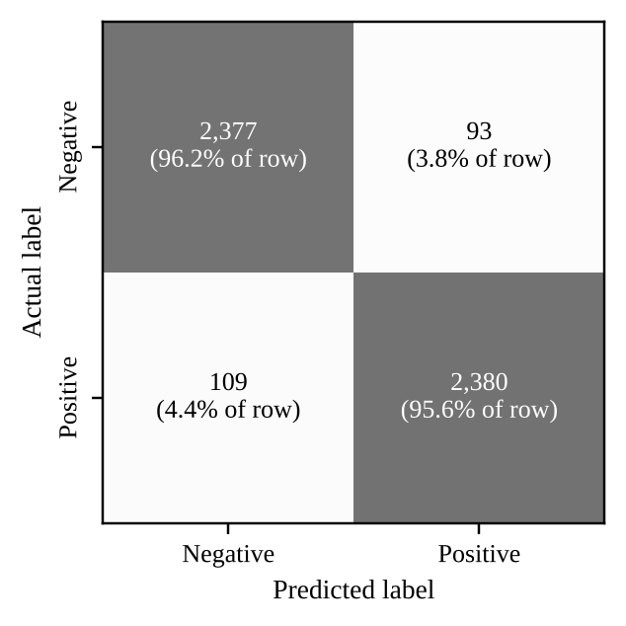
Fig. 5. Confusion matrix of the proposed model on the IMDb test set (4,959 reviews).
The counts behind the confusion matrix are listed in Table 8, with the positive class as the reference class. Of the 2,470 negative reviews, 2,377 are classified correctly and 93 are classified as positive; of the 2,489 positive reviews, 2,380 are classified correctly and 109 are classified as negative. In total 202 of 4,959 reviews are wrong, an error rate of 4.07%, which corresponds to the accuracy of 95.93%. The false positive rate for negative reviews is 3.77% (93 of 2,470) and the false negative rate for positive reviews is 4.38% (109 of 2,489). The two rates are close, so the model makes both types of error at a similar level.
Table 8. Confusion matrix counts on the test set (4,959 reviews)
Actual \ Predicted | Negative | Positive | Total
Negative | 2,377 | 93 | 2,470
Positive | 109 | 2,380 | 2,489
Total | 2,486 | 2,473 | 4,959

The precision and recall in Table 7 can be recomputed from these counts. For the positive class, precision is 2,380 / (2,380 + 93) = 96.24% and recall is 2,380 / (2,380 + 109) = 95.62%. For the negative class, precision is 2,377 / (2,377 + 109) = 95.62% and recall is 2,377 / (2,377 + 93) = 96.23%.

8.2 Comparison with the Reference Model
The training-time figures should not be interpreted as evidence of greater efficiency the reference result covers five epochs whereas this experiment covers three (about 54 minutes per epoch if the full 162-minute duration is divided by three).
Table 9. Comparison with reference RoBERT a BiLSTM model on IMDb
Parameter | RoBERTa-BiLSTM [3] | ModernBERT + attention pooling
Test accuracy | 92.36% | 95.93%
Weighted F1-score | 92.35% | 95.93%
Number of epochs | 5 | 3
Reported training time | 170.98 min | approx. 162 min
Architecture | Transformer + BiLSTM | Transformer + attention pooling

Table 10 gives the absolute difference in percentage points, and Fig. 6 shows the accuracies side by side. The error rate of the proposed model (4.07%) is lower than that of RoBERTa-BiLSTM (7.64%), which is roughly 47% fewer errors; this figure only restates the difference in the reported numbers and is subject to the same cautions about the comparison.

Table 10. Accuracy of the proposed model relative to the reviewed approaches
Reference approach | Accuracy | Proposed | Difference
Logistic Regression [3] | 87.12% | 95.93% | +8.81 pp
RoBERTa-base [3] | 91.32% | 95.93% | +4.61 pp
RoBERTa-BiLSTM [3] | 92.36% | 95.93% | +3.57 pp

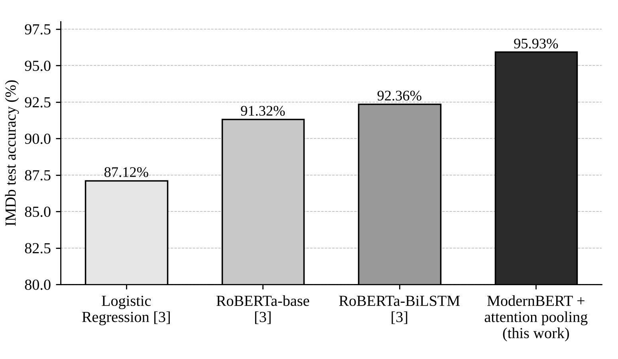
Fig. 6. Comparison of IMDb test accuracy of the reviewed approaches and the proposed model (vertical axis starts at 80%).

8.3 Discussion and Error Analysis
This may be the result of the context representations of ModernBERT, the attention-pooling layer, or some other part of the training setup. This experiment, however, does not allow us to tell how much of the difference can be attributed to each of the above elements, and we cannot isolate from each other how much each of these three factors contributes to the results..
In the confusion matrix (Fig. 5), 93 negative reviews are classified as positive and 109 positive reviews as negative, giving 202 errors among 4,959 reviews.
The 202 misclassified reviews were not manually inspected so their causes cannot be confirmed from this above given experiment. error types include reviews that denote many words to plot description before stating an opinion or reviews that combinly praise and criticism and sarcastic comments whose intended meaning differs from their literal wording.
The validation accuracy (96.07%) and test accuracy (95.93%) are very close, and the class-wise precision and recall values are similar.
The sampling uncertainty of the test result can be estimated from the number of test reviews. As per the described in Section 4.6, the standard error of the accuracy is about 0.28 percentage points, and the approximate 95% confidence interval for the true accuracy of this model on data like the test set is therefore from 95.4% to 96.5%. The difference of 3.57 percentage points from the published RoBERTa - BiLSTM accuracy is much larger than this interval so it is unlikely to be explained by sampling noise alone. It can still be explained by the differences in encoders, data splits and training procedures between the two studies, which the interval does not capture.

8.4 Computational Cost
The training I put on is 162 minutes for 3 epochs on Tesla T4, so about 54 minutes an epoch. The ref RoBERTa-BiLSTM paper shows it was 170.98 minutes for 5 epochs. So about 34.2 mins an epoch [3]. But these are not the same metrics to compare as the hardware, batch size, sequence length, software version, and setup could all be different.

8.5 Limitations
This comparison is not revealing whether the attention pooling helps since the encoders and settings are not the same. In an additional experiment, RoBERTa-BiLSTM should be re-implemented with the same data split for training versus inference with the [CLS]-only head, and check for training time, inference latency, and GPU memory cost with the same measurement environment.
We only used one train-test split and run the training once so we cannot estimate the variability that could have been introduced by our random intialization and shuffling. We only tested with English movie reviews, which could potentially be easier to classify than other forms of text. We truncated inputs to 512 tokens, which could eliminate potentially the most marked sentiment sentences. We did not use multiple seeds and datasets.

8.6 Summary of Findings
The main findings of the experiments are summarized below.
1. ModernBERT-base attention pooling reported test accuracy and weighted F1-score of 95.93% on 4,959 held-out IMDb reviews with best validation accuracy of 96.07%.
2. F1-scores and recall are negligible different for positive and negative reviews (~ 96%) and the 202 errors are roughly evenly split into false positives (93) and false negatives (109) so this is not a sentimentist.
3. The accuracy is 3.57 percentage points higher than the published RoBERTa-BiLSTM result, 4.61 points higher than RoBERTa-base, and 8.81 points higher than Logistic Regression [3].
4. The training time of about 162 minutes for three epochs on a Tesla T4 GPU is of the same order per epoch as that reported for the reference, so no efficiency advantage can be claimed without a controlled measurement.
5. The evidence supports the use of the proposed model as a strong and practical classifier, but it does not isolate the contribution of ModernBERT, of attention pooling, or of the training setup.

9. Conclusion and Future Scope

9.1 Conclusion
Similarly, this was used to train a ModernBERT-base classifier with attention pooling to classify positive-vs-negative IMDb reviews using the [CLS] representation and an attention-weighted sum of token representations.While these results look promising, the difference does not seem straightforward to compare across the different implementations, nor was it compared to the simple attention pooling architectures.
Cost on accuracy it may not saved the transformer training still have the attention calculation, forward backward propagations, parameters updating. We should be put a control test to measure the effect of each parts of architecture.The class metric is about 96%. 202 errors (93 false positives + 109 false negatives).
Based on the architecture, our experiment is reaching the conclusion that pretrained encoder + cloud GPU computing power should be the best choice of sentiment-classification. The head with attention-pooling instead of the whole transformer is not so complicated that plug into different encoder should have no difference.

9.2 Future Scope
1. Architecture comparison: compare ModernBERT with RoBERTa-BiLSTM, DeBERTa-based models [28], and other Transformers under consistent settings.
2. Attention-pooling ablation: test alternative pooling methods and the role of the [CLS] representation.
3. Hyperparameter tuning: vary learning rates, batch sizes, dropout, and sequence length.
4. Computational efficiency: measure training time, inference latency, and GPU memory.
5. Generalization: evaluate on additional sentiment datasets.
6. Model optimization: explore mixed-precision training [29], quantization, and knowledge distillation.

9.3 Concluding Remarks
Sentiment classification of long reviews depends on the encoder, the method used to combine token representations, and the reliability of the evaluation procedure. In this experiment, ModernBERT-base with attention pooling achieved 95.93% accuracy on IMDb without a recurrent layer.

10. References
[1] B. Pang and L. Lee, “Opinion mining and sentiment analysis,” Found. Trends Inf. Retr., vol. 2, no. 1–2, pp. 1–135, 2008. [Online]. Available: https://doi.org/10.1561/1500000011
[2] B. Liu, Sentiment Analysis and Opinion Mining. San Rafael, CA, USA: Morgan & Claypool, 2012. [Online]. Available: https://www.cs.uic.edu/~liub/FBS/SentimentAnalysis-and-OpinionMining.html
[3] M. M. Rahman, A. I. Shiplu, Y. Watanobe, and M. A. Alam, “RoBERTa-BiLSTM: A context-aware hybrid model for sentiment analysis,” IEEE Trans. Emerg. Topics Comput. Intell., vol. 9, no. 6, pp. 3788–3805, 2025, doi: 10.1109/TETCI.2025.3572150. [Online]. Available: https://doi.org/10.1109/TETCI.2025.3572150
[4] B. Pang, L. Lee, and S. Vaithyanathan, “Thumbs up? Sentiment classification using machine learning techniques,” in Proc. Conf. Empirical Methods Natural Lang. Process. (EMNLP), 2002, pp. 79–86. [Online]. Available: https://aclanthology.org/W02-1011/
[5] S. Hochreiter and J. Schmidhuber, “Long short-term memory,” Neural Comput., vol. 9, no. 8, pp. 1735–1780, 1997. [Online]. Available: https://doi.org/10.1162/neco.1997.9.8.1735
[6] M. Schuster and K. K. Paliwal, “Bidirectional recurrent neural networks,” IEEE Trans. Signal Process., vol. 45, no. 11, pp. 2673–2681, Nov. 1997. [Online]. Available: https://doi.org/10.1109/78.650093
[7] A. Vaswani et al., “Attention is all you need,” in Advances in Neural Information Processing Systems (NeurIPS), vol. 30, 2017, pp. 5998–6008. [Online]. Available: https://arxiv.org/abs/1706.03762
[8] J. Devlin, M.-W. Chang, K. Lee, and K. Toutanova, “BERT: Pre-training of deep bidirectional transformers for language understanding,” in Proc. Conf. North Amer. Chapter Assoc. Comput. Linguistics: Human Lang. Technol. (NAACL-HLT), vol. 1, 2019, pp. 4171–4186, doi: 10.18653/v1/N19-1423. [Online]. Available: https://aclanthology.org/N19-1423/
[9] Y. Liu et al., “RoBERTa: A robustly optimized BERT pretraining approach,” arXiv preprint arXiv:1907.11692, 2019. [Online]. Available: https://arxiv.org/abs/1907.11692
[10] C. Sun, X. Qiu, Y. Xu, and X. Huang, “How to fine-tune BERT for text classification?” in Chinese Computational Linguistics (CCL), Lecture Notes in Computer Science, vol. 11856. Cham, Switzerland: Springer, 2019, pp. 194–206. [Online]. Available: https://arxiv.org/abs/1905.05583
[11] B. Warner et al., “Smarter, better, faster, longer: A modern bidirectional encoder for fast, memory efficient, and long context finetuning and inference,” arXiv preprint arXiv:2412.13663, 2024. [Online]. Available: https://arxiv.org/abs/2412.13663
[12] A. L. Maas, R. E. Daly, P. T. Pham, D. Huang, A. Y. Ng, and C. Potts, “Learning word vectors for sentiment analysis,” in Proc. 49th Annu. Meeting Assoc. Comput. Linguistics: Human Lang. Technol. (ACL-HLT), Portland, OR, USA, 2011, pp. 142–150. [Online]. Available: https://aclanthology.org/P11-1015/
[13] S. Minaee et al., “Deep learning-based text classification: A comprehensive review,” ACM Comput. Surv., vol. 54, no. 3, Art. no. 62, 2021, doi: 10.1145/3439726. [Online]. Available: https://doi.org/10.1145/3439726
[14] R. Socher et al., “Recursive deep models for semantic compositionality over a sentiment treebank,” in Proc. Conf. Empirical Methods Natural Lang. Process. (EMNLP), Seattle, WA, USA, 2013, pp. 1631–1642. [Online]. Available: https://aclanthology.org/D13-1170/
[15] D. Bahdanau, K. Cho, and Y. Bengio, “Neural machine translation by jointly learning to align and translate,” in Proc. Int. Conf. Learn. Represent. (ICLR), 2015. [Online]. Available: https://arxiv.org/abs/1409.0473
[16] Z. Yang, D. Yang, C. Dyer, X. He, A. Smola, and E. Hovy, “Hierarchical attention networks for document classification,” in Proc. Conf. North Amer. Chapter Assoc. Comput. Linguistics: Human Lang. Technol. (NAACL-HLT), San Diego, CA, USA, 2016, pp. 1480–1489. [Online]. Available: https://aclanthology.org/N16-1174/
[17] S. Jain and B. C. Wallace, “Attention is not explanation,” in Proc. NAACL-HLT, Minneapolis, MN, USA, 2019, pp. 3543–3556. [Online]. Available: https://aclanthology.org/N19-1357/
[18] S. Wiegreffe and Y. Pinter, “Attention is not not explanation,” in Proc. Conf. Empirical Methods Natural Lang. Process. 9th Int. Joint Conf. Natural Lang. Process. (EMNLP-IJCNLP), Hong Kong, China, 2019, pp. 11–20. [Online]. Available: https://aclanthology.org/D19-1002/
[19] J. Su, M. Ahmed, Y. Lu, S. Pan, W. Bo, and Y. Liu, “RoFormer: Enhanced transformer with rotary position embedding,” Neurocomputing, vol. 568, Art. no. 127063, 2024. [Online]. Available: https://doi.org/10.1016/j.neucom.2023.127063
[20] N. Shazeer, “GLU variants improve transformer,” arXiv preprint arXiv:2002.05202, 2020. [Online]. Available: https://arxiv.org/abs/2002.05202
[21] T. Dao, D. Y. Fu, S. Ermon, A. Rudra, and C. Ré, “FlashAttention: Fast and memory-efficient exact attention with IO-awareness,” in Advances in Neural Information Processing Systems (NeurIPS), vol. 35, 2022, pp. 16344–16359. [Online]. Available: https://arxiv.org/abs/2205.14135
[22] F. Pedregosa et al., “Scikit-learn: Machine learning in Python,” J. Mach. Learn. Res., vol. 12, pp. 2825–2830, 2011. [Online]. Available: https://jmlr.org/papers/v12/pedregosa11a.html
[23] A. Paszke et al., “PyTorch: An imperative style, high-performance deep learning library,” in Advances in Neural Information Processing Systems (NeurIPS), vol. 32, 2019, pp. 8024–8035. [Online]. Available: https://arxiv.org/abs/1912.01703
[24] T. Wolf et al., “Transformers: State-of-the-art natural language processing,” in Proc. Conf. Empirical Methods Natural Lang. Process.: Syst. Demonstrations, 2020, pp. 38–45. [Online]. Available: https://aclanthology.org/2020.emnlp-demos.6/
[25] W. McKinney, “Data structures for statistical computing in Python,” in Proc. 9th Python Sci. Conf. (SciPy), 2010, pp. 56–61. [Online]. Available: https://proceedings.scipy.org/articles/Majora-92bf1922-00a
[26] C. R. Harris et al., “Array programming with NumPy,” Nature, vol. 585, no. 7825, pp. 357–362, Sep. 2020. [Online]. Available: https://doi.org/10.1038/s41586-020-2649-2
[27] J. D. Hunter, “Matplotlib: A 2D graphics environment,” Comput. Sci. Eng., vol. 9, no. 3, pp. 90–95, May/Jun. 2007. [Online]. Available: https://doi.org/10.1109/MCSE.2007.55
[28] P. He, X. Liu, J. Gao, and W. Chen, “DeBERTa: Decoding-enhanced BERT with disentangled attention,” in Proc. Int. Conf. Learn. Represent. (ICLR), 2021. [Online]. Available: https://arxiv.org/abs/2006.03654
[29] P. Micikevicius et al., “Mixed precision training,” in Proc. Int. Conf. Learn. Represent. (ICLR), 2018. [Online]. Available: https://arxiv.org/abs/1710.03740

LIST OF PUBLICATION
ACCEPTED / SUBMITTED / PUBLISHED (If Any)
No publications to report at present.

PLAG REPORT (Through Turnitin)
Similarity Plagiarism Report + AI Plagiarism Report
[Attach the Turnitin similarity report and AI-writing report for this document on this page.]

