Curriculum Vitae

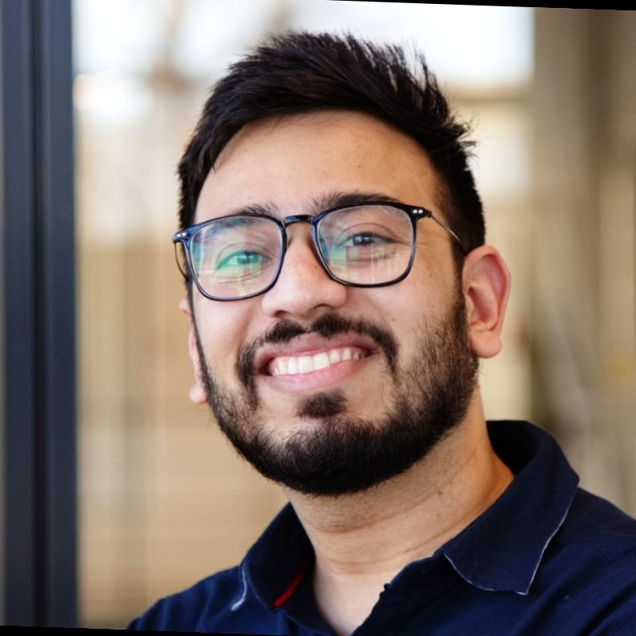

[](https://github.com/Pranav-SA)**Pranav Shankar**

[](https://www.linkedin.com/in/pranav-shankar-447452150/)MSc Informatics

Technical University of Munich.

STAR Program SAP SE,

Munich, Germany.

pranav.shankar@sap.com

# Professional Experience

03/2021-09/2021 Master Thesis, Cloud Resiliency - Chaos Engineering, SAP Concur *(STAR Program Rotation -3)*

10/2021-03/2022 Working student, Cloud Native Developer - Observability, SAP Kyma *(STAR Program Rotation -2)*

03/2021-09/2021 Working student, Full Stack Developer, SAP Customer Experience *(STAR Program Rotation -1)*

01/2020-06/2020 Software Development, Accolite Software India Pvt Ltd

02/2019-12/2019 Research Project, Machine Learning based Sentiment Analysis

System for Multiple Domains, research project collaboration of Panjab University with King Abdulaziz University, Saudi Arabia

06/2018-07/2018 Software Developer**,** ESD Networks India (6 weeks) 05/2018-06/2018 Machine Learning Internship, Verzeo Edutech Pvt Ltd.

# Education

10/2020-11/2022 **M.Sc.** Informatics, Technical University of Munich, Germany (ongoing)

03/2022 Certified Kubernetes Application Developer (CKAD) (LF-gnk0upqz61)

12/2021 Aero Edu: Agile Developer (TUM – Aero Edu)

09/2021 Google Cloud: Foundations, AWS Cloud Practitioner

08/2020 Deep Learning Specialization, Coursera (8Z3AH9Z29XLN)

07/2016-06/2020 **B.E.** Computer Science and Engineering, University Institute of Engineering and Technology, Panjab University. [**9.48/10.00**]

02/2019 One M2M Developer workshop initiative under India-EU Cooperation On ICT-Related Standardization, Policy and Legislation

05/2018 Microsoft Technology Associate Certification, Machine Learning (wmyKc-48CC) 04/2015-03/2016 12th Science Stream, St. Mary’s Academy, Saharanpur [**94.2/100**]

04/2014-03/2015 10th, St. Mary’s Academy, Saharanpur [**10.0/10.0**]

# Academic Employment

02/2019-12/2019 **Research Intern**, Deep Learning and NLP, University Institute of Engineering and Technology, Panjab University, Chandigarh India

# Scholarships and Awards

|  |  |
| --- | --- |
| 2020  2019 | Software Engineering Virtual Experience, JPMorgan Chase & Co.  **Data Research Scholarship**, University Institute of Engineering and |
|  | Technology, Panjab University, Chandigarh, India |
| 2018 | **Merit Award** for excellence in Academics, Panjab University |
| 2017 | **Best Paper** presentation at CHASCON, Chandigarh Science Congress |
|  | hosted by Panjab University to encourage young researchers. |
| 2016 | **Merit Reward**, a laptop for excellence in Board Examinations by Uttar |
|  | Pradesh Government, India |
| 2014 | **Merit Award** for outstanding performance and for obtaining Grade ‘A1’ |
|  | in all the five subjects, class 10th by Central Board of Secondary  Education, India |

**Publications and Projects**

*“Best Energy”, a Web3 Decentralized application for peer-to-peer energy distribution.*  Blockchain technology for renewable energy sharing and trading, A project for DLT4PI with Fortis Munich.

*“Mobility Connect”, bring all your transportation needs in one application*, Software Engineering for Business Applications SEBA Masters project.

*“Analyzing Varied Approaches for Forecast of Stock Prices by Combining News Mining and Time Series Analysis”*- Pranav Shankar, Manika Arora, Rajat Kaushal, Iknoor Singh, IEEE Conference 47222 (https://ieeexplore.ieee.org/document/8940491)

*“Green Cloud Computing using Genetic Algorithm for Load Balancing by Considering Individual Node Metrics”* - Pranav Shankar, Vidushi Arora, Pratik Joshi, J-No 49102

*“Privacy and Coevolution”-* Paper presentation at CHASCON (Chandigarh Science Congress hosted by Panjab University), awarded best paper

*“News Analyzer, A Web Data Analysis Engine”* – Intern Project at ESD India

*“Review on Image Creation Synthesis using Generative Adversarial Networks by providing Textual Description”* – Minor Project 7th Semester

*“College Sarathi, from students for the students”* – Hackathon project, All India Grand Finalist, Smart India Hackathon

# Languages Hindi , English C1, German A2