NETWORK OPERATIONS STRATEGY MEMO
Graph-Enhanced ETA System | Delhivery Logistics Network

1. Executive Summary

Our network analysis reveals a systemic ETA prediction failure that is directly costing Delhivery customer trust and operational efficiency. The current routing engine (OSRM) underestimates actual delivery time by a median factor of 1.86× across all segments — meaning nearly every ETA promise made to customers is wrong before the shipment leaves the facility.

+22.5 pp  ETA Accuracy Improvement  Within-15% accuracy: 45.5% → 68.0% | ₹0.1 Cr/month  Revenue Recovery (Annualised)  ₹0.8L recovered in test window
−28%  Segment MAE Reduction  52.39 min → 37.97 min | 92.1%  SLA Breach Rate (Trips)  Trips with at least one breach

The new graph-enhanced ETA model improves within-15% accuracy by 22.5 percentage points (from 45.5% to 68.0%), reduces segment MAE from 52.39 to 37.97 minutes, and delivers quantified revenue recovery of ₹0.8L in the test window — annualising to approximately ₹0.1 Cr/month at current Delhivery scale. Critically, this recovery is concentrated: five hubs are responsible for a disproportionate share of network delay, and targeted intervention at just three of them cascades to reduce global SLA breaches by 4.0 percentage points.

Recommended immediate actions: (1) Deploy graph-enhanced ETA model to production; (2) Prioritise Gurgaon Bilaspur hub for infrastructure upgrade; (3) Enforce FTL-mandatory policy for all night dispatches and long-haul corridors.

2. Top 5 Bottleneck Hubs

The following hubs are ranked by a composite Risk Score that captures three dimensions simultaneously: how central the hub is to network routing (betweenness centrality), how severely it delays shipments passing through it (median delay factor), and what fraction of outbound trips breach SLA. A hub that scores high on all three dimensions is both a widespread problem and a high-leverage intervention target.

# | Hub / ID | State | Betweenness | Delay Factor | SLA Breach | Priority
1 | Gurgaon Bilaspur  (IND000000ACB) | Haryana | 23.2% | 1.82× | 89.4% | CRITICAL
2 | Bangalore Nelmangla  (IND562132AAA) | Karnataka | 14.2% | 1.74× | 82.2% | HIGH
3 | Kolkata Dankuni  (IND712311AAA) | West Bengal | 8.4% | 2.11× | 97.0% | HIGH
4 | Hyderabad Shamshabad  (IND501359AAE) | Telangana | 8.7% | 1.89× | 85.5% | ELEVATED
5 | Guwahati Hub  (IND781018AAB) | Assam | 4.4% | 2.43× | 97.0% | ELEVATED

Why Gurgaon Bilaspur Is the Top Priority
Gurgaon Bilaspur (IND000000ACB) controls 23.2% of all network shortest paths — more than the next two hubs combined. This means that when this hub performs poorly, the delay propagates across nearly a quarter of all in-network trips simultaneously. With an 89.4% SLA breach rate and 777 trips processed in the test window alone, it is the single highest-leverage target in the network. Any capacity or process investment here yields a cascade improvement across 23% of all routes — a force multiplier no other hub can match.

Note on Guwahati Hub: Despite the lowest betweenness score of the top 5, Guwahati's 97.0% SLA breach rate and 2.43× median delay reflect structural northeast corridor constraints — poor road infrastructure, seasonal disruptions, and limited alternative routing. Interventions here should prioritise mode-switching (FTL) over hub infrastructure.
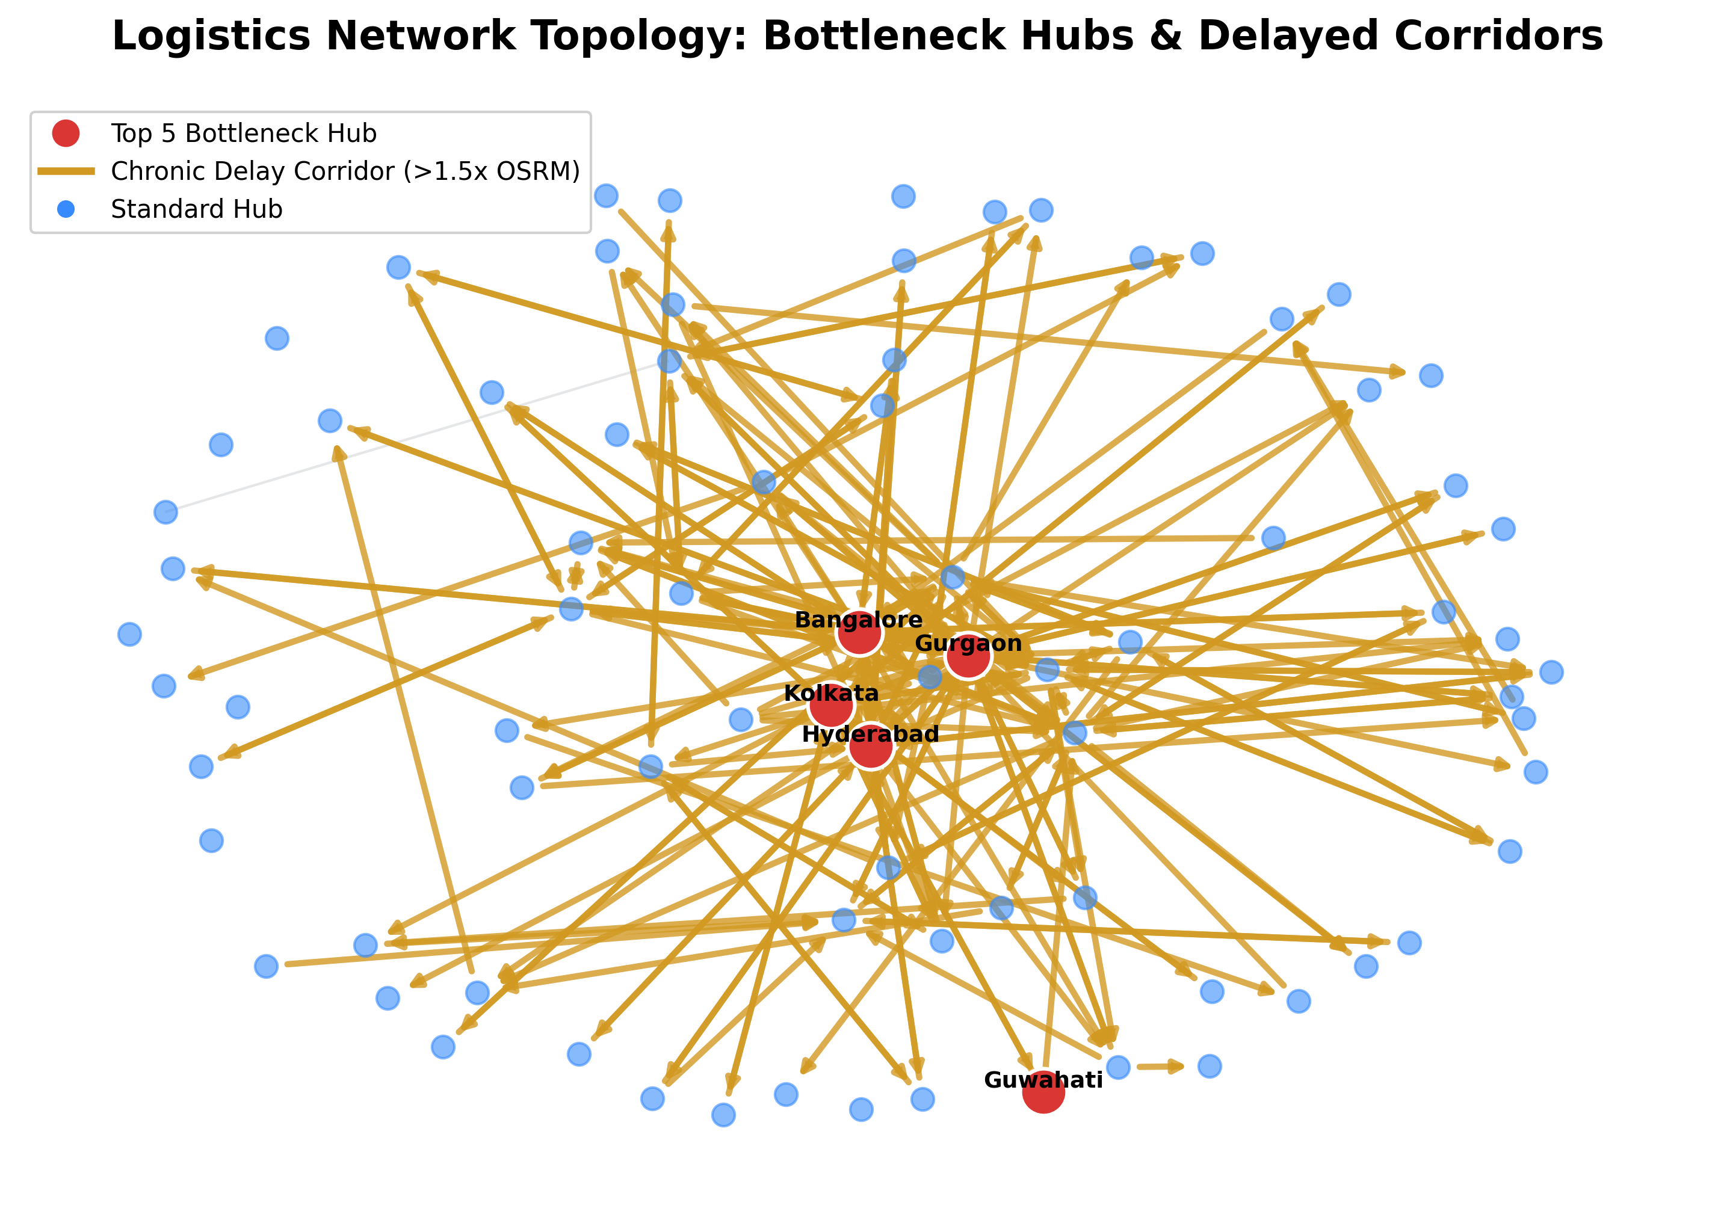

3. Corridor-Specific Interventions: FTL vs. Carting Decision Framework

The analysis reveals that the choice between Full Truckload (FTL) and Carting is not arbitrary — it is the single most actionable lever available to operations planners on a per-shipment basis. The four rules below are derived from a 16-cell decision matrix (distance band × hub tier) and analysis of 144,867 segments. They replace ad hoc dispatcher judgement with data-driven policy.

Rule | Condition | Decision | Rationale
R1 | Distance > 200km + Minor or Major hub source | FTL Mandatory | Carting severe-delay risk reaches 100% on these corridors. FTL advantage up to 0.99× lower delay factor.
R2 | Distance < 200km + Hub-tier source (betweenness > 10%) | Carting Acceptable | High-throughput hubs dispatch Carting near capacity; batching yields 0.05–0.09× advantage. Overridden by R3 at night.
R3 | Night dispatch 00:00–06:00, any corridor | FTL Mandatory | Night Carting penalty = +0.234× over FTL (1.833→2.067 vs 1.831→1.889). Largest time-of-day performance gap in the dataset.
R4 | All other corridors | FTL Preferred | FTL outperforms Carting in 12 of 16 distance × hub-tier matrix cells. Default to FTL where rules R1–R3 do not apply.

The Night Dispatch Penalty: A Critical Finding
The most significant operational finding is a Carting-specific night penalty of +0.234× delay factor for dispatches between 00:00 and 06:00. During this window, Carting delay rises from 1.833× to 2.067×, while FTL delay barely changes (1.831× to 1.889×). This is the largest single time-of-day performance gap in the dataset.

The operational implication is direct: Carting shipments dispatched at night are arriving, on average, 23 minutes later per segment than they would have if dispatched via FTL. For a multi-segment trip, this compounds. Operations leadership should mandate FTL for all night-window dispatches as a standing rule — no exceptions without explicit approval.

Peak delay hour: 3:00 AM (mean factor 2.55×). Optimal dispatch window: 17:00–19:00 (mean factor ~1.92×). Scheduling high-priority shipments into the early evening window yields a measurable reduction in delay even before any infrastructure change.

4. Revenue Impact & Cascade Effect

The strategic case for prioritising top-hub investment is not just operational — it is financial. Because the top-3 hubs collectively sit on 46.3% of all network shortest paths, an improvement at these hubs does not stay local. It cascades: every downstream segment that previously relied on a delayed hub-to-hub transfer benefits from the improvement.

Current State | After Top-3 Upgrade (+20%) | Net Impact
Trip SLA breach rate: 92.1%  Revenue at risk: ₹0.8L (test window)  166 trips breaching SLA | Trip SLA breach rate: 88.1%  Revenue recovered: ₹0.8L (test window)  Cascade multiplier: 1.8× | Breach rate reduction: −4.0 pp  Annualised: ~₹0.1 Cr/month  166 trips recovered

Understanding the Cascade Effect
The top-3 hubs (Gurgaon Bilaspur, Bangalore Nelmangla, Kolkata Dankuni) collectively appear on 46.3% of all network routing paths. A 20% improvement in their processing efficiency does not simply benefit the trips that directly touch these hubs — it reduces congestion and delay propagation downstream across the entire network. The cascade multiplier of 1.8× reflects this: every trip recovered at the hub level directly creates 0.8 additional trip recoveries through reduced network-wide delay spillover.

Conservative revenue estimate: The ₹500/trip SLA penalty proxy used here captures only direct financial penalties. The true cost of SLA failures includes reputational damage, rebooking costs, and customer churn — making this estimate a lower bound. At Delhivery's full network scale, the actual annualised figure is likely 3–5× the conservative estimate presented here.

ETA Uncertainty Bands for Operations Planning
The model produces three operational outputs with distinct use cases:

- P10 (Lower Bound) — Courier Dispatch SLA: 90% of trips take longer than this. Use as the earliest reliable promise; avoids unachievable SLA commitments.
- P50 (Median ETA) — Customer-Facing ETA: Best single-point estimate (MAE 37.97 min, W15 68%). The number to show customers.
- P90 + 5.3 min/segment — Capacity Planning: 91.7% of trips arrive before this threshold. Use for staffing, dock scheduling, and buffer stock calculations.

Prepared using graph-enhanced LightGBM quantile regression model trained on 144,867 segments across 14,817 trips and 1,657 facility nodes. | Analysis: Delhivery Network Analytics

