Examination Management Portal (EMP)
Project report — Flask + SQLite web application · October 2026
Student | Your full name
Enrolment no. | Your enrolment number
Source code | Single ZIP with one root folder (emp/); run with python app.py
Demo video | Paste your video link here (also repeated on page 5)

1. Introduction
EMP is a role-based, server-rendered web application that manages oral/practical examinations end to end. An Admin creates courses and exams, defines a grading rubric and four date windows, assigns examiners and moves each exam through its lifecycle. Examiners (after Admin approval) publish time slots inside the slot-creation window and later score every rubric criterion for each student. Students register, search exams, book exactly one slot per exam inside the booking window, cancel before the deadline and finally see marks, a per-criterion breakdown and remarks once the Admin publishes results.
Core flow: Course → Exam (+ rubric, + examiners) → Slot Creation → Booking Open → Closed → evaluation → Completed → results published. Every action is a plain HTML form post or a link; JavaScript is used only for the optional charts on the Admin Reports page.

2. Technology and frameworks
Component | Version | Used for
Python | 3.14 | Language of the whole back-end
Flask | 3.1.3 | Web framework: routing, blueprints (auth, admin, examiner, student), sessions, flash messages
Flask-SQLAlchemy / SQLAlchemy | 3.1.1 / 2.1.4 | ORM: models, constraints, parameterised queries, transactions
SQLite | 3 (built in) | Single-file database instance/app.db, created in code by db.create_all()
Werkzeug | 3.1.9 | Password hashing (generate_password_hash / check_password_hash), signed cookies
Jinja2 | 3.1.6 | Server-side templates with template inheritance and auto-escaping
HTML5 + custom CSS | – | 38 templates, one small stylesheet (static/style.css); no CSS framework, no front-end build step
Chart.js (CDN, optional) | 4.4.1 | Three charts on the Admin Reports page only

Only Flask, Flask-SQLAlchemy and SQLAlchemy are listed in requirements.txt; Werkzeug, Jinja2, itsdangerous, click and blinker are installed automatically as their dependencies.

3. How to run
pip install -r requirements.txt
python app.py # creates instance/app.db and the Admin on first start
# open http://127.0.0.1:5000 Admin login: admin@emp.com / admin123

The Admin is seeded in code on first start; there is no Admin registration page. Students register and are active at once; Examiners register as pending and cannot use the portal until the Admin approves them.

4. Architecture
EMP is a single-process, server-rendered monolith. Routes stay thin: they read the form, call a service and render or redirect. Every business rule that matters lives in the service layer or in helpers.py, so a rule is written once and cannot be bypassed from a template.
Browser  Jinja2 pages + plain HTML forms | → | Blueprints  auth · admin · examiner · student, role decorators | → | Services  booking · evaluation · admin · profile | → | Models  SQLAlchemy, 10 tables + constraints | → | SQLite  instance/app.db

Project structure  emp/  |-- app.py app, blueprints, create_all, seed  |-- extensions.py db = SQLAlchemy()  |-- helpers.py role_req, examiner_required,  | slot_creation_open, slots_editable,  | booking_open  |-- models/ one file per table + enums.py  |-- routes/ auth, admin, admin_exam,  | admin_extra, examiner, student  |-- services/ booking, evaluation, admin,  | profile  |-- templates/ base.html + admin/ examiner/  | student/ auth/ (38 files)  |-- static/style.css  |-- report/ this report  `-- requirements.txt | Security  • Passwords are stored only as Werkzeug hashes.  • Flask signed-cookie session holds user_id, role, name.  • role_req(role) guards each page: not logged in → login, wrong role → 403.  • examiner_required also shows the “pending” page until the examiner is approved.  • Object-level checks: an examiner reaches only own slots/students (403); a student only own bookings/results (404).  • All queries go through SQLAlchemy (parameterised); Jinja auto-escaping stays on.  • State-changing actions are POST forms, never links.  • Results are hidden (404) until the Admin publishes them.

5. Business rules and where they are enforced
Rule | Enforced by
Slots only in the creation period | slot_creation_open: status Slot Creation and now inside the date window; examiner must be assigned
Edit / cancel slot before booking starts | slots_editable (before booking_start) and no active bookings in the slot
Book only in the booking period | booking_open inside booking_service.book
No overbooking | UPDATE slots SET available_seats = available_seats - 1 WHERE id=? AND available_seats > 0; 0 rows changed = full. Plus CHECK(available_seats >= 0 AND <= capacity)
Slot Full at 0 seats, reopened on cancel | status flips Available ↔ Full in the same transaction
One booking per exam | service pre-check + partial unique index on (student_id, exam_id) WHERE status='booked'
No overlapping bookings (extra) | _clashes: same date and overlapping times
Cancel before the deadline | status Booked and now < booking_end; seat returned
Examiner evaluates only own students | slot.examiner_id == session user, otherwise 403
Marks formula | total = Σ(awarded ÷ criterion max × weightage) ÷ 100 × exam max marks
Exam lifecycle | Draft → Slot Creation (needs weightage = 100 and ≥1 examiner) → Booking Open → Closed → Completed (needs every booking evaluated) → publish
Full history, never deleted | booking_history rows for book, cancel, reschedule, examiner change, completion
Admin reschedule / change examiner | admin_service: one transaction, free seat, no clash, approved examiner; logged
Deactivate examiner | refused while they own upcoming slots with bookings

6. Database design (ER diagram)
PK primary key · FK foreign key · UQ unique. Solid lines: parent → child inside the exam data. Dashed brown lines: references to users (examiner / student / acting admin). 1 = one, N = many. Every table also has a created_at column.
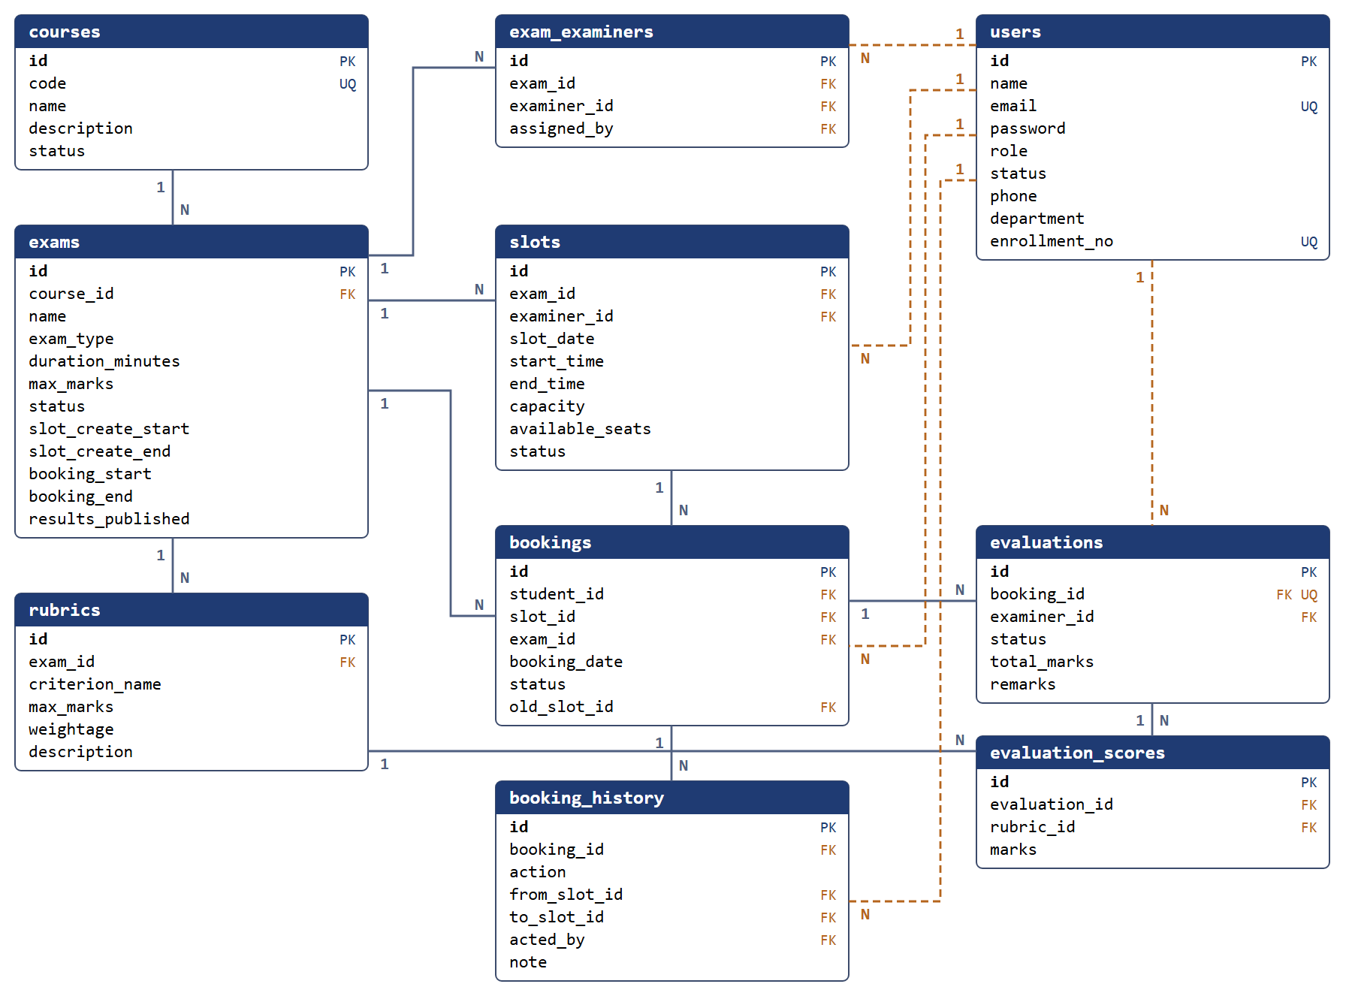

Relationships
• One course has many exams.  • One exam has many rubric criteria, slots, bookings and assigned examiners (exam_examiners, unique per exam + examiner).  • One user with role examiner owns many slots; a user with role student has many bookings.  • One slot has many bookings; bookings.old_slot_id remembers a reschedule. | • One booking has many booking_history rows and at most one evaluation (booking_id unique).  • One evaluation has one evaluation_scores row per rubric criterion (unique per evaluation + rubric).  • Roles (admin, examiner, student) share one users table; status is active / pending / rejected / inactive.  • Enums are stored as lowercase text; CHECK constraints guard marks, capacity, seats, time and date order.

Status lifecycles (stored in the status columns)
Entity | Allowed values and moves
Exam | draft → slotcreation → bookingopen → closed → completed; results_published (0/1) is set after completed. Each step is an Admin button, and the date windows must also hold.
Slot | available ↔ full as seats change; cancelled when the examiner removes it; completed when the exam is completed.
Booking | booked → cancelled (student or Admin) or booked → completed (after the examiner submits the evaluation).
Evaluation | draft → submitted. Results are visible only when it is submitted and the exam's results are published.
User | students: active. examiners: pending → active or rejected; active ↔ inactive. Admin: active (seeded).

7. Endpoint table (57 routes)
Generated from the running Flask app. Every page after login lives under its role prefix (/admin, /examiner, /student); opening another role's URL returns 403. POST routes are plain HTML form submissions followed by a redirect. The optional JSON API (/api/v1) is not part of this build.
Method | Route | Access | Purpose
GET | / | Public | Landing page
GET/POST | /login | Public | Login for all roles, redirects by role
GET/POST | /register/<role> | Public | Register as student / examiner (examiner starts pending)
POST | /logout | Any user | End the session
GET | /admin/bookings | Admin | All bookings with filters
GET | /admin/bookings/<booking_id> | Admin | Booking detail and history
POST | /admin/bookings/<booking_id>/cancel | Admin | Cancel a booking
POST | /admin/bookings/<booking_id>/reschedule | Admin | Move a booking to another slot
GET | /admin/bookings/export.csv | Admin | Download bookings as CSV
GET | /admin/courses | Admin | Course list
POST | /admin/courses/<course_id>/delete | Admin | Delete a course (blocked if it has exams)
GET/POST | /admin/courses/<course_id>/edit | Admin | Edit a course
POST | /admin/courses/<course_id>/toggle | Admin | Activate / deactivate a course
GET/POST | /admin/courses/new | Admin | Create a course
GET | /admin/dashboard | Admin | Totals and pending-examiner count
GET | /admin/examiners | Admin | Examiner list and approval queue
GET | /admin/examiners/<user_id> | Admin | Examiner profile and workload
POST | /admin/examiners/<user_id>/<action> | Admin | Approve / reject / deactivate / reactivate
GET | /admin/exams | Admin | Exam list
GET | /admin/exams/<exam_id> | Admin | Exam page: rubric, examiners, status buttons
POST | /admin/exams/<exam_id>/delete | Admin | Delete an exam (Draft only)
GET/POST | /admin/exams/<exam_id>/edit | Admin | Edit an exam (Draft only)
POST | /admin/exams/<exam_id>/examiners/<user_id>/remove | Admin | Remove an assigned examiner
POST | /admin/exams/<exam_id>/examiners/add | Admin | Assign an examiner to an exam
POST | /admin/exams/<exam_id>/rubrics/<rubric_id>/delete | Admin | Remove a rubric criterion
POST | /admin/exams/<exam_id>/rubrics/new | Admin | Add a rubric criterion
POST | /admin/exams/<exam_id>/status/<action> | Admin | Lifecycle step / publish results
GET/POST | /admin/exams/new | Admin | Create an exam with its four dates
GET | /admin/history | Admin | Completed exams, filter by course / date
GET | /admin/reports | Admin | Charts: trend, workload, completion
GET | /admin/search | Admin | Search students, examiners, exams, bookings
GET | /admin/slots | Admin | All slots with filters
GET | /admin/slots/<slot_id> | Admin | Slot detail and its students
POST | /admin/slots/<slot_id>/change-examiner | Admin | Change the examiner of a slot
GET | /admin/students | Admin | Student list with search
GET | /admin/students/<user_id> | Admin | Student profile, bookings, activity log
GET | /examiner/dashboard | Examiner | Assigned exams, slots, pending evaluations
GET/POST | /examiner/evaluate/<booking_id> | Examiner | Score every criterion + remarks
GET | /examiner/evaluations | Examiner | Pending and finished evaluations
GET | /examiner/exams | Examiner | Assigned exams
GET | /examiner/exams/<exam_id> | Examiner | Exam, rubric and own slots
GET/POST | /examiner/profile | Examiner | Edit contact details and password
GET | /examiner/slots | Examiner | My slots
POST | /examiner/slots/<slot_id>/cancel | Examiner | Cancel a slot (before booking, no bookings)
GET/POST | /examiner/slots/<slot_id>/edit | Examiner | Edit a slot (before booking, no bookings)
GET | /examiner/slots/<slot_id>/students | Examiner | Roster of one slot
GET/POST | /examiner/slots/new | Examiner | Create a slot (creation window only)
GET | /student/bookings | Student | My active bookings
POST | /student/bookings/<booking_id>/cancel | Student | Cancel before the booking deadline
GET | /student/dashboard | Student | Open exams and upcoming bookings
GET | /student/exams | Student | Search / filter exams
GET | /student/exams/<exam_id> | Student | Exam with slots and seats left
GET | /student/history | Student | All bookings and activity log
GET/POST | /student/profile | Student | Edit profile and password
GET | /student/results | Student | Published results
GET | /student/results/<booking_id> | Student | Marks per criterion and remarks
POST | /student/slots/<slot_id>/book | Student | Book a slot (all guards applied)

8. Testing
• Manual walkthrough of the full story: register examiner (blocked) → Admin approves → course, exam, rubric, assignment → slots → two students book, the third is refused at capacity → evaluation → complete → publish → student sees results.
• Scripted request-level checks (79 assertions, all passing): every page for every role, booking and seat counts, duplicate / full / clash refusals, cancel returns the seat, evaluation maths and range checks, 403 / 404 access rules, reschedule, change examiner, deactivation rule, profile and password changes.
• Clean-install check: in a brand-new virtual environment pip install -r requirements.txt followed by python app.py creates the database and the Admin and serves every page.

9. Known limitations and future work
• CSRF tokens (Flask-WTF) are not implemented yet; the secret key and default Admin password are development values and must be changed before real use.
• The optional JSON API, PDF scorecard and e-mail notifications are not implemented. Lists are not paginated.
• SQLite allows one writer at a time (fine for a local demo); times are stored as local time without a time-zone.

10. AI / LLM declaration
AI assistance was used in this project. The large-language model Claude (Anthropic), used through the Claude Code tool, helped with drafting the architecture and database design, writing and reviewing code (routes, services, models, templates, CSS), debugging error messages, writing test checks, and writing the README and this report. I ran the application, tested the flows and reviewed the code that was produced.

11. Frameworks and libraries used
Flask 3.1.3 · Flask-SQLAlchemy 3.1.1 · SQLAlchemy 2.1.4 · Werkzeug 3.1.9 · Jinja2 3.1.6 · itsdangerous 2.2.0 · click 8.5.0 · blinker 1.9.0 · MarkupSafe 3.0.4 · SQLite 3 · Chart.js 4.4.1 (CDN, optional) · HTML5 / CSS3 (no CSS framework).

12. Demo video
Video link | Paste your video link here
Suggested demo order | Admin login → approve examiner → course / exam / rubric / assign → examiner slots → student books (show a full slot) → evaluation → publish → student results → Admin reschedule, change examiner, search, reports

