FaultNet Network Resilience Testing using Controlled Fault Injection
BCSE308P - Computer Networks
PROJECT BASED COMPONENT REPORT
by
Pranav Suresh
24BCE2086
Soham Sameer Borikar
24BAI0142
School of Computer Science and Engineering

DECLARATION
We hereby declare that the report entitled "FaultNet Network Resilience Testing using Controlled Fault Injection" submitted by us, for the BCSE308P - Computer Networks to VIT is a record of Bonafide work carried out by us under the supervision of Dr. S. Ebenezer Juliet.
We further declare that the work reported in this report has not been submitted and will not be submitted, either in part or in full, for any other courses in this institute or any other institute or university.
Place: Vellore
Pranav Suresh
Soham Sameer Borikar
Signature of the Candidate(s)
TABLE OF CONTENTS
1. Introduction 4
1.1 Practical Applications 4
2. Problem Statement 4
3. Objectives 5
4. Literature Review and Existing System 5
5. Abstract 7
6. Workflow of the Proposed Project work and System Architecture 7
6.1 Dashboard Roles and Separation 8
6.2 Workbench Functions and Fault Mechanisms 9
6.3 Live Proxy Cockpit Functions 9
7. Contribution of Individual Team Member 10
8. Modules Explanation 10
9. Project Implementation 11
9.1 Experimental Setup with Hardware and Software Requirements 11
9.2 Test Cases 12
9.3 Results of Execution and Screenshots 13
9.4 Performance Analysis and Comparison of Methods 15
9.4.1 Delay Calibration and Distribution 15
9.4.2 Bandwidth Shaping and Rate Attainment 16
9.4.3 Timeout Tradeoff and Failure Outcomes 17
9.4.4 Interception Cost and Recovery 18
9.4.5 Live Proxy Evaluation 19
9.4.6 Packet Evidence and Timing Correlation 20
9.4.7 Routing Comparison in Packet Tracer 21
9.5 Critical Evaluation and Optimization 23
10. Results and Discussion 23
10.1 Findings and Inferences 23
10.2 Innovation Novelty and Evidence 24
11. Conclusion 24
12. Limitations and Future Enhancement 24
References 25
Appendix A Reproduction Procedure 26

1. Introduction
Reliable communication requires more than a successful request under normal conditions. A service can return correct data while delivering an unacceptable response time, and a connection can end before its body is complete. Developers need controlled conditions that expose these differences and evidence that connects a configuration to its observed effect.
FaultNet is a local resilience-testing system with two complementary interfaces. Its experiment workbench runs a fixed HTTP workload through baseline, faulty and recovery phases. Its live proxy cockpit applies operator-selected effects to development requests. Wireshark independently observes the real packet exchange, while separate Cisco Packet Tracer labs examine reachability after a simulated router-link failure.
The central contribution is a reproducible connection between configuration, measurement and interpretation. The evaluation measures fault calibration, request completion, payload goodput, timeout tradeoffs and restoration. It also reports the cost of interception and the conditions under which the configured delivery rate is not attained. The project does not assume that a testing tool makes a connection faster; it makes failure behavior inspectable.

1.1 Practical Applications
Potential applications include checking a registration portal under delayed responses, examining a checkout interface after an HTTP 503 response, testing a download client under restricted delivery or disconnection, and exercising a frontend against controlled JSON responses. A development client must actually route its requests through the live entry for these controls to act. The implemented experiments use synthetic data rather than real customer transactions.
For teaching, the workbench provides comparable phase observations and saved evidence. Packet analysis connects an HTTP result with packet timing, and the routing labs illustrate how an alternate physical path becomes useful only when a routing method selects it. These activities link application behavior, transport evidence and network-layer reachability without conflating them.

2. Problem Statement
Ordinary application testing often establishes that a response is correct without measuring how the same workload behaves when communication is slow, rate-limited or interrupted. Uncontrolled repetitions can change the timeout, payload or request count and produce misleading comparisons. A dashboard can also hide failures if it presents only successful timing samples.
The project addresses four questions: whether the configured faults produce measurable changes; whether deadline choices affect completion; whether fault clearance restores successful responses; and whether the supporting packet and routing evidence is consistent with the claimed behavior. Measurements must preserve failed outcomes, sample counts and units as well as successful-response statistics.

3. Objectives
- Establish a fixed 65,536-byte workload and compare its direct and proxied execution.
- Quantify added response time and its deviation from configured delays.
- Compare measured payload goodput with configured response-body restrictions.
- Measure request success, failure duration and recovery evidence without replacing missing successful timings by zero.
- Evaluate the completion-versus-waiting tradeoff while changing only the client timeout.
- Demonstrate manual live-proxy controls, independent packet evidence and static/RIP/OSPF link-failure behavior.
- Preserve settings and observations so that report tables and figures can be reproduced.

4. Literature Review and Existing System
Published work on resilience testing and network experimentation provides the methodological basis for FaultNet. The following studies address deliberate failures, controlled emulation, packet-level interpretation and reproducibility. Their relevance is a connection between experimental methods; their published performance results are not treated as measurements of FaultNet.
Basiri et al. describe chaos engineering as experimentation on distributed systems using hypotheses about measurable steady-state behavior [1]. The study emphasizes observing the effect of disruptive events at the system boundary. FaultNet adopts a bounded local comparison: a fixed workload is measured before, during and after a selected fault. Its successful-payload and latency measurements are local HTTP indicators; the project does not claim to reproduce Netflix's production-scale experiments or business-level availability metrics.
Alvaro, Rosen and Hellerstein introduce lineage-driven fault injection, implemented by MOLLY, which reasons backward from a successful outcome to identify failure combinations worth testing [2]. This provides a research basis for relating an injected failure to an explicit outcome instead of merely displaying fault settings. FaultNet uses operator-selected scenarios and a fixed response contract. It does not perform lineage analysis, automatically search distributed failure schedules or provide MOLLY's configuration-specific completeness guarantees.
Carbone and Rizzo examine Dummynet's link-emulation capabilities and the operating conditions that affect experimental accuracy [3]. Their work makes fidelity a measurement question, rather than an assumption that a configured rate or delay is achieved exactly. FaultNet applies HTTP forwarding waits and body pacing in user space. Its calibration study therefore compares observed timing and payload goodput with configured settings. Dummynet models network-link behavior more broadly; the two systems act at different layers and are not benchmarked against each other here.
Paxson studies end-to-end Internet packet dynamics using TCP traces and separates transport behavior from underlying network effects [4]. This supports careful interpretation of packet observations alongside application measurements. FaultNet correlates individual requests with captured streams and distinguishes response data arrival, HTTP reconstruction and completion of the application's read. Its local loopback results are not presented as estimates of Internet-wide delay, loss, reordering or congestion, and an HTTP completion failure is not relabelled as IP packet loss.
Lantz, Heller and McKeown present Mininet as an interactive network-prototyping environment using lightweight operating-system virtualization [5]. The study demonstrates the value of constructing controllable topologies on one computer while acknowledging performance-fidelity limits. FaultNet uses a real local HTTP data path, whereas its separate Packet Tracer cases examine simulated routing and alternate-path selection. These activities answer different questions. The project does not claim to run Mininet or to equate a simulator topology with a measured production network.
Handigol et al. evaluate reproducible network experiments using container-based emulation and Mininet-HiFi, emphasizing resource isolation, provisioning and monitoring [6]. Their study connects a repeatable experimental setup with the credibility of reported results. FaultNet records settings, runtime, sample counts and validated outcomes, and supplies analysis scripts for its tables and figures. The present evaluation retains ordinary desktop scheduling and one host, so the report confines its quantitative conclusions to that environment rather than claiming equivalent isolation or performance fidelity.
Table 1. Capability comparison with published research
Study or system | Layer and faults | Automation and evidence | Limitations
Chaos engineering [1] | System-level disruptive events; method rather than one injector | Hypothesis-led steady-state experiments; tool-specific automation and storage | No direct HTTP calibration or performance comparison with FaultNet.
MOLLY [2] | Distributed execution faults and failure combinations | Lineage-guided schedule selection and counterexample traces | Requires lineage/model support; FaultNet uses selected scenarios, not automated schedule search.
Dummynet [3] | Kernel/link emulation: delay, rate limits, queues and loss | Configurable packet pipelines; experiment storage supplied by surrounding tooling | Different injection layer; host resources and configuration affect fidelity.
Packet dynamics [4] | Observational TCP/network trace analysis; no injector | Trace-derived packet measurements; recorded traces are the evidence | Internet-path study, not an interactive fault dashboard or local loopback benchmark.
Mininet [5] | Virtual hosts, links and switches; topology and control experiments | Interactive CLI and scripted experiments; no FaultNet-style validated phase records | Shared-host resource constraints limit performance fidelity.
Mininet-HiFi [6] | Container-based network experiments with resource controls | Scripted reproductions with provisioning and monitoring | Resource isolation improves fidelity under stated conditions; not benchmarked against FaultNet.
FaultNet | HTTP proxy waits, body pacing and interruption; broader manual live effects | Automatic baseline/fault/recovery; validated JSON/CSV; live monitor in memory | Fixed local workload, timer granularity, clock-validation rejection; no IP-loss or lineage search.

5. Abstract
FaultNet is a local HTTP resilience-testing system that combines automated experiments with manual development-proxy controls. The workbench coordinates baseline, faulty and recovery phases against a fixed 64 KiB response, validates observations and saves JSON evidence. The evaluation comprises 100 workbench runs with 1300 phase observations, 100 direct/proxy calibration requests and 80 live-proxy samples. Ten repeated runs are used per workbench configuration. The 1,500 ms delay condition adds a median 1,506.52 ms relative to matching baselines. At 16 KiB/s, observed payload goodput is 15.96 KiB/s, while the 128 KiB/s condition attains 61.81% of its configured rate. Increasing timeout from 500 to 2,000 ms under a fixed 1,000 ms delay changes faulty completion from 0% to 100%. Packet timings provide independent traffic evidence. Reviewed routing cases show that RIP and OSPF use the alternate path after the tested direct-link failure, whereas the static control lacks a backup route. The findings support controlled local fault testing and expose platform-dependent pacing limitations.

6. Workflow of the Proposed Project work and System Architecture
A single Node.js process owns four loopback listeners. Port 3000 serves both interfaces and their protected control APIs. The fixed demo on port 3001 returns HTTP 200 and exactly 65,536 synthetic F bytes for GET /payload. The experiment proxy on port 3002 applies the workbench fault. The separate live proxy on port 8080 forwards development traffic under its applied configuration.
Table 2. Listener responsibilities
Component | Port | Function
Control server | 3000 | Dashboard assets, settings, readiness, records, exports and live control.
Demo server | 3001 | Fixed response contract for repeatable experiments.
Experiment proxy | 3002 | One selected delay, rate restriction or interruption per run.
Live proxy | 8080 | Independent configurable HTTP/HTTPS development forwarding.

The measured workbench path is Node probe → experiment proxy → demo server; the body returns through the proxy to the probe. The runner assigns phases, clears faults and saves observations. The browser retrieves measurements through the control API and renders charts; it neither generates the measured duration nor directly reads result files. Control traffic is kept separate from the faulted data path.
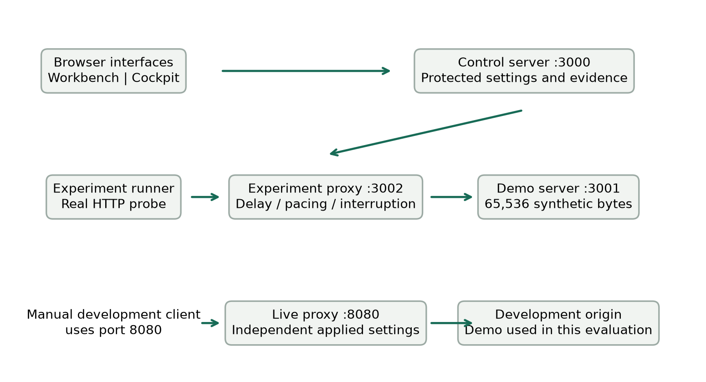
Figure 1. Control and data paths in FaultNet. The workbench and live proxy have independent fault configurations; replies return through the same proxy path.
The workbench validates a request, saves its initial record, runs baseline probes, activates the selected fault, runs faulty probes, clears the fault, checks recovery and saves the terminal record. One experiment is active at a time. Stop cancels active work and clears held operations. If a process ends unexpectedly, a previously active persisted record is marked interrupted on restart rather than silently completed.

6.1 Dashboard Roles and Separation
Table 3. Why the project uses two dashboards
Aspect | Experiment workbench | Live proxy cockpit
Question | How does this fault alter a controlled workload? | How do individual development requests behave under applied effects?
Target | Fixed 64 KiB demo | Validated development origins; demo by default
Sequence | Automatic baseline/fault/recovery | Operator applies settings, sends traffic and resets
Persistence | Validated local JSON and JSON/CSV exports | Latest 50 finished requests in process memory
Measurements | Phase counts, distributions and comparisons | Per-request status, duration, bytes and applied effects

Separate configurations protect reproducible measurements from exploratory edits. The workbench constrains the workload and comparison protocol; the cockpit provides broader manual combinations. Changing one dashboard does not change the other proxy's fault configuration. Neither interface automatically repairs a failing application.

6.2 Workbench Functions and Fault Mechanisms
Six editable presets cover a healthy baseline, mild/severe delay, constrained bandwidth, timeout stress and complete HTTP outage. A preset fills settings without starting traffic. Start begins the experiment; Stop requests cancellation; saved-run reuse copies a configuration without modifying its evidence. Auto or explicit phase selection controls the displayed analysis. Protocol-compatible saved runs can be compared, and records can be exported as JSON or CSV.
Table 4. The three workbench fault mechanisms
Mechanism | Implementation action | Measured consequence
Delay | Await a timer before forwarding | Additional complete-response time; possible client timeout.
Bandwidth | Schedule 1 KiB body chunks at rate-based deadlines | Longer transfer and lower payload goodput.
Interruption | Destroy the faulty client connection before forwarding | No complete successful HTTP payload; subsequent recovery checked after clearance.

The timer wait is asynchronous and does not busy-wait. Bandwidth scheduling honors downstream backpressure and buffers only the known payload. These operations alter actual proxied HTTP exchanges, not the laptop's physical bandwidth or an IP packet-loss percentage. Timeout stress is an existing delay mechanism paired with a shorter client deadline.
Each probe succeeds only after HTTP 200, all 65,536 bytes and the expected payload contents arrive before timeout. Mean, median and p95 use successful samples. Eligible requests exclude user cancellation, and unavailable successful timing remains null. Charts present all three phase medians, attempt durations, successful-response distributions and successful/failed/cancelled counts.

6.3 Live Proxy Cockpit Functions
Unified routing forwards to one origin; split routing selects frontend or backend origins using path prefixes. The client must use the port-8080 entry for effects to apply. Presets/sliders change a draft, Apply changes activates it for new requests, and Reload applied retrieves current settings. Reset removes effects and rules, discards drafts and cancels live work while retaining the applied targets and routes.
Table 5. Live fault and response controls
Control | Purpose
Request/response delay and jitter | Vary forwarding and response waits; jitter applies in both directions and clamps negative waits to zero.
Upload/download limits | Pace body delivery in KiB/s; zero means unlimited.
Timeout / stall / disconnect | Delay headers, hold a body, or interrupt body delivery.
Status injection | Return a selected 400–599 status for a path prefix at a configured probability.
Header controls | Remove CORS/cache headers or mismatch Content-Type.
JSON mocks | Return local JSON without contacting upstream; selected status rules have precedence.

Send sample performs a GET with a five-second client ceiling. The monitor provides status, duration, bytes, outcome, effect labels, filtering and aggregate counts for the latest 50 finished requests. Clear monitor affects that window only. Live configuration and monitoring survive a page refresh but reset with the process. Named mobile profiles are illustrative settings, not carrier measurements.

7. Contribution of Individual Team Member
Table 6. Division of project responsibilities
Member | Registration number | Project responsibilities
Pranav Suresh | 24BCE2086 | Coordinated workbench/cockpit requirements, presets and interface refinements; prepared HTTP/Wireshark demonstrations; coordinated repeated evaluation, interpretation and the editable report/evidence package.
Soham Sameer Borikar | 24BAI0142 | Prepared and uploaded static, RIPv2 and OSPF .pkt labs on the separate lab branch; configured the router triangle and alternate paths; prepared the routing/link-failure demonstration.

The application and routing components form one demonstration with distinct evidence paths. Both members must be able to explain the fault settings, actual observations, routing changes and limitations of the conclusions. The source repository preserves application context and the separately reviewed lab history.

8. Modules Explanation
Table 7. Important code modules
Important module | Responsibility
src/app.js and src/main.js | Dependency wiring, listener startup and orderly shutdown.
src/control/server.js | API routing for experiments, records, export and live controls.
src/control/validation.js and security.js | Input bounds, allowed shapes, Host/Origin checks and capability protection.
src/experiments/runner.js | Phase coordination, cancellation, deadline, recovery and saves.
src/experiments/probe.js | HTTP request, elapsed timer, payload/status verification and outcomes.
src/experiments/metrics.js | Phase counts, mean/median/p95 and payload goodput.
src/proxy/server.js | Fixed-target delay, body pacing and interruption.
src/live/server.js and config.js | Independent forwarding, validated targets and live effects.
src/storage/records.js and export.js | Record validation, safe persistence and JSON/CSV export.
public/app.js, results.js and charts.js | Workbench events, derived views, comparisons and SVG visualizations.
public/live.js and live-model.js | Applied/draft controls, presets and live traffic presentation.

9. Project Implementation

9.1 Experimental Setup with Hardware and Software Requirements
The application evaluation used Windows_NT build 10.0.26300, a 12th Gen Intel(R) Core(TM) i7-12650H processor and 23.7 GiB of visible memory. The measured application runtime was v22.23.1. The application uses Node built-in HTTP, timing, filesystem and test facilities with plain HTML/CSS/JavaScript and no external runtime packages. Analysis tooling is separate from application dependencies.
The application source baseline is commit 313822e in the project repository. Measurement and report scripts are maintained separately from the application modules. The emphasis on recording a repeatable setup is consistent with the reproducibility concerns studied by Handigol et al. [6]. A different laptop or source revision can legitimately produce different timings; comparisons must retain the recorded settings and runtime.
All measured traffic used the numeric loopback address. HTTP probes disabled connection pooling, verified the fixed payload, and measured the entire exchange with performance.now(). UTC starts identify records for packet matching. Background desktop applications and normal operating-system scheduling remained present; the results describe this local environment rather than an isolated hardware benchmark.
Project repository: https://github.com/Pranav-Suresh1024/FaultNet
Application revision: 313822e58f7d4420550a1836ebe949dc4727b88c. Evaluation scripts and sanitized numerical inputs: 515ff591e4433c98021599623c0b14664f17329a. Appendix A separates document regeneration, numerical recalculation and fresh collection.
Permanent evidence snapshot: Evaluation scripts, numerical inputs and aggregate evidence at the pinned revision
Table 8. Measurement protocol and reproducibility controls
Protocol choice | Value or procedure
Repeated blocks | 10 runs per configuration; cyclic configuration order across blocks.
Workload | 65,536 F bytes; five baseline and five faulty probes per run.
Interval | 250 ms between probes within a phase.
Default deadline | 5,000 ms; timeout study changes only this to 500 or 2,000 ms.
Recovery | Three consecutive successful responses within 15,000 ms after clearance.
Overhead test | 50 direct and 50 fault-free proxied requests, grouped in ten paired blocks; three warm-up pairs excluded.
Live study | Eight configurations, ten sequential samples each; five-second sample ceiling.
Packet capture | Npcap loopback; TCP 3001, 3002 and 8080; dashboard control excluded.

The comparison budget is 2 × count × (timeout + interval) + 15,000 ms. Five probes, a 5,000 ms timeout and 250 ms interval give a conservative 67,500 ms bound, below 120,000 ms. This is a safety bound, not a duration prediction. The timeout pair retains the same payload, delay, count and interval; its different deadlines intentionally make it incompatible with the dashboard's automatic cross-run guard.

9.2 Test Cases
Table 9. Experimental cases and hypotheses
Condition | Controlled variable | Expected observation
Delay calibration | 0, 150, 500, 1,500 ms | Added timing follows the injected wait with measurable overhead.
Bandwidth calibration | 16, 32, 128 KiB/s | Ideal 64 KiB delivery is 4, 2 and 0.5 seconds; actual rate is measured.
Connection interruption | Close each faulty connection | Faulty requests fail to complete, followed by successful clearance/recovery.
Timeout tradeoff | 1,000 ms delay; 500 vs 2,000 ms timeout | Completion may improve when the deadline exceeds the delay.
Live behavior | Normal, delay, jitter, rate, 503, disconnect, stall, mock | Each request exhibits the applied effect with honest status/bytes/outcome.
Routing link failure | R1 G0/0 disabled | Static control lacks backup; dynamic labs can select R3.

A completed experiment is not automatically a successful faulty workload: the interruption and short-timeout conditions can complete the experiment while recording all faulty requests as failures. No cancelled request was reclassified as a successful timing sample. Run-level record validation checks structure, summaries, ordering and recovery chronology before analysis.
Within each run, added delay is faulty median minus baseline median. The calibration table reports the median of ten paired run-level differences. The exploratory 95% percentile bootstrap interval uses 3,000 resamples and seed 308, resampling whole run-level differences rather than treating the five faulty requests within each run as independent repeats. There are ten runs per condition and 50 faulty requests in total. The sorted bootstrap medians use positions 75 and 2,925 (one-based). These local intervals and pooled nearest-rank p95 are descriptive, not population guarantees.
Request success rate (%) equals 100 × successful attempts / eligible attempts; user cancellations are excluded from eligibility. For a successful fixed response, payload goodput (KiB/s) equals 64 / (elapsed milliseconds / 1,000); the table reports the arithmetic mean of these per-request rates. The mean of reciprocal durations need not equal 64 KiB divided by the median duration. The nearest-rank p95 uses position ceiling(0.95 × N) in sorted successful timings. These definitions preserve the distinction between slow success, failed completion and missing successful latency.
The configured automated test command passed all 61 tests with zero failures or skipped tests. Coverage includes fault behavior, cancellation and cleanup, recovery, persistence/export validation, control security, live proxy behavior and frontend calculations. This verifies the tested paths; it does not establish correctness under every workload or replace the separate packet and simulator evidence.

9.3 Results of Execution and Screenshots
The completed dataset contains 100 workbench runs and 1300 phase observations, plus 100 overhead requests and 80 live samples. Each workbench condition has ten runs and 50 faulty attempts. The following tables report measurements, while the comparison plots explain their relationship to configuration. The workbench interface figure is a representative reviewed screenshot; its displayed example values are separate from the repeated-study aggregates.
Record quality is reported separately from request success. There were 101 attempted workbench runs: 100 supplied validated terminal records and 1 failed record validation. In the rejected bandwidth trial, UTC recovery duration and elapsed-clock duration differed by 2.38 ms, above the validator's 2 ms tolerance. The retained rejected record is excluded from timing aggregation and the condition is repeated to preserve the ten-run design. Thus 100 accepted runs do not imply that every attempted record was saved successfully.
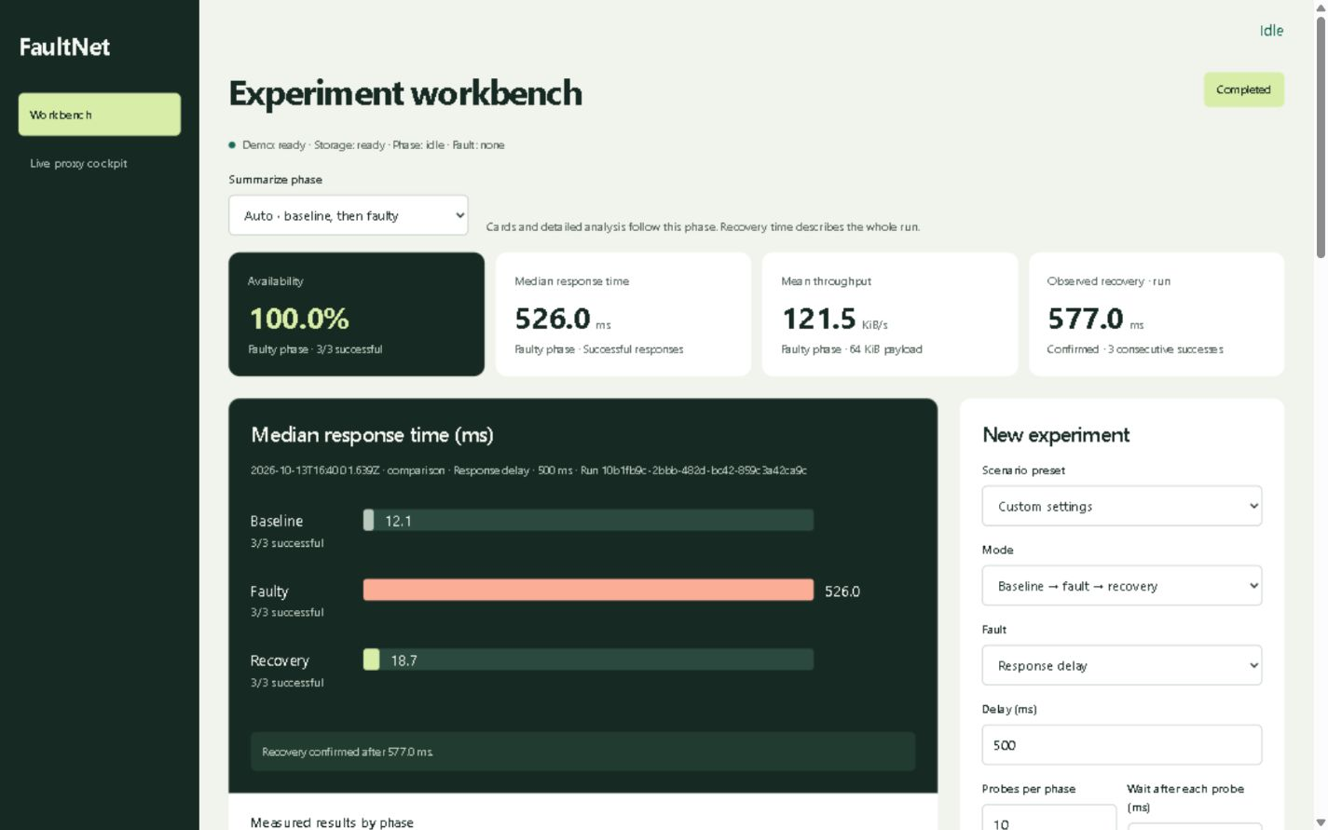
Figure 2. Representative workbench interface showing settings, phase comparisons, successful timing and recovery evidence. Displayed example values are not the repeated-study aggregate.
Repeated-run summaries and figures are calculated from measured observations; the representative interface image illustrates the controls and their presentation.
Table 10. Faulty-phase results across repeated workbench trials
Condition | Success | Successful median ms | Successful p95 ms | Mean per-request goodput KiB/s
delay-0 | 50/50 | 17.81 | 20.65 | 4,822.55
delay-150 | 50/50 | 160.72 | 167.87 | 397.47
delay-500 | 50/50 | 507.53 | 517.91 | 125.56
delay-1500 | 50/50 | 1,510.35 | 1,522.01 | 42.35
bandwidth-16 | 50/50 | 4,010.29 | 4,017.72 | 15.96
bandwidth-32 | 50/50 | 2,012.64 | 2,017.88 | 31.81
bandwidth-128 | 50/50 | 819.62 | 929.94 | 79.12
interruption | 0/50 | Not applicable | Not applicable | Not applicable
timeout-500 | 0/50 | Not applicable | Not applicable | Not applicable
timeout-2000 | 50/50 | 1,010.22 | 1,018.53 | 63.32

A missing successful median or goodput is not zero: interruption and deadline failures have no successful full-response sample. Their attempted durations are analysed separately. Bandwidth and delay both reduce whole-request goodput, but their mechanisms differ: one paces the body and the other waits before forwarding.

9.4 Performance Analysis and Comparison of Methods

9.4.1 Delay Calibration and Distribution
Table 11. Configured delay against paired added response time
Delay ms | Paired added ms | Error % | 95% percentile bootstrap interval ms
0 | 14.61 | Not applicable | 13.57 to 15.10
150 | 156.55 | 4.37 | 155.93 to 157.89
500 | 503.41 | 0.68 | 502.09 to 506.54
1500 | 1,506.52 | 0.43 | 1,503.80 to 1,508.07

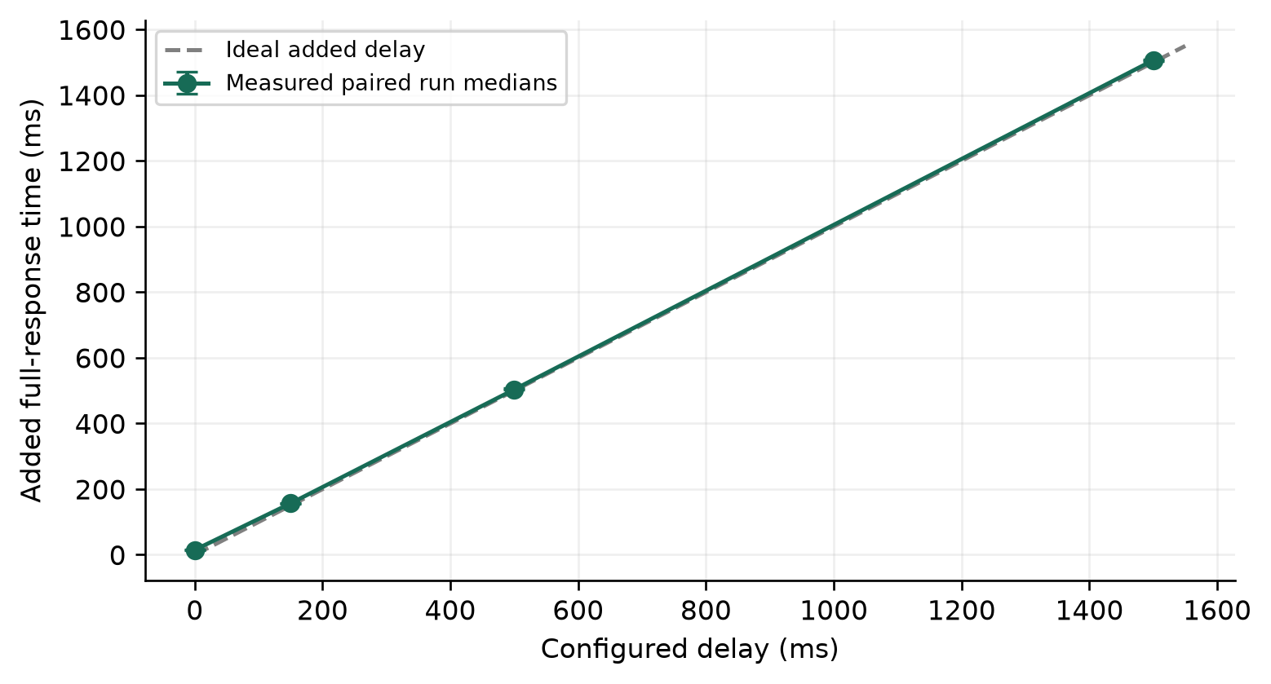
Figure 3. Configured delay versus paired measured increase. Error bars are exploratory bootstrap intervals across ten runs.
The 1,500 ms condition produced an added median of 1,506.52 ms, an error of 0.43%. The zero-delay condition adds 14.61 ms relative to its in-run no-fault baseline. Percentage error is undefined at a zero setting. This differs from the separate 2.32 ms direct-versus-fault-free-proxy estimate: both phases of a zero-delay run already traverse the proxy, and only the faulty phase dispatches the delay timer. The studies also use different sequences and background conditions. Timer dispatch and desktop scheduling are plausible contributors, but this dataset does not isolate the cause of the gap. A controlled follow-up should interleave fault-free proxy and zero-delay operations, instrument timer waits, and repeat under controlled load; 14.61 ms must not be subtracted as a universal correction.
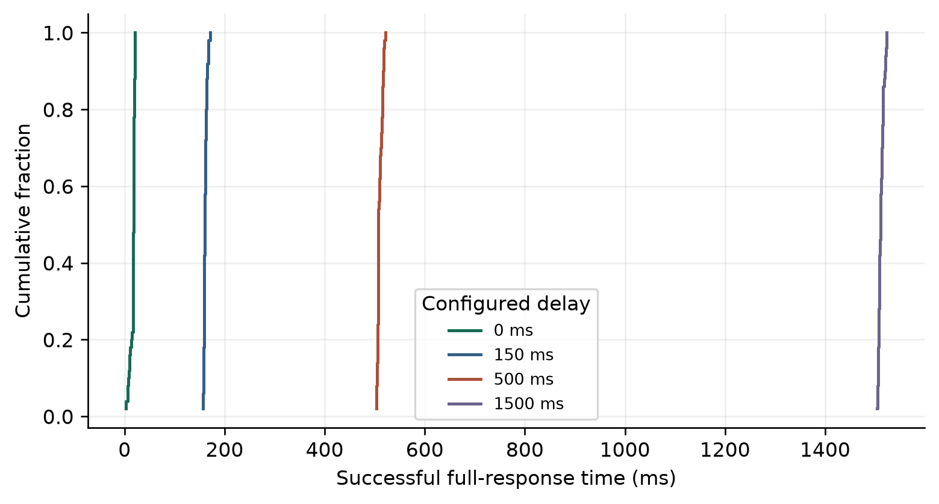
Figure 4. Empirical distributions of successful faulty response times; 50 observations per configured delay. Curves show separation and within-condition variation.
Distribution separation shows that the configured wait changes actual response behavior, rather than only changing a summary label. A percentile based on 50 successful samples remains descriptive. It should be read alongside the number of successes, failure outcomes and the repeated-run spread.

9.4.2 Bandwidth Shaping and Rate Attainment
Table 12. Configured response rate compared with measured payload goodput
Limit KiB/s | Ideal ms | Median ms | Goodput KiB/s | Attainment %
16 | 4,000.00 | 4,010.29 | 15.96 | 99.75
32 | 2,000.00 | 2,012.64 | 31.81 | 99.40
128 | 500.00 | 819.62 | 79.12 | 61.81

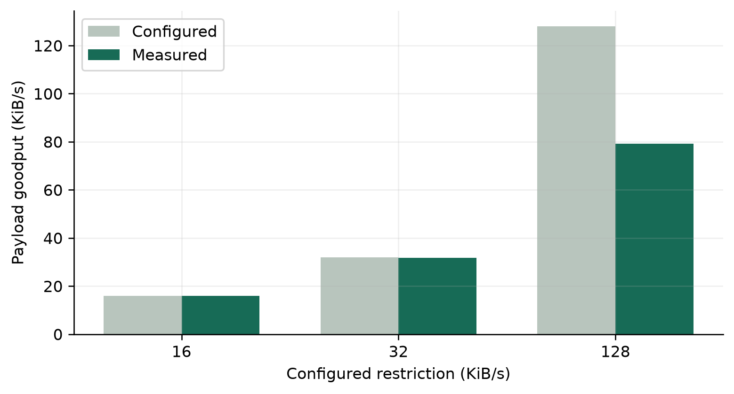
Figure 5. Measured whole-request goodput versus configured restriction for the same 64 KiB payload.
The 16 KiB/s condition attained 99.75% of its configured rate. The 128 KiB/s condition attained 61.81%, so the implementation should be interpreted as a delivery cap rather than a guarantee of exact target throughput. The 1 KiB schedule has nominal chunk intervals of 62.5, 31.25 and 7.8125 ms at 16, 32 and 128 KiB/s respectively. At short waits, timer dispatch and local scheduling can consume a larger fraction of the interval. This is a plausible explanation consistent with the mechanism; timer causes were not independently isolated.
This comparison is useful even where calibration is weaker: it identifies the operating range where the simple pacing approach follows its configuration closely. The report retains the high-rate result instead of silently discarding it or widening an accuracy claim.

9.4.3 Timeout Tradeoff and Failure Outcomes
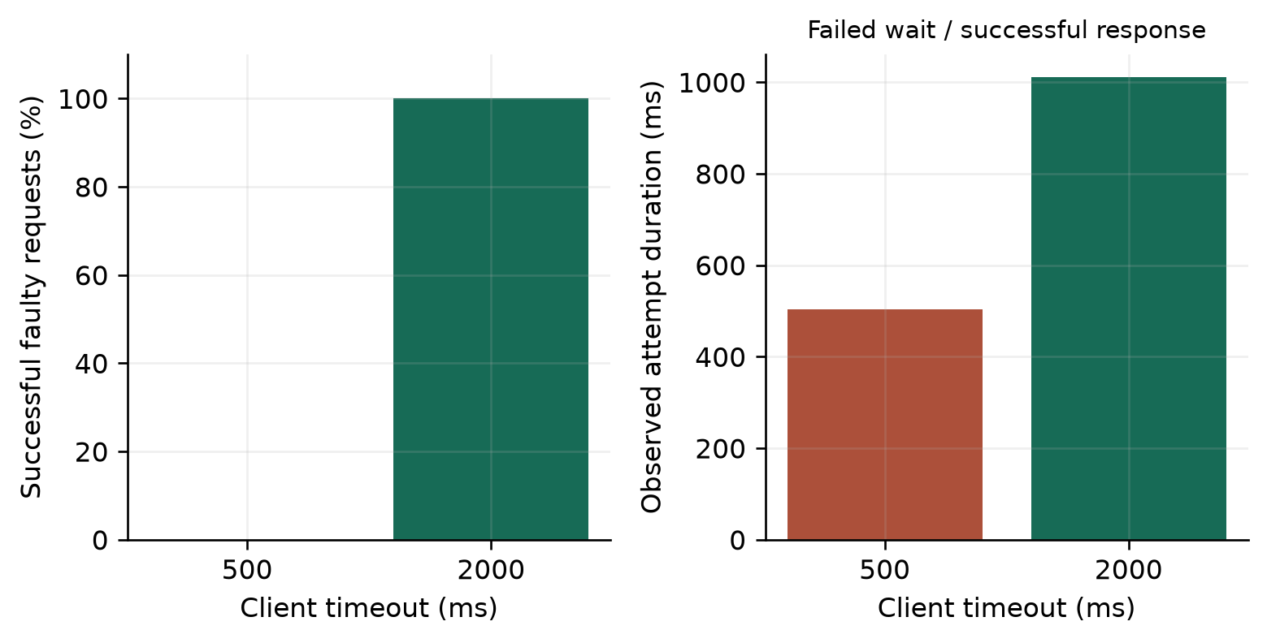
Figure 6. Fixed 1,000 ms injected delay with two client deadlines. The duration panel distinguishes failed waiting time from successful response latency.
At a 500 ms timeout, 0 of 50 faulty requests succeeded and the median failed-attempt duration was 503.88 ms. At 2,000 ms, 50 of 50 succeeded with a successful median of 1,010.22 ms. The observed completion difference is 100 percentage points. The delay itself was unchanged. Longer waiting improves tolerance in this case, but also postpones failure detection when a service will not recover.
The interruption condition produced 0 successful faulty responses out of 50. This is an application-level completion result; it is not an estimate of random IP packet loss, nor does it imply that every connection necessarily used a TCP reset flag.

9.4.4 Interception Cost and Recovery
Across 50 direct and 50 fault-free proxied requests, pooled medians were 2.37 and 5.08 ms. The median paired block difference was 2.32 ms, with an exploratory bootstrap interval from 1.39 to 3.03 ms. This quantifies instrumentation cost on the fixed local workload. It is not a web-scale throughput measurement.
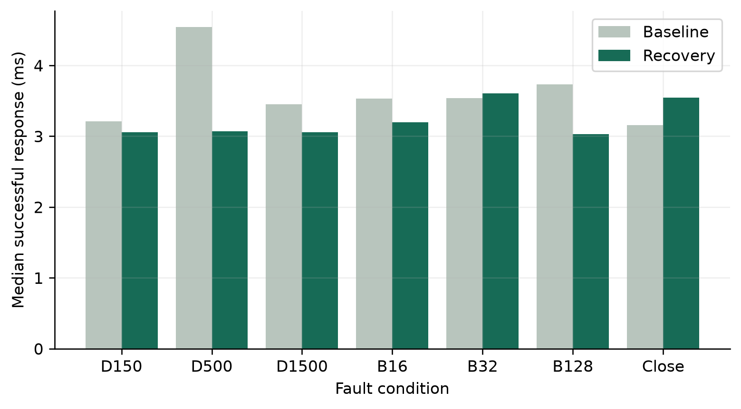
Figure 7. Baseline and recovered successful response times for selected conditions; Table 13 covers all ten. Recovery phase medians and confirmation duration are distinct metrics.
Table 13. Restoration evidence for all ten conditions
Condition | Confirmed runs | Confirmation median ms | Recovery minus baseline ms
delay-0 | 10/10 | 532.35 | 0.29
delay-150 | 10/10 | 532.38 | -0.00
delay-500 | 10/10 | 531.15 | -0.68
delay-1500 | 10/10 | 531.10 | -0.89
bandwidth-16 | 10/10 | 530.77 | 0.40
bandwidth-32 | 10/10 | 532.55 | 0.07
bandwidth-128 | 10/10 | 529.61 | -0.50
interruption | 10/10 | 536.42 | 0.14
timeout-500 | 10/10 | 532.42 | 0.24
timeout-2000 | 10/10 | 536.95 | -0.77

With three required successes and 250 ms between recovery attempts, two waits alone contribute approximately 500 ms. Confirmation therefore includes observation policy and scheduling, not just fault removal. The recovery residual compares successful response behavior after clearance with that run's baseline and is useful alongside the confirmation flag.

9.4.5 Live Proxy Evaluation
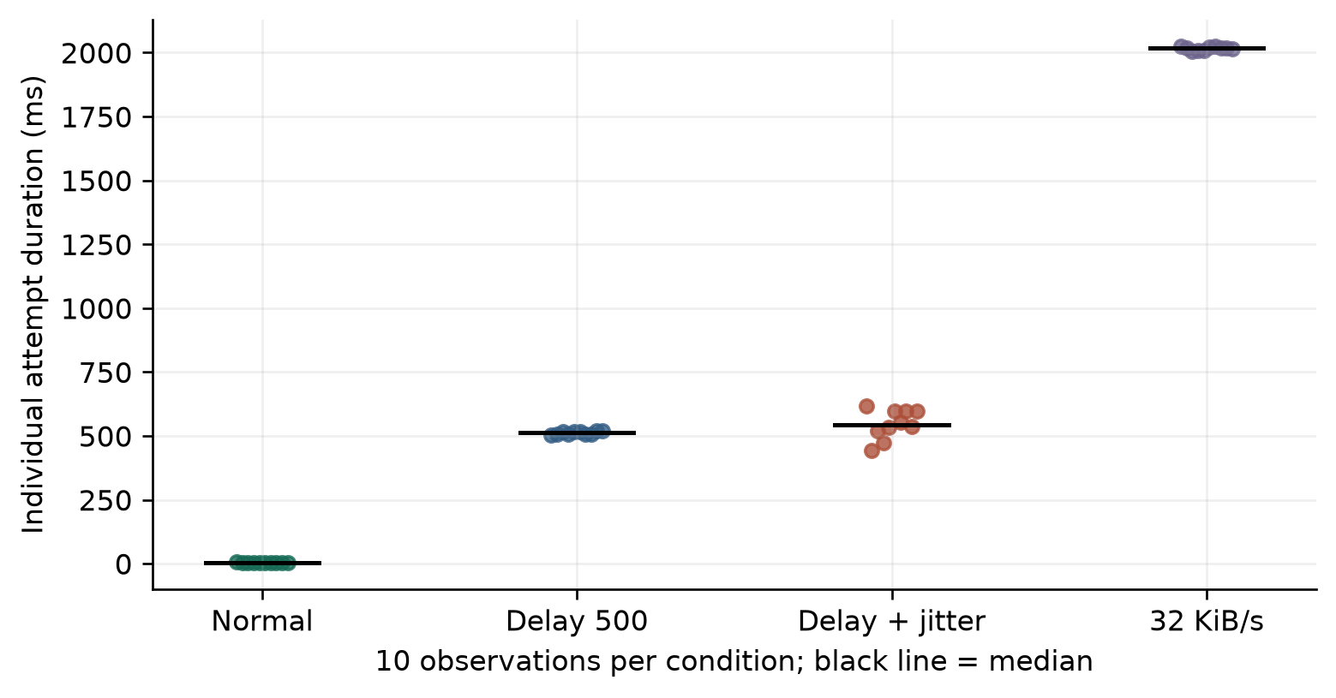
Figure 8. Individual live attempt durations under normal, delayed, jittered and rate-restricted configurations; ten observations per condition, with black median markers.
Table 14. Manual live-proxy sample outcomes
Live condition | Completed | Completed with HTTP 200 | Median attempt duration ms | Median bytes
normal | 10/10 | 10/10 | 2.80 | 65,536
delay-500 | 10/10 | 10/10 | 512.10 | 65,536
jitter-100 | 10/10 | 10/10 | 544.25 | 65,536
download-32 | 10/10 | 10/10 | 2,018.00 | 65,536
http-503 | 10/10 | 0/10 | 2.20 | 46
disconnect | 0/10 | 0/10 | 32.25 | 16,384
stalled-body | 0/10 | 0/10 | 5,012.25 | 0
mock | 10/10 | 10/10 | 2.60 | 32

The fixed-delay condition had a sample standard deviation of 6.54 ms, compared with 57.66 ms under configured jitter. Jitter applies to both request and response waits, including the request direction with base zero, where negative variation is clamped. Consequently the jitter condition is not assumed to have exactly the same mean as fixed response delay alone.
The 100% HTTP 503 rule returned that status in 10/10 samples. Those samples can be completed HTTP exchanges while still reporting an application error. Stalled-body samples can receive headers before the five-second sample ceiling expires, so a recorded status 200 alone is insufficient to establish success. Body bytes and completion outcome must also be inspected. The final reset check returned HTTP 200 with 65,536 bytes.

9.4.6 Packet Evidence and Timing Correlation
The filtered loopback capture contains 55,392 packets; 0 packets match the dashboard control port. Complete HTTP reconstruction on port 3002 enables stream-specific timing checks. Probe starts are matched to GET timestamps and stream endpoints, with first response data and completed reconstruction considered separately. The capture began after the overhead warm-up sequence, so it is used only for matching covered experiment requests.
Capture-drop statistics are unknown: the saved capture has no interface-statistics block. Zero control-port packets describes the filter, not zero capture loss. TShark/Npcap observations establish the matched traffic intervals without asserting that every generated packet was recorded.
Table 15. Packet-to-probe correlation for representative covered runs
Condition | Matched streams | Median HTTP time ms | Median probe time ms
delay-500 | 5 | 504.98 | 507.62
delay-1500 | 5 | 1,507.79 | 1,510.29
bandwidth-32 | 5 | 2,010.28 | 2,011.82

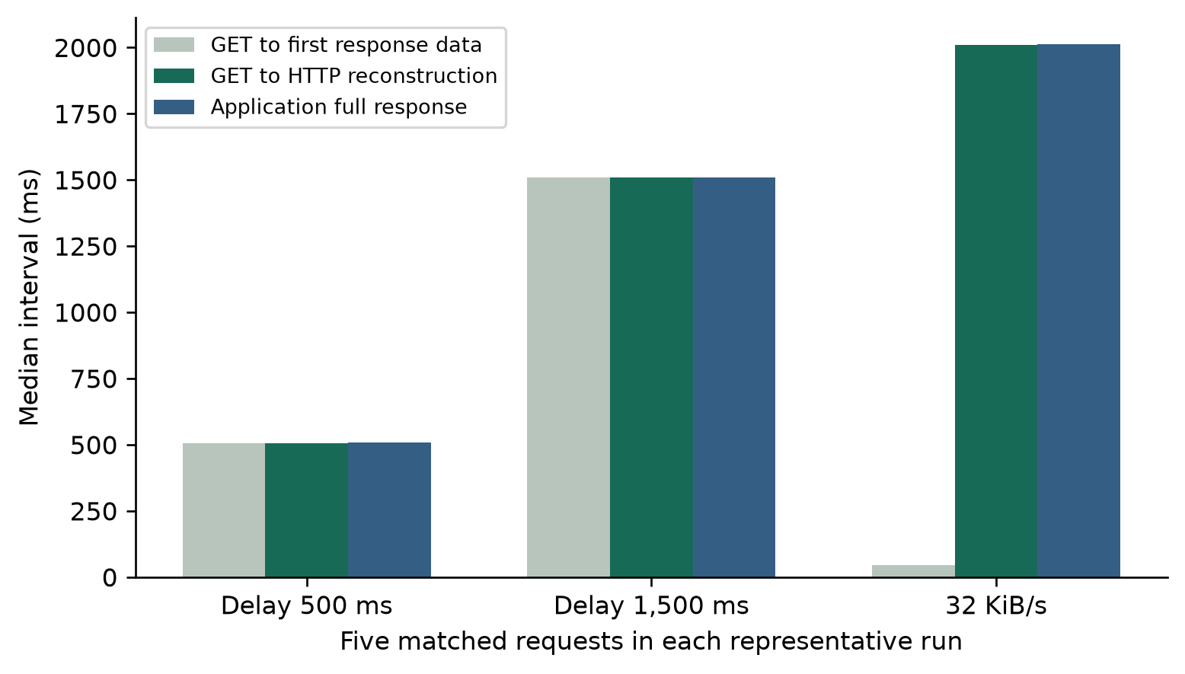
Figure 9. Measured request and response timing extracted with TShark from the loopback capture. This is an analytical packet view, not a simulated Wireshark screenshot.
The matched streams distinguish first response data, the packet completing HTTP reconstruction and completion of the application's read. The measured intervals can therefore differ without contradiction. Stream matching supplies the local evidence for this distinction. Paxson's analysis motivates separating packet observations from transport effects [4]. Application elapsed time and reconstructed-response intervals measure different stages of an exchange; neither is TCP acknowledgement RTT. Capture loss describes recording loss and must be reported separately from injected HTTP failures.

9.4.7 Routing Comparison in Packet Tracer
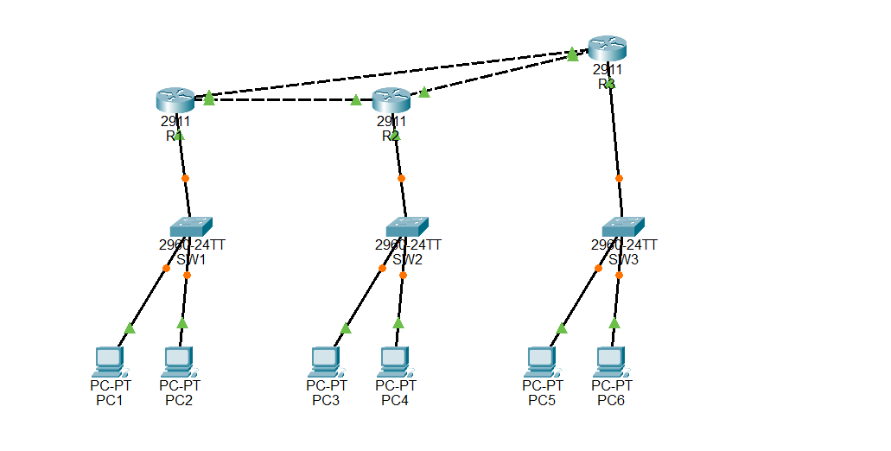
Figure 10. Reviewed Packet Tracer topology with three routers, three switches and six PCs. The router triangle offers an alternate R1–R3–R2 path.
The reviewed lab workload sends PC1 (192.168.0.2) to PC3 (192.168.1.2). R1 GigabitEthernet0/0 is disabled to remove the direct R1–R2 path. Stable ping batches and the R1 route table are inspected after convergence, and the interface is restored afterward. These simulator observations are a separately reviewed evidence set, not repetitions of the HTTP experiment dataset.
The independent review used Cisco Packet Tracer 9.0.1 and lab revision 9f72386cf4a1ae30ccd50ba7c0a1a403b3178229. The topology image establishes layout; the following route excerpts and settled ping summaries support reachability and alternate next-hop selection.
Table 16. Settled routing observations under the same direct-link failure
Method | Settled baseline | Direct link disabled | Alternate-route evidence
Static without backup | 4/4 replies | 0/4 replies | No configured alternate route for the destination LAN.
RIPv2 | 4/4 replies | 4/4 replies | R 192.168.1.0/24 via 10.0.0.9, G0/1; [120/2].
OSPF | 4/4 replies | 4/4 replies | O 192.168.1.0/24 via 10.0.0.9, G0/1; [110/3].

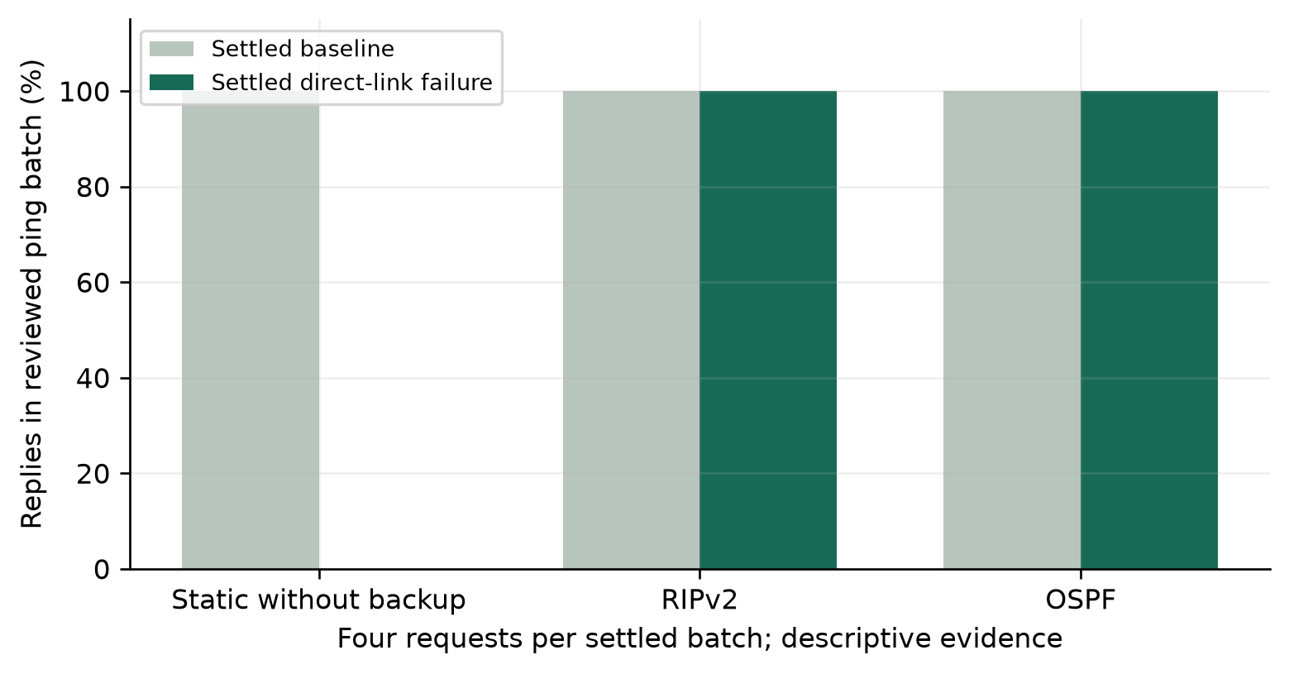
Figure 11. Descriptive reachability comparison of reviewed four-ping batches. Bars are observations of this topology, not reliability estimates for each protocol.
R1# show ip route | direct R1-R2 link disabled
RIP: R 192.168.1.0/24 [120/2] via 10.0.0.9, GigabitEthernet0/1
OSPF: O 192.168.1.0/24 [110/3] via 10.0.0.9, GigabitEthernet0/1
PC1> ping 192.168.1.2 | settled fault batches:
Static: 0/4 replies; RIPv2: 4/4 replies; OSPF: 4/4 replies.
The route lines are reviewed excerpts; the final ping line is a compact summary of separate batches, not one combined terminal session. Both dynamic routes use R3 (10.0.0.9) through G0/1.
Dynamic routing preserved reachability in the settled fault state of this topology, while the deliberately unprotected static configuration did not. Static routing can be configured with backup routes; the result is not a universal failure of static routing. Warm-up and restoration batches included transient losses. Fast Forward Time advanced the simulator, so the records do not support wall-clock convergence comparisons or a claim that OSPF was faster than RIP. Route selection, next hop and reachability establish the demonstrated benefit.

9.5 Critical Evaluation and Optimization
The strongest evidence comes from controlled changes paired with matching baselines. Delay calibration quantifies whether the fault behaves as configured. Bandwidth attainment shows both the useful lower-rate range and the limits of fine-grained local pacing. The timeout study demonstrates a real completion-versus-waiting tradeoff without pretending that a higher deadline optimizes the network.
The metrics also prevent misleading conclusions. Success counts accompany latency; unavailable successful timings are not zeros. Recovery confirmation includes the polling policy. Direct comparison measures interception overhead rather than assuming it is negligible. Routing metrics are interpreted within their protocol and are not numerically ranked across RIP and OSPF.
The current 1 KiB scheduling method could be evaluated against adaptive chunk sizes or batching at higher rates. A sound optimization study would hold the payload and target rate constant, compare attained goodput and CPU use, and retain cancellation/backpressure behavior. That is an engineering implication of the measured pacing limitation, not an implemented improvement claimed by this report.

10. Results and Discussion

10.1 Findings and Inferences
First, added response time follows the configured delay, with the 1,500 ms condition producing 1,506.52 ms of paired added median. Second, payload pacing is close to its lower configured restrictions but attains only 61.81% at 128 KiB/s. Reporting both outcomes is more informative than assuming every rate is exact.
Third, the timeout intervention changes faulty completion by 100 percentage points while retaining the same 1,000 ms configured wait. The longer deadline tolerates that response; it does not remove its delay. Fourth, post-clearance observations supply repeated restoration evidence and distinguish service response timing from the duration of the recovery criterion.
Live results show why status, body size and completion must be considered together. A mock can complete with a small local JSON body; an injected 503 can complete with an error status; a stalled body can time out after headers. The cockpit therefore addresses manual application behavior that cannot be reduced to the workbench's fixed payload success criterion.
Packet evidence is consistent with real HTTP traffic under the tested conditions. The separately reviewed routed topology demonstrates alternate-path selection under a specific failure. The application and simulator answer related resilience questions at different layers; neither evidence set is used to invent measurements for the other.

10.2 Innovation Novelty and Evidence
Published studies already establish deliberate fault experiments [1], outcome-guided fault selection [2] and controllable network emulation [3]. FaultNet's contribution is the integration of local HTTP fault settings, validated phase observations, saved evidence and a separate live development interface into an inspectable teaching workflow. The project does not claim a new fault-injection principle, routing protocol or performance advantage over these research systems. Its quantitative findings concern the measured FaultNet configuration.
Useful improvement claims are attached to actual comparisons. The longer deadline improves completion for the chosen delayed workload, and dynamic route selection improves settled reachability over the no-backup control in the reviewed topology. Neither claim implies general superiority over unrelated systems. Calibration and interception results identify costs as well as benefits.

11. Conclusion
FaultNet implements controlled HTTP fault injection with saved experiments and a separate live development cockpit. A repeated evaluation of 100 workbench runs supports measurable delay, pacing, failure and restoration behavior. The timeout comparison improves observed completion from 0% to 100% by permitting longer waiting, while the high-rate pacing result exposes a concrete limitation. Packet analysis and reviewed routing observations provide complementary evidence. The system is useful for local development testing and networking education because configurations, measurements and explanations can be examined together.

12. Limitations and Future Enhancement
The study uses one shared Windows laptop, sequential requests and a fixed synthetic payload. Operating-system scheduling, background applications and capture activity can affect timing. Fifty faulty attempts per condition support descriptive comparisons, not universal request-success or tail-latency guarantees. The bootstrap intervals describe variation among ten local blocks and do not remove environmental dependence.
One attempted run failed the record validator at the UTC-versus-elapsed recovery tolerance boundary. This is a persistence/validation limitation, separate from an injected connection failure. The rejected record remains in the local audit data and its count is included in record quality; only structurally validated records contribute to the comparison tables.
Request elapsed time is not TCP RTT, payload goodput is not wire bandwidth, and HTTP interruption is not random IP loss. Recovery confirmation depends on three-success sampling and its waits. The routing cases use small settled ping batches and simulated-time advancement; they establish path selection without a convergence-speed ranking. Representative interface screenshots illustrate the application rather than replacing the current measurement tables.
Further evaluation can vary payload sizes, use additional machines and controlled background load, compare pacing strategies at short chunk intervals, and measure routing convergence on a common time base. More frequent crash-durable saves and separate processes could be assessed alongside their storage and coordination costs. These extensions follow directly from the observed limits and do not alter the conclusions for the measured configuration.

References
[1] A. Basiri, N. Behnam, R. de Rooij, L. Hochstein, L. Kosewski, J. Reynolds, and C. Rosenthal, “Chaos Engineering,” IEEE Software, vol. 33, no. 3, pp. 35–41, 2016.
DOI: 10.1109/MS.2016.60
Free full text: Full author manuscript deposited on arXiv
[2] P. Alvaro, J. Rosen, and J. M. Hellerstein, “Lineage-driven Fault Injection,” Proceedings of the ACM SIGMOD International Conference on Management of Data, pp. 331–346, 2015.
DOI: 10.1145/2723372.2723711
Free full text: Full paper hosted by the author at UC Santa Cruz
[3] M. Carbone and L. Rizzo, “Dummynet Revisited,” ACM SIGCOMM Computer Communication Review, vol. 40, no. 2, pp. 12–20, 2010.
DOI: 10.1145/1764873.1764876
Free full text: Full author manuscript hosted at the University of Pisa
[4] V. Paxson, “End-to-End Internet Packet Dynamics,” Proceedings of ACM SIGCOMM, pp. 139–152, 1997.
DOI: 10.1145/263105.263155
Free full text: Full conference paper hosted at UC San Diego
[5] B. Lantz, B. Heller, and N. McKeown, “A Network in a Laptop: Rapid Prototyping for Software-Defined Networks,” Proceedings of the 9th ACM SIGCOMM Workshop on Hot Topics in Networks, pp. 1–6, 2010.
DOI: 10.1145/1868447.1868466
Free full text: Full workshop paper hosted by the author at Stanford University
[6] N. Handigol, B. Heller, V. Jeyakumar, B. Lantz, and N. McKeown, “Reproducible Network Experiments Using Container-Based Emulation,” Proceedings of the 8th International Conference on Emerging Networking Experiments and Technologies (CoNEXT), pp. 253–264, 2012.
DOI: 10.1145/2413176.2413206
Free full text: Full published conference paper from the ACM SIGCOMM conference proceedings site
Additional author copy: Stanford-hosted full conference paper

Appendix A Reproduction Procedure
The pinned evidence revision in section 9.1 contains evaluation/analysis scripts and the numerical inputs used for the published results. It preserves the original measurements; recalculation is not a new experiment. The later report revision contains the document builder and the revised prose/layout.
1. Regenerate the document: use the report revision identified in FINAL-REPORT-HANDOFF.md, install Python packages python-docx and pypdf, run python scripts/build-final-report.py, then use Microsoft Word to refresh the contents and export the PDF (scripts/export-report.ps1). This reads committed aggregates and figures; it does not recalculate results. Close or save any open report before rebuilding. The preserved partial report supplies the course cover and declaration.
2. Recalculate numerical results: install matplotlib and numpy, then run python scripts/analyze-report.py from the repository. The default input is docs/reports/evidence/analysis-inputs.json. It contains the original numerical phase durations, success flags, recovery durations, overhead blocks and live outcomes, without session capabilities, HTTP bodies or wall-clock timestamps. It reproduces the workbench/live/overhead statistics, bootstrap intervals and their figures. The rejection count and clock discrepancy are retained audit facts; this reduced dataset cannot revalidate the original record chronology.
3. Packet and routing evidence: the committed packet summary allows inspection of the 15 matched timings and frame references, but independently decoding streams or checking capture completeness requires the original local capture. Route excerpts and ping summaries document the bounded simulator review; reproducing that execution requires Packet Tracer 9.0.1 and the separately pinned lab files. Sanitized inputs do not replace packet capture or simulator execution.
4. Collect replacement measurements: use Node 22.23.1 and npm start on an idle local setup, then node scripts/evaluate-report.mjs. The collector checks application files against the pinned application baseline. Preserve any rejected record and resume only after review. Run python scripts/prepare-report-inputs.py to derive a sanitized numerical dataset, then analyze it. Fresh timings will differ and must be labelled as a replacement evaluation; never silently combine new samples with this study. Follow the evidence guide for optional loopback capture and packet correlation.

