Contents

1) Data Preparation Process 1

1.1 Data Cleaning 1

1.2 Creation of Calendar Table 3

1.3 Data Modelling 4

2) Dashboards 5

2.1 Which period has the most sales? 5

2.2 What are the top 5 most popular products for the various sales channel? 10

2.3 What are the top and bottom 5 branches in terms of profit? 13

2.4 What is the performance of the manufacturers? 15

# **1) Data Preparation Process**

## **1.1 Data Cleaning**

Before starting with the analysis of the data, I was checking the state of the data and realized the data was not clean as I identified several problems in the dataset. However, I did not have to do a substantial amount of data cleaning as the data was not too dirty.

There were no null values present in the data as well which made the data preparation process simpler. I will now share the problems that I have identified in the data.

Correcting Store Name

3 of the stores with StoreKey 22, 23, and 24 have the name as a Region. To correct it, I referred to the Geography.csv table to refer to the BranchLocation of the store. Then I replaced the StoreName with the BranchLocation and concatenated it with the word ‘Store’.

Standardizing Promotion Name

In the Promotions.csv table, I noticed that there is ‘Holiday Promotion’ and ‘Holidays Promotion’. So, I removed the letter ‘s’ from the ‘Holidays Promotion’ to standardize the Promotion Name

Correcting Date Format

The Date column in the Sale.csv table is identified as a Text data type instead of a Date data type. This is because the date format is ‘dd_MM_yyyy’ and PowerBI is not able to identify it as a Date data type. So, I converted the date format to ‘dd/MM/yyyy’ by replacing the underscores with slashes. After that, I was able to convert the Date column to a Date Data Type.

Channel Key Mismatch in Sales.csv and Stores.csv

In the Sale.csv table, the StoreKey and the channelKey do not match the StoreKey and the ChannelKey in the Stores.csv table. For example, in the Sale.csv table, for StoreKey 16 the channelKey would be 3. However, in the Stores.csv table, StoreKey 16 is supposed to have a ChannelKey 1. This problem occurs to the StoreKey 8, 16, 19-24. To fix this problem, the solution is to either disregard the channelKey in the Sale.csv table or disregard the ChannelKey in the Stores.csv table. I decided to disregard the ChannelKey in the Stores.csv table and instead use the channelKey in the Sale.csv table.

## **1.2 Creation of Calendar Table**

Having a custom calendar table is important for analysis as I can customize the calendar table to my requirements and have additional columns like Weeks. This will be beneficial when I am creating visuals and performing time series analysis. The code below creates a Calendar table with additional important columns.



## **A screenshot of a computer Description automatically generated1.3 Data Modelling**

# **2) Dashboards**

## **2.1 Which period has the most sales?**

This dashboard is mainly going to be used for time series analysis and how the company is performing for each period mainly focusing on sales. It also focuses on promotions and see how they are effective. I will now share about the various visualizations used in the dashboard.

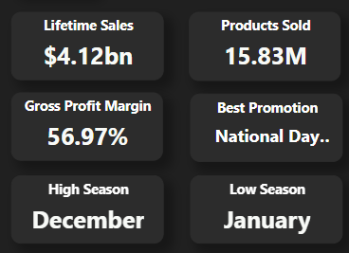The card visuals are used to show the user how the company has done over the years using and some other important information like seeing which month does the company perform the best and worst and see which promotion is the best performing. These cards provide users with a quick and easily understandable snapshot of important information without overwhelming them with extensive data. I have used measures to identify high-season and low-season. I have provided the DAX code for the measures below.



This line chart is showing the comparison between the current month's sales and the previous month's sales and examines the fluctuations. The primary purpose of this chart is to track how sales are evolving over time. This helps identify trends and patterns, such as seasonal variations or consistent growth, which can inform decision-making and strategy. To obtain the sales last month, I have used DAX code which I provided below.



The toggle button is used for a detailed view of the line chart to gain more analysis. By clicking on it the user can use the slicers at the bottom to find the sales drop or growth over the years. This chart will allow users to see how they have performed this year compared to the past 1 or 2 years and this can be insightful as they can compare sales figures across multiple years allowing them to assess the business's overall performance and growth trajectory. It helps determine whether sales are increasing, decreasing, or remaining relatively stable over time.

I have done a 3 Month Moving Average for both sales and gross profit and found some good insights. By doing the moving average I smoothened the chart and was also able to discover seasonality in the data. For each year, the sales and gross profit have 2 peaks and 1 valley and the timing where the peaks and valleys occur for each year is around the same. Finding seasonality in the data could be of great help with forecasting future data with the help of SARIMAX. I have included the DAX code for the 3 month moving average below.



I have created a calendar chart as well which is able to show the daily sales and also show the promotion for each day. I have also added a new feature where it will be able to tell the public holidays as well. This chart is very helpful as it can show which promotions are able to drive sales. For example, on 1st March 2021, the sales were very high and the promotion on the day was Singapore CNY Promotion and Singapore Spring Promotion

This chart can highlight which time period has been performing below average and above average. It is also filtered with the help of the slicer above. This chart does not only show the total sales by Year but also by, Quarter, Month, Week, and Day. As the slicer is adjusted the chart is also dynamically adjusted to fit the period. This allows users to filter the time and get the chart based on the time period they need without the need of a drill down.

This simple doughnut chart is used to compare the profit-cost ratio for different time periods. The users can filter this chart with the other charts and find out the ratio based on the filtered time periods. This can be useful to see the change in the ratio over different time periods.

## **2.2 What are the top 5 most popular products for the various sales channel?**

This dashboard is mainly going to be used for product analysis and to see what the top 5 products in each category and brand are. There are two views in this dashboard, one is the Sales view and the other is the Quantity view. Moreover, the charts can be filtered by the channel type as well. I will now share the various visualizations used in the dashboard.

This matrix table is used to show how the current top 5 products performed over the last few years to see if the product has been improving or getting worse. By looking at the chart, these top 5 products are improving consistently while the other products have some fluctuations in their improvement. However, there are no products that are declining.

Based on this chart, users can understand how a product's rank changes over the years and this can provide insights into its lifecycle stage. Products might start with high ranks when introduced, experience peak popularity, and then decline in rank as they become outdated or face increased competition. I have provided the DAX code on how to do ranking



This waterfall chart is used to analyze the top 5 products more in-depth about the change over the years of the top 5 products. Based on this chart all the top 5 categories are consistently improving over the years and the rate of improvement is also increasing over the years. Additionally, this chart can bring so many insights for example on resource allocation. If a product has consistently shown positive YoY changes, users might consider investing more resources in its marketing, production, or development. This can also aid in inventory management as the company can inform the manufacturers if they need more or a lower supply of goods.

This chart is inspired by the Pareto Principle in which to check how many product categories result in 80% of the sales quantity. The bars highlighted in dark blue show the product categories that result in 80% of the sales quantity. In this chart the top 13 products contribute to 80% of the sales. Users can also click on the bars here to filter the matrix table and the waterfall chart to the top 5 products in that selected category. The DAX code below shows how the Pareto line chart is done.

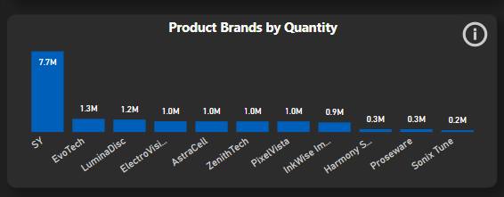

This bar chart allows users to see which brands perform well in terms of Quantity. In this chart, the SY brand is dominating the other brands based on quantity. This may be because SY is a brand that focuses on Cell Phone Accessories and usually they are cheap, so customers are able to buy them in bulk.

Users can also click on the bars here to filter the matrix table and the waterfall chart to the top 5 products in that selected brand.

## **2.3 What are the top and bottom 5 branches in terms of profit?**

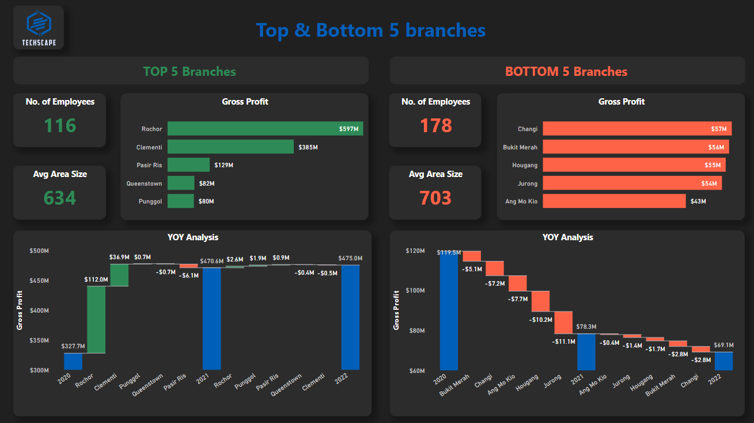

This dashboard is mainly going to be used for branch analysis and to see the top 5 and bottom 5 branches. Through this dashboard, I am going to share strategies on how to make informed decisions and optimize resources. I will now share the various visualizations used in the dashboard.

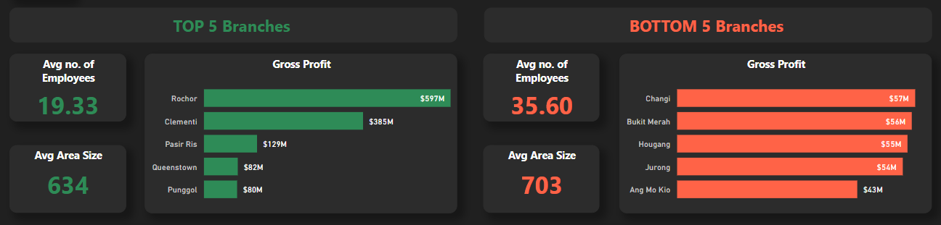

In this group of charts, I have used some card visuals and bar charts to show the top 5 and bottom 5 branches. The top 5 branches have an average of 19 employees, but the bottom 5 branches have an average of 35 employees. This is not a good use of manpower as more employees are placed in poorly performing branches, but fewer employees are in better-performing branches. So, a good strategy is to transfer some employees from the bottom 5 branches like Changi, Bukit Merah, Hougang, Jurong, and Ang Mo Kio to the top branches like Rocher and Clementi especially as these branches are the best performers.

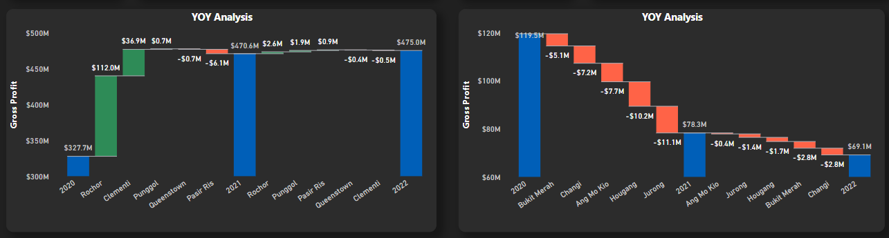

The chart on the left shows the Year-on-Year analysis of the top 5 branches in terms of gross profit while the chart on the right shows that same chart but with the bottom 5 branches. For the top 5 branches, there has been a significant jump in profit from 2020 to 2021 for the branches in Rocher and Clementi. However, other than that the other top 5 branches were performing consistently with minor fluctuations from 2020 to 2021. Then from 2021 to 2022, all the top 5 branches performed consistently with minor fluctuations.

Meanwhile, the bottom 5 branches performed badly from 2020 to 2021 as the drop was very drastic where the percentage change was up to -42% for especially the Jurong branch. However, from 2021 to 2022, even though there was a drop in profit it wasn’t of a big magnitude. With even more promotional and marketing campaigns by next year, the bottom 5 branches can improve and also stop being an underperforming branch.

## **2.4 What is the performance of the manufacturers?**

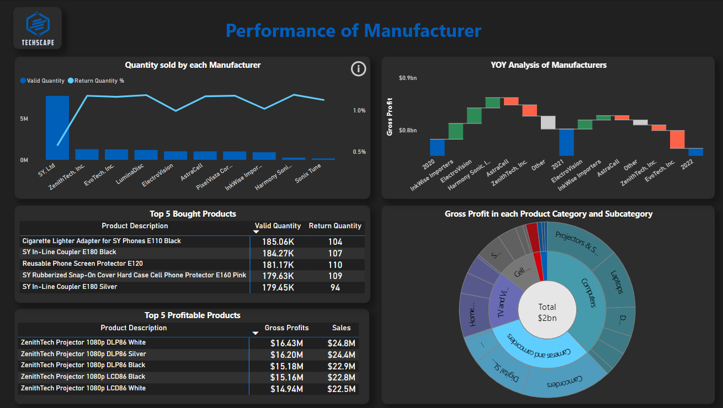

Understanding the performance of manufacturers enables improved decision-making and inventory management, resulting in the company being more proactive than reactive. I will now share about the visualizations that I have created.

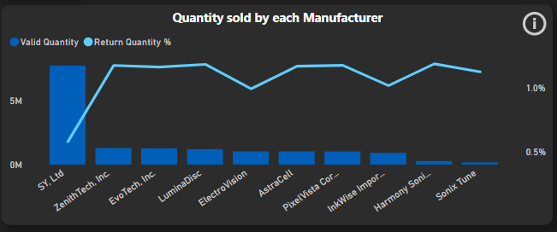

This bar chart allows users to see which brands perform well in terms of Quantity. In this chart, the SY brand is dominating the other brands based on quantity. This may be because SY is a brand that focuses on Cell Phone Accessories and usually they are cheap, so customers are able to buy them in bulk. The line chart shows the percentage of returned products. SY.Ltd has a low rate of return items compared to other manufacturers. Having a low return rate is a good indicator as it shows that the manufacturer is able to produce items without as many defects and manufacturers with high return rates have to improve or else customers will not be satisfied with the manufacturer. The reason why SY. Ltd may have a low return rate because the products they manufacture are accessories that are not very complex to manufacture so there is a lower chance of them making an error while producing the products.

Users can also click on the bars here to filter the matrix tables to the top 5 products in that selected manufacturer.

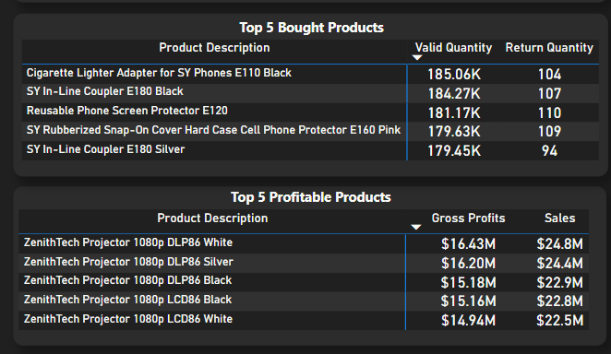

These matrices are used to show the top 5 most bought products and profitable products for each manufacturer. Showing this matrix table is important for manufacturers as identifying the most bought products provides insights into what customers prefer and purchase the most. This knowledge helps manufacturers align their production and marketing efforts with customer demands. Moreover, knowing which products are most popular allows manufacturers to optimize inventory levels, ensuring that high-demand products are readily available while minimizing excess stock for less popular items. This can improve customer satisfaction as customers will not have to face a situation where the product is out of stock. This brings a more proactive approach than a reactive approach in the company and the manufacturer.

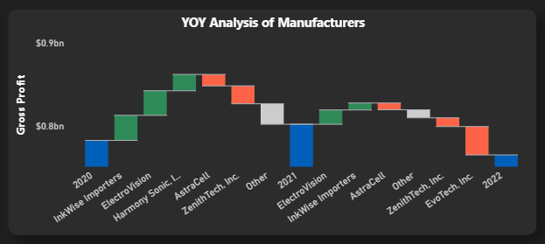

This waterfall chart shows the performance of the manufacturers based on profit and shows the changes over the years. Based on the chart, from 2020 to 2021, the manufacturers that were resulting in positive growth were InkWise Importers, ElectroVision, and Harmony Sonic, Inc. The other manufacturers had a decline in their growth. Then from 2021 to 2022, the manufacturers that were resulting in positive growth were now only InkWise Importers, and ElectroVision. The other manufacturers including Harmony Sonic, Inc. had a decline in growth.

This chart helps assess whether the business's partnerships and collaborations with manufacturers align with its overall business strategy. It provides evidence of the impact of these partnerships on the business's profit performance.

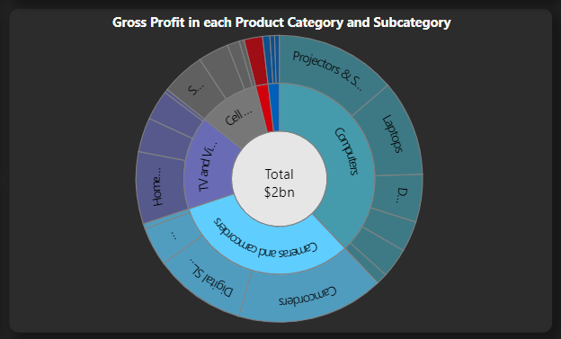

This sunburst chart is used when the dashboard is filtered by the manufacturer. What this will show are the product categories and subcategories the manufacturer produces, and the gross profit made through each product category and subcategory. Each manufacturer produces different goods, and this chart will identify the goods that the manufacturer produces.