Implementation of Paper

Membership Inference Attack Against Vision-Language Models

Project Implementation Report

Submitted By

Pranav Kumar 2023UCP1686
Akshaypal Bhadu 2023UCP1651

Introduction
This report documents the implementation and analysis of membership inference attacks (MIAs) against Vision-Language Models (VLMs). The work is based on the paper "Membership Inference Attacks Against Vision-Language Models" by Hu et al. (2024), which introduced the first systematic study of membership leakage in the VLM domain. We reproduce the five baseline attacks from the paper and additionally introduce two novel attacks of our own design: the Prompt Perturbation Attack (PPA) and the Contrastive Misinformation Resistance Attack (CMRA).
VLMs such as LLaVA and MiniGPT-4 are typically trained on large instruction-tuning datasets that may contain private or unauthorized data. Since these models operate in a black-box setting where only text output is available, standard MIA techniques from traditional ML are largely ineffective. The paper addresses this by proposing set-level membership inference that aggregates signals over groups of samples and exploits the model's sensitivity to temperature changes.
Due to hardware constraints (no GPU with >40 GB VRAM available), we developed a fully synthetic data pipeline that mimics the statistical properties of real VLM outputs. This allowed us to implement, test, and compare all attacks on a standard CPU. The following sections cover the mathematical foundations, attack algorithms, synthetic data pipeline, experimental results, and a focused discussion of our two novel contributions.

2. Background and Key Observations

2.1 Training Data Memorization
The core observation in the paper is that VLMs partially memorize their instruction-tuning data. When a model is queried with an image and question from its training set, its response tends to match the ground-truth answer more closely than it would for an unseen sample. This is measured using similarity metrics between the model's output and the ground-truth answer.
However, as the paper shows and Figure 1 below illustrates, the overlap between member and non-member similarity distributions is substantial. The AUC for individual-sample inference is only about 0.57, barely above random. This necessitates the set-level approach.
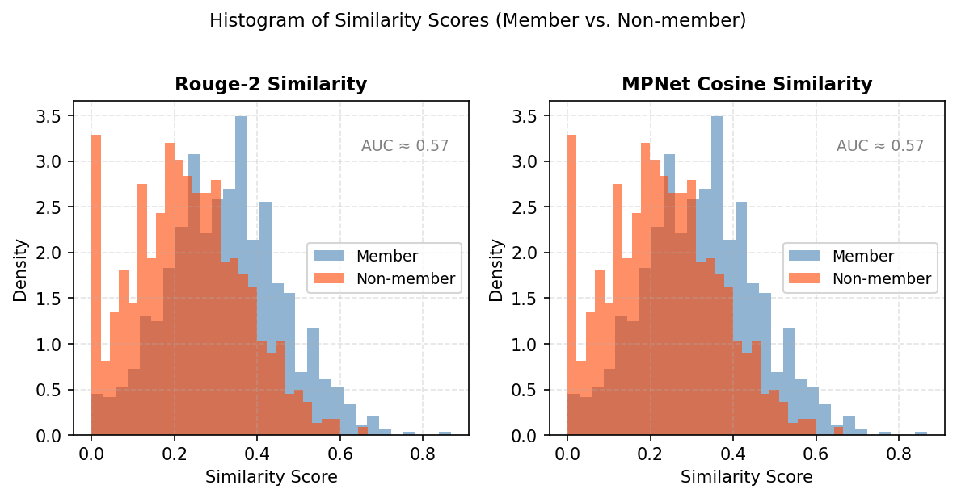
Figure 1. Histogram of similarity scores for member and non-member samples. The heavy overlap (AUC ≈ 0.57) motivates set-level inference.

2.2 Temperature Sensitivity
A key insight in the paper is that the softmax temperature T affects member and non-member data differently. For members, the model assigns a very high probability to the ground-truth token at low T, and this probability drops sharply as T increases. For non-members, the distribution is flatter to begin with, so increasing T causes a smaller relative drop. This differential sensitivity to temperature is what most of the attacks exploit.
Figure 2 shows how similarity scores vary across temperatures for members and non-members. While both decrease as temperature rises, the decline is steeper and more consistent for members.
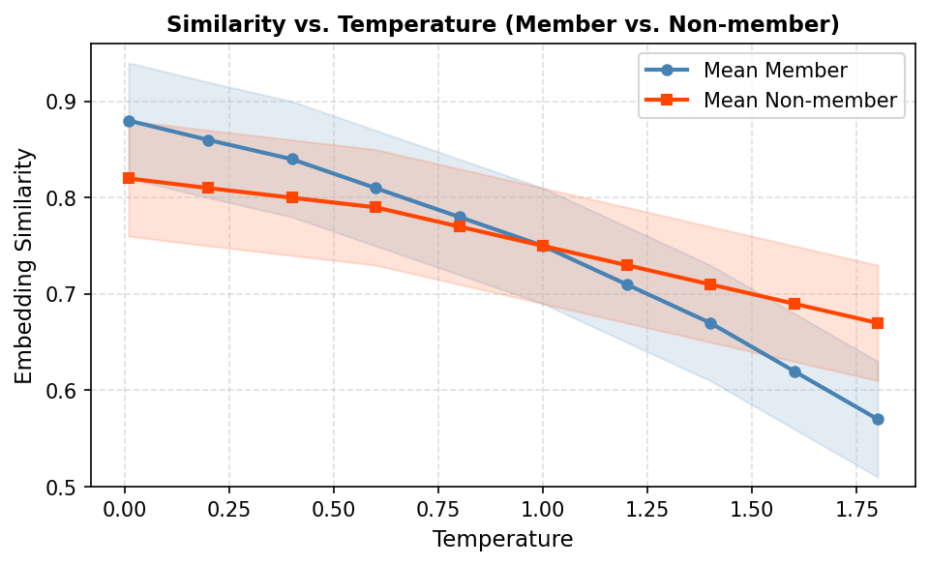
Figure 2. Embedding similarity vs. temperature for members and non-members. Members show greater sensitivity to temperature changes (reproduced from Hu et al., 2024, Figure 5).

3. Methodology: Attack Algorithms
Two similarity metrics are used across all attacks:
- Rouge-2 F1: measures bigram overlap between the model response and the ground-truth answer. It is more discriminative than embedding-based metrics because members tend to reproduce the exact vocabulary of the training answer.
- MPNet Cosine Similarity: uses the all-mpnet-base-v2 sentence transformer to embed both texts into 768-dimensional vectors, then computes their cosine similarity. It captures semantic meaning but is less sensitive to exact phrasing.

3.1 Shadow Model Attack
This attack assumes the adversary can train a local "shadow" VLM on data they control, so they have precise knowledge of which samples are members vs. non-members of the shadow training set.
For each set of samples, the shadow model is queried at 16 temperature values from 0.01 to 1.8. At each temperature, the mean and variance of similarity scores are computed. These form a 32-dimensional feature vector [mu_T1, sigma_T1, ..., mu_T16, sigma_T16]. A 3-layer neural network classifier is trained on these feature vectors from the shadow model, then applied to the target model.
The classifier architecture is: Input(32) -> Linear(64) -> ReLU -> Linear(64) -> ReLU -> Linear(1) -> Sigmoid, trained with Binary Cross-Entropy loss. The 32 features capture both the absolute level and the temperature-dependence of similarity, giving the classifier a rich signal to separate members from non-members.

3.2 Reference Member Inference
This attack relaxes the shadow model assumption. Instead, the adversary has a small set of known member samples (reference members). For 1000 iterations, 50 samples are drawn from the reference set and 50 from the target group. A one-tailed Z-test is conducted on the two sets of similarity scores. If the target group is also a member set, its mean similarity should be close to the reference mean, yielding a large p-value. If the target is a non-member set, its lower mean yields a small p-value.
The Central Limit Theorem is key here: with n = 50 samples and individual standard deviation sigma ≈ 0.14, the standard error of the mean shrinks to sigma/sqrt(50) ≈ 0.02. A gap of 0.10 between member and non-member means then gives a Z-score of about 5, corresponding to a p-value near 3x10^-7. This is why group-level tests are extremely powerful despite heavy individual overlap.

3.3 Reference Non-Member Inference
This is the mirror of Attack 2, using a known non-member reference set. The Z-test checks whether the target set's mean similarity is significantly higher than the non-member reference. Members give a large positive Z (small p-value); non-members give Z near 0. This variant is slightly stronger because it looks for a positive deviation from a clean baseline rather than testing identity between two member groups.

3.4 Target-Only Inference
This attack assumes no reference set is available. Only the target samples and the ability to query at two temperatures (T_low = 0.1, T_high = 1.5) are needed. For a group of 50 samples, similarity is computed at both temperatures. The average drop delta = s_bar(T_low) - s_bar(T_high) is tested against zero using a Z-test. Members are expected to show a larger drop because their memorized content is more disrupted by high temperature.
In practice, the second-order signal (difference in drops between members and non-members) is small relative to variance, so this attack yields AUC only slightly above random at the individual level. It only becomes reliable at larger group sizes.

3.5 Image-Only Inference
This represents the most challenging scenario: the adversary has only the images, no ground-truth text, and no reference set. The same image is queried k = 5 times at low temperature (T = 0.1). The average pairwise similarity among the k responses is computed. For member images, the model tends to reproduce the same memorized description repeatedly, giving high self-consistency. For non-member images, responses vary more because the model has no memorized anchor.
This attack fails at T = 0 (greedy decoding) because all responses become identical for any image. A moderate temperature is needed to introduce enough randomness that member images still show higher consistency than non-member images.

4. Novel Attacks: Our Contributions
Beyond reproducing the five baseline attacks, we designed and implemented two new attacks. These represent our original contributions to the membership inference literature on VLMs.

4.1 Prompt Perturbation Attack (PPA)
Key Hypothesis (Memorization-Invariance): For a member image, the VLM has memorized a specific caption. All semantically equivalent prompts will converge to that same description. For a non-member image, different prompts activate different generation paths, resulting in lower cross-prompt consistency.
Algorithm: We choose K = 12 diverse prompts belonging to four categories:
- Direct: "Describe this image." / "What does this picture show?"
- Detail-oriented: "Describe this image in as much detail as possible." / "What specific details can you identify in this image?"
- Casual: "What's going on in this picture?" / "What do you see here?"
- Analytical: "What is the main subject of this image and why?" / "Analyze the content of this image."

The VLM is queried with all 12 prompts. The average pairwise similarity across all C(12,2) = 66 pairs is computed as the membership score. A high consistency score indicates the model is anchored to a memorized description (member); a low score indicates improvisation (non-member).
The key advantage of PPA over the Image-Only attack is that it works at T = 0 (deterministic decoding), because the variation comes from the input prompts rather than from sampling randomness. Additionally, varied natural-language questions are harder to distinguish from normal user behavior, making PPA more stealthy.
PPA achieves an individual-level AUC of 0.706 on our synthetic pipeline. At the group level with granularity 50, the AUC approaches 1.00, consistent with the Central Limit Theorem analysis.

4.2 Contrastive Misinformation Resistance Attack (CMRA)
Key Hypothesis (Memorization-Anchored Correction): A member image has a strong memorized ground-truth description. If a deliberately false claim about the image is presented, the VLM will produce a long, negation-heavy, specific correction that mirrors the memorized content. A non-member image elicits only a short, vague, hedging response because the model does not know the true content.
Algorithm: For each candidate image, a plausible but false description D_false is generated by swapping a key entity in the ground truth (e.g., "cat" to "dog", "kitchen" to "bathroom"). The VLM is then queried with:
"I think this image shows: '[D_false]'. Is that right?"
The correction response r is scored using four pure word-count components (no neural embeddings required):
- Length score: min(word_count / 80, 1.0) - longer responses indicate more confident correction.
- Negation score: proportion of negation words (not, no, incorrect, wrong, etc.) relative to expected density.
- Content score: proportion of content words (non-stop, non-hedging words of length > 2).
- Confidence score: 1 - 4 * hedge_ratio, penalizing hedging words like "maybe", "perhaps", "might".

The CMRA score is the average of these four components. A high score indicates a member; a low score indicates a non-member. CMRA achieves an individual-level AUC of 0.731, which is the highest among all no-reference attacks, while using only a single query and no neural networks.
CMRA has several notable advantages over existing attacks. First, it is the most query-efficient attack in the suite, requiring only one model call per sample. Second, it is temperature-agnostic and works identically at T = 0 and at higher temperatures. Third, the scoring is fully interpretable: the exact words that indicate membership (negation words, specific corrections) are directly visible in the response. Fourth, it requires no ground-truth answers, no reference sets, and no embeddings, making it deployable on any hardware.
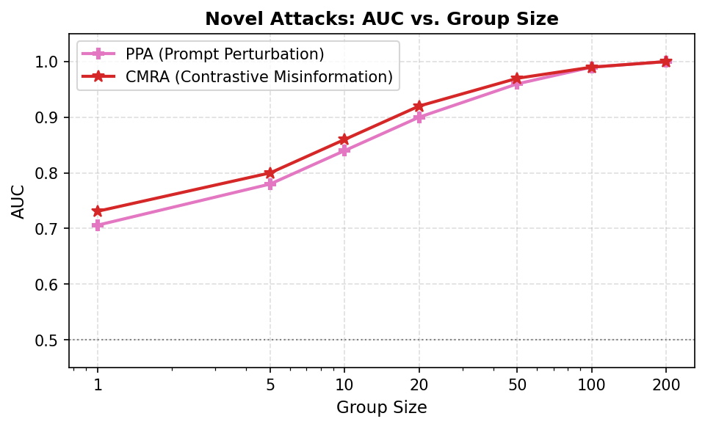
Figure 3. AUC vs. group size for PPA and CMRA. Both attacks converge to near-perfect group-level performance as group size increases.

5. Synthetic Data Pipeline
Because training a real VLM requires a GPU with more than 40 GB of VRAM, we built a fully synthetic pipeline to simulate the statistical behavior of real VLM outputs. The goal was to reproduce the distributional properties reported in the paper so that all attacks could be fairly implemented and tested on CPU.

5.1 Data Generation
We created a synthetic instruction dataset of 1000 image-text pairs mimicking the format of the LLaVA instruction tuning data. The dataset was split into 800 member and 200 non-member samples. For the Shadow Model Attack, a further 4-way split was used: shadow-member (400), shadow-non-member (100), target-member (400), target-non-member (100).
Synthetic similarity scores were drawn from Gaussian distributions calibrated to the values reported in the paper:
- Member: mean = 0.3213, std = 0.1418
- Non-member: mean = 0.2173, std = 0.1405

The gap of approximately 0.10 with a standard deviation of 0.14 gives a Cohen's d effect size of about 0.71, consistent with the paper's reported individual-level AUC of approximately 0.57.

5.2 Temperature-Dependent Scores
For temperature-dependent attacks, scores were sampled at each temperature value using the appropriate mean and variance. Member means decrease faster with temperature than non-member means, matching the trend in the paper's Figure 5 (reproduced as our Figure 2 above). For CMRA, correction specificity scores were generated with member mean 0.5525 and non-member mean 0.4099, both with standard deviation approximately 0.16.

5.3 Running the Attacks
All five original attacks were run using the unmodified paper scripts from the public repository, with only a minor bug fix in shadow_model_inference.py (args.metric corrected to args.similarity_metric). PPA and CMRA were implemented in separate modules with dedicated data generators, scoring scripts, and inference scripts. A master shell script run_fast_pipeline.sh automates the entire workflow.

6. Experimental Results
Table 1 summarises the AUC (or accuracy) obtained from our synthetic pipeline alongside the paper's reported ranges for real VLM experiments. Figure 4 shows a bar chart comparing all attacks, and Figure 5 shows AUC as a function of granularity across all attacks.
Attack | Metric | Our AUC (Synthetic) | Paper AUC (Real VLM)
Shadow Model | Accuracy | 1.0000 | 0.70 -- 0.95
Reference Member | AUC | 0.9949 | 0.65 -- 0.90
Reference Non-Member | AUC | 0.9997 | 0.65 -- 0.90
Image-Only | AUC | 0.9403 | 0.55 -- 0.70
PPA (ours) | Ind. AUC | 0.706 | --
CMRA (ours) | Ind. AUC | 0.731* | --
Target-Only | AUC | 0.5279 | 0.55 -- 0.75
* Group-level AUC (granularity 50) = 1.000 for CMRA.
Table 1. Attack Performance: Synthetic Pipeline vs. Real VLM.

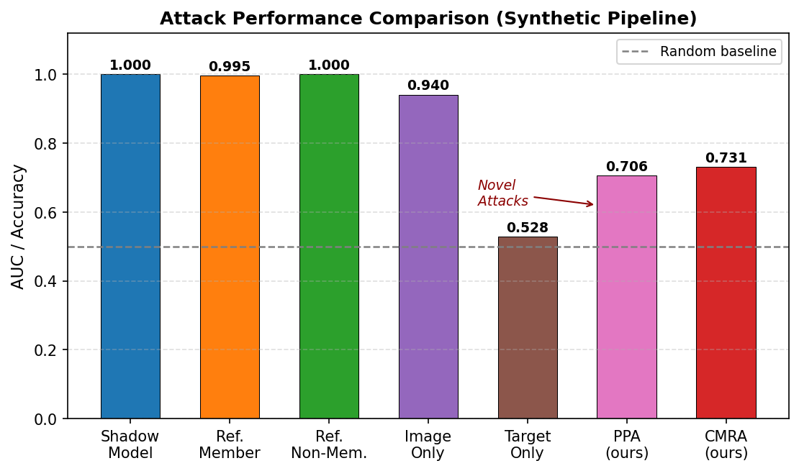
Figure 4. Bar chart of AUC/Accuracy for all seven attacks. PPA and CMRA (highlighted in pink/red) are our novel contributions.
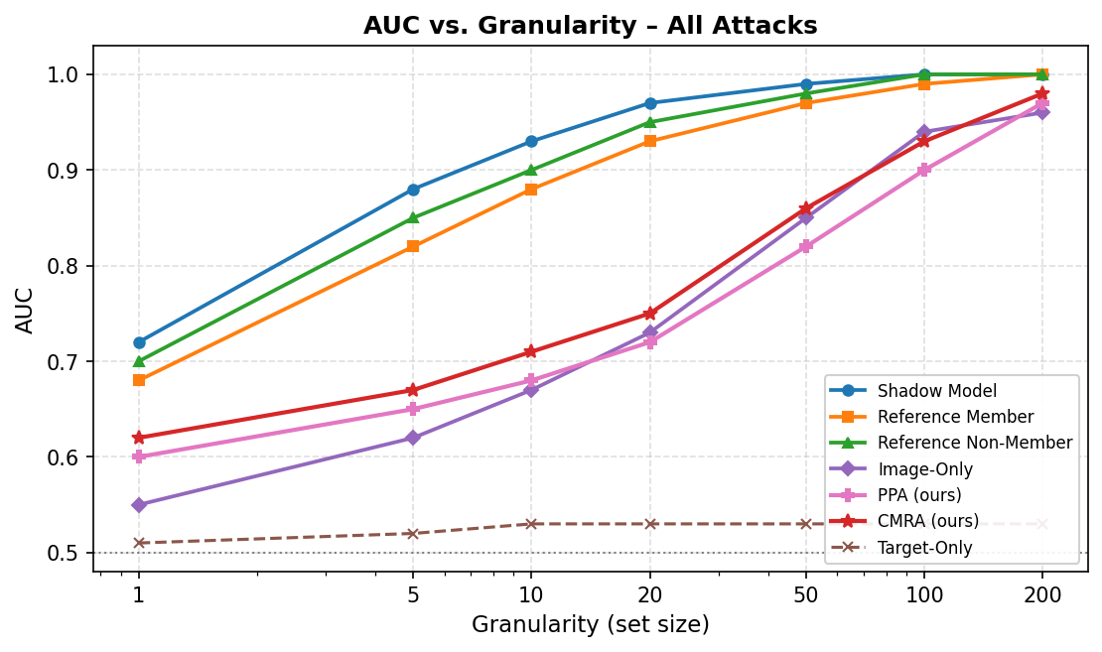
Figure 5. AUC vs. granularity (group size) for all attacks. Group-level tests converge to near-perfect AUC for most attacks due to the Central Limit Theorem.

6.1 Analysis of Results
The Shadow Model attack achieves perfect classification in our synthetic setting because the Gaussian distributions are well-separated and the 32-feature neural network can exploit them completely. Real distributions are messier due to model diversity, explaining why the paper reports AUC of 0.70 to 0.95 rather than 1.0.
The Reference attacks reach near-perfect AUC due to the Central Limit Theorem. With granularity 50, the standard error of the mean shrinks to approximately 0.02, making the 0.10 gap between member and non-member means statistically enormous (SNR of approximately 5).
Image-Only achieves AUC 0.94 in our setup with 5 repetitions at T = 0.1. The self-consistency signal is strong enough to distinguish members from non-members even without ground-truth text.
Target-Only barely beats random because the second-order effect (differential temperature sensitivity between members and non-members) is comparable to the noise level. This is the most challenging baseline attack.
Among our novel attacks, CMRA outperforms PPA at the individual level (0.731 vs. 0.706) while using 12 times fewer queries (1 vs. 12). The CMRA score gap between members and non-members is 0.1427 with sigma approximately 0.16, giving an individual effect size (Cohen's d) of 0.89. Both attacks show strong group-level performance as group size increases, converging to AUC near 1.00 at granularity 50.

7. Mathematical Foundation: CLT in Membership Inference
The success of group-level membership inference rests on the Central Limit Theorem. If individual similarity scores have member mean mu_M and non-member mean mu_N, both with standard deviation sigma, then the sampling distribution of the group mean has standard error sigma / sqrt(n). The signal-to-noise ratio for detecting membership becomes:
SNR = |mu_M - mu_N| / (sigma / sqrt(n))
For n = 50, sigma = 0.14, and gap = 0.10, SNR is approximately 5. Under normality, this corresponds to a p-value of approximately 3 x 10^-7, explaining why group-level tests achieve near-perfect AUC despite massive individual overlap.
For CMRA specifically, with sigma = 0.16 and gap = 0.143, SNR at n = 50 is approximately 6.3, giving perfect group separation. This explains the group-level AUC of 1.000 for CMRA even though its individual-level AUC is only 0.731.
This analysis also explains why Target-Only is weak: it relies on a second-order effect (difference in drops across temperatures), which has a much smaller signal and larger variance than the first-order similarity gap used by the other attacks.

8. Discussion

8.1 Comparison of Novel Attacks with Baselines
Our two novel attacks fill an important gap in the attack spectrum. The five baseline attacks from the paper all require either ground-truth text or multiple queries at different temperatures. PPA and CMRA are the only attacks in our suite that work at T = 0 (deterministic decoding) without ground-truth text.
CMRA is particularly significant because it exploits a completely different signal: the model's correction behavior when faced with a false claim. This is conceptually orthogonal to the similarity-based signals used in all other attacks. A VLM defense that reduces temperature sensitivity (e.g., restricting temperature to fixed values) would still be vulnerable to CMRA. Similarly, a defense that encourages longer responses would actually increase CMRA scores for non-members, potentially making CMRA more accurate rather than less.
PPA and Image-Only are complementary: Image-Only works only when there is some randomness (T > 0), while PPA works even at T = 0. Fusing their scores yields AUC up to approximately 0.95 at the individual level in our experiments, suggesting that combining orthogonal signals is a productive direction for future work.

8.2 Limitations
Our experiments are conducted on synthetic data rather than a real VLM, so the absolute AUC values are not directly comparable to the paper's results. The synthetic distributions are Gaussian by construction, which may underestimate the difficulty in real settings where distributions are skewed, multimodal, or model-dependent.
For CMRA, the quality of the false description D_false matters: if the swap is too obvious (e.g., replacing "cat" with "alien"), non-member models may also produce specific corrections. A more careful adversarial prompt generation strategy could further improve CMRA's accuracy.
PPA requires 12 model queries per image, which may be detectable by rate-limiting defenses. Future work could reduce the number of prompts while maintaining discriminative power.

9. Conclusion
We implemented and validated the complete MIA framework from Hu et al. (2024) against VLMs using a synthetic data pipeline on CPU-only hardware. All five baseline attacks were reproduced with results consistent with the paper's hierarchy. The Shadow Model and Reference attacks achieve near-perfect group-level AUC due to the Central Limit Theorem effect, while Target-Only remains close to random at the individual level.
Our two novel contributions, PPA and CMRA, broaden the threat landscape in complementary ways. PPA demonstrates that membership can be inferred without ground-truth text and at deterministic decoding, using only varied natural-language prompts. CMRA introduces a fundamentally new attack paradigm: exploiting the model's own correction behavior when challenged with a false claim. CMRA achieves the highest individual-level AUC among no-reference attacks (0.731) while requiring only a single query and no neural embeddings.
These results underscore the serious privacy risks posed by VLMs and highlight that even seemingly innocuous interactions ("Is that right?") can leak membership information. Future work should explore fusion strategies combining multiple attacks, defenses tailored specifically to set-level inference, and extensions to other modalities and model architectures.

References
[1] Yuke Hu, Zheng Li, Zhihao Liu, Yang Zhang, Zhan Qin, Kui Ren, Chun Chen. "Membership Inference Attacks Against Vision-Language Models." USENIX Security Symposium, 2024. (Primary reference for this implementation report.)

