DevOps Day 2 – Automation using Jenkins push image from github to docker hub using jenkins automation
docker
___

# sudo apt install docker.io -y
# sudo service docker restart
# sudo service docker status

# sudo usermod -aG docker $USER

docker images
docker ps

# sudo chmod 666 /var/run/docker.sock
curl -LO https://dl.k8s.io/release/v1.32.0/bin/linux/amd64/kubectl
sudo install -o root -g root -m 0755 kubectl /usr/local/bin/kubectl
chmod +x kubectl
mkdir -p ~/.local/bin
mv ./kubectl ~/.local/bin/kubectl
kubectl version –client
udo install -o root -g root -m 0755 kubectl /usr/local/bin/kubectl

chmod +x kubectl
mkdir -p ~/.local/bin
mv ./kubectl ~/.local/bin/kubectl

kubectl version –client
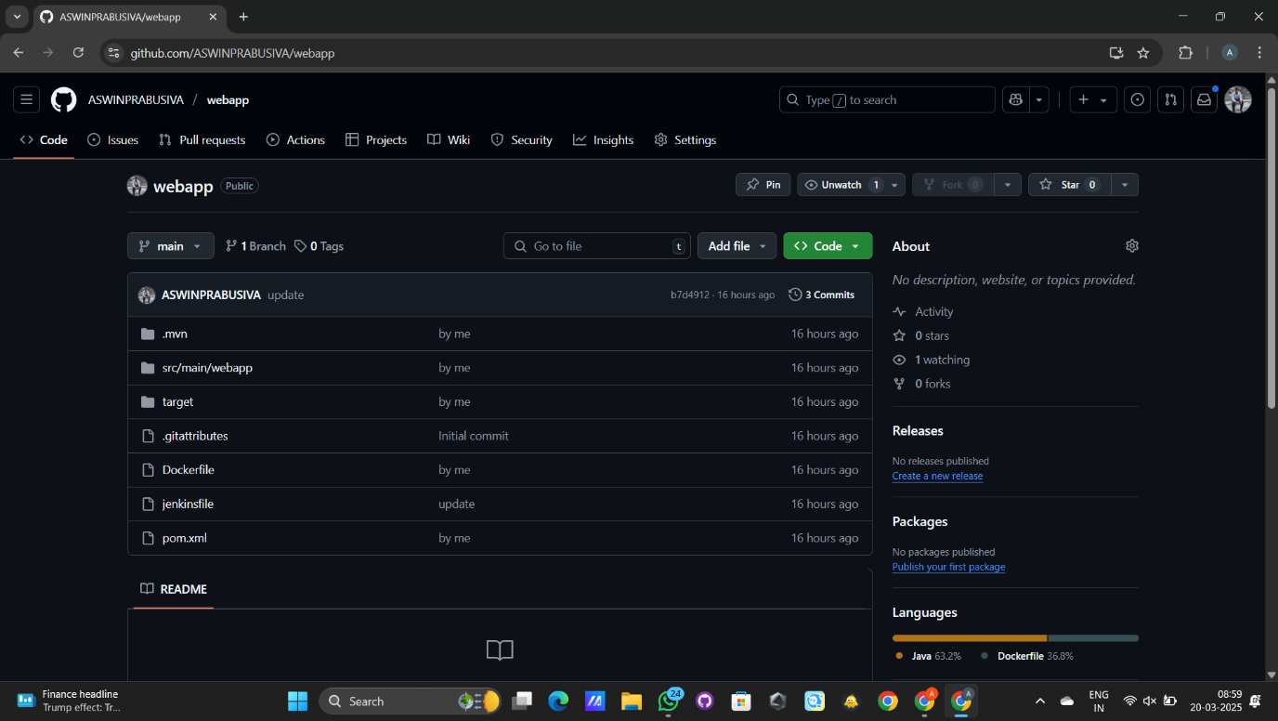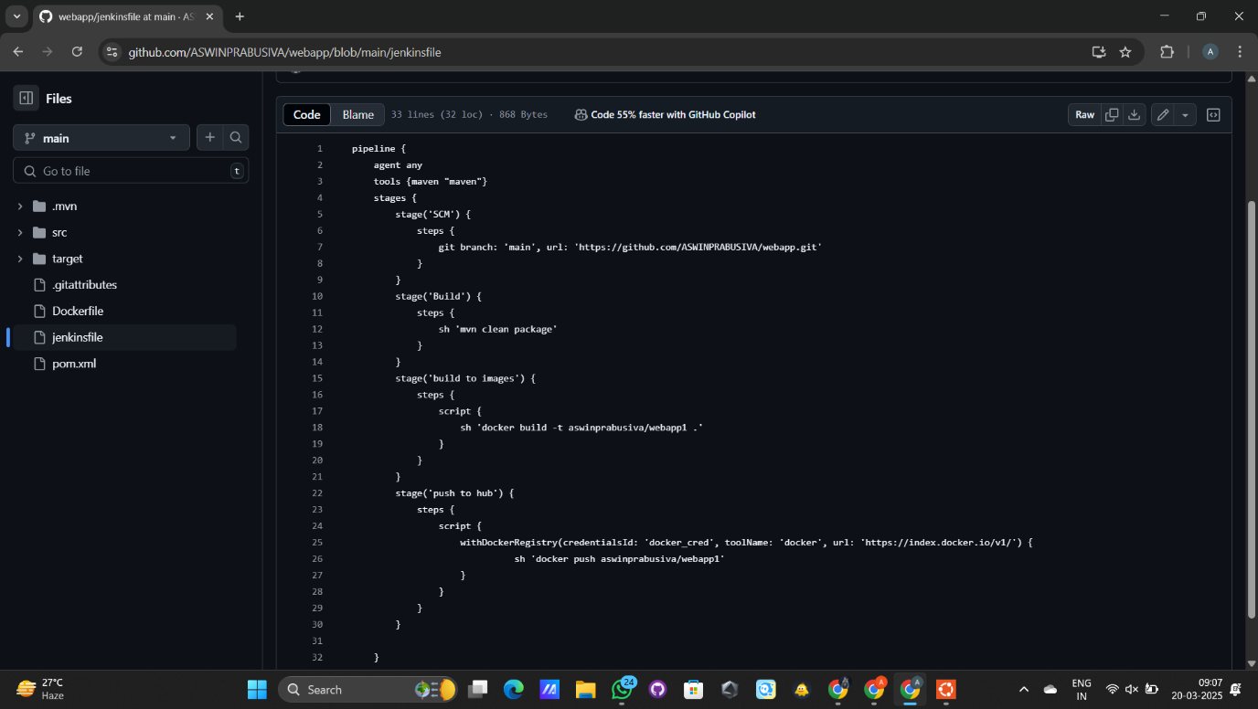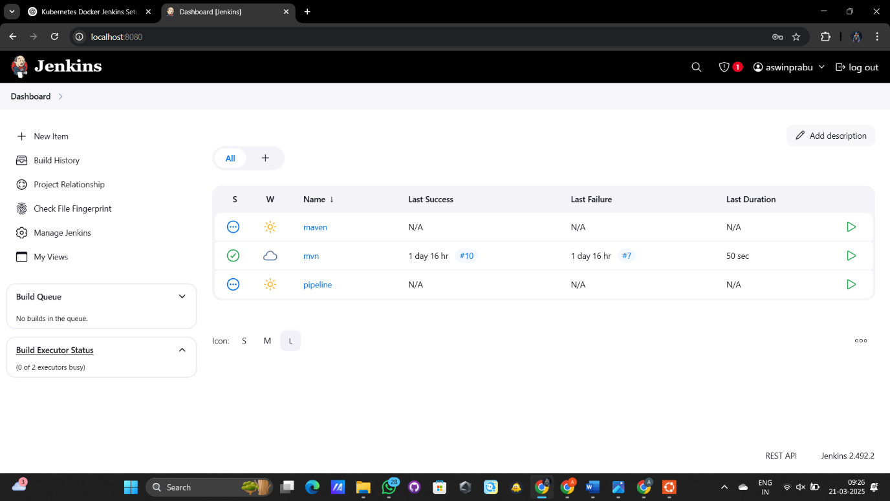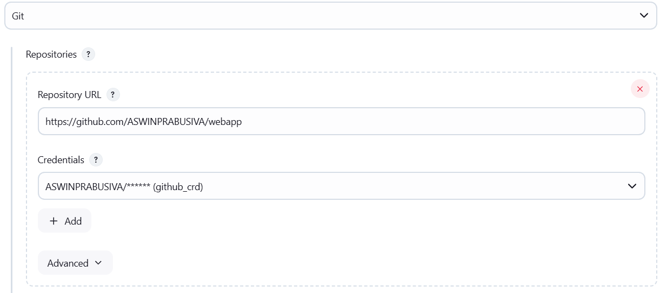

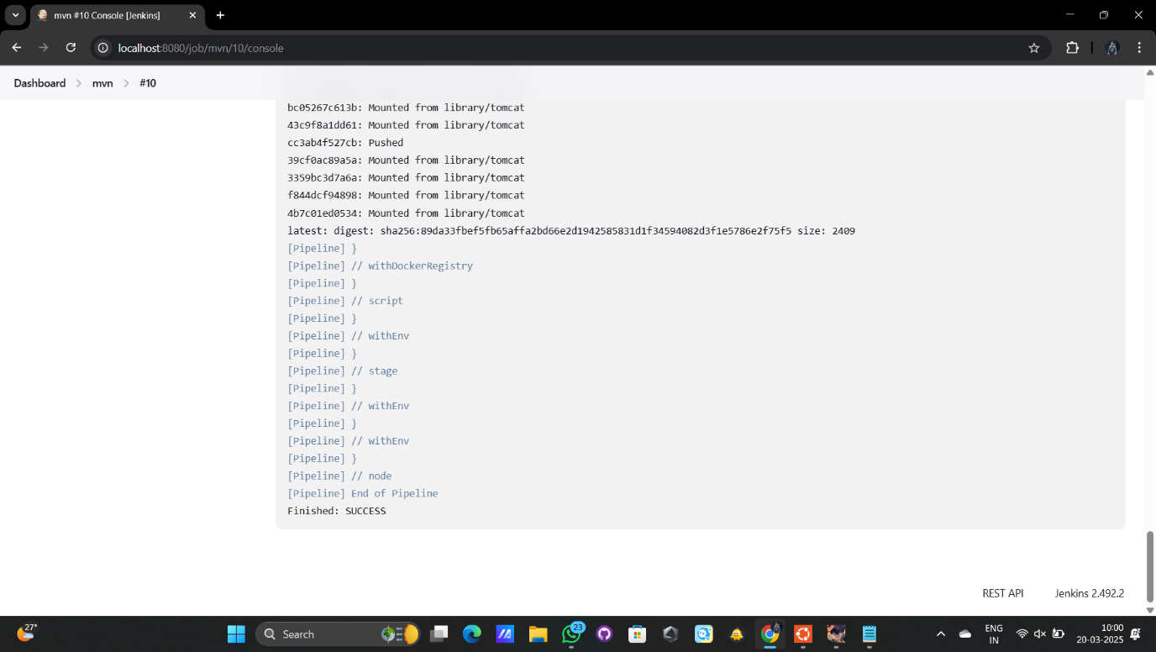

Pipeline code
pipeline {
agent any
tools {maven "maven"}
stages {
stage('SCM') {
steps {
git branch: 'master', url: 'https://github.com/Saran-Avinash/DevOps.git'
}
}
stage('Build') {
steps {
sh 'mvn clean package'
}
}
stage('build to images') {
steps {
script {
sh 'docker build -t saranavinashb/webapp1 .'
}
}
}
stage('push to hub') {
steps {
script {
withDockerRegistry(credentialsId: 'docker_cred', toolName: 'docker', url: 'https://index.docker.io/v1/') {
sh 'docker push saranavinashb/webapp1'
}
}
}
}

}
}

