DETAILED DESIGN DOCUMENT
REVA Internship Opportunities (RIO) | School of Computer Science and Engineering, REVA University, Bengaluru
Particulars | Details
Task | Task 4 (SL 4), Project Track: Detailed Design of the Module
Name of Student | R Sai Pranav
University Seat Number (USN) | R23EM069
Project Title | ForgeGuard: An AI-Based Document Forgery Detection and Verification System
Track | PS 109
Faculty Guide | Mala B M
Date of Submission | 2 November 2026

1. Introduction
1.1 Purpose. The System Design Document fixed the architecture: four detector services behind one orchestrator, one API, one data model. This document goes a full level deeper, into the classes, algorithms, data structures, interfaces and error handling that implement that architecture — detailed enough to code directly, not just to diagram. Every service gets the same six-part treatment: component breakdown, data-flow diagram, algorithm detail, data structures, interface specification, and error handling.
1.2 Scope. Section 2 covers the assigned module, Document Tamper Detection and Localisation, at the level of the actual working prototype in tamper_localisation/ — including excerpts of the real code, parameter counts and a test-to-requirement map. Sections 3–6 cover the remaining three services and the orchestrator at the same structural depth, in pseudocode, since they are designed but not yet implemented. Section 7 gives the full column-level data design. Section 8 gives the full request/response schema for every API route. Section 9 is the complete system sequence diagram with error paths. Section 10 is system-wide error handling. Section 11 is the full traceability table.
1.3 Identifiers. Gap N refers to the Literature Survey Report, O1–O9 to the Project Objectives, and FR-*/NFR-* to the System Design Document. All four documents trace against the same identifiers.

2. Detailed Design — Tamper Detection and Localisation (assigned module)

2.1 Component breakdown
Component | Responsibility
SRMFilter | Fixed, non-trainable depthwise convolution applying 3 high-pass kernels (horizontal residual, vertical residual, Laplacian-style) to each input channel. 3-channel RGB in → 9-channel noise-residual tensor out. Implements the noise-residual half of FR-D1/FR-D2.
preprocess() | FR-D1: deskew (row-variance search over ±10°), resize/normalise to 256×256 in [0,1], compute the ELA map (JPEG re-save at quality 90, pixel-wise difference). Returns the RGB tensor and the single-channel ELA map.
TamperLocaliser (model) | The dual-stream encoder-decoder itself: two independent encoders (RGB+ELA, SRM residual), a fusion layer, and a decoder that outputs a per-pixel tamper logit map. Pure nn.Module, no I/O.
SyntheticTamperDataset | Generates document-like images with a randomly spliced patch and a pixel-accurate mask, plus rotation/blur/noise/recompression augmentation (NFR-10). Stand-in for FSD (paper [29]) until real scans are available.
TamperLocalisationService | The module's only external surface (NFR-7): predict(image) runs preprocessing, the model, thresholding, connected-component region extraction and scoring, and returns the fixed output contract. Everything above is an implementation detail behind this one method.

2.2 Internal data flow
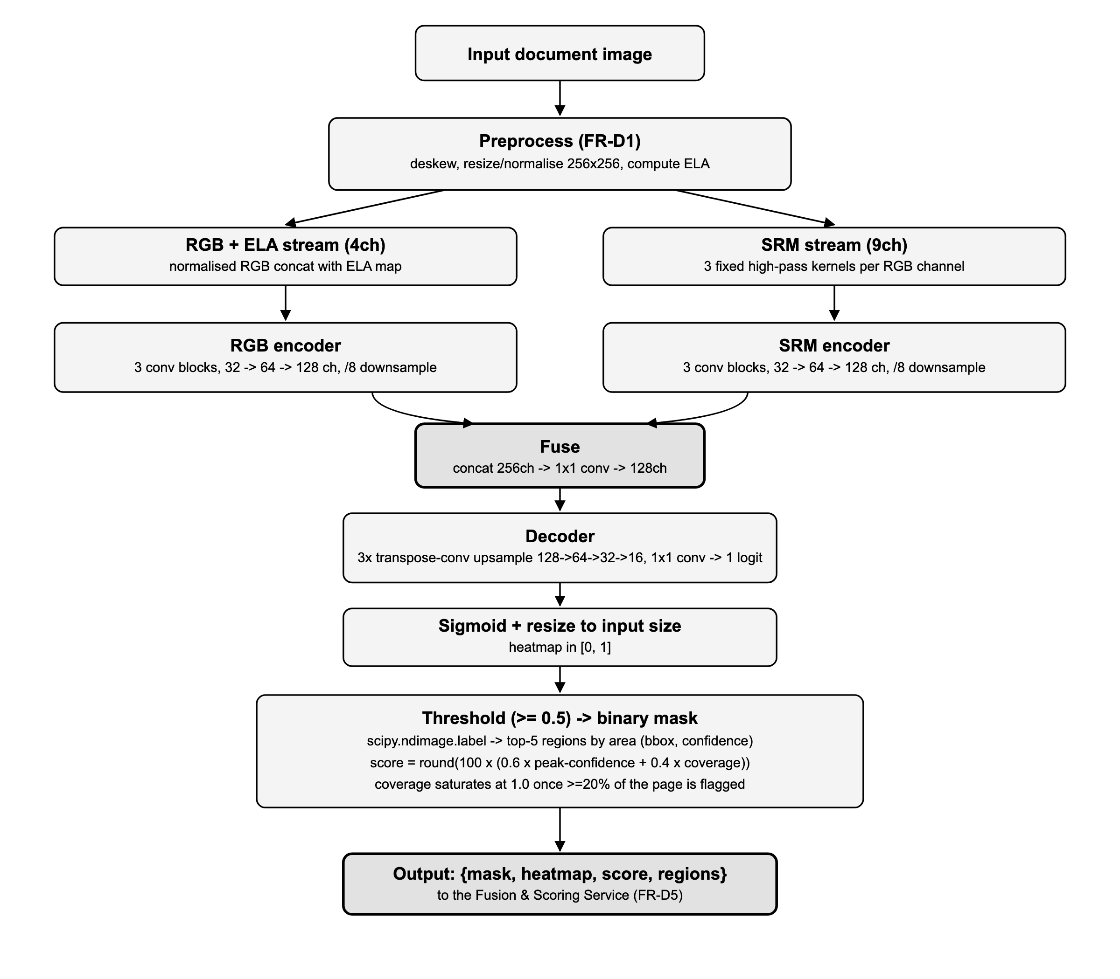

2.3 Algorithm detail
Deskew. For angle in [-10°, +10°] stepped by 1°, rotate the grayscale page and score it by the variance of row-wise pixel-intensity sums (text rows create high-variance peaks when horizontal; a skewed page blurs them together). Keep the angle with the highest variance. Cheap, needs no extra dependency, and good enough for the small scan tilts the problem calls for.
ELA. Re-save the page as JPEG at quality 90 and take the per-pixel absolute difference against the original, averaged over the 3 colour channels, normalised to [0, 1]. Untouched regions re-compress almost losslessly; edited regions (pasted from a different source, or re-saved at a different quality) show a brighter residual. Used only as one input channel alongside the RGB stream (Gap 4): the model is free to learn how much to trust it, rather than thresholding on it directly.
SRM kernels (applied per RGB channel, zero-padding, fixed weights, never updated by backprop):
horizontal residual [[ 0, 0, 0], [0, -1, 1], [0, 0, 0]]
vertical residual [[ 0, 0, 0], [0, -1, 0], [0, 1, 0]]
Laplacian residual [[ 0, 1, 0], [1, -4, 1], [0, 1, 0]]
Loss. BCEWithLogits(logits, mask) + DiceLoss(logits, mask), where DiceLoss = 1 - (2|P∩T| + ε) / (|P| + |T| + ε) on sigmoid probabilities P against ground truth T. BCE alone is dominated by the large background class on a sparsely-tampered page; Dice pulls the gradient toward getting the (small) tampered region right, which is what IoU in the NFR-5 evaluation actually measures.
Region extraction. Threshold the heatmap at 0.5, label connected components with scipy.ndimage.label, rank components by pixel area, keep the top 5, and report each as {bbox: [x, y, w, h], confidence: mean heatmap value inside the component} — this is the "largest suspicious regions with coordinates" FR-D6 asks for.
Tamper sub-score. score = round(100 × (0.6 × peak_confidence + 0.4 × coverage_term)), where peak_confidence is the heatmap's maximum value and coverage_term = min(flagged_area_fraction / 0.2, 1.0). A small, high-confidence edit and a large, lower-confidence one can both reach a high score; a few stray low-confidence pixels cannot.

2.4 Reference implementation
The service method and its two private helpers, exactly as implemented in tamper_localisation/infer.py:
@torch.no_grad()
def predict(self, image: Image.Image, threshold: float = 0.5) -> dict:
pre = preprocess(image, size=self.img_size)
rgb = torch.from_numpy(pre["rgb"]).float().unsqueeze(0).to(self.device)
ela = torch.from_numpy(pre["ela"]).float().unsqueeze(0).unsqueeze(0).to(self.device)
heatmap = torch.sigmoid(self.model(rgb, ela))[0, 0].cpu().numpy() # (H, W) in [0, 1]
mask = (heatmap >= threshold).astype(np.uint8) * 255
regions = self._top_regions(heatmap, threshold)
score = self._tamper_score(heatmap, mask)
return {"mask": mask, "heatmap": heatmap, "score": score, "regions": regions}
@staticmethod
def _tamper_score(heatmap: np.ndarray, mask: np.ndarray) -> int:
"""0-100: weighted blend of peak confidence and flagged-area coverage."""
peak = float(heatmap.max())
coverage = float((mask > 0).mean())
coverage_term = min(coverage / 0.2, 1.0)
return int(round(100 * (0.6 * peak + 0.4 * coverage_term)))

2.5 Data structures
RGB tensor | torch.FloatTensor, shape (3, 256, 256), values in [0, 1]
ELA map | torch.FloatTensor, shape (1, 256, 256), values in [0, 1]
SRM residual | torch.FloatTensor, shape (9, 256, 256), produced inside the model, never persisted
Logit map | torch.FloatTensor, shape (1, 256, 256), raw model output before sigmoid
Heatmap | numpy.float32, shape (256, 256), values in [0, 1]
Mask | numpy.uint8, shape (256, 256), values ∈ {0, 255}
Region | {"bbox": [x, y, w, h] (int), "confidence": float}, list ordered largest-area first, length ≤ 5
Score | int, 0–100

2.6 Interface specification (NFR-7)
Method | TamperLocalisationService.predict(image: PIL.Image, threshold: float = 0.5) -> dict
Input | image: a full page as a PIL image, any size. threshold: mask/region cutoff on the [0,1] heatmap.
Output | mask, heatmap, score, regions as defined in 2.5.
Construction | TamperLocalisationService(checkpoint=None, device=None, img_size=256). A missing checkpoint runs the (untrained) architecture — useful for interface/contract tests, never for a real score.
Replaceability | The orchestrator only ever calls predict(). A newer localiser (different backbone, added anomaly head for Gap 8/O8) is a drop-in replacement for this class as long as it keeps the same method signature and output keys.

2.7 Complexity and performance (NFR-2)
Trainable parameters | ~1.1M (two encoders at 32/64/128 channels, 1x1 fusion, 3-stage transpose-conv decoder) — roughly two orders of magnitude below a ResNet-50 backbone.
Fixed parameters | 27 (the 3 SRM kernels x 3x3, never updated)
Forward pass cost | Dominated by the two /8-downsampling encoders over a 256x256 input; comparable to running two small CNNs over a quarter-megapixel image, well within the single-consumer-GPU-or-CPU budget NFR-2 sets.
Memory | Largest activation is the SRM stream at full input resolution (9, 256, 256) before the first downsample; no activation ever exceeds a few tens of MB at batch size 1.

2.8 Error handling and edge cases
- No tamper present. regions is an empty list and score is low; this is a normal, expected output, not an error.
- Degenerate AUC. If a batch's ground truth is all-genuine or all-forged, roc_auc_score is undefined; evaluate.py reports nan for that batch rather than raising, so a batch imbalance does not crash an evaluation run (NFR-5).
- Untrained / missing checkpoint. TamperLocalisationService runs with random weights if no checkpoint is given; callers must not treat that output as a real decision (see 2.6, Construction).
- Device fallback. device defaults to CUDA if available, else CPU, satisfying NFR-2 without any caller-side branching.
- Oversized/undersized pages. preprocess() resizes to a fixed 256×256 before the model ever sees the image, so input resolution cannot change the model's memory footprint or runtime.
- Corrupt/unreadable image. Image decoding happens before predict() is called (at the API gateway); the service assumes a valid, already-decoded PIL.Image and is not responsible for file-format errors.

2.9 Verification against test_module.py
Test | Checks
test_model_forward_shape | Model output shape matches input spatial size regardless of batch size — the decoder's upsampling and the final bilinear resize are correct (2.2).
test_dataset_sample_shapes | Synthetic dataset emits the exact tensor shapes/types the model consumes (2.5), and masks are binary.
test_service_predict_contract | End-to-end: predict() on an untrained model still satisfies the full output contract (2.6) — shapes, score range, region count.
test_pixel_metrics_known_values | Precision/recall/IoU formulas (NFR-5) against a hand-computed 2x2 example, independent of the model.

3. Detailed Design — Signature Verification Service

3.1 Component breakdown
Component | Responsibility
SignatureDetector | Object detector that locates the signature region on the full page and returns a bounding box (paper [13]). FR-S1.
SignatureCleaner | Removes ruled lines, stamps and background noise from the detected crop before embedding. FR-S2.
SignatureEncoder | Writer-independent Siamese/metric-learning encoder (papers [3], [6], [12]), frozen at inference; maps a signature crop to a fixed-length embedding vector.
SignatureService | The module's external surface: verify(page, signer_id) runs detect → clean → embed → compare and returns a similarity score and decision. FR-S3.

3.2 Data flow
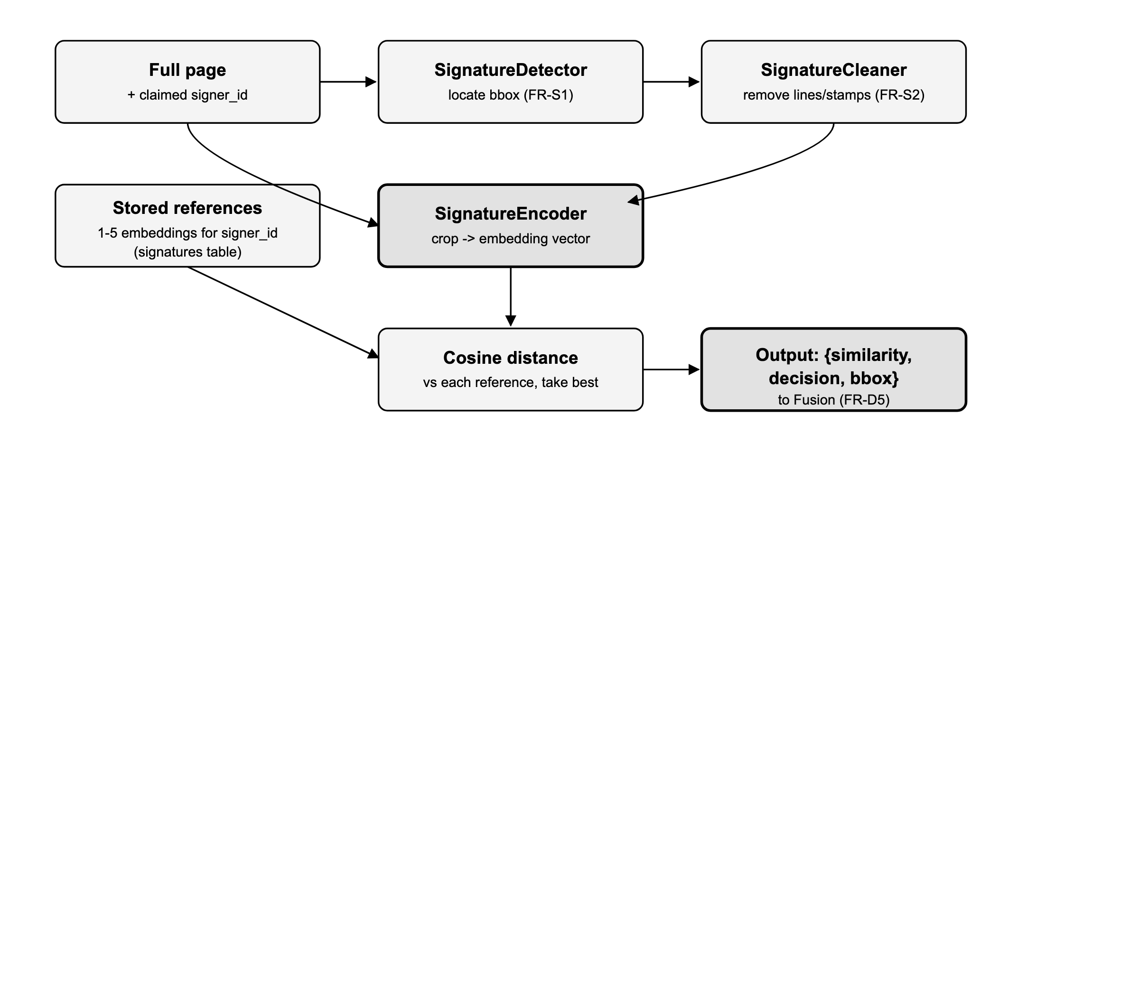

3.3 Algorithm detail
Detection. A lightweight object detector (anchor-free, single class "signature") trained on signature bounding boxes over real document pages, following the multilingual detection approach of paper [13]; returns the highest-confidence box above a detection threshold, or "not found" if none clears it.
Cleaning. Binarise the crop, remove long straight lines (ruled lines under the signature) via morphological opening with a wide horizontal structuring element, and remove small disconnected blobs below an area threshold (stamp fragments, noise), following the cleaning stage of paper [13].
Comparison. similarity = max(cosine(embed(crop), ref_i)) for ref_i in references; decision = "genuine" if similarity >= threshold else "forged". The threshold is tuned on a validation split, not hard-coded, so it can be recalibrated per deployment (NFR-5).

3.4 Data structures
Embedding | Fixed-length float vector (encoder output dimension, e.g. 128), L2-normalised before cosine comparison
Reference set | List of 1–5 embeddings per signer_id, loaded from the signatures table
Output | {"similarity": float [0,1], "decision": "genuine"|"forged", "bbox": [x,y,w,h]}

3.5 Interface specification (NFR-6, NFR-7)
Method | SignatureService.verify(page: Image, signer_id: str) -> dict
Replaceability | Adding a signer is an INSERT into signatures, never a retrain (NFR-6); swapping the encoder for a better metric-learning model changes nothing outside this class (NFR-7).

3.6 Error handling
- No signature detected. Returns decision = "not found" rather than guessing; the fusion stage treats this sub-score as unavailable (Section 6.4).
- No reference signatures registered for the signer. Returns an error the orchestrator surfaces to the verifier (FR-U4 requires at least one reference before verification can run).

4. Detailed Design — OCR / Field Validation Service

4.1 Component breakdown
Component | Responsibility
OCREngine | Text extraction; consensus across multiple engines for financial documents, following FORENSIQ's triple-OCR approach (paper [39]).
FieldValidator | Per-document-type regex/format rules on names, dates and ID numbers. FR-D3.
ArithmeticGate | For financial documents, checks that the total equals the net amount plus tax. FR-D4.
OCRService | External surface: check(page, doc_type) -> dict, running extraction, field checks and (where applicable) the arithmetic gate.

4.2 Data flow
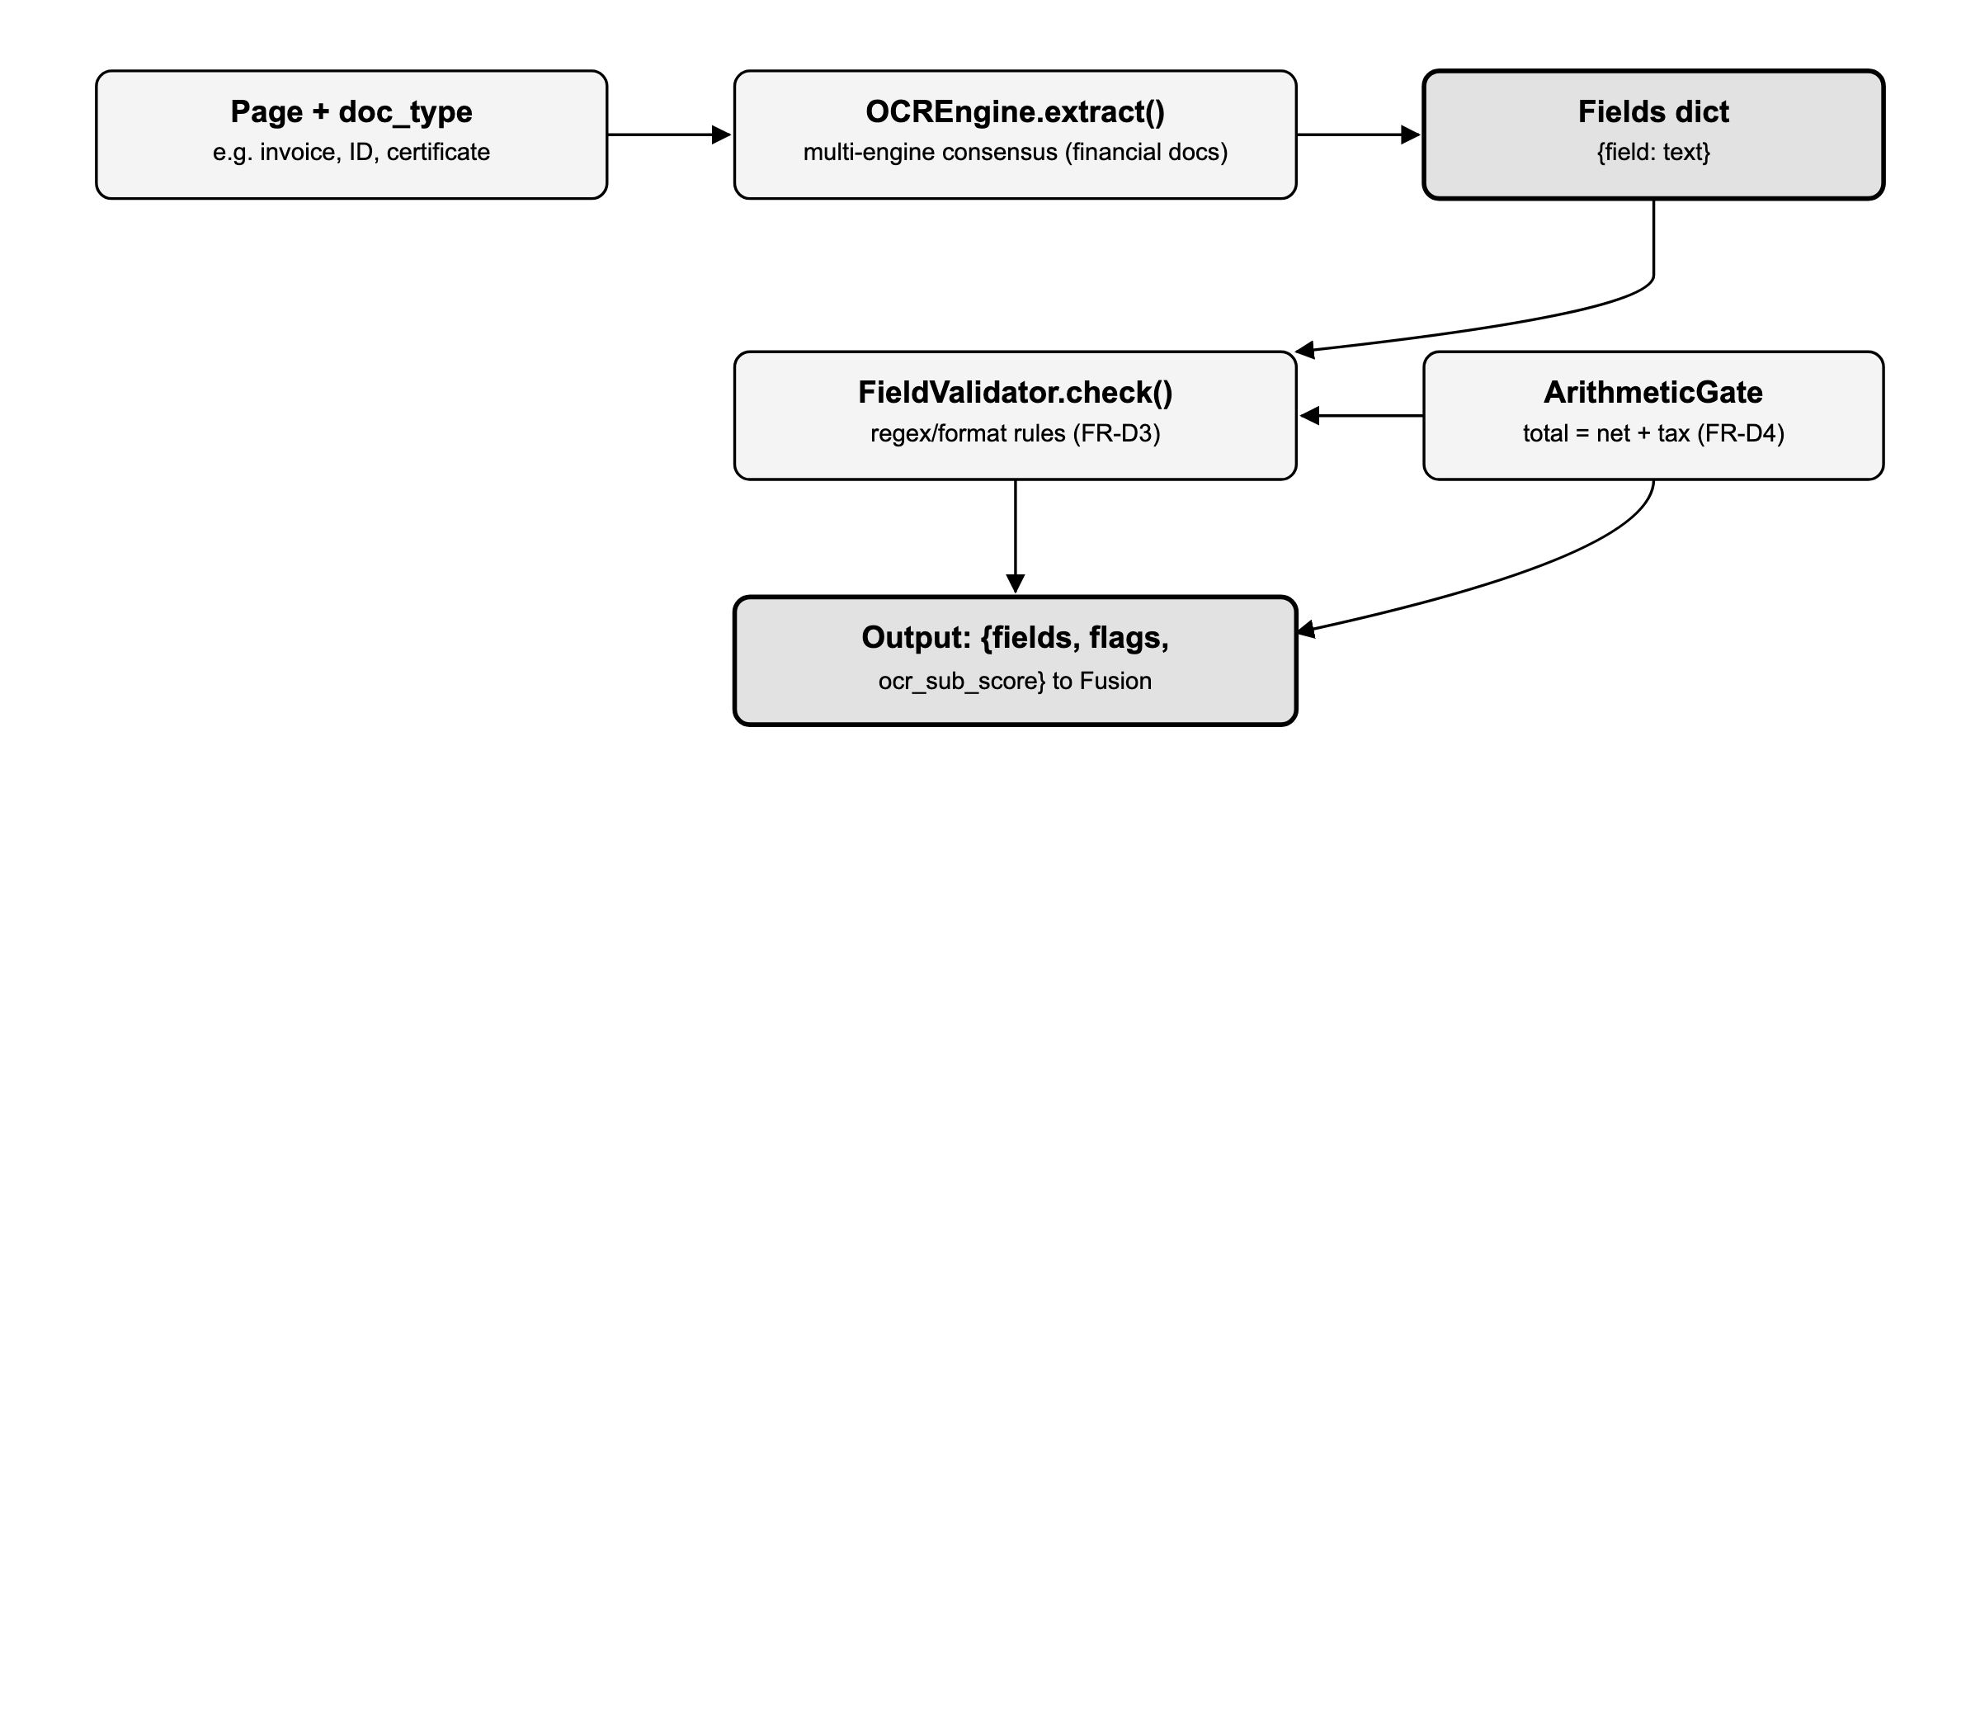

4.3 Algorithm detail
Extraction. For financial documents, run 3 independent OCR engines and take the field value a majority agree on (falling back to the highest-confidence single result if no majority), following FORENSIQ (paper [39]), which found this materially more reliable than any single engine. Non-financial documents use one engine.
Field validation. Each doc_type has a fixed set of regex/format rules (date formats, ID-number patterns, name character sets); a field fails if it does not match its rule, is empty where required, or (for a date) falls outside a sane range.
Arithmetic gate. abs(total - (net + tax)) <= tolerance (a small absolute/relative tolerance for rounding), applied only when doc_type is financial (invoice, receipt, bank statement).
OCR sub-score. 100 × (fraction of fields that passed) × (1 if arithmetic gate passes or is not applicable else 0.5) — an arithmetic failure is weighted as a strong signal without zeroing the whole sub-score outright, since a single mis-OCR'd digit can also fail the gate on an otherwise genuine document.

4.4 Data structures
Fields | dict[str, str], keyed by field name (e.g. "date", "total", "id_number")
Flags | dict[str, bool], one entry per field, True = passed its rule
Output | {"fields": dict, "flags": dict, "arithmetic_ok": bool|None, "ocr_sub_score": int}

4.5 Interface specification
Method | OCRService.check(page: Image, doc_type: str) -> dict (FR-D3, FR-D4)

4.6 Error handling
- Unreadable text region. A field the OCR engine cannot read at all is recorded as failed, not silently omitted, so the sub-score reflects the gap.
- doc_type with no registered rule set. Field validation is skipped and the OCR sub-score is derived from extraction confidence only; this is logged so new document types get rule coverage added, not silently scored as perfect.

5. Detailed Design — Fusion & Scoring Service

5.1 Component breakdown
Component | Responsibility
ScoreFuser | Combines the three sub-scores into one weighted authenticity score. FR-D5.
Labeller | Maps the fused score to Genuine/Suspicious/Forged against configurable thresholds.
ReasonBuilder | Builds the plain-language explanation from the lowest-scoring sub-check. FR-D6.
FusionService | External surface: score(signature, tamper, ocr) -> dict.

5.2 Data flow
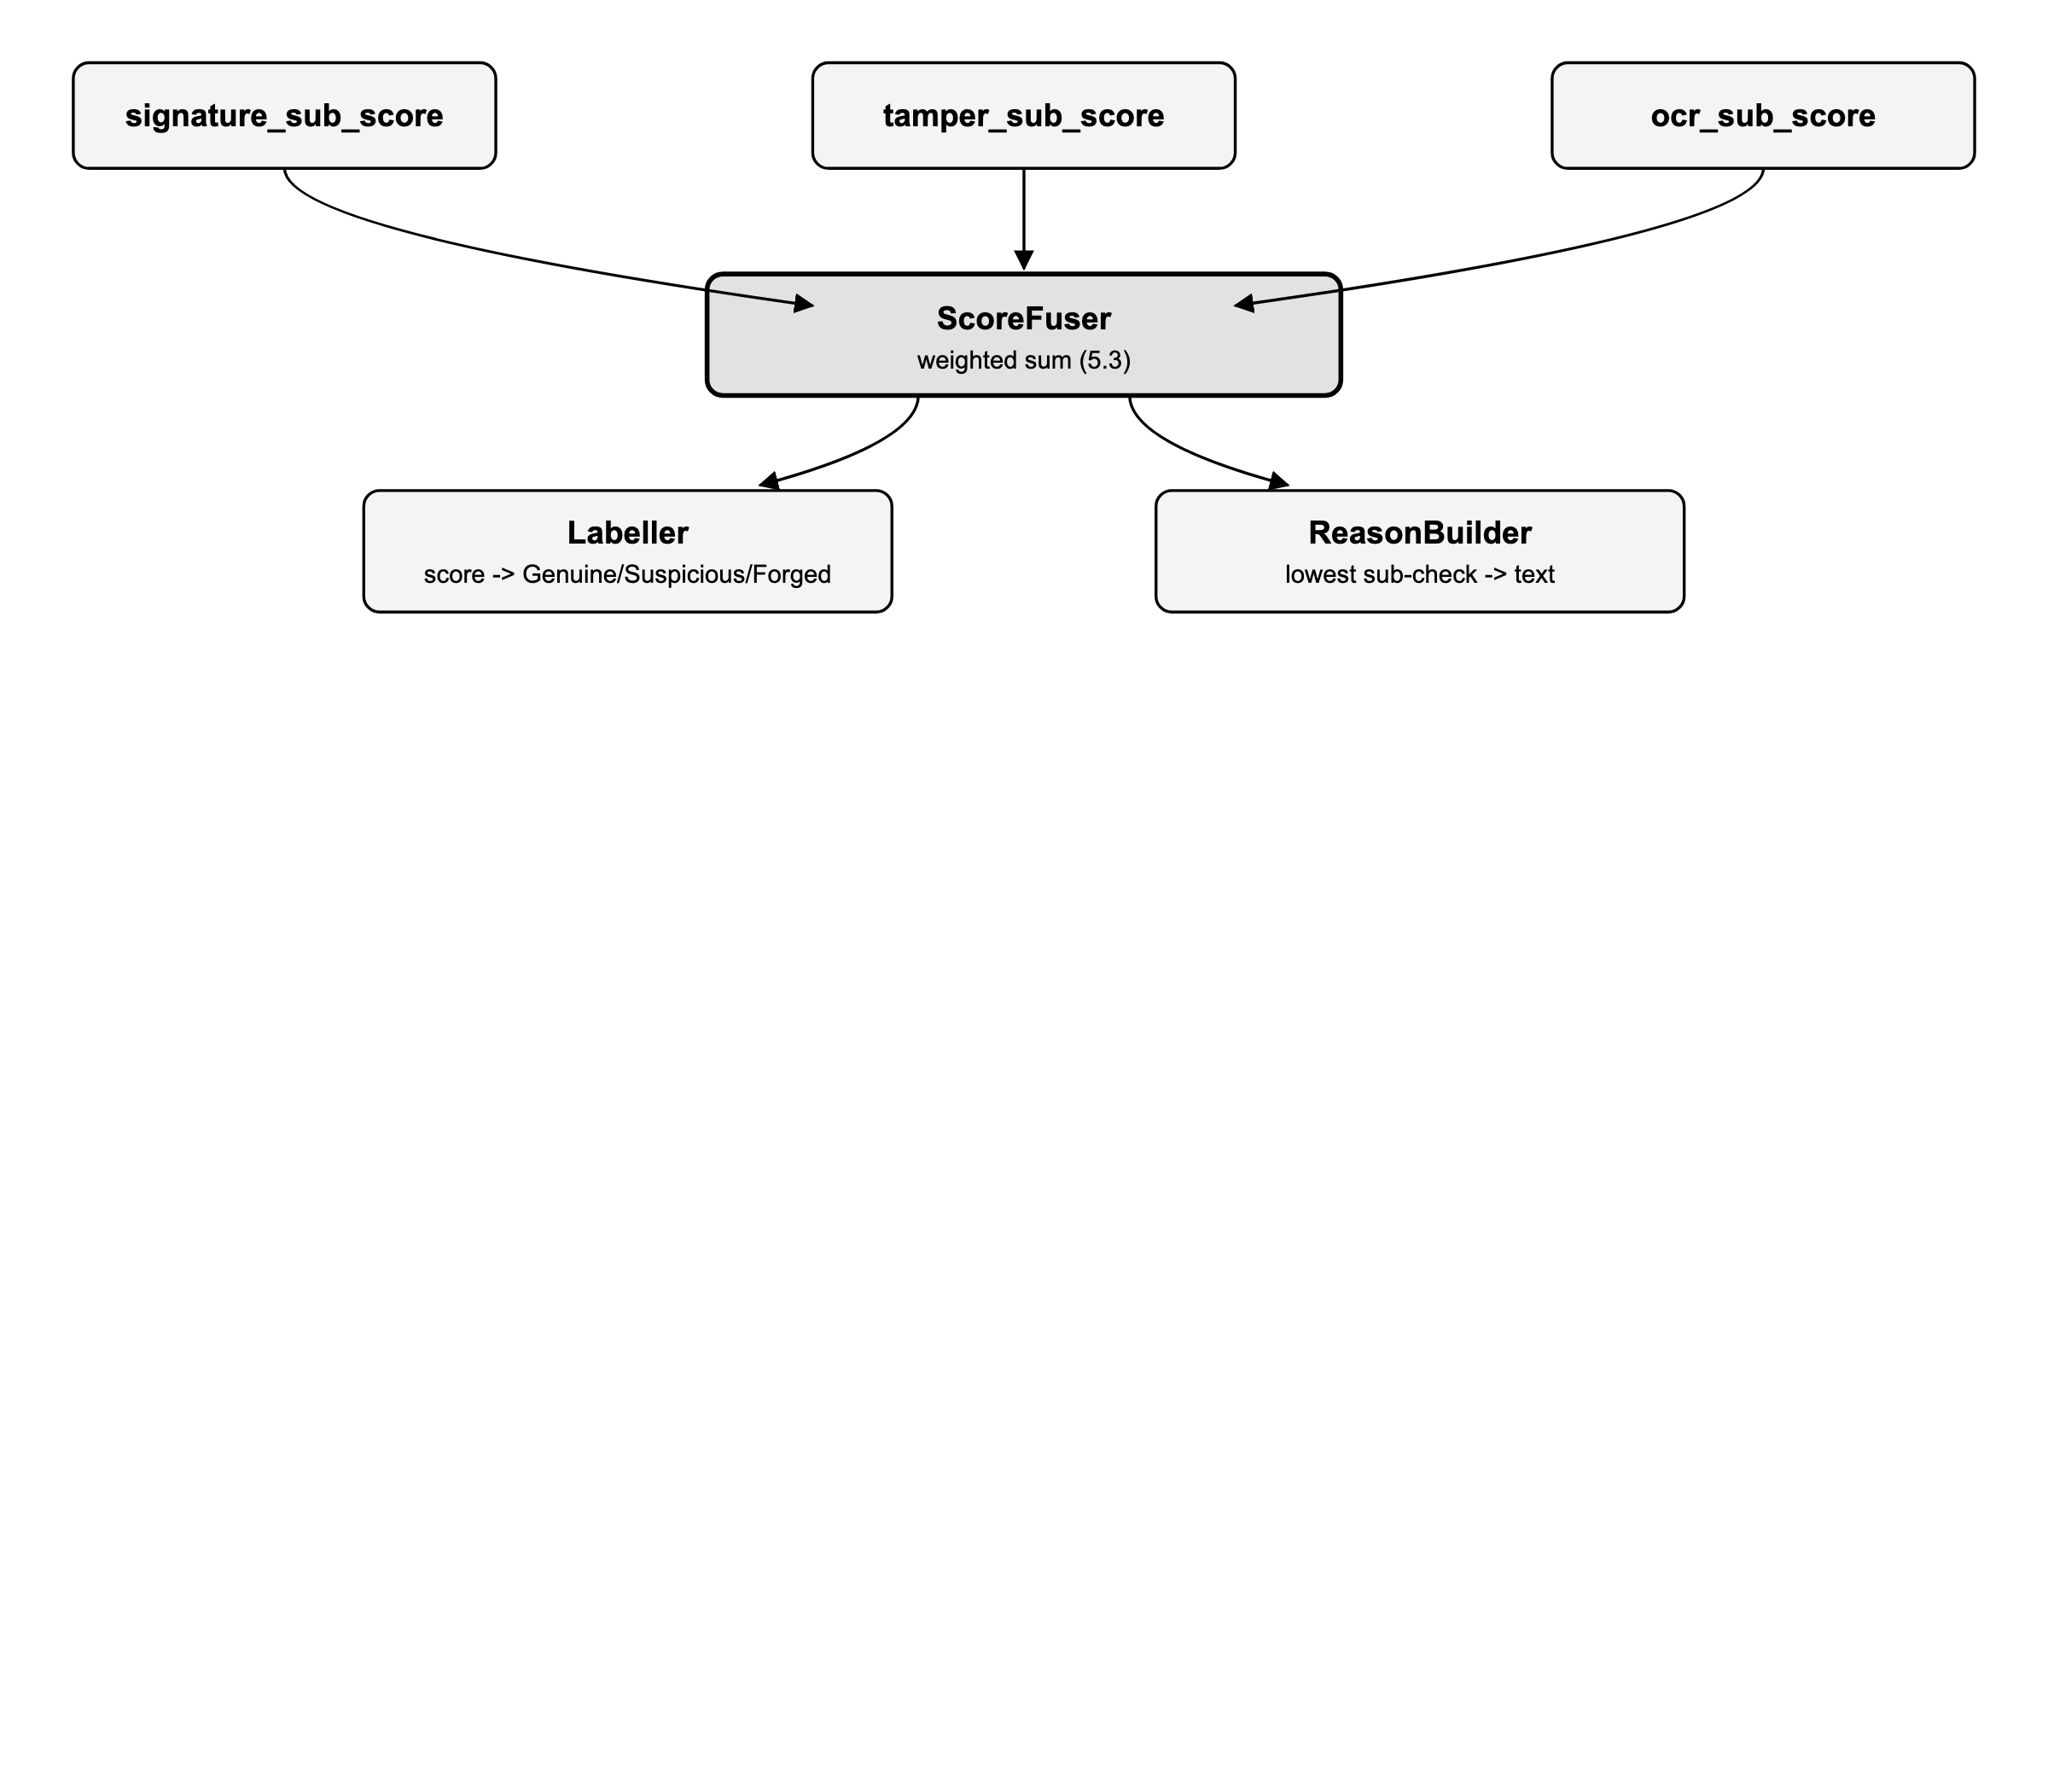

5.3 Algorithm detail
final_score = w_sig * signature_sub_score
+ w_tmp * tamper_sub_score
+ w_ocr * ocr_sub_score # w_sig + w_tmp + w_ocr = 1, default 1/3 each
label = "Genuine" if final_score >= 80
= "Suspicious" if 40 <= final_score < 80
= "Forged" if final_score < 40
reason = template(lowest-scoring sub-check, its threshold, its evidence)
# e.g. "signature similarity 0.41 (below 0.6 threshold)"
A weighted rule, not a learned end-to-end classifier (Gap 5/O5): each sub-score and the reason it produced stay inspectable, which a black-box classifier would not give (Gap 6/O6). Weights and thresholds are configuration, not code, so they can be recalibrated per deployment or document type without a redeploy.

5.4 Data structures
Weights | {w_sig: float, w_tmp: float, w_ocr: float}, sum to 1, stored as configuration
Thresholds | {genuine: 80, suspicious_floor: 40}, configuration
Output | {"score": int, "label": str, "reason": str, "sub_scores": {signature, tamper, ocr}, "heatmap_key": str} — this is the row persisted into verifications (Section 7)

5.5 Interface specification
Method | FusionService.score(signature: dict, tamper: dict, ocr: dict) -> dict (FR-D5, FR-D6)

5.6 Error handling
- A sub-score is missing (detector failed or timed out, Section 6.4). Its weight is redistributed proportionally across the remaining sub-scores, and the label is capped at Suspicious — a verification is never reported Genuine on partial evidence.
- All three sub-scores missing. The request itself is reported as failed rather than fused into a meaningless label.

6. Detailed Design — Verification Orchestrator

6.1 Responsibilities
The orchestrator is the single entry point (FR-P1) for every verification: it pre-processes the upload, fans the three detector calls out, fans their results back in, calls fusion, writes the audit log, and returns to the caller. It contains no detection logic of its own.

6.2 Dispatch algorithm
def verify(document):
pre = preprocess(document) # FR-D1, shared pre-pass
tasks = {
"signature": call_with_timeout(signature_service.verify, pre, timeout=6),
"tamper": call_with_timeout(tamper_service.predict, pre, timeout=6),
"ocr": call_with_timeout(ocr_service.check, pre, timeout=6),
}
results = await_all(tasks) # fan-in; NFR-1 budget: 10s total per page
for name, outcome in results.items():
if outcome is TIMEOUT or outcome is ERROR:
results[name] = None # treated as missing evidence, not a crash
fused = fusion_service.score(results["signature"], results["tamper"], results["ocr"])
audit_log.write(document.id, fused) # NFR-8, append-only
if fused.label == "Suspicious":
admin_queue.add(document.id) # FR-A2
return fused

6.3 Full system sequence
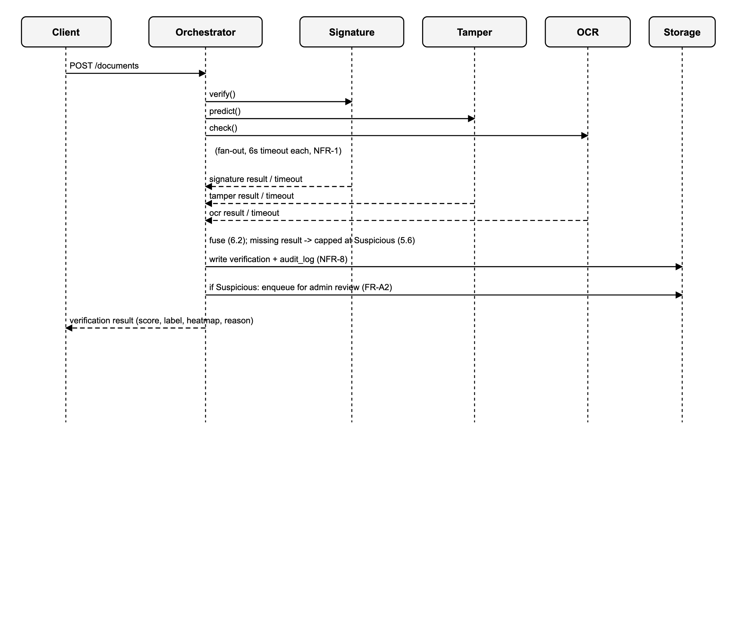

6.4 Concurrency and failure handling
- Each detector call runs under its own timeout (6s default, leaving headroom inside the 10s NFR-1 budget for pre-processing and fusion).
- A timeout or exception in one detector does not cancel the others; the orchestrator awaits whichever complete and records None for the rest.
- Fusion (5.6) is the single place that decides how to degrade a label when evidence is missing — the orchestrator itself makes no scoring decisions.
- Audit log writes (Section 7) are the last step before returning, so a result is never handed to the client without a corresponding record.

7. Detailed Data Design
Table | Columns (type, constraint)
users | id UUID PK · email text UNIQUE NOT NULL · password_hash text NOT NULL · role enum(verifier, admin) NOT NULL · created_at timestamptz NOT NULL
signatures | id UUID PK · user_id UUID FK→users · image_key text NOT NULL · embedding float[] NOT NULL · created_at timestamptz NOT NULL · CHECK: ≤5 rows per user_id (FR-U4)
documents | id UUID PK · uploaded_by UUID FK→users · doc_type text NOT NULL · file_key text NOT NULL · sha256_hash char(64) NOT NULL, INDEXED (FR-P2) · uploaded_at timestamptz NOT NULL
verifications | id UUID PK · document_id UUID FK→documents · signature_sub_score int NULL · tamper_sub_score int NULL · ocr_sub_score int NULL · final_score int NOT NULL · label enum(Genuine, Suspicious, Forged) NOT NULL · heatmap_key text NULL · reason_text text NOT NULL · created_at timestamptz NOT NULL, INDEXED
audit_log | id UUID PK · actor_id UUID FK→users NULL (system actions) · action text NOT NULL · verification_id UUID FK→verifications NULL · detail_json jsonb NOT NULL · created_at timestamptz NOT NULL · no UPDATE/DELETE grant for the application role (NFR-8)
feedback | id UUID PK · verification_id UUID FK→verifications · admin_id UUID FK→users · final_decision enum(Genuine, Forged) NOT NULL · created_at timestamptz NOT NULL · append-only, latest row per verification_id is authoritative (FR-A2)

8. Detailed API Design
Route | Request / Response
POST /auth/register | req {email, password} → 201 {id, email, role} / 409 if email taken
POST /auth/login | req {email, password} → 200 {token} / 401 on bad credentials
POST /signatures | req multipart {signer_id, image} → 201 {id} / 400 if signer already has 5 references (FR-U4)
POST /documents | req multipart {file, doc_type} → 202 {document_id} / 400 unsupported file type / 413 too large
GET /documents/{id}/verification | 200 {score, label, heatmap_url, sub_scores, reason} / 202 if still processing / 404
GET /documents/{id}/report.pdf | 200 PDF stream / 404
GET /verifications?user_id= | 200 [{id, document_id, score, label, created_at}], paginated
POST /admin/verifications/{id}/decision | req {final_decision} → 201 (FR-A2) / 403 if role != admin (NFR-9)
GET /admin/audit-log | 200 [{action, actor_id, verification_id, detail, created_at}], paginated / 403
GET /admin/analytics | 200 {counts_by_label, avg_score, avg_latency} / 403

9. System-Wide Error Handling
Invalid file / type | 400 at the gateway, before the orchestrator; never coerced into a wrong document type
Detector timeout/failure | Handled per Section 6.4: request completes, capped confidence, reason notes the gap — never a 500
Auth/role failure | 401/403 at the gateway (NFR-9); not logged as a verification attempt
Concurrent admin decisions | feedback append-only; latest row authoritative, all prior rows retained (NFR-8)
Storage write failure | Verification is not returned to the client as complete until its audit_log row is confirmed written

10. Traceability
Section | Traces to
2 (assigned module) | O1–O4, O6–O8; FR-D1, FR-D2, FR-D6; NFR-2, NFR-5, NFR-7, NFR-10; Gap 3, Gap 4
3 (signature) | O1, O2; FR-S1–S3; NFR-6; Gap 1, Gap 2
4 (OCR/field) | FR-D3, FR-D4; Gap 5
5 (fusion) | O5, O6; FR-D5, FR-D6; Gap 5, Gap 6
6 (orchestrator) | FR-P1; NFR-1
7 (data design) | FR-P2, FR-A2, FR-A3, FR-U4; NFR-8
8 (API design) | FR-P1, FR-U1–U4, FR-A1–A3
9 (error handling) | NFR-1, NFR-8, NFR-9

11. Conclusion
The assigned module is detailed to the level of running code: the component breakdown, data flow diagram, algorithm descriptions and reference implementation in Section 2 match tamper_localisation/ line for line, and Section 2.9 ties each self-check in test_module.py back to the requirement it verifies. The remaining services, the orchestrator, the data design and the API are detailed to the same structural depth — component, data flow, algorithm, data structures, interface, error handling — so implementing them means filling in the classes and functions named here against contracts that are already fixed.

