

School of Electronics Engineering

Predictive Shipment Delay Analytics
for Logistics Decision Support
DA3 Completion and Presentation Report

Course : BCSE402L – Big Data Analytics
Digital Assignment - III

Submitted By
Pranav Satish Khadse – 23BLC1237
Rishi Jain – 23BLC1242
Anmol Kapil – 23BLC1229
Abhinav Kumar Singh – 23BLC1209
Submission Date – 20th October 2026

1 Abstract and Problem Statement

1.1 Abstract
This project delivers an integrated system for analyzing shipment delays and estimating whether an order will arrive late using information available when the order is placed. The final application combines configurable local or HDFS ingestion, PySpark order-level cleaning, Spark SQL analytics, a React dashboard and a versioned Random Forest prediction service. Tree SHAP explains both overall model behavior and individual predictions; predefined rules turn relevant positive contributions into operator review actions. Optional Groq assistance produces requested summaries and translates natural-language questions into validated SQL.
The final pipeline processes 181,169 item rows into 62,897 eligible orders, of which 36,048 (57.31%) are delayed. On a chronological test population of 12,631 orders, the selected model achieves ROC-AUC 0.7482, accuracy 69.46%, precision 80.68% and recall 61.67%. The result supports risk prioritization but does not justify a claim of high-accuracy automated delivery guarantees.

1.2 Problem statement and objective
Logistics operators need to identify orders that may miss their promised delivery time before dispatch, while understanding the basis of a warning. Historical dashboards alone describe completed orders; an operational tool must also estimate risk for a new order, explain that estimate and show an appropriate review action. The system therefore separates historical delivery analytics from prediction using only order-time inputs.

1.3 Completion of the final scope
Deliverable | Final evidence
Data engineering and storage | Real CSV; whole-order validation; explicit local/HDFS modes
Analytics and visualization | Filters, trends, segments, regional views and delay-rate heatmap
Model evaluation | LR/RF comparison, chronological tuning and final test metrics
Explainability and action | Global/local SHAP, reconstruction checks and predefined rules
Integrated assistance | On-demand Groq summary; direct and natural-language Spark SQL
Verification and documentation | 35 backend tests, build and browser checks; final report and slides

2 System Architecture and Big Data Concepts
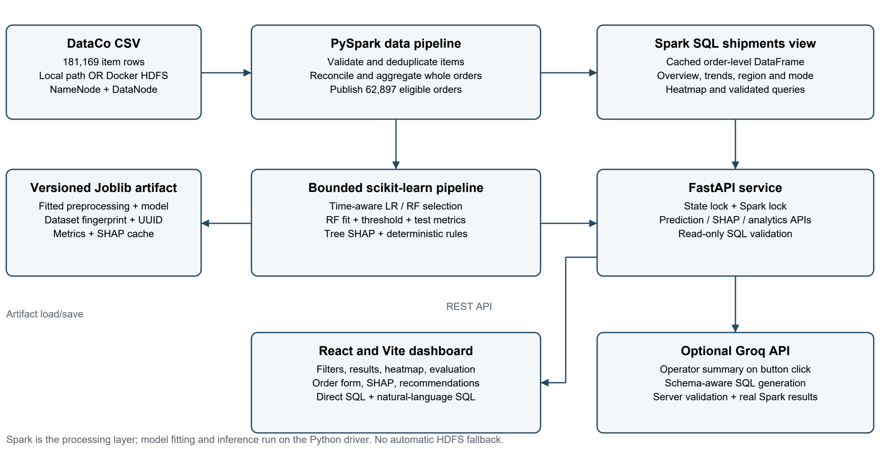
Figure 1.1 System Data Flow

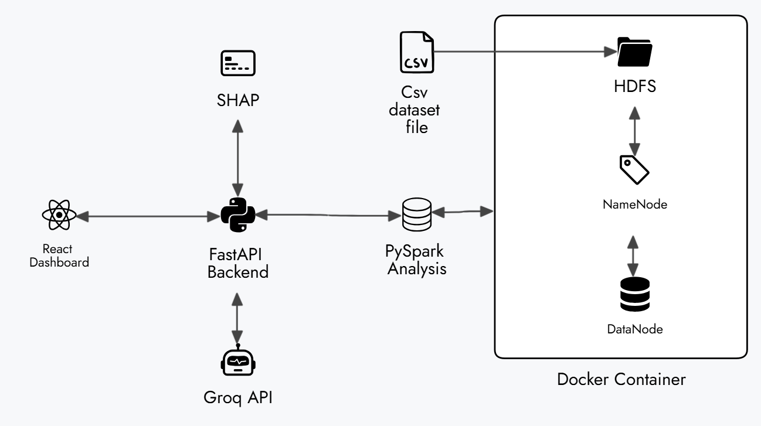
Figure 1.2 System Architecture

The raw CSV enters one explicitly selected storage mode. HDFS mode uses Docker NameNode and DataNode services; local mode uses a configurable filesystem path. Failure in HDFS mode is reported rather than silently replaced with a local read. PySpark validates and groups records, caches the eligible-order DataFrame and registers the shipments SQL view. Spark SQL computes aggregates for the API and dashboard, including the heatmap.
Model fitting is intentionally separate: a bounded, deterministic extraction transfers allowlisted features to the Python driver. A scikit-learn Pipeline owns preprocessing and classification. The artifact stores the fitted pipeline, selected threshold, validation evidence, dataset fingerprint, model UUID and SHAP results. FastAPI coordinates state and Spark access; React renders backend results. Groq is optional and cannot replace model predictions or Spark query results.
Layer | Implementation and application
Storage and ingestion | DataCo CSV; Docker HDFS or local path; configurable environment
Distributed processing | PySpark 3.5.7 DataFrames, lazy transformations, grouping and caching
Analytics | Spark SQL aggregates, temporary view, filtered region × mode heatmap
Model and explanations | scikit-learn LR/RF; one-hot encoding; SHAP 0.49.1; Joblib
Application | FastAPI, React/Vite, optional Groq API; Windows Python and Java 17

Big Data concepts applied include separating storage from compute, transformation lineage, distributed aggregation, schema validation, caching and bounded driver collection. This is a single-machine demonstration with a single DataNode.

3 Dataset Preparation and Label Definition
The DataCo supply-chain file spans January 2015 to January 2018. Its 181,169 rows represent order items, not 181,169 independent shipments. The dataset has no physical shipment identifier, so one eligible order is explicitly used as a shipment proxy. This avoids counting multi-item orders several times in delivery rates and evaluation.
Stage or population | Observed count
Raw item rows | 181,169
Exact duplicate rows removed | 650
Remaining item rows | 180,519
Distinct order identifiers | 65,752
Canceled or suspected-fraud orders excluded | 2,855
Eligible order proxies | 62,897
Delayed eligible orders | 36,048
On-time or early eligible orders | 26,849

3.1 Cleaning at the correct grain
Exact duplicates are removed first. Invalid or conflicting item records exclude their whole order; keeping only a convenient valid line would bias order totals. Order dates, durations, labels and non-missing dimensions must agree within an order. Consistent non-missing dimensions may repair a missing value; fully absent dimensions become Unknown. Quantity, gross sales and net sales are summed by order. Zero-sales orders remain valid. On this run, invalid-row, conflicting-item and target-mismatch counts are all zero.

3.2 Outcome and leakage controls
The binary target is delayed = 1 when actual shipping days exceed scheduled shipping days; otherwise delayed = 0, including early delivery. Canceled shipping, canceled orders and suspected fraud are excluded because they do not represent the same completed-transit outcome. Actual duration and outcome/status fields are used only for label checking and historical analytics. They never enter the predictive feature matrix.
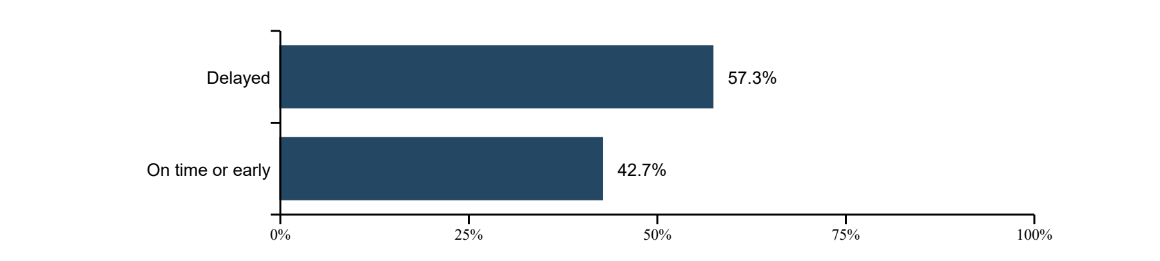
Figure 2 Eligible-order class proportions 57.31% delayed and 42.69% on time or early

4 Predictive Methodology and Model Selection
Feature group | Order-time inputs and preprocessing
Schedule | Scheduled days as a numeric feature; shipping mode excluded as redundant
Order basket | Total quantity, net sales and item count; numeric scaling for LR only
Calendar | Order weekday and month derived from order placement timestamp
Categorical context | Market, destination region, customer segment and payment type; one-hot encoding
Excluded predictors | IDs, actual days, shipping date, delivery status, order outcome/status and profit

4.1 Chronological validation
Orders are separated at the approximate 80th-percentile timestamp, keeping tied timestamps together. The earlier development population contains 50,266 orders; the later test contains 12,631. Within development, two expanding folds train on the earliest 45% and 65%, then validate on the following 20% each. The combined forward-validation population is 20,107 orders. The latest 15% of development is reserved for explanations and excluded from final fitting.
Partition | Order count | Time coverage
Final fitted model | 42,726 | 2015-01-01 to 2017-02-21
Reserved explanations | 7,540 | Later development period; not final test
Final chronological test | 12,631 | 2017-07-09 to 2018-01-31

4.2 Compact search and measured feature choices
Standard Logistic Regression and Random Forest estimators are used; no custom learning algorithm is claimed. Logistic Regression tests C = 1 and 0.1. Forest configurations compare 200 trees with depth/leaf settings 16/5 and 10/20, square-root feature sampling and seed 42. Each model family also tests cyclical weekday/month encoding and a small basket-ratio group. Mean forward-validation ROC-AUC selects the model because the objective is to rank delay risk.
Numeric Random Forest reaches mean validation AUC 0.73993 versus 0.70520 for numeric Logistic Regression. Cyclical encoding gives 0.73969 for the forest; basket ratios give 0.74048. Neither satisfies the required stable gain of 0.002, so the simpler numeric feature representation is retained. The additional feature groups were measured, then rejected rather than advertised as improvements.

4.3 Decision threshold and evaluation boundary
Thresholds 0.25 - 0.75 are assessed using validation probabilities only. An F1 gain must also respect accuracy and precision loss limits; no candidate meets the acceptance rule, so threshold 0.50 remains. The final test does not select features, parameters or thresholds. Earlier project versions have already exposed historical test results; genuinely fresh confirmation requires new orders, not another claim that the same historical population is unseen.

5 Model Results and Discussion
Validation model | Mean AUC | Accuracy | Precision | Recall | F1
Logistic Regression | 0.70520 | 69.25% | 83.09% | 58.34% | 68.55%
Random Forest selected | 0.73993 | 68.96% | 81.84% | 59.05% | 68.60%

Table 1 Both candidates use the same forward-validation orders and threshold 0.50. Mean AUC averages fold scores; other metrics pool validation predictions. Better ranking does not imply a large improvement in thresholded accuracy.
Final test metric | Value | Interpretation
ROC-AUC | 0.74816 | Ranking discrimination across decision thresholds
Accuracy | 69.46% | 8,774 correct classifications out of 12,631
Precision | 80.68% | 4,480 true delays among 5,553 flagged orders
Recall | 61.67% | 4,480 detected among 7,264 actual delays
F1 score | 69.91% | Balance of precision and recall
Majority baseline | 57.51% | Always predict the test majority class delayed

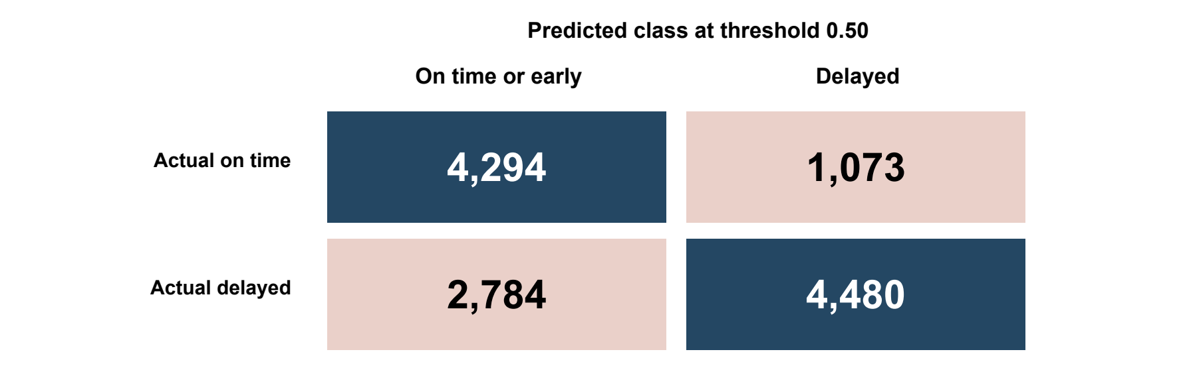
Figure 3 Final chronological test confusion matrix rows are actual classes and columns are predictions
The model exceeds majority-class accuracy by 11.95 percentage points, yet misses 2,784 delays and incorrectly flags 1,073 on-time orders. Its precision makes it useful for prioritising an operator review queue; moderate recall prevents treating an unflagged order as guaranteed on time. AUC and accuracy answer different questions, and the confusion matrix reports counts rather than an expected score above 80.
Limited order-time information, overlap between outcomes and changing business conditions constrain predictability. Strong scheduled-day importance is expected because lateness is defined relative to the promise. It is not by itself proof of overfitting or proof of causation. No large accuracy improvement or probability-calibration guarantee is claimed. More reliable improvement requires new operational signals and fresh forward evaluation.

6 Spark SQL Analytics and Heatmap
Across all 62,897 eligible orders, average actual shipping duration is 3.50 days, compared with 2.94 scheduled days. Mean nonnegative delay is 0.93 days including zero-delay orders. Rates and counts are computed by Spark SQL over the same cleaned shipments view.
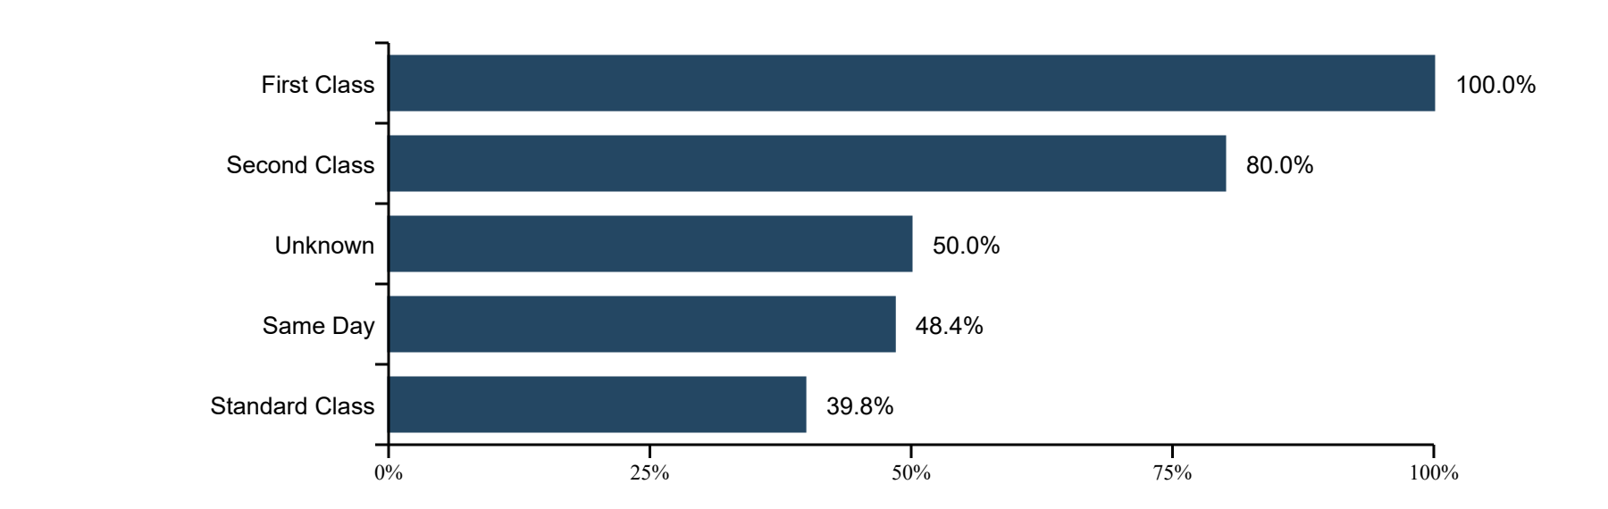
Figure 4 Observed eligible-order delay rate by shipping mode
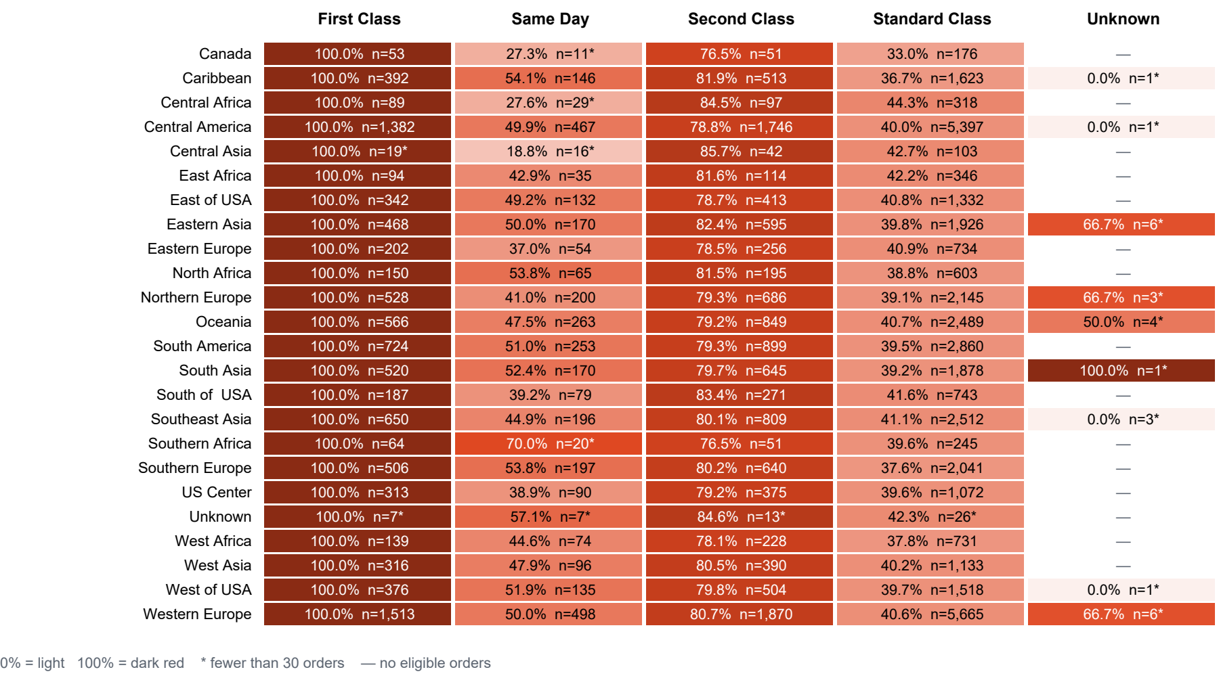
Figure 5.1 Region by shipping mode delay-rate heatmap with the eligible count in every observed cell
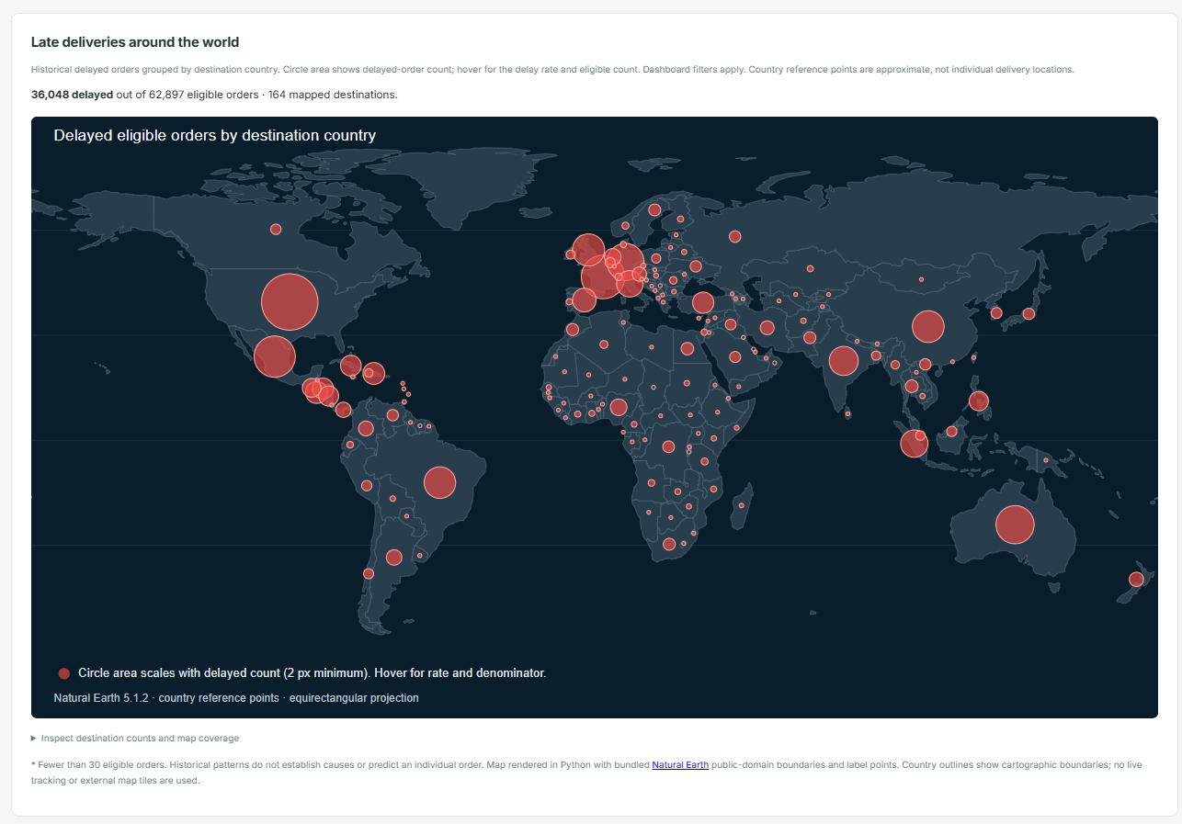
Figure 5.2 Geographic Representation for delayed order across the world

The website heatmap uses the same SQL aggregates as Figure 5.1 and respects region, shipping-mode and order-date filters. Darker cells mean higher historical delay rates; absent combinations show a dash, and cells with fewer than 30 orders are marked. Denominators help avoid interpreting a sparse region as strong evidence. Differences reflect historical service-promise and order context, not causal effects of choosing a shipping mode. Figure 5.2 is geographical representation of Late orders across the world.

7 Integrated Dashboard and Global Explainability
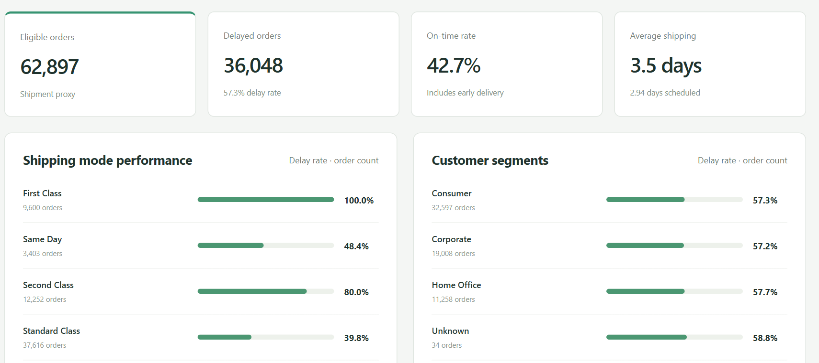
Figure 6 Actual dashboard overview showing the processed eligible population and performance views
The frontend provides Overview, Data Quality, Delay Analytics, Model Evaluation, Model Explainability and SQL Analytics sections. Filters change historical analytics; model evaluation remains dataset-wide. Loading, empty and error states are explicit. After ingestion or retraining, model identity changes reset stale predictions and refresh explanations.
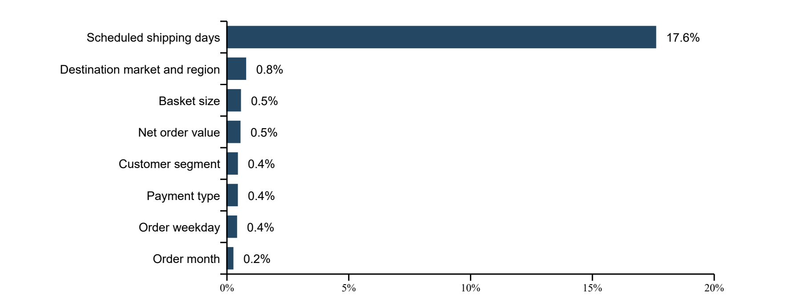
Figure 7 Global mean absolute grouped SHAP values in probability units on 96 reserved validation orders
Interventional Tree SHAP explains the selected fitted forest using 32 training-reference orders. Encoded-category contributions are summed into eight original input groups. The reference probability is 55.02%; the largest mean absolute contribution is scheduled shipping days at 0.17591, about 17.59 percentage points. Variation is measured across explained orders, not permutation repeats. Global explanations never use final-test orders.
For each local prediction, base value plus all signed SHAP contributions reconstructs the model probability; the maximum checked global additivity error is below 1 × 10⁻⁸. Positive contributions raise the model output relative to its reference, while negative ones lower it. SHAP describes model associations, can share credit among correlated features and does not establish that changing a feature will change delivery outcomes. A separate grouped permutation ROC-AUC diagnostic remains available.

8 Predictions Recommendations and Groq Assistance
The demonstrated order uses a one-day promise, quantity 2, two item lines, net sales 125.50, Europe and Western Europe, Consumer segment, DEBIT payment and order date 15 January 2018. It produces 89.69% modeled delay probability at threshold 0.50. This is a submitted demonstration input, not a newly observed outcome or an additional evaluation case.
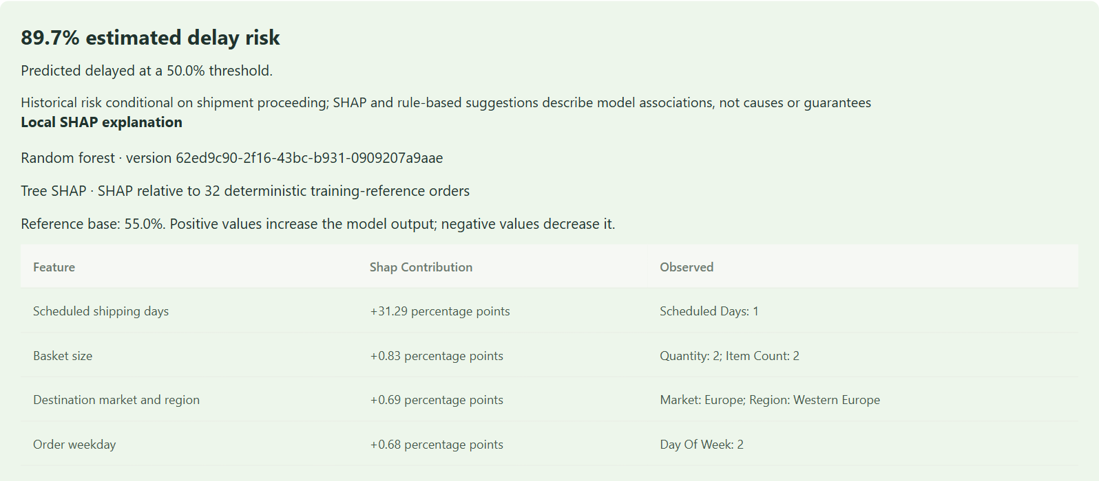
Figure 8 Live individual prediction and leading SHAP factors screenshot excerpt
Deterministic recommendations use the predicted class and positive actionable SHAP factors to suggest dispatch, route or capacity checks. They do not estimate causal benefits. A separate Generate summary button sends server-computed prediction, SHAP and rule facts to Groq only when requested.
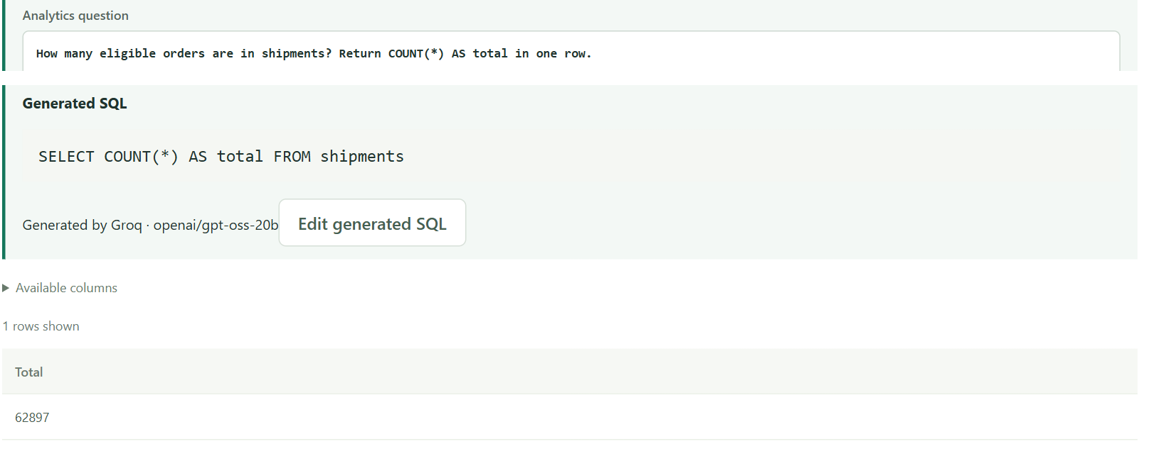
Figure 9 Natural-language question generated SQL and actual Spark count screenshot excerpts
Direct SQL remains available. Natural-language mode sends the current schema/categories and question to Groq, validates its candidate against a restricted read-only grammar, then executes Spark SQL. Results come from Spark. Scheduled days 0–7 are accepted; unseen durations 3, 5, 6 and 7 carry coverage notices.

9 Verification Learning and Conclusion
Check performed | Outcome
Backend pytest suite | 35 passed; preprocessing, chronological tuning, metrics, SHAP, artifacts, API, Groq and SQL guards
Frontend production build | Passed after heatmap integration
Live browser integration | Passed; filters, heatmap, model, prediction, SHAP, recommendations, Groq summary and SQL
Responsive heatmap | Horizontal table scroll is contained; mobile page has no horizontal overflow
Real processed population | 62,897 eligible orders; same denominators across SQL, charts and heatmap

9.1 Understanding and lessons learned
Correct analytical grain mattered more than simply adding models: duplicate order-item rows and canceled outcomes can distort both rates and evaluation. Chronological validation exposed the difference between a plausible feature and a reliably useful one. ROC-AUC measured ranking quality while the threshold determined the precision/recall trade-off. Separating Spark processing from bounded driver-side fitting made the architecture reproducible without claiming that scikit-learn training was distributed. Explanations required a fitted model, a defensible reference population and identity checks, rather than static charts.

9.2 Conclusion and future scope
The implemented final scope combines real data preparation, SQL analytics, a filterable heatmap, comparative model evaluation, order-time prediction, genuine SHAP and operator assistance in one application. The selected forest offers moderate ranking power and useful precision, with substantial missed delays that require operator judgement. Future work should prioritise new carrier, route, warehouse-capacity and weather signals available at prediction time, probability-calibration assessment, cost-based threshold selection and genuinely new chronological evaluation. Multi-node performance, authentication and production access controls require separate work.
Local Spark was verified for this revision. HDFS upload and matching local/HDFS counts were verified previously; the current heatmap revision did not rerun HDFS. The single-DataNode demonstration does not establish production fault tolerance. The optional Groq service depends on credentials and network availability; local prediction and direct SQL remain usable without it.

References and implementation evidence
[1] Final implementation and saved API outputs, feature/shipment-analytics-enhancements. Repository reference: github.com/Pranav-github-pixel/Shipment_Delay_Analytics.
[2] DataCoSupplyChainDataset.csv and DescriptionDataCoSupplyChain.csv supplied with the project.
[3] Apache Spark 3.5.7 documentation: spark.apache.org/docs/3.5.7/.
[4] SHAP TreeExplainer documentation: shap.readthedocs.io/en/latest/generated/shap.TreeExplainer.html.
[5] scikit-learn documentation: scikit-learn.org/stable/.
[6] Groq API documentation: console.groq.com/docs/openai.

