HEALTHCARE PLATFORM TECHNICAL SPECIFICATION
System Architecture, Setup Guide & Interactive Walkthrough
Master Engineering Manual for Cloud Deployment, Full-Stack Configuration, Google Calendar/Meet Integration, and Gemini AI Clinical Triage.

Project Name & Version | HealthCare Platform ('Thoughtful Health') — Release v2.4.0
Architecture Tier | React/Vite SPA + FastAPI REST Server + Supabase DB + Gemini AI
Target Environments | Local Development, Docker Containers, Render / Cloud Deployments
Document Classification | Master Technical Reference & Operations Manual (August 2026)

📌 Executive Summary & Technical Scope
This master technical document provides end-to-end instructions for spinning up the frontend and backend microservices, configuring cloud security variables, architecting database schemas, and understanding the user workflow through annotated visual walkthroughs.

1. Platform Architecture & Technology Stack
The platform is engineered with a decoupled, modern architecture separating the client-side single-page application (SPA), the asynchronous high-performance API server, cloud-native managed persistence, and external third-party medical and scheduling integrations.

1.1 High-Level Architecture Components
- • Frontend Layer (Vite/React): Client-side React application powered by Vite, providing responsive, highly accessible UI components with zero bundle bloat.
- • Application Backend (FastAPI): Asynchronous RESTful microservice built with Python 3.11+ and FastAPI, handling business logic, OAuth credential exchanges, slot validation, and AI prompt pipelines.
- • Database & Identity (Supabase): Managed PostgreSQL cluster providing Row-Level Security (RLS), GoTrue identity management, and real-time data sync.
- • AI Clinical Intelligence (Google Gemini): Powered by Google Generative AI (Gemini 1.5 Pro/Flash), converting unstructured patient complaints into structured medical triage reports and diagnostic prep questions.
- • Telehealth & Scheduling (Google Calendar API): Automated two-way appointment synchronization and instant Google Meet video conference provisioning via Google Cloud OAuth 2.0 API.
- • Notification Engine (SMTP Relay): Transactional email pipeline via secure TLS/STARTTLS dispatching automated booking confirmations and intake summaries to doctors and patients.

1.2 System Architecture Interaction Model
The diagram below outlines how client requests flow across the API boundary, database, Google services, and Gemini LLM:
+-----------------------------------------------------------------------------------------+
| CLIENT APPLICATION LAYER (React / Vite) |
| - Patient Sanctuary Hub - Multi-Step Booking Wizard - Video Call Launchpad |
+--------------------------------------------+--------------------------------------------+
| HTTPS / JSON REST
v
+-----------------------------------------------------------------------------------------+
| BACKEND API SERVICE (FastAPI / Python) |
| - OAuth 2.0 Flow Manager - Slot Availability Engine - AI Prompt Orchestrator |
| - JWT / Supabase Auth Guard - Appointment Lifecycle Mgmt - SMTP Notification Engine |
+--------------+-----------------------------+------------------------------+-------------+
| | |
v v v
+---------------------------+ +---------------------------+ +---------------------------+
| SUPABASE (PostgreSQL) | | GOOGLE CLOUD API | | GOOGLE GEMINI AI |
| - Profiles & RBAC | | - Calendar Event Sync | | - Pre-visit Triage |
| - Appointments & Slots | | - Auto Google Meet Link | | - Urgency Classification |
| - Prescriptions & Leaves | | - Guest Invite Dispatch | | - Diagnostic Prep Qs |
+---------------------------+ +---------------------------+ +---------------------------+

2. Development Setup & Installation Guide
Follow the standardized instructions below to provision the local development environment for both the frontend single-page application and the FastAPI backend service.

2.1 Prerequisites & Toolchain Verification
Before starting, ensure your local workstation meets the following minimum version requirements:
- • Node.js Toolchain: Node.js v18.0.0 or higher with npm v9.0.0+
- • Python Environment: Python 3.10, 3.11, or 3.12 with pip and virtualenv support
- • Supabase Account: Active Supabase project (URL, Anon Key, and Service Role Secret)
- • Google Cloud Console: Project with Calendar API enabled and OAuth Client ID created
- • Gemini AI API: API Key from Google AI Studio

2.2 Frontend Configuration (React / Vite)
The client application is contained within the `/frontend` directory. Run the following commands in your terminal:
# 1. Navigate to the frontend directory
cd frontend
# 2. Install all node dependencies
npm install
# 3. Configure environment variables
cp .env.example .env
# 4. Launch local development server with Hot Module Reloading (HMR)
npm run dev
# Server will start at: http://localhost:5173

2.3 Backend Configuration (FastAPI / Python)
The backend service is located in the `/backend` directory. Follow standard Python virtual environment practices:
# 1. Navigate to the backend directory
cd backend
# 2. Create an isolated virtual environment
python -m venv .venv
# 3. Activate the virtual environment
# On Linux/macOS:
source .venv/bin/activate
# On Windows (PowerShell):
.venv\Scripts\Activate.ps1
# 4. Install required dependencies
pip install -r requirements.txt
# 5. Configure environment variables
cp .env.example .env
# 6. Run the Uvicorn ASGI server with hot reloading
uvicorn app.main:app --reload --port 8000
# API Swagger documentation available at: http://localhost:8000/docs

3. Environment Variables Reference (.env.example)
Properly configuring environment variables is critical for service orchestration, authentication, and secure communication between third-party APIs.

3.1 Backend Environment Configuration (`backend/.env`)
Below is the complete specification of all backend environment variables:
# ==========================================
# SUPABASE DATABASE & AUTHENTICATION
# ==========================================
SUPABASE_URL="https://your-project-id.supabase.co"
SUPABASE_PUBLISHABLE_KEY="your-anon-key"
SUPABASE_SECRET_KEY="your-service-role-key"
# ==========================================
# GOOGLE GEMINI AI CONFIGURATION
# ==========================================
GEMINI_API_KEY="your-gemini-api-key"
# ==========================================
# EMAIL NOTIFICATIONS (SMTP RELAY)
# ==========================================
SMTP_SERVER="smtp.gmail.com"
SMTP_PORT=587
SMTP_USER="your-email@gmail.com"
SMTP_PASSWORD="your-app-password"
# ==========================================
# GOOGLE CALENDAR & OAUTH 2.0 AUTHENTICATION
# ==========================================
GOOGLE_CLIENT_ID="your-google-oauth-client-id.apps.googleusercontent.com"
GOOGLE_CLIENT_SECRET="your-google-oauth-client-secret"

Variable Name | Scope / Type | Purpose & Operational Guidance
SUPABASE_URL | Backend / String | HTTPS endpoint for the Supabase PostgreSQL REST & Auth API.
SUPABASE_SECRET_KEY | Backend / Secret | Service role JWT key with admin privileges to bypass RLS for server operations.
GEMINI_API_KEY | Backend / Secret | API authentication key for Google Generative AI LLM triage pipelines.
SMTP_USER / PASSWORD | Backend / Credential | Sender mailbox address and 16-character Google App Password for mail alerts.
GOOGLE_CLIENT_ID | Backend / OAuth | OAuth 2.0 Web Application client identifier registered in Google Cloud.
GOOGLE_CLIENT_SECRET | Backend / Secret | Private cryptographic secret used to exchange auth code for OAuth refresh token.

3.2 Frontend Environment Configuration (`frontend/.env`)
The React Vite client requires only public/browser-safe variables prefixed with `VITE_`:
VITE_SUPABASE_URL="https://your-project-id.supabase.co"
VITE_SUPABASE_ANON_KEY="your-anon-key"
VITE_API_BASE_URL="http://localhost:8000/api/v1" # Or production deployment URL

📌 Security Best Practice: Key Segregation
Frontend bundles are publicly readable in the browser. Only the public anon key (VITE_SUPABASE_ANON_KEY) and public endpoints should reside in client-side code.

4. Google Calendar & Google Meet Integration Workflow
To enable bidirectional calendar scheduling and automatic generation of Google Meet consultation rooms, the backend communicates with Google APIs using OAuth 2.0.

4.1 Google Cloud Console Step-by-Step Setup
- Step 1: Create Project — Navigate to the Google Cloud Console (https://console.cloud.google.com/) and create a dedicated project (e.g., 'HealthCare-Platform-App').
- Step 2: Enable Calendar API — Go to APIs & Services > Library. Search for 'Google Calendar API' and click Enable.
- Step 3: Configure Consent Screen — Under APIs & Services > OAuth consent screen, select 'External' (or 'Internal' for workspace orgs). Add application name, support email, and add the scope `https://www.googleapis.com/auth/calendar`.
- Step 4: Create OAuth Client — Go to APIs & Services > Credentials. Click '+ Create Credentials' and select 'OAuth client ID'.
- Step 5: Select Web App — Choose 'Web application' as the Application Type.
- Step 6: Add Redirect URI — Under Authorized redirect URIs, add your backend callback endpoint (e.g. `http://localhost:8000/api/v1/auth/google/callback` or production equivalent).
- Step 7: Store Credentials — Copy the generated Client ID and Client Secret, pasting them into `backend/.env`.
- Step 8: Token Lifecycle — When a doctor or patient links their calendar, the backend exchanges the one-time auth code for an encrypted refresh token, enabling headless calendar updates.

5. Core Relational Database Schema (Supabase PostgreSQL)
The database architecture is built on PostgreSQL inside Supabase, utilizing strict relational integrity and role-based data isolation.
Table Name | Primary Columns & Types | Description & Relationships
profiles | id (UUID PK -> auth.users)  role (PATIENT/DOCTOR/ADMIN)  full_name (TEXT)  avatar_url (TEXT) | Extends Supabase Auth users with healthcare identity, profile photo, and role permissions.
appointments | id (UUID PK)  doctor_id (UUID FK)  patient_id (UUID FK)  start_time, end_time (TIMESTAMPTZ)  status (SCHEDULED/CANCELLED/COMPLETED)  meet_link (TEXT) | Core consultation booking registry storing temporal boundaries, telehealth links, and visit statuses.
medications | id (UUID PK)  appointment_id (UUID FK)  patient_id (UUID FK)  name, dosage, freq (TEXT)  is_active (BOOLEAN) | Active and historical prescriptions issued to patients during or after clinical consultations.
notifications | id (UUID PK)  user_id (UUID FK)  title, body (TEXT)  is_read (BOOLEAN)  created_at (TIMESTAMPTZ) | Real-time in-app notification feed alerting users of booking confirmations, reminders, and updates.
doctor_availability | id (UUID PK)  doctor_id (UUID FK)  day_of_week (INT 0-6)  start_time, end_time (TIME)  slot_duration_mins (INT) | Base weekly recurring operating hours used by the slot-generation engine to compute free slots.
leaves | id (UUID PK)  doctor_id (UUID FK)  start_datetime (TIMESTAMPTZ)  end_datetime (TIMESTAMPTZ)  reason (TEXT) | Doctor leave and out-of-office blocks that dynamically subtract slots from availability calculation.

6. Core REST API Endpoint Documentation
The FastAPI application exposes structured RESTful endpoints versioned under `/api/v1/`. All private routes require a Bearer JWT passed in the Authorization header.
HTTP Method | Path & Auth | Description & Payload
GET | /api/v1/appointments/me  [Auth: Patient/Doctor] | Fetches the full consultation list for the authenticated user, including Google Meet link and clinical summary.
POST | /api/v1/appointments/book  [Auth: Patient] | Books a designated slot. Dispatches Google Calendar event, sends confirmation email, and triggers Gemini pre-visit analysis.
POST | /api/v1/appointments/{id}/cancel  [Auth: Patient/Doctor] | Cancels an existing booking, frees the slot in database, deletes/updates Google Calendar invite, and sends notification.
GET | /api/v1/doctors/{id}/slots  [Auth: Public/Patient] | Calculates real-time available 30-min consultation windows based on doctor availability, active bookings, and approved leaves.
POST | /api/v1/llm/chat  [Auth: Authenticated] | Interactive AI chat endpoint for patient health inquiries and medical terminology assistance with safety guardrails.
GET | /api/v1/auth/google/login  [Auth: Public] | Initiates Google OAuth 2.0 flow for calendar synchronization, redirecting user to Google consent screen.

7. Google Gemini AI Clinical Triage & Prompt Configuration
The clinical intelligence layer uses Google Gemini to translate raw patient symptom descriptions into structured clinical summaries for doctors before the consultation begins.

7.1 Base Clinical System Prompt
The following prompt is injected into all clinical triage contexts to ensure strict medical ethics, empathy, and non-prescriptive safety:
SYSTEM_PROMPT = """
You are an intelligent, empathetic medical assistant AI for the HealthCare platform.
Your role is to help patients triage symptoms, prepare questions for their doctor,
and understand general medical terminology.
CRITICAL SAFETY RULES:
1. You must never provide definitive medical diagnoses.
2. You must never prescribe medication or suggest dosages.
3. Always advise the patient to consult their doctor for clinical decisions.
4. Classify urgency into: Low, Medium, High, or Urgent (Emergency).
5. Generate 3 targeted diagnostic questions the physician can use during intake.
"""

8. Visual End-to-End System Walkthrough
This section provides a thorough visual walkthrough of the platform's user experience and underlying technical execution, illustrated with actual production screenshots.

8.1 Secure Authentication & Member Portal
Patients and clinicians access the platform via the Secure Member Portal. The authentication layer is integrated directly with Supabase Auth and supports both standard email/password authentication and Google OAuth Single Sign-On (SSO).
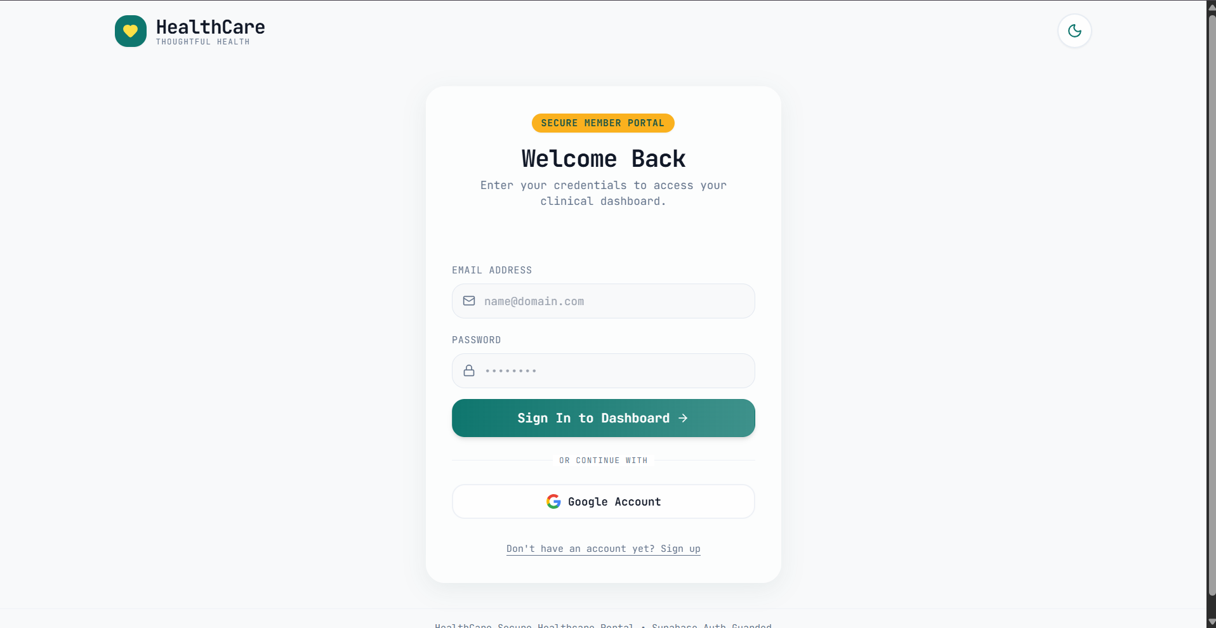
Figure 1: Secure Member Portal — Entry point for patient and doctor authentication with Supabase Auth guard and Google Account SSO integration.
- • Frontend Mechanics: Client form captures credentials with instant validation.
- • Backend Mechanics: Passes tokens to Supabase GoTrue Auth endpoint. On success, an encrypted session JWT is stored and user profile role is resolved.

8.2 Patient Hub & Dashboard Overview
Upon successful authentication, patients land on their personalized sanctuary dashboard (`Patient Hub`). The header displays dynamic greetings, real-time Google Calendar synchronization status, and active consultation cards.
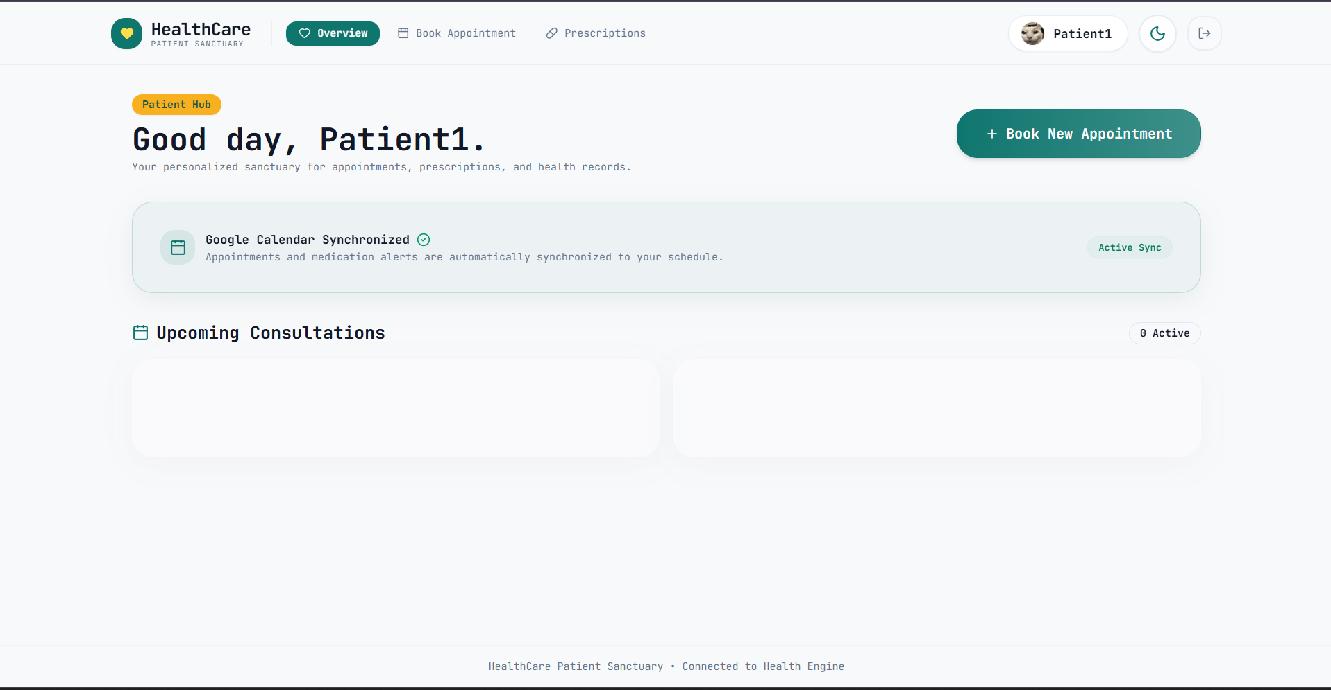
Figure 2: Patient Hub Dashboard (Initial State) — Featuring active Google Calendar synchronization status, appointment booking trigger, and empty consultation state.
- • UI Overview: Displays persistent navigation (Overview, Book Appointment, Prescriptions), current synchronization badge ('Active Sync'), and direct '+ Book New Appointment' call-to-action button.

8.3 Profile Management & User Settings
Users can customize their clinical identity via the Account Settings modal, supporting avatar photo uploads up to 5MB and real-time name synchronization across medical records.
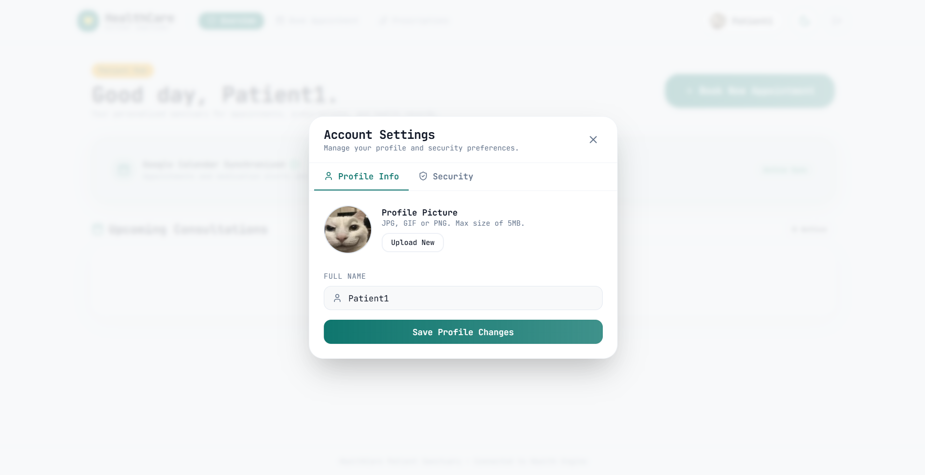
Figure 3: Account Settings Modal — User profile picture management (JPG/PNG/GIF up to 5MB) and profile name update with Supabase Storage integration.
- • Technical Implementation: Uploaded images are streamed directly to a private Supabase Storage bucket (`avatars`), updating the `profiles.avatar_url` database column.

8.4 Multi-Step Booking Wizard — Step 1: Medical Specialty Selection
The appointment booking wizard is structured as a 4-step progressive workflow: Specialty -> Doctor -> Slot -> Symptoms. In Step 1, the patient selects the medical discipline matching their condition.
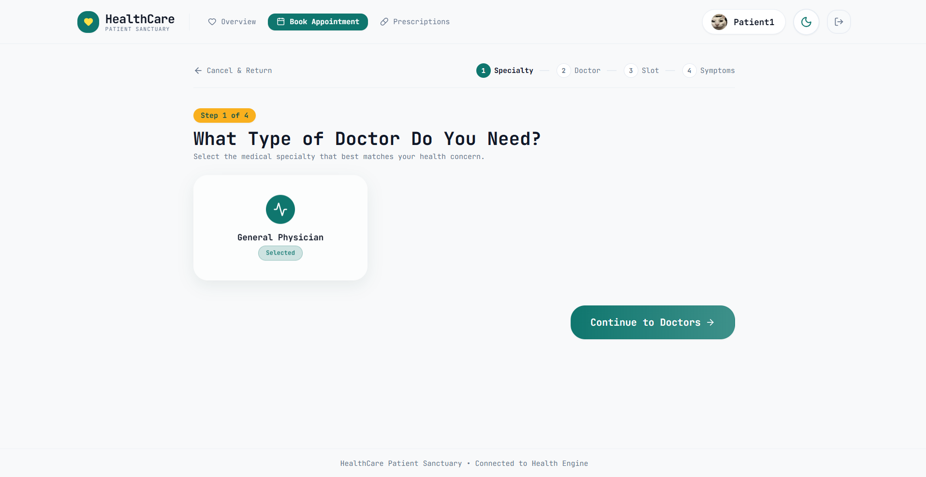
Figure 4: Step 1 of 4: Medical Specialty Selection — Selecting 'General Physician' to filter available certified medical professionals.
- • Clinical Logic: Filters verified clinicians by specialty tags before fetching calendar schedules.

8.5 Multi-Step Booking Wizard — Step 3: Date & Consultation Slot Selection
Step 3 queries the backend `/api/v1/doctors/{id}/slots` endpoint to generate dynamic 30-minute consultation windows based on the doctor's weekly recurring availability, minus existing bookings and approved leaves.
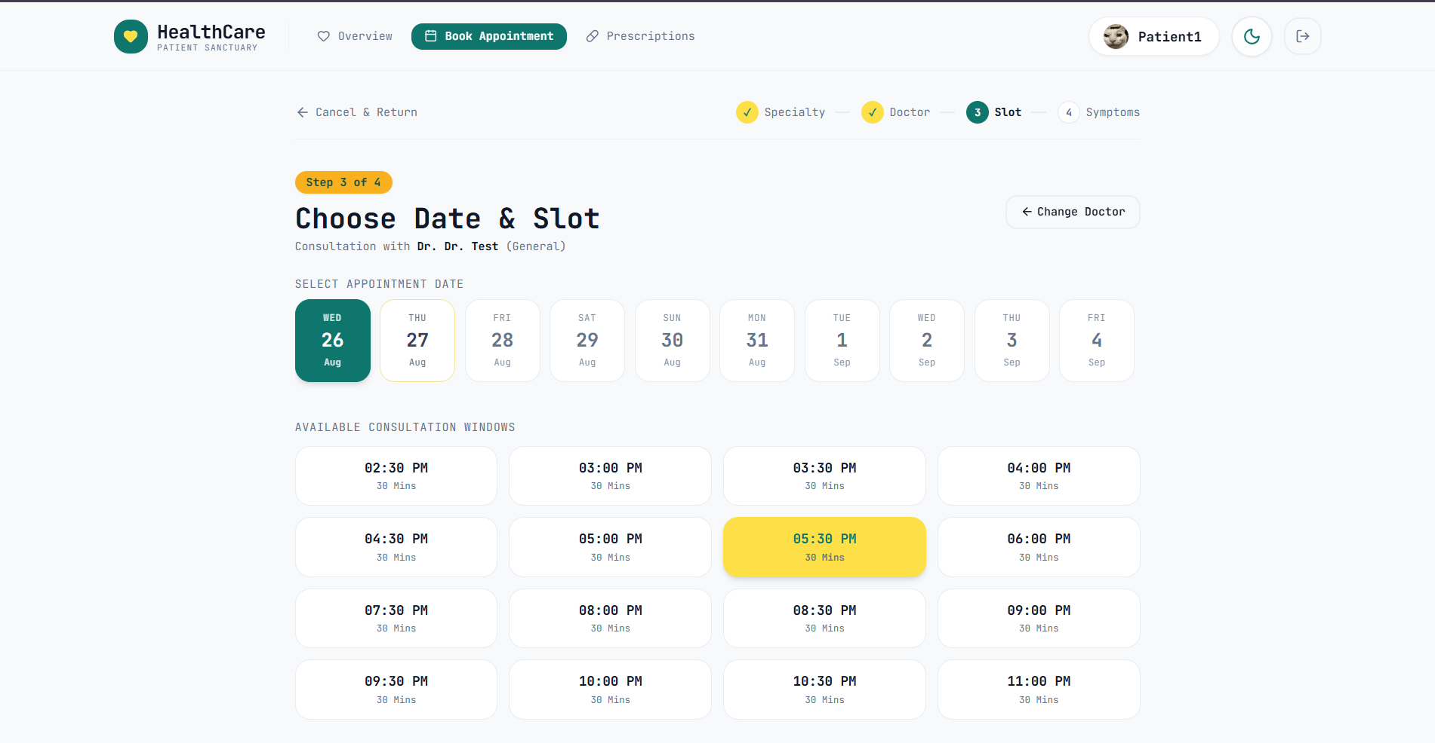
Figure 5: Step 3 of 4: Date & Slot Allocation — Dynamic calendar date selector (Wed, Aug 26) with real-time 30-minute time slot tiles (05:30 PM selected).
- • Concurrency Control: 30-minute interval blocks are computed in real time. Active bookings lock the slot instantly with transactional concurrency control to prevent double booking.

8.6 Multi-Step Booking Wizard — Step 4: Symptom Intake & AI Context Preparation
In the final booking step, patients provide their chief health concern. The system provides one-click quick suggestion chips (e.g., 'Severe headache', 'Joint pain', 'Routine Health Checkup') or full descriptive text.
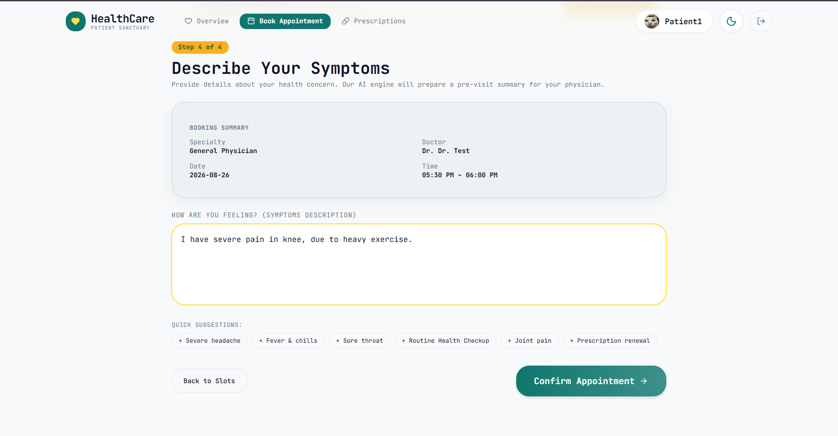
Figure 6: Step 4 of 4: Symptom Intake — Structured booking summary confirmation and detailed symptom intake ('I have severe pain in knee, due to heavy exercise.').
- • Data Transmission: The symptom description is packaged into the booking payload and dispatched to the Gemini AI pipeline for pre-visit clinical triage.

8.7 Gemini AI Pre-Visit Clinical Analysis & Instant Booking Confirmation
Immediately after booking submission, the Gemini AI engine executes an asynchronous pre-visit analysis, extracting the chief complaint, classifying triage urgency, and formulating diagnostic questions for the doctor.
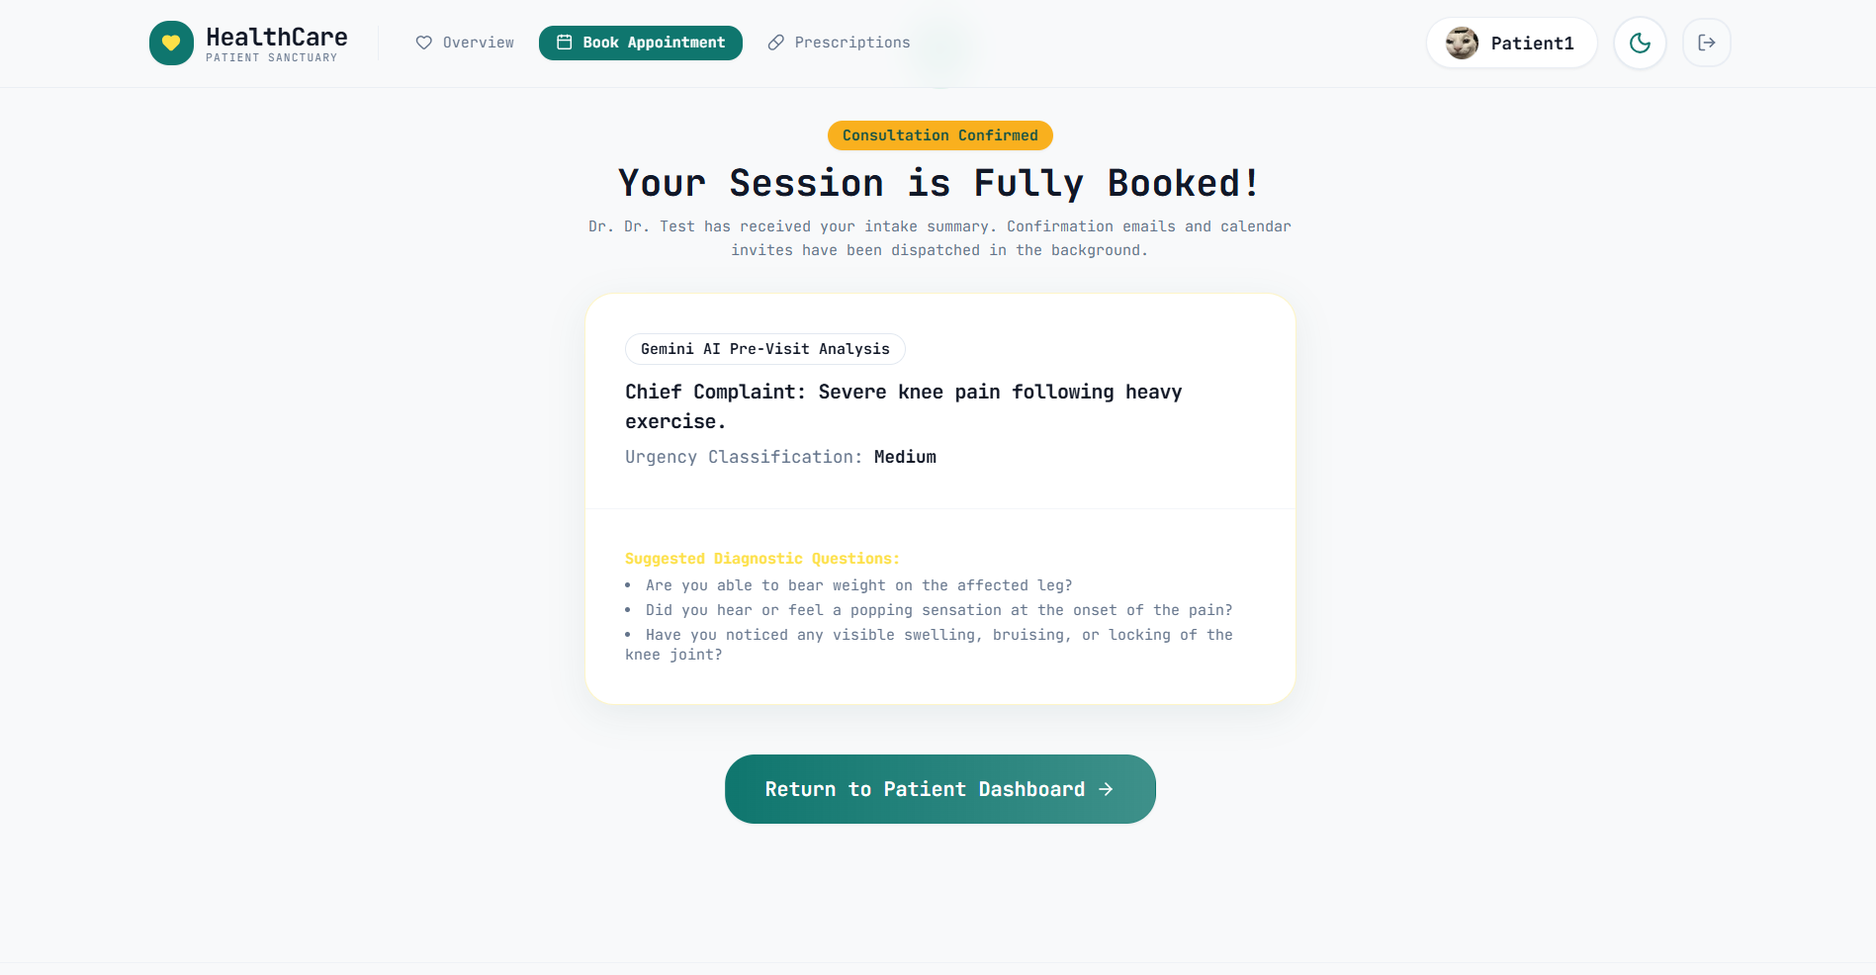
Figure 7: Booking Confirmation & Gemini AI Pre-Visit Analysis — Automated chief complaint extraction, medium urgency classification, and 3 targeted diagnostic questions.
- • Extracted Chief Complaint: 'Severe knee pain following heavy exercise.'
- • Urgency Classification: 'Medium' (Non-emergency acute pain requiring musculoskeletal evaluation).
- • Generated Clinical Questions: Formulates targeted diagnostic prep questions:
1. Are you able to bear weight on the affected leg?
2. Did you hear or feel a popping sensation at the onset of the pain?
3. Have you noticed any visible swelling, bruising, or locking of the knee joint?

8.8 Active Consultations & Telehealth Launchpad
The patient dashboard reflects all confirmed sessions. Telehealth appointments feature an integrated 'Open Google Meet Call' launch button with real-time status badges.
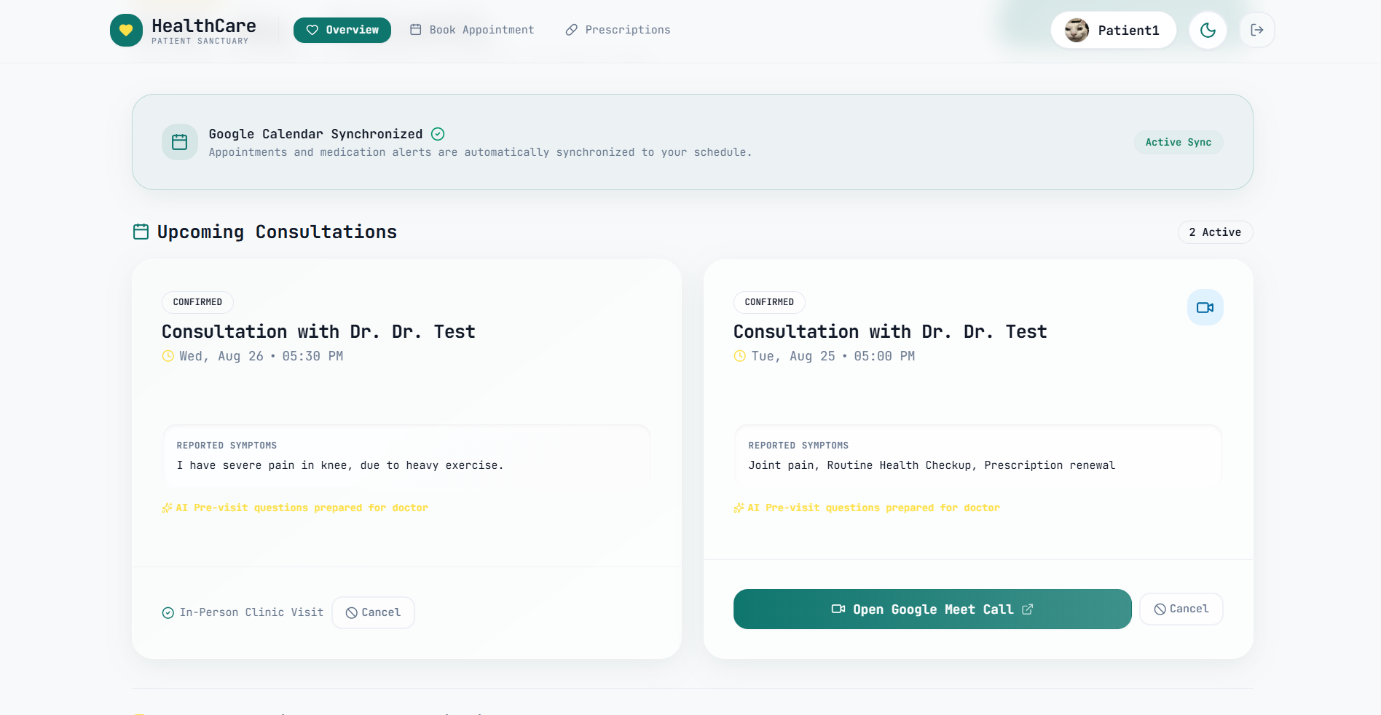
Figure 8: Updated Patient Dashboard — Displaying 2 confirmed active appointments: an in-person clinic visit and a virtual consultation with integrated Google Meet launch button.
- • Dashboard Presentation: Displays two appointment modes side-by-side: In-Person Clinic Visit (Aug 26) and Virtual Telehealth Consultation (Aug 25) with 1-click video launch.

8.9 Two-Way Automated Google Calendar & Google Meet Synchronization
The backend automatically provisions an official Google Calendar event with a dedicated Google Meet room, syncing with both doctor and patient mobile devices in real time.
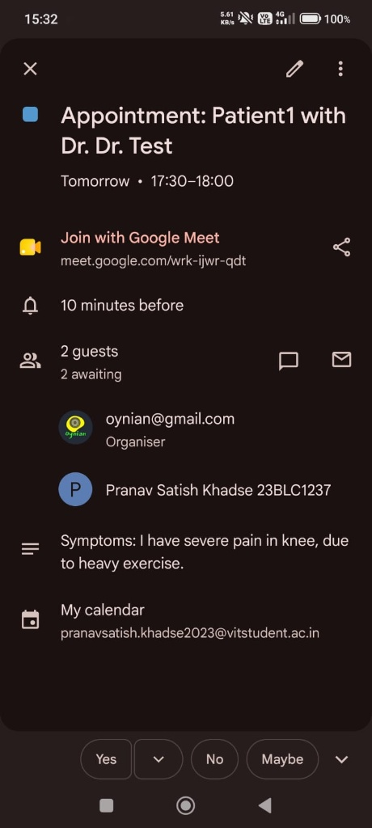
Figure 9: Mobile Google Calendar Synchronization — Automated event invite confirming participants, auto-generated Google Meet URL (meet.google.com/wrk-ijwr-qdt), and intake symptoms.
- • Automated Event Title: Creates event titled 'Appointment: Patient1 with Dr. Dr. Test' scheduled for 17:30-18:00.
- • Telehealth Room Provisioning: Automatically generates video link `meet.google.com/wrk-ijwr-qdt`.
- • Participant Dispatch: Invites organizer (`oynian@gmail.com`) and patient (`pranavsatish.khadse2023@vitstudent.ac.in`) with automated email updates.
- • Clinical Notes Attachment: Attaches intake symptom text directly into calendar notes for quick doctor reference.

9. Troubleshooting & Operational Runbook
When operating the platform in staging or production, reference this runbook for resolving common integration errors:

9.1 Common Integration Issues & Mitigations
- • Google Calendar OAuth 'Invalid Grant' / Expired Token: Ensure `GOOGLE_CLIENT_ID` and `GOOGLE_CLIENT_SECRET` are valid. If token expires, verify that `access_type=offline` and `prompt=consent` were passed during the initial OAuth handshake to obtain a permanent refresh token.
- • CORS Policy Violation: Ensure FastAPI CORS middleware (`CORSMiddleware`) includes your frontend origin (e.g. `http://localhost:5173`) in `allow_origins` and `allow_credentials=True`.
- • Gemini API Rate Exceeded / 429 Quota Error: If rate limits are encountered, implement exponential backoff retry in the backend service and fallback to a default template summary if LLM service is temporarily degraded.
- • Supabase Database RLS Permission Denied: Verify that RLS policies permit `auth.uid() = patient_id` for SELECT/INSERT operations, or utilize the `SUPABASE_SECRET_KEY` on backend service routes.
- • SMTP Relay Auth Failure (535 5.7.8): Ensure Gmail App Passwords (16 letters without spaces) are utilized rather than standard account passwords. Ensure port 587 with STARTTLS is enabled.

10. Security & Production Deployment Guidelines
For enterprise and clinical production deployments, adhere to the following architecture hardening checklist:
- 1. SSL/TLS Encryption: Configure custom domain with automated SSL/TLS certificates via Let's Encrypt / Cloudflare.
- 2. Secret Management: Store all API keys in enterprise secret managers (e.g. AWS Secrets Manager, Google Secret Manager, or Render Environment Secrets).
- 3. HIPAA/GDPR Compliance: Encrypt all patient health information (PHI) at rest and ensure strict Row-Level Security policies are enforced on all clinical tables.
- 4. Docker Multi-Stage Builds: Build containerized production images using multi-stage Docker builds for minimal attack surface.

