Project Report

(PMCA506L)

On

**Attendance Management System Using Facial Recognition in Firebase**

School of Computer Science and Engineering (SCOPE)



Under the Guidance of:

# DR. ANUSOOYA G

#### Associate Professor

Vellore Institute of Technology

Submitted By:

Pranav Sanjay Manapure (23MCA1041)

Anshul Sharma (23MCA1054)

Preeti Negi (23MCA1057)

School of Computer Science and Engineering

Vellore Institute of Technology

**ABSTRACT**

In today's digital era, traditional methods of attendance tracking are increasingly proving to be inefficient. To address this challenge, we present an innovative solution: an Attendance Management System leveraging facial recognition technology seamlessly integrated with Firebase, a real-time database platform. This system offers automation to the attendance process, offering educational institutions a streamlined and efficient method for tracking student attendance.

Manual attendance management poses a significant burden on educators. To alleviate this issue, we introduce a smart and automated attendance system. By employing this framework, concerns such as proxy attendance and inaccurate records are mitigated. The system operates by capturing live video streams, with frames extracted using OpenCV. Face detection and recognition, facilitated by dlib, are pivotal steps in this process. Subsequently, recognized faces are matched against a database containing student facial data. This model promises to revolutionize attendance management in educational settings, offering a robust and effective solution.

**Introduction**

The rise of face recognition technology has sparked interest across various domains, offering a reliable means of identifying individuals with applications ranging from security to human-computer interaction. Meanwhile, traditional attendance management systems, reliant on manual processes, face challenges such as inaccuracies and inefficiencies. In response, automated face recognition systems have emerged as a promising solution, capable of streamlining attendance tracking processes.

This project aims to capitalize on the potential of face recognition techniques to develop a real-time Face Attendance system. By seamlessly integrating face recognition technology with a live database infrastructure, the system seeks to revolutionize attendance management in educational institutions, corporate settings, and event management scenarios.

Automated face recognition systems offer unparalleled accuracy and reliability compared to manual methods, mitigating the risks of errors and unauthorized access. Leveraging advancements in digital devices and cloud computing, the proposed system aims to deliver a user-friendly platform for attendance tracking.

In essence, this project represents a fusion of cutting-edge technologies and practical applications, aiming to modernize attendance management practices. By harnessing the capabilities of face recognition technology and integrating them with a live database infrastructure, the project endeavors to provide a robust and scalable solution to meet the evolving needs of today's educational and organizational environments.

**Objectives and Arguments**

The main objectives of the project include:

1. Develop a real-time face recognition system capable of accurately identifying individuals.
2. Integrate the face recognition system with a live database for real-time data management.
3. Design an intuitive graphical interface to enhance user interaction and experience.
4. Implement features such as attendance tracking, data upload/download, and attendance updating.
5. Evaluate the system's performance in terms of accuracy, efficiency, and usability.

The project argues for the adoption of automated face recognition systems in attendance management to improve efficiency, reduce administrative burden, and minimize errors associated with manual processes. By leveraging computer vision and cloud-based databases, the proposed system offers a scalable and robust solution for attendance tracking in various settings such as educational institutions, workplaces, and events.

**Methodology**

The implementation of the Face Recognition with Real-Time Database system involves several key steps:

1. **Setup:** The project utilizes Firebase for real-time database management. Firebase credentials are initialized, and necessary modules are imported.
2. **Encoding Generator:** The system generates facial encodings for known individuals using images stored in a designated folder. These encodings are essential for face recognition.
3. **Webcam Integration:** The system captures live video feed from a webcam and performs face recognition on each frame using the OpenCV and face_recognition libraries.
4. **Graphics:** A graphical user interface (GUI) is designed to display the live video feed along with relevant information such as student details and attendance status.
5. **Face Recognition:** Face recognition is performed by comparing the facial encodings of detected faces with the pre-generated encodings of known individuals. The system identifies matched faces and retrieves corresponding information from the database.
6. **Database Setup:** Firebase Realtime Database is used to store student information such as name, major, attendance records, etc. Firebase Storage is utilized to store student images.
7. **Add Data to the Database:** Initial student data, including unique identifiers and information, are added to the Firebase database.
8. **Upload Images to the Database:** Student images are uploaded to Firebase Storage and linked to their respective database entries.
9. **Download User Data:** Upon face recognition, the system retrieves student information from the database based on the matched face.
10. **Update Attendance:** The system updates attendance records in real-time, incrementing the total attendance count and updating the last attendance time.
11. **Check if Already Marked:** Before updating attendance, the system checks if the student has already been marked present within a specified time frame to prevent duplicate entries.
12. **Loading:** The GUI displays loading messages and transitions between different modes based on system status and user interactions.

**Components**

The system comprises three main components:

**1. Face Recognition Module:**

* Implemented using OpenCV and the face_recognition library.
* Captures live video feed from a camera.
* Detects faces in the video frames and matches them with pre-registered student profiles.
* Utilizes advanced facial recognition algorithms to achieve high accuracy.

**2. Firebase Integration:**

* Firebase serves as the backend infrastructure for the system.
* Real-time database management and storage capabilities of Firebase are utilized.
* Student profiles, attendance records, and images are stored in Firebase's cloud-based database.
* Firebase authentication ensures secure access to the system's functionalities.

**3. Containerization:**

* Docker technology is employed for containerizing the application.
* The system components are packaged into Docker containers, providing isolation and portability.
* Containerization facilitates easy deployment across different environments and ensures consistency in the application's behavior.

**Database Used**

Firebase Realtime Database is the chosen database solution for this project. The database schema includes the following fields for each student:

* Student ID
* Name
* Major
* Starting year
* Total attendance count
* Gender
* Academic year
* Last attendance time

**Results**

The system demonstrates robust face recognition capabilities with real-time performance. Through testing and evaluation, the following results were observed:

* High accuracy in identifying known individuals under various lighting conditions and facial expressions.
* Real-time attendance tracking with instant database updates.
* Intuitive graphical interface for easy interaction and monitoring.
* Efficient handling of large datasets and simultaneous face recognition tasks.

Performance metrics such as accuracy, speed, and user satisfaction were assessed to validate the system's effectiveness in meeting project objectives.

**Screen Shots**

**Screenshot 1:**

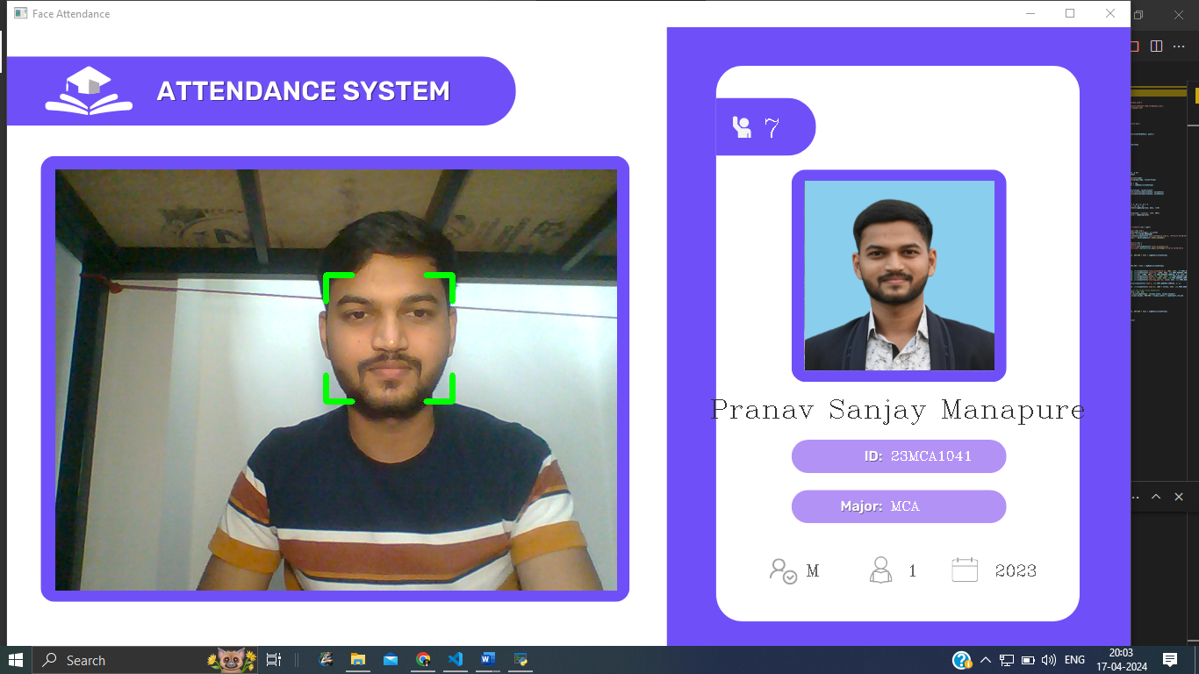

**Screenshot 2:**

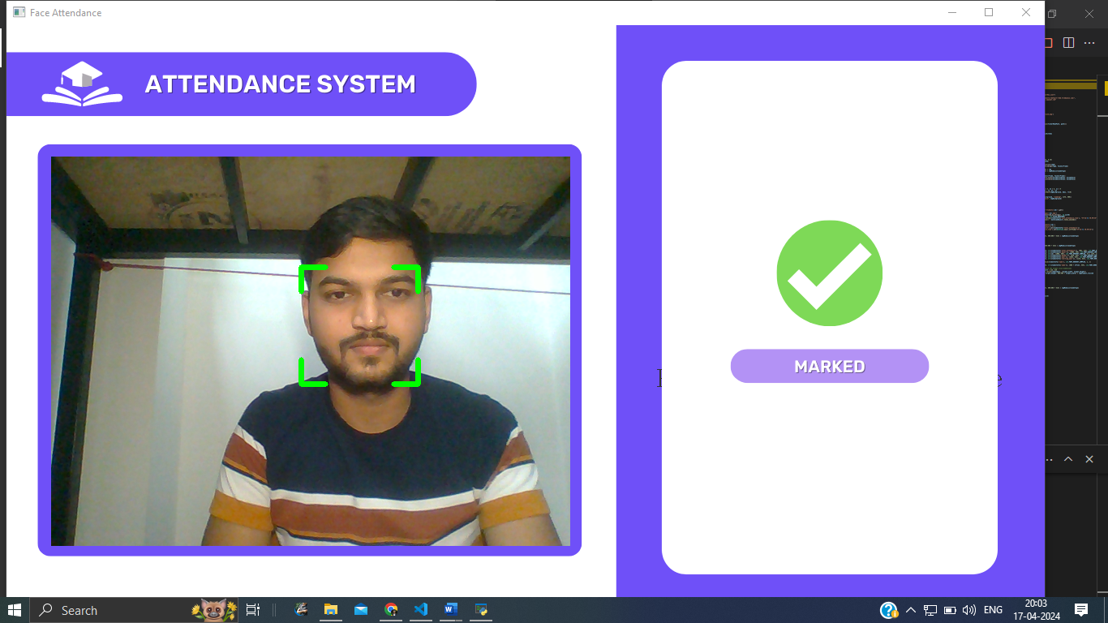

**Screenshot 3:**

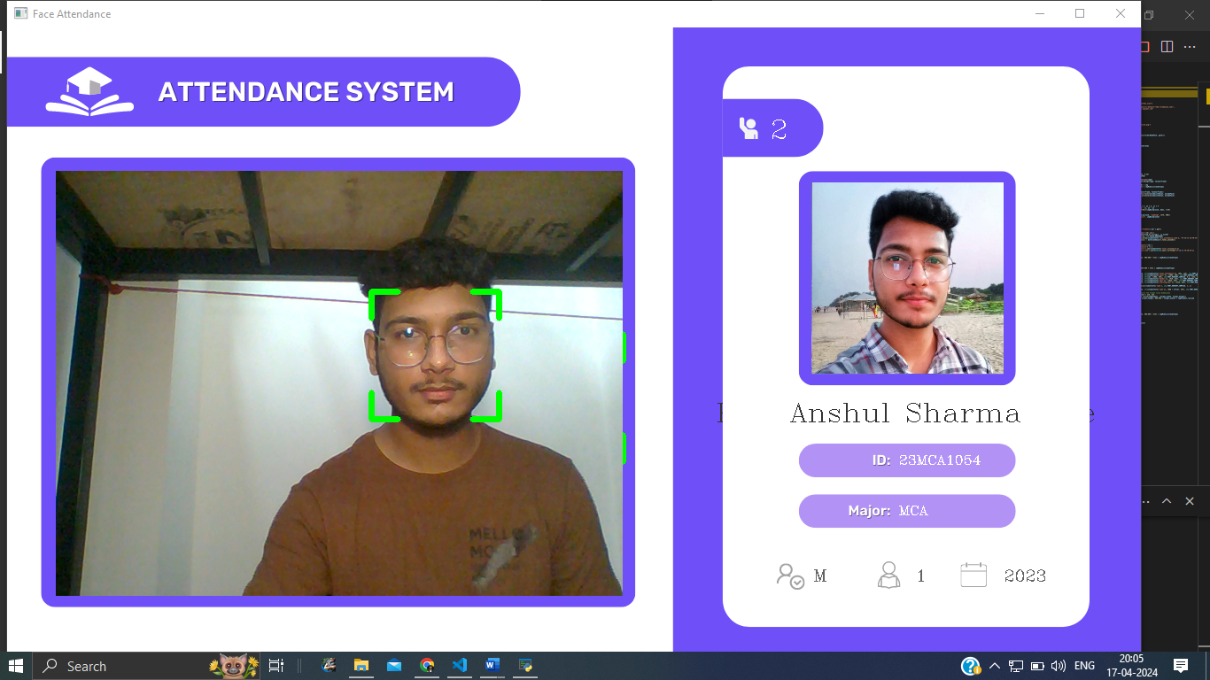

**Screenshot 4:**



**Screenshot Of Database**

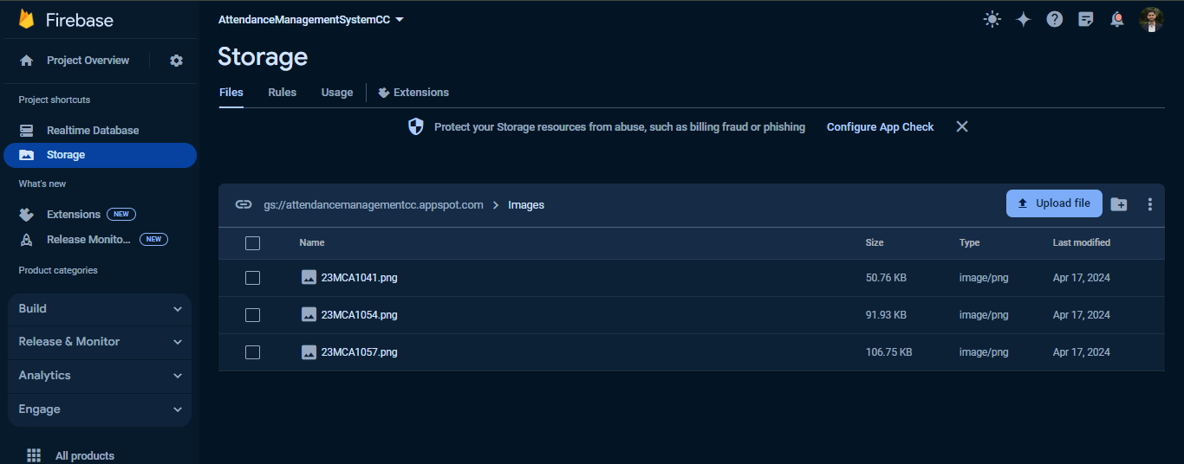**Images Stored in Firebase:**

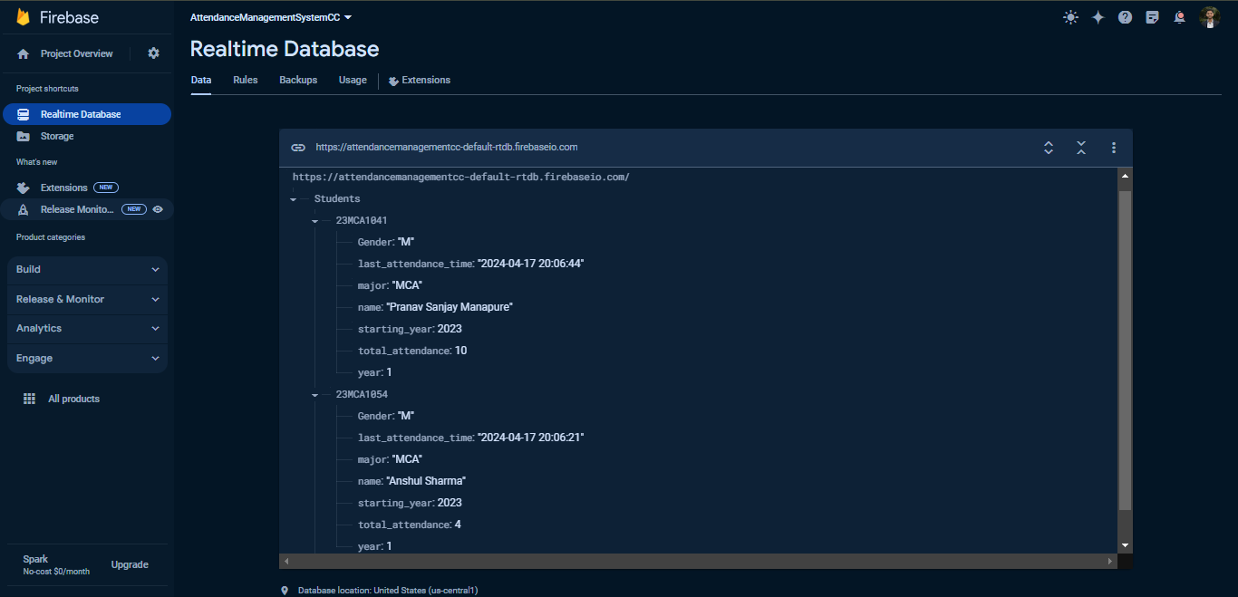**Student’s details and records Stored in data base:**

**Conclusion**

The Face Recognition with Real-Time Database project presents a comprehensive solution for automated attendance management using face recognition technology. By integrating real-time face recognition with cloud-based database management, the system offers a scalable and efficient approach to attendance tracking in educational and organizational settings. The project demonstrates the feasibility and practicality of deploying face recognition systems for various applications beyond traditional security use cases. Further enhancements and optimizations can be explored to improve the system's accuracy, scalability, and user experience in real-world deployment scenarios.

**Reference**

[1] Gomes, C., Chanchal, S., Desai, T., & Jadhav, D. (2020). Class attendance management system using facial recognition. In ITM Web of Conferences (Vol. 32, p. 02001). EDP Sciences.

[2] Godswill, O., Osas, O., Anderson, O., Oseikhuemen, I., & Etse, O. (2021). Automated student attendance management system using face recognition. International Journal of Educational Research and Information Science, 5(4), 31-37.

[3] Kakarla, S., Gangula, P., Rahul, M. S., Singh, C. S. C., & Sarma, T. H. (2020, September). Smart attendance management system based on face recognition using CNN. In 2020 IEEE-HYDCON (pp. 1-5). IEEE.

[4] <https://www.computervision.zone/courses/face-recognition-with-real-time-database/>

[5] https://youtu.be/w7xKZ5PWizs?si=FSdAeIkGPtVDY2R-