AGRIVISION
Autonomous Crop Disease Detection and Targeted Spraying Rover
Hackathon prototype documentation: project idea, system model, hardware, circuit diagrams, software and progress log
Team:
Pranav Sai -2410040141(hardware and embedded systems)
Musthakeem (AI and software)
Yashaswin-2410040058 (hardware and embedded systems)
Rohit-2410040081(hardware and embedded systems)
Venkatesh-2410040082 (hardware and embedded systems)
Version: 25 October 2026
At a glance
Goal | A small rover drives between crop rows, photographs leaves, detects disease with an AI model and sprays only the infected plants.
Prototype | 4-wheel cardboard rover, Raspberry Pi 4 plus Arduino Uno with an HW-130 motor shield, and a USB webcam mounted on a servo.
Spraying and soil probe | Represented by servos for the demo. No pumps or tanks are connected yet.
AI model | Image classifier on a FastAPI server on the teammate's laptop, reached over the hotspot Wi-Fi. The Pi uploads a photo and receives predicted_class, confidence and model.
Status | Pi setup, live camera view, photo upload to the AI server and the camera servo work. The drive motors and power supply need fixing (Sections 7 and 8).

1. Project idea

1.1 The problem
- Crop diseases are usually spotted late, by eye, and manual scouting is slow and depends on expert knowledge.
- Blanket spraying of a whole field wastes pesticide, raises cost and harms soil and farmers' health.
- Existing agricultural robots are large and expensive, out of reach for small farmers and student prototypes.
- In muddy fields small robots slip, so they lose track of which plant is which.

1.2 Our solution
A compact autonomous rover (about 10 to 20 cm wide) moves between two crop rows, photographs the leaves, uses an AI model to detect disease and recommends a pesticide, then sprays only the affected plants with a controlled dose. The target crops are row crops with a clear gap between rows, such as tomato, chilli and brinjal.

1.3 Objectives
- Build a compact 4-wheel rover that drives between two crop rows.
- Capture leaf images at regular intervals.
- Detect common leaf diseases with an AI model and recommend a pesticide.
- Record the location of every infected plant.
- Spray only the infected plants from two tanks (two different chemicals) with a controlled dose.
- Test on a small prototype crop bed and report detection accuracy, row-following error and localization error.

2. System model and method

2.1 How the rover works
- The rover drives to a plant and stops.
- The webcam, rotated by its servo, takes a photo of the leaves.
- The Raspberry Pi uploads the photo over Wi-Fi to the AI server (a FastAPI service on the teammate's laptop).
- The server returns the predicted disease class, a confidence percentage and the model name.
- A lookup, still to be added, turns the disease class into a pesticide and a sprayer. The Pi then moves that sprayer servo and logs the result.
Two ways to run it. In the two-pass method the rover scouts the whole row first, saves the infected positions, then returns and sprays. In the single-pass method it stops at each plant, captures, classifies and sprays at once. Single-pass is simpler and more reliable in mud, and both will be compared in testing. A later dual-rover version (one scout rover, one spray rover) is future work.

2.2 System block diagram
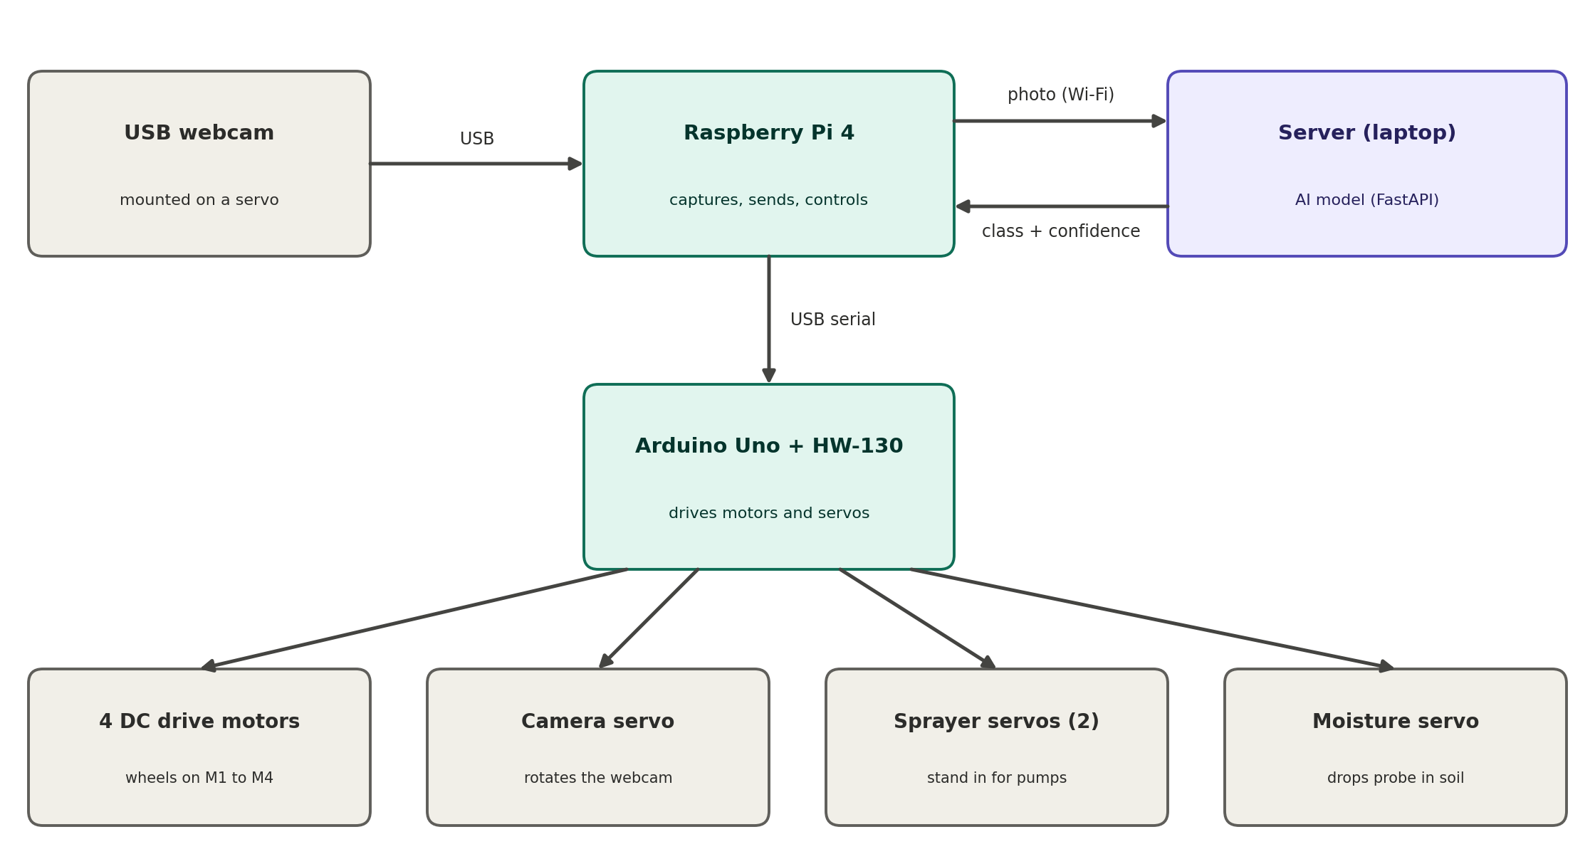
Figure 1. System block diagram: sensing, compute, AI server and actuators
The Raspberry Pi is the brain: it takes the photos, talks to the server and sends commands. The Arduino Uno with the HW-130 shield does the muscle work: it drives the wheel motors and the four servos. The server runs the AI model. The pesticide lookup is still to be added.

2.3 Proposal versus hackathon prototype
The full proposal is larger than what can be built in a hackathon. This table shows what the prototype keeps, replaces or leaves out.
Subsystem | Proposal | Hackathon prototype
Drive | 4WD chassis, 12 V gear motors with encoders, 2x L298N drivers | 4 DC motors on the HW-130 shield (Arduino Uno), no encoders yet
Controller | ESP32 | Arduino Uno (ESP32 kept for later)
Compute | Raspberry Pi 4 | Raspberry Pi 4
Camera | One camera per side of the rover | One USB webcam on a rotating servo (10 to 170 degrees)
Spraying | 2 pumps, 2 tanks of 500 ml, nozzles | 2 servos that move to represent spraying
Navigation | Ultrasonic sensors, IMU, encoders, PID row following | Manual keyboard control. Autonomy is future work
Power | 3S Li-ion pack with BMS, 2 buck converters | 3S Li-ion pack with BMS, 1 buck converters
AI | Lightweight classifier on a server over Wi-Fi | Same. The teammate's FastAPI server runs the model and returns predicted_class, confidence and model. A live camera view is added on the Pi

3. Prototype hardware

3.1 Components in hand
Component | Quantity | Role
Raspberry Pi 4 | 1 | Brain: runs the control script, takes photos, uploads them
USB webcam (digital microscope type) | 1 | Leaf photos, mounted on the camera servo. An 8 MP Pi camera module is also available but not used
Arduino Uno | 1 | Receives single-letter commands from the Pi
HW-130 motor shield (2x L293D) | 1 | Drives 4 DC motors; has SER1 and SER2 servo headers
DC gear motors | 4 | Wheels, fitted on the cardboard chassis
Servo motors | 4 | Camera rotation, sprayer 1, sprayer 2, moisture probe
Li-ion cells (3 x 2500 mAh) in a holder, plus a single-cell socket | 3 + 1 | Motor power. Three cells in series give 11.1 V nominal, 12.6 V full, 27.75 Wh
TP4056 charger modules | - | Charging single Li-ion cells
5 V 3 A power bank | 1 | Powers the Pi for now
Laptop (control and viewing) | 1 | SSH terminal for the keys, browser for the live camera
Teammate's laptop (AI server) | 1 | Runs the FastAPI service and the disease model
ESP32, nRF wireless module, AMS1117-5V module | 1 each | Not used yet. Reserved for later sensors, pumps and a remote. The AMS1117 is limited to 1 A, so it must never power the Pi

3.2 Suggested layout

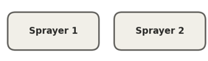
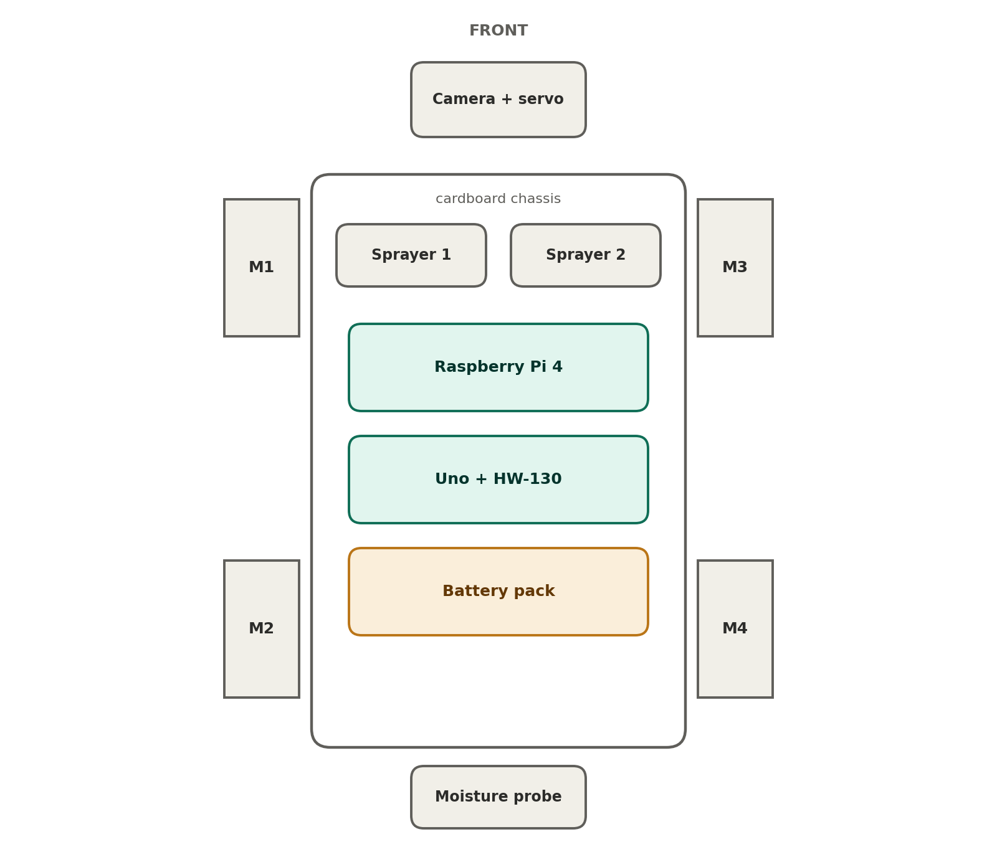
Figure 2. Top view of the rover, suggested layout (schematic, not to scale)

4. Circuit diagrams

4.1 Power
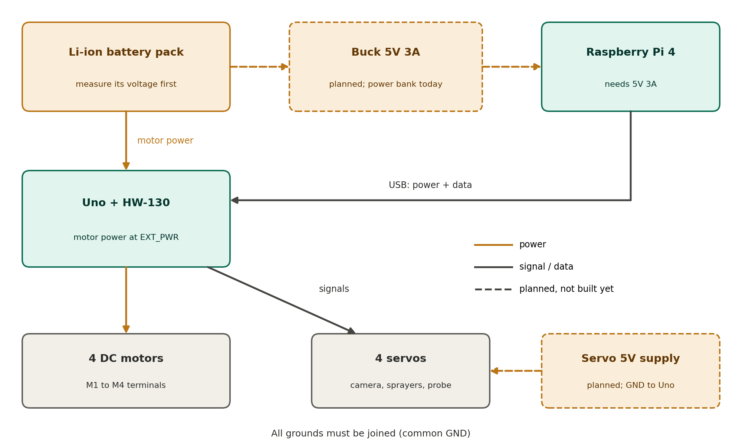
Figure 3. Power diagram. Dashed items are planned and not built yet
- Remove the PWR jumper on the HW-130. The battery then feeds only the motors (EXT_PWR terminal), while the Uno is powered by the Pi over USB.
- Check the battery voltage against the motor rating before connecting. A fully charged 3S pack is 12.6 V, which is too high for typical 3 to 6 V gear motors. Set a buck converter to the motor voltage with a multimeter before it touches the shield.
- Battery capacity (estimate). Three 2500 mAh cells in series store about 27.75 Wh (3 x 3.7 V x 2.5 Ah). At an assumed 11 W average draw this gives roughly 2.5 hours of continuous running, or 3 to 4 hours with stops. These are estimates, so log the real runtime during testing.
- Power the Pi from a 5 V 3 A source, not from the AMS1117. Motor and servo spikes must not share the Pi's supply.
- Servos need their own 5 V supply at the final stage, with its GND joined to the Uno's GND.
- All grounds must be common.

4.2 Pin wiring
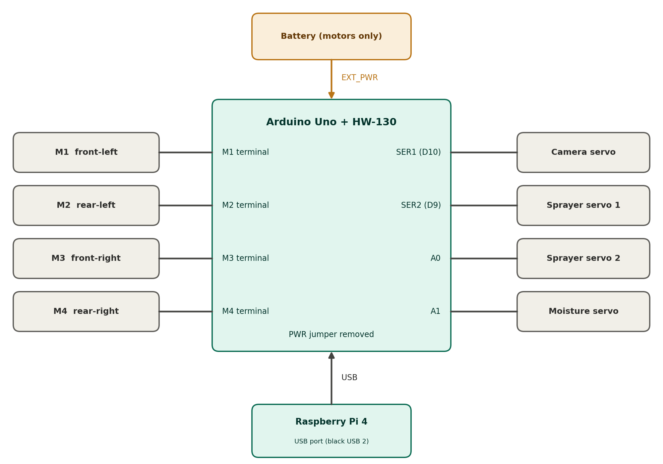
Figure 4. Arduino Uno + HW-130 connections to the motors, servos, battery and Pi
Item | Connects to | Notes
Motors M1 to M4 | M1, M2, M3, M4 screw terminals | One motor per channel (M1 front-left, M2 rear-left, M3 front-right, M4 rear-right). If a wheel turns the wrong way, swap its two wires
Battery | EXT_PWR terminal, through a switch | Motors only. PWR jumper removed
Camera servo | SER1 header (pin D10) | Limited to 10 to 170 degrees in software
Sprayer servo 1 | SER2 header (pin D9) | Rests at 10 degrees, moves to 90 and back
Sprayer servo 2 | Pin A0, plus 5 V and GND | Signal wire on A0; red and brown wires to 5 V and GND
Moisture probe servo | Pin A1, plus 5 V and GND | Probe up at 20 degrees, down at 150
Pi to Uno | USB cable, black USB 2 port on the Pi | Appears as /dev/ttyUSB0 (the Uno has an FTDI chip)
USB webcam | Blue USB 3 port on the Pi | Appears as /dev/video0

Servo wire colours: brown or black is GND, red is 5 V, orange or yellow is the signal. On the SER1 and SER2 headers, orient the plug so the brown wire sits on the GND pin.

4.3 Notes on the HW-130 shield
- It is an Arduino Motor Shield V1 type board, so the Adafruit Motor Shield library (V1) is needed. The V2 library does not work with it.
- The shield uses pins 4, 7, 8 and 12 for its shift register and pins 11, 3, 5 and 6 for motor PWM. Pins D9 and D10 feed the servo headers.
- Each L293D channel is rated for only 0.6 A continuous, so one motor per channel, kept at low PWM (150 or below). Heavier loads need a stronger driver.
- Moving the shield to an ESP32 is not recommended: the logic levels differ (3.3 V versus 5 V) and the shift register needs 5 V signals.

4.4 Battery charging
- Take the cells out of the holder and charge them one at a time in a TP4056 module with protection, or in a normal 18650 charger.
- Cells put back in series should read within about 0.1 V of each other.
- Never charge a series holder through a single-cell TP4056. Series packs need a matching 2S or 3S BMS board and charger.
- Do not charge from the Pi or Uno USB port, and never charge a cell that is hot, swollen or below about 2.5 V.

5. Software

5.1 Overview
Part | Runs on | Job
Arduino sketch (rover.ino) | Arduino Uno | Reads single-letter commands and moves motors and servos safely
Pi control script (rover.py) | Raspberry Pi | Reads keyboard keys, sends commands, streams the camera, takes photos, uploads them
Server (teammate's app.py, FastAPI) | Teammate's laptop | Receives photos on /predict, runs the model, returns predicted_class, confidence and model
Live camera stream (inside the Pi script) | Raspberry Pi | MJPEG video on port 8080, viewed in a browser on the laptop
AI model | Teammate's laptop | Running on the teammate's server; the first test returned a result

5.2 Keyboard controls
Key | Action
W / S / A / D | Forward / backward / spin left / spin right (the rover stops 0.7 s after the last command)
Space | Stop
Q / E / F | Camera servo left / right by 10 degrees / back to the centre
C | Capture a frame from the live camera, save it with the date and time in the name, and upload it in the background
1 / 2 | Move sprayer servo 1 / 2 out and back once
M / N | Moisture probe down into the soil / back up
X | Quit (restores the terminal and stops the motors)

5.3 Safety features in the Arduino sketch
- Every servo is limited to 10 to 170 degrees, so none can hit its end stops and stall.
- Servos move in 2-degree steps with a short pause, which avoids sudden current spikes.
- Each servo is given its start angle before it is attached, and the four are attached one after another, so they do not all pull current at once.
- The wheels stop before any sprayer or probe moves, and also if no drive command arrives for 0.7 seconds.
Commands travel as single characters at 9600 baud over the USB cable. The Uno echoes each character back so the Pi can see it arrived.

5.4 Photo upload and server interface
Pressing C saves a frame in the photos folder as leaf_YYYYMMDD_HHMMSS.jpg and uploads it in a background thread, so the keys keep working. The upload is an HTTP POST with multipart form data.
Setting | Value
Framework | FastAPI (run with uvicorn)
Endpoint | POST /predict, port 8000
Form field name | file
Reply (JSON) | predicted_class, confidence (already a percentage), model

{"predicted_class": "<class name>", "confidence": 19.35, "model": "<model name>"}

The Pi prints short messages only: saved, uploading...; image sent -> <class> (<percent>); server not reached; server timeout; server error <code>: <text>; and upload failed.
Network requirements: the Pi, the laptop and the server laptop must be on the same hotspot (same first three numbers of the IP, for example 10.139.64.x). The server must run with --host 0.0.0.0, and the Windows firewall must allow port 8000. Read the server laptop's current IPv4 address with ipconfig, because it changes between networks.
Spraying: the server does not return a sprayer yet, so AUTO_SPRAY stays off until a disease-to-sprayer lookup is added.

5.5 AI model and pesticide table
- Data: start with a public leaf-disease dataset such as PlantVillage, then add real field images from our own camera to close the gap between lab and field images.
- Model: a lightweight image classifier (MobileNet or EfficientNet-Lite class) with disease classes for the chosen crop. Inference runs on the laptop for the prototype.
- Pesticide lookup: the values in the server are placeholders. They must be checked against ICAR or agriculture department guidelines before any real use.
- Testing liquids: prototype trials use water with food colour, one colour per tank, instead of real pesticide.
- First test: the first end-to-end upload returned a class name with a confidence of 19.35, which is already a percentage. The Pi first multiplied it by 100 and printed 1935%, so the multiplication was removed.

5.6 Live camera view
A small Flask server inside the control script streams the camera as MJPEG on port 8080. On the laptop, open http://<pi-ip>:8080/ in a browser. Find the Pi's address with hostname -I, and use the IP address because agripi.local often does not resolve in a Windows browser. The stream and the C-key capture share one camera object protected by a lock, so they never fight over it. The delay is roughly 0.2 to 0.5 seconds (estimate).

6. Raspberry Pi setup (headless)
No screen or keyboard is needed on the Pi. Everything is controlled from the laptop over Wi-Fi.
- Write Raspberry Pi OS Lite (64-bit) to the Pi's microSD card with Raspberry Pi Imager. Under Edit Settings set a hostname (agripi), a username and password, the phone hotspot name and password, the country, and turn on SSH.
- Turn on the phone hotspot (2.4 GHz), put the card in the Pi and power it from the power bank. Wait 3 to 5 minutes for the first boot.
- Join the laptop to the same hotspot and connect with ssh your-username@agripi.local (or use the Pi's IP address if the name does not resolve). From Windows, use the Pi's IP address (from hostname -I) in the browser.
- Install the libraries, then reboot and reconnect:
sudo apt update
sudo apt install -y python3-serial python3-opencv python3-requests python3-flask
sudo usermod -aG dialout $USER
sudo reboot

Do not use pip install flask. Raspberry Pi OS blocks it with an externally-managed-environment error. Check the install with python3 -c "import flask, requests, cv2, serial; print('all good')".
- Upload the Arduino sketch from the laptop with the Arduino IDE (board: Arduino Uno, library: Adafruit Motor Shield V1) before connecting the Uno to the Pi.
- Plug the Uno into a black USB 2 port and the webcam into a blue USB 3 port. Check with ls /dev/ttyUSB*, lsusb and ls /dev/video*.
- Create rover.py with nano (paste, Ctrl+O, Enter, Ctrl+X) and run python3 rover.py. It was called rover_control.py in earlier versions.
- Find the Pi's IP address with hostname -I and open http://<that-ip>:8080/ in the laptop browser to see the live camera.

7. Build stages and test status
The build goes one stage at a time: wheels first, then the camera servo, then the sprayer servos, then the moisture probe.
Stage | Item | Status | Notes
Setup | Pi headless setup and SSH | Done | Connected over the phone hotspot
Setup | Webcam photo on key press | Done | Photos saved in the photos folder
Setup | Pi to Uno serial link | Done | Uno echoes the commands back on /dev/ttyUSB0
1 | Wheels (W/A/S/D) | Needs attention | Motors only hummed without a battery. With the battery they ran, but directions were wrong and fumes appeared (Section 8)
2 | Camera servo (Q/E/F) | Working | Works after the sketch fix. Limits of 10 to 170 degrees added
3 | Sprayer servos (1 and 2) | Partly tested | Sprayer 1 responded in one test. Sprayer 2 not wired yet. Later runs were interrupted by USB drops
4 | Moisture probe servo (M/N) | Not tested | To be wired to pin A1
Link | Photo upload to server | Working | Reaches the teammate's server and gets a result. The server must still save received images
Link | Live camera view in a browser | Done | http://<pi-ip>:8080/
AI | Disease model | Running | On the teammate's server; the first test returned a result

8. Issues found, causes and fixes
Issue | Cause | Fix and status
agripi.local not found | The Pi was still joining the hotspot | Waited a few minutes and the name resolved. The IP address also works. Fixed
/dev/ttyACM0 missing | The Uno has an FTDI chip, so it appears as /dev/ttyUSB0 | The script now finds the port automatically. Fixed
Camera servo ignored Q, E, F | A pasted comment swallowed the camServo.attach(10) line | Clean sketch with a correct setup(). Fixed
Uno disconnects ('Input/output error') | Probably a power dip when servos start or stall on the Pi's USB supply (not confirmed) | Give the servos a separate 5 V supply with common GND; check vcgencmd get_throttled. Open
Typed text invisible after a crash | The script crashed before restoring the terminal mode | The script restores the terminal first. Type reset to recover. Fixed
Servo stuck at the end of its range | The angle reached 0 or 180 degrees | Limits of 10 to 170 and slow steps on every servo. Fixed in code
Wheels: A moved forward, D backward, W and S did nothing | Probably the motors on one side are wired in reverse (not confirmed; the board may also be damaged) | Swap both wires on one side after the board is checked. Open
Fumes from the Uno / HW-130 | Not confirmed. The pack is three 2500 mAh Li-ion cells (likely 3S, up to 12.6 V), so over-voltage is the top suspect. Others: an overloaded L293D (0.6 A per channel), the PWR jumper left on, or a wiring short. The motor rating still has to be read | Disconnected; inspect and measure before powering again. Open
pip install flask fails | Pi OS blocks system-wide pip (PEP 668) | Use sudo apt install python3-flask. Fixed
nano warns the file is over 5 KiB | Only a size warning for a large pasted file | Save normally with Ctrl+O, Enter, Ctrl+X. Harmless
Browser cannot open agripi.local | Windows often cannot resolve .local names in a browser | Use the Pi's IP and port 8080. Fixed
'Uno not found' after the power incident | No serial device listed; cause not recorded. The Uno shows an FTDI chip, so a burnt ATmega16U2 does not apply | A later run found it again. If it repeats, check ls /dev/ttyUSB*, lsusb, dmesg, another cable or port. Monitor
ping to the server shows 100% loss | Windows blocks ping (ICMP) by default | Test with curl instead. Not an error
Server unreachable (timeout) | Wrong IP given (10.231.x.x instead of 10.139.64.254) | Read the real IPv4 with ipconfig. Fixed
Server listening only on 127.0.0.1 | uvicorn started without --host 0.0.0.0 | uvicorn app:app --host 0.0.0.0 --port 8000, check with netstat. Fixed
uvicorn import errors | .py typed in the command, wrong module name or wrong folder | Go to the folder with app.py and run uvicorn app:app. Fixed
Port 8000 blocked | No Windows firewall rule for the port | Added an inbound rule for port 8000. Fixed
curl returned 405 | /predict accepts POST only | A 405 means the server is reachable. Not an error
Upload returned 422 | The Pi sent the field image; the server expects file | Changed the field name to file. Fixed
Confidence printed as 1935% | The server already sends a percentage (19.35) | Print the value as it is. Fixed
Teammate could not find the uploaded image | FastAPI does not save uploads unless the code writes them | Add save code to /predict and restart the server. Open until confirmed

Before powering the rover again
1. Disconnect the battery and USB. Let the board cool, then look for burn marks, discolouration or a burnt smell on the two L293D chips and the Uno's regulator.
2. Check that the Pi still boots with the Uno unplugged.
3. Measure the battery voltage and read the voltage printed on the motors.
4. Remove the PWR jumper. Add a buck converter set to the motor voltage (set it with a multimeter first), and a fuse if available.
5. Test one motor at low PWM. If the HW-130 behaves oddly, replace it, or move to a higher-current driver such as an L298N, TB6612 or BTS7960.
6. If the Pi says Uno not found, check the cable and port, run lsusb and dmesg, and test the Uno on a laptop.

9. Next steps
- Make the power safe: inspect the board, add the buck converter, and give the servos a separate 5 V supply.
- Re-test the wheels and fix the motor directions.
- Wire and test sprayer servo 2 and the moisture probe servo.
- Add the disease-to-pesticide-to-sprayer lookup (on the Pi or on the server), then turn AUTO_SPRAY on.
- Have the server save every received image, and replace the placeholder pesticide values with ones checked against ICAR guidelines.
- Add the sensing and autonomy from the proposal: ultrasonic sensors, IMU, encoders and PID row following.
- Fit real pumps and tanks, calibrate the dose, and run trials on a mock crop bed. Report detection accuracy, row-following error and localization error.

10. Server setup and network checklist (for the AI teammate)
- Open PowerShell in the folder that holds app.py.
- Start the server on all interfaces.
- Check that it shows 0.0.0.0:8000, not 127.0.0.1:8000.
- Allow the port in an Administrator PowerShell.
- From the Pi, test that the server is reachable. A 405 reply means it works.
- From the Pi, test an upload. A 200 reply with predicted_class means it works.
# 2. start the server
uvicorn app:app --host 0.0.0.0 --port 8000
# if uvicorn is not recognised
python -m uvicorn app:app --host 0.0.0.0 --port 8000
# 3. check the binding
netstat -ano | findstr :8000
# 4. firewall rule (Administrator PowerShell)
New-NetFirewallRule -DisplayName "FastAPI 8000" -Direction Inbound -Protocol TCP -LocalPort 8000 -Action Allow -Profile Any
# 5. reachability test (on the Pi)
curl -m 5 -v http://<server-ip>:8000/predict
# 6. upload test (on the Pi)
curl -v -F "file=@photos/<photo>.jpg" http://<server-ip>:8000/predict

11. Estimates (not measured)
These figures come from planning calculations, not tests. Log real values during testing and replace them.
Item | Estimate
Battery | 27.75 Wh; about 2.5 hours continuous, 3 to 4 hours with stops
Hotspot range | 10 to 20 m reliable; keep demos within 15 m
Upload time | 1 to 3 s at 5 to 15 m; 3 to 8 s beyond 20 m
Live view delay | about 0.3 s at 5 to 15 m
System cost | about Rs 11,000 (team estimate; replace with the real bill of materials)

Appendix A. Arduino sketch (rover.ino)
#include <AFMotor.h> // HW-130 motor shield library (V1)
#include <Servo.h> // built-in servo library

AF_DCMotor fl(1), rl(2), fr(3), rr(4); // four drive motors on M1 to M4
Servo camServo, spray1, spray2, soilServo; // four servos

const int SPEED = 150; // motor PWM, kept low

const int SERVO_MIN = 10; // no servo ever goes below 10 degrees
const int SERVO_MAX = 170; // and none above 170 degrees
const int STEP_DEG = 2; // slow moves go 2 degrees at a time
const int STEP_MS = 15; // with 15 ms between steps

const int CAM_STEP = 10; // camera moves 10 degrees per key press
const int SPRAY_REST = 10; // sprayer resting angle
const int SPRAY_OUT = 90; // sprayer "spraying" angle
const int PROBE_UP = 20; // moisture probe raised
const int PROBE_DOWN = 150; // moisture probe lowered into soil

int camAngle = 90; // current angle of each servo
int spray1Angle = SPRAY_REST;
int spray2Angle = SPRAY_REST;
int soilAngle = PROBE_UP;

unsigned long lastCmd = 0; // time of the last drive command
bool moving = false; // true while a drive command is active

void setAll(uint8_t l, uint8_t r) { // set both sides in one call
fl.run(l); rl.run(l); // left side motors
fr.run(r); rr.run(r); // right side motors
}

void stopWheels() { // stop the rover before moving a servo
setAll(RELEASE, RELEASE);
moving = false;
}

void moveSlow(Servo &s, int &current, int target) { // glide a servo to a target angle
target = constrain(target, SERVO_MIN, SERVO_MAX); // keep inside the safe range
while (current != target) { // step until we arrive
if (current < target) current = min(current + STEP_DEG, target);
else current = max(current - STEP_DEG, target);
s.write(current); // go to the new angle
delay(STEP_MS); // short pause between steps
}
}

void sprayOnce(Servo &s, int &angle) { // sprayer goes out and back
stopWheels(); // never spray while driving
moveSlow(s, angle, SPRAY_OUT); // glide to the spray position
delay(800); // hold it
moveSlow(s, angle, SPRAY_REST); // glide back to rest
}

void setup() {
Serial.begin(9600); // serial link to the Pi
fl.setSpeed(SPEED); rl.setSpeed(SPEED);
fr.setSpeed(SPEED); rr.setSpeed(SPEED);
setAll(RELEASE, RELEASE); // start stopped

camServo.write(camAngle); camServo.attach(10); // SER1: camera rotation
delay(300); // wait so servos don't start together
spray1.write(spray1Angle); spray1.attach(9); // SER2: sprayer 1
delay(300);
spray2.write(spray2Angle); spray2.attach(A0); // A0: sprayer 2
delay(300);
soilServo.write(soilAngle); soilServo.attach(A1); // A1: moisture probe
}

void loop() {
if (moving && millis() - lastCmd > 700) { // no drive command for 0.7 s
stopWheels(); // stop for safety
}
if (Serial.available() > 0) {
char c = Serial.read(); // one command character
if (c == 'F' || c == 'B' || c == 'L' || c == 'R') {
lastCmd = millis(); moving = true; // restart the safety timer
}
switch (c) {
case 'F': setAll(FORWARD, FORWARD); break;
case 'B': setAll(BACKWARD, BACKWARD); break;
case 'L': setAll(BACKWARD, FORWARD); break;
case 'R': setAll(FORWARD, BACKWARD); break;
case 'S': stopWheels(); break;
case 'q': moveSlow(camServo, camAngle, camAngle - CAM_STEP); break;
case 'e': moveSlow(camServo, camAngle, camAngle + CAM_STEP); break;
case 'f': moveSlow(camServo, camAngle, 90); break;
case '1': sprayOnce(spray1, spray1Angle); break;
case '2': sprayOnce(spray2, spray2Angle); break;
case 'm': stopWheels(); moveSlow(soilServo, soilAngle, PROBE_DOWN); break;
case 'n': stopWheels(); moveSlow(soilServo, soilAngle, PROBE_UP); break;
}
Serial.println(c); // echo so the Pi sees it arrived
}
}

Appendix B. Raspberry Pi control script (rover.py)
import serial, time, sys, tty, termios, os, threading, glob
from datetime import datetime
import cv2
import requests
from flask import Flask, Response

SERVER = "http://10.139.64.254:8000/predict"
AUTO_SPRAY = False
STREAM_PORT = 8080

ports = glob.glob('/dev/ttyUSB*') + glob.glob('/dev/ttyACM*')
if not ports:
sys.exit("Uno not found. Check the USB cable.")
ser = serial.Serial(ports[0], 9600, timeout=0.1)
print("Uno on", ports[0])
lock = threading.Lock()
time.sleep(2)

drive = {'w': 'F', 's': 'B', 'a': 'L', 'd': 'R', ' ': 'S'}
passthru = set('qef12mn')
os.makedirs('photos', exist_ok=True)

camera = cv2.VideoCapture(0)
camera_lock = threading.Lock()

def send(cmd):
try:
with lock:
ser.write(cmd.encode())
except Exception:
pass

def capture():
with camera_lock:
for _ in range(3):
camera.read()
ok, frame = camera.read()
if not ok:
return None
name = f"photos/leaf_{datetime.now():%Y%m%d_%H%M%S}.jpg"
cv2.imwrite(name, frame)
return name

def upload(path):
try:
with open(path, 'rb') as f:
files = {"file": (os.path.basename(path), f, "image/jpeg")}
r = requests.post(SERVER, files=files, timeout=30)
if r.status_code != 200:
print(f"server error {r.status_code}: {r.text[:200]}\r")
return
res = r.json()
disease = res.get("predicted_class", "?")
conf = res.get("confidence")
pct = f"{conf:.1f}%" if isinstance(conf, (int, float)) else "?"
print(f"image sent -> {disease} ({pct})\r")
if AUTO_SPRAY:
action = res.get("action")
if action and action.get("sprayer") in (1, 2):
send(str(action["sprayer"]))
except requests.exceptions.ConnectionError:
print("server not reached\r")
except requests.exceptions.Timeout:
print("server timeout\r")
except Exception:
print("upload failed\r")

app = Flask(__name__)

def gen_frames():
while True:
with camera_lock:
ok, frame = camera.read()
if not ok:
time.sleep(0.05)
continue
ok, buf = cv2.imencode('.jpg', frame, [cv2.IMWRITE_JPEG_QUALITY, 70])
if not ok:
continue
yield (b'--frame\r\n'
b'Content-Type: image/jpeg\r\n\r\n' + buf.tobytes() + b'\r\n')

@app.route('/video')
def video():
return Response(gen_frames(),
mimetype='multipart/x-mixed-replace; boundary=frame')

@app.route('/')
def index():
return ('<html><head><title>Rover cam</title></head>'
'<body style="margin:0;background:#000">'
'<img src="/video" style="width:100%">'
'</body></html>')

threading.Thread(
target=lambda: app.run(host='0.0.0.0', port=STREAM_PORT, threaded=True),
daemon=True
).start()
print(f"Camera: http://<pi-ip>:{STREAM_PORT}/\r")

fd = sys.stdin.fileno()
old = termios.tcgetattr(fd)
try:
tty.setcbreak(fd)
print("w/a/s/d drive, space stop, q/e/f cam servo, c photo+send, 1/2 spray, m/n probe, x quit\r")
while True:
k = sys.stdin.read(1)
if k == 'x':
break
if k in drive:
send(drive[k])
elif k in passthru:
send(k)
elif k == 'c':
name = capture()
if name:
print("saved, uploading...\r")
threading.Thread(target=upload, args=(name,), daemon=True).start()
try:
ser.reset_input_buffer()
except Exception:
pass
finally:
termios.tcsetattr(fd, termios.TCSADRAIN, old)
send('S')
camera.release()

Appendix C. Reference server (FastAPI)
The teammate's real app.py is the server in use. This reference version shows the interface the Pi expects and how to save the received images.
import os
from datetime import datetime
from fastapi import FastAPI, UploadFile, File

app = FastAPI()
SAVE_DIR = "received_images"
os.makedirs(SAVE_DIR, exist_ok=True)

@app.post("/predict")
async def predict(file: UploadFile = File(...)):
data = await file.read()
name = f"{SAVE_DIR}/{datetime.now():%Y%m%d_%H%M%S}_{file.filename}"
with open(name, "wb") as f:
f.write(data)
# ... run the model on data here ...
return {
"predicted_class": "placeholder_class", # replace with the model result
"confidence": 0.0, # percentage, 0 to 100
"model": "placeholder_model" # replace with the model name
}

