Practical No: 03
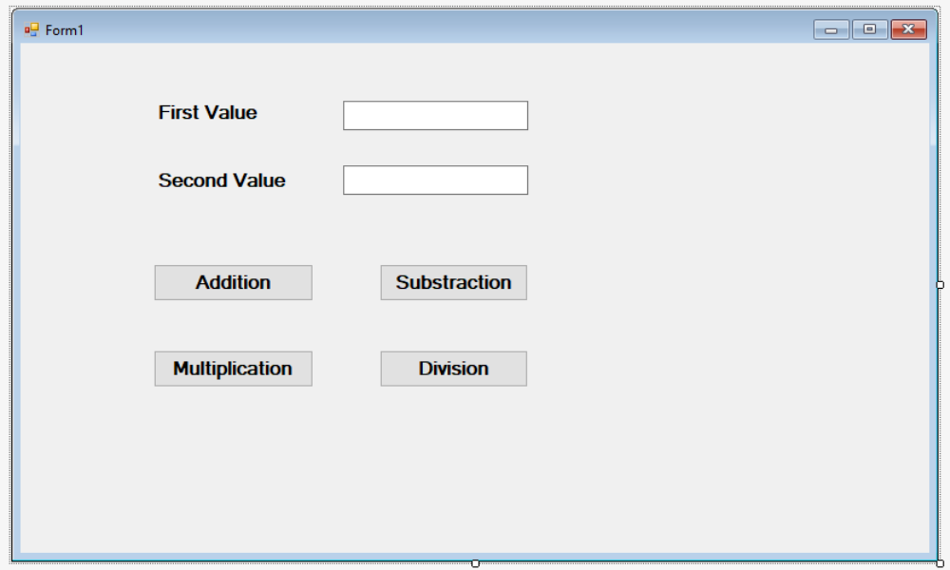
Public Class Form1 Dim n As Integer

Private Sub Button1_Click(sender As Object, e As EventArgs) Handles Button1.Click
n = Val(TextBox1.Text) + Val(TextBox2.Text)
MsgBox("Addition=" & n)
End Sub

Private Sub Button2_Click(sender As Object, e As EventArgs) Handles Button2.Click
n = Val(TextBox1.Text) - Val(TextBox2.Text)
MsgBox("Substraction=" & n)
End Sub

Private Sub Button3_Click(sender As Object, e As EventArgs) Handles Button3.Click
n = Val(TextBox1.Text) * Val(TextBox2.Text)
MsgBox("Multiplication=" & n)
End Sub

Private Sub Button4_Click(sender As Object, e As EventArgs) Handles Button4.Click
n = Val(TextBox1.Text) / Val(TextBox2.Text)
MsgBox("Division=" & n)
End Sub
End Class

Practical No: 04

Module Module1

Sub Main()
Dim n As Integer
Console.WriteLine("Enter a Number")
n = Console.ReadLine()
If (n > 0) Then
Console.WriteLine("Number is Positive")
Else
Console.WriteLine("Number is Negative")
End If
Console.ReadLine()
End Sub

End Module

- Write program for finding greatest among three numbers –

➢ Module Module1
Sub Main()
Dim a, b, c As Integer
Console.Write("Enter the values of a, b and c:")
a = Val(Console.ReadLine())
b = Val(Console.ReadLine())
c = Val(Console.ReadLine())

If (a > b) and (a > c) Then
Console.WriteLine("Greatest Number is:" & a)

ElseIf (b > a) and (b > c) Then
Console.WriteLine("Greatest Number is:" & b)

Else
Console.WriteLine("Greatest Number is:" & c)
End If
Else
Console.ReadLine()
End Sub
End Module

- Implement the program using if-else statement to find the number is even or odd –

Module Module1
Sub Main()
Dim i As Integer
Console.WriteLine("Enter Number")
i = Console.ReadLine()
If ((i Mod 2) = 0) Then
Console.WriteLine("Number is Even")
Else
Console.WriteLine("Number is Odd")
End If
Console.ReadLine()
End Sub
End Module

Practical No: 05

Write a Program using select case statement in VB.NET

Sub Main()
Dim grade As String
Console.WriteLine("Enter Your grade")
grade = Console.ReadLine()
Select Case grade
Case "A"
Console.WriteLine("High Distinction")
Case "A-"
Console.WriteLine("Distinction")
Case "B"
Console.WriteLine("Credit")
Case "C"
Console.WriteLine("Pass")
Case Else
Console.WriteLine("Fail")
End Select
Console.ReadLine()
End Sub

- Implement the program using Select Case statement to count the number of Vowels in A to Z alphabets.

Sub Main()

Dim str As String = "ABCDEFGHIJKLMNOPQRSTUVWXYZ"
Dim numberOfVowels As Integer = 0
For Each c As Char In str

Select Case c
Case "A"c, "E"c, "I"c, "O"c, "U"c
numberOfVowels = numberOfVowels + 1
End Select

Next
Console.WriteLine("Number of vowels: " & numberOfVowels) Console.ReadKey()

End Sub

- Develop a program for performing arithmetic operations –

Sub Main()
Dim N1, N2, Result, choice As Integer
Do
Console.WriteLine("Menu:-\n1.Add\n2.Subtract" & _
"\n3.Multiply\n4.Divide\n5.Exit.")
Console.WriteLine("Enter choice: ")
choice = Console.ReadLine()
Console.WriteLine("Enter number 1: ")
N1 = Console.ReadLine()
Console.WriteLine("Enter number 2: ")
N2 = Console.ReadLine()
Select Case
choice Case 1
Result = N1 + N2 Console.WriteLine("Sum = " & Result)
Case 2
Result = N1 - N2 Console.WriteLine("Difference = " & Result)
Case 3
Result = N1 * N2 Console.WriteLine("Product = " & Result)
Case 4
Result = N1 \ N2
Console.WriteLine("Quotient = " & Result)
Result = N1 Mod N2
Console.WriteLine("Remainder = " & Result)
Case 5
Exit Sub Case Else
Console.WriteLine("Wrong option ...") End Select
Loop While choice = 5
End Sub
End Module

Practical No 06
Write a program using While & Do loop in VB.Net
Sub Main()
Dim a As Integer = 1
While (a < 10)
Console.WriteLine(a)
a = a + 1
End While
Console.ReadLine()
End Sub

For Do loop.

Sub Main()
Dim a As Integer = 1
Do
Console.WriteLine(a)
a = a + 1
Loop While (a<10)
Console.ReadLine()
End Sub
1. Write a program using While statement to print the prime numbers between 1 to 100.
Sub Main()
Dim i, j As Integer
i = 2
While (i <= 100)
j = 2
While (j < i)
If (i Mod j = 0) Then
Exit While
ElseIf (i = j + 1) Then
Console.WriteLine(i)
End If
j = j + 1
End While
i = i + 1
End While
Console.ReadLine()
End Sub
2. Write a program using While statement to print even-odd numbers between 1 to 50.
Sub Main()
Dim i As Integer = 1
While (i <= 50)
If ((i Mod 2) = 0) Then
Console.WriteLine(i & " Even")
Else
Console.WriteLine(i & " Odd")
End If
i = i + 1 End While
Console.ReadLine()
End Sub
End Module

Practical No 07

For Each Loop

Sub Main()

Dim str As String = "ABCDEFGHIJKLMNOPQRSTUVWXYZ"
Dim numberOfVowels As Integer = 0
For Each c As Char In str

Select Case c
Case "A"c, "E"c, "I"c, "O"c, "U"c
numberOfVowels = numberOfVowels + 1
End Select

Next
Console.WriteLine("Number of vowels: " & numberOfVowels) Console.ReadKey()

End Sub
Armstrong Numbers

Sub Main()

Dim num, temp, r, s, t As Integer

Console.WriteLine(" Armstrong Number Between 1 to 500: ")

For num = 1 To 500

temp = num
s = 0

For t = 0 To num
d=0
While(temp>0)
d =d+1
temp = temp \ 10
end while
temp = num
While(temp>0)
r = temp Mod 10
s = s+math.pow(r,d)
temp = temp \ 10
Next

If num = s Then
Console.WriteLine(num)
End If Next

Console.ReadKey()

End Sub

Practical No 08

Write a program to demonstrate the use of Button, Textbox and Label.

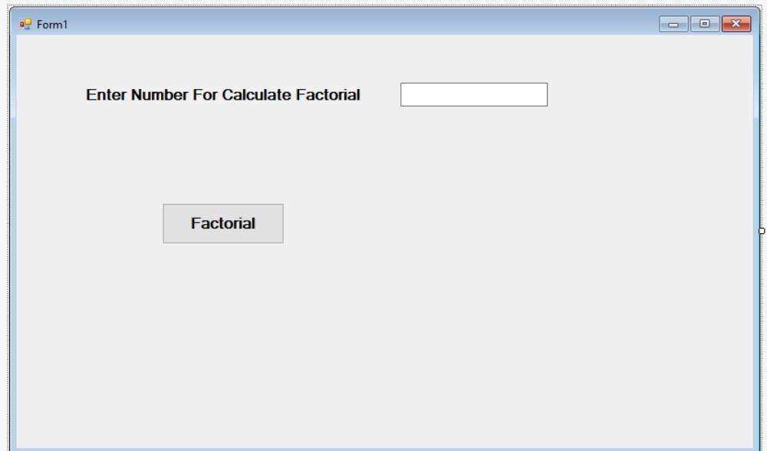
Public Class Form1
Private Function Factorial(ByVal num As Integer)
As Long
Dim fact As Long = 1
Dim i As Integer
For i = 1 To num fact *= i
Next
Factorial = fact
End Function
Private Sub Button1_Click(sender As Object, e As EventArgs) Handles Button1.Click
Dim fact As Long
fact = Factorial(TextBox1.Text)
Msgbox("Factorial of " & TextBox1.Text &
" is " & fact, "Factorial")
End Sub End Class

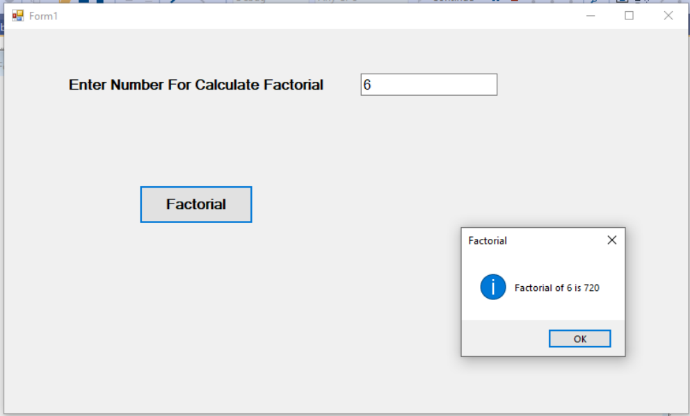
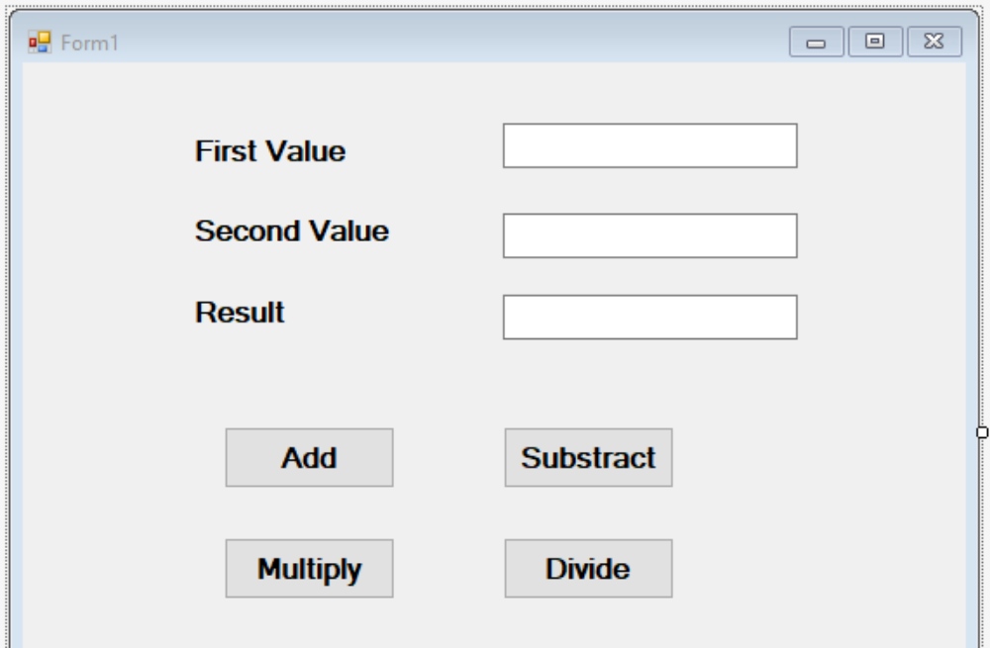

Public Class Form1 Dim n As Integer
Private Sub Button1_Click(sender As Object, e As EventArgs) Handles Button1.Click
n = Val(TextBox1.Text) + Val(TextBox2.Text)
TextBox3.Text = n
End Sub
Private Sub Button2_Click(sender As Object, e As EventArgs) Handles Button2.Click
n = Val(TextBox1.Text) - Val(TextBox2.Text)
TextBox3.Text = n
End Sub
Private Sub Button3_Click(sender As Object, e As EventArgs) Handles Button3.Click
n = Val(TextBox1.Text) * Val(TextBox2.Text)
TextBox3.Text = n
End Sub
Private Sub Button4_Click(sender As Object, e As EventArgs) Handles Button4.Click
n = Val(TextBox1.Text) / Val(TextBox2.Text)
TextBox3.Text = n
End Sub
End Class
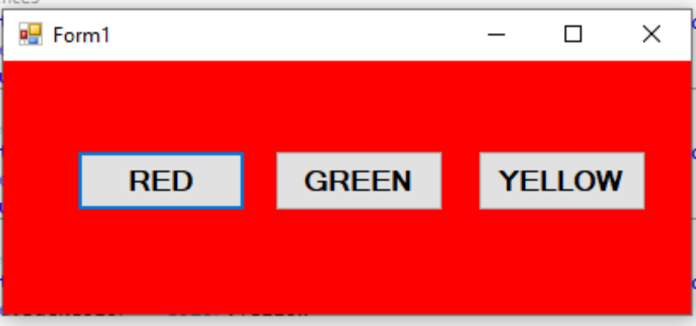
Public Class Form1
Private Sub Button1_Click(sender As Object, e As EventArgs) Handles Button1.Click Me.BackColor = Color.Red
End Sub
Private Sub Button2_Click(sender As Object, e As EventArgs) Handles Button2.Click Me.BackColor = Color.Green
End Sub
Private Sub Button3_Click(sender As Object, e As EventArgs) Handles Button3.Click Me.BackColor = Color.Yellow
End Sub End Class

2. Write the code to generate button at runtime in VB.Net.
➢ Public Class Form1

Private Sub Form1_Load(sender As Object, e As EventArgs) Handles MyBase.Load
Dim Btn As New Button
Btn.size=new size(150,30)
Btn.location=new point(50,40)
b.Text = "Dynamic Button"
Me.Controls.Add(b)
Addhandler btn.click,addressof Btn_click
End Sub
Private sub btn_click()
Msgbox(“New button created”)
End sub
End Class

Practical No 09

- Write the program using RadioButton to change the bulb state ON/OFF.

Public Class Form1
Private Sub RadioButton1_CheckedChanged(sender As Object, e As EventArgs) Handles RadioButton1.CheckedChanged
PictureBox2.Show()
PictureBox1.Hide()
End Sub
Private Sub RadioButton2_CheckedChanged(sender As Object, e As EventArgs) Handles RadioButton2.CheckedChanged
PictureBox1.Show()
PictureBox2.Hide()
End Sub
End Class

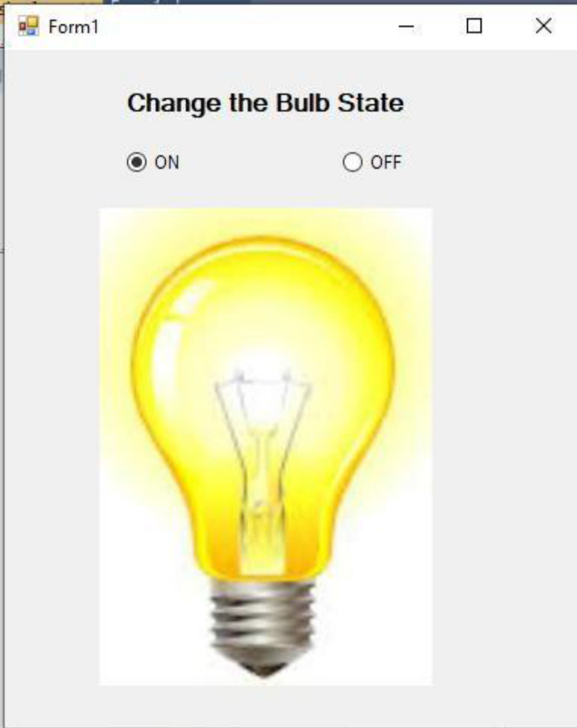
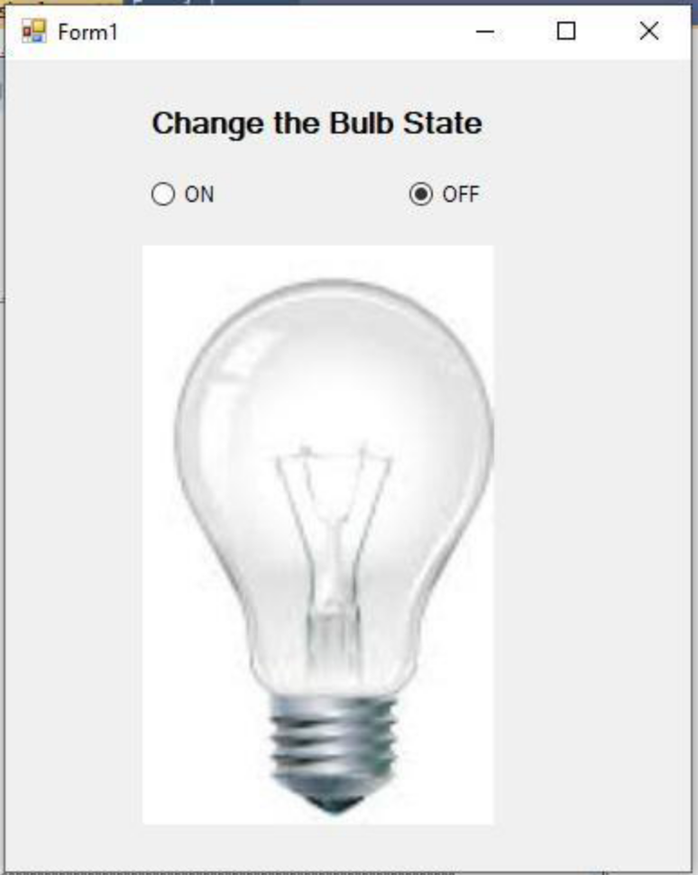

1. Write a program to change the ForeColor of the text in Label using different RadioButtons such Red, Green, Blue.
Public Class Form1
Private Sub RadioButton1_CheckedChanged(sender As Object, e As EventArgs) Handles RadioButton1.CheckedChanged
Label1.ForeColor = Color.Red
End Sub
Private Sub RadioButton2_CheckedChanged(sender As Object, e As EventArgs) Handles RadioButton2.CheckedChanged
Label1.ForeColor = Color.Green
End Sub
Private Sub RadioButton3_CheckedChanged(sender As Object, e As EventArgs) Handles RadioButton3.CheckedChanged
Label1.ForeColor = Color.Blue
End Sub
End Class
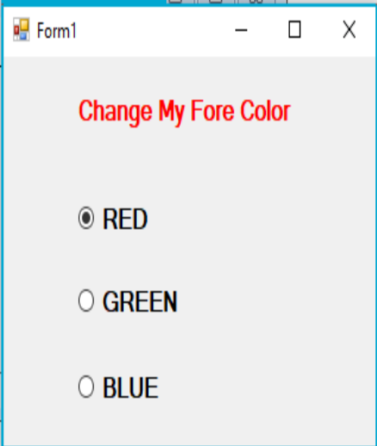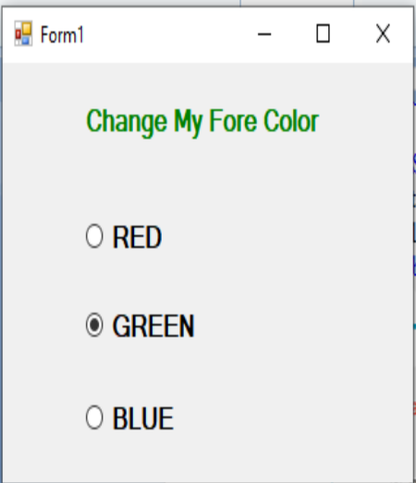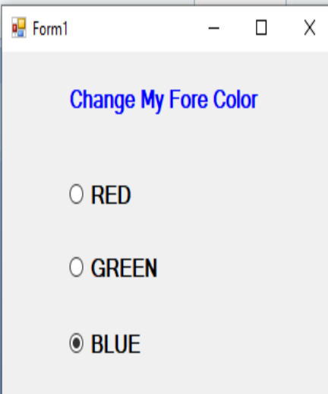

CheckBox

Public Class Form1
Private Sub CheckBox1_CheckedChanged(sender As Object, e As EventArgs) Handles CheckBox1.CheckedChanged
MessageBox.Show("you are select VB.NET") End Sub
Private Sub CheckBox2_CheckedChanged(sender As Object, e As EventArgs) Handles CheckBox2.CheckedChanged
MessageBox.Show("you are select JAVA") End Sub
End Class
OUTPUT :
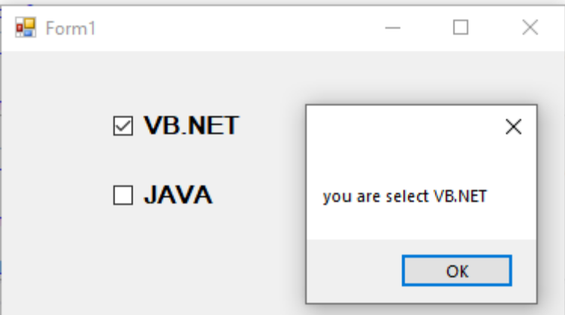

Practical No 10

Write a program to demonstrate the use of ListBox and ComboBox. (Code for Add Items to ListBox & Remove Selected Item from ListBox)

Public Class Form1
Private Sub Button1_Click(sender As Object, e As EventArgs) Handles Button1.Click ListBox1.Items.Add(TextBox1.Text)
TextBox1.Text = "" TextBox1.Focus()
End Sub
Private Sub Button2_Click(sender As Object, e As EventArgs) Handles Button2.Click ListBox1.Items.Remove(ListBox1.SelectedItem)
End Sub
End Class
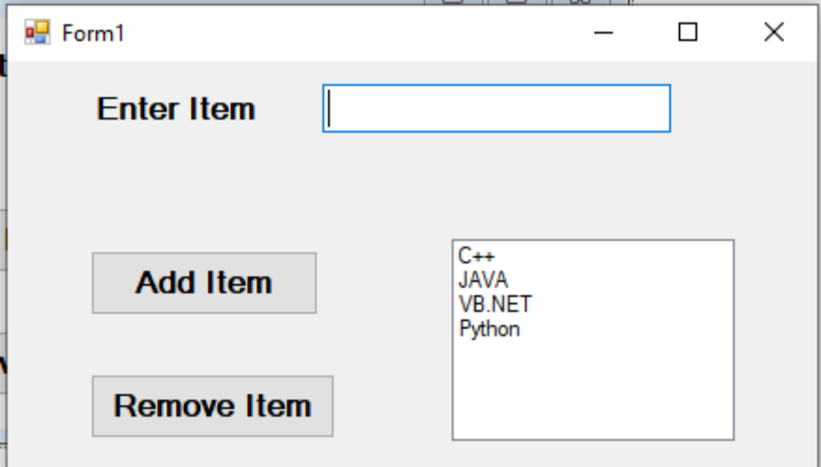

Write the program to select multiple subjects using ListBox control.

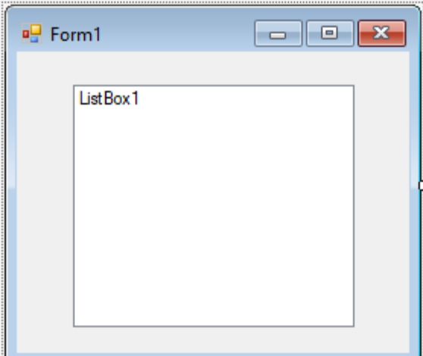

Public Class Form1
Private Sub Form1_Load(sender As Object, e As EventArgs) Handles MyBase.Load ListBox1.
SelectionMode = SelectionMode.MultiSimple
ListBox1.Items.Add("C")
ListBox1.Items.Add("C++")
ListBox1.Items.Add("JAVA")
ListBox1.Items.Add(".NET")
ListBox1.Items.Add("PHP")
ListBox1.Items.Add("Python")
End Sub
End Class

Write the program to select colleges using single ComboBox
Public Class Combo_Box
Private Sub Form1_Load(sender As Object, e As EventArgs) Handles MyBase.Load ComboBox1.Items.Add("MET")
ComboBox1.Items.Add("GGSP")
ComboBox1.Items.Add("KKW") ComboBox1.Items.Add("GP")
End Sub
Private Sub ComboBox1_SelectedIndexChanged(sender As Object, e As EventArgs) Handles ComboBox1.SelectedIndexChanged
MsgBox(ComboBox1.SelectedItem.ToString)
End Sub
End Class
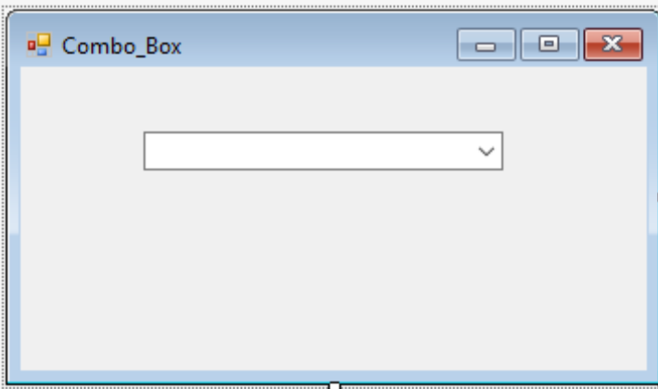

- Write a program to select multiple subjects for single semester.

Public Class Student_Registration
Private Sub Student_Registration_Load(sender As Object, e As EventArgs) Handles MyBase.Load
ComboBox1.Items.Add("First Semester")
ComboBox1.Items.Add("Second Semester")
ComboBox1.Items.Add("Third Semester")
ComboBox1.Items.Add("Fourth Semester")
End Sub
Private Sub ComboBox1_SelectedIndexChanged(sender As Object, e As EventArgs) Handles ComboBox1.SelectedIndexChanged
If (ComboBox1.SelectedIndex = 0) Then
ListBox1.Items.Clear() ListBox1.Items.Add("Chemistry")
ListBox1.Items.Add("Physics")
ListBox1.Items.Add("Maths")
ListBox1.Items.Add("English")
End If

If (ComboBox1.SelectedIndex = 1) Then
ListBox1.Items.Clear()
ListBox1.Items.Add("PIC")
ListBox1.Items.Add("Maths")
ListBox1.Items.Add("CHM") ListBox1.Items.Add("WPD")
End If
If (ComboBox1.SelectedIndex = 2) Then
ListBox1.Items.Clear()
ListBox1.Items.Add("DBM")
ListBox1.Items.Add("OOP")
ListBox1.Items.Add("CGR")
ListBox1.Items.Add("DSU")
End If
If (ComboBox1.SelectedIndex = 3) Then
ListBox1.Items.Clear()
ListBox1.Items.Add("JPR")
ListBox1.Items.Add("DCC")
ListBox1.Items.Add("GUI")
ListBox1.Items.Add("SEN")
End If
End Sub
End Class

