Standard Operating Procedure — eng_02

Tools and Materials
- Sewing machine
- Sewing thread
- Schmetz Universal needles
- Bobbin
- Fabric scissors
- Straight ruler
- Tape measure
- Seam ripper
- Gutermann 100% polyester thread

Safety Points
- None mentioned in transcript

Procedure Steps
1. Plug the power cord into the machine (at 35.2s)
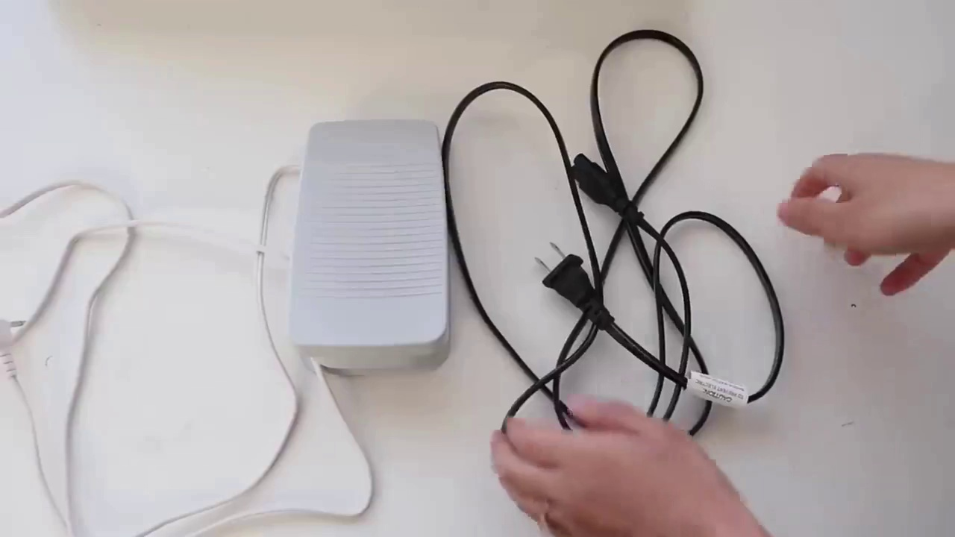
Selected image: eng_02-Scene-004-01.jpg
2. Turn the machine on (at 49.3s)
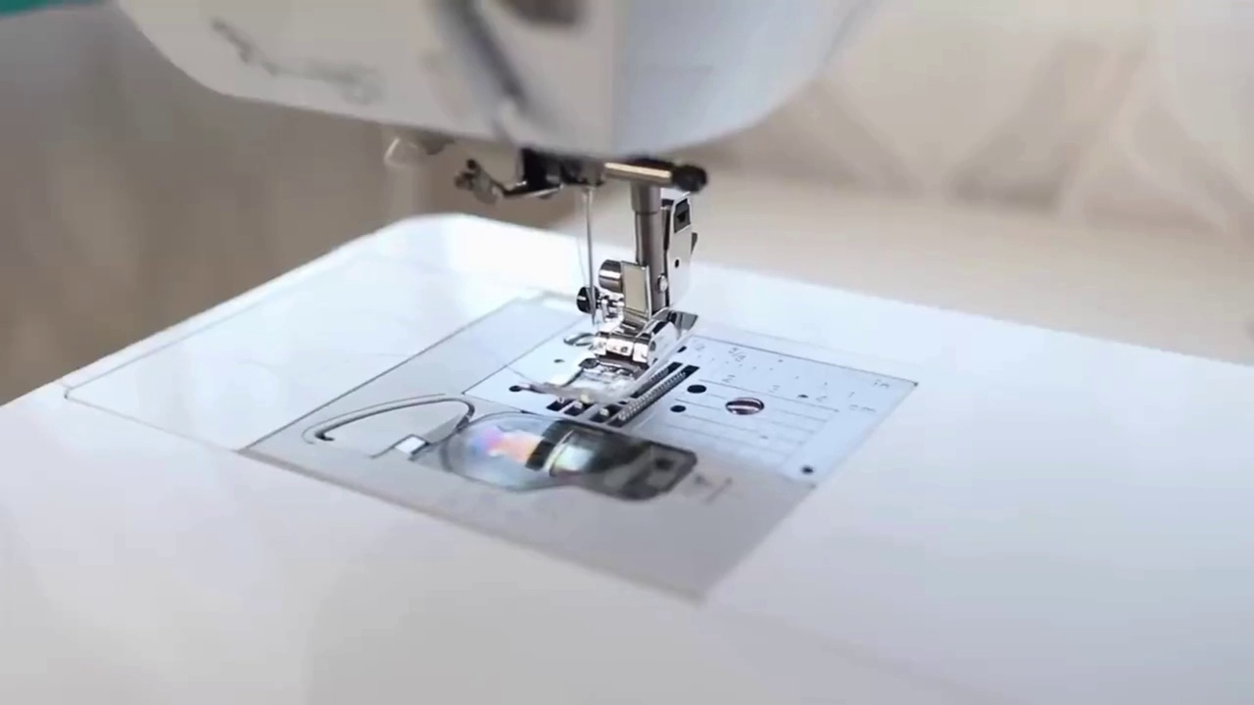
Selected image: eng_02-Scene-005-01.jpg
3. Reach hand behind to press lever to release foot (at 104.7s)
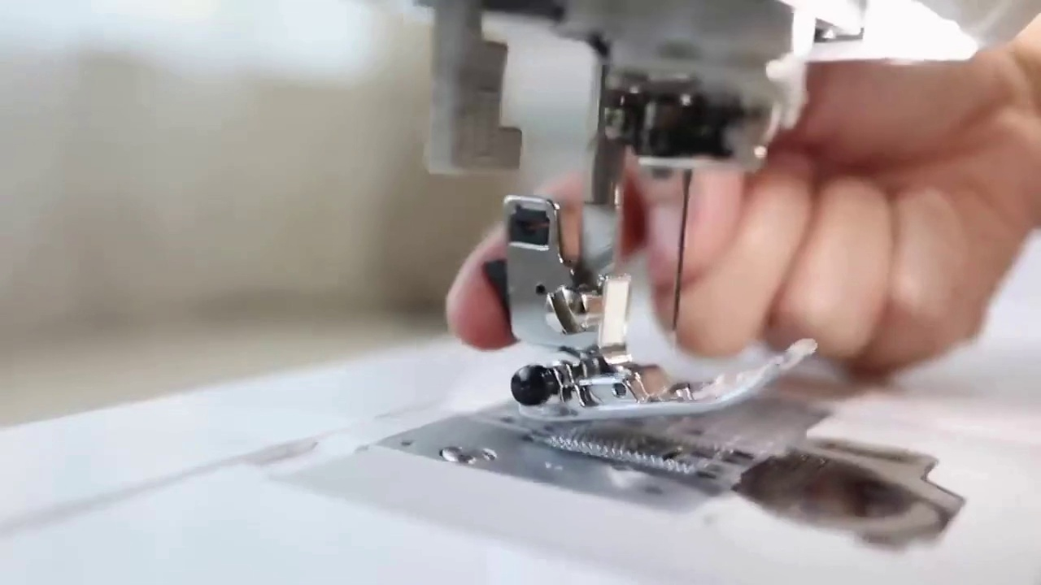
Selected image: eng_02-Scene-009-01.jpg
4. Slide presser foot underneath and push middle bar until it clicks in place (at 109.6s)
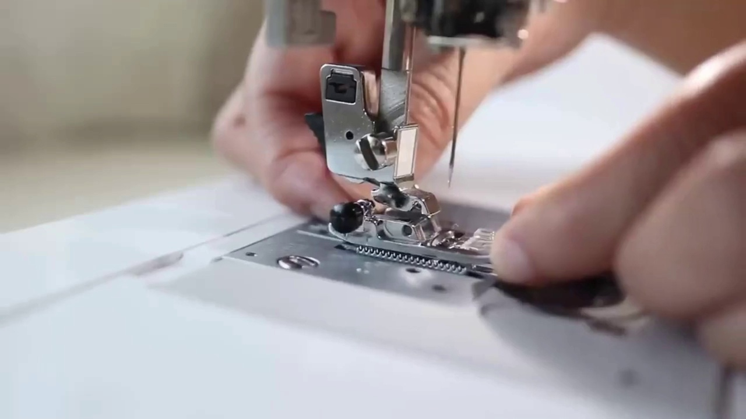
Selected image: eng_02-Scene-010-01.jpg
5. Raise and lower presser foot by reaching to back and pulling down or pushing up lever (at 124.1s)
Selected image: eng_02-Scene-010-01.jpg
6. Grab your empty bobbin (at 164.6s)
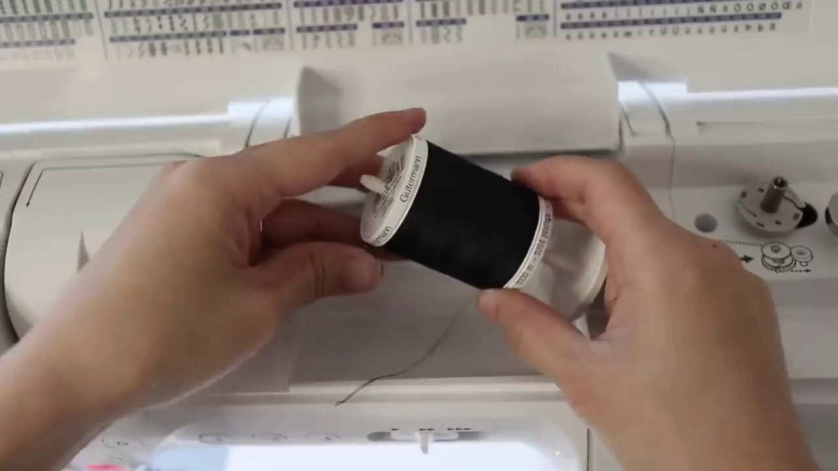
Selected image: eng_02-Scene-013-01.jpg
7. Place bobbin on stub (at 183.7s)
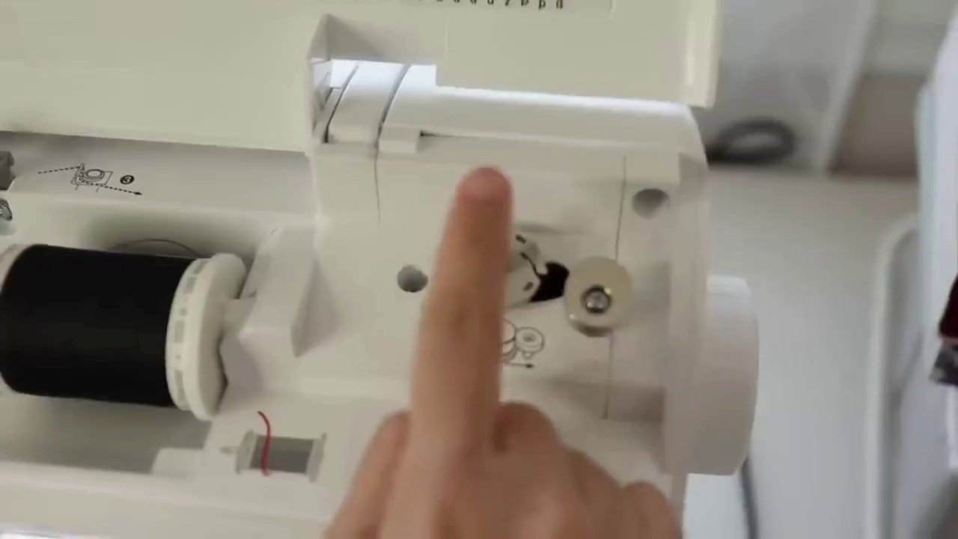
Selected image: eng_02-Scene-014-01.jpg
8. Turn the handwheel to enable bobbin threading (at 195.3s)
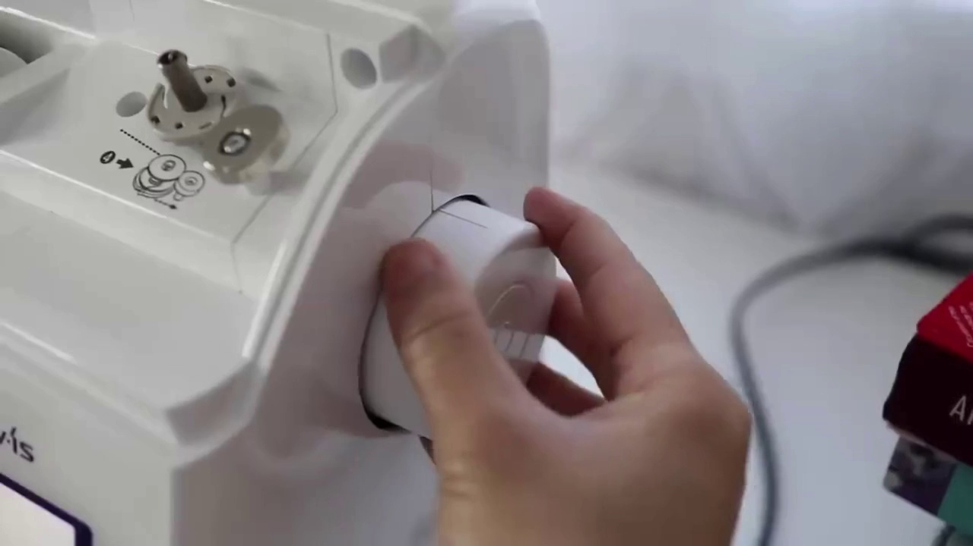
Selected image: eng_02-Scene-015-01.jpg
9. Follow the arrow to bring the thread around the bobbin (at 204.7s)
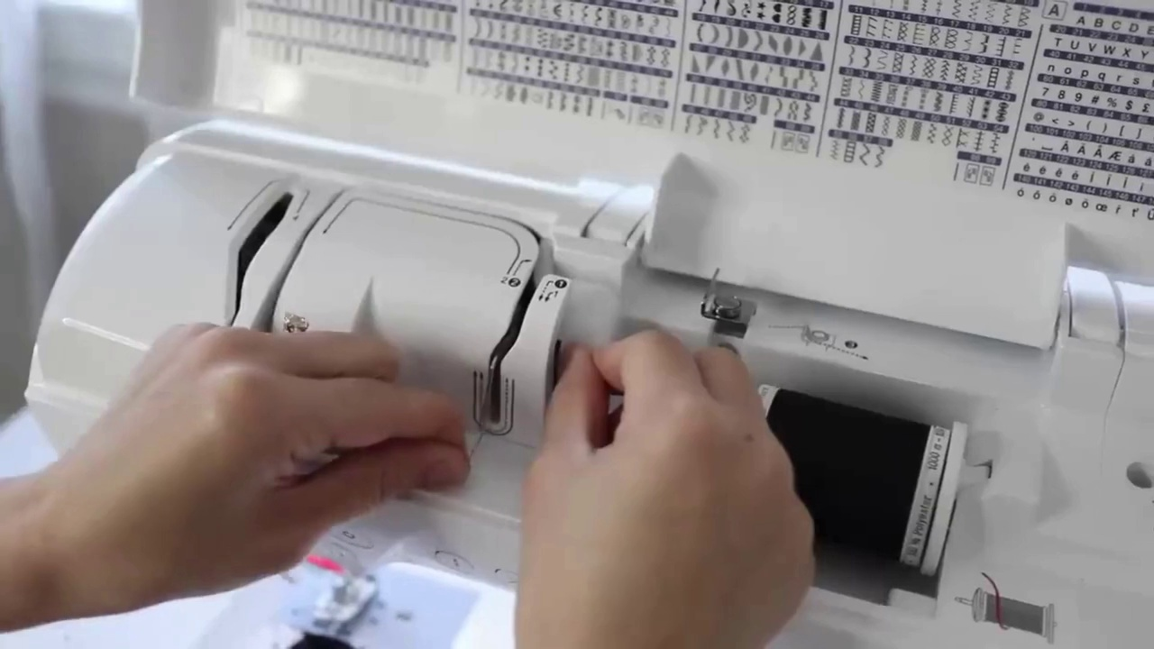
Selected image: eng_02-Scene-016-01.jpg
10. Wrap the thread around the bobbin a few times (at 210.9s)
Selected image: eng_02-Scene-016-01.jpg
11. Use the thread cutter after wrapping (at 226.5s)
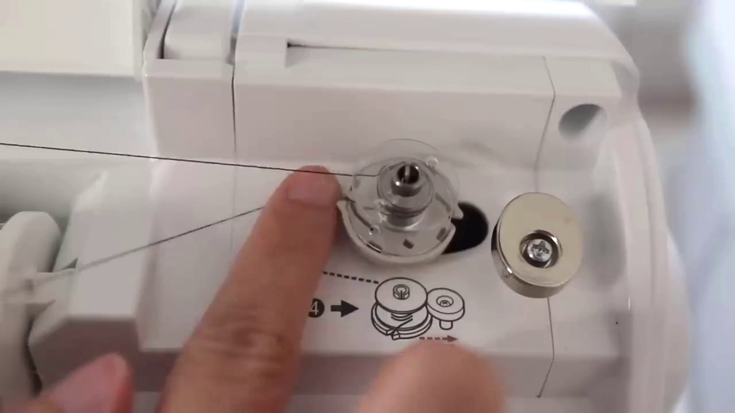
Selected image: eng_02-Scene-017-01.jpg
12. Place the thread in one of the bobbin holes (at 231.1s)
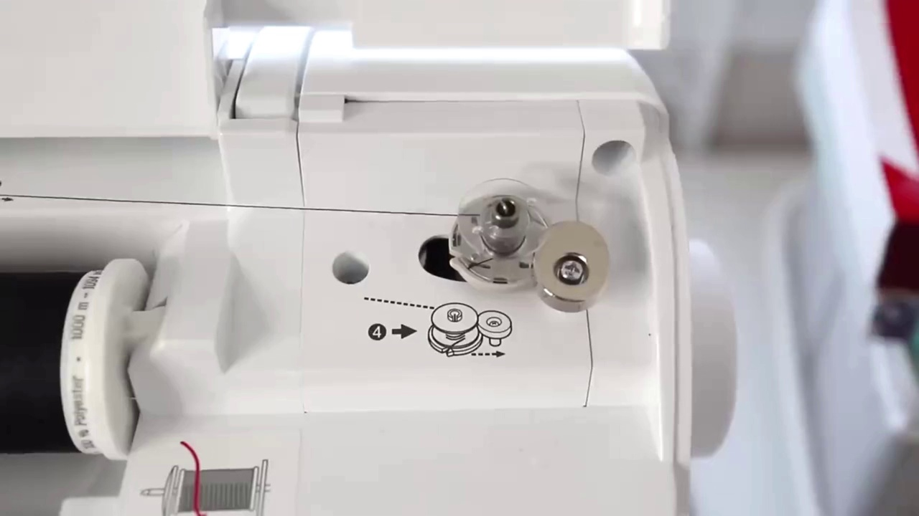
Selected image: eng_02-Scene-018-01.jpg
13. Step on the foot pedal to start winding the bobbin (at 241.2s)
Selected image: eng_02-Scene-018-01.jpg
14. Switch the stub to the other side when the bobbin is full (at 253.7s)
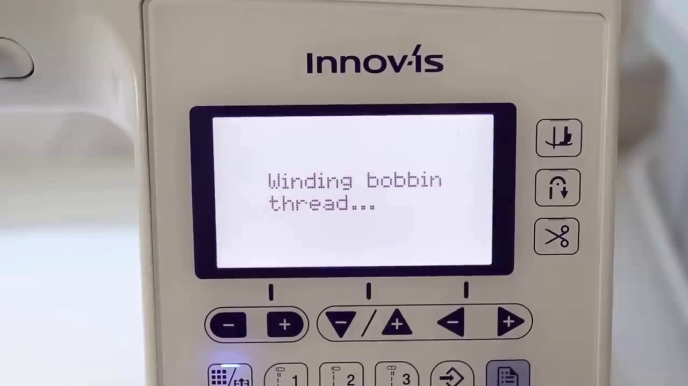
Selected image: eng_02-Scene-019-01.jpg
15. Pull out thread from the bobbin (at 264.9s)
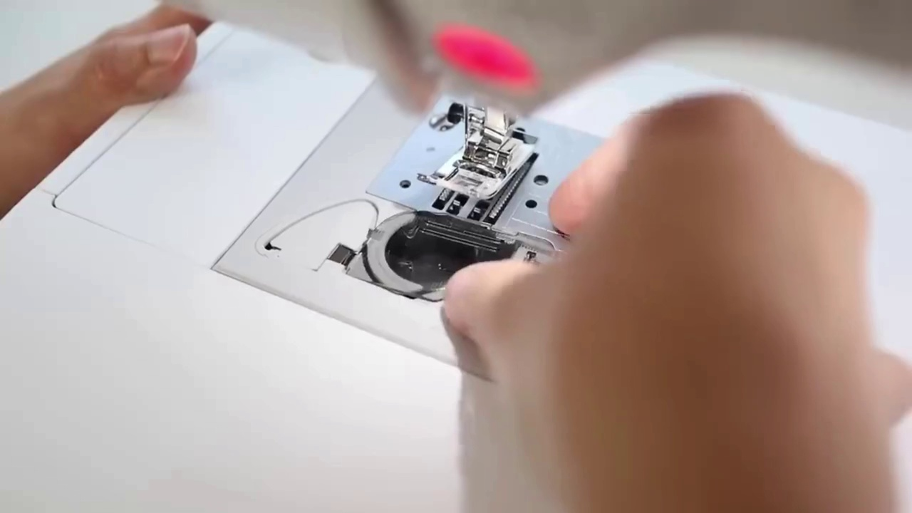
Selected image: eng_02-Scene-020-01.jpg
16. Turn hand wheel to move the metal hook up (at 294.0s)
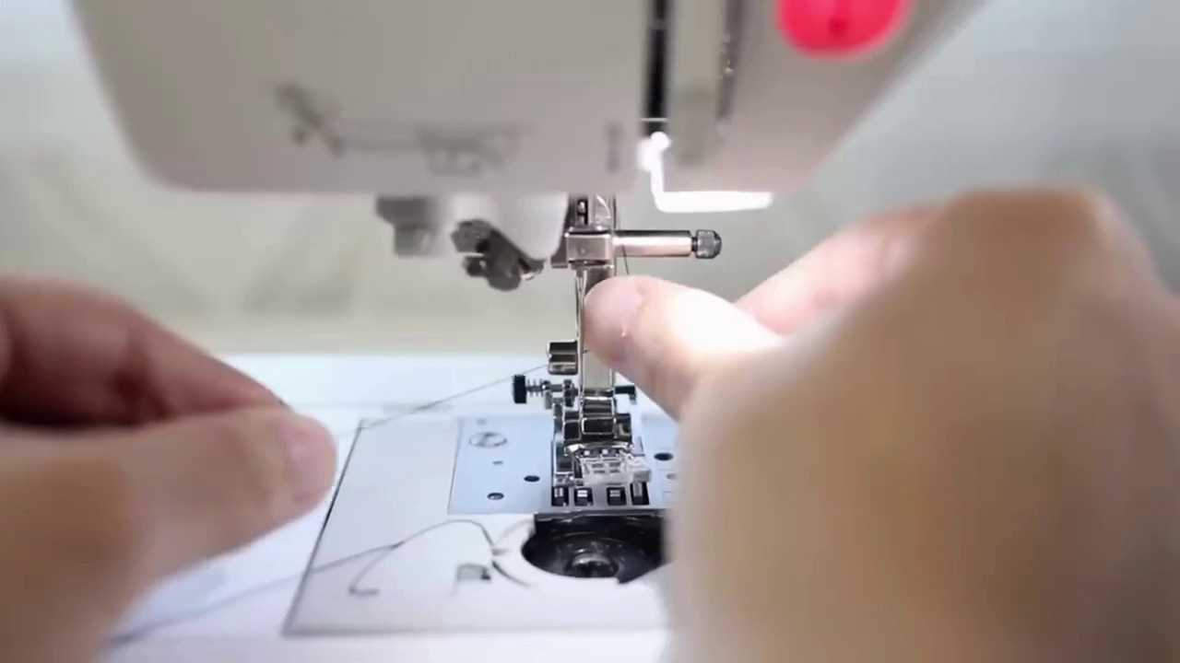
Selected image: eng_02-Scene-023-01.jpg
17. Bring thread down to the needle and secure behind the hook (at 298.4s)
Selected image: eng_02-Scene-023-01.jpg
18. Hold thread with left hand (at 308.1s)
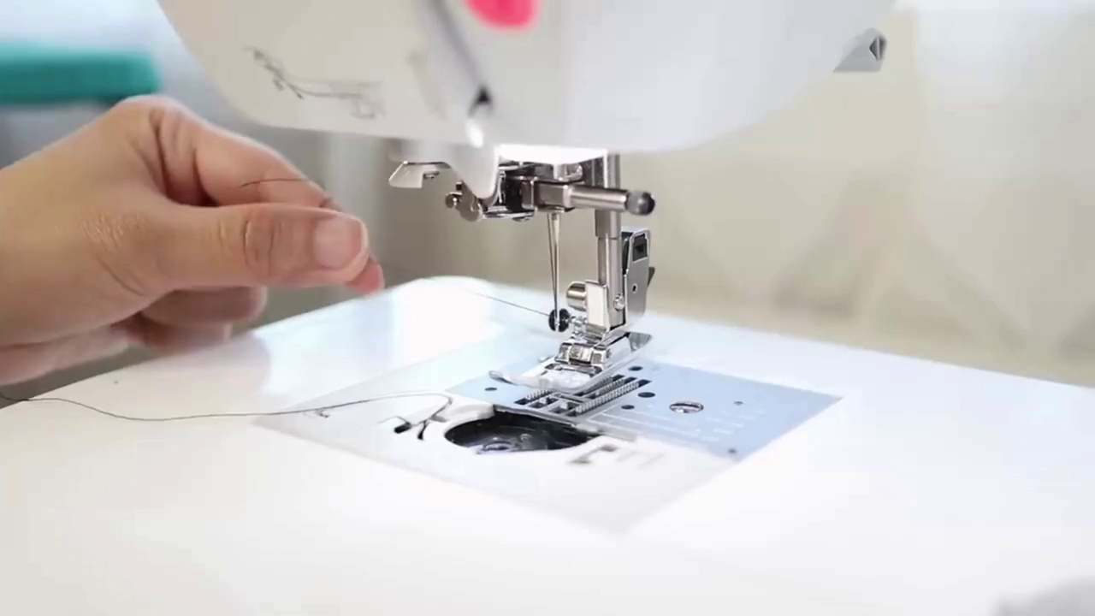
Selected image: eng_02-Scene-024-01.jpg
19. Turn hand wheel with right hand (at 313.6s)
Selected image: eng_02-Scene-024-01.jpg
20. Tug top thread while turning wheel (at 318.1s)
Selected image: eng_02-Scene-024-01.jpg
21. Pull bobbin thread up with left hand (at 323.1s)
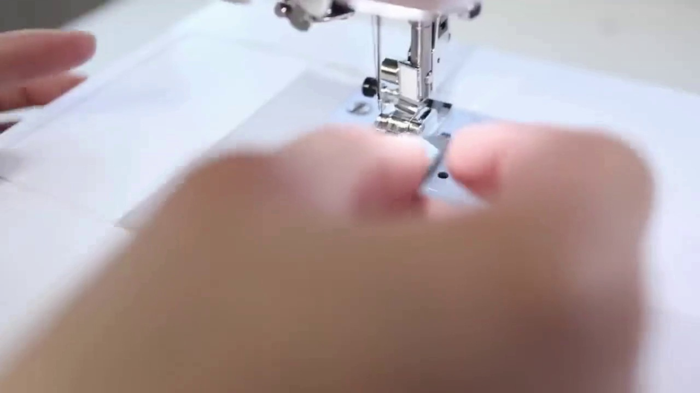
Selected image: eng_02-Scene-025-01.jpg
22. Lower presser foot after sewing to the corner (at 436.5s)
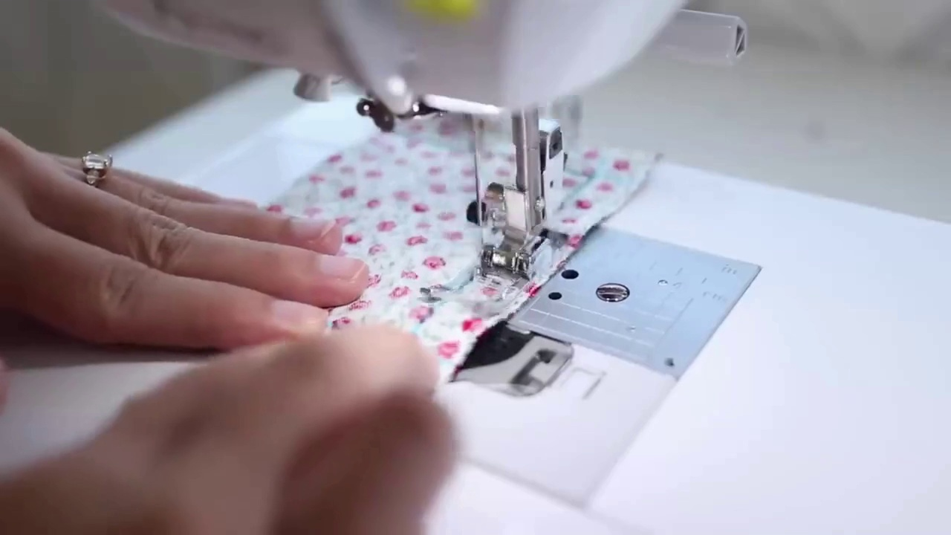
Selected image: eng_02-Scene-032-01.jpg
23. Turn fabric and continue sewing (at 440.0s)
Selected image: eng_02-Scene-032-01.jpg
24. Slide fabric under presser foot (at 464.5s)
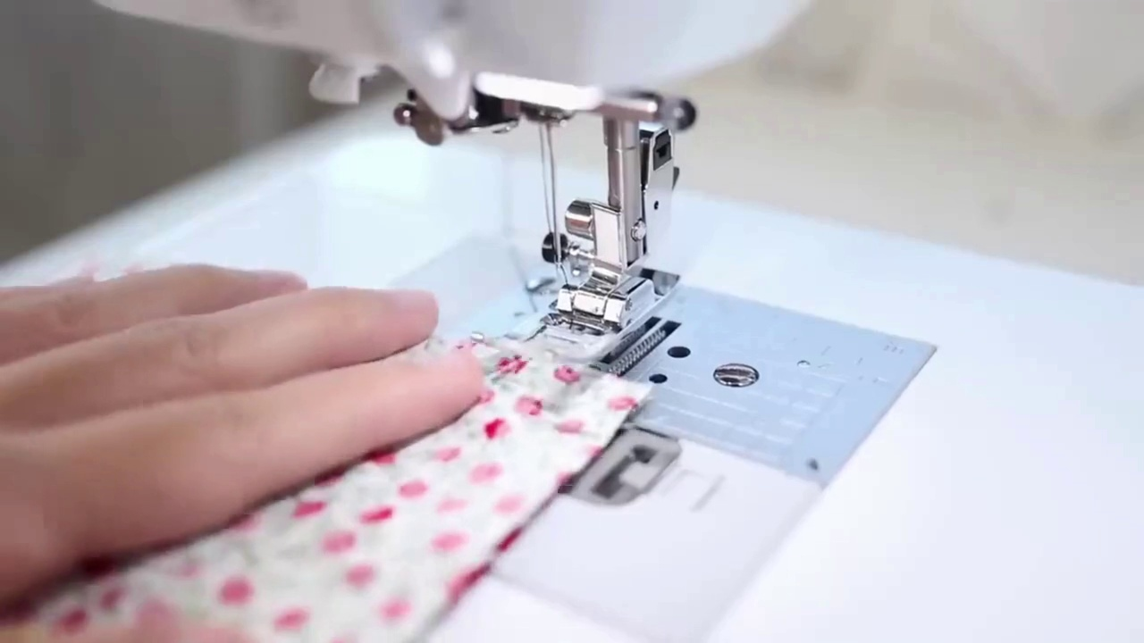
Selected image: eng_02-Scene-034-01.jpg
25. Align fabric with seam allowance (at 468.9s)
Selected image: eng_02-Scene-034-01.jpg
26. Mark seam lines with chalk or disappearing ink pen (at 476.5s)
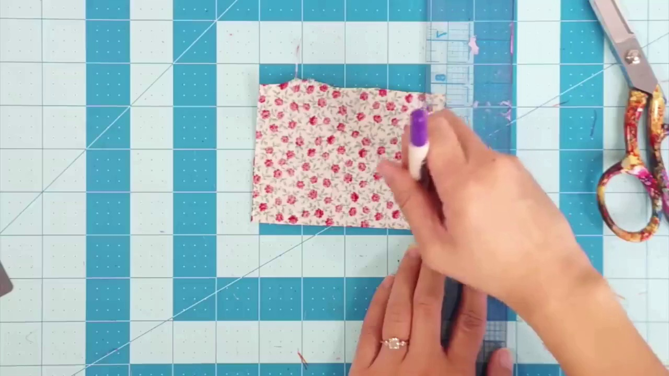
Selected image: eng_02-Scene-035-01.jpg
27. Measure from the needle to the seam allowance (at 514.2s)
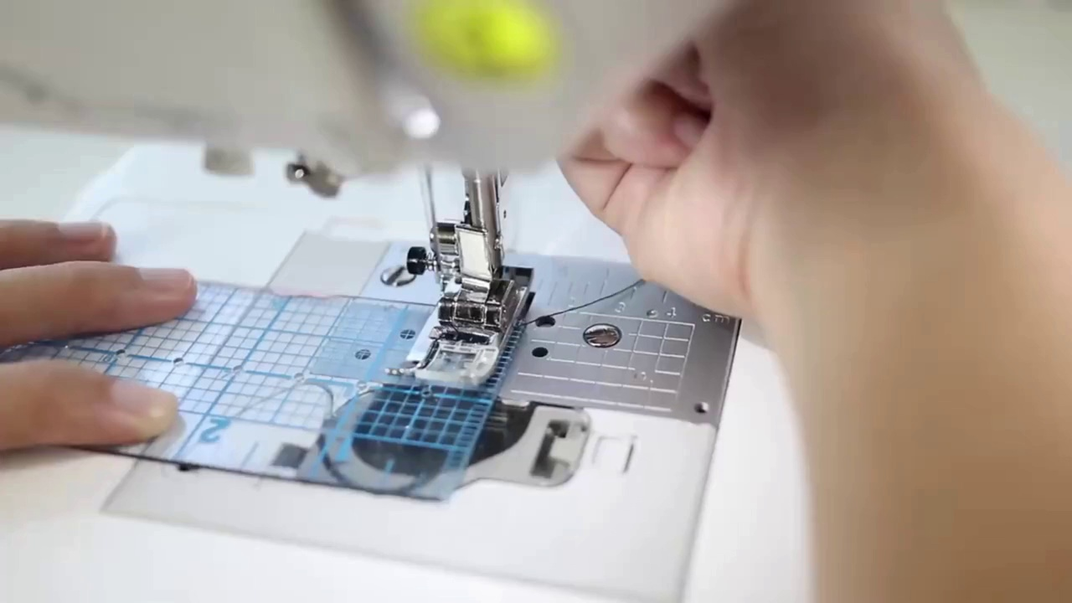
Selected image: eng_02-Scene-038-01.jpg
28. Back stitch whenever you start sewing (at 545.8s)
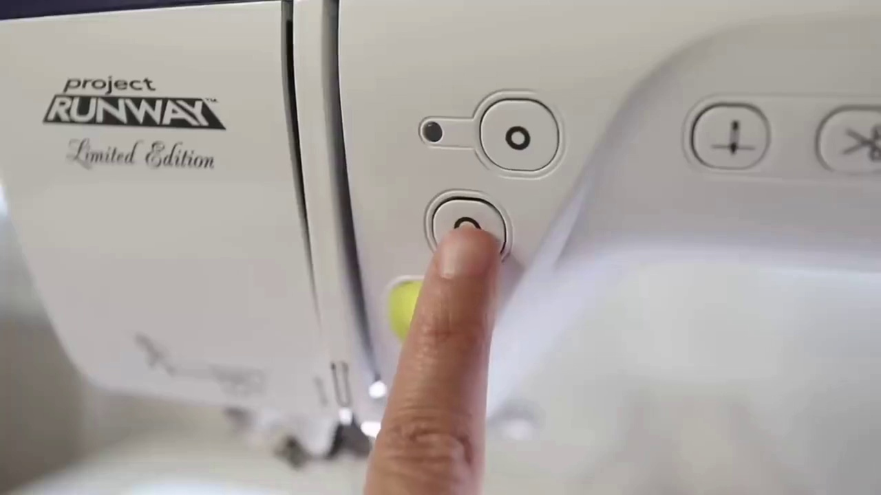
Selected image: eng_02-Scene-041-01.jpg
29. Back stitch at the end when you finish sewing (at 553.6s)
Selected image: eng_02-Scene-041-01.jpg
30. Sew a couple stitches forward by stepping on your foot pedal (at 565.4s)
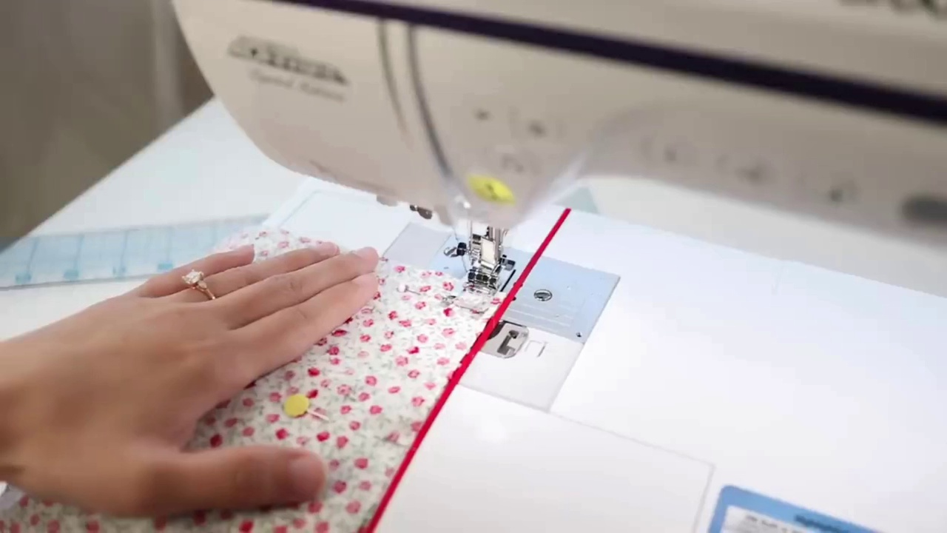
Selected image: eng_02-Scene-042-01.jpg
31. Sew a few stitches back by holding the back stitch button (at 570.7s)
Selected image: eng_02-Scene-042-01.jpg
32. Continue sewing the rest of your seam forward (at 574.5s)
Selected image: eng_02-Scene-042-01.jpg

