Standard Operating Procedure — eng_01

Tools and Materials
- Ultrasound machine
- Probe

Safety Points
- None mentioned in transcript

Procedure Steps
1. Demonstrate on arm (at 16.2s)
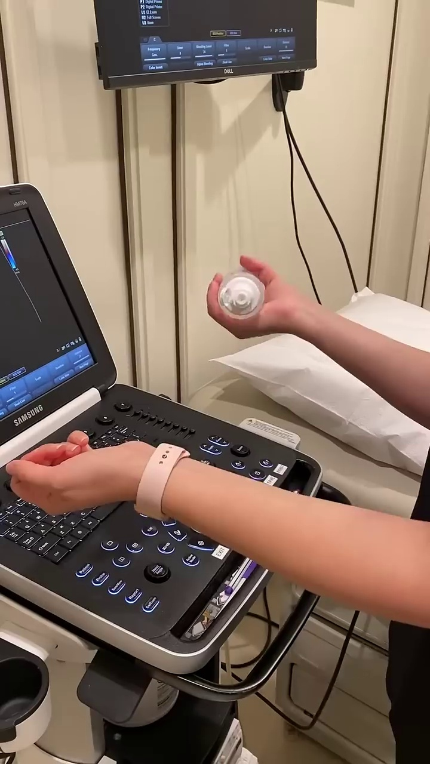
Selected image: eng_01-Scene-002-01.jpg

