Standard Operating Procedure — eng_03

Tools and Materials
- 2x4 lumber
- Drill
- Jackery Explorer 1000
- Caster
- One-by-fours
- Planer
- Jigsaw

Safety Points
- None mentioned in transcript

Procedure Steps
1. Fire up the drills (at 89.3s)
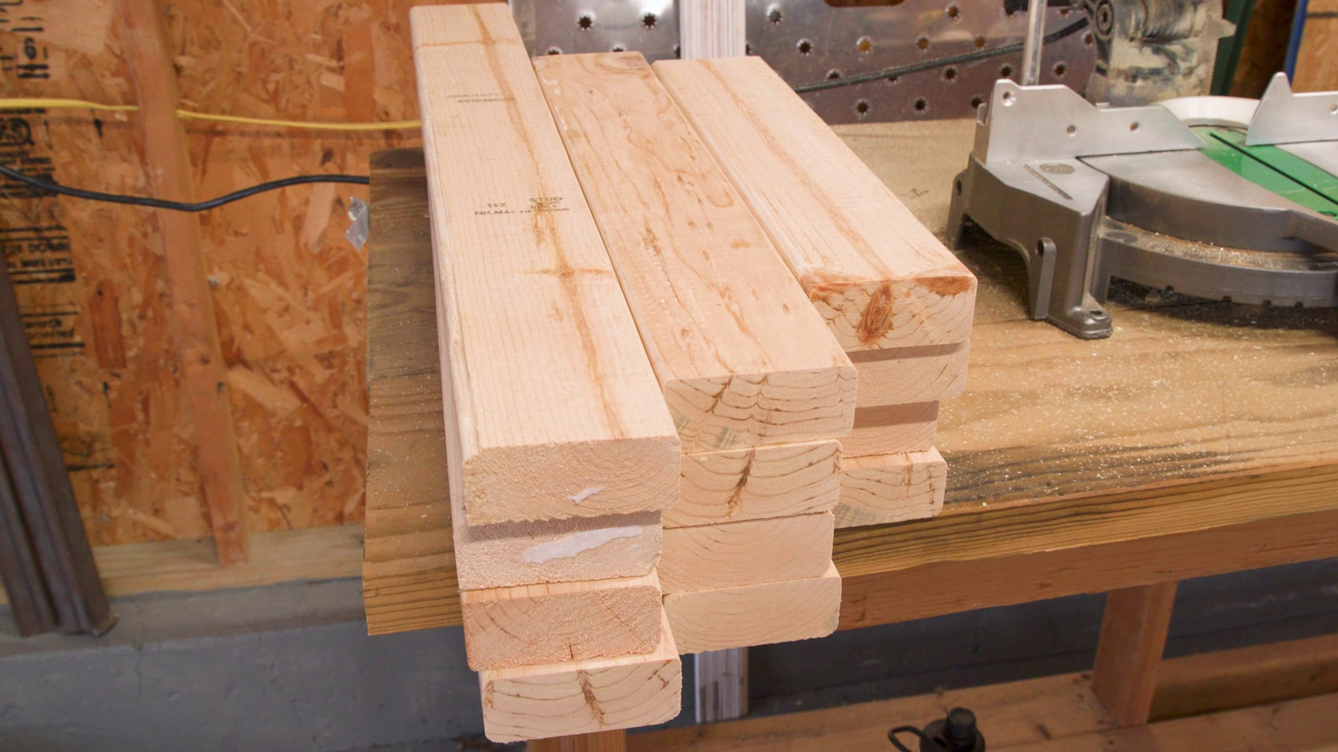
Selected image: eng_03-Scene-006-03.jpg
2. Get started by making the two side sub-assemblies (at 91.9s)
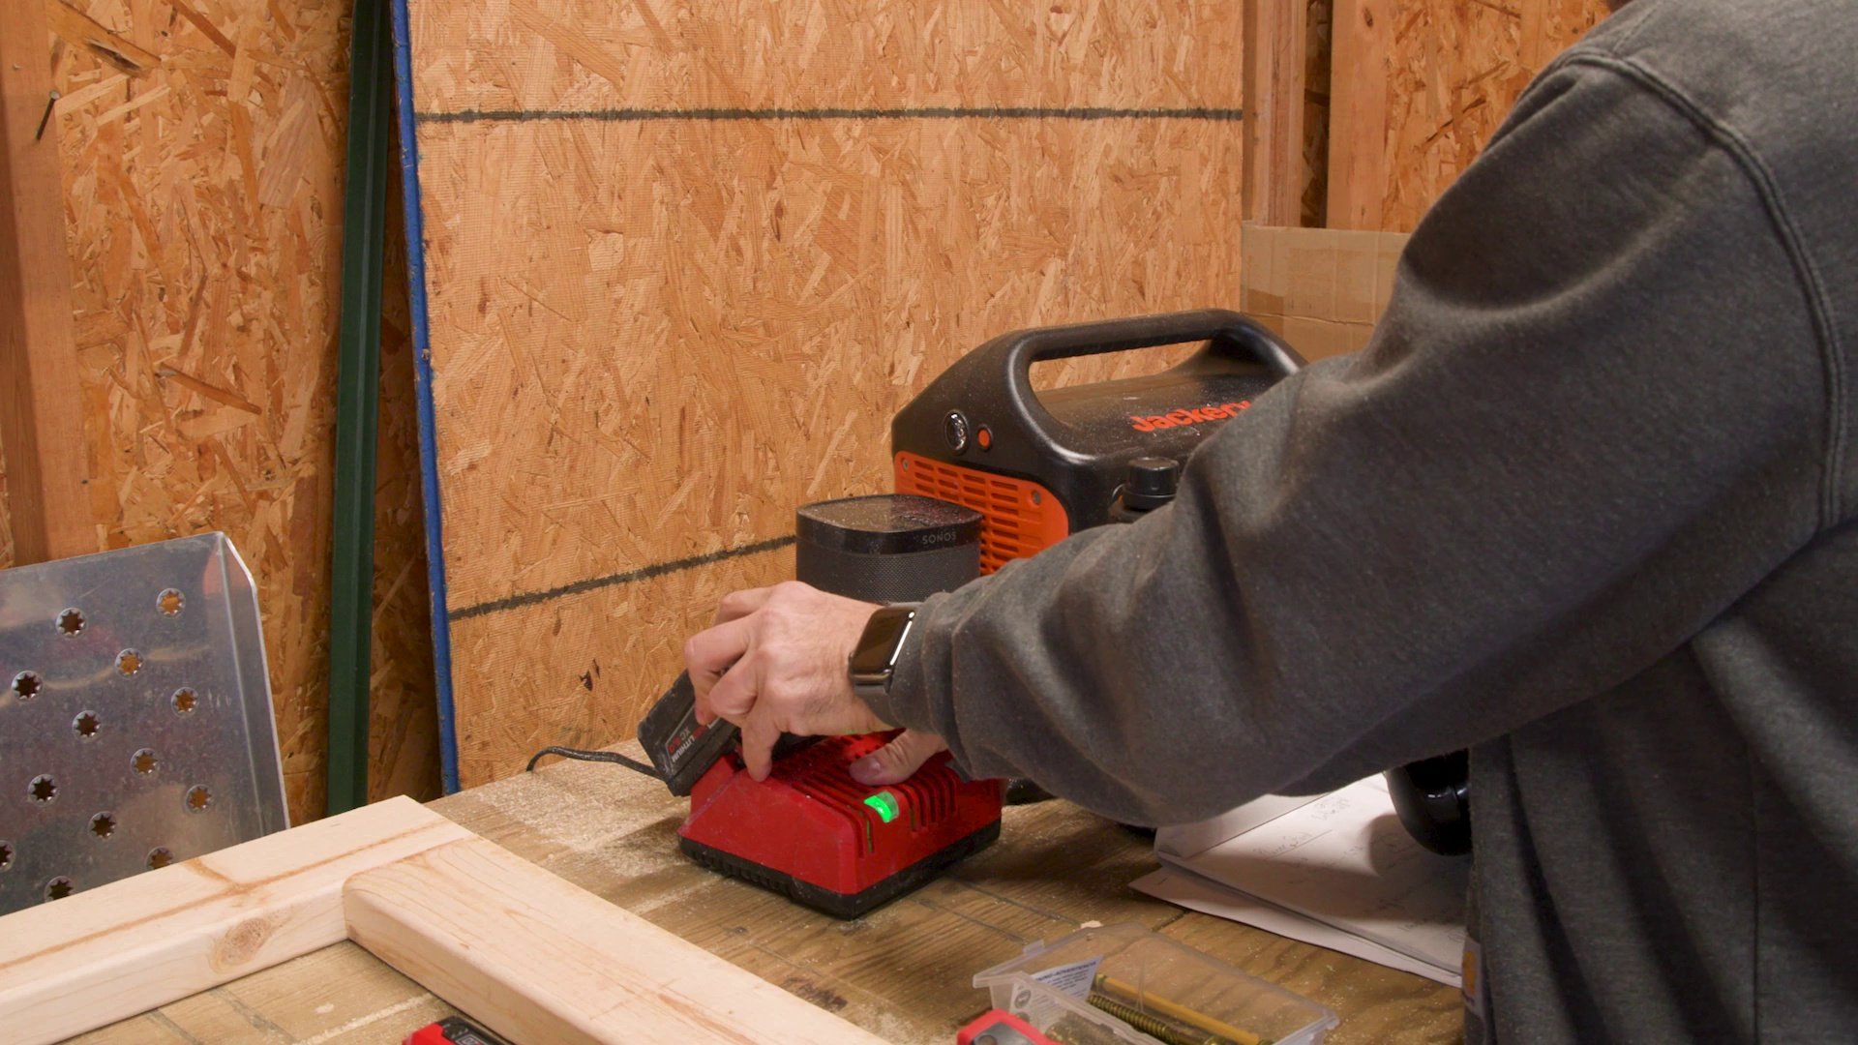
Selected image: eng_03-Scene-007-01.jpg
3. Jam screws in from the outside (at 100.5s)
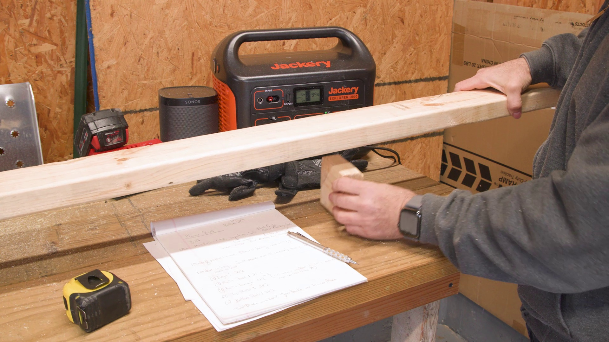
Selected image: eng_03-Scene-006-02.jpg
4. Mark screw locations (at 106.0s)
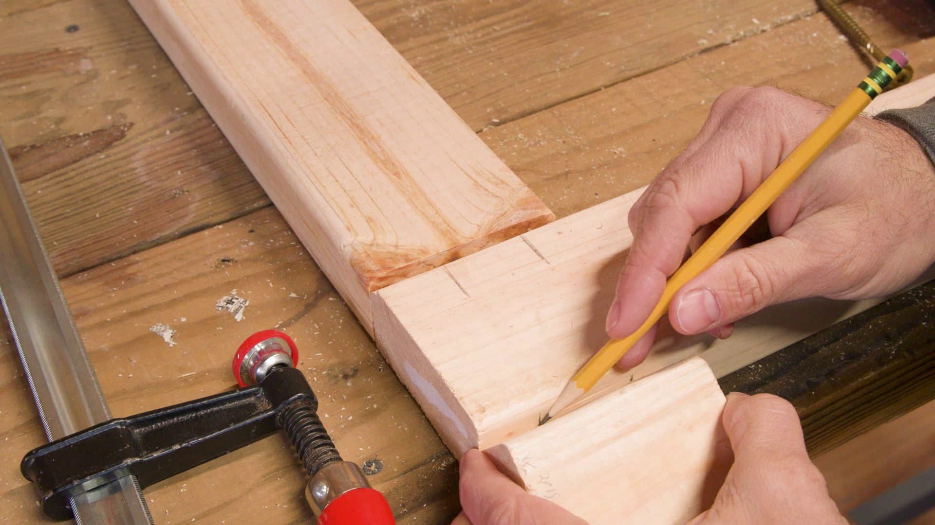
Selected image: eng_03-Scene-007-03.jpg
5. Drill pilot holes from the outside (at 111.9s)
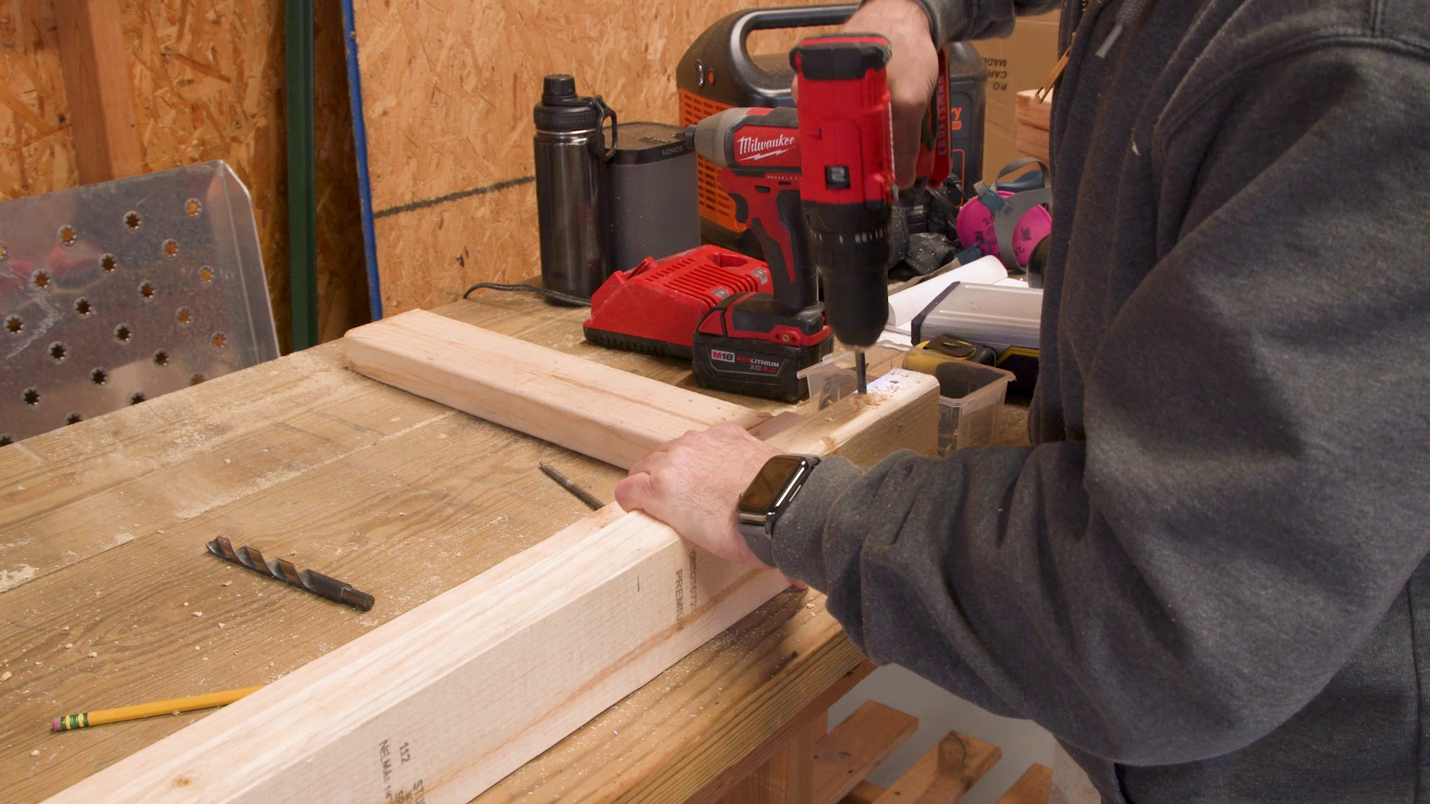
Selected image: eng_03-Scene-008-02.jpg
6. Use larger bit to counterbore about an inch down (at 125.5s)
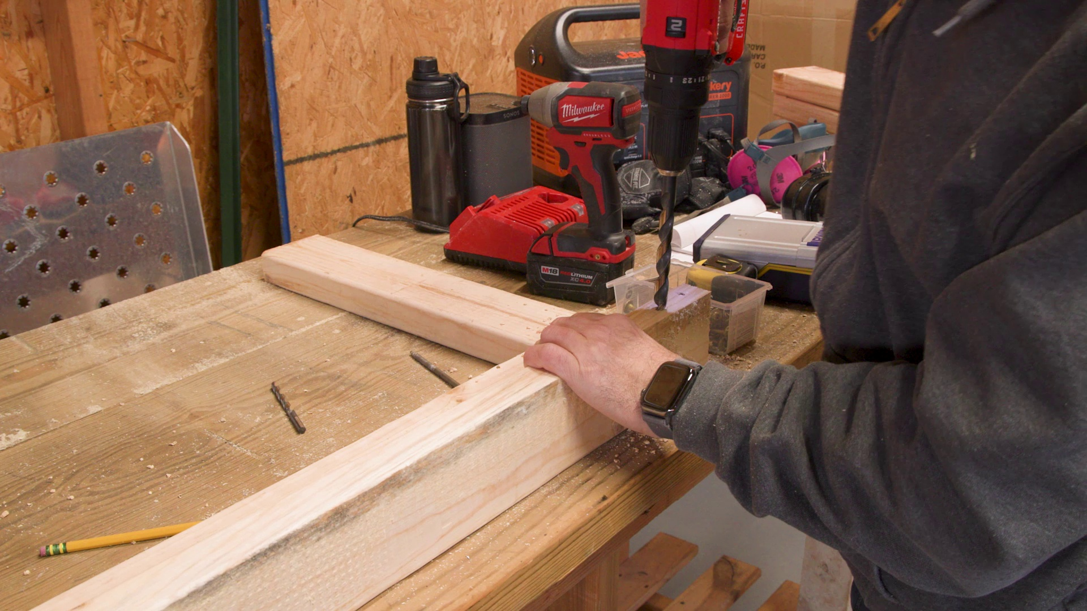
Selected image: eng_03-Scene-008-03.jpg
7. Apply glue to each joint (at 136.5s)
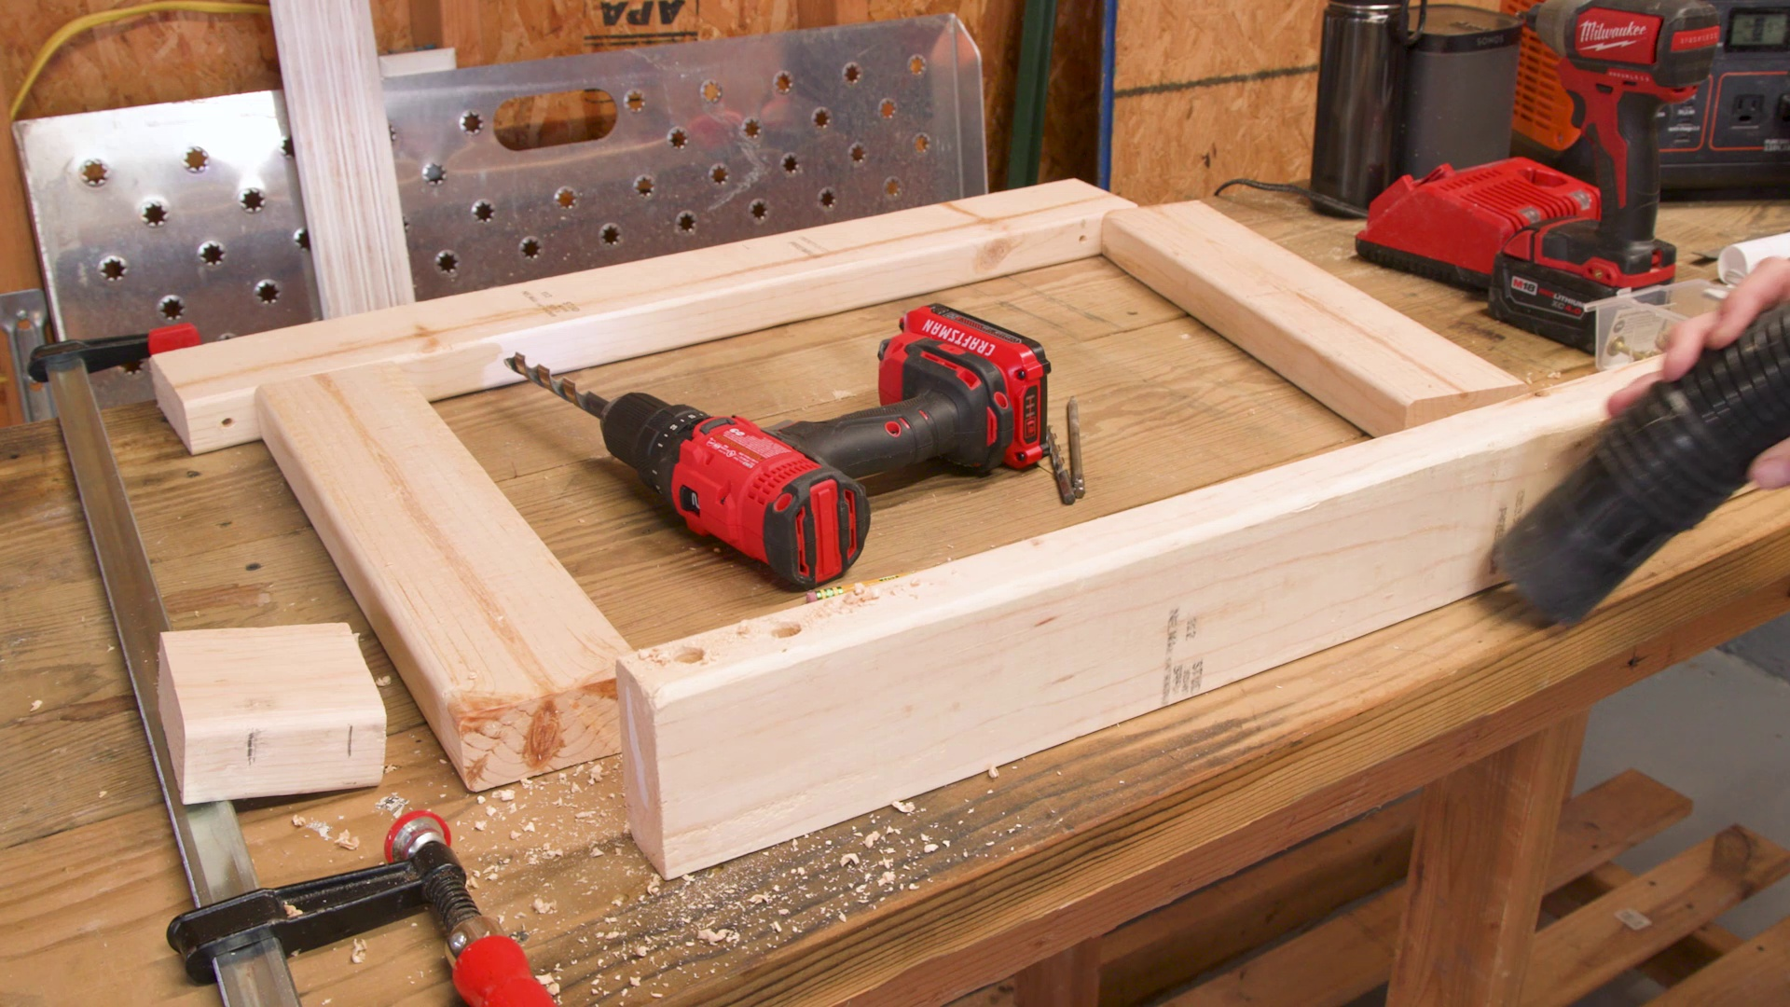
Selected image: eng_03-Scene-009-02.jpg
8. Carefully locate the screw holes (at 188.8s)
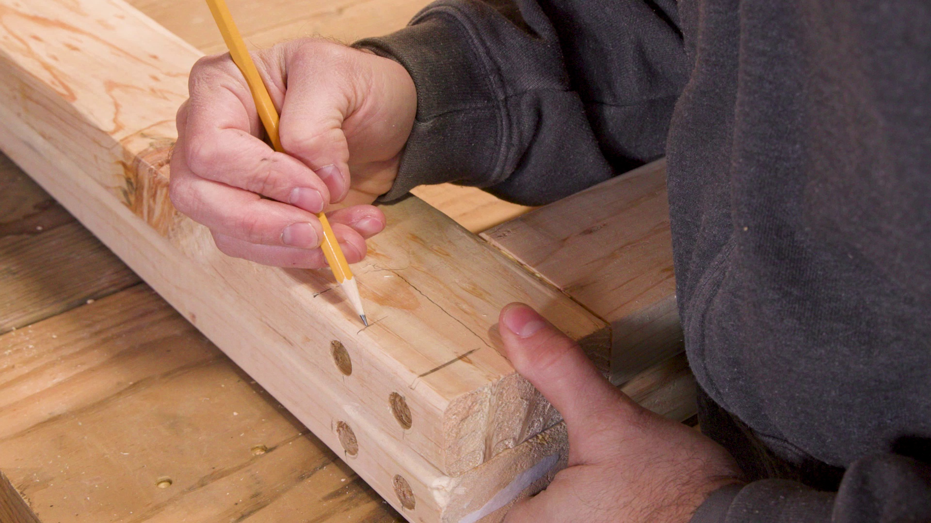
Selected image: eng_03-Scene-012-02.jpg
9. Start one side at a time (at 201.3s)
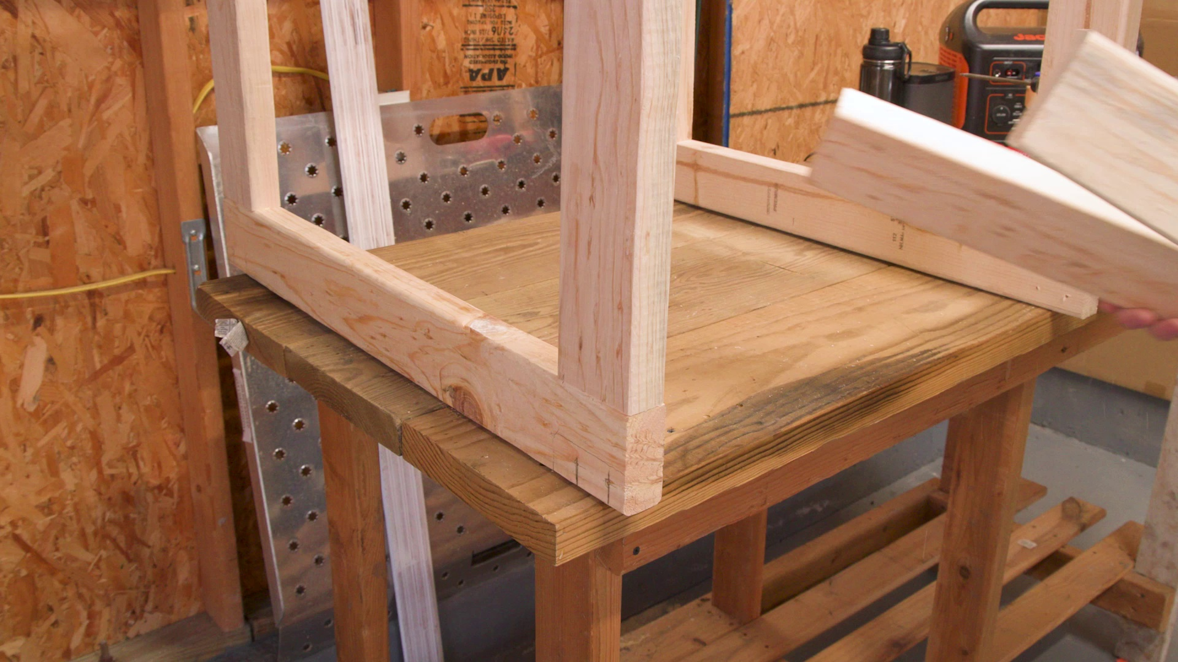
Selected image: eng_03-Scene-013-02.jpg
10. Keep things from shifting (at 216.9s)
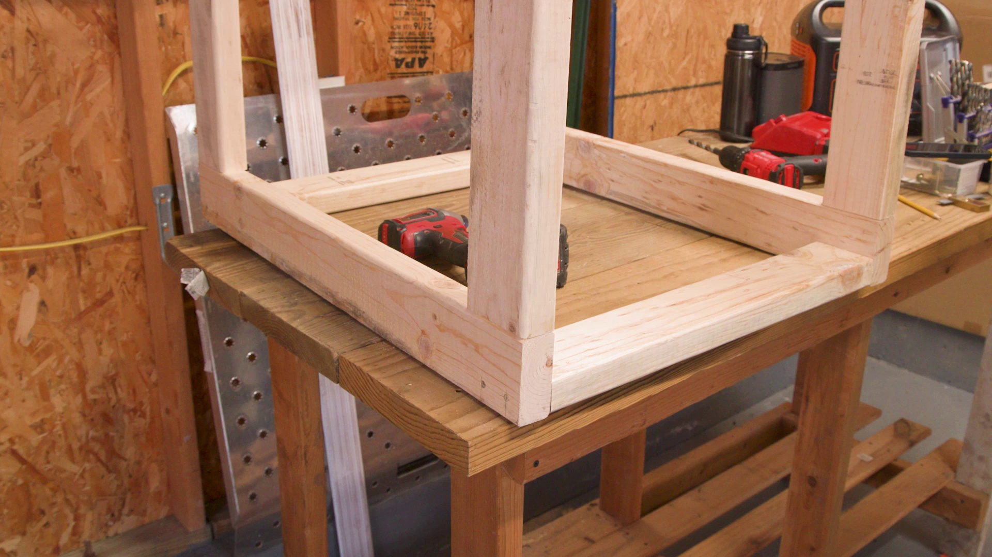
Selected image: eng_03-Scene-014-03.jpg
11. Cut one-by-fours into slats (at 398.3s)
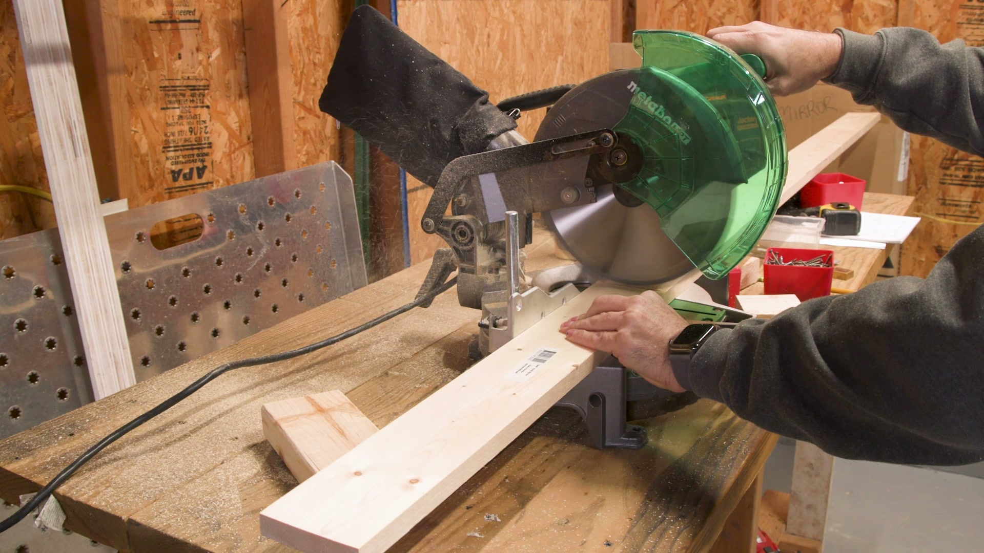
Selected image: eng_03-Scene-023-04.jpg
12. Notch outer slats for legs (at 400.8s)
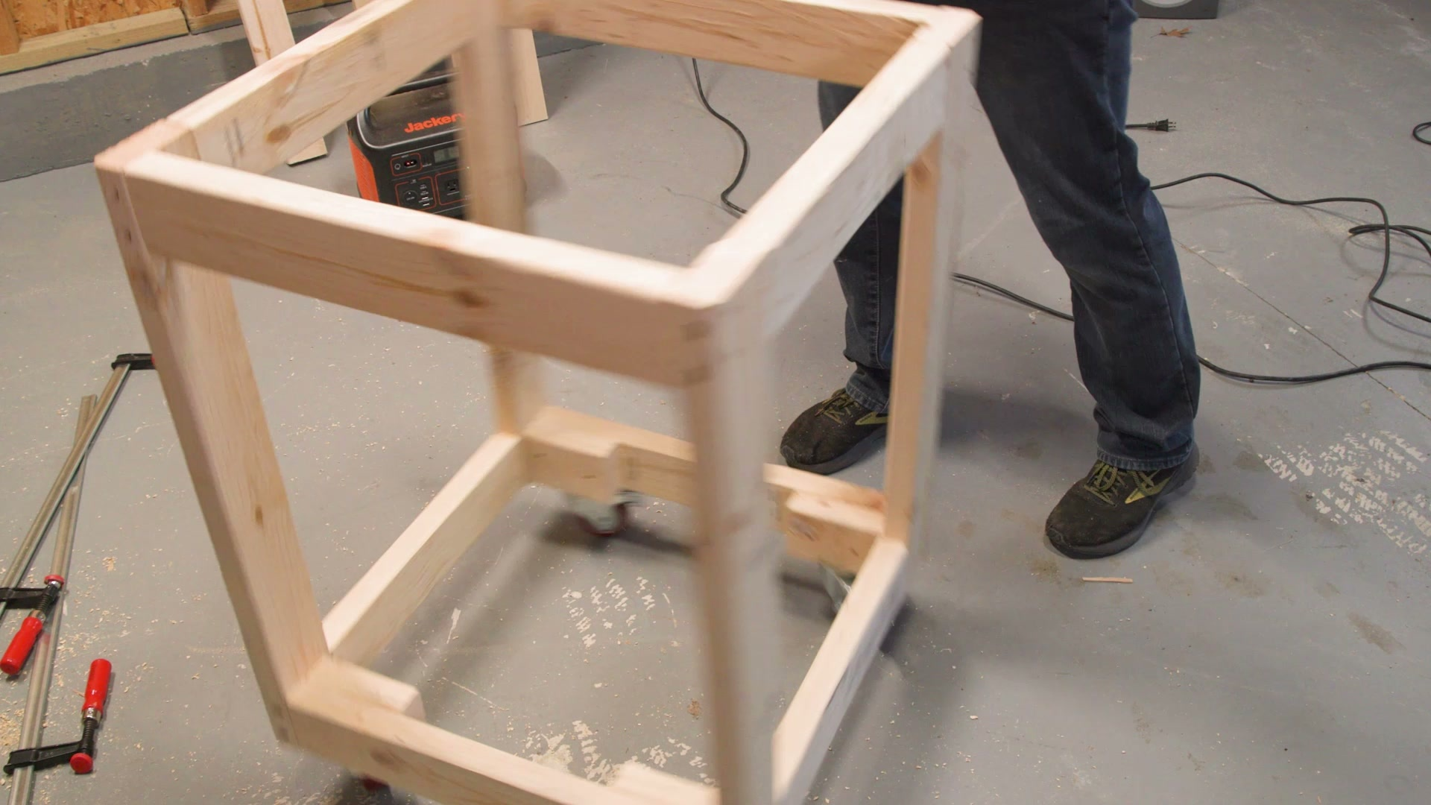
Selected image: eng_03-Scene-023-03.jpg
13. Draw lines for notching (at 401.8s)

Selected image: eng_03-Scene-023-05.jpg
14. Use a jigsaw to cut out the notches (at 412.2s)
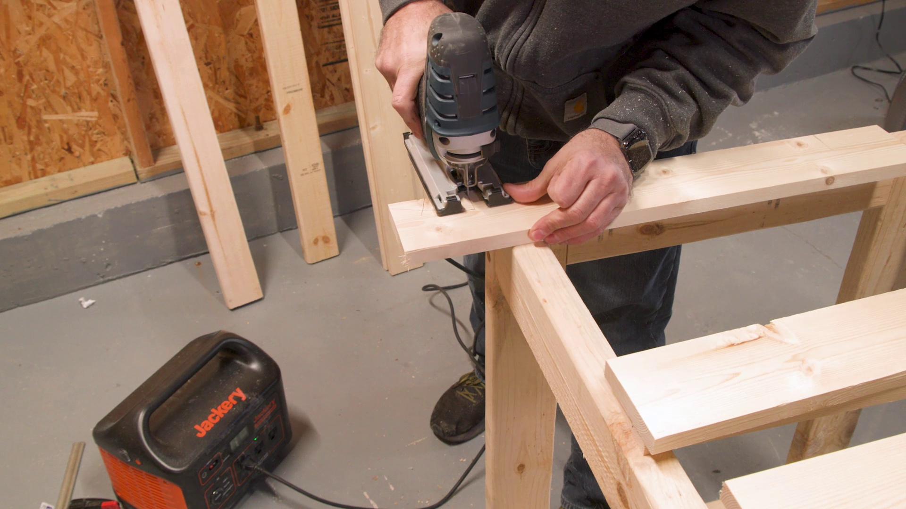
Selected image: eng_03-Scene-024-02.jpg
15. Attach the slat to the frame with a single screw (at 423.9s)
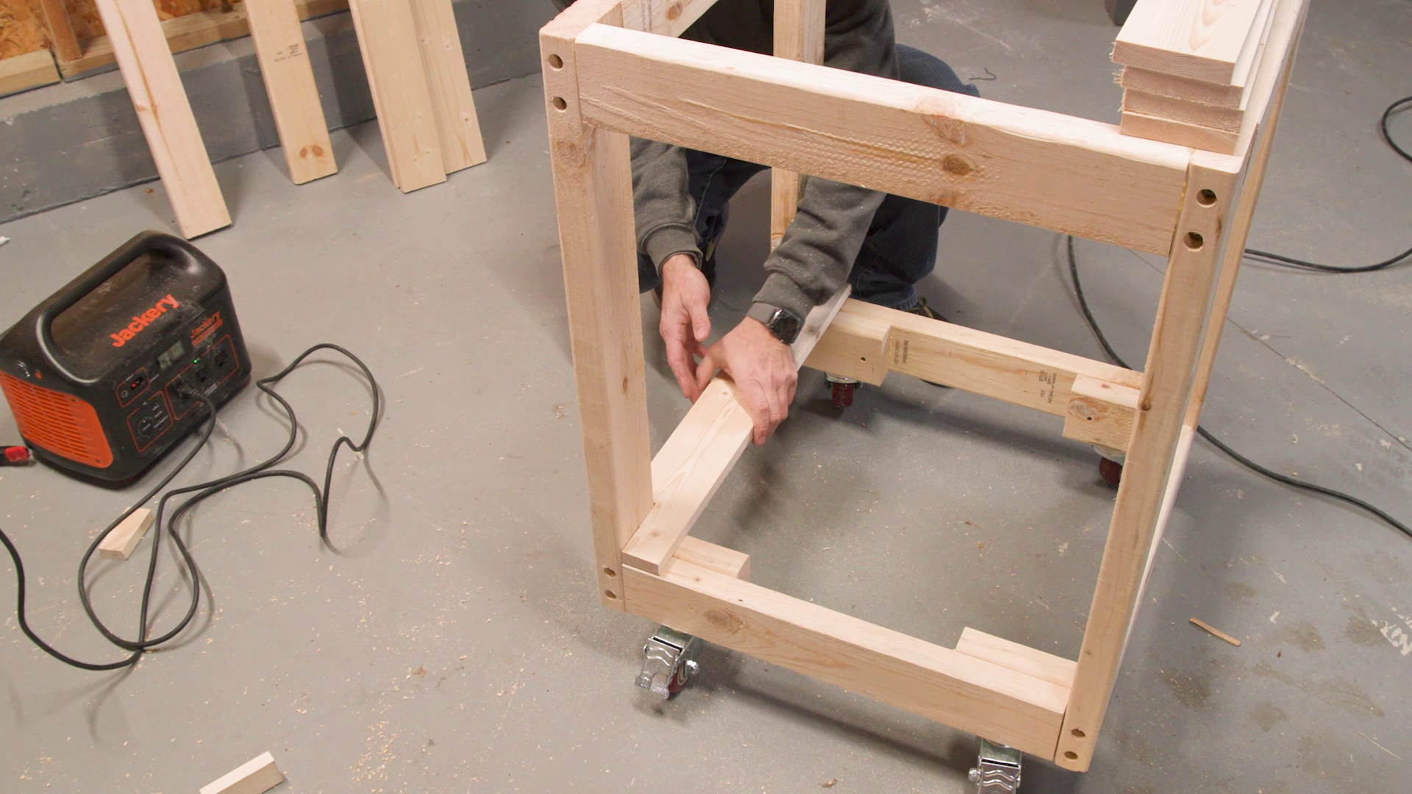
Selected image: eng_03-Scene-024-03.jpg
16. Place a single screw in the middle (at 426.1s)
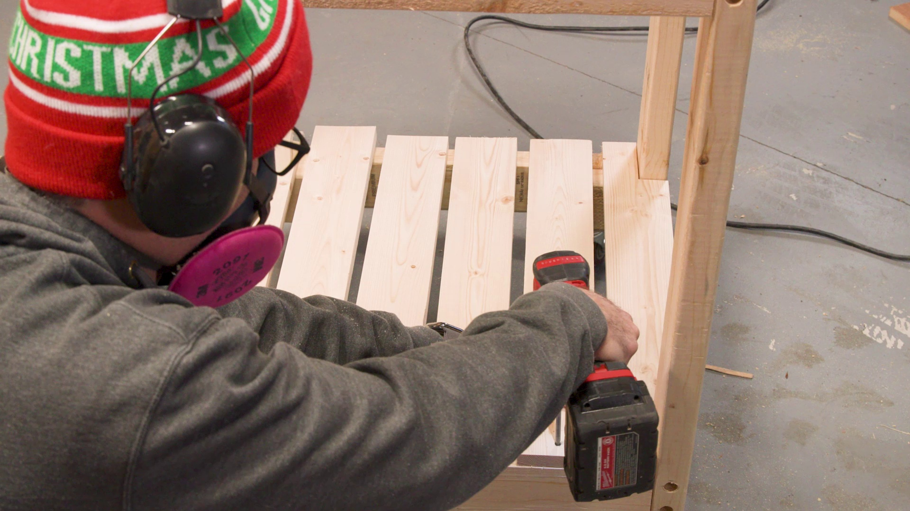
Selected image: eng_03-Scene-025-02.jpg
17. Add a little overhang on each side of the top (at 439.4s)
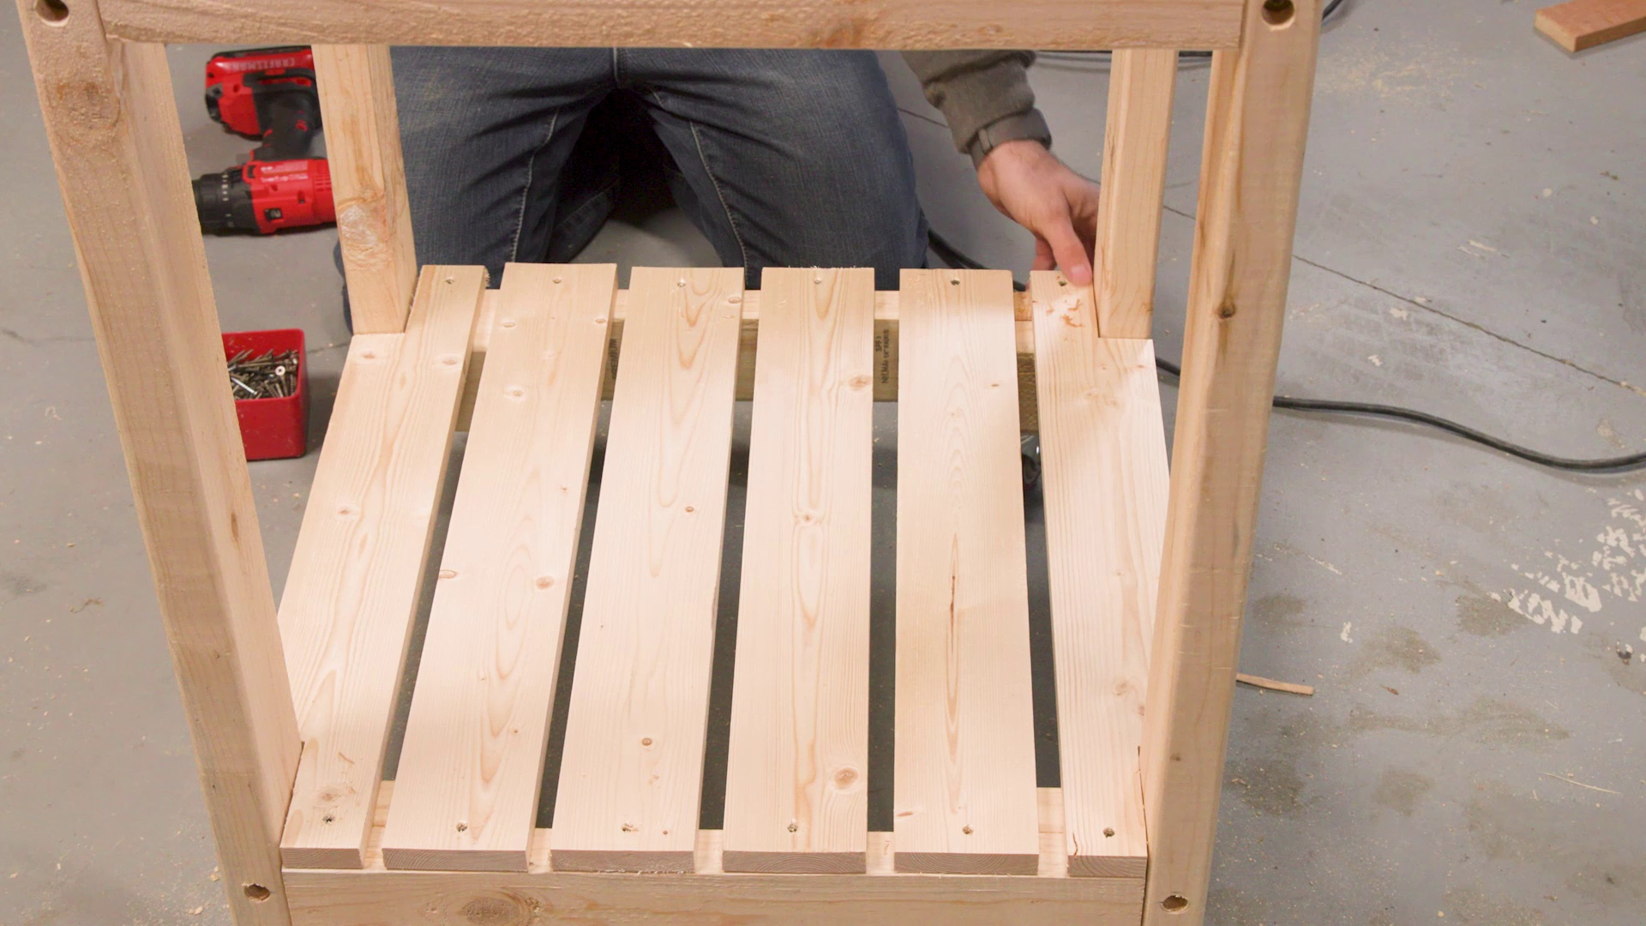
Selected image: eng_03-Scene-025-03.jpg
18. Bring in the planer to test the finished stand (at 453.1s)
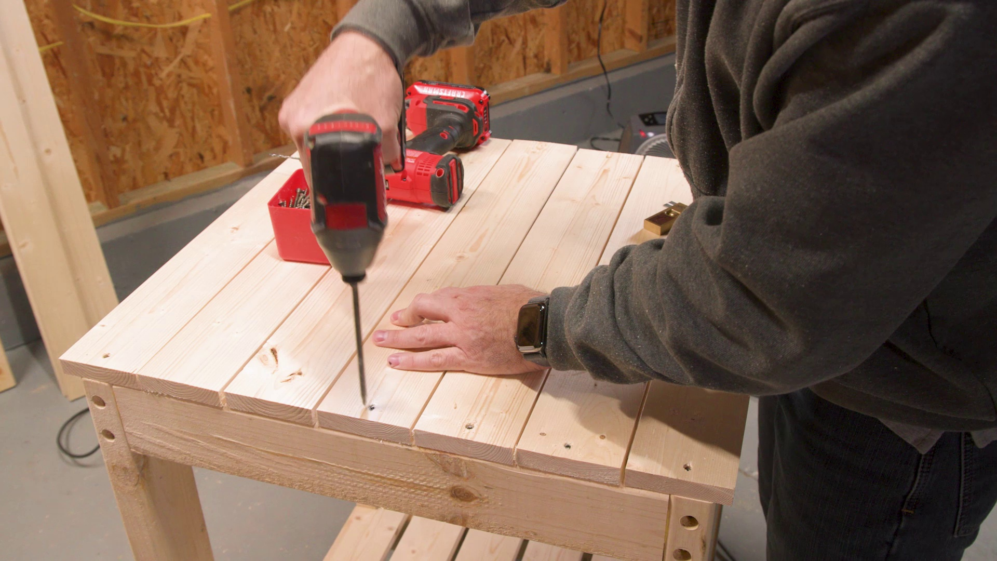
Selected image: eng_03-Scene-026-03.jpg

