Standard Operating Procedure — eng_04

Tools and Materials
- Planer
- 2x4 lumber
- 1x4 lumber
- Square
- Screw
- Stretchers
- Dowel stock

Safety Points
- None mentioned in transcript

Procedure Steps
1. Get measurements (at 49.3s)
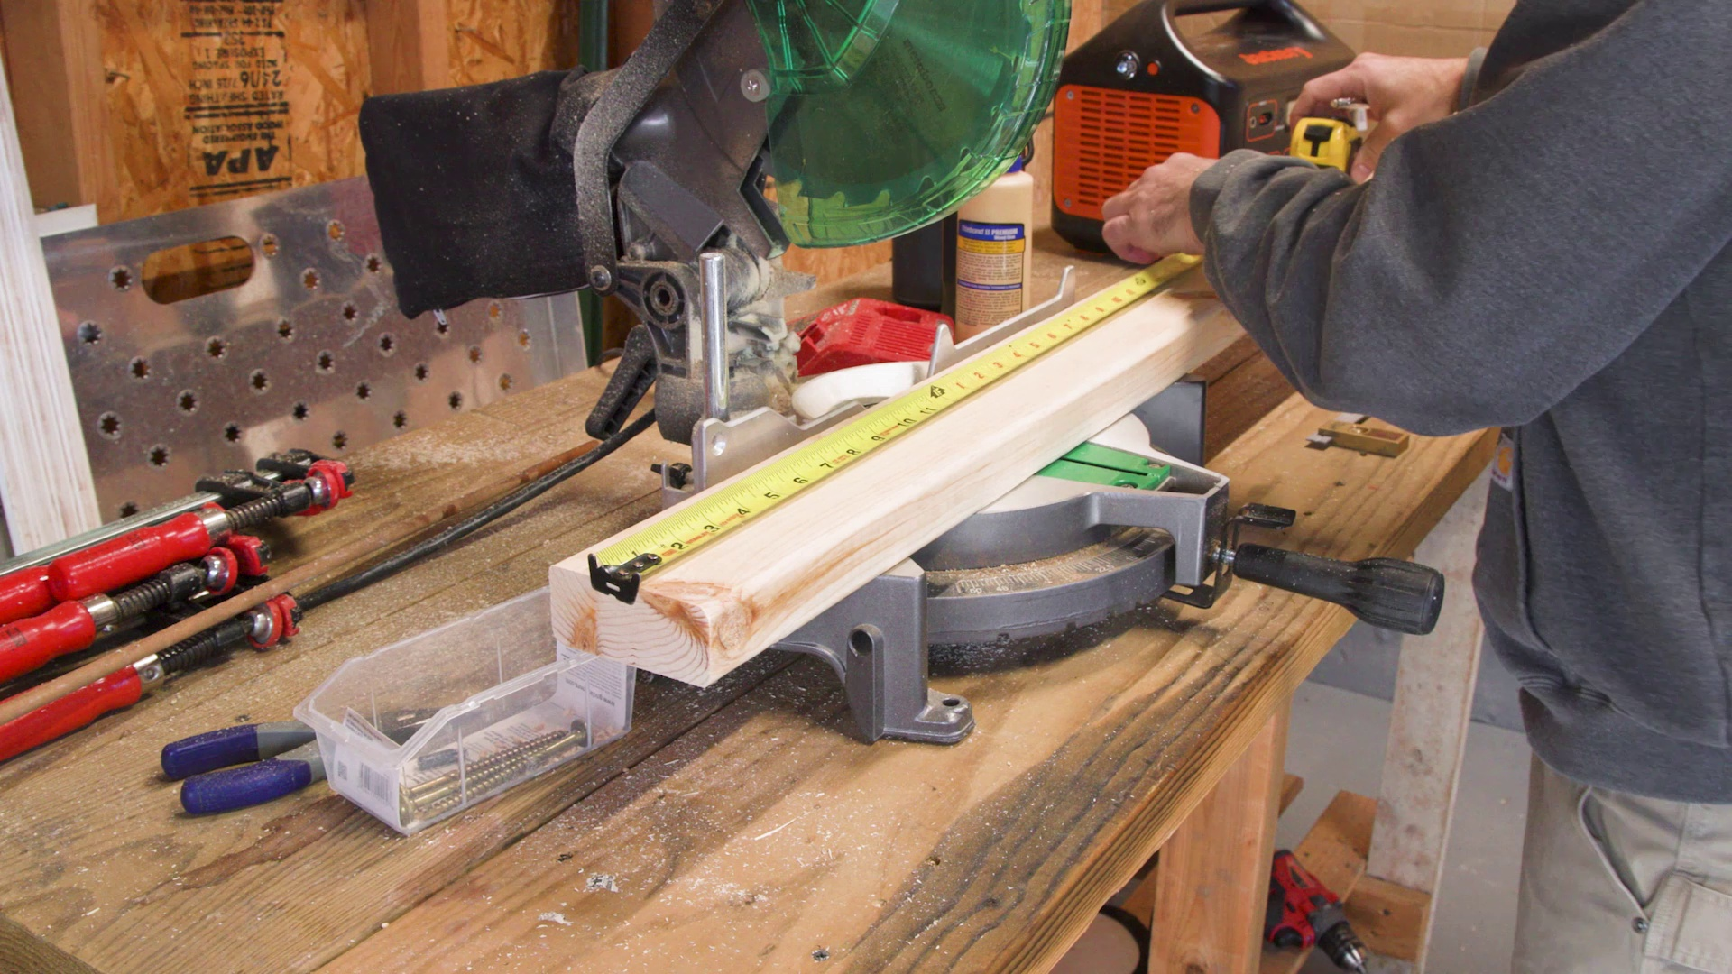
Selected image: eng_04-Scene-004-03.jpg
2. Start cutting the material on paper (at 49.3s)
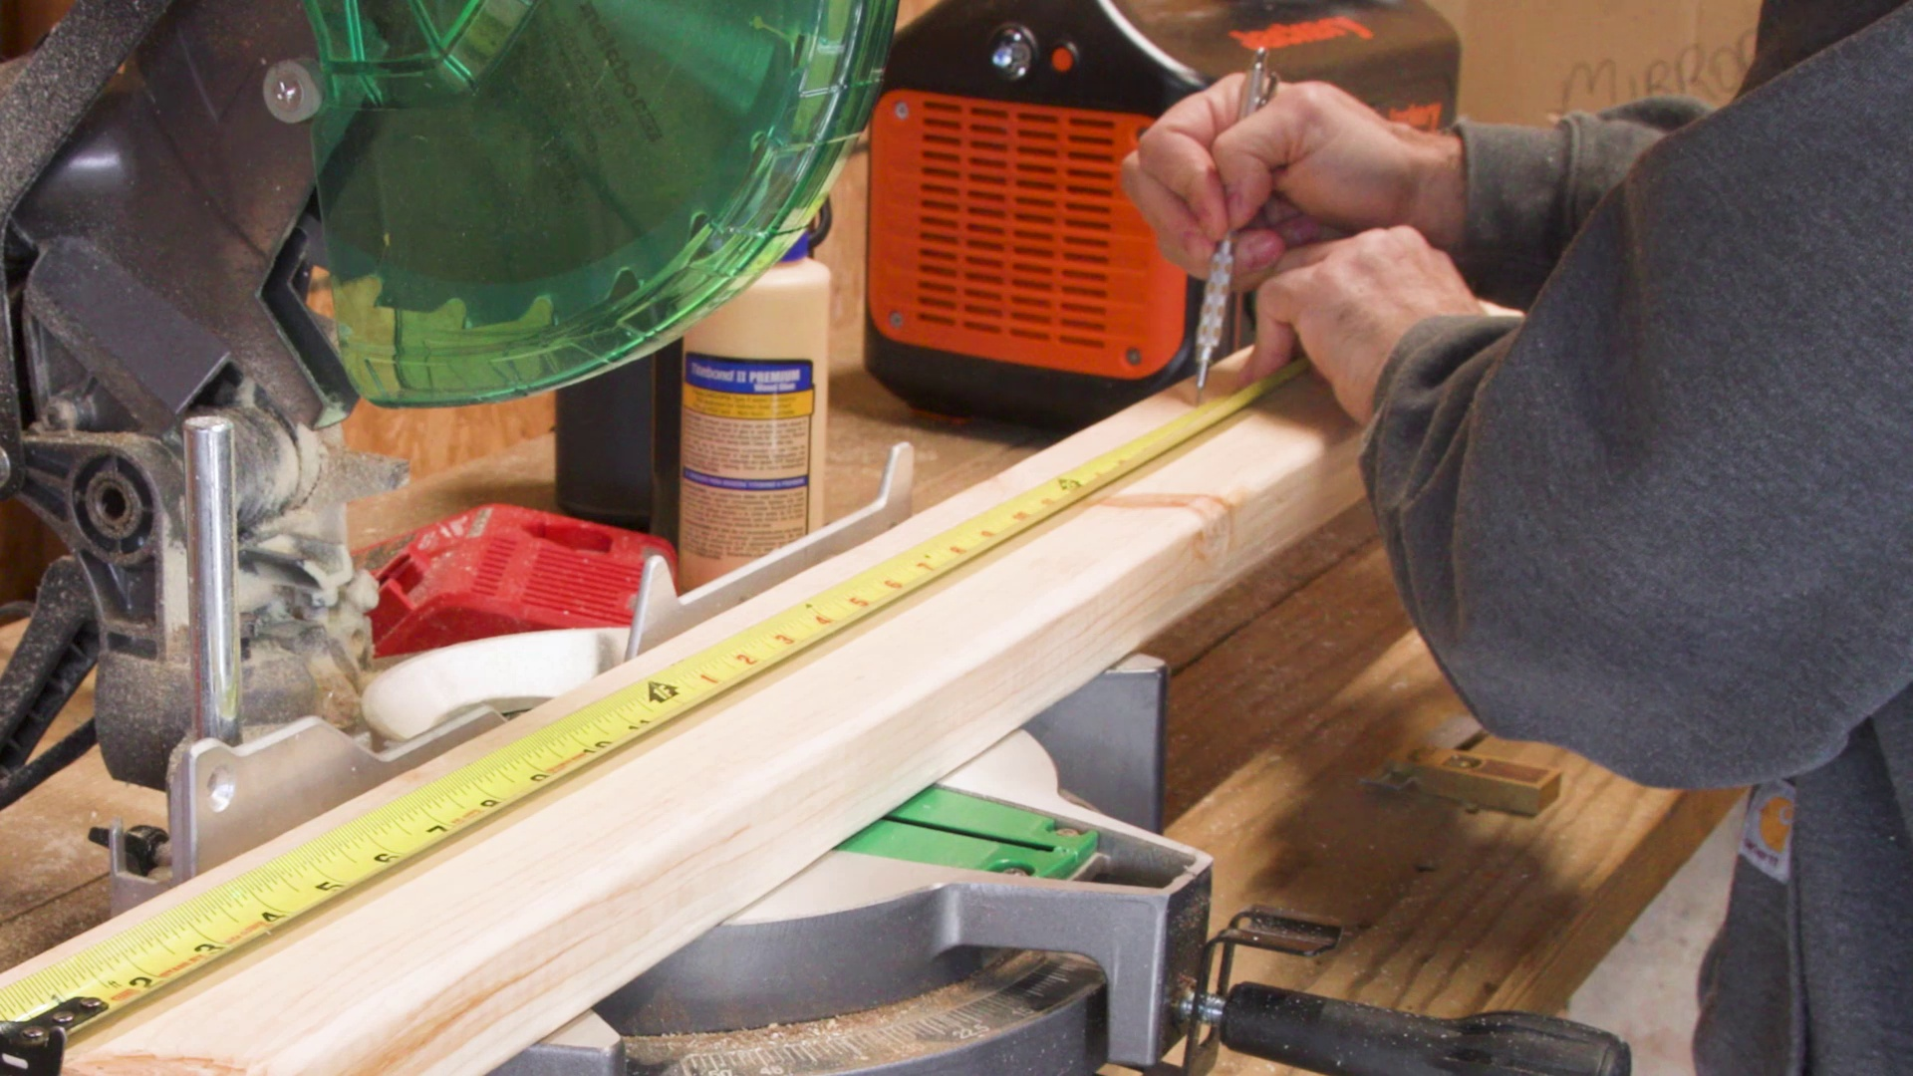
Selected image: eng_04-Scene-005-01.jpg
3. Position a piece of scrap to support the upright while aligning it with a square (at 89.7s)
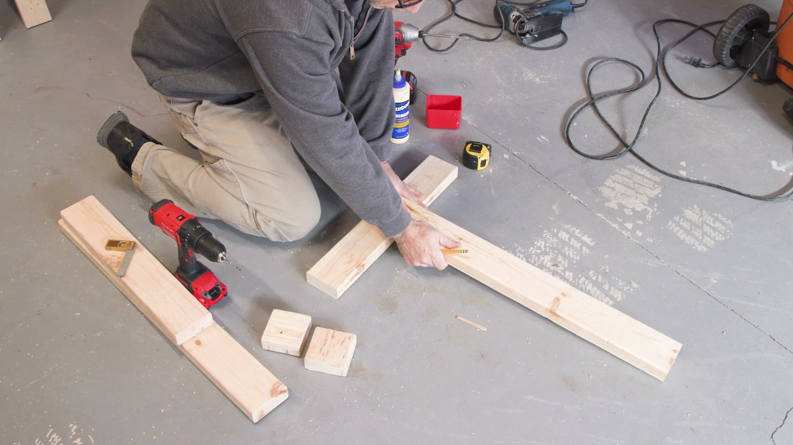
Selected image: eng_04-Scene-006-02.jpg
4. Secure legs with screws at each joint (at 109.2s)
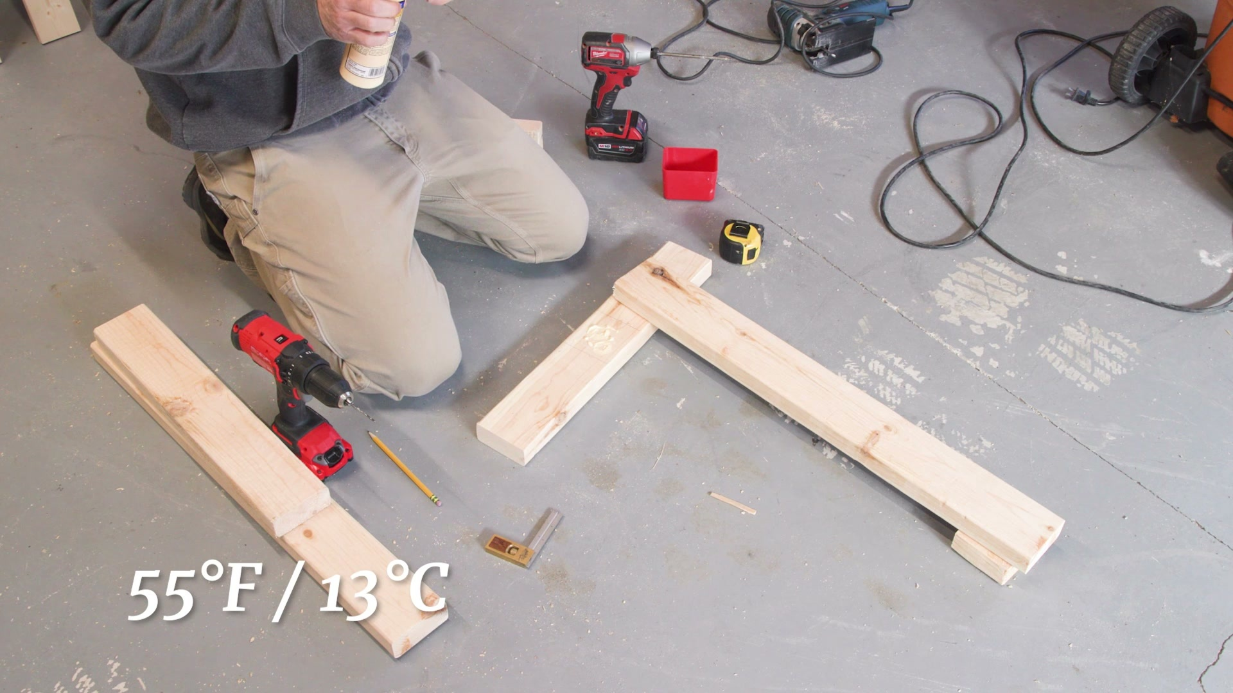
Selected image: eng_04-Scene-006-04.jpg
5. Measure out locations for screws (at 131.0s)
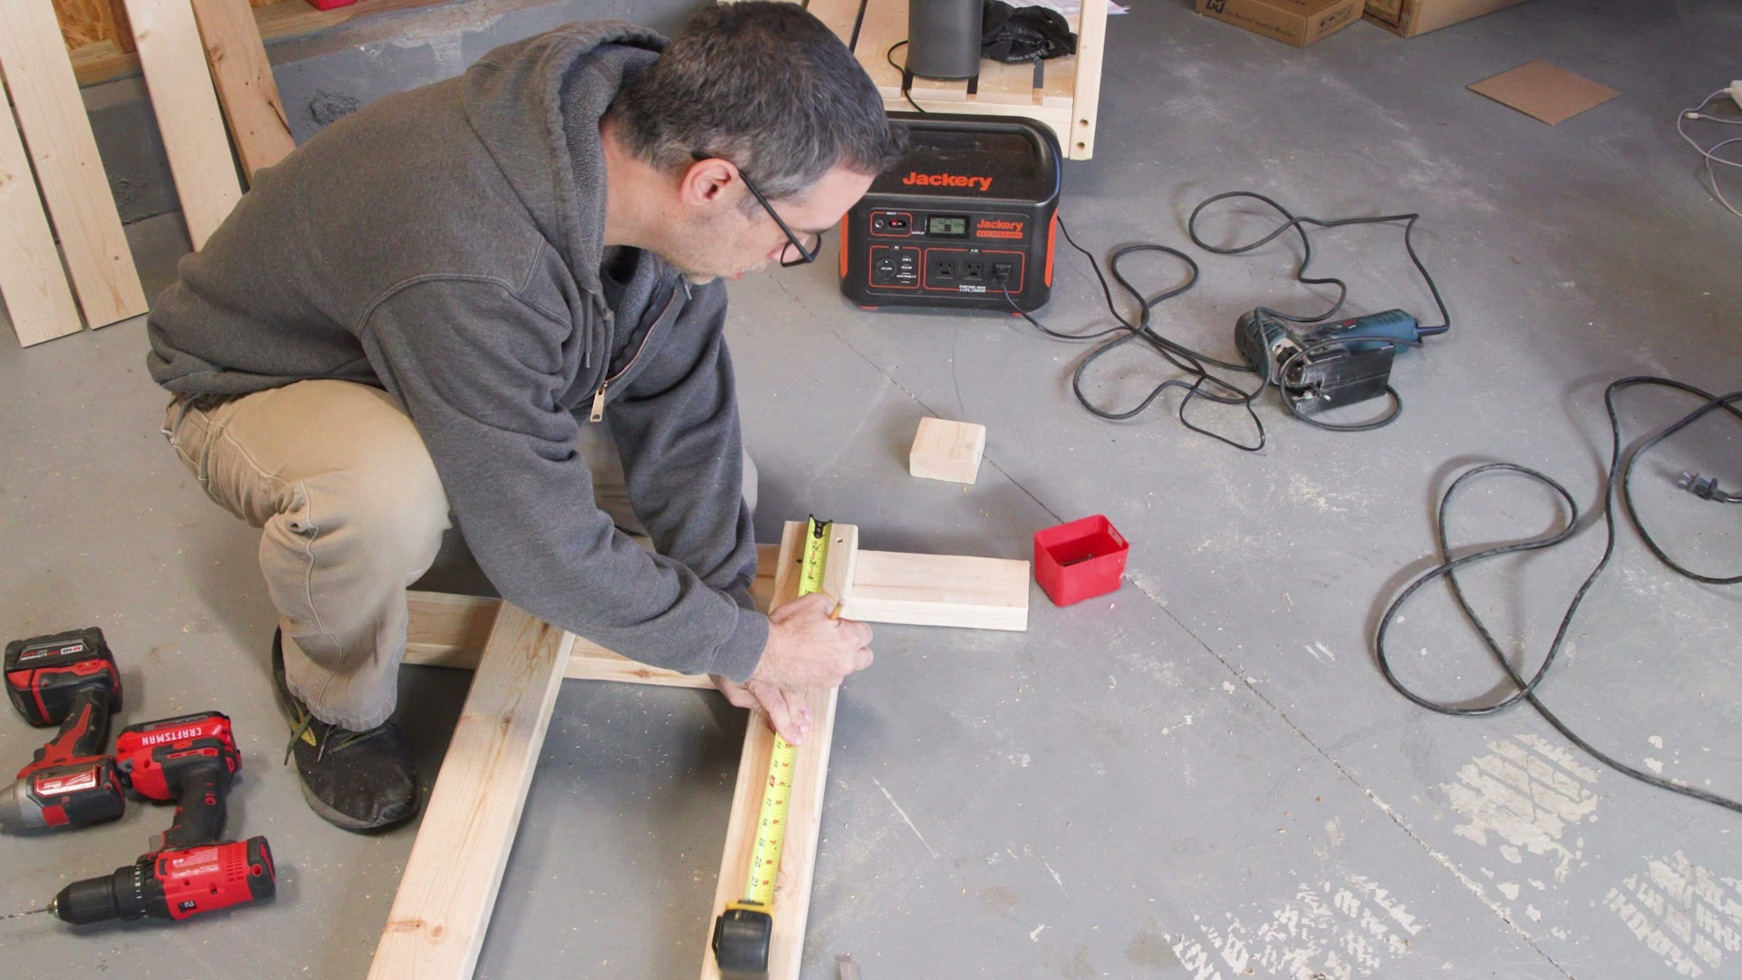
Selected image: eng_04-Scene-006-06.jpg
6. Pre-drill for screws (at 134.8s)
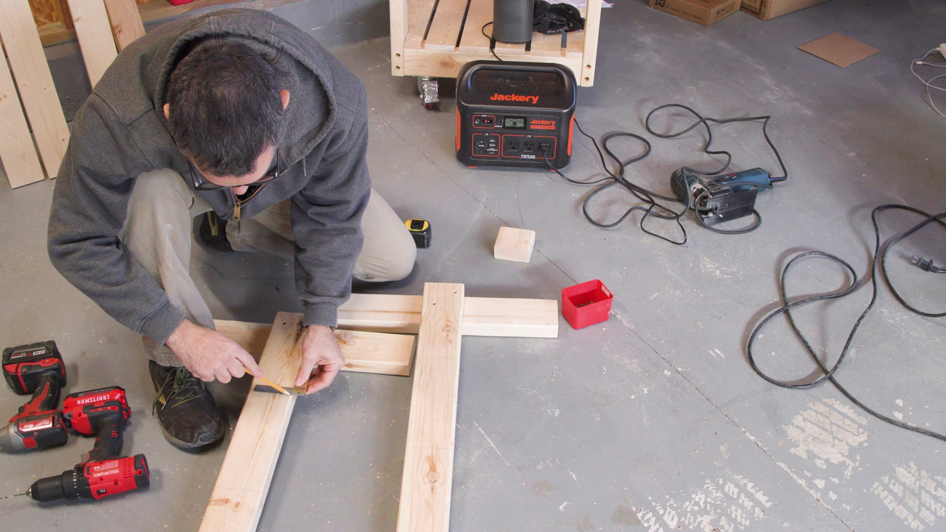
Selected image: eng_04-Scene-007-02.jpg
7. Clamp the stretchers in place (at 161.5s)
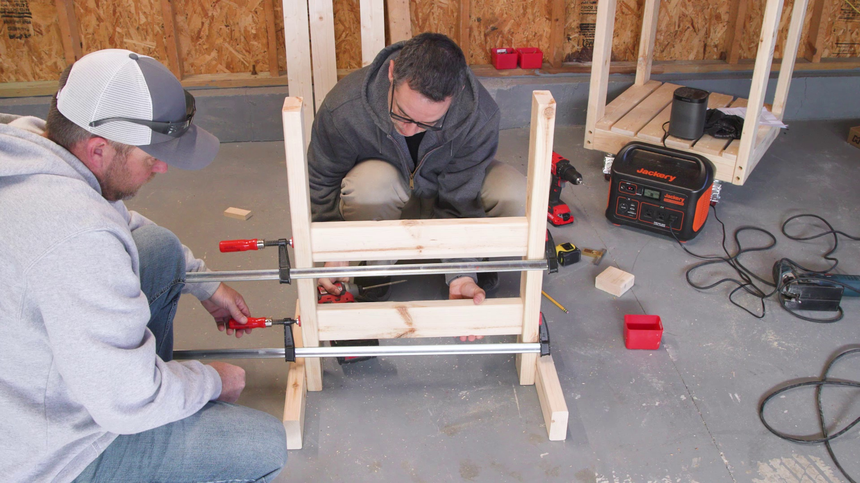
Selected image: eng_04-Scene-008-03.jpg
8. Start cutting the 1x4s for the adjustable work support (at 175.8s)
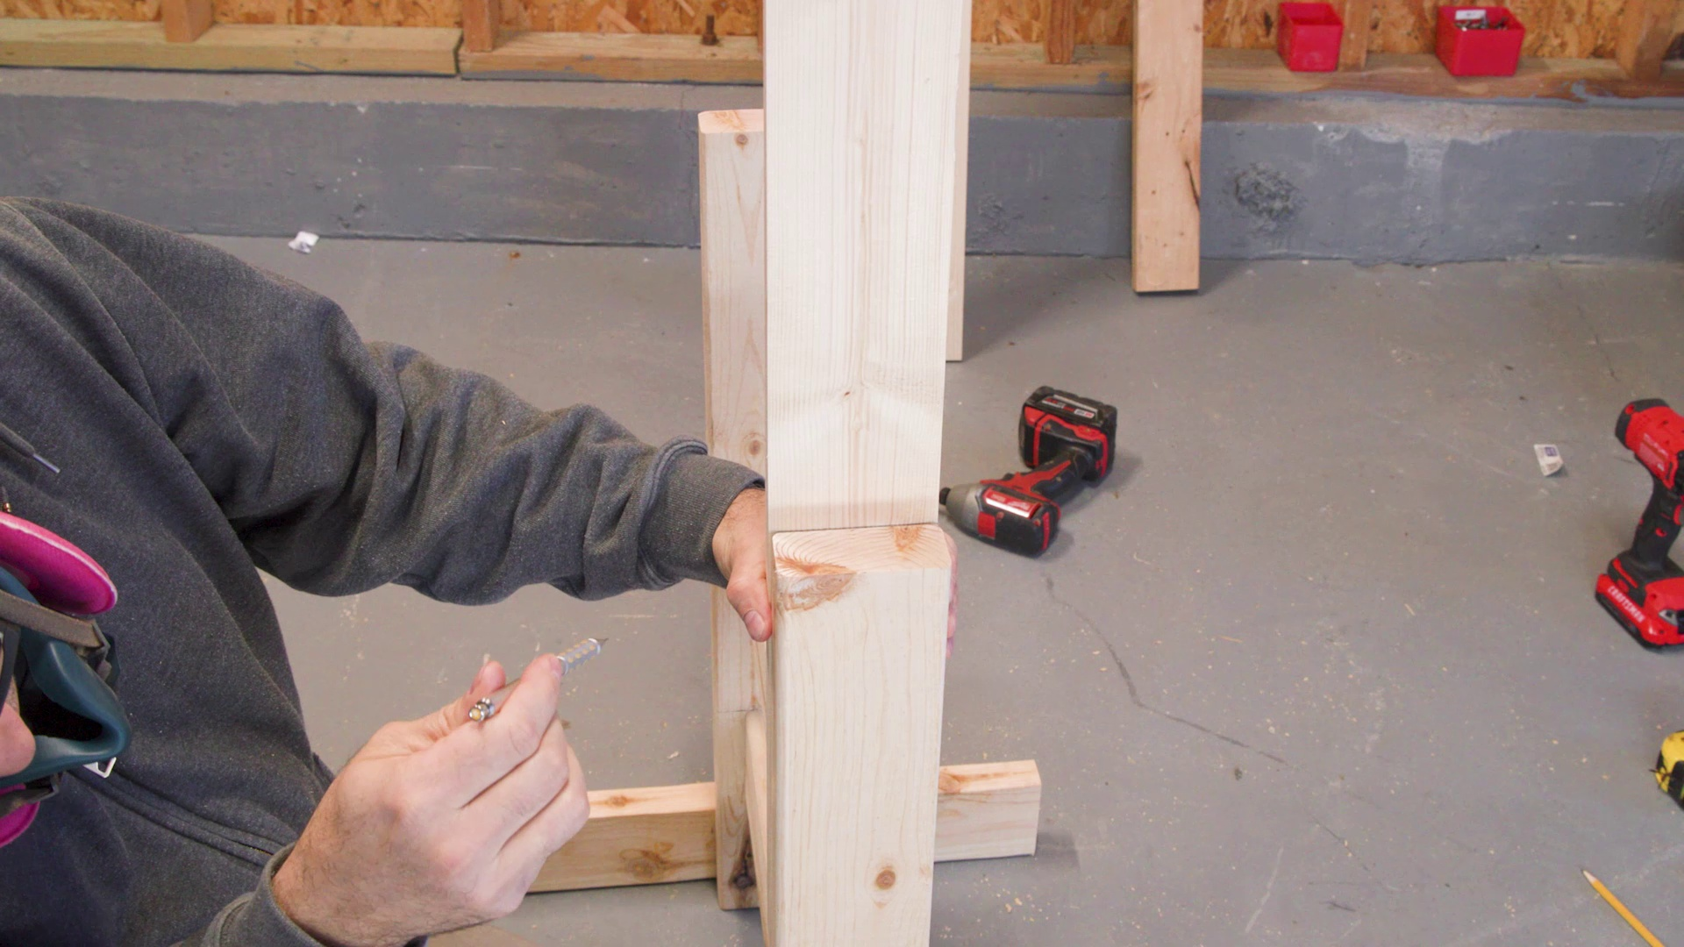
Selected image: eng_04-Scene-009-03.jpg
9. Make four of these (at 186.7s)
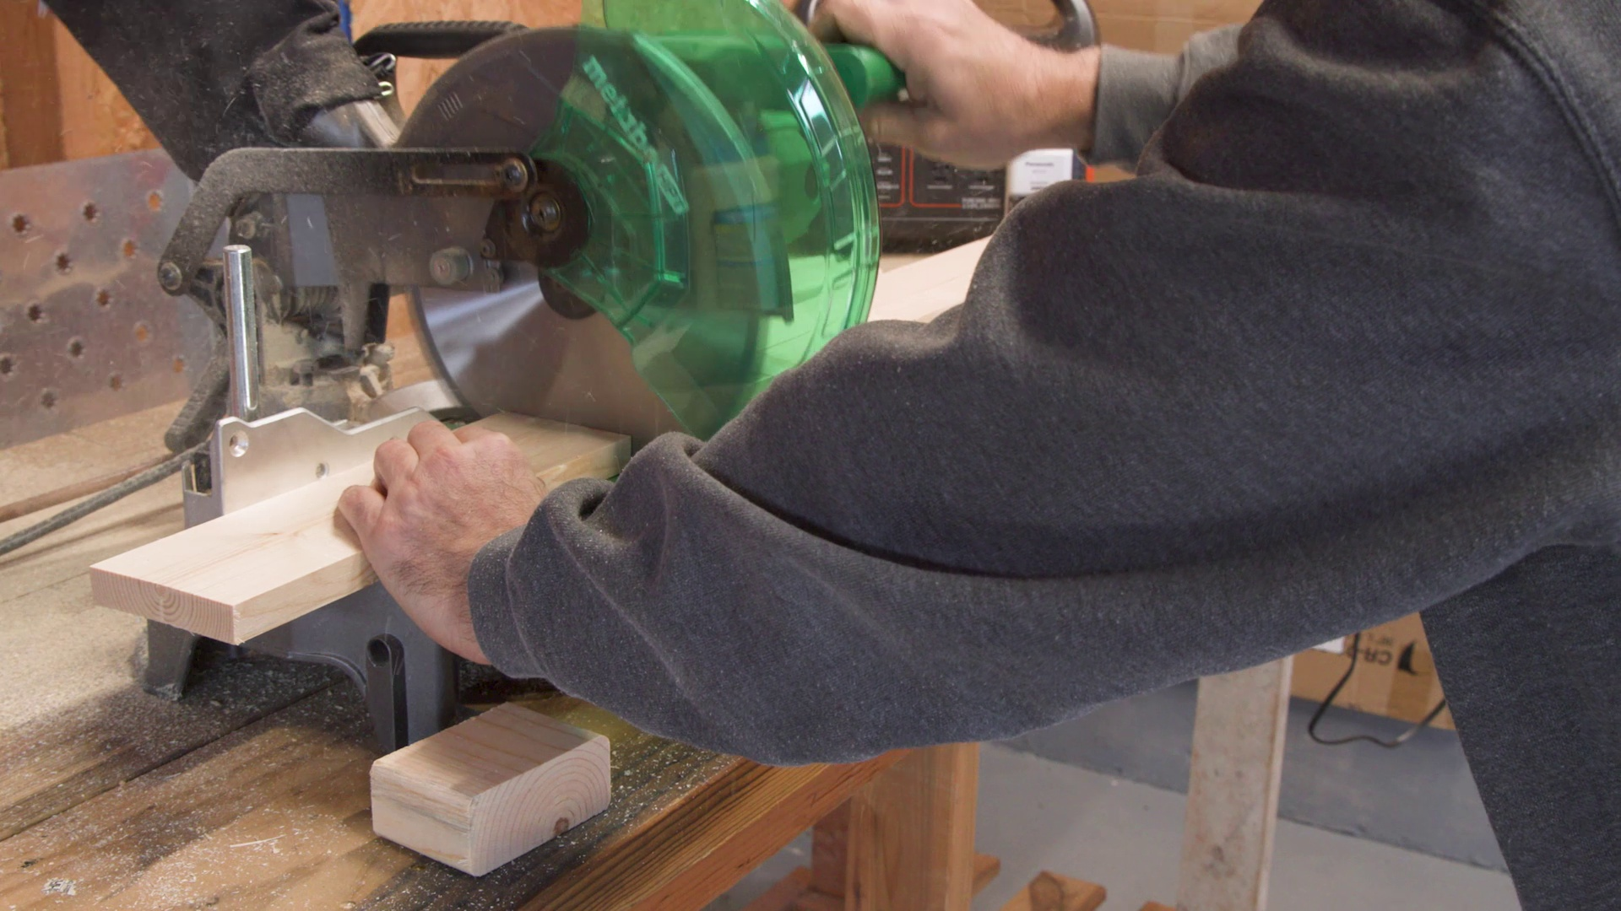
Selected image: eng_04-Scene-010-02.jpg
10. Cut support piece to length using measurement from work stand (at 357.6s)
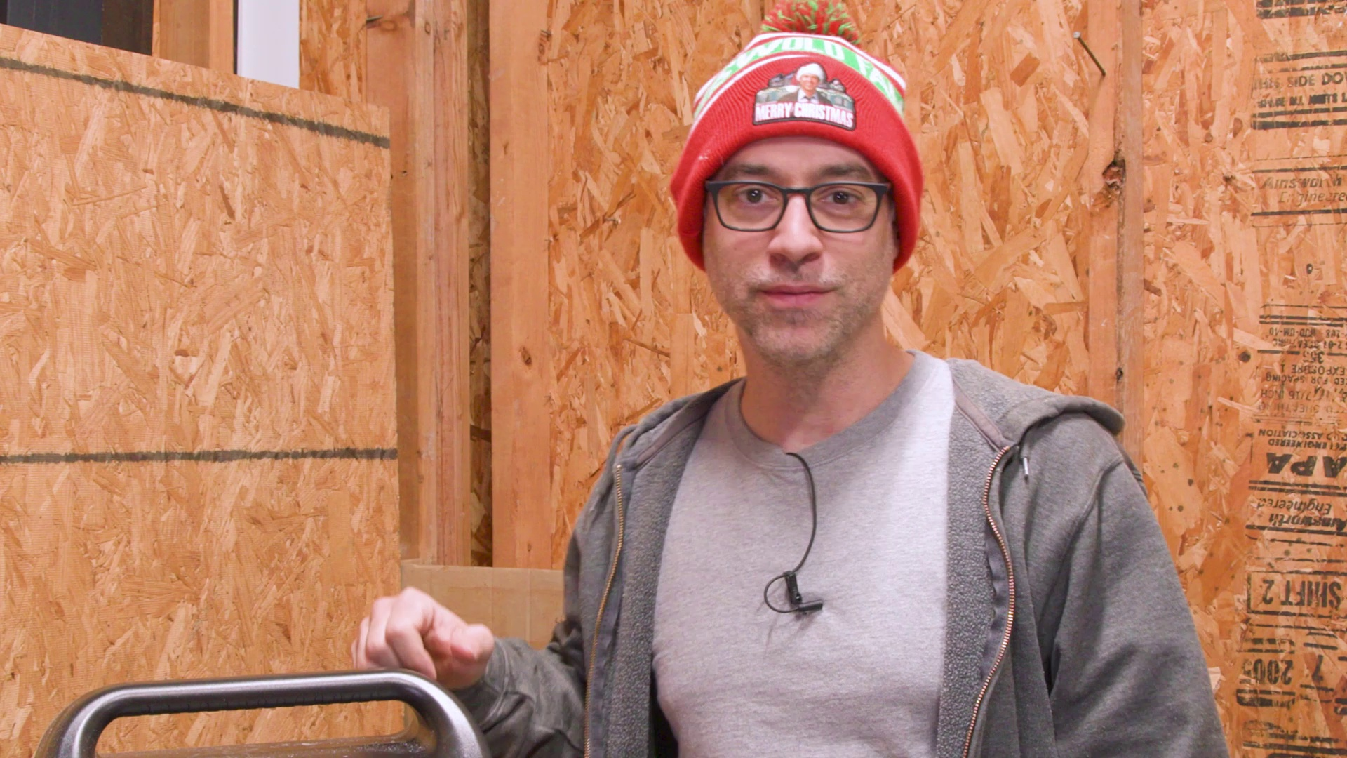
Selected image: eng_04-Scene-017-03.jpg
11. Mark location for screws (at 375.7s)
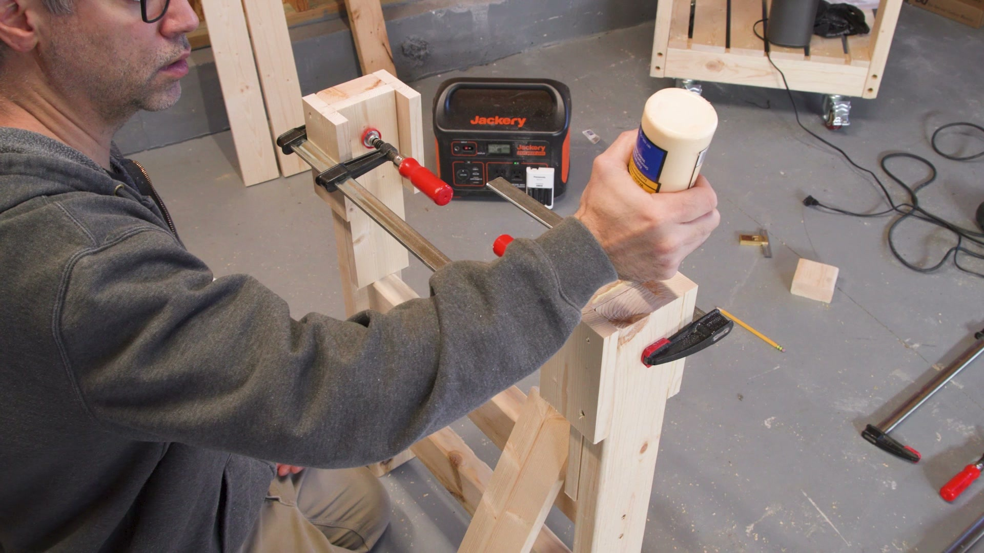
Selected image: eng_04-Scene-018-03.jpg
12. Apply glue and drive screws (at 379.9s)
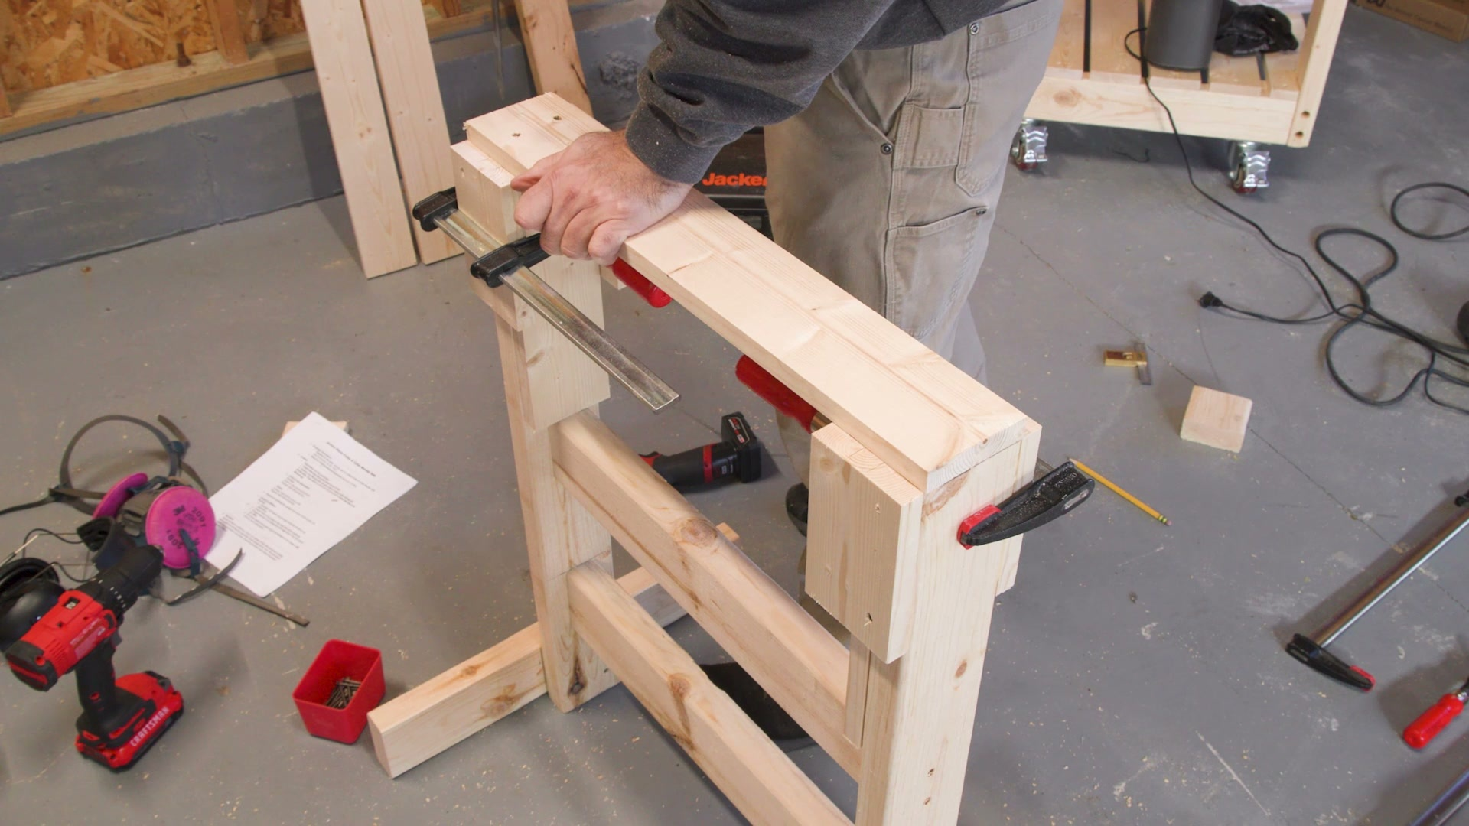
Selected image: eng_04-Scene-018-04.jpg
13. Pre-drill holes (at 395.6s)
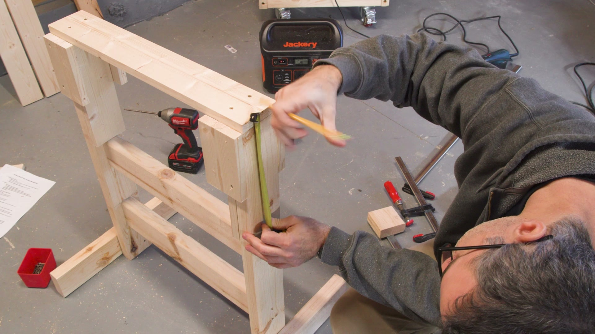
Selected image: eng_04-Scene-018-05.jpg
14. The top hole goes all way through both pieces (at 397.6s)
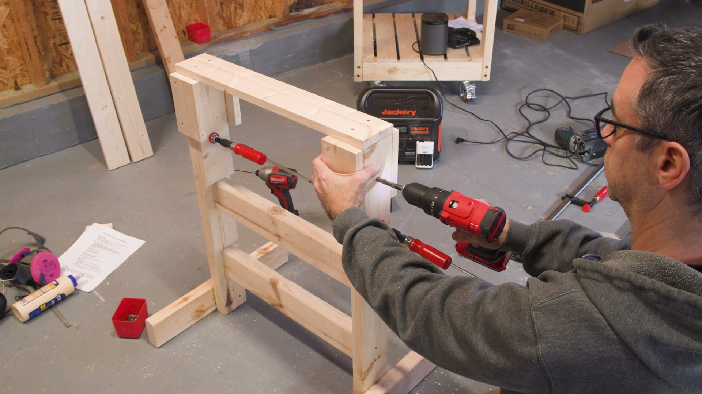
Selected image: eng_04-Scene-018-06.jpg
15. Do that on the other side (at 443.0s)
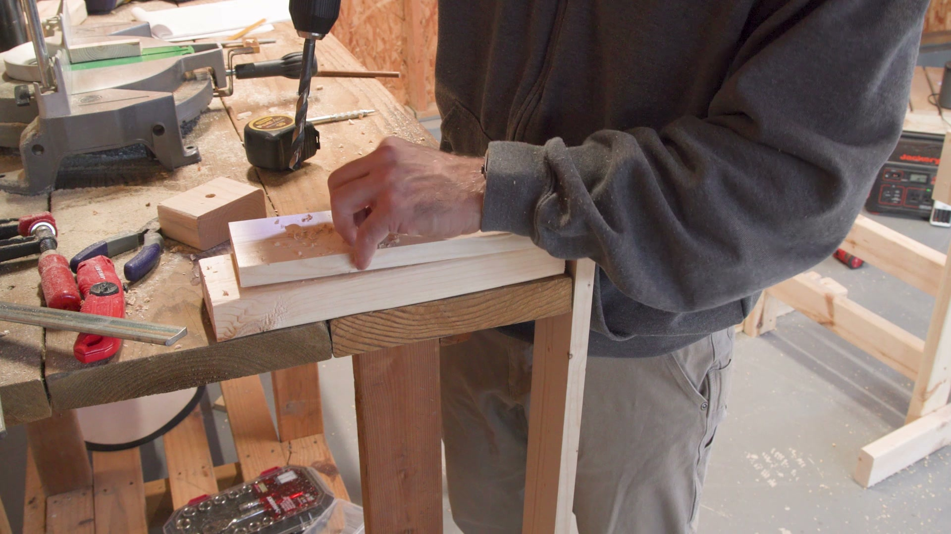
Selected image: eng_04-Scene-018-10.jpg
16. Cut two lengths of 3 eighths inch dowel stock (at 461.6s)
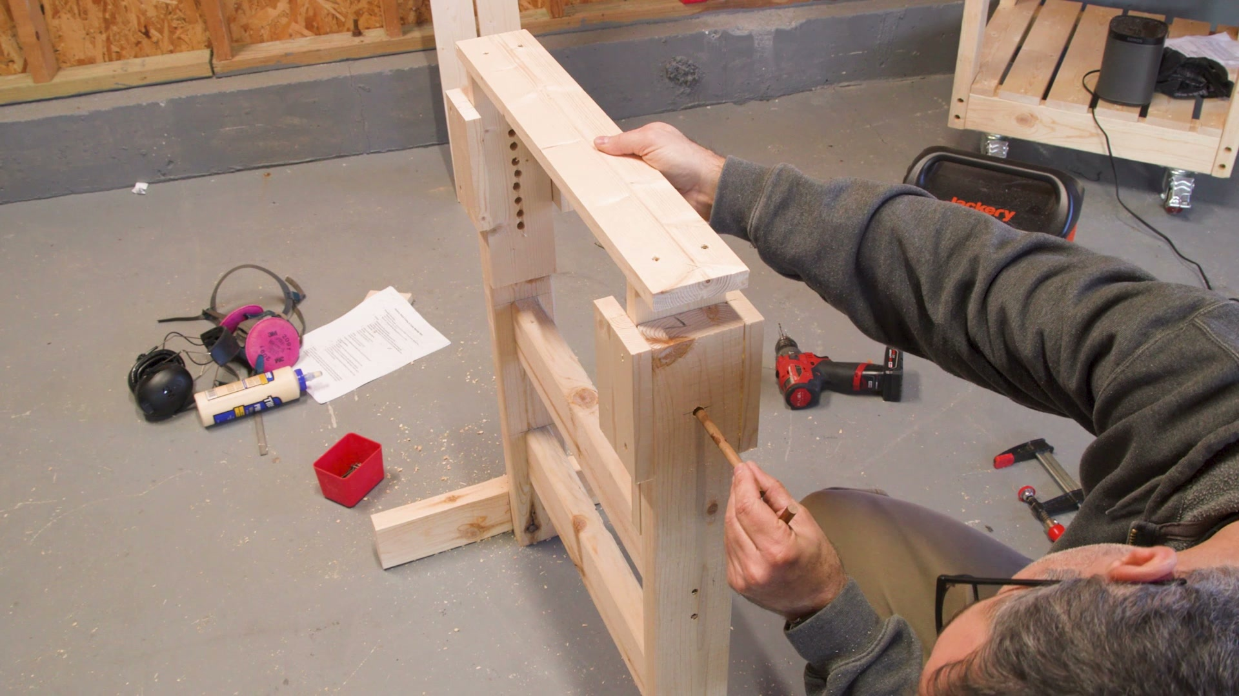
Selected image: eng_04-Scene-019-02.jpg
17. Drill two holes up (at 467.5s)
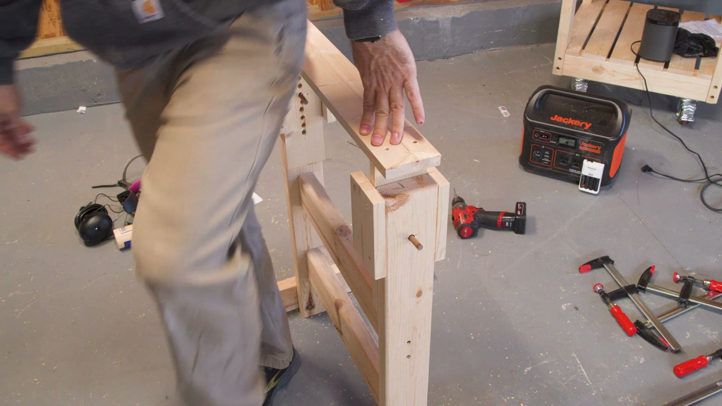
Selected image: eng_04-Scene-019-03.jpg
18. Hold the shop vac (at 534.2s)
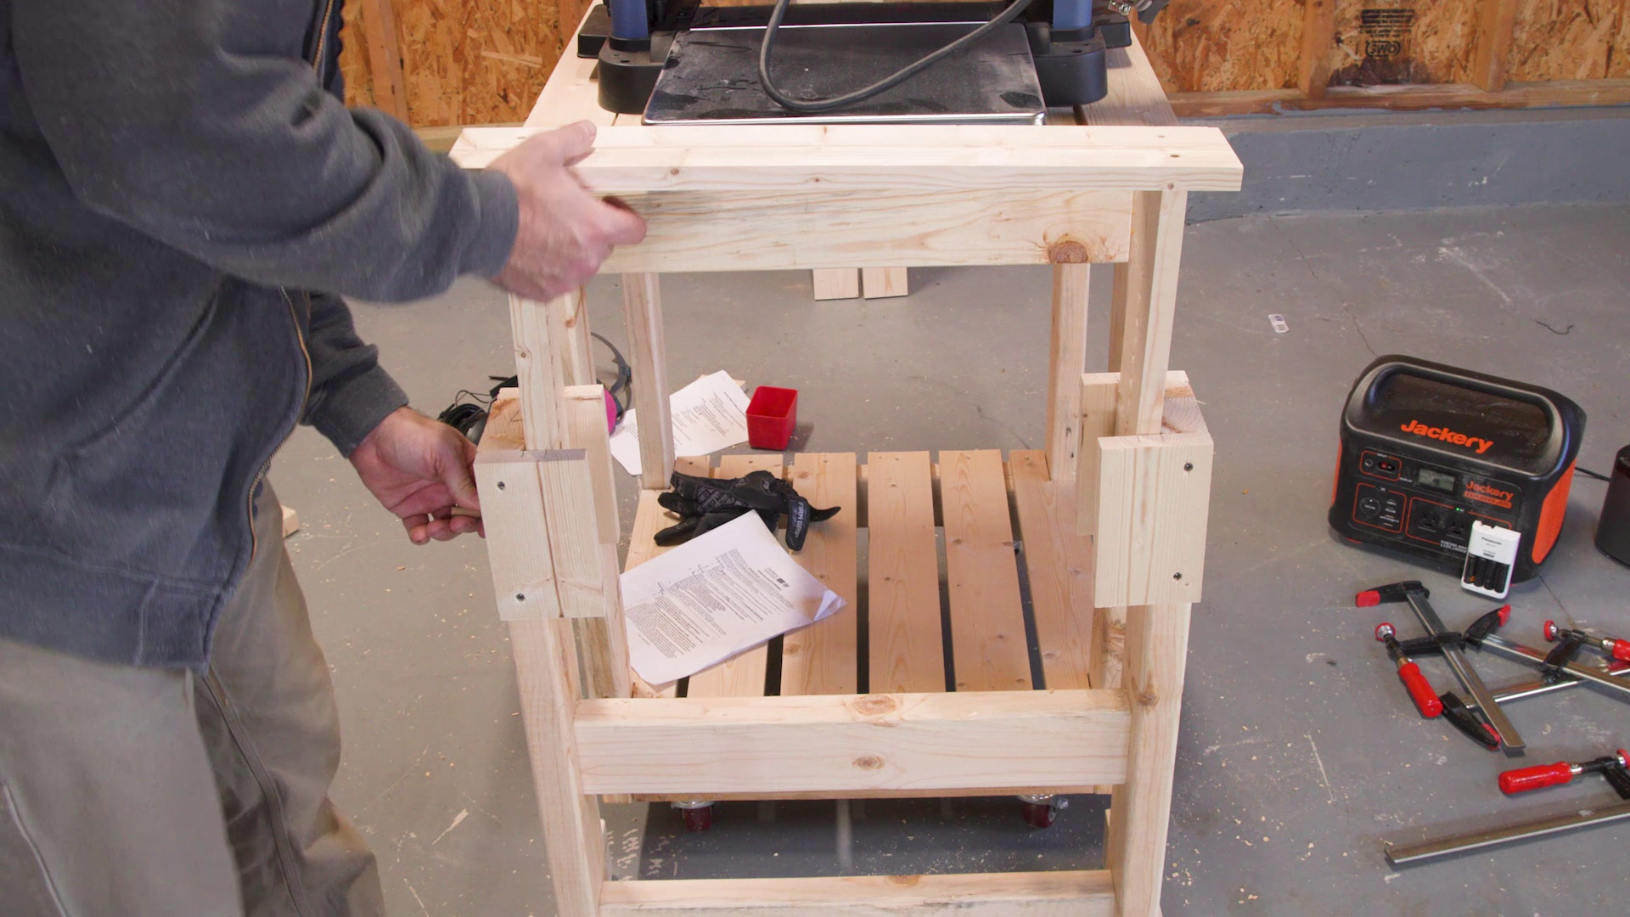
Selected image: eng_04-Scene-021-02.jpg
19. Make it a little less messy (at 551.3s)
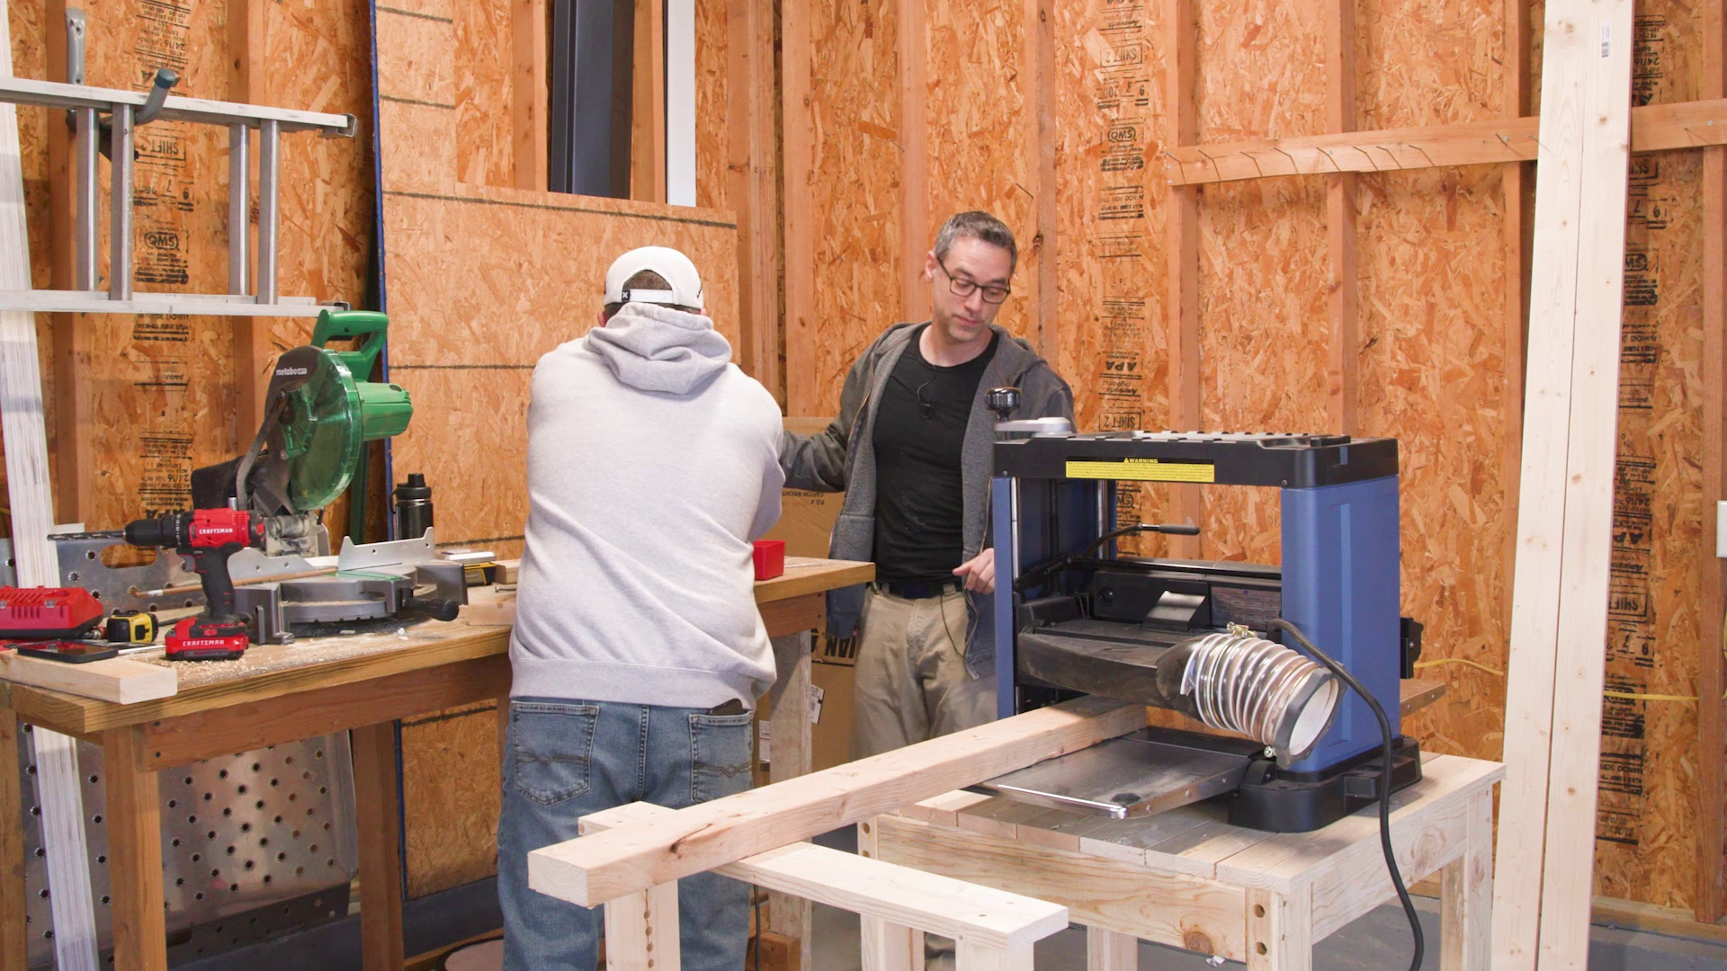
Selected image: eng_04-Scene-022-03.jpg

