Standard Operating Procedure — eng_05

Tools and Materials
- Forklift
- Rinsing machine
- Hot melt modular labelling machine
- Hi-Tech Inspection Machine
- Fillers reservoir
- Capping machine
- Crown capping machine
- Can cleaning system
- Can seamer
- Shrink wrap machine

Safety Points
- None mentioned in transcript

Procedure Steps
1. Blend and pump syrup, water, and sweetener through pipes (at 74.8s)
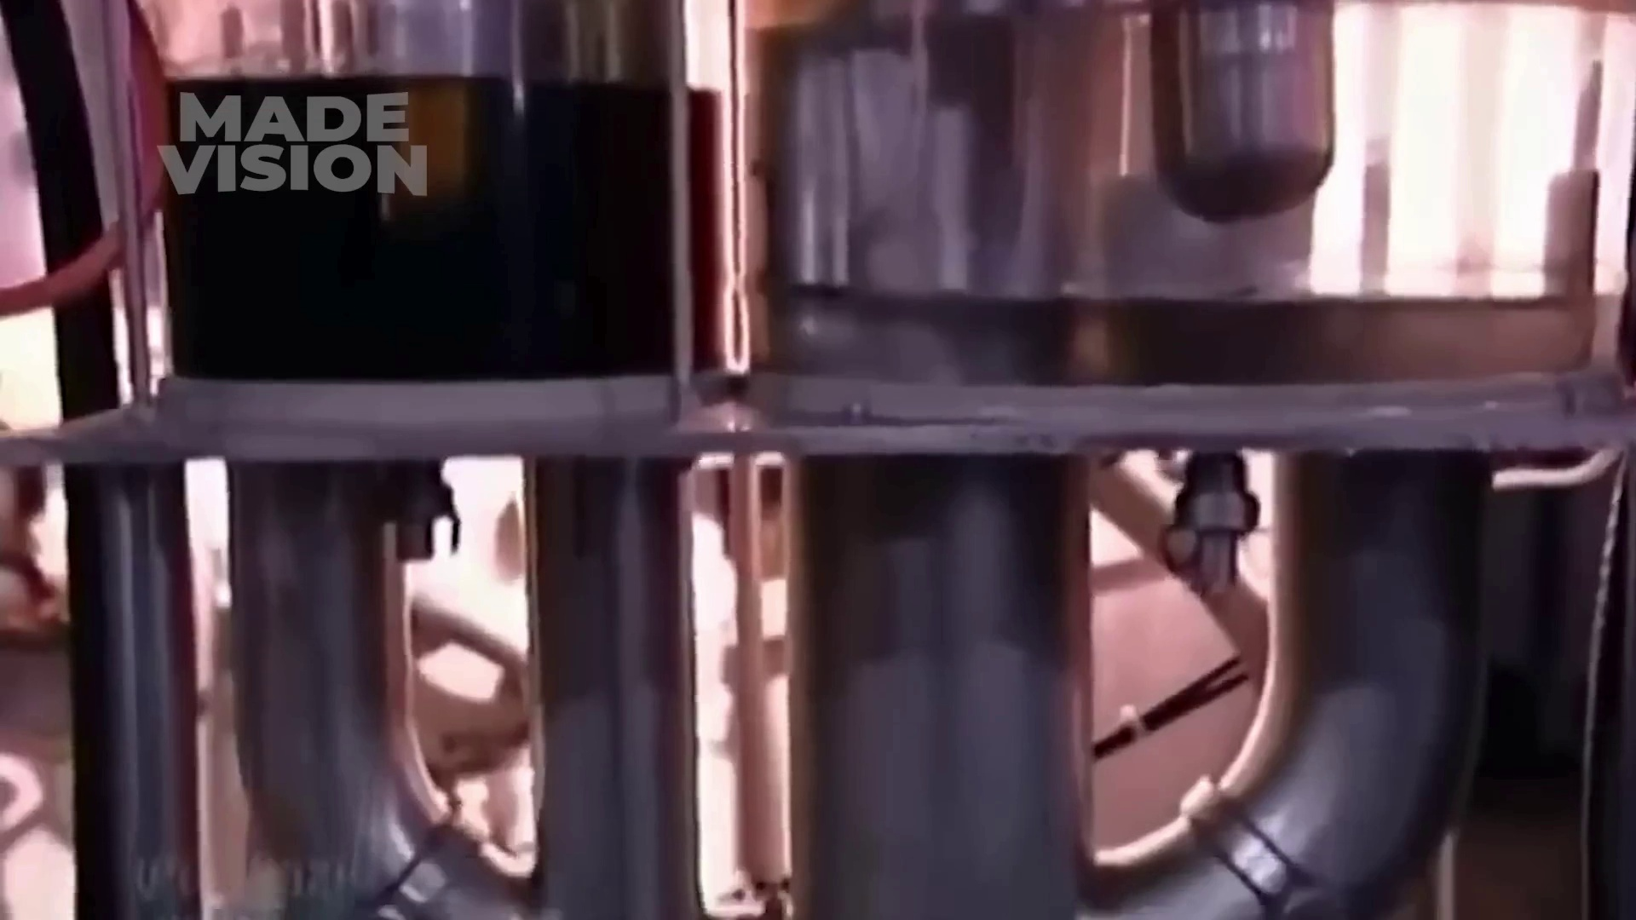
Selected image: eng_05-Scene-007-02.jpg
2. Transfer mixture to batch tanks (at 80.4s)
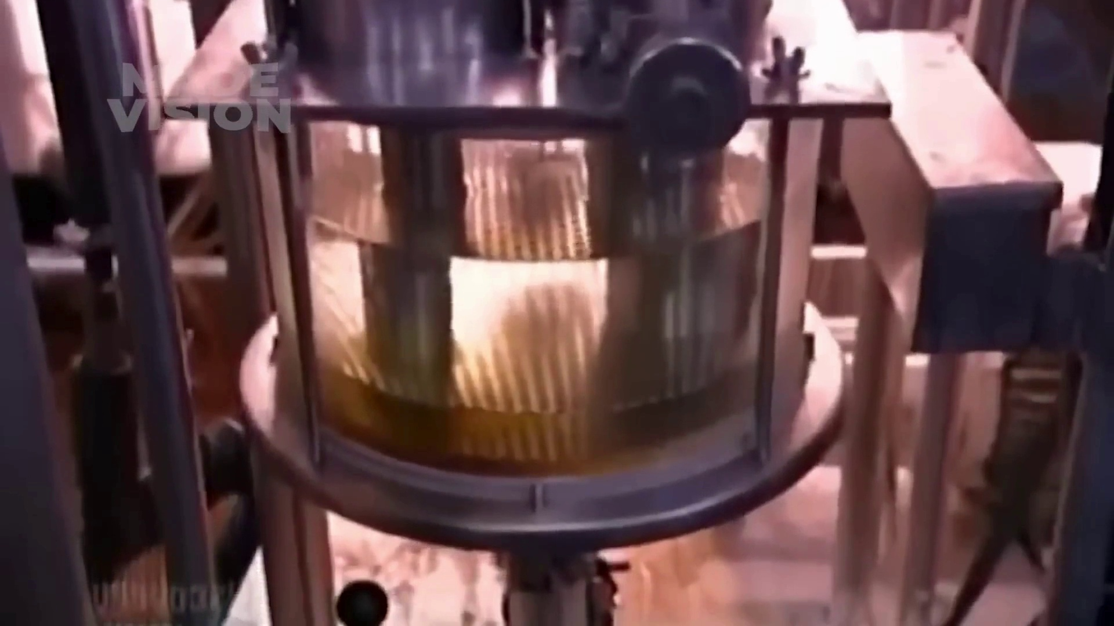
Selected image: eng_05-Scene-007-03.jpg
3. Carbonate mix with CO2 in votator (at 86.1s)
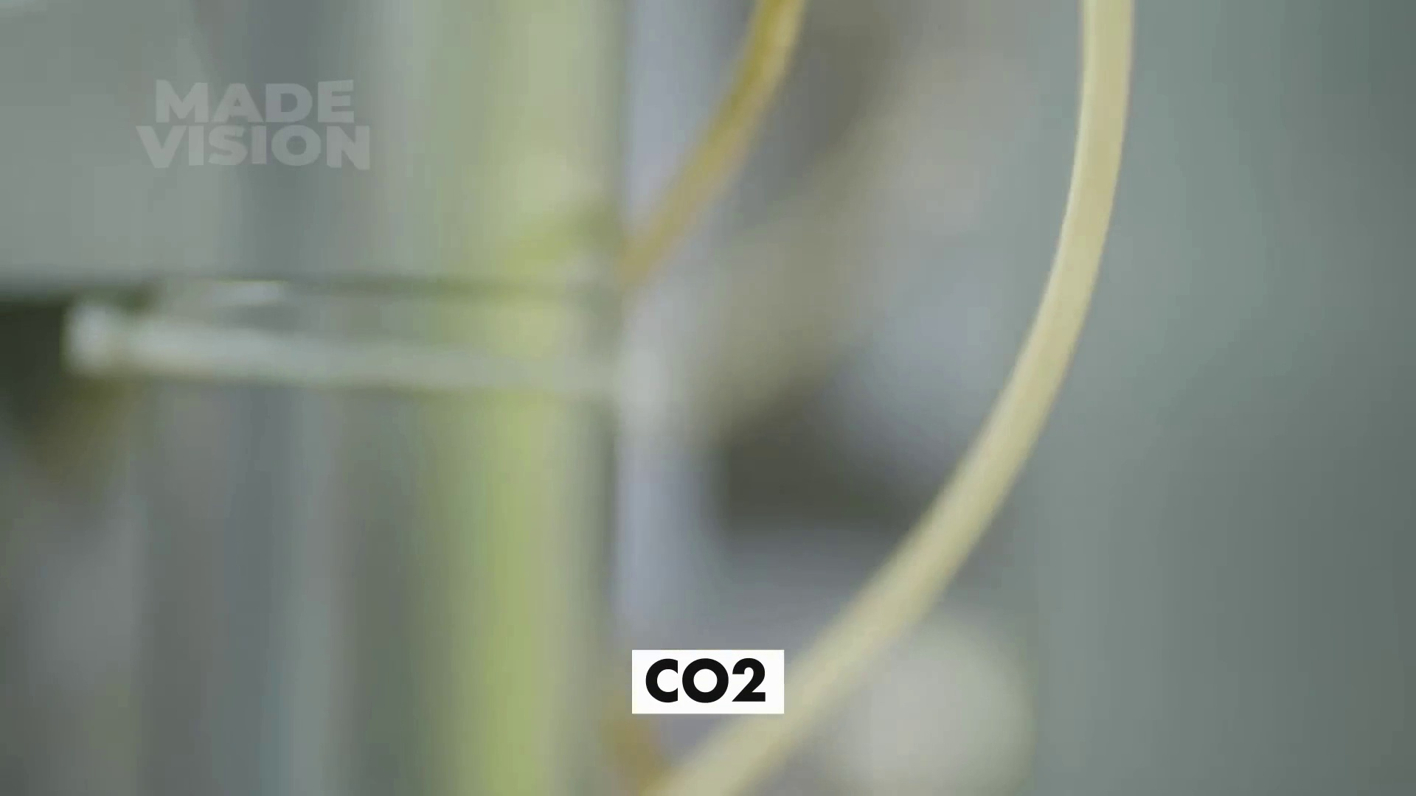
Selected image: eng_05-Scene-008-02.jpg
4. Label bottles (at 107.8s)
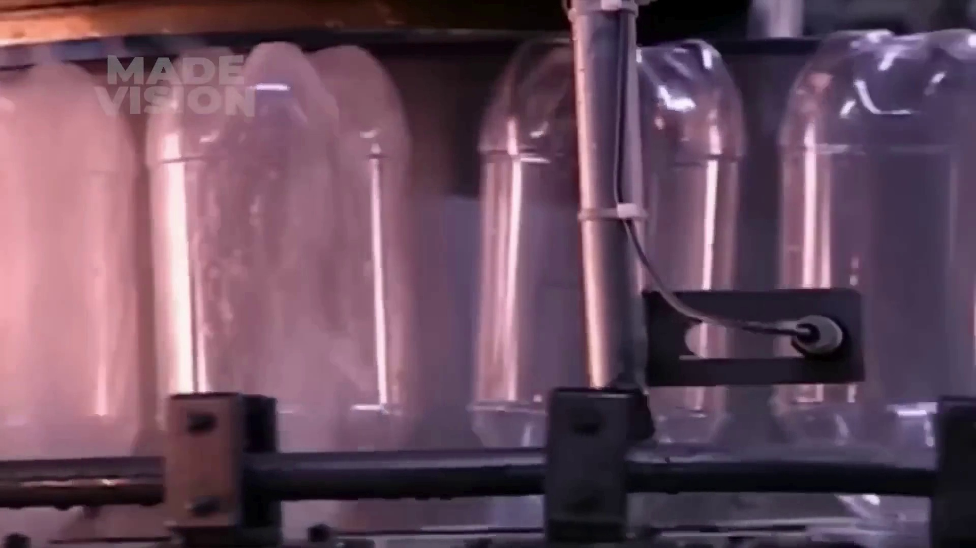
Selected image: eng_05-Scene-009-03.jpg
5. Scan bottles for defects (at 142.0s)
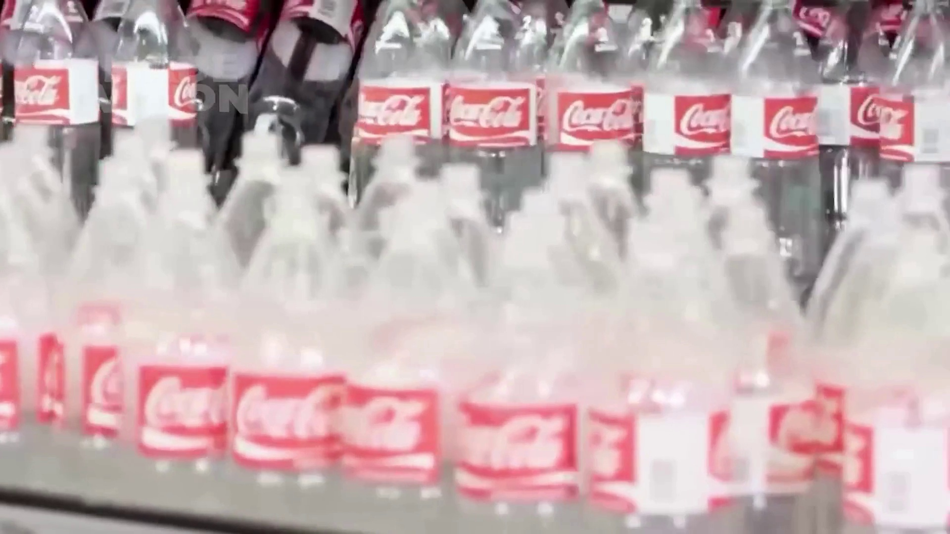
Selected image: eng_05-Scene-012-03.jpg
6. Air removed from bottles (at 183.8s)
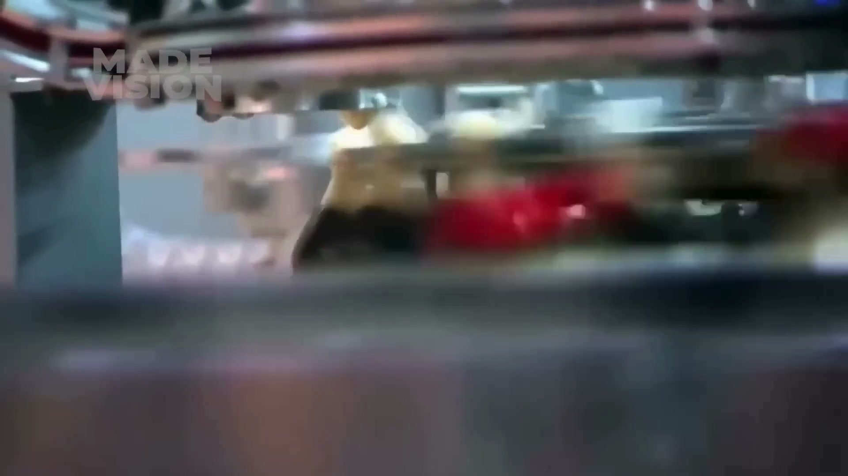
Selected image: eng_05-Scene-014-04.jpg
7. Apply aluminum crown to bottles (at 189.1s)
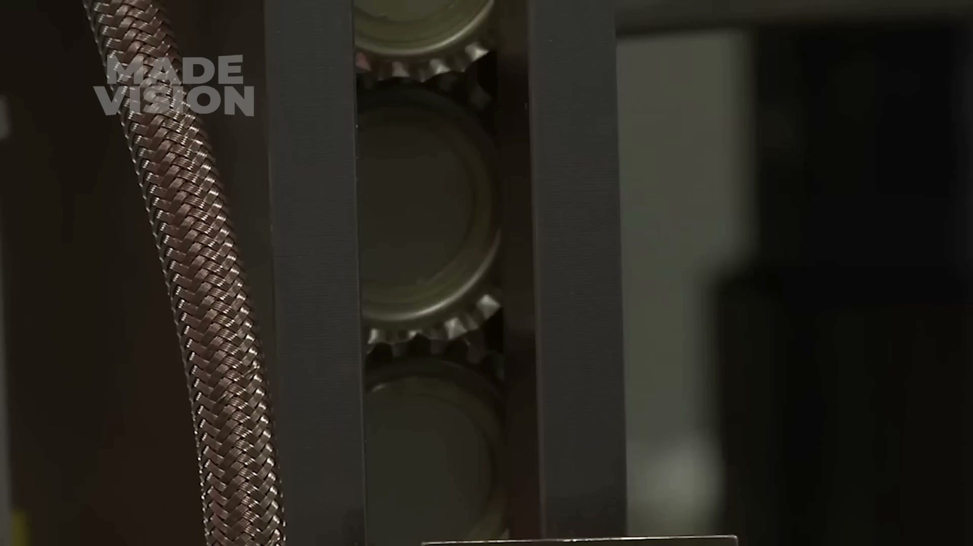
Selected image: eng_05-Scene-014-05.jpg
8. Pump mixture into filling lines (at 220.6s)
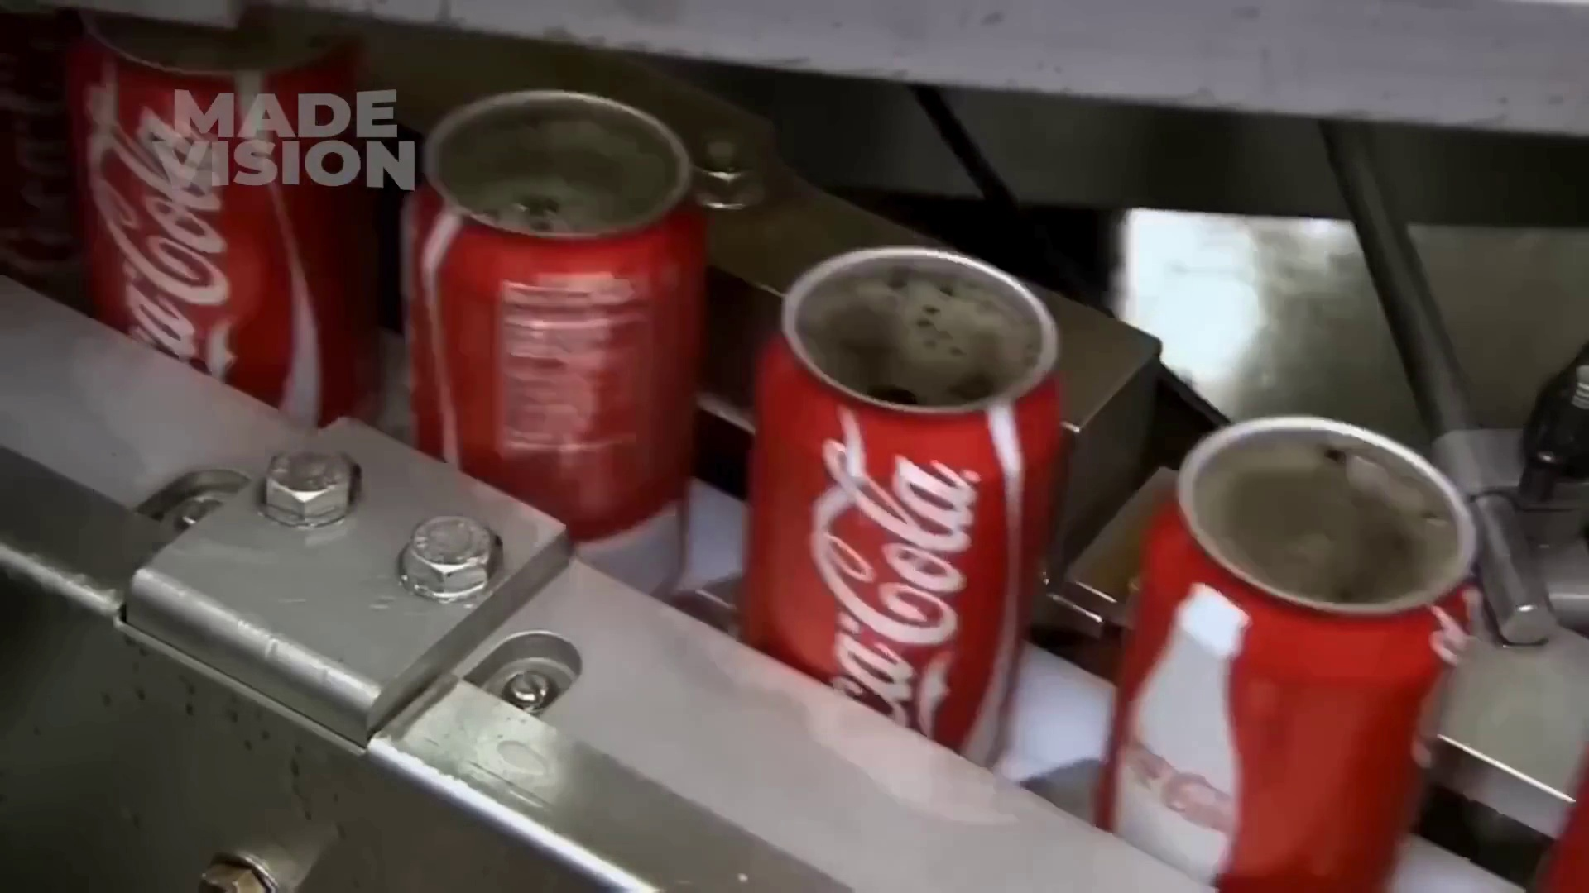
Selected image: eng_05-Scene-017-02.jpg
9. Fill cans with mixture (at 224.9s)
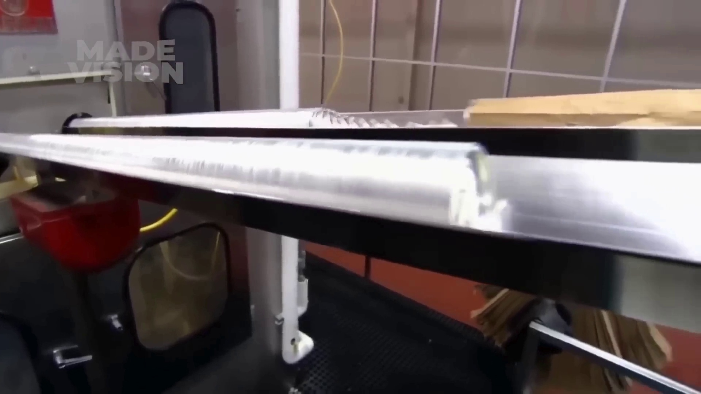
Selected image: eng_05-Scene-017-03.jpg
10. Supervise can seaming process (at 230.1s)
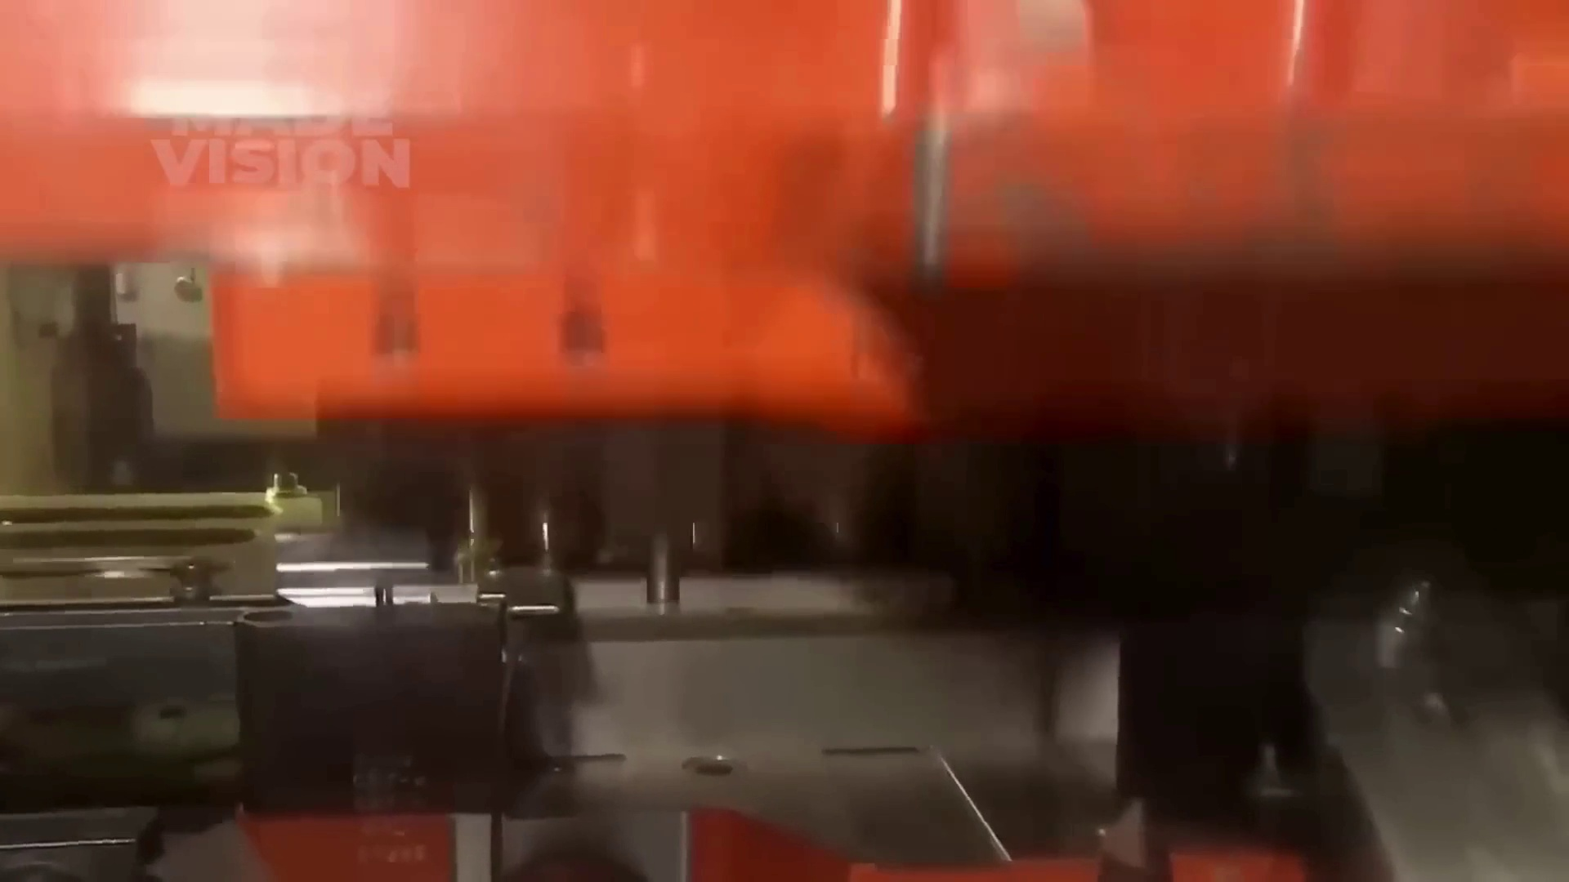
Selected image: eng_05-Scene-018-02.jpg
11. Cut cardboard to correct length (at 269.2s)
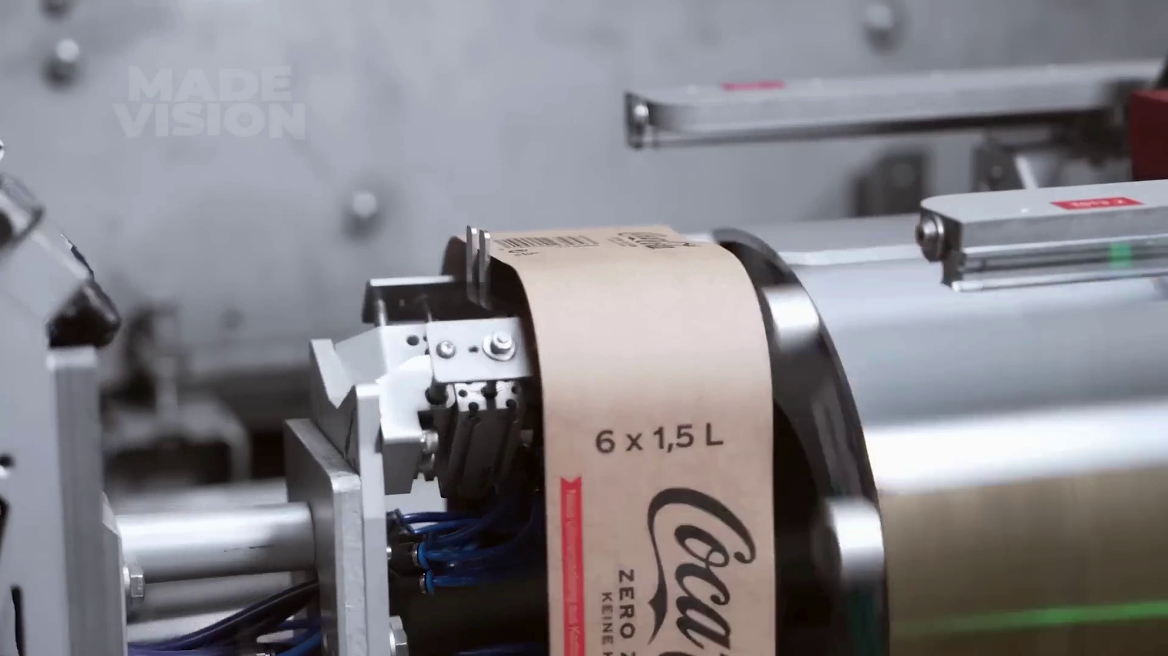
Selected image: eng_05-Scene-021-02.jpg
12. Shape cardboard to fit bottles (at 274.0s)
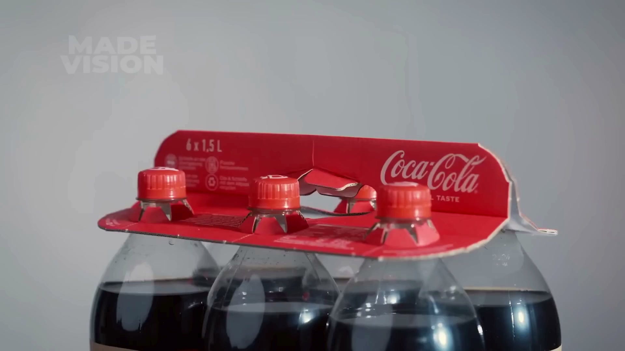
Selected image: eng_05-Scene-022-01.jpg
13. Secure packaging with pre-folded clips (at 278.5s)
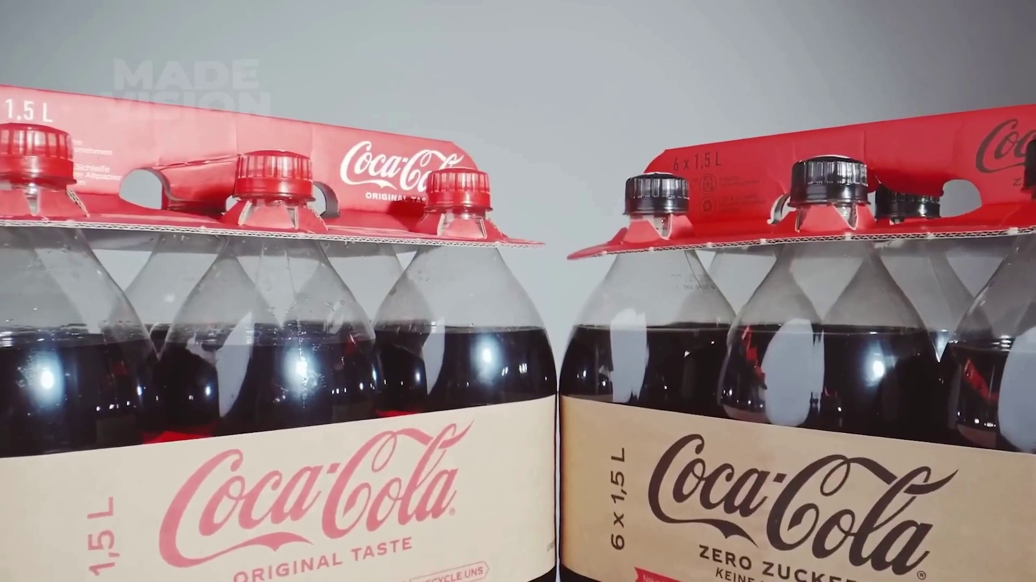
Selected image: eng_05-Scene-021-03.jpg
14. Wrap bottles in shrink film (at 283.1s)
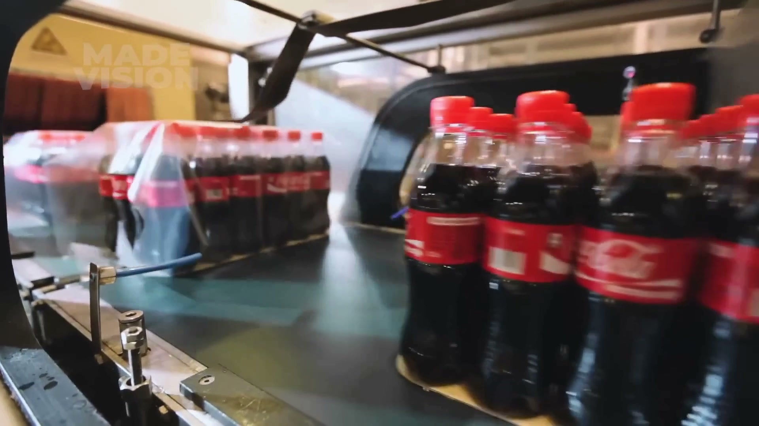
Selected image: eng_05-Scene-022-02.jpg
15. Pack cans into boxes (at 296.4s)
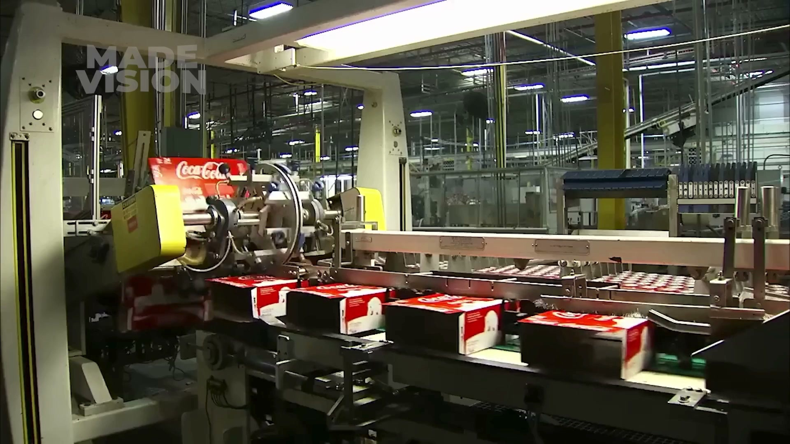
Selected image: eng_05-Scene-022-04.jpg
16. Wrap plastic film around boxes (at 312.2s)
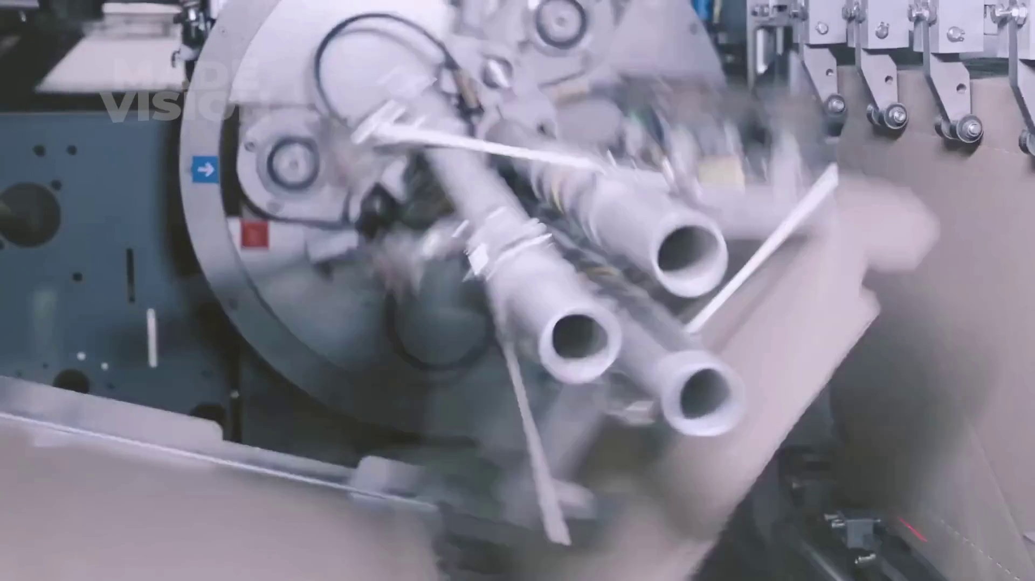
Selected image: eng_05-Scene-023-03.jpg
17. Heat the shrink wrap film (at 315.6s)
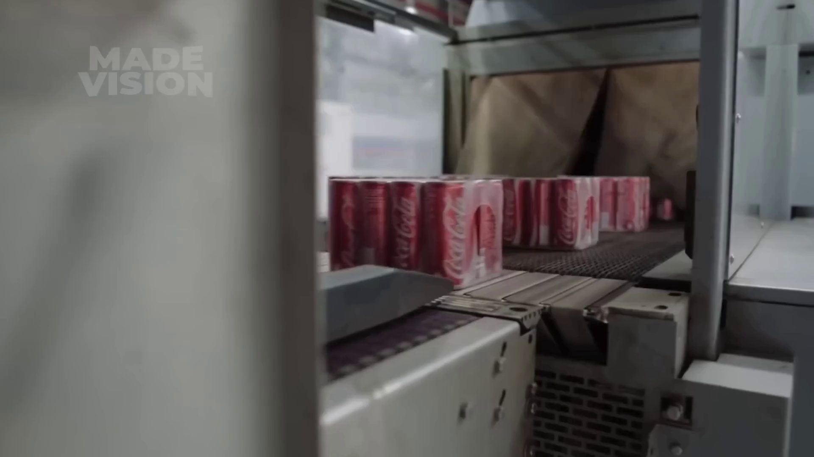
Selected image: eng_05-Scene-024-01.jpg
18. Shrink wrap cans (at 318.9s)
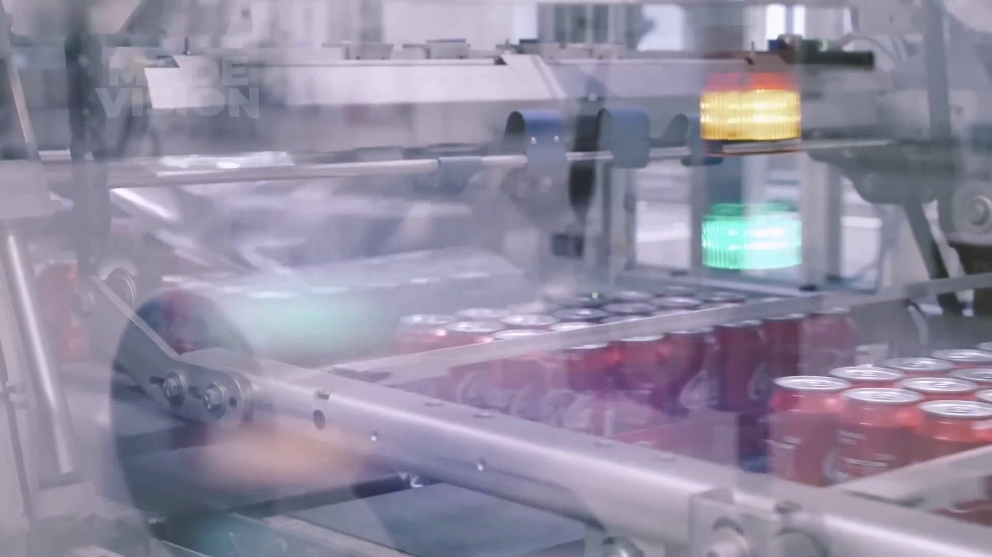
Selected image: eng_05-Scene-024-02.jpg
19. Wrap sorted cases to keep them stable during transport (at 355.3s)
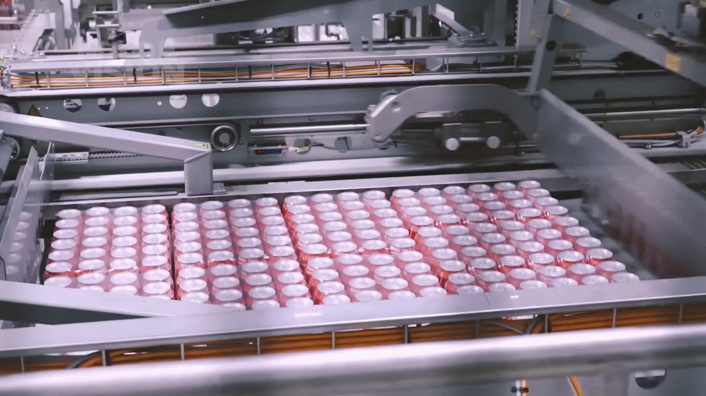
Selected image: eng_05-Scene-027-02.jpg
20. Load pallets onto trucks (at 389.2s)
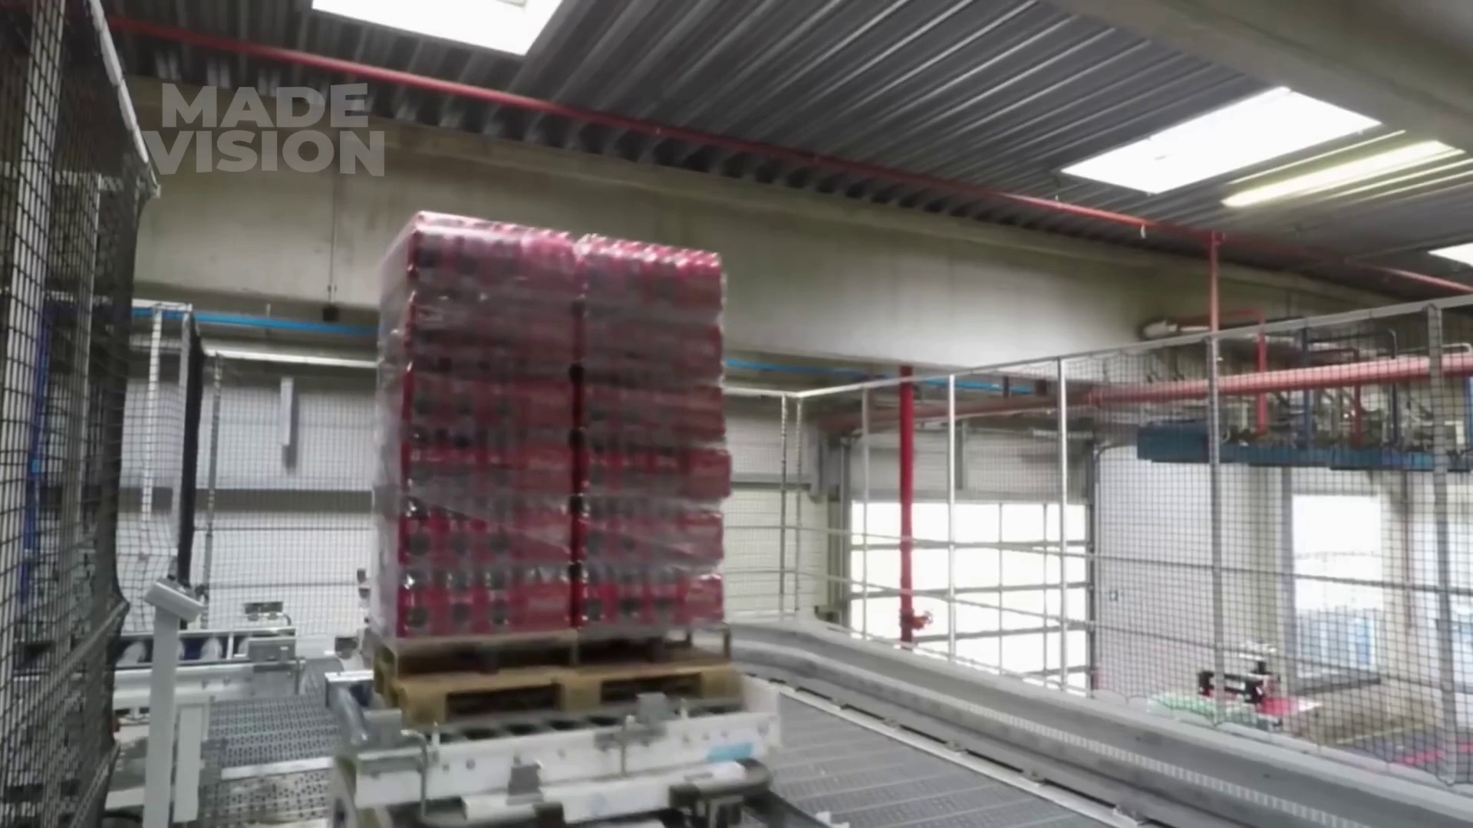
Selected image: eng_05-Scene-030-02.jpg

