**Name: Jasmine Sayyad**

**PRN: 22510033**

You have been provided data in the CSV file. Use this file to fit a linear regression model using ChatGPT alone. ‘y’ is the target variable and ‘x1,x2,…..x11’ are the input variables. Please take a screenshot of your prompts and chatGPT’s responses and submit in a word document or ppt. 10*coefficient of determination will be your score. Copying of prompts will lead to assignment disqualification.

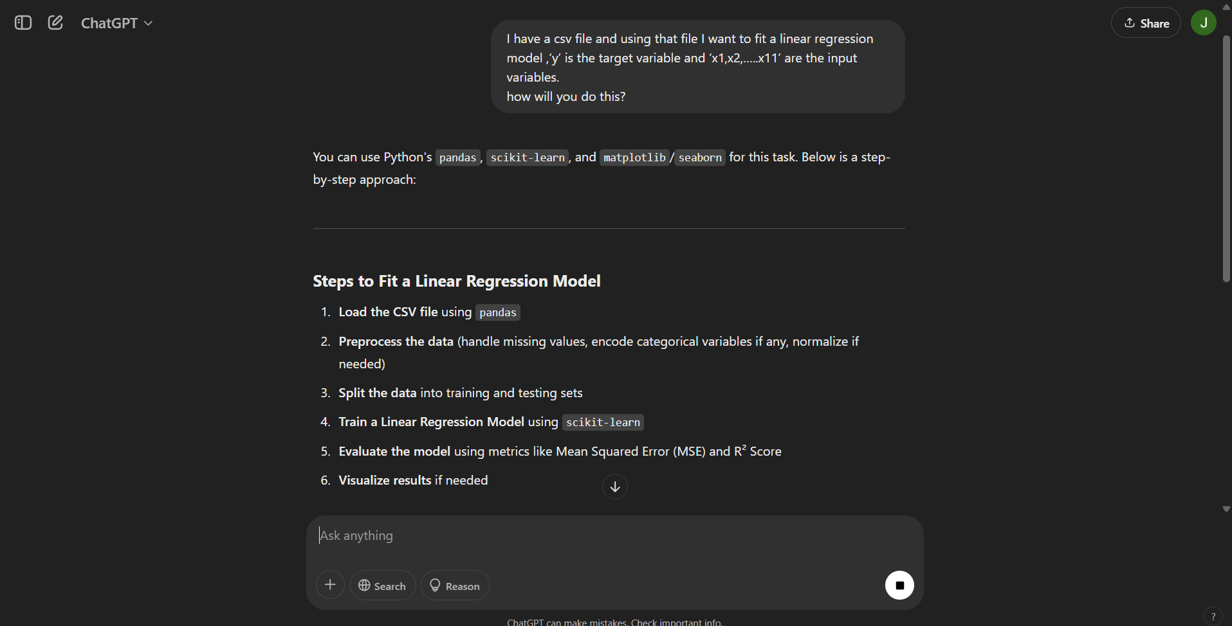

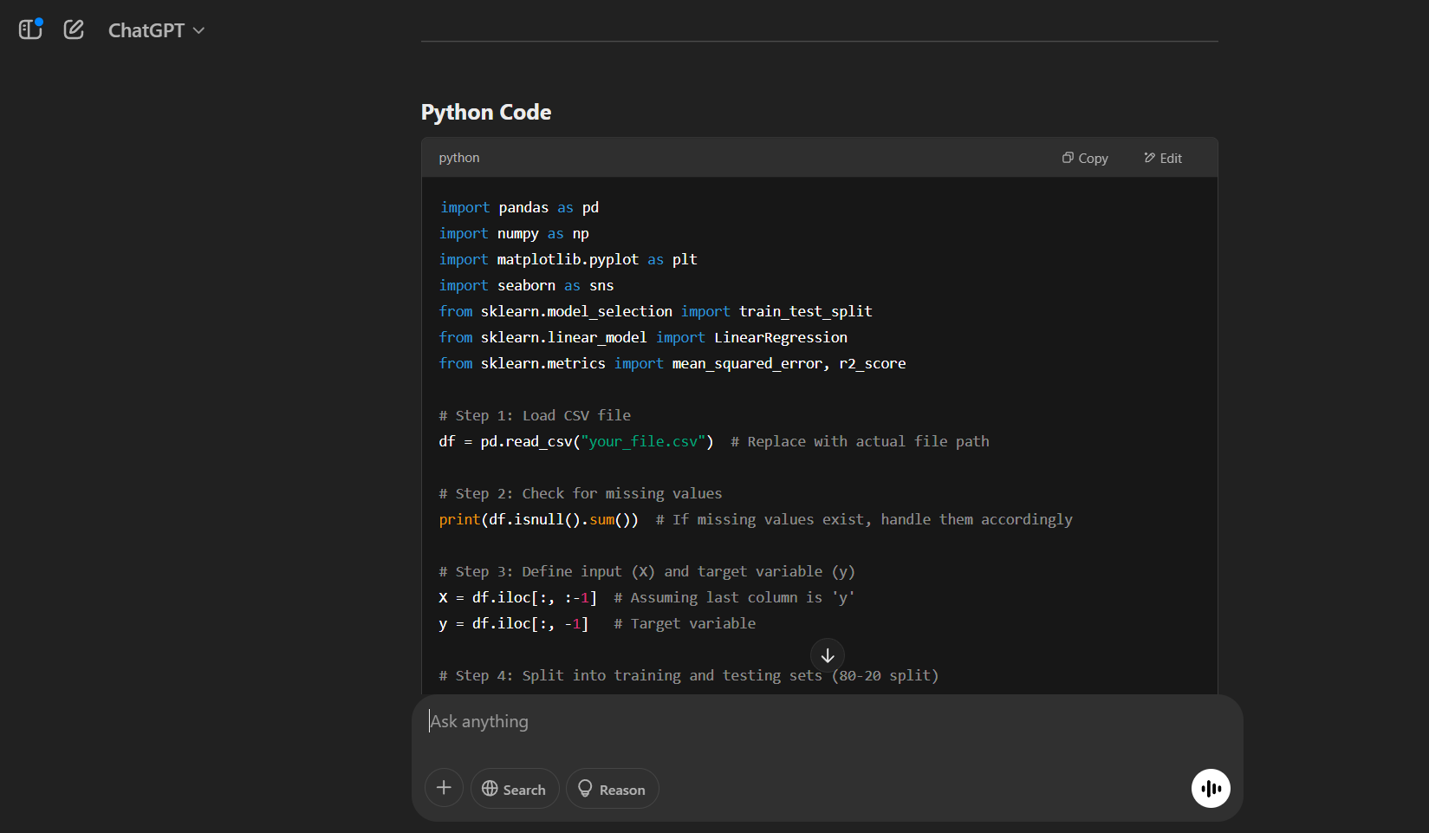

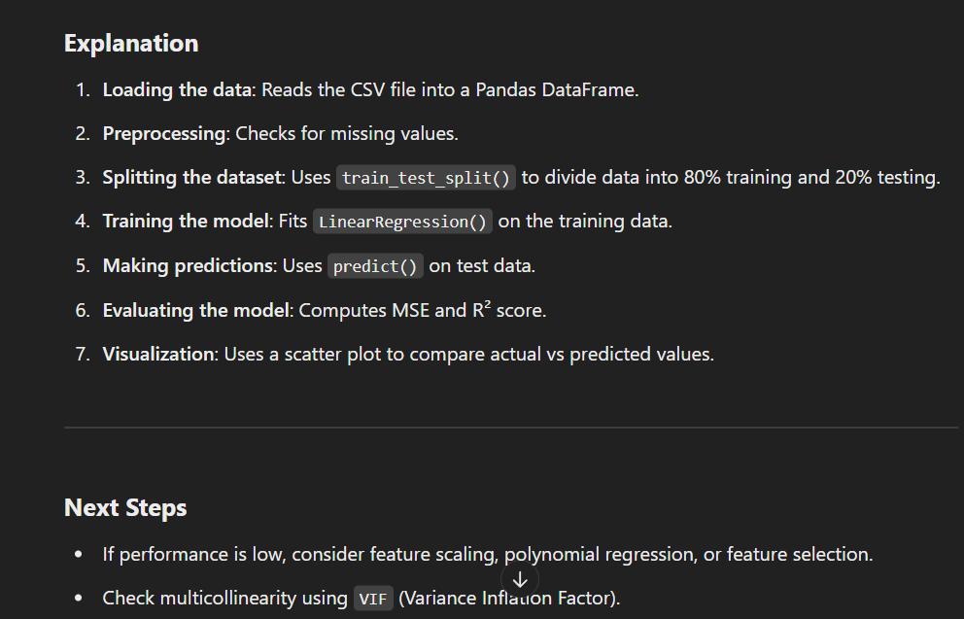

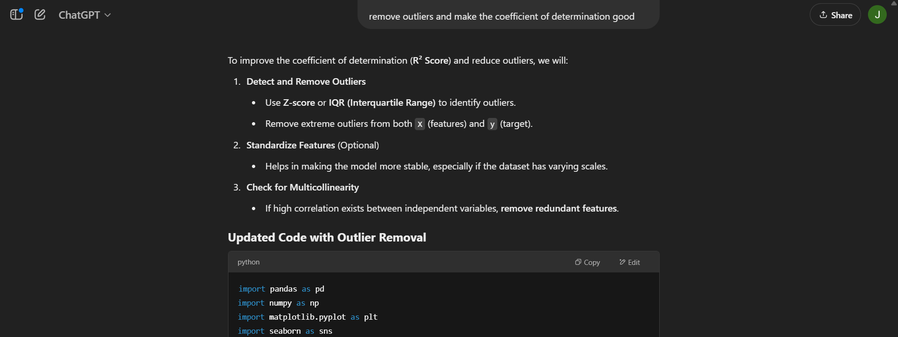

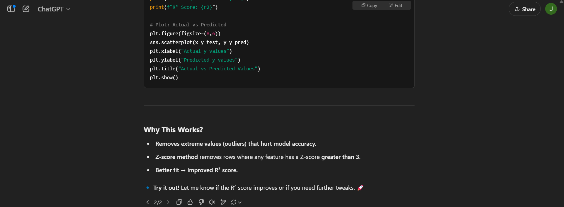  
  
code:

import pandas as pd

import numpy as np

import matplotlib.pyplot as plt

import seaborn as sns

from sklearn.model_selection import train_test_split

from sklearn.linear_model import LinearRegression

from sklearn.metrics import mean_squared_error, r2_score

from scipy.stats import zscore  # Import Z-score function

# Load CSV file

df = pd.read_csv("linear_regression_3.csv")  # Replace with actual file path

# Check for missing values

print(df.isnull().sum())

# Ensure X is a DataFrame and y is a Series

y = df.iloc[:, 0]        # First column is 'y' (Series)

X = df.iloc[:, 1:].copy()  # Rest are features (DataFrame)

# ---- Step 1: Remove Outliers using Z-score ----

df_clean = df[(np.abs(zscore(df)) < 3).all(axis=1)]  # Keep only rows with Z < 3

# Extract cleaned X and y

y = df_clean.iloc[:, 0]

X = df_clean.iloc[:, 1:].copy()

# Train-test split (80-20)

X_train, X_test, y_train, y_test = train_test_split(X, y, test_size=0.2, random_state=42)

# Train Linear Regression Model

model = LinearRegression()

model.fit(X_train, y_train)

# Make Predictions

y_pred = model.predict(X_test)

# Model Evaluation

mse = mean_squared_error(y_test, y_pred)

r2 = r2_score(y_test, y_pred)

print(f"Mean Squared Error: {mse}")

print(f"R² Score: {r2}")

# Plot: Actual vs Predicted

plt.figure(figsize=(8,6))

sns.scatterplot(x=y_test, y=y_pred)

plt.xlabel("Actual y values")

plt.ylabel("Predicted y values")

plt.title("Actual vs Predicted Values")

plt.show()

Output of code

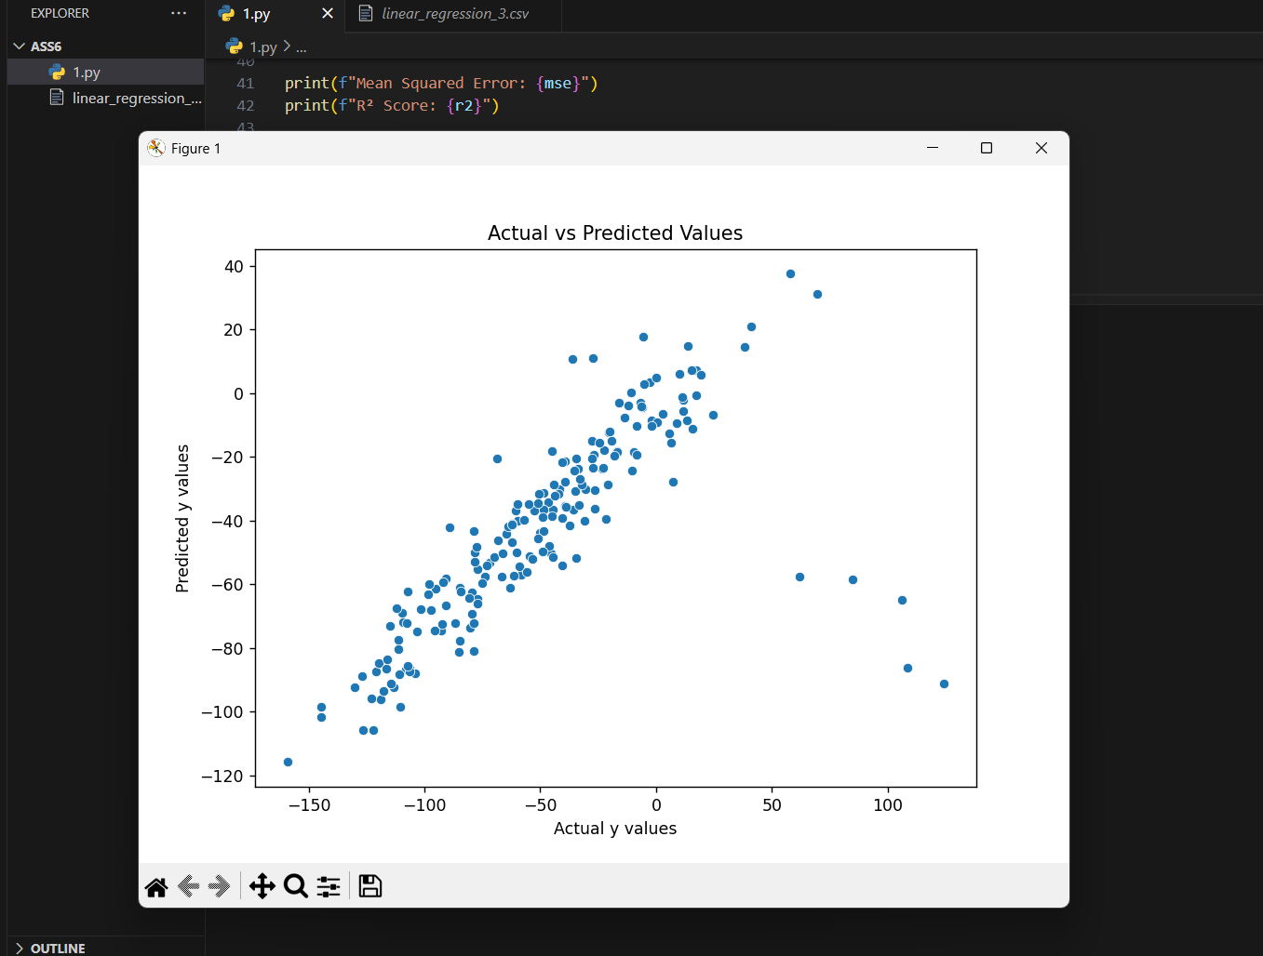

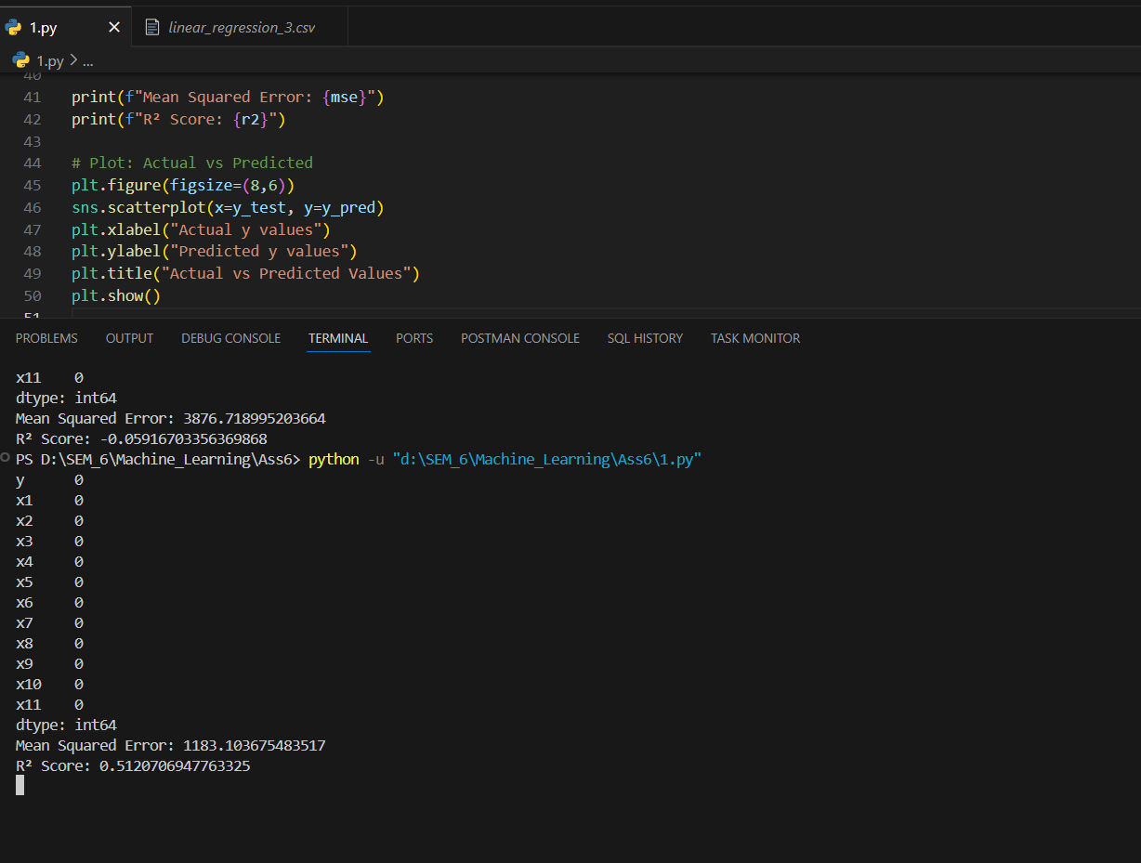

coefficient of determination is => 0.5121670