Machine Learning  
Assignment 07

Name: Jasmine Imtiyaj Sayyad

PRN: 22510033

Batch: T-2

You have been provided data in the CSV file. Use this file to fit a linear regression model . ‘y’ is the target variable and ‘x1,x2,…..x11’ are the input variables.

Steps:

1. **Remove the outliers using IQR method**

Calculates Q1 (25th percentile) and Q3 (75th percentile**)**.

Identifies **outliers** using the IQR formula:

Lower Bound=Q1−1.5×IQR

Upper Bound=Q3+1.5×IQR

Removes data points beyond these bounds.

Outliers are removed to prevent them from distorting the model.

1. **VIF Calculation and Multicollinearity Handling**

Computes **VIF** (Variance Inflation Factor) for all features.

Iteratively removes features with **VIF > 4**.

Multicollinearity can be reduced by dropping correlated features.

1. **Influence Detection and Removal**

Calculates Cook’s Distance and DFFITS to detect influential points.

Removes high-influence points using:

**Cook’s Distance**

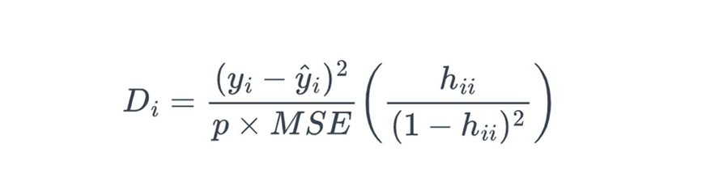

Threshold Cook’s Distance=2.8/n

**DFFITS**

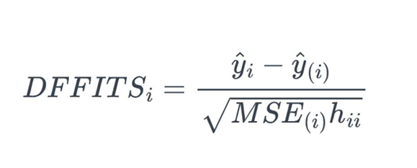

High-influence data points removed to prevent model distortion.

1. Train-Test Split and Model Training:

Splits the data into **training (80%)** and **testing (20%)**.

1. Final Output:

Coefficient of Determination is :



Code:

import pandas as pd

import numpy as np

from sklearn.model_selection import train_test_split

from sklearn.linear_model import LinearRegression

from sklearn.metrics import r2_score

import statsmodels.api as sm

from statsmodels.stats.outliers_influence import variance_inflation_factor

file_path = "linear_regression_3.csv"

df = pd.read_csv(file_path)

#Remove Outliers using IQR method

Q1 = df.quantile(0.25)

Q3 = df.quantile(0.75)

IQR = Q3 - Q1

lower_bound = Q1 - 1.5 * IQR

upper_bound = Q3 + 1.5 * IQR

df_iqr_clean = df[~((df < lower_bound) | (df > upper_bound)).all(axis=1)]

X_iqr = df_iqr_clean.drop(columns=['y'])

y_iqr = df_iqr_clean['y']

#Remove features with high VIF (VIF > 4)

def calculate_vif(X):

    vif_data = pd.DataFrame()

    vif_data["Feature"] = X.columns

    vif_data["VIF"] = [variance_inflation_factor(X.values, i) for i in range(X.shape[1])]

    return vif_data

def remove_high_vif(X, vif_threshold=4.0):

    vif_data = calculate_vif(X)

    while vif_data["VIF"].max() > vif_threshold:

        high_vif_feature = vif_data.sort_values(by="VIF", ascending=False).iloc[0]["Feature"]

        X = X.drop(columns=[high_vif_feature])

        vif_data = calculate_vif(X)

    return X

X_vif_clean = remove_high_vif(X_iqr, vif_threshold=4.0)

X_vif_const = sm.add_constant(X_vif_clean)

#Detect Influence Points using Cook's Distance and DFFITS

model = sm.OLS(y_iqr, X_vif_const).fit()

influence = model.get_influence()

cooks_d, _ = influence.cooks_distance

threshold_cook = 2.8 / len(X_vif_clean)

defits_values, _ = influence.dffits

threshold_dffits = 1.1 * np.sqrt(X_vif_clean.shape[1] / len(X_vif_clean))

# Detect high influence points

high_influence_points = (cooks_d > threshold_cook) | (np.abs(defits_values) > threshold_dffits)

df_final_clean = df_iqr_clean[~high_influence_points]

# Train-Test Split

X_final = df_final_clean.drop(columns=['y'])

y_final = df_final_clean['y']

X_train, X_test, y_train, y_test = train_test_split(X_final, y_final, test_size=0.2, random_state=42)

linear_model = LinearRegression()

linear_model.fit(X_train, y_train)

#Evaluation

y_pred = linear_model.predict(X_test)

r2_final = r2_score(y_test, y_pred)

print(f"R² Score: {r2_final:.4f}")

Output:

