**Assignment 9: Clustering**

**Name**: Jasmine Imtiyaj Sayyad

**PRN**: 22510033

**Batch**: T2

Here are the **observations** derived from the **code**, **graphs**, and **console output** you’ve provided:

### ****1.**** Elbow Method (Inertia vs K)

To Identify the point where adding more clusters doesn’t significantly reduce inertia (i.e., the "elbow").

**Observation from Graph:**

The elbow point appears to be at **k = 2**.

After k=2, the rate of decrease in inertia slows down.

**Conclusion:** Optimal k = 2 clusters based on the Elbow method.

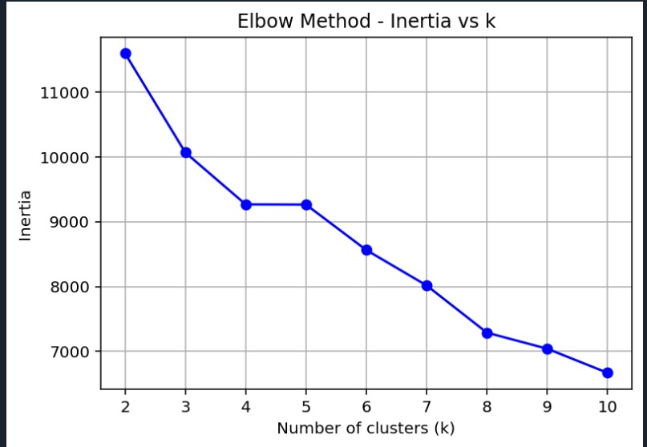

### ****2.**** Silhouette Analysis (Silhouette Score vs K)

To Evaluate clustering quality. A higher silhouette score means better-defined clusters.

**Observation from Graph:**

Maximum silhouette score occurs at **k = 2** (~0.345).

Silhouette score drops sharply as k increases beyond 4.

**Conclusion:** **k = 2** is again optimal based on silhouette score, affirming the Elbow Method result

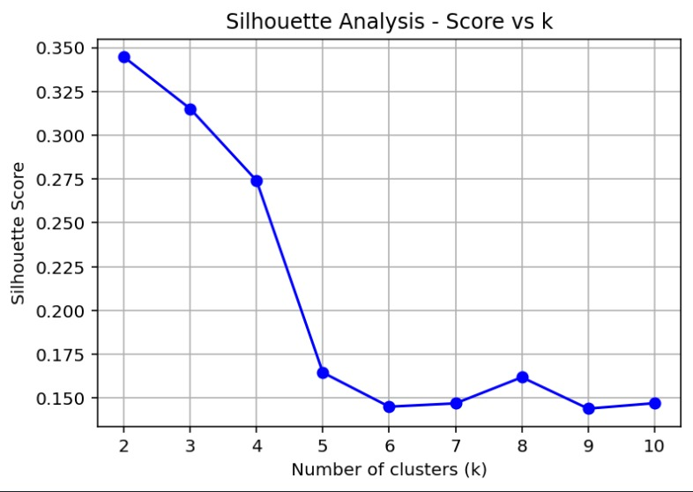.

### ****3.**** KMeans Clustering Results

**Optimal k (from inertia):** 2

**Homogeneity Score:** 0.5249

Indicates **moderate clustering accuracy**, i.e., the clusters align decently with actual diagnosis (M or B).

**Interpretation:** KMeans with k=2 does reasonably well in separating malignant and benign tumors.

### ****4.**** DBSCAN Clustering

To Use density-based clustering without needing to specify k.

**k-distance graph:** Used to estimate a good eps value (distance threshold).

**Best Parameters (from grid search):**

eps = 2.3, min_samples = 2

**Homogeneity Score:** 0.3201

**Interpretation:** DBSCAN was able to find clusters but performed **worse than KMeans** in terms of homogeneity. It may not be well-suited due to the dataset’s structure or scaling.

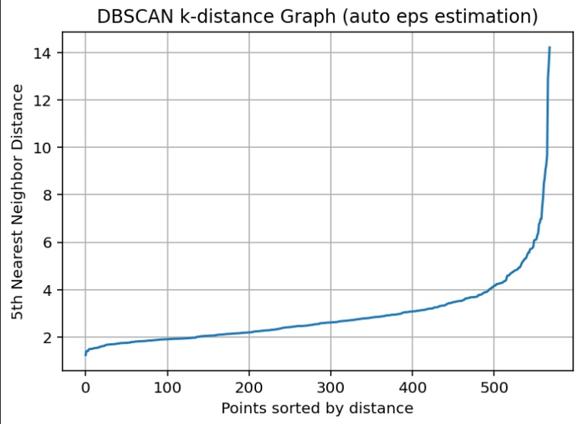

### OUTPUT :

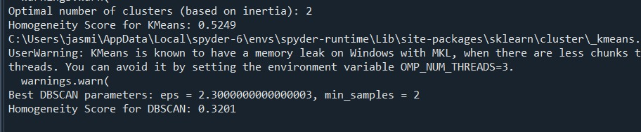

Code :

import pandas as pd

import numpy as np

from sklearn.cluster import KMeans, DBSCAN

from sklearn.metrics import silhouette_score, homogeneity_score

from sklearn.preprocessing import StandardScaler

import matplotlib.pyplot as plt

from sklearn.neighbors import NearestNeighbors

df = pd.read_csv('Cancer_Data.csv')

original_diagnosis = df['diagnosis']

df = df.drop(columns=['id', 'diagnosis'])

df = df.dropna(axis=1, how='all')

df = df.fillna(df.mean())

scaler = StandardScaler()

df_scaled = scaler.fit_transform(df)

inertia = []

k_range = range(2, 11)

for k in k_range:

    kmeans = KMeans(n_clusters=k, random_state=42)

    kmeans.fit(df_scaled)

    inertia.append(kmeans.inertia_)

silhouette_scores = []

for k in k_range:

    kmeans = KMeans(n_clusters=k, random_state=42)

    kmeans.fit(df_scaled)

    score = silhouette_score(df_scaled, kmeans.labels_)

    silhouette_scores.append(score)

plt.plot(k_range, inertia, 'bo-')

plt.xlabel('Number of clusters (k)')

plt.ylabel('Inertia')

plt.title('Elbow Method - Inertia vs k')

plt.grid(True)

plt.show()

plt.plot(k_range, silhouette_scores, 'bo-')

plt.xlabel('Number of clusters (k)')

plt.ylabel('Silhouette Score')

plt.title('Silhouette Analysis - Score vs k')

plt.grid(True)

plt.show()

optimal_k_inertia = k_range[inertia.index(max(inertia))]

optimal_k_silhouette = k_range[silhouette_scores.index(max(silhouette_scores))]

optimal_k = optimal_k_inertia

print(f"Optimal number of clusters (based on inertia): {optimal_k}")

kmeans = KMeans(n_clusters=optimal_k, random_state=20)

kmeans.fit(df_scaled)

labels = kmeans.labels_

diagnosis_numerical = original_diagnosis.map({'M': 1, 'B': 0})

homogeneity = homogeneity_score(diagnosis_numerical, labels)

print(f"Homogeneity Score for KMeans: {homogeneity:.4f}")

min_samples_for_eps = 5

neighbors = NearestNeighbors(n_neighbors=min_samples_for_eps)

neighbors_fit = neighbors.fit(df_scaled)

distances, indices = neighbors_fit.kneighbors(df_scaled)

k_distances = np.sort(distances[:, -1])

plt.plot(k_distances)

plt.ylabel(f'{min_samples_for_eps}th Nearest Neighbor Distance')

plt.xlabel('Points sorted by distance')

plt.title('DBSCAN k-distance Graph (auto eps estimation)')

plt.grid(True)

plt.show()

eps_values = np.arange(2.2,4.2,0.1)

min_samples_values = range(2,8)

best_homogeneity = -1

best_eps = None

best_min_samples = None

for eps in eps_values:

    for min_samples in min_samples_values:

        dbscan = DBSCAN(eps=eps, min_samples=min_samples)

        dbscan_labels = dbscan.fit_predict(df_scaled)

        if len(set(dbscan_labels)) > 1:

            homogeneity_dbscan = homogeneity_score(diagnosis_numerical, dbscan_labels)

            if homogeneity_dbscan > best_homogeneity:

                best_homogeneity = homogeneity_dbscan

                best_eps = eps

                best_min_samples = min_samples

print(f"Best DBSCAN parameters: eps = {best_eps}, min_samples = {best_min_samples}")

print(f"Homogeneity Score for DBSCAN: {best_homogeneity:.4f}")