Sample part taken to build this model :- Y9T-63121

Basic approach followed to build AI model to detect the crack defect:-

1. We’ll start with comparing images of Good part.
2. This will serve as training data and should be taken to train the model.
3. We have to similarity measure between good part images and set a threshold level.

For e.g. let’s say similarity threshold level is 60%.

So similarity less than 60% will be considered as bad or defective.

1. Then we have to test the similarity measure with the bad part image.

If it is greater than threshold level, it is considered as good part.

If it is less than threshold level, it is considered as bad part.

1. So, this will serve as testing data and should be taken to test the model.

Output Images:

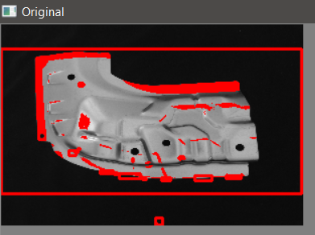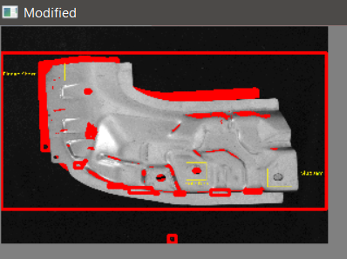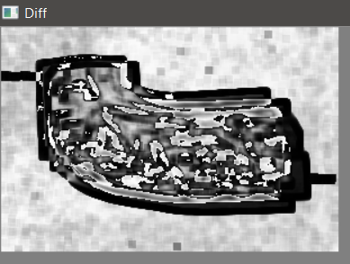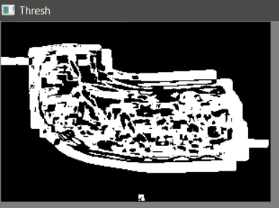

**Difference In Images:**

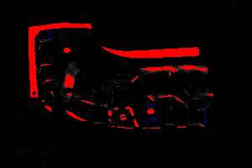

Diff Over Image 1:

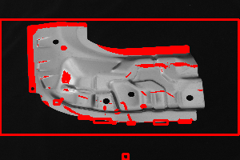

Diff Over Image 2:

