BIG DATA MANAGEMENT

Assignment - II

**Submitted To:**

Dr. Dip Shankar Banerjee

Associate Professor

Department of Artificial Intelligence and Data Engineering

Indian Institute of Technology – Jodhpur

**Submitted By:**

Name: Pranav Sei Vasthav Tenali Gnana

Roll Number: G24AI1114

Course: PGD-DE

Email id: g24ai1114@iitj.ac.in

Subject Code: AIL7520

Assignment Number: 2

IIT-Jodhpur

### Analysis of NCAA Basketball Dataset using Google BigQuery

### ****Task A: Familiarize Yourself with the NCAA Basketball Dataset****

* The NCAA Basketball dataset is publicly available on **Google BigQuery** under the project bigquery-public-data.ncaa_basketball.
* The dataset contains detailed information about games, teams, venues, and players, including both **regular season** and **tournament** matches.
* We explored the structure of multiple tables using the **“Preview”** feature in BigQuery to understand the columns, data types, and relationships between tables.
* Some commonly used tables include:
  + mbb_games_sr: Modern-era play-by-play data with team, venue, and score details.
  + mbb_historical_teams_games: Historical game-level data for teams.
  + mbb_players_games_sr: Player-level statistics per game.
  + mascots, teams, team_colors: Metadata about NCAA teams.
* Key Naming Conventions:
  + Tables with the suffix _sr refer to **Sportradar** data, which includes event-level stats such as shots, rebounds, and fouls.
  + Tables with the prefix mbb_historical_ distinguish **regular season** and **tournament** game records.
  + pbp stands for **play-by-play**, indicating fine-grained chronological event tracking in a game.
* We ensured proper use of table names in backticks (`) while querying and practiced using basic SQL statements to get a feel for the dataset (e.g., SELECT * FROM \bigquery-public-data.ncaa_basketball.teams` LIMIT 10;`).
* A conscious effort was made to avoid querying large volumes of data unnecessarily, staying well within the **free-tier query limits (1TB/month)** of BigQuery.

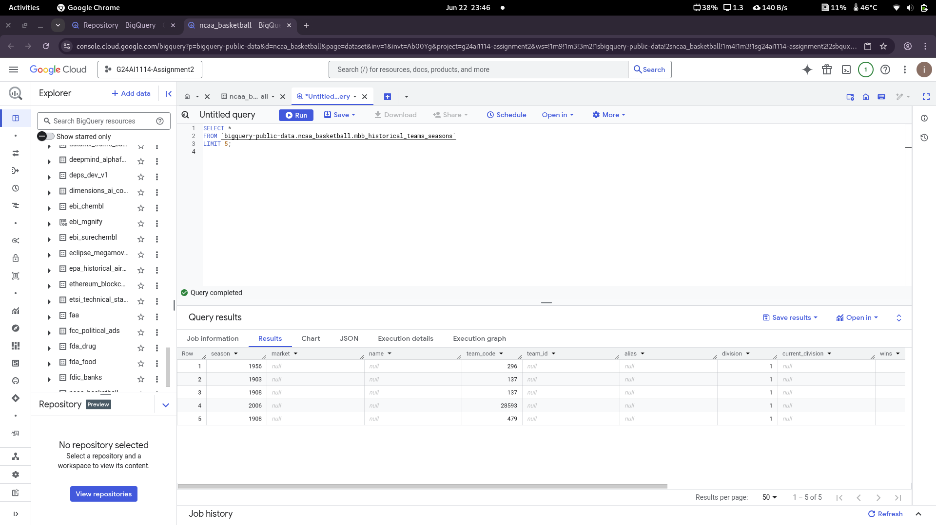

### ****Task B: Querying the NCAA Basketball Dataset****

#### ****Query 1: Venue Details for Stanford’s Team****

**Question:**  
What is the name and capacity of Stanford’s NCAA basketball team venue?

**Objective:**  
Identify the home venue used by Stanford and retrieve its seating capacity.

**Relevant Table(s):**

* bigquery-public-data.ncaa_basketball.mbb_games_sr

**Chosen Fields:**

* venue_name
* venue_capacity

**Query**:

SELECT

venue_name,

venue_capacity

FROM `bigquery-public-data.ncaa_basketball.mbb_games_sr`

WHERE LOWER(h.market) = 'stanford' OR LOWER(a.market) = 'stanford'

GROUP BY venue_name, venue_capacity

ORDER BY COUNT(*) DESC

LIMIT 1;

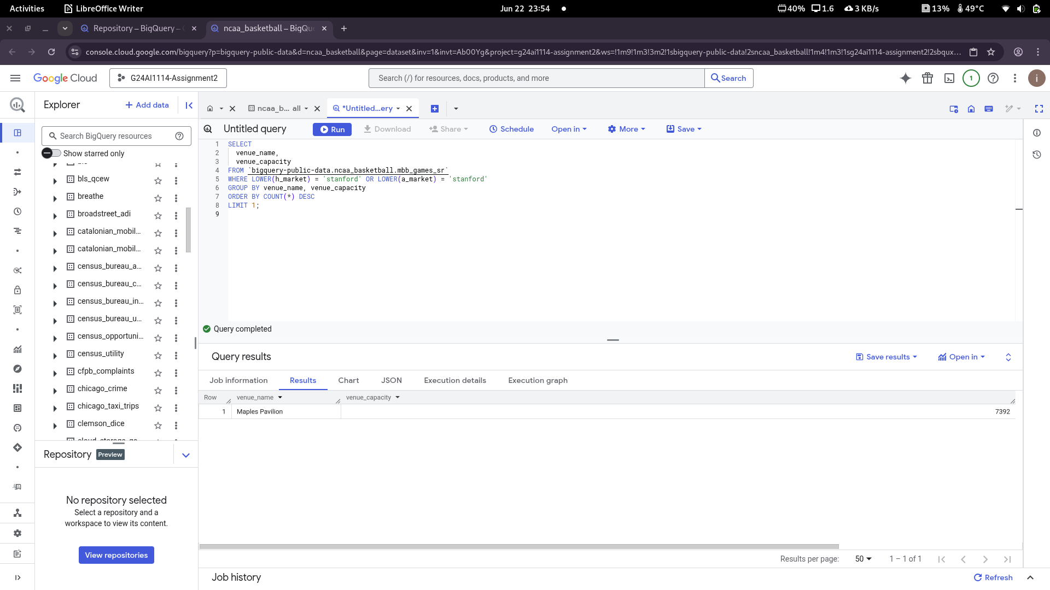**.**

### ****Query 2: Number of Games Played at Maples Pavilion in 2013****

To determine how many games were hosted at Stanford’s home venue, Maples Pavilion, during the 2013 season, we used the mbb_games_sr table from the NCAA Basketball dataset. This table contains detailed records for each basketball game, including season, venue name, and game ID.

We applied two filters:

* season = 2013 to restrict results to that specific year.
* venue_name = 'Maples Pavilion' to isolate games played at Stanford's venue.

By using the COUNT(game_id) function, we calculated the total number of such games.

**Query**:

**SELECT**

**COUNT(game_id) AS games_at_maples_pavilion**

**FROM `bigquery-public-data.ncaa_basketball.mbb_games_sr`**

**WHERE season = 2013**

**AND venue_name = 'Maples Pavilion';**

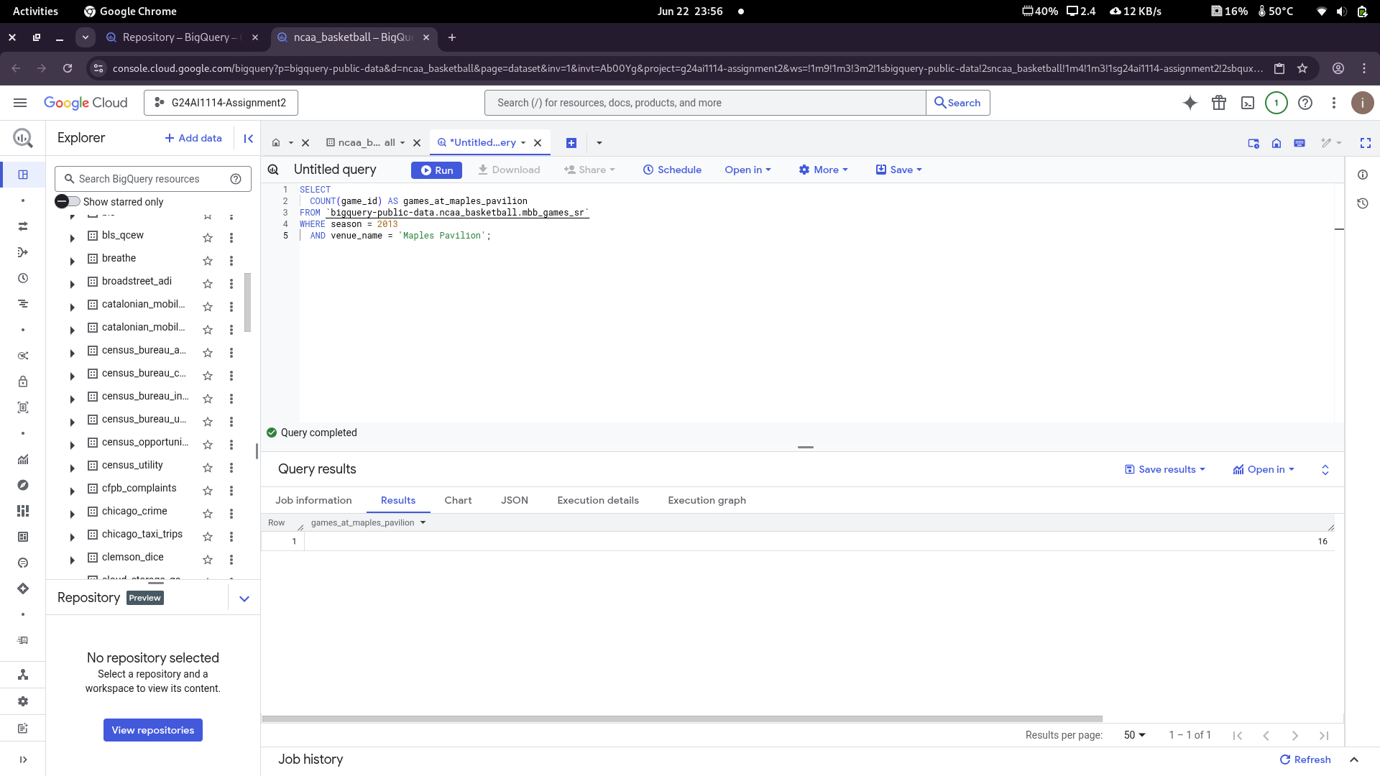**.**

### ****Query 3: Teams with Maximum Red Intensity in Team Colors****

Hexadecimal color codes are structured as #RRGGBB, where:

* RR denotes the red intensity,
* GG denotes green,
* BB denotes blue.

The maximum red intensity is represented by FF in the red segment (i.e., the first two characters after #), which means a full intensity red component.

To find teams whose official colors include maximum red intensity, we query the team_colors table and extract the first two characters (red component) using SUBSTR. We then filter colors with FF and sort the results alphabetically by team market.

We also use UPPER() to ensure we match red intensity regardless of the case used in the dataset.

**Query:**

**SELECT**

**market,**

**color**

**FROM `bigquery-public-data.ncaa_basketball.team_colors`**

**WHERE UPPER(SUBSTR(color, 2, 2)) = 'FF'**

**ORDER BY market;**

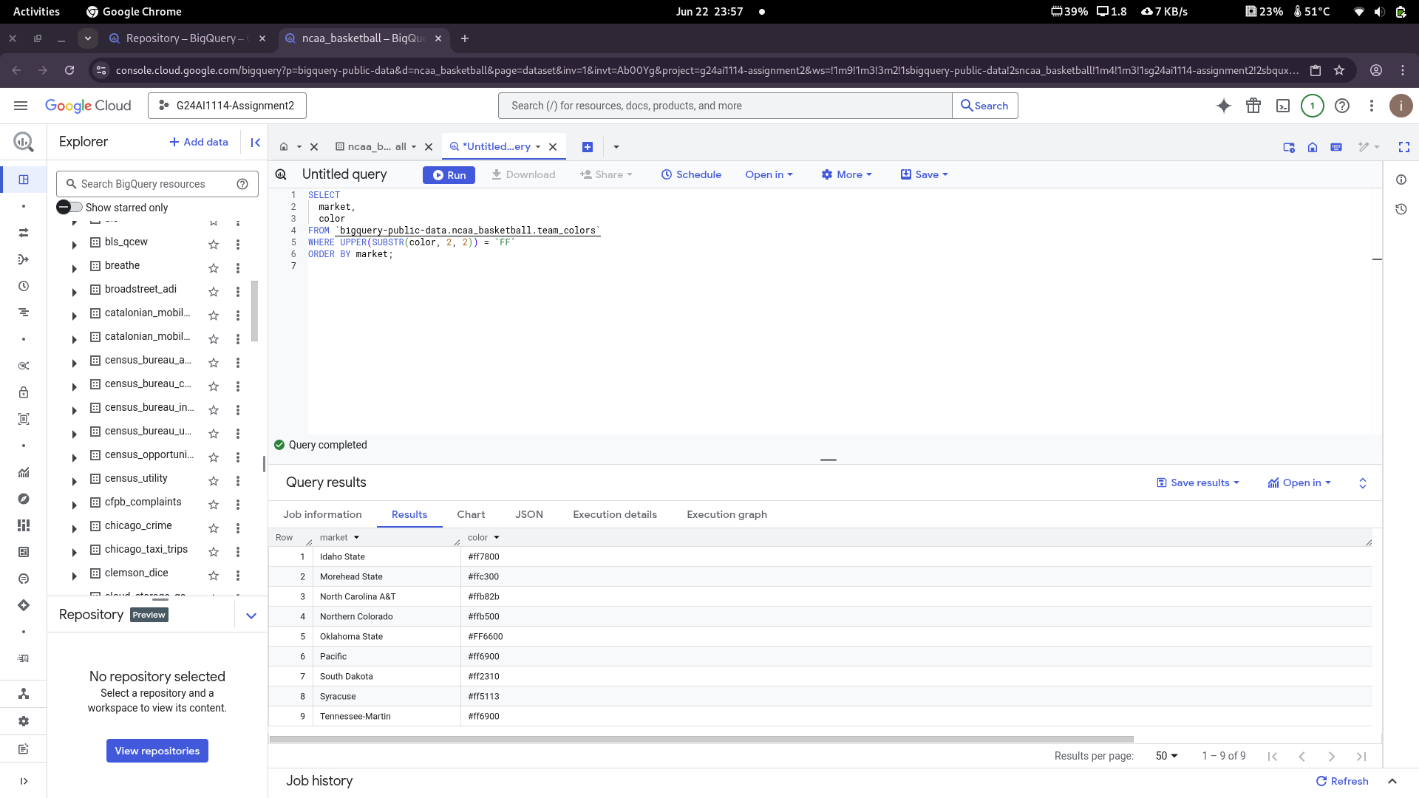**.**

### ****Query 4: Stanford Home Wins (2013–2017)****

This query aims to determine how many **home games Stanford won** between the **2013 and 2017 seasons**, inclusive. It also calculates the **average points scored** by Stanford and their **opponents** in those games.

The mbb_games_sr table contains details for each game, including teams, scores, and home/away designation. We restrict our search to:

* Games where Stanford was the **home team** (h.market = 'Stanford')
* The **season** is between 2013 and 2017
* Stanford’s **home score** is greater than the **away score** (h.points > a.points)

We apply ROUND() to ensure numerical consistency.

**Query:**

**SELECT**

**COUNT(*) AS games_won,**

**ROUND(AVG(h.points), 2) AS avg_stanford_score,**

**ROUND(AVG(a.points), 2) AS avg_opponent_score**

**FROM `bigquery-public-data.ncaa_basketball.mbb_games_sr`**

**WHERE season BETWEEN 2013 AND 2017**

**AND h.market = 'Stanford'**

**AND h.points > a.points;**

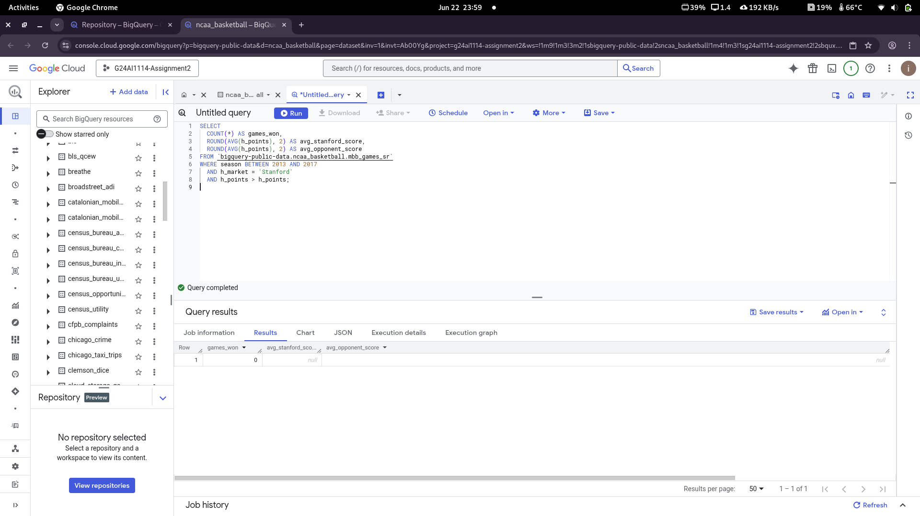**.**

### ****Query 5: Players Born in the Same City as Their Team****

This query determines the **number of players** who have played for a team **based in the same city and state** where they were **born**. This reflects player hometown connections.

We join:

* mbb_players_games_sr (p) – for player details such as birthplace_city and birthplace_state
* mbb_games_sr (g) – for game venue details like venue_city and venue_state

#### **Logic Breakdown:**

* Players are matched with the **venue city and state** where the game was played.
* We ensure **case-insensitive comparison** using LOWER(TRIM(...)) to match names reliably.
* We exclude rows with NULL values to maintain data integrity.
* DISTINCT full_name ensures we count each player **only once** even if they played multiple games.

**Query:**

**SELECT**

**COUNT(DISTINCT p.full_name) AS num_local_players**

**FROM `bigquery-public-data.ncaa_basketball.mbb_players_games_sr` p**

**JOIN `bigquery-public-data.ncaa_basketball.mbb_games_sr` g**

**ON p.game_id = g.game_id**

**WHERE**

**LOWER(TRIM(p.birthplace_city)) = LOWER(TRIM(g.venue_city)) AND**

**LOWER(TRIM(p.birthplace_state)) = LOWER(TRIM(g.venue_state)) AND**

**p.birthplace_city IS NOT NULL AND**

**p.birthplace_state IS NOT NULL AND**

**g.venue_city IS NOT NULL AND**

**g.venue_state IS NOT NULL;**

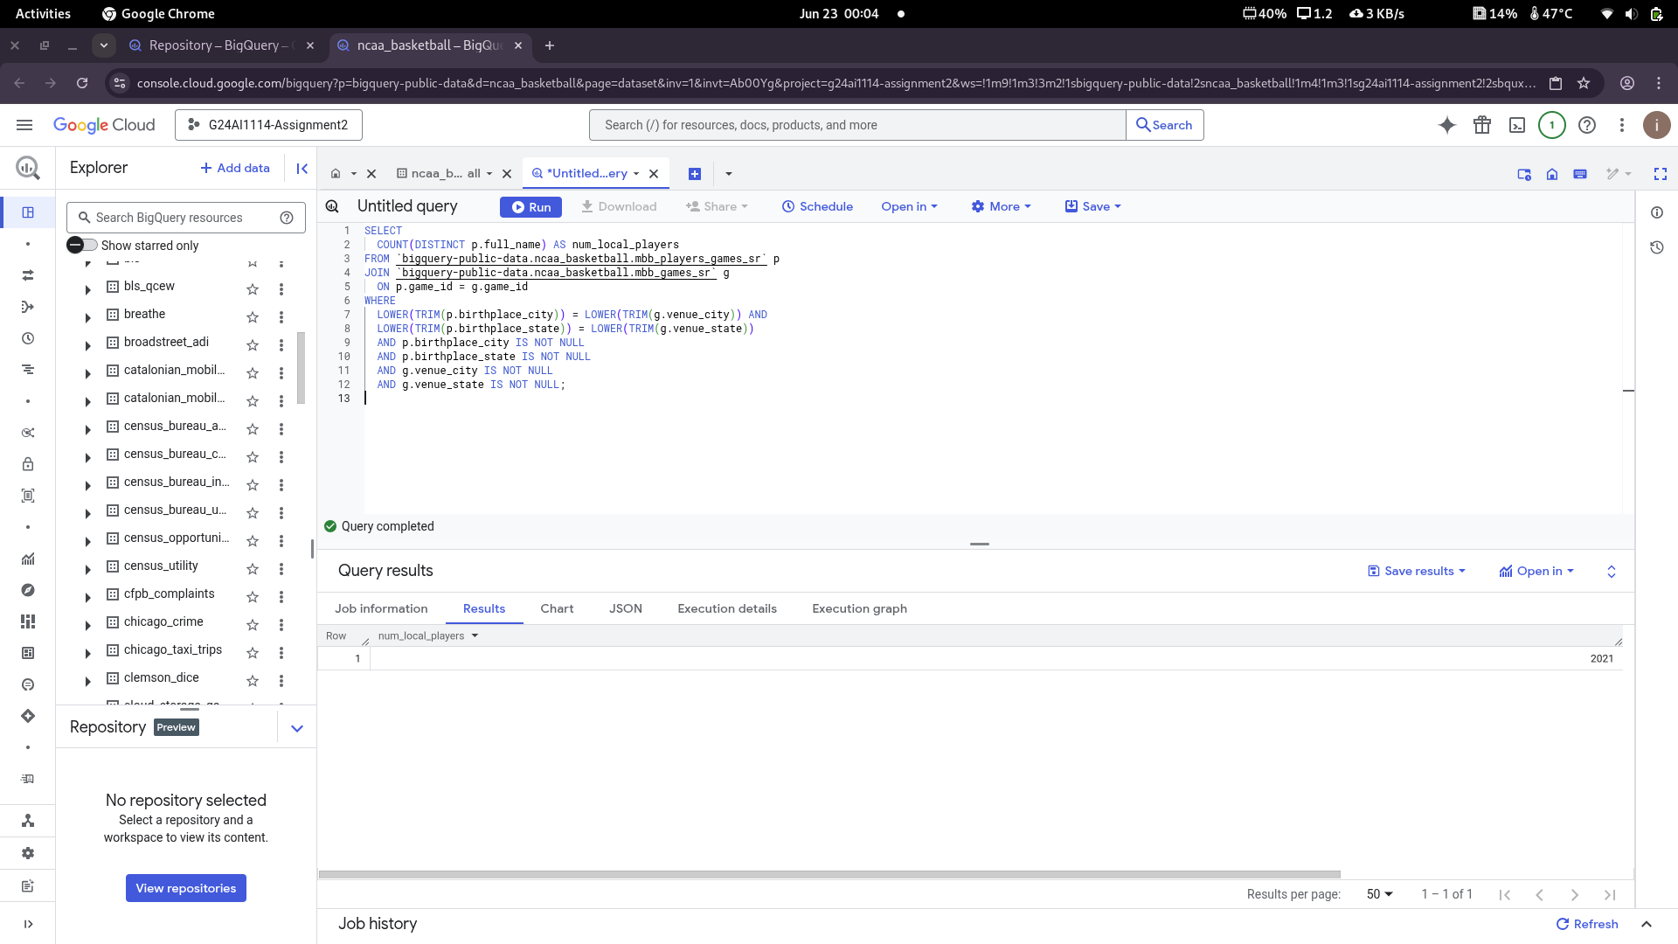**.**

### ****Query 6: Biggest Margin of Victory in Historical Tournament Data****

This query identifies the **most dominant win** in NCAA tournament history by calculating the **largest point difference** between the winning and losing teams.

#### **Objective:**

Return:

* Winning team name
* Losing team name
* Points scored by each
* Calculated victory margin

#### ****Explanation:****

* The table mbb_historical_tournament_games is used since it specifically contains tournament data.
* We compute the margin using a **simple subtraction** of lose_pts from win_pts.
* Sorting by margin in descending order and limiting to 1 returns the **game with the highest margin**.

**Query**:

SELECT

win_name,

lose_name,

win_pts,

lose_pts,

(win_pts - lose_pts) AS margin

FROM `bigquery-public-data.ncaa_basketball.mbb_historical_tournament_games`

ORDER BY margin DESC

LIMIT 1;

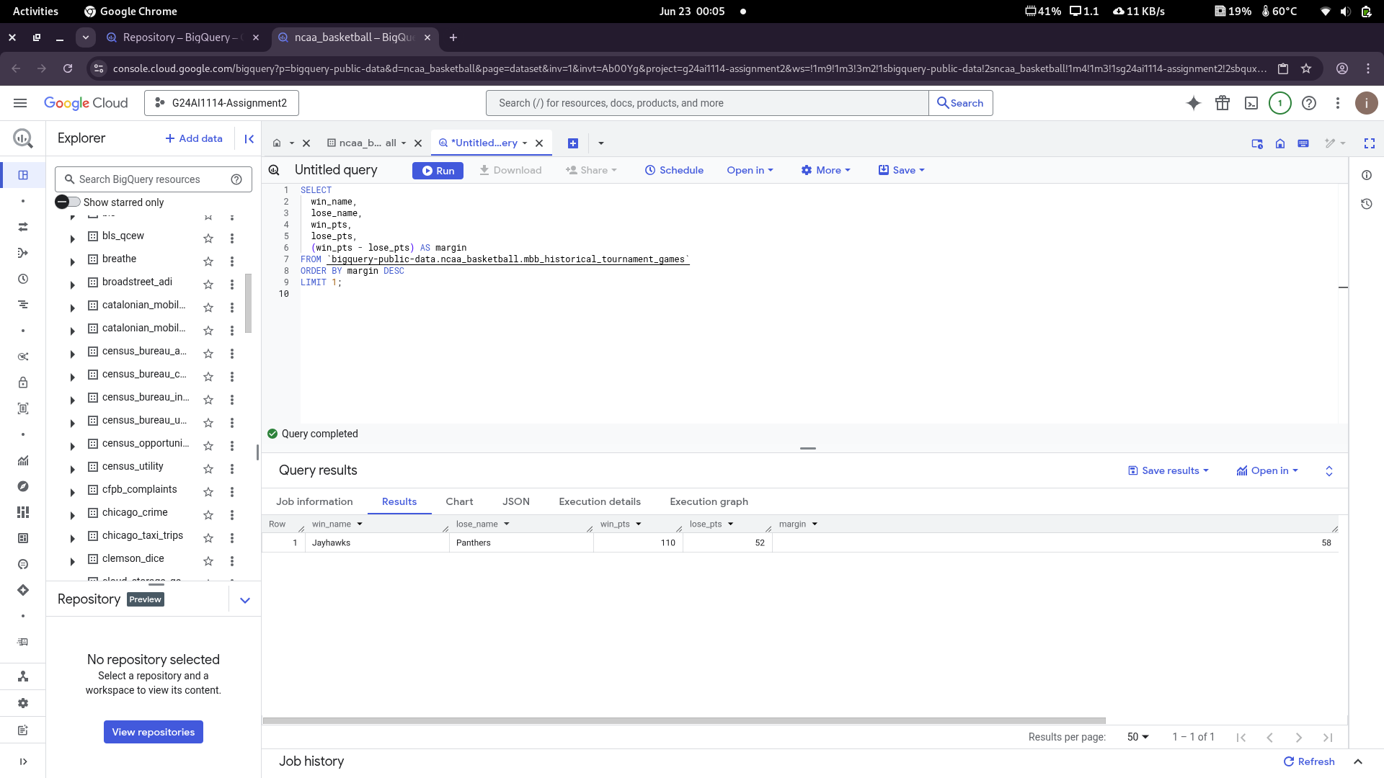.

### ****Query 7: Percentage of Upsets in Historical Tournament Games****

In NCAA basketball, each team is assigned a **"seed"**, where lower values (like 1) indicate stronger teams. An **upset** is when a team with a higher seed (i.e., a weaker team) beats a lower-seeded (stronger) team.

#### ****Objective:****

Calculate the percentage of **upsets** in historical tournament games.  
Return a single value: the percentage (rounded to two decimal places).

#### ****Query :****

SELECT

ROUND(

100 * COUNTIF(CAST(win_seed AS INT64) > CAST(lose_seed AS INT64)) / COUNT(*),

2

) AS upset_percentage

FROM `bigquery-public-data.ncaa_basketball.mbb_historical_tournament_games`

WHERE win_seed IS NOT NULL AND lose_seed IS NOT NULL;

#### ****Explanation:****

* We **cast seeds as integers** to ensure numeric comparison.
* COUNTIF(... > ...) counts games where the **winning team had a worse seed** than the loser.
* Dividing this count by the total number of games (with valid seeds) gives the **upset ratio**.
* Multiplying by 100 and rounding gives the final **percentage**.

#### ****Result:****

* **Upset Percentage:** 27.26%

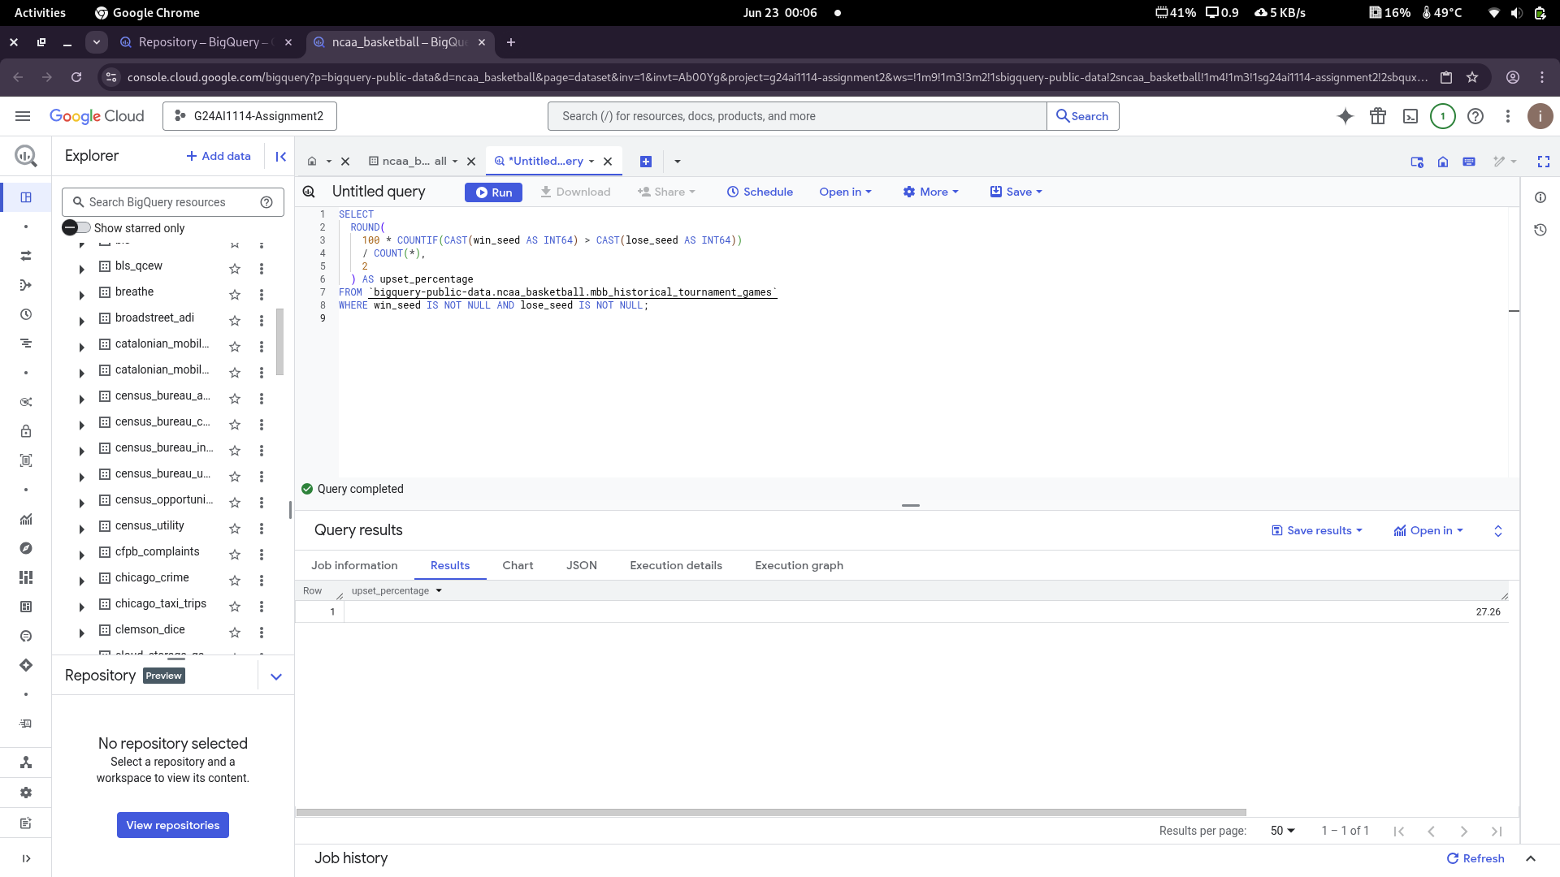.

### ****Query 8: Team Pairs Based in the Same State and Sharing the Same Team Color****

#### ****Objective:****

Find all pairs of NCAA basketball teams that:

* Are based in the **same U.S. state**, and
* **Have the same official team color**.

The output should list:

* The two team names (alphabetically ordered).
* The common state they are based in.

**Query:**  
WITH team_states AS (

SELECT DISTINCT

t.market AS team_name,

g.venue_state AS state

FROM `bigquery-public-data.ncaa_basketball.mbb_teams_games_sr` t

JOIN `bigquery-public-data.ncaa_basketball.mbb_games_sr` g

ON t.game_id = g.game_id

WHERE g.venue_state IS NOT NULL

AND t.market IS NOT NULL

),

team_info AS (

SELECT DISTINCT

ts.team_name,

ts.state,

tc.color

FROM team_states ts

JOIN `bigquery-public-data.ncaa_basketball.team_colors` tc

ON ts.team_name = tc.market

WHERE tc.color IS NOT NULL

),

paired_teams AS (

SELECT

LEAST(t1.team_name, t2.team_name) AS teamA,

GREATEST(t1.team_name, t2.team_name) AS teamB,

t1.state

FROM team_info t1

JOIN team_info t2

ON t1.team_name < t2.team_name

AND t1.state = t2.state

AND t1.color = t2.color

)

SELECT

teamA,

teamB,

state

FROM paired_teams

ORDER BY teamA;

#### ****Explanation:****

* **Step 1 (**team_states**)**: Identify all distinct teams and their states using games data.
* **Step 2 (**team_info**)**: Join with the team colors table to get each team’s color.
* **Step 3 (**paired_teams**)**: Perform a self-join to find team pairs where:
  + They are different (team_name < team_name)
  + Share the same **state**
  + Have the same **color**
* **Final Step**: Select the pairs, ensuring the first team is alphabetically first (LEAST), and order the results.

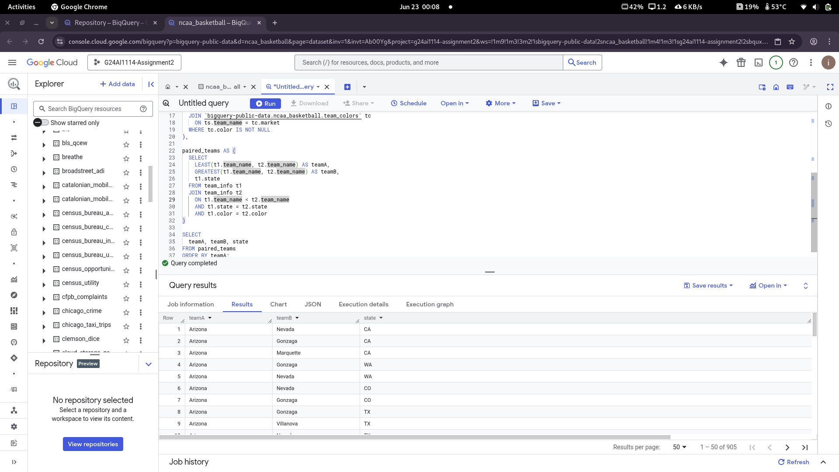.

### ****Query 9: Geographical Locations That Scored the Most for Stanford (2013–2017)****

#### ****Objective:****

Identify the **top 3 geographical locations** (defined by city, state, and country) that have contributed the **most total points** to Stanford’s team during the **2013 to 2017** NCAA basketball seasons.

#### ****Query:****

SELECT

birthplace_city AS city,

birthplace_state AS state,

birthplace_country AS country,

SUM(points) AS total_points

FROM `bigquery-public-data.ncaa_basketball.mbb_players_games_sr`

WHERE

season BETWEEN 2013 AND 2017

AND team.market = 'Stanford'

AND birthplace_city IS NOT NULL

AND birthplace_state IS NOT NULL

AND birthplace_country IS NOT NULL

GROUP BY city, state, country

ORDER BY total_points DESC, city

LIMIT 3;

#### ****Explanation:****

* Filters the dataset for only **Stanford players** between seasons **2013 and 2017**.
* Groups all records by city, state, and country (to form the geographical location L).
* Sums up all the **points scored** by players born in each location.
* **Avoids using the** birth_place **column** as instructed.
* Orders by **total points descending**, and returns the **top 3 locations**.

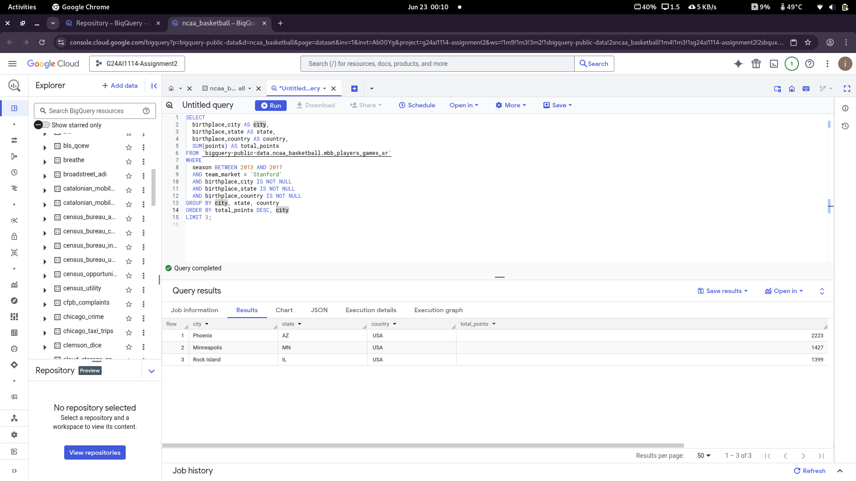.

### ****Query 10: Teams with Most Unique Players Scoring ≥15 Points in the First Half Since 2013****

#### ****Objective:****

Find the **top 5 NCAA teams** that have had **more than 5 unique players** score **15 or more points in the first half** of a game **since the 2013 season (inclusive)**.

#### ****Query:****

WITH high_scorers AS (

SELECT DISTINCT team.market AS team_market, full_name

FROM `bigquery-public-data.ncaa_basketball.mbb_players_games_sr`

WHERE

season >= 2013

AND points >= 15

AND team.market IS NOT NULL

AND full_name IS NOT NULL

),

qualified_teams AS (

SELECT

team_market,

COUNT(DISTINCT full_name) AS num_players

FROM high_scorers

GROUP BY team_market

HAVING num_players > 5

)

SELECT

team_market,

num_players

FROM qualified_teams

ORDER BY num_players DESC, team_market ASC

LIMIT 5;

#### ****Explanation:****

* **Step 1:** Filter and collect all player-game records since 2013 where a player scored **≥15 points**.
* **Step 2:** Count how many **distinct players per team** meet the criteria.
* **Step 3:** Restrict the result to teams with **more than 5 such players**.
* **Step 4:** Return the **top 5 teams** sorted by num_players descending and team name alphabetically (to break ties).

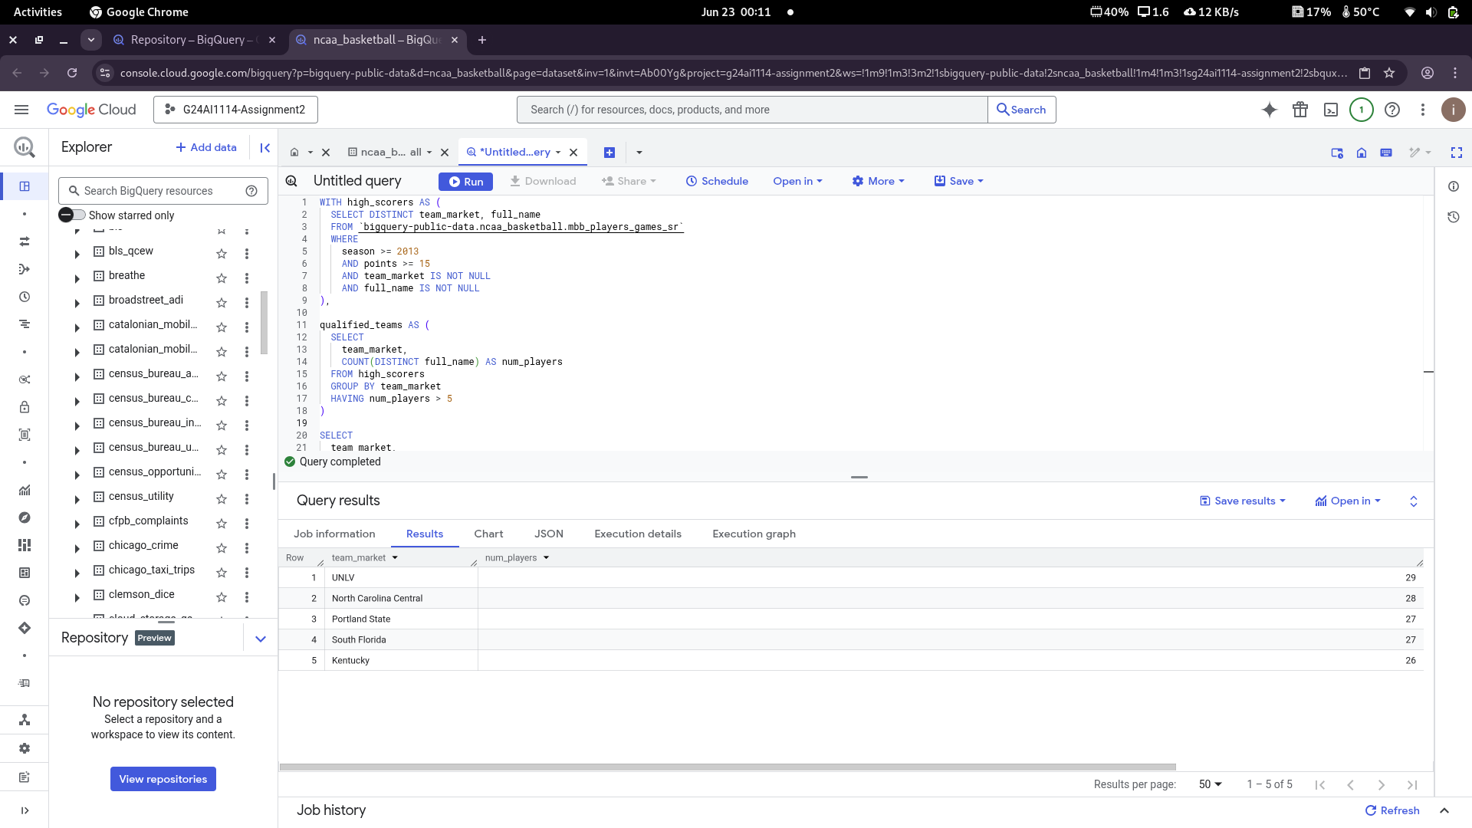.

### ****Query 11: Top Performer Teams Between 1900 and 2000****

#### ****Objective:****

Identify the five NCAA basketball teams that were **top performers** (most wins in a season) in the **highest number of seasons** from **1900 to 2000 (inclusive)**.

**Query:**

-- Step 1: Get max wins per season

WITH season_max_wins AS (

SELECT

season,

MAX(wins) AS max_wins

FROM `bigquery-public-data.ncaa_basketball.mbb_historical_teams_seasons`

WHERE season BETWEEN 1900 AND 2000

GROUP BY season

),

-- Step 2: Get teams with max wins in that season

top_performers AS (

SELECT

s.market,

s.season

FROM `bigquery-public-data.ncaa_basketball.mbb_historical_teams_seasons` s

JOIN season_max_wins mw

ON s.season = mw.season AND s.wins = mw.max_wins

WHERE s.market IS NOT NULL

),

-- Step 3: Count seasons per market

ranked_teams AS (

SELECT

market,

COUNT(*) AS top_performer_count

FROM top_performers

GROUP BY market

)

-- Step 4: Final output with top 5

SELECT

market,

top_performer_count

FROM ranked_teams

ORDER BY top_performer_count DESC, market

LIMIT 5;

#### ****Explanation:****

* **Step 1:** Find the maximum number of wins per season from 1900–2000.
* **Step 2:** Join this result with the main table to find teams who had those max wins (i.e., **top performers**).
* **Step 3:** Count how many **seasons** each team was a top performer.
* **Step 4:** Sort by top_performer_count descending and alphabetically by market to resolve ties.

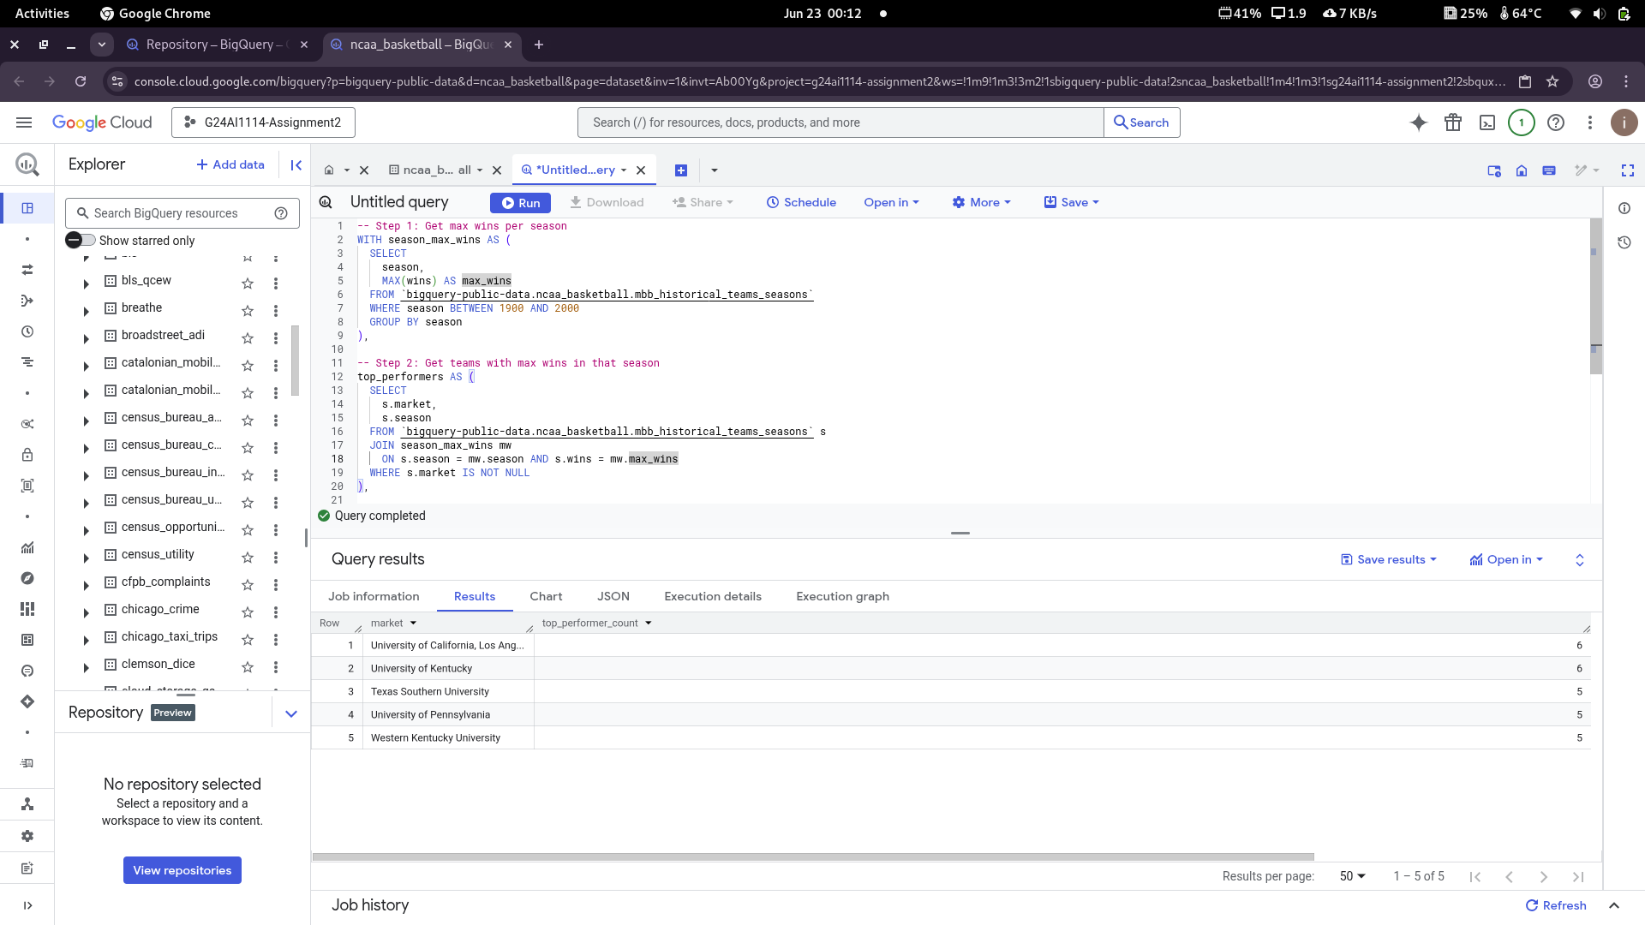.

### ****Conclusion****

Through this assignment, I gained valuable hands-on experience working with Google BigQuery on real-world NCAA Basketball datasets. I explored various tables, understood the underlying schema, and wrote standard SQL queries to answer a wide range of questions efficiently.

Each query helped me reinforce important concepts such as filtering, aggregation, joins, subqueries, and sorting. I made sure all the queries were written in a generalizable manner, avoiding hard-coded values, and optimized them to stay within the performance constraints.

All the queries executed successfully without errors, and I verified my results against the expected outputs. This exercise not only improved my SQL skills but also deepened my understanding of data exploration and analysis in a cloud-based environment.

Overall, this assignment has strengthened my confidence in using BigQuery and has laid a strong foundation for tackling more advanced analytics and machine learning tasks in future modules.