**1.1) Learn version control- Git, GitHub**

-> Version control refers to the practice of tracking and managing changes to software code, and

Version Control Systems refers to software tools that assist software teams in managing changes to source code over time.

-> Benefits of Version Control Systems are -

a. Trace the changes made to the code

b. Simplify code review

c. Revert changes that introduce bugs

d. Maintaining multiple versions of the project

e. Modify code efficiently

f. Better collaboration and improved team productivity

-> Git is a distributed version control framework that is free and open source.

Linus Torvalds, the developer of the Linux operating system kernel, created it in 2005. Git provides all of the benefits of a distributed Version Control system.

-> Features of Git are -

a. Fully Distributed VCS

b. Data Integrity And Security

c. Branching

d. Supports Non-linear Development

-> Basic Git Workflow

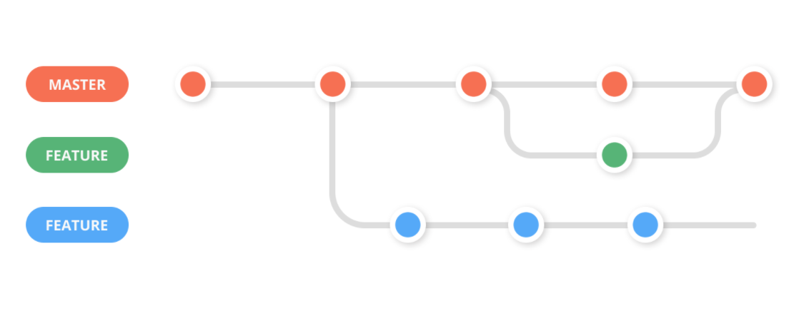

1. When you browse and work on files in your repository, you are on a working tree, and all of your files are untracked at first.

2. The files you want to record are then staged and moved to index.

3. The staged files are then committed and saved in the local repository.

4. When you're ready to make them public, add them to a remote repository hosting service such as Github.

-> GITHUB -

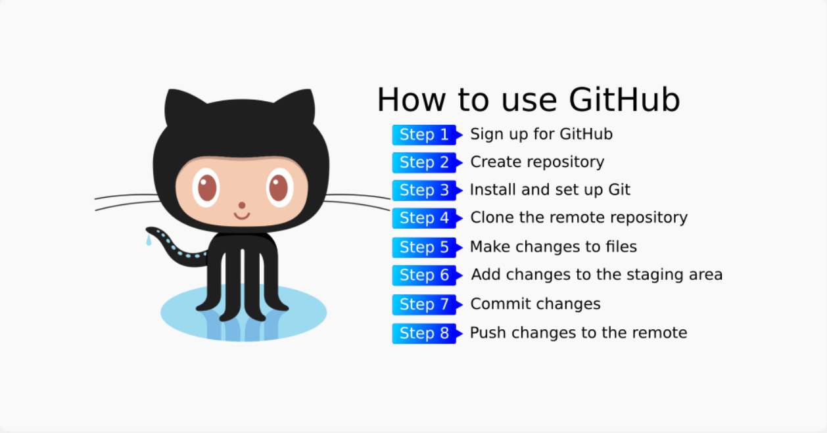

GitHub is a platform built on top of git that allows developers to manage and communicate their projects with the rest of the globe.

Git is a version control system, and GitHub is a cloud-based hosting service that helps in managing Git repositories.

Alternatives to Github are -

Gitlab

Bitbucket

AWS Code Commit