**Hotel Management System**

Submitted in partial fulfilment of the requirements of the degree

**BACHELOR OF ENGINEERING** IN **I.T. ENGINEERISNG**

By

**Pranav Dani 72**

**Farhan Shaikh 94**

**Smith Shah 93**

Supervisor

**Prof. Gopal Pardesi**



**Department of Information Technology**

**Engineering Thadomal Shahani College**

**Bandra(w), Mumbai - 400 050**

**University of Mumbai**

**( AY 2020-21)**

# CERTIFICATE

This is to certify that the Mini Project entitled **“ HOTEL MANAGEMENT SYSTEM ”** is a bona fide work of **Pranav Dani(72),Farhan Shaikh(94),Smith Shah(93)** submitted to the University of Mumbai in partial fulfilment of the requirement for the award of the degree of **“Bachelor of Engineering”** in **“Department of Information Technology” .**

**(Prof.Gopal Pardesi)**

Supervisor

**(Prof._________________ ) (Prof._________________ )**

Head of Department Principal

# Mini Project Approval

This Mini Project entitled “HOTEL MANAGEMENT SYSTEM**”** by **Pranav Dani(72),Farhan Shaikh(94),Smith Shah(93)** is approved for the degree of **Bachelor of Engineering** in **Department of Information Technology.**

**Examiners**

**1………………………………………**

(Internal Examiner Name & Sign)

**2…………………………………………**

(External Examiner name & Sign)

Date: 16/12/2020

Place:

# Contents

**Abstract**   **ii**

**Acknowledgments**   **iii**

1. **Introduction 1**
   1. Introduction
   2. Motivation
   3. Problem Statement & Objectives
   4. Organization of the Report
2. **Literature Survey 11**
   1. Survey of Existing System
   2. Limitation Existing system or research gap
   3. Mini Project Contribution
3. **Proposed System (eg New Approach of Data Summarization ) 18**
   1. Introduction
   2. Architecture/ Framework
   3. Algorithm and Process Design
   4. Details of Hardware & Software
   5. Experiment and Results
   6. Conclusion and Future work.

**References 30**

**Project 30**

**Abstract:**

This hotel management system is developed for hotels those are using a manual system to handle hotel processes. There are three main users in hotel management system, administrator, Manager and Receptionist. Administrator can maintain daily updates in the hotel records. This system will automate the major operations of the hotel. Administrator can access to all system functionalities without any restrictions. Administrator is must be an authorized user. He can further change the password. There is the facility for password recovery, logout etc. Manager can access to all system functionalities with limited restrictions. Receptionist can only access to the Reservation Management section. The main aim of the entire activity is to automate the process of day to day activities of Hotel.

The Reservation System is to keep track in room and hall reservation and check availability. Using this system user can check which room is reserved and which room is available. He can reserve room from reservation module. The Room Management System is for manage all room types room services. Room management module help user to keep track of all information of hotel room. He can check room laundry service, food service and sweeping service from this module. The Inventory Control System will keep track in all inventories of the hotel and guest details will handled by guest management. Administration department will monitor the all. the main of developing this system is to computerize all the activity of the hotel like Admission of a New Customer, Assign a room according to customer’s demand, checkout of a customer and releasing the room and finally compute the bill etc. Using this system you can manage check in and check out process easily. At check in, you can easily check the availability of rooms in the hotel. And at check out you can easily generate the total bill.

The main objective of the entire activity is to automate the process of day to day activities of Hotel. Using this system you can manage room activities and keep track of admission of a New Customer. Using this system you can check rooms according to customer’s need and can assign easily room to customer. Checkout of a customer and updating the releasing room information in the system is very easy. When user do checkout system will generate final bill after calculating all the bills. User can also check online, all the packages available. He can also book rooms online. He can also cancel booked room online. Hotel management can also check the list of Regular customers and feedback of the hotel’s customer.

**Acknowledgement**

We take this occasion to thank God, almighty for blessing us with his grace and taking our endeavour to a successful culmination. We extend our sincere and heartfelt thanks to our esteemed guide Prof. Gopal Pardesi, for providing us with the right guidance and advice at the crucial junctures and for showing us the right way. We would like to thank our friends and family for the support and encouragement they have given us during the course of our work without which it would not been possible to achieve our target.

**CHAPTER 1**

This chapter gives an overview about objective, problem statement, background and motivation of choosing this topic.

## 1.1 INTRODUCTION

Hotel management is an array of roles and responsibilities all held together under one umbrella. Being able to adapt, meet challenges and place yourself on a scale of personal growth is vital herein

Hotel management as the name suggested seems to be simple as looking into hospitality and care but on a broad basis It requires a lot of strategies and planning not only for proper functioning but also for better performance and improved incentives

An effective way of managing hotels and hotel industry are created to get the business flourishing.

## 1.2 Motivation

Hotel management system makes the complex procedure of hotel management more easy, systematic. The modular design and construction system is very much user oriented.

Performance reporting regular collection and analysis of data are the things to work to improve the performance.

An app-based application that allows the hotel management and owner to handle all activities online and easily and safely.

User Interactive GUI; anyone can easily learn to use the complete system. No paper work while simultaneously owe keeps a check on the function of hotel easily. A simple comfortable user, friendly system, giving the authority and flexibility to manage the entire system from a single online postal. Purpose is to ease the daily or regular activities of Hotel management Into an automatic computerized retrievable process.

## 1.3 Problem statement and objective

A hotel system manages various information about rooms, reservation, customers, building etc.

This customer can make a reservation through hotel website. He requires details as in, availability of rooms, dates, customer details-If everything seems fine he receives a confirmation number from the website.

The desk clerk checks in the time and billing record is created at that time. Customer billing is recorded is updated every night at

12.Customer can pay by cash when they check out

If the customer needs a pick up/down service, online availability can also be made. One has an access to the details of the driver the nature of vehicle, his current location. And the type of car used by driver.

The app bears many more function.

* Room status
* Allocated Room Modification
* Check In/Check Out details
* Customer details
* Total customer present in hotel
* Services like rides, also included
* Billing
* Hotel staff and their details
* Miscellaneous services.

There are new Strategies technologies emerging every day that one needs to track on. How effective one manages their property, pays to have your finger on the pulse. Its thereby essential to have the most effective system incorporating multiple areas with all its ardently meticulously and its caliber.

## 1.4 Organization of Report:-

The report basically is basically divided where chapter 1 gives a brief idea about the introduction, objectives of choosing the project, the problem statement and motivation. Chapter 2 gives an idea about the

survey, challenges Chapter 3 gives an idea about how we approached our project, frame work and results we obtained. This is how our report is organized.

## CHAPTER 2 - Literature Survey

### 2.1 Survey Of Existing System

In the existing system, most of the activities takes place manually, manually carrying out this activity in very tedious time consuming. As we have tried to develop computerized application so as to handle all the activity that takes place in Hotel. As all the activities that happen in the Hotel such as information of new customers, check status, information on drivers ,rooms and other employees etc. can be handled on this system simultaneously.

The existing system of Hotel Management was manual. So all the daily routines is carried out manually and the records are maintained in the record books or the registers.

Since it is a manual system a lot of time is spent in communicating the information across different branches. There is a need for an integrated automated system, which has some centralized control over the entire process. Conventional System makes use of huge amounts of paper for recording transactions. The existing system is a manually maintained system. All the Hotel records are to be maintained for the details of each customers, Fee details, Room Allocation , Attendance etc. All these details are entered and retrieved manually.

Due to manual system the efficiency of manager decreases to handle all the hotel activities . And managing various hotel rooms , condition of the rooms , availability of rooms , employees , etc. makes working an inconvenience for the manager and other employees too .

#### 2.2 Limitation of Existing System

1. The word manual itself makes the existing system outdated in today’s high tech world.
2. Processing of application manually takes a lot of time .
3. A lot of time is also wasted in summing up records of employees , customers , budgets etc.
4. The staff is also deviated from its main stream work , by paying more time to manual processing information . As a result need of employing more staff is being felt , which involves a lot of expenditure.
5. The system is not deprived of common manual mistakes .
6. The system is also prone to insecurities .
7. All the data the receptionist used to give the customer was based on paper works, there was no clear idea of the status of rooms like they are available or not or cleaned or not cleaned as they did not update automatically.
8. There is no particular defense for admin and the information of the customers .
9. Existing system also decreases efficiency of the hotel .

#### 2.3 Mini - Project Contribution

Hotel Management System project is designed in such a way that it is user friendly. It can be used by anyone as the name of the buttons are self-explanatory for their work. This project competes with the apps and software available on the internet and can be used for professional use too.

**CHAPTER-3**

**3.1 Introduction**

This hotel management system is developed for hotels those are using a manual system to handle hotel processes. There are three main users in hotel management system, administrator, Manager and Receptionist. Administrator can maintain daily updates in the hotel records. This system will automate the major operations of the hotel. Administrator can access to all system functionalities without any restrictions. Administrator is must be an authorized user. He can further change the password. There is the facility for password recovery, logout etc. Manager can access to all system functionalities with limited restrictions. Receptionist can only access to the Reservation Management section. The main aim of the entire activity is to automate the process of day to day activities of Hotel.

The Reservation System is to keep track in room and hall reservation and check availability. Using this system user can check which room is reserved and which room is available. He can reserve room from reservation module. The Room Management System is for manage all room types room services. Room management module help user to keep track of all information of hotel room. He can check room laundry service, food service and sweeping service from this module. The Inventory Control System will keep track

in all inventories of the hotel and guest details will handled by guest management. Administration department will monitor the all. the main of developing this system is to computerize all the activity of the hotel like Admission of a New Customer, Assign a room according to customer’s demand, checkout of a customer and releasing the room and finally compute the bill etc. Using this system you can manage check in and check out process easily. At check in, you can easily check the availability of rooms in the hotel. And at check out you can easily generate the total bill.

The main objective of the entire activity is to automate the process of day to day activities of Hotel. Using this system you can manage room activities and keep track of admission of a New Customer. Using this system you can check rooms according to customer’s need and can assign easily room to customer. Checkout of a customer and updating the releasing room information in the system is very easy. When user do checkout system will generate final bill after calculating all the bills. User can also check online, all the packages available. He can also book rooms online. He can also cancel booked room online. Hotel management can also check the list of Regular customers and feedback of the hotel’s customer.

## 3.2 Framework :-

**Cover Page :-** It includes topic of our mini project and a next button which proceeds to the login page.

**Login Page :-** It includes a Create button which takes you to the new user registration page. Else it contains a login button which matches your username and password you entered in their respective field. The Cancel button can be used to exit the program.

**Dashboard :-** This is the main page of our project which contains Admin and reception dropdown menu.

**Admin :-** The admin section contains Add driver, Add Employee and Add Room options.

**Reception :-** This section contains all the necessary tools for the Receptionist of the Hotel.

**3.3 Algorithm and process design**

Steps to run the project :

* Run the main page of the hotel management system in eclipse.
* After cover page appears, click on next.
* Create a new account or login with an existing account.
* Use the admin section to add new rooms, drivers or employees.
* The Reception section can be used to keep track of all the necessary systems in the Hotel like the customer details, rooms available and all the necessary information.

## 3.4 Details of Hardware and Software

Software Configuration: The project is developed using Java as front end which is supported by Oracle. MySQL is used as back end to store the data in the database.

Operating System: Windows 7, 8, 10 / Macintosh / Linux(any distro with a proper setup)

Language: Java Runtime Environment, Eclipse IDE

Database: MySQL

Hardware Configuration: Processor: Intel CORE i3 / AMD Ryzen 3 / Apple M1 or greater

Hard disk: Minimum 50GB

Ram: 4 GB or more

**3.5 Experiment and Result**

## A) Cover Page

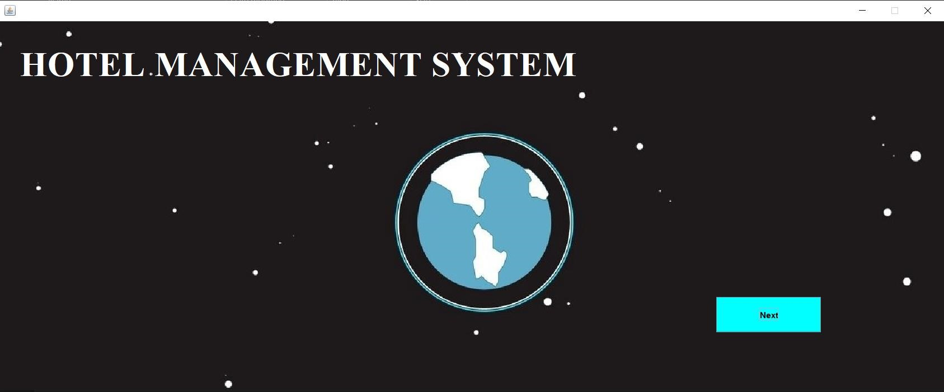

1. **Login Page**

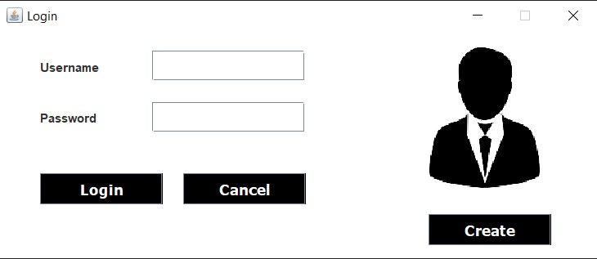

1. **New User Registration Page**

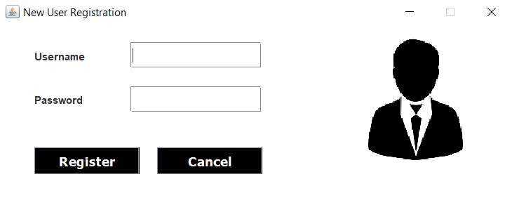

1. **Dashboard**

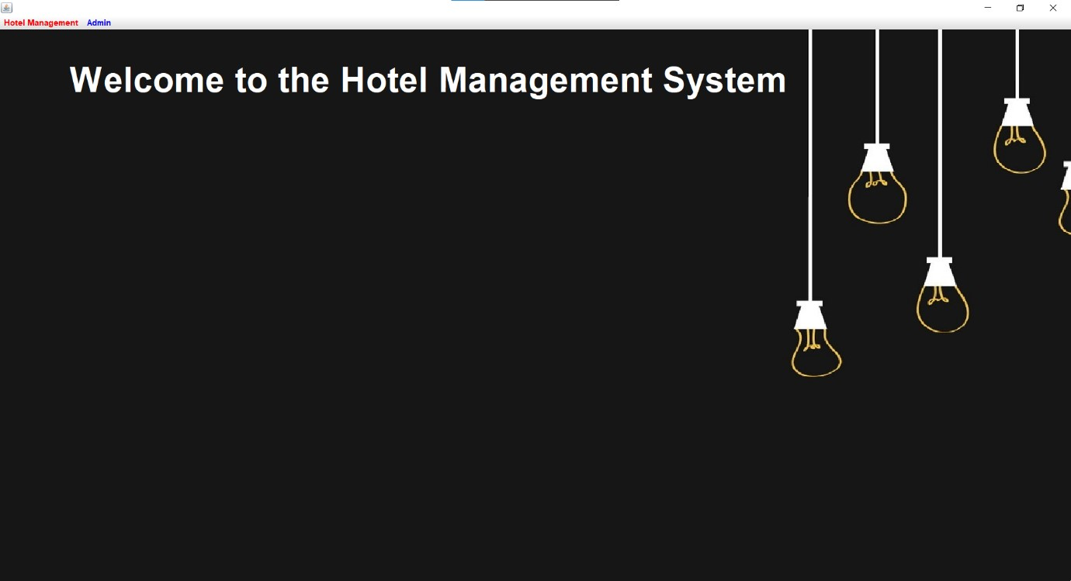

1. **Add Employee Details**

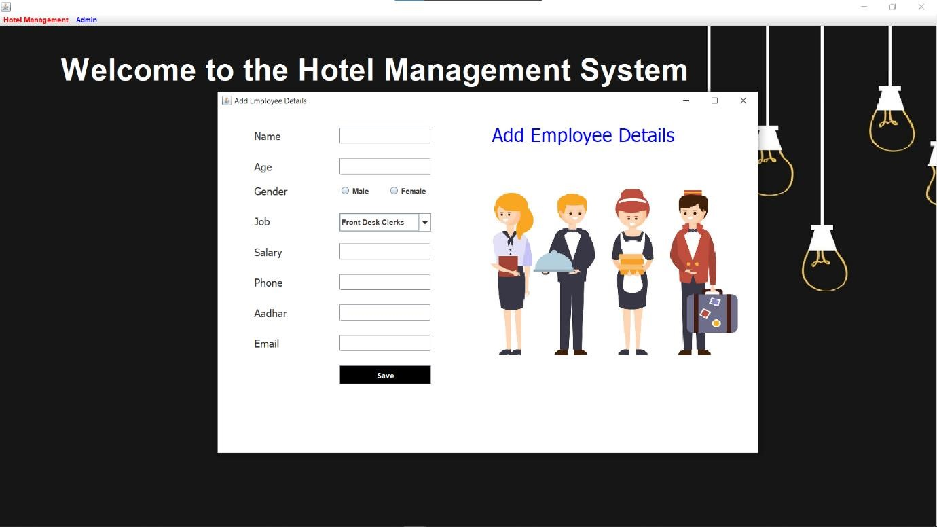

1. **Update Room Status**

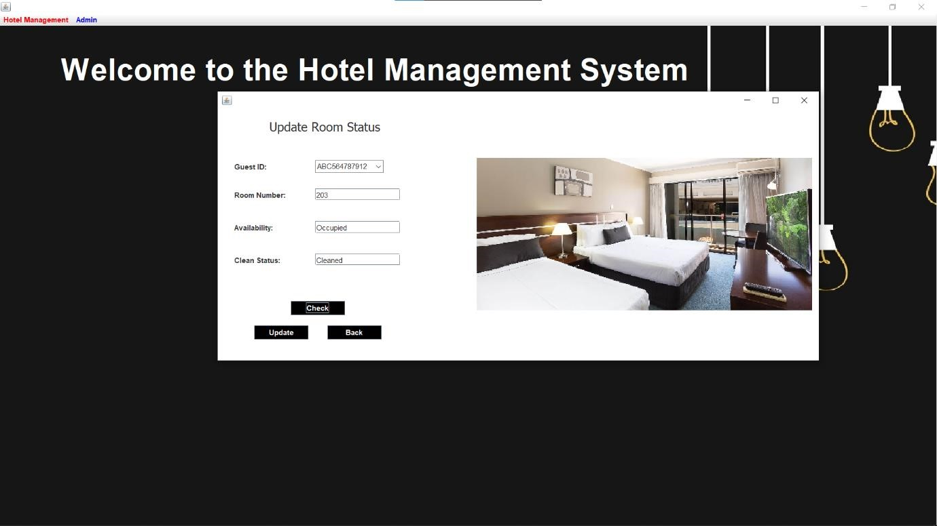

1. **Check – in details**

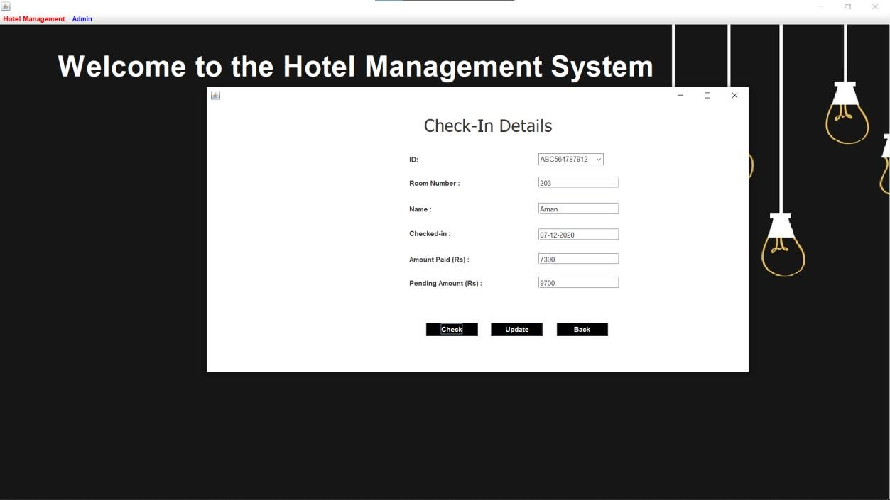

1. **Check – out details**

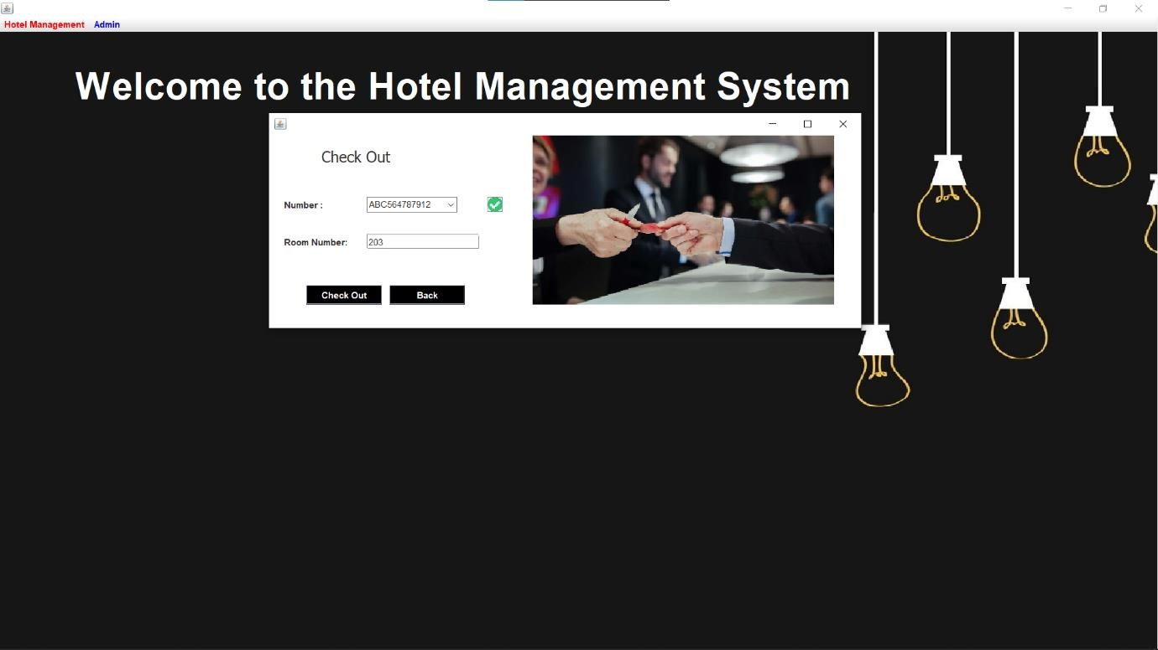

## Manager Details

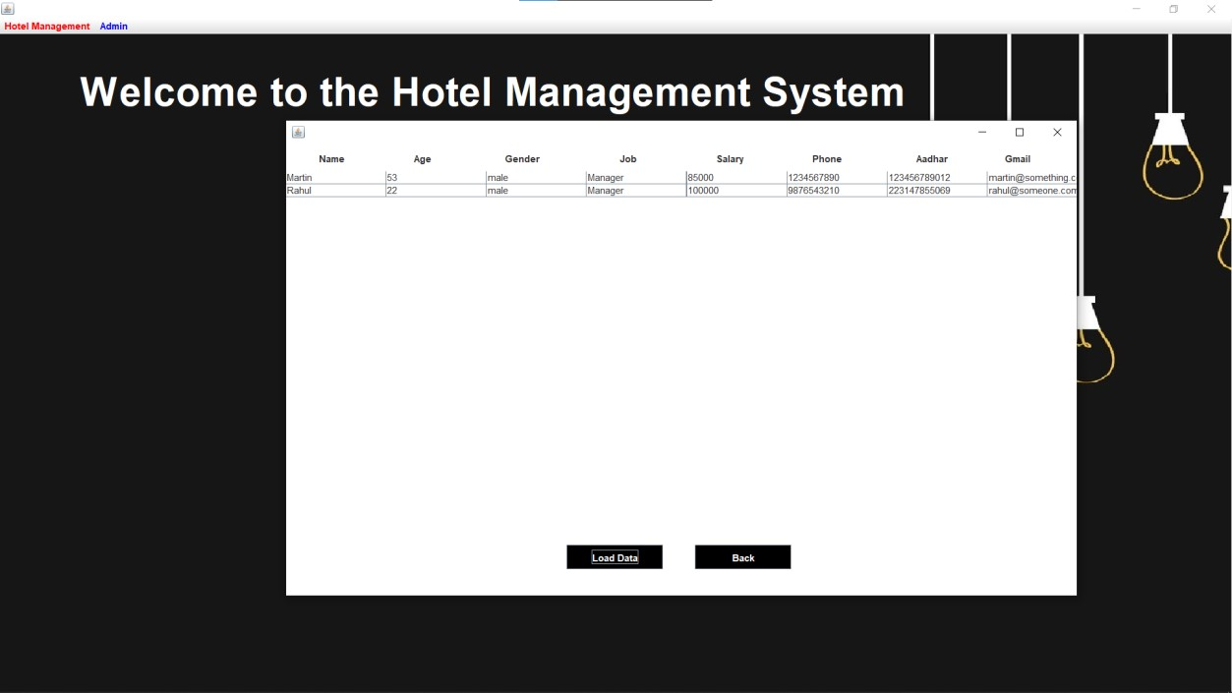

1. **Customer Details**

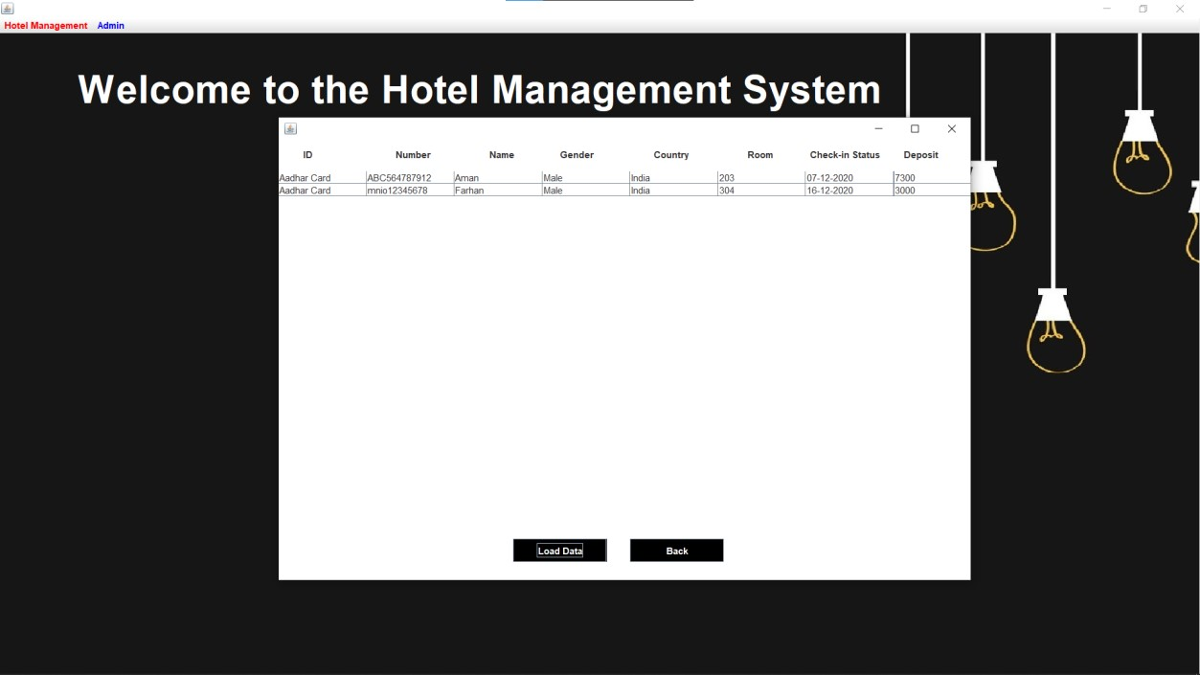

1. **Employee Details**

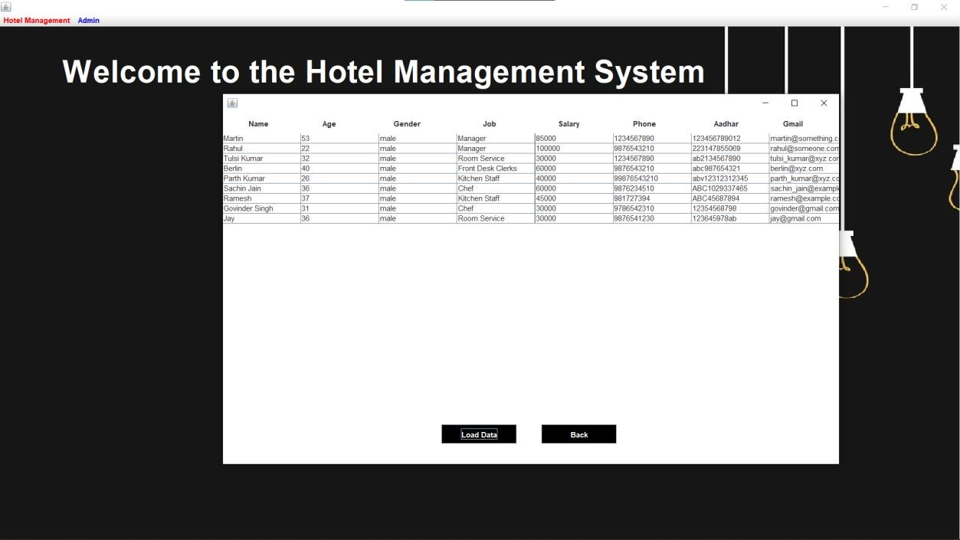

1. **Department Details**

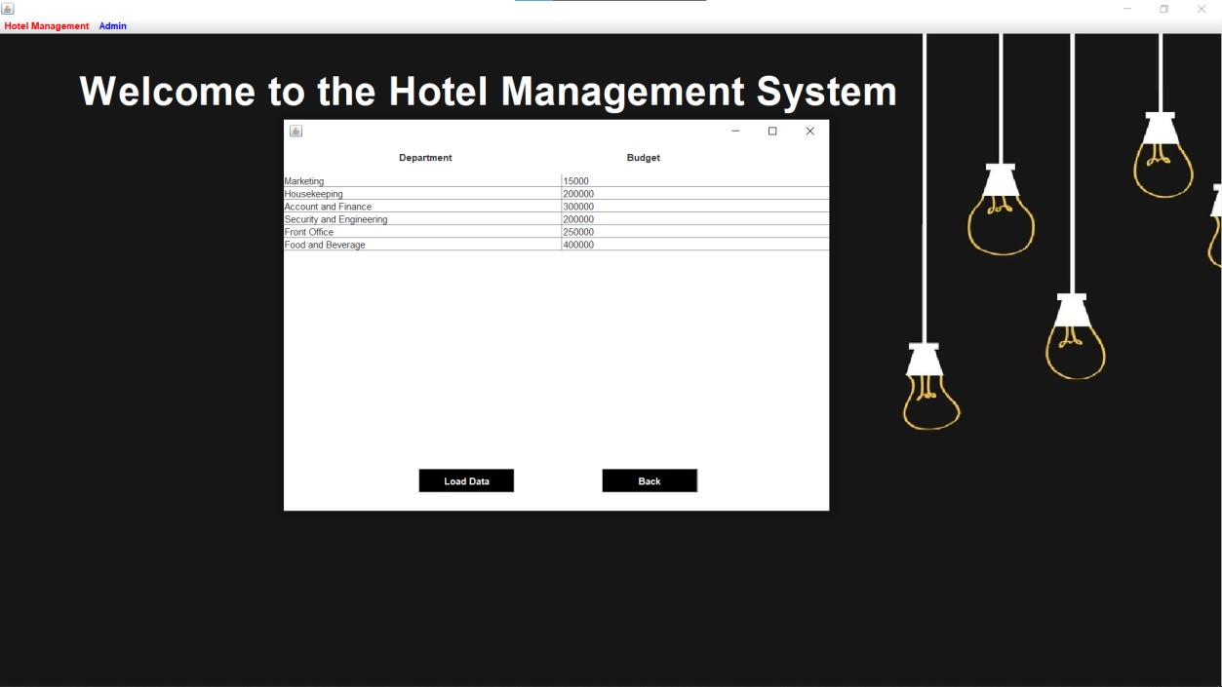

1. **Room Status**

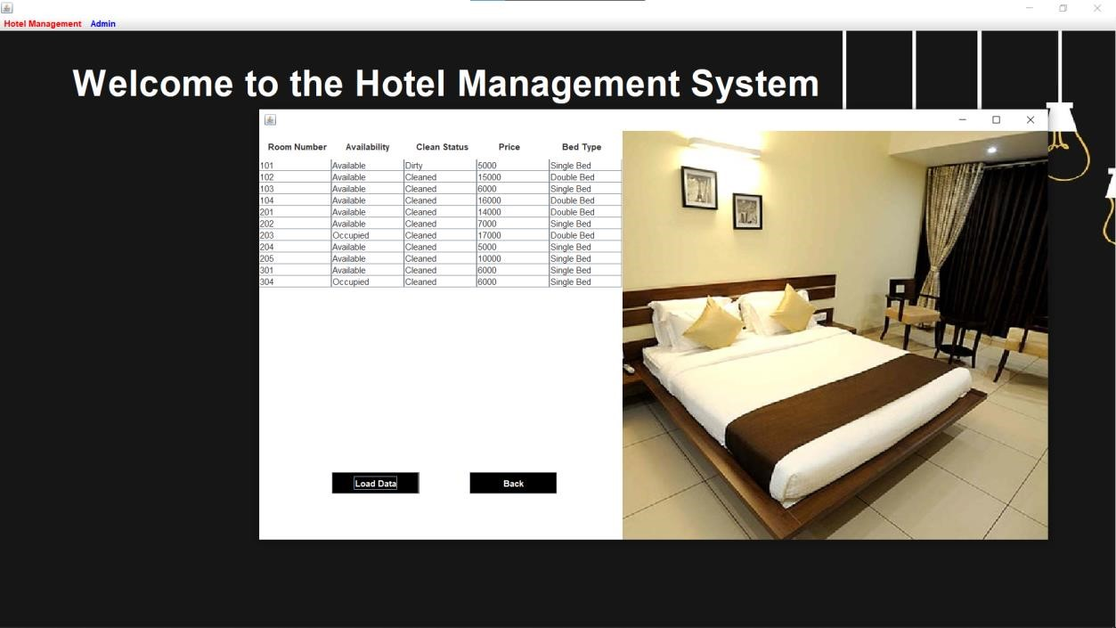

1. **New Customer Details**

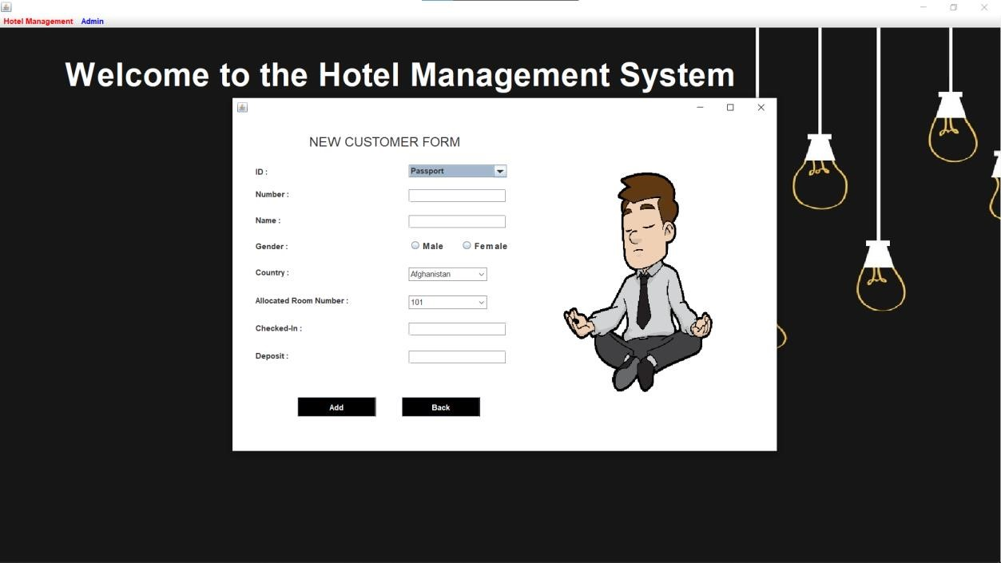

1. **Reception Page**

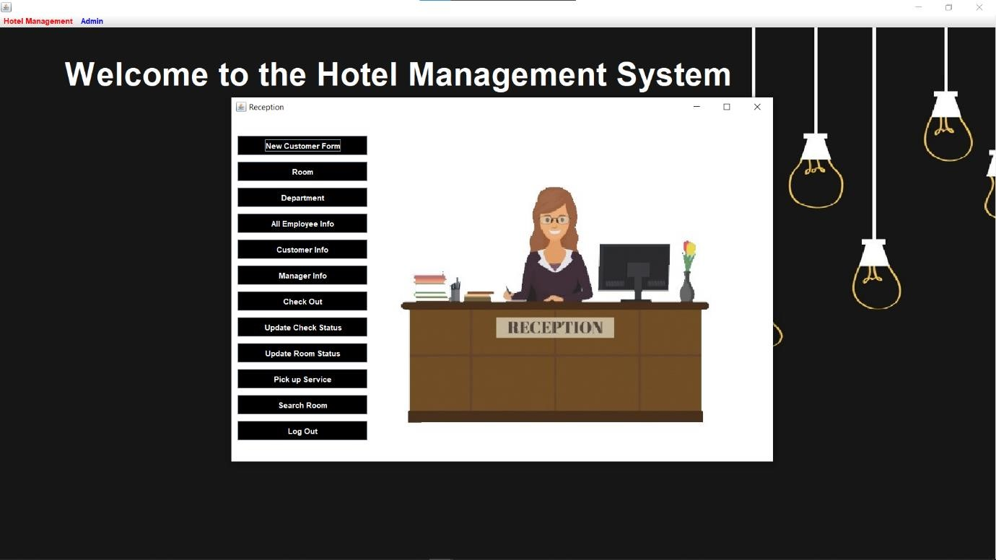

1. **Driver Details**

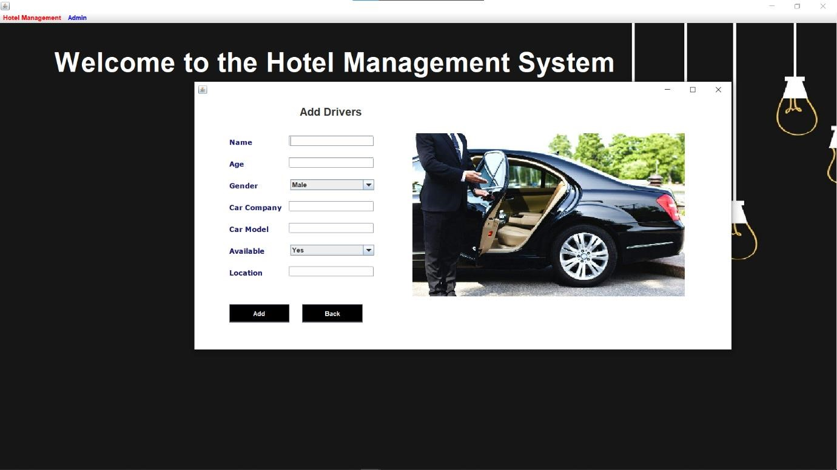

1. **Add Room Details**

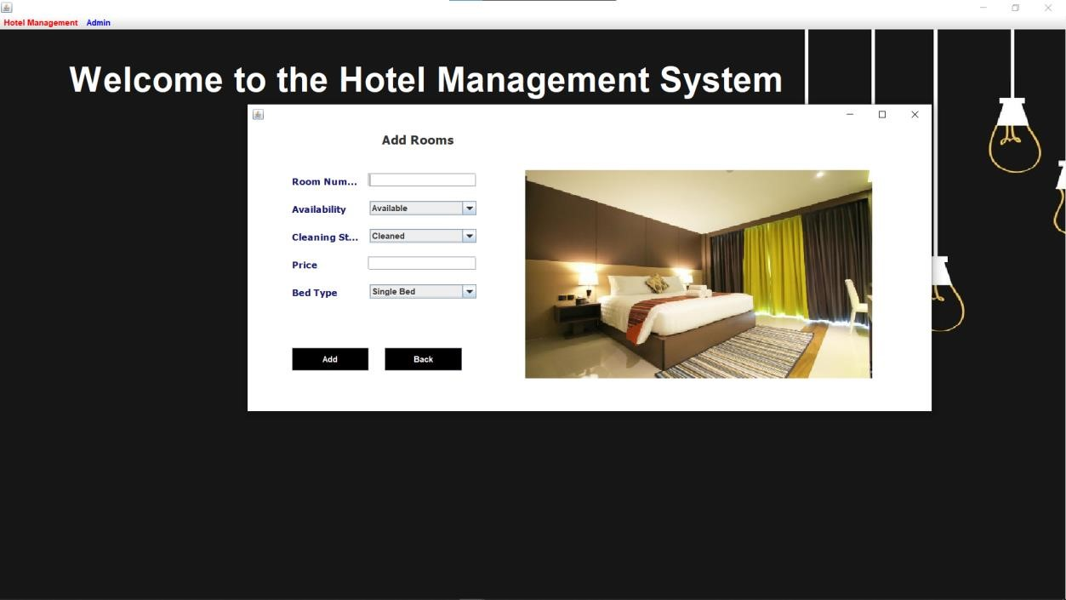

### Search For Rooms

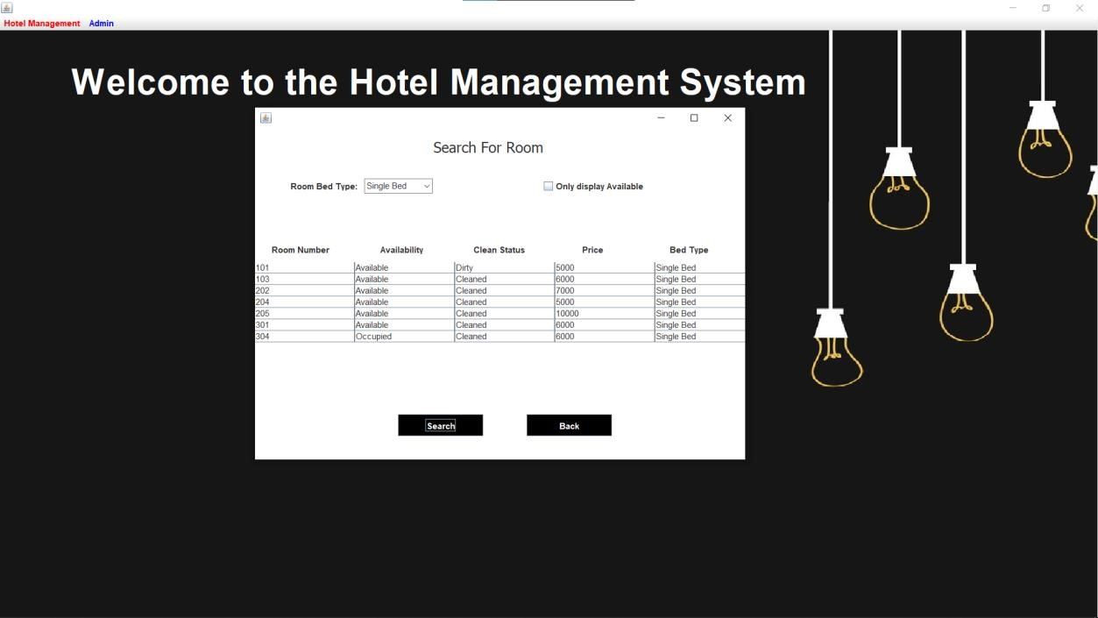

## S) Pick – up service

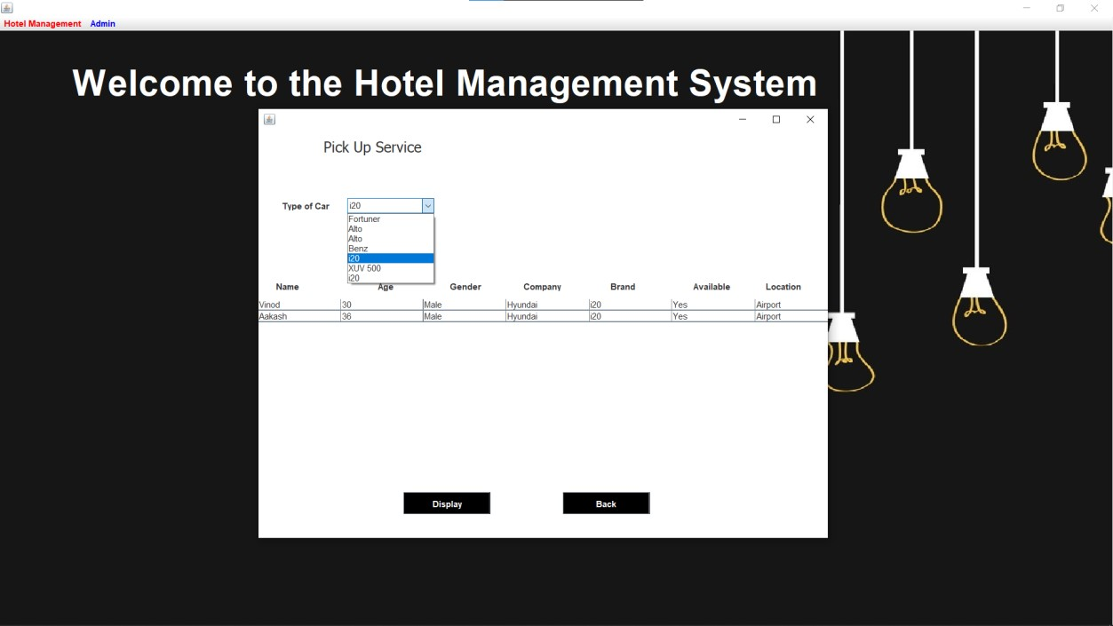

# References :

https://stackoverflow.com/ https://www.javatpoint.com/javaswing https://docs.oracle.com/javase/tutorial/uiswing/index.html https://www.guru99.com/java-swing-gui.html https://www.edureka.co/blog/java-swing/ https://www.tutorialspoint.com/swing/index.htm https://www.codejava.net/java-se/swing https://www.geeksforgeeks.org/

https://www.studytonight.com/java/ https://www.javastring.net/ <https://javarevisited.blogspot.com/>

**Project :**

<https://github.com/Pranav1642/Mini-Project>

To Set up the project using Git bash,

git clone https://github.com/Pranav1642/Mini-Project.git