CS15 Individual Member Technical Note: AI-Based and Adaptive Scheduling (S01, S02, S03)
DRAFT — not submission-ready
Field | Value
Student ID | [STUDENT_ID — PENDING CONFIRMATION]
Batch ID | [BATCH_ID — PENDING CONFIRMATION]
Sub-problems owned | S01, S02, S03 (single-member batch; scope pending faculty approval). Whether one combined note or one note per sub-problem is expected is to be confirmed.
Code / data | schedlab/ (Python), cpp/ (C++ simulator, OpenMP executor); raw CSVs results/raw/; provenance provenance/; batch report CS15_Integrated_Report_DRAFT.docx

1. Individual contribution
I designed and implemented the shared scheduling core and all three sub-problems:
- Shared core (schedlab/model.py, workloads.py, heuristics.py, runner.py, analysis.py): an execution simulator for DAG schedules with gap insertion, an independent schedule validator, a seeded synthetic workload generator with content-hash-disjoint train/validation/test/unseen splits, six baseline heuristics (FCFS-EAT, FCFS-EFT, SPT-EFT, LPT-EFT, HEFT, MINMIN), a campaign runner writing one raw CSV row per run, and analysis that derives the manual's 19-column CSV, tables, figures and integrity checks.
- S01 (ga.py): random-key plus processor-assignment GA with heuristic seeding and equal-budget controls.
- S03 (adaptive.py): nine workload features, decision-tree policy selector with novelty guard, and a separately labelled GA contingency extension.
- S02 (rl.py): twelve candidate features, REINFORCE with a HEFT-relative advantage, greedy deterministic policy.
- C++/OpenMP (cpp/schedsim, cpp/ompexec; interop.py, rederive.py, ompexec.py, omp_analysis.py): a bit-exact C++ workload simulator, exact re-derivation of every accepted search, learned and adaptive schedule, and an OpenMP executor (static replay with completion flags, OpenMP tasks, serial baseline) used in a locked measured campaign of 194,400 runs with independent trace checks.
- Methodology: predeclared hypotheses, primary comparisons and verdict bands; locked configurations with pinned model ids; independent verification scripts; execution and post-processing provenance records.

2. Method summary
All methods produce static, non-preemptive list schedules for the same synthetic DAGs (4 workload classes; 50, 100, 200 tasks; 2, 4, 8 simulated processors; plus unseen sets with 400 tasks, 16 processors, fork-join DAGs and work CV 3.0), placed through one insertion-capable simulator; the baselines include HEFT [1] and Min-min [2], and the S01 chromosome uses random keys [3]. The S03 selector is evaluated against the single best and virtual best solvers [4]. Quality is simulated makespan, also normalised by a lower bound; speedup is relative to serial execution on the best single simulated processor; scheduling time is measured in seconds (in the simulation campaigns communication, synchronization and energy are not modelled: NA; in the measured replay, static-mode dependency waiting is recorded as synchronization time, while communication and energy remain NA). Deterministic methods are timed 3 times per instance; stochastic methods run with seeds 0, 1, 2; S02 has 3 training seeds. Each sub-problem has one predeclared primary comparison, tested with a Wilcoxon signed-rank test [5] on paired makespans, with Holm's correction [6] across the three and bootstrap confidence intervals (percentile method) [7]. The schedules were then executed on real threads (GCC 15.2, OpenMP; Apple M4): 360 instances, 15 methods, mean task 1 ms / 100 µs / 10 µs, 10 repetitions each, speedup against serial execution, three predeclared measured comparisons.

3. Key results (held-out data; verified against saved tables)
 | Primary comparison | Result | Interpretation
S01 | GA vs per-instance best heuristic, 450 test instances | mean paired improvement +1.169% (CI 0.96–1.39%), 330 / 114 / 6, p = 6.2e-52 | Small, consistent improvement, largely on instances where the GA's seed heuristics were best; ~1,100–1,730× HEFT's scheduling time. An equal-budget hill climber reached +0.90%; the keys-only ablation +3.38% (better than the primary). Analysis population not predeclared
S03 | ADAPTIVE vs SBS (HEFT), 360 test_id | −0.016%, 6 / 342 / 12, p = 0.78, gap closed −0.03 (CI −0.30–0.19) | Null result: no improvement over the best fixed policy. HEFT is within 0.48% of the per-instance oracle, leaving ≤ 0.45% to gain. The GA extension (+0.10%, CI including 0) is reported separately
S02 | RL (mean of 3 seeds) vs HEFT, 360 test_id | ρ = 1.0097 (CI 1.0034–1.0160), RL worse on 226 / 360, p = 6.8e-6 | Statistically worse than HEFT by ~1%, yet within the predeclared ±2% band → verdict "matches". Improves on FCFS-EAT by ~18% (ρ 0.822). Seed-dependent; generalises to larger DAGs, not to 16 processors or fork-join
Measured | GA vs HEFT; ADAPTIVE (incl. decision time) vs HEFT; OpenMP tasks vs static HEFT; 1 ms tasks, 360 test_id | ratio 0.984 (CI 0.980–0.988); 1.008; 1.188; all Holm-significant | GA's gain survives on real threads in aggregate, mostly within noise per instance and absent at 8 threads; decision overhead makes ADAPTIVE slower; the dynamic runtime is 19% slower; HEFT efficiency 0.42 at 8 threads (consistent with efficiency cores; inferred from task timings, placement not recorded)

4. What I learned
- A strong cheap heuristic sets a high bar: on deterministic, communication-free DAGs, HEFT left little room for selection or learning, and search gains cost three orders of magnitude more time.
- Controls change conclusions: seeding guarantees "never worse than the seeds", so improvement over the seeds is not evidence of evolutionary search; an equal-budget hill climber nearly matched the GA.
- Statistical and practical significance differ: S02's 1% shortfall is highly significant but inside a predeclared practical-equivalence band.
- Measured noise (≈ 2% per run) is as large as the simulated effects: they show up on hardware only in aggregate, and the hardware (efficiency cores at 8 threads) changes the picture the simulator gives.
- Reproducibility needs engineering: pinned model ids, deterministic training, hash-checked data splits and saved execution snapshots caught and documented several issues (e.g. a non-reproducible model id from stored timings, transcription errors corrected in docs/report/ERRATA.md).

5. Limitations
Quality results simulated (no communication costs); the measured replay uses a synthetic kernel on one unpinned M4, with an ≈ 8% serial calibration offset and host records lost to a driver defect (manifest reconstructed); whether the C++/OpenMP components meet the tooling requirement is pending faculty confirmation; S01 and S03 timings measured on battery power; one synthetic generator; three RL training seeds; the S03 objective to use findings from Batches 1–3 and 7 is not met (findings unavailable, none invented).

6. References
[1] H. Topcuoglu, S. Hariri, and M.-Y. Wu, "Performance-effective and low-complexity task scheduling for heterogeneous computing," IEEE Transactions on Parallel and Distributed Systems, vol. 13, pp. 260–274, 2002, doi: 10.1109/71.993206.
[2] T. D. Braun et al., "A comparison of eleven static heuristics for mapping a class of independent tasks onto heterogeneous distributed computing systems," Journal of Parallel and Distributed Computing, vol. 61, pp. 810–837, 2001, doi: 10.1006/jpdc.2000.1714.
[3] J. C. Bean, "Genetic algorithms and random keys for sequencing and optimization," ORSA Journal on Computing, vol. 6, pp. 154–160, 1994, doi: 10.1287/ijoc.6.2.154.
[4] P. Kerschke, H. H. Hoos, F. Neumann, and H. Trautmann, "Automated algorithm selection: Survey and perspectives," Evolutionary Computation, vol. 27, no. 1, pp. 3–45, 2019, doi: 10.1162/evco_a_00242.
[5] F. Wilcoxon, "Individual comparisons by ranking methods," Biometrics Bulletin, vol. 1, no. 6, p. 80, 1945, doi: 10.2307/3001968.
[6] S. Holm, "A simple sequentially rejective multiple test procedure," Scandinavian Journal of Statistics, vol. 6, pp. 65–70, 1979, doi: 10.2307/4615733.
[7] B. Efron and R. Tibshirani, "Bootstrap methods for standard errors, confidence intervals, and other measures of statistical accuracy," Statistical Science, vol. 1, no. 1, pp. 54–75, 1986, doi: 10.1214/ss/1177013815.
Full bibliography of the batch report: docs/report/references.bib (IEEE style).
Supporting figure (same as Figure 9 of the batch report):
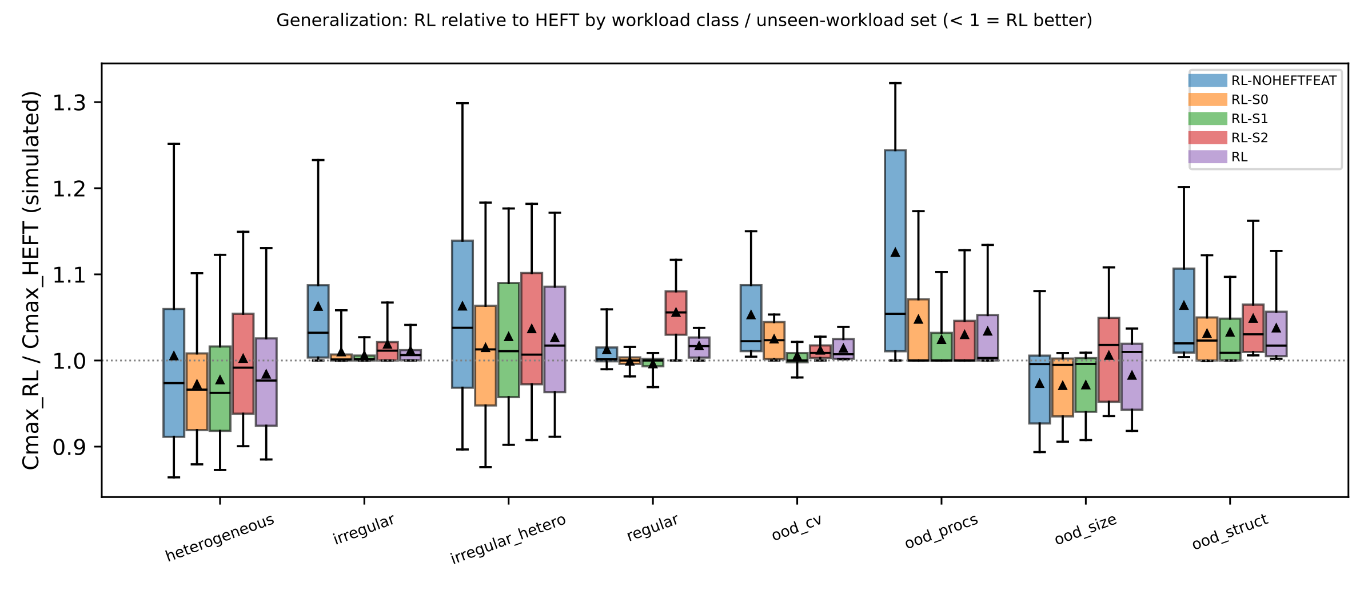
Figure 9. S02 — Generalization: ρ = Cmax_RL / Cmax_HEFT per instance by workload class and unseen-workload set (< 1 = RL better). Source: results/figures/20261017T115054Z-s02_final-898ee9e1/g6_rho_by_group.{pdf,svg,csv}.

