How Much Can AI-Based Scheduling Gain over a Strong List Heuristic? A Controlled Comparison of Evolutionary, Reinforcement-Learning and Adaptive DAG Schedulers in Simulation and Measured OpenMP Execution
Field | Value
Course | BCSE412L Parallel Computing, Fall Semester 2026-27, Slot C1+TC1
Case study | CS15 — AI-Based and Adaptive Scheduling: S01 Evolutionary task scheduling; S02 RL-based scheduling; S03 Adaptive workload-aware scheduler
Batch ID | [BATCH_ID — PENDING CONFIRMATION]
Student ID(s) | Pranav Kumar(23BCE0358)

2. Abstract
The problem of DAG scheduling on heterogeneous processors is known to be NP-hard, and AI schedulers usually outperform list heuristics. We evaluate three such schedulers on a single simulator for the same set of synthetic workloads: a genetic algorithm with heuristics as seeds (S01), a REINFORCE policy choosing processors for ready tasks (S02), and a decision tree that chooses one out of six heuristics (S03), competing with FCFS and HEFT on 360 test and 90 novel workloads, using predetermined tests and Holm's correction. The genetic algorithm achieved a 1.17% decrease in the makespan compared to the best heuristics for each workload (p = 6.2e-52) and ran up to ~1,100 - 1,730 times slower than HEFT. The selector was not able to surpass the best fixed policy by (−0.016%, p = 0.78). The RL policy outperformed FCFS by 18% while being 1.0% behind HEFT. A C++ simulator was able to reproduce the makespans for 41,850 accepted jobs exactly and running the schedules using OpenMP on an Apple M4 proved that GA surpassed HEFT in aggregate by 1.6% (95% confidence interval 1.2% to 2.0%), that the OpenMP task was 19% slower than a statically scheduled HEFT job, and that efficiency dropped to 0.42 at eight threads. HEFT is close to the upper limit of affordable scheduling.

3. Introduction and literature review

3.1 Motivation
In other words, a task DAG for a parallel program will be as efficient as possible based upon its schedule: the order in which ready tasks begin to execute and the processors assigned to those tasks determine both the makespan and the processor utilization efficiency. The problem of determining the optimal schedule in a general setting is NP-complete [1], [2], so efficient list heuristics are implemented in practice. In the case of heterogeneous platforms (consisting of CPUs and accelerators with speed-ups depending on tasks), the allocation of tasks to processors becomes as important as the task order and the same question stated in CS15 applies here.

3.2 Literature review
Directed Acyclic Graph List scheduling and heterogenous heuristics. Kwok & Ahmad [1] reviewed and categorized 27 static algorithms for task graph scheduling in multiprocessor systems and described the terms used in this essay such as task priority, processor selection, insertion in idle slots and evaluation on random graphs. Topcuoglu et al. [2] proposed two new algorithms named HEFT (Heterogeneous Earliest Finish Time) and CPOP for scheduling tasks on a limited number of heterogeneous processors and they were devised for obtaining near-optimal schedules at a low cost. In this project, HEFT was developed using upward rank task priority, earliest finish time processor selection and insertion in idle slots (ALGORITHM_DESIGN §2). Braun et al. [3] evaluated eleven static heuristics for mapping independent tasks onto heterogenous processors under some common assumptions. A genetic algorithm obtained the best mapping in all cases and the best solution obtained by it in each case always came from a population generated by seeding Min-min solution and Min-min heuristic which took less time to generate near optimal solutions.
Evolutionary scheduling. Hou, Ansari and Ren [4] employed a genetic algorithm in multiprocessor scheduling and made comparisons with respect to list scheduling and optimal scheduling on randomly generated task graphs. Bean [5] introduced a genetic algorithm using random keys for sequencing and optimization problems such as multiple machine scheduling – a concept used in the design of our S01 GA (every chromosome in our decoder assigns a priority between ready tasks hence every chromosome represents a precedence feasible schedule). In recent literature, Sulaiman et al. [6] introduced hybrid genetic algorithm/list heuristics (HHG, HTDG) which use two guided chromosomes to improve the initial population, producing a makespan superior to two GAs and two list heuristics (HEFT and PEFT). Jiang et al. [7] introduced real-relative encoding where every chromosome decodes into a precedence valid schedule. Restrictions related to our research question (abstracts): there are comparisons with other metaheuristic/heuristic approaches, but in the analyzed abstracts there are no data on the same-budget comparison with non-evolutionary searches (random search, hill climbing), and although [6] uses guided seeding to increase the quality of solutions, the fact that their approach is "never worse than the seeds" is an attribute of the algorithm rather than search. [6]'s abstract shows better average execution time than its counterparts; it was impossible to check it against HEFT as the text was not available.
Reinforcement-learning scheduling. Mao et al. [8] (Decima) demonstrated that learned schedules could allocate DAG jobs and reduce average job processing time by at least 21% relative to manually tuned heuristics in their cluster environment. Grinsztajn et al. [9] (READYS) introduced an approach based on a combination of graph convolutional networks and actor-critic algorithm for dynamically allocating DAG tasks on CPU/GPU architectures. In simulation, it was comparable to HEFT if task execution times were deterministic, outperformed HEFT if there was more variability in task execution times, and was able to transfer from smaller training graphs to larger graphs. Zhadan et al. [10] applied multi-agent reinforcement learning to select a heuristic rule and achieved an average improvement of 5.32% over the best baseline (DONF) on random DAGs. Specific limitations related to our question: improvements are claimed in cases when durations are stochastic, when there are clustering or step-level switching dynamics, or compared to a baseline which uses different placement rules and different overheads; the inference overhead of the RL policy and its training costs are not the performance metric in focus (for [10], cited in its abstract). Specifically, improvements of READYS over HEFT become apparent only when there are stochastic durations [9]. Does a policy that was trained using a deterministic and zero-communication model outperform HEFT?
Workload-aware and adaptive scheduling (algorithm selection). Rice [11] defined the algorithm selection problem: Given instance attributes, choose an algorithm that is expected to solve it optimally. Kerschke et al. [12] reviewed automated algorithm selection and its interrelations with configuration, scheduling, and portfolios; the two standard metrics for assessing the selector performance are the single best solver (SBS) and the virtual best solver (VBS, the oracle); a selector is assessed on how much of the SBS-VBS gap it closes, which we will follow. Uzunoglu et al. [13] employed learning-to-rank algorithms for selecting, based on per-instance data, a suitable learning-augmented construction heuristic for a serial batch scheduling problem. Selection outperformed single best heuristic on all size categories (mean relative improvement over worst competitor, 6.42% vs 2.23%), and Genetic Algorithm enhancement of the selected solutions resulted in 39.19% mean relative improvement. Limitations with respect to our research question: Algorithm selection makes sense when there is no one superior algorithm; the actual size of the SBS-VBS gap in a particular problem setting and whether a selector can close it at marginal decision cost has to be measured.
Evaluation methodology. When comparing a number of AI techniques based on common baselines, multiplicity appears since we perform a single pre-specified primary comparison for each sub-problem using Holm’s sequentially rejective procedure [14]; this comparison involves a Wilcoxon signed-rank test [15] of paired makespans, and effect sizes are provided along with bootstrap percentile confidence intervals [16].

3.3 Research gap
In all reviewed literature, an AI-based scheduler is benchmarked in isolation, compared to other metaheuristics or heuristics, against models devised by the authors themselves, and gains are stated in percent improvements. There are four questions that are not always answered in one study and with equal standing: (i) how much better does a search, learning or selection method perform compared to the best cheap heuristic on the same set of test cases using the same placement algorithm; (ii) does the improvement withstand the application of various controls (equal-budget search, blind search, oracle and single-best controls), out-of-sample test cases; (iii) how much does it cost in scheduling times; and (iv) do the observed improvements translate into real performance gains when tested on real hardware? This particular case study answers all four in one setting for one common simulator and an OpenMP replay experiment with clearly stated hypotheses, primary tests and verdicts, including null and negative ones.

4. Problem statements, research questions and hypotheses
Common problem. Given a DAG of n tasks with a cost matrix of cost[t, p] where cost[t, p] is the time for task t to run on processor p, determine a feasible non-preemptive schedule that optimises the makespan Cmax with m processors. There are no communication costs considered.
Table 1. sub-problems, the manual's research questions and the hypotheses predeclared in the architecture phase (docs/ARCHITECTURE.md).
Sub-problem (manual) | Research question (manual) | Predeclared hypothesis (ARCHITECTURE.md, architecture phase)
S01 Evolutionary task scheduling | Can evolutionary optimization reduce makespan compared with baseline heuristics? | H1 GA produces lower makespan than FCFS and than the best heuristic on the same instances. H1b its improvement shrinks where heuristics are close to the lower bound; optimization time grows with n.
S02 RL-based scheduling | Can RL scheduling improve over a conventional heuristic after training? | H2 after training, the greedy RL policy matches or beats HEFT on unseen in-distribution instances. H2b RL degrades on out-of-distribution workloads more than heuristics do.
S03 Adaptive workload-aware scheduler | Can an adaptive scheduler outperform a fixed scheduling policy across diverse workloads? | H3 the selector has lower mean normalised makespan than the single best fixed policy (gap-closed CI above 0). H3b it does so at lower scheduling cost than running all policies (TRY-ALL).
All | — | H4 once scheduling overhead is charged, the ranking of methods depends on the task time scale.

Role of each part (manual: baseline / main dimension / optimization-adaptation). The core and baseline heuristics determine the problem as well as the algorithmic behavior; S01 checks to what extent per-instance search can outperform the heuristics (quality dimension) and at what cost for optimization; S02 asks if the per-instance search can be substituted with a learnt constructive policy; S03 checks if selecting among affordable policies per workloads is sufficient.

5. System architecture and shared scheduling model
A Python package, schedlab, implements the schedulers, workloads, runner and analysis, and two C++ programs (cpp/) add an independent workload simulator and an OpenMP executor; each sub-problem lives in one module, and all share the same simulator, workloads, baselines, runner and analysis (Table 2).
Table 2. modules of the shared schedlab package and their responsibilities.
Module | Responsibility
model.py | Instance, ScheduleBuilder (the execution simulator: precedence, processor availability, optional insertion into idle gaps), an independent schedule validator, lower bound LB = max(critical path at fastest costs, total min work / m) and the speedup baseline serial_best
workloads.py | seeded synthetic DAG and cost-matrix generator, content hashing, split separation
heuristics.py | six baselines: FCFS-EAT, FCFS-EFT, SPT-EFT, LPT-EFT, HEFT (upward rank + insertion EFT), MINMIN; all insertion-based
ga.py (S01) | random-key + processor-assignment GA, GA-KEYS-EFT ablation, GA-UNSEEDED, RANDOM-SEARCH, HILL-CLIMB controls
rl.py (S02) | 12 candidate features, REINFORCE trainer, greedy policy
adaptive.py (S03) | 9 workload features, decision-tree selector with novelty guard, GA-1000 contingency extension
runner.py, analysis.py | one raw CSV row per (instance, method, repeat or seed); derived metrics, tables, figures, campaign checks
cpp/schedsim (C++17) | workload simulator: independent port of model.py and the six heuristics, bit-exact (hex-float I/O, numpy's summation order, no FMA contraction)
cpp/ompexec (C++17, OpenMP) | runs a schedule on m threads (static replay with acquire/release completion flags; OpenMP tasks as dynamic baseline; serial T1) with work-calibrated compute kernels and a per-task trace
interop.py, rederive.py, ompexec.py, omp_analysis.py, omp_master.py | file interface to the C++ programs, exact re-derivation of accepted schedules, measured-campaign driver, analysis and 19-column CSV

Every schedule from every method passes through the same validator before its row is accepted, and every derived metric is recomputed from raw columns. The manual's 19-column CSV (master.csv) is produced for every campaign, with Execution_Time = simulated makespan and Scheduling_Time = measured seconds; how every overhead category is treated is given in Table 3 (§6); the measured replay has its own master.csv with Execution_Time in seconds. The architecture diagram is in docs/architecture_diagram.mmd; every table and figure is traced to its source file in docs/report/TRACEABILITY.md.

6. Experimental methodology
Common experimental environment. Apple M4 (4 performance + 6 efficiency cores), 16 GB RAM, macOS 27.2 (arm64); Python 3.12.9, NumPy 2.4.4, SciPy 1.17.1, scikit-learn 1.8.0, PyTorch 2.11.0 (CPU, one thread), pandas 3.0.2, Matplotlib 3.10.8. One worker process, one thread per scheduler call; time measurement using perf_counter_ns around the scheduler call only. S01 and S03 were run using battery power; S02 training and its last campaign were run on mains power (noted in the manifests). No GPU usage (PyTorch running on the CPU), hence no GPU memory or GPU driver versions to mention. Python execution environment: one worker process, one thread (torch.set_num_threads(1)), deterministic PyTorch algorithms, deterministic seeds. C++ components: Homebrew GCC 15.2, -O2 -std=c++17 -ffp-contract=off -fno-fast-math, -fopenmp (libgomp, _OPENMP 201511); OMP_DYNAMIC=false, default wait policy, no thread pinning (OMP_PROC_BIND unset).
Parallel strategy. The parallelism being studied is task-level parallelism of a DAG using m processors: all schedulers generate a static, non-preemptive schedule which allocates a processor and a start time to each task according to precedence such that independent tasks get executed in parallel on different processors; heterogenous processors have different speeds when executing different tasks. All schedulers insert tasks into the same processor simulator capable of insertions and also use the same independent validator. The schedulers are sequential software programs; the experiments execute in a single worker thread without distortion of the measured times caused by resource contention. In the measured replay (§7.8), the same schedules are executed by real threads: thread p executes the tasks assigned to processor p in the schedule in order and waits for completion flags for predecessors executed by other threads; the dynamic baseline is an OpenMP task runtime that starts each task once its predecessors complete.
Repetitions and seeds. These are different. Deterministic techniques (the six heuristics; ADAPTIVE, ADAPTIVE-TOP2, ADAPTIVE-NOGUARD, TRY-ALL; RL policy learned for each) are run thrice per instance for timing repeats, with identical makespans claimed. Stochastic techniques (five search techniques of S01; RANDOM-SELECT, ADAPTIVE-GA, GA-1000) are run once per technique with seeds 0, 1 and 2, averaging over seeds per instance. S02 has three training seeds (0, 1, 2) with one ablation version (seed 0), all trained once. Rows: S01 14,850, S03 17,550, S02 13,500.
Workloads. Layered random DAGs: four variants – regular (work coefficient of variation, CV 0.1, equally sized layers, homogeneous processors), irregular (work CV 1.5, uneven layer sizes, homogeneous), heterogeneous (work CV 0.5, CPUs + accelerators, heterogeneous), irregular_hetero (work CV 1.5, irregular layers, heterogeneous). In-distribution problem sizes: n ∈ {50, 100, 200} and numbers of processors: m ∈ {2, 4, 8} (three problem sizes, three resource sizes). Out-of-distribution workloads (test_ood): ood_size (n = 400), ood_procs (m = 16), ood_struct (fork-join DAGs), ood_cv (work CV 3.0).
Splits (disjoint from content-hash, verified on each new campaign setup): training: 1,080 (S03 label sets; S02 had a distinct stream with 48,000 training split items), validation: 180 (all model & parameter settings), test_id: 360 and test_ood: 90 (final evaluation, once for each sub-problem with fixed configurations & fixed model ids).
Metrics. Makespan (simulated), normalised makespan Cmax/LB (≥ 1), speedup serial_best/Cmax (baseline: all tasks run sequentially on the single best simulated processor), efficiency speedup/m, utilization Σ busy time / (m·Cmax), measured scheduling/optimization/decision/inference time (seconds), paired improvement (C_base − C_alg)/C_base and ratio ρ = C_alg/C_base per instance, regret vs the per-instance best heuristic.
Statistics. Matched by problem instance; seeding strategies averaged over the number of seeds per problem instance; 95% bootstrap CIs (percentile method) [16] (10,000 samples of instances); Wilcoxon signed-rank test [15] per subproblem for the pre-declared primary comparison; Holm adjustment [14] over the three; secondary comparisons only include CIs but not p-values. Timing outliers (above Q3 + 3·IQR per algorithm × n × m) are marked, not discarded.
Measured execution (C++/OpenMP). All 360 test_id instances × 15 methods (SERIAL = T1; 13 schedules: FCFS-EAT, HEFT, GA and GA-KEYS-EFT seeds 0–2, RL-S0–S2, ADAPTIVE, TRY-ALL; OpenMP tasks) × 3 task granularities (mean task 1 ms, 100 µs, 10 µs) × 10 timed repetitions after 2 warm-ups: 194,400 runs, 54 min, mains power. A task runs a compute kernel of llround(cost · u · 813.1) iterations, u = µs per sim_tu (calibrated; linearity R² 0.9997); instance, granularity and method order were randomized with fixed seeds. The schedules are the accepted ones, re-derived exactly (10,350 runs, 0 differences), and the C++ simulator reproduced every accepted heuristic and re-derived makespan bit for bit. Per instance the median of the 10 repetitions is used; speedup = T1/Tp. Design, three predeclared comparisons (primary at 1 ms tasks, Holm) and acceptance criteria were locked before launch (docs/MD_ANALYSIS_PLAN.md).
Overheads (Table 3). In the simulation campaigns only scheduling-side costs are measured and task execution is simulated; the OpenMP replay measures execution; quantities that are not modelled are NA, never 0.
Table 3. treatment of computation, communication, synchronization, scheduling, data-movement and other overheads.
Quantity | Status | Where recorded
Computation (task execution) | Simulated, sim_tu; measured seconds in the OpenMP replay | Execution_Time (makespan; replay: wall time); busy time in raw busy_time_sim / compute_s
Scheduling / optimization / decision / inference | Measured, seconds (wall clock, one thread) | Scheduling_Time per run; decision or inference part in Decision_Time (S03, S02)
Training (S02 policies, S03 selectors) | Measured once per model, seconds | measured block of each model's model.json (not per row)
Communication | Not modelled (DAG model has no data-transfer costs) | Communication_Time = NA
Synchronization | Campaigns: not measured (implicit in the simulated makespan). Replay: dependency waiting measured per run; fork/join ≈ 8 / 14 / 47 µs at 2 / 4 / 8 threads (calibration) | Replay Synchronization_Time (static mode); otherwise NA
Runtime queueing (OpenMP tasks) | Measured; includes waiting for a free thread (contention), not only dispatch | replay Ready_Queue_Time_incl_contention
Data movement | Not modelled | not recorded (NA)
Memory | Measured: process-wide peak RSS, an upper bound per run | Memory_Use (kB)
Energy | Unavailable | Energy_if_available = NA

Table 4. per-sub-problem configuration, controls, primary comparison and final campaign.
 | S01 | S03 | S02
Proposed method | GA: random keys + processor per task, population 60, 6,000 evaluations, tournament 3, uniform crossover 0.9, Gaussian key mutation σ 0.15, 2 elites, seeded with HEFT, MINMIN, FCFS-EAT; 3 algorithm seeds | ADAPTIVE: depth-2 decision tree over 9 workload features, trained on train, depth and SBS chosen on val, novelty guard → SBS | RL: MLP 12→64→64→1 scoring every valid (ready task, processor) pair; REINFORCE with HEFT-relative advantage, 3,000 updates × 16 episodes, best val checkpoint; 3 training seeds
Controls / ablations | GA-KEYS-EFT, GA-UNSEEDED, RANDOM-SEARCH, HILL-CLIMB (equal budget) | ADAPTIVE-TOP2, ADAPTIVE-NOGUARD, RANDOM-SELECT, TRY-ALL; extension ADAPTIVE-GA, GA-1000 | RL-NOHEFTFEAT (rank and EFT features removed)
Primary comparison | GA vs per-instance best heuristic | ADAPTIVE vs SBS (= HEFT, chosen on val), test_id | RL (seed mean) vs HEFT, test_id
Final campaign | 20261017T044734Z-s01_final-430d8a10: 14,850 rows, 7,106 s | 20261017T083329Z-s03_final-b8e5be9a: 17,550 rows, 237 s | 20261017T115054Z-s02_final-898ee9e1: 13,500 rows, 80 s (+ 4 × ~16 min training)
Failures | 0 | 0 | 0

7. Results and discussion

7.1 Combined results (identical test_id instances, n = 360)
Table 5. mean over instances (seed-averaged per instance) on the 360 in-distribution test instances. Cmax/LB and speedup are simulated (baseline for speedup: serial on best single processor); time is the measured median seconds per call (S01 and S03 on battery power, S02 on mains). Heuristic makespans are identical across the three campaigns (verified on all 2,700 instance–heuristic pairs). Source: results/derived/<campaign>/master.csv.
Method | Part | Cmax/LB | Speedup | Efficiency | Utilization | Time (s)
FCFS-EAT (conventional baseline) | base | 1.581 | 2.859 | 0.682 | 0.852 | 0.0003
HEFT (strong baseline; SBS) | base | 1.180 | 3.502 | 0.813 | 0.895 | 0.0004
MINMIN | base | 1.391 | 2.959 | 0.705 | 0.716 | 0.0010
GA (6,000 evals) | S01 | 1.157 | 3.546 | 0.830 | 0.900 | 0.563
GA-KEYS-EFT (ablation) | S01 | 1.123 | 3.634 | 0.850 | 0.900 | 1.000
HILL-CLIMB (control) | S01 | 1.162 | 3.541 | 0.825 | 0.904 | 0.592
ADAPTIVE | S03 | 1.181 | 3.502 | 0.813 | 0.890 | 0.0005
TRY-ALL (oracle over six) | S03 | 1.175 | 3.514 | 0.818 | 0.891 | 0.0025
ADAPTIVE-GA (extension) | S03 | 1.179 | 3.504 | 0.815 | 0.893 | 0.0005
RL-S0 / RL-S1 / RL-S2 | S02 | 1.176 / 1.181 / 1.211 | 3.484 / 3.477 / 3.377 | 0.821 / 0.819 / 0.796 | 0.858 / 0.844 / 0.818 | 0.006
RL-NOHEFTFEAT (ablation) | S02 | 1.217 | 3.352 | 0.797 | 0.822 | 0.005

Efficiency on heterogeneous platforms can exceed what m identical processors allow, because the speedup baseline is a single processor while tasks run on their preferred device; values are comparable across methods, not with 1.

7.2 Predeclared primary comparisons
Table 6. primary comparisons. ρ = C_method / C_baseline per instance (< 1 favours the method); Wilcoxon signed-rank on paired makespans; Holm correction over the three tests. Sources: s01_paired.csv, s03_paired.csv, s02_paired.csv.
Sub-problem | Comparison | Population (n) | Mean paired improvement or ρ | 95% CI | better / tie / worse | p | Holm
S01 | GA vs best heuristic | all test (450)† | +1.169% | +0.96% – +1.39% | 330 / 114 / 6 | 6.2e-52 | reject
S03 | ADAPTIVE vs SBS | test_id (360) | −0.016% | ratio 0.9991 – 1.0012 | 6 / 342 / 12 | 0.78 | not rejected
S02 | RL vs HEFT | test_id (360) | ρ = 1.0097 (RL 0.97% longer) | 1.0034 – 1.0160 | 100 / 34 / 226 | 6.8e-6 | reject (RL worse)

† S01's analysis population was not specified in advance; test_id gives +1.33% (CI 1.07–1.60%, p = 3.0e-43) and test_ood +0.54% (p = 2.2e-10). The Holm decisions are the same for every S01 population (adjusted p: S01 ≤ 9.1e-43, S02 1.4e-5, S03 0.78). S03's population was fixed before its pilot; S02's in the approved S02 plan before any S02 data; both were predeclared before the respective test evaluation.

7.3 S01 — Evolutionary task scheduling
The mean improvement of the GA over the per-instance best of the six heuristics is 1.169% (Table 6): a small but significant effect with ties for 114 out of 450 instances. Interpretation of the result is limited by two design issues. First, the GA uses HEFT, MINMIN and FCFS-EAT as seeds and always maintains its best-so-far solution, and thus can never be worse than those seeds; the heuristics were the best on 405 out of 450 instances. In essence, then, the experiment mainly tests the improvement through search when starting from the seeds, and all six losses were observed on those instances where one of the unsampled heuristics (either LPT-EFT or FCFS-EFT) had proven the best. Secondly, the comparison is done in simulated time, while the GA optimization costs time: median optimization time of 0.25 s (n=50) to 3.7 s (n=400), or ~1,100 – 1,730 × HEFT’s scheduling time (Figure 2a).
Controls are the better result (Table 7). The equal-budget hill climber, with the same mutation and seeds, achieved 0.90% (a 0.27% lead for GA on 190 but 162 worse) performance. Thus, for this budget, GA does not need population and crossover. Random sampling never beat its seeds. Without seeds, GA was 17% worse than the best heuristic. The ablated version of the GA – GA-KEYS-EFT that evolves only task priorities, placing each task in append-mode order by EFT – outperformed the primary GA (3.38% against 1.17%; GA worse on 343 of 450). Its seeds are decoded task orders rather than heuristic schedules, so it cannot claim the "never worse than seeds" guarantee; the merit of this variant is a greatly reduced search space that allows for better searching with 6,000 evaluations. The primary algorithm was chosen prior to the test and did not change afterwards.
Table 7. S01 controls and ablations vs the per-instance best heuristic, all 450 test instances (s01_paired.csv).
Method | Mean paired improvement | 95% CI (ratio) | better / tie / worse
GA (primary) | +1.169% | 0.9861 – 0.9904 | 330 / 114 / 6
GA-KEYS-EFT | +3.375% | 0.9622 – 0.9702 | 353 / 83 / 14
HILL-CLIMB | +0.899% | 0.9892 – 0.9928 | 337 / 103 / 10
RANDOM-SEARCH | −0.134% | 1.0007 – 1.0021 | 0 / 428 / 22
GA-UNSEEDED | −16.958% | 1.1494 – 1.1913 | 53 / 32 / 365

The hypothesis H1 is confirmed when compared with FCFS (+19.7%), and, just barely and to a large extent due to the method’s construction, with the best heuristic. Hypothesis H1b is confirmed since the superiority of the algorithm under investigation decreased from 2.5% at n = 50 to 1.0% at n = 400 while the optimization time increased (see Figure 2a), and was obtained mostly for heterogeneous tasks (see Figure 3).
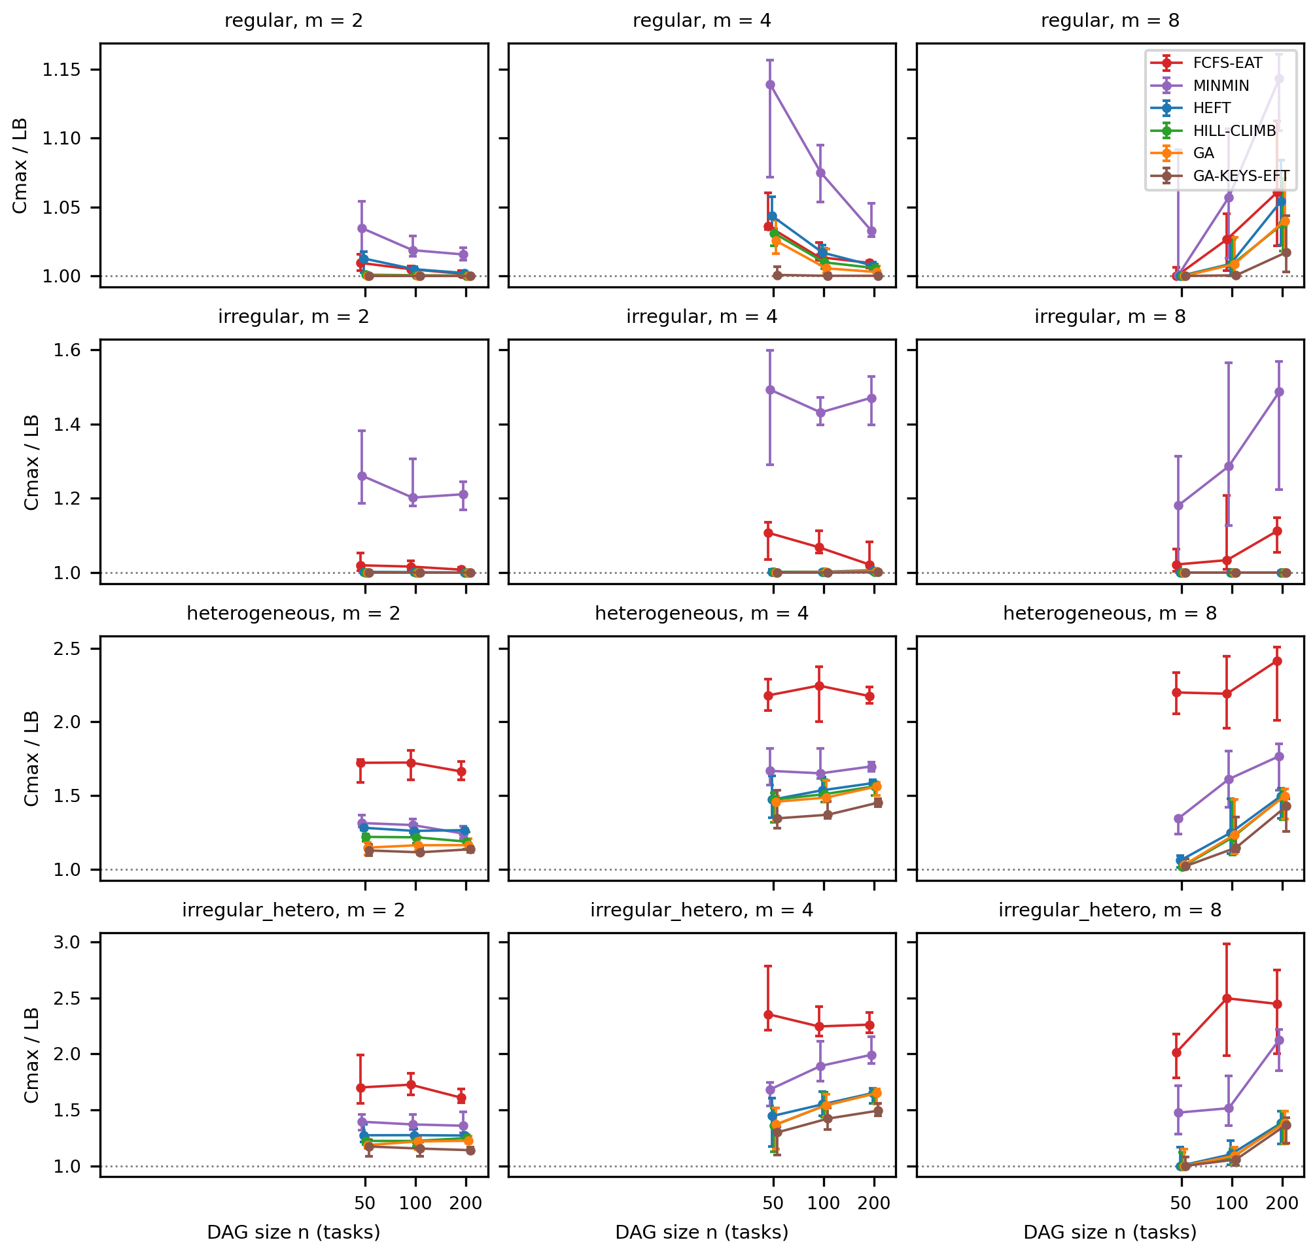
Figure 1. S01 — DAG size vs simulated makespan / lower bound, test_id, one panel per workload class × processor count, median and IQR over the 10 instances per cell (seed mean per instance); six methods shown. Report view drawn from the saved plotted-summary CSV (subset saved as docs/report/word/figures/derived/fig01_S01_makespan_vs_size_report_subset.csv); the full figure with all methods and unseen-workload cells is the accepted one. Source: results/figures/20261017T044734Z-s01_final-430d8a10/g1_makespan_vs_size.{pdf,svg,csv}.
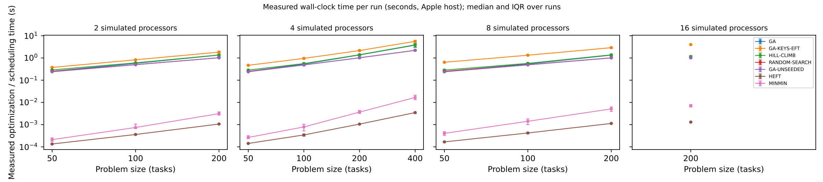  Figure 2a. S01 — Measured optimization / scheduling time per run (seconds, log scale, battery power) vs DAG size; median and IQR over runs. Source: results/figures/20261017T044734Z-s01_final-430d8a10/g2_opt_time_vs_size.{pdf,svg,csv}. | 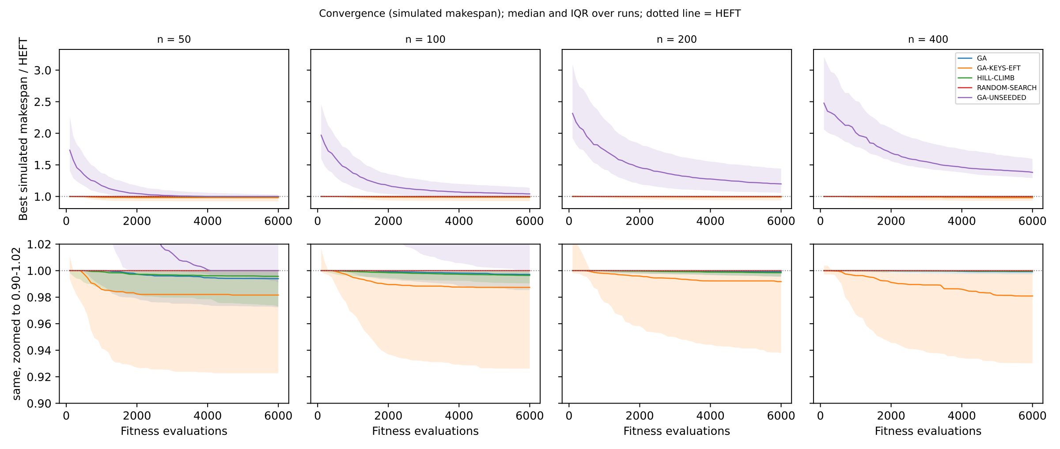  Figure 2b. S01 — Convergence: best-so-far simulated makespan / HEFT vs fitness evaluations, median and IQR over runs; lower row zoomed. Source: results/figures/20261017T044734Z-s01_final-430d8a10/g2_convergence.{pdf,svg,csv}.

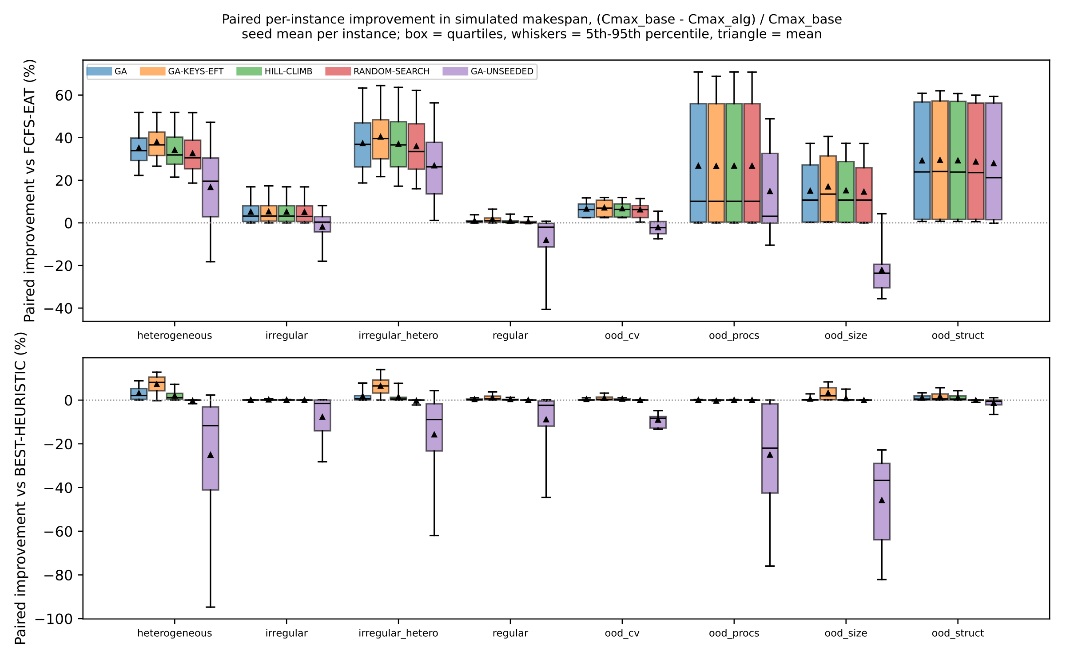
Figure 3. S01 — Paired per-instance improvement (%) in simulated makespan vs FCFS-EAT (top) and vs the per-instance best heuristic (bottom), by workload class and unseen-workload set. Source: results/figures/20261017T044734Z-s01_final-430d8a10/g3_improvement_by_class.{pdf,svg,csv}.

7.4 S03 — Adaptive workload-aware scheduling
The key finding is null (see Table 6), as ADAPTIVE outperformed SBS (HEFT) on just 18 out of 360 in-distribution data points (from the heterogeneous class, where the decision tree recommended MINMIN): it was superior in 6 instances and inferior in 12 others; thus, the gap narrowed by −0.03 (95% CI: −0.30, 0.19). Hypothesis H3 fails to hold. The explanation is based on the structure of the problem: HEFT was the best of six heuristics for 71% of training data and was within 0.48% of the per-instance oracle on test_id, which means that the best hypothetical selector can achieve only up to 0.45% of improvement on average over these six heuristics (TRY-ALL vs SBS). H3b holds by definition (decision time is about 0.15 ms, while total time for SBS is about 0.5 ms vs 2.5 ms for TRY-ALL) but does not matter anyway, as there is no gain to be obtained.
Under test_ood workloads that are unseen, the novelty guard reverted to SBS in 66% of the cases (for all n = 400 and 19 of 20 fork-join instances), while the other cases saw HEFT being selected as well, such that ADAPTIVE matched SBS in all 90 cases. The deficiencies of fixed policies came about through the distribution (for example, mean regret of MINMIN on ood_cv is 63%; see Figure 6).
Contingency extension (secondary). The pre-decided rule (SBS–VBS gap val < 2%; observed 0.66%) introduced the 1,000-evaluation GA as a seventh choice in addition, where the selected margin was θ = 2%. ADAPTIVE-GA beat SBS by 0.10% in test_id (CI for closing gap = −0.20–0.66, includes 0), and did not improve in test_ood, at 5- to 28-fold HEFT time. The always-GA-1000 choice improved 0.87% at 155 to 282 times HEFT.
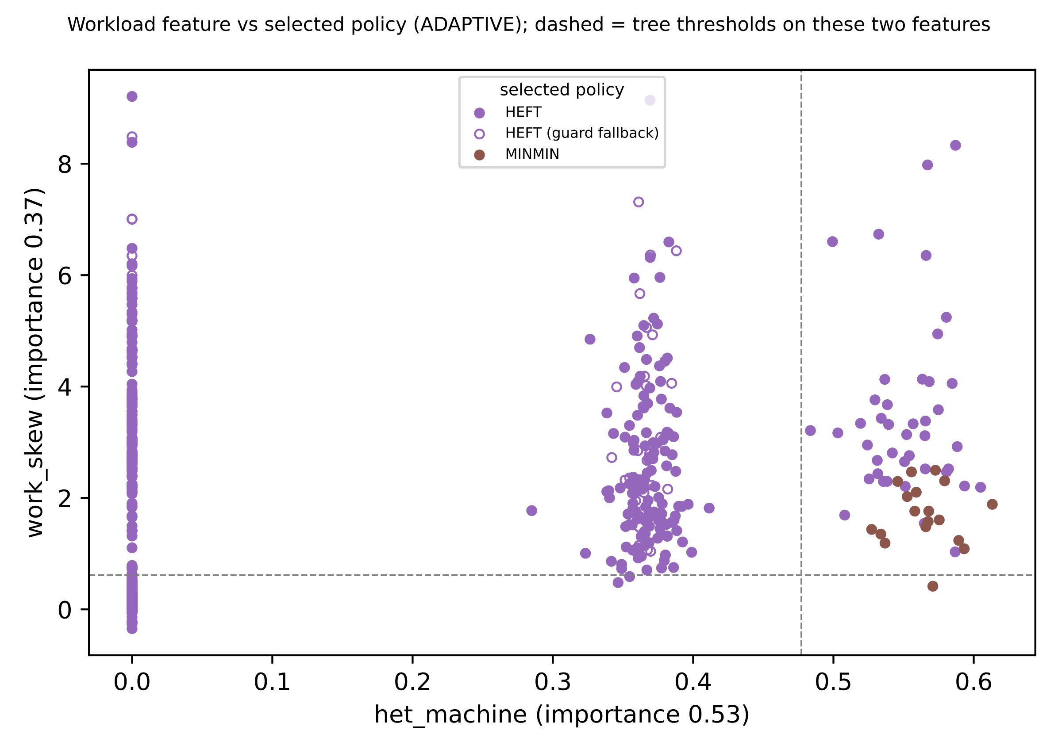
Figure 4. S03 — Workload feature vs selected policy (ADAPTIVE, test splits): the two most important tree features, points coloured by selected heuristic, hollow = novelty-guard fallback; dashed = tree thresholds. Source: results/figures/20261017T083329Z-s03_final-b8e5be9a/g7_feature_vs_policy.{pdf,svg,csv}.
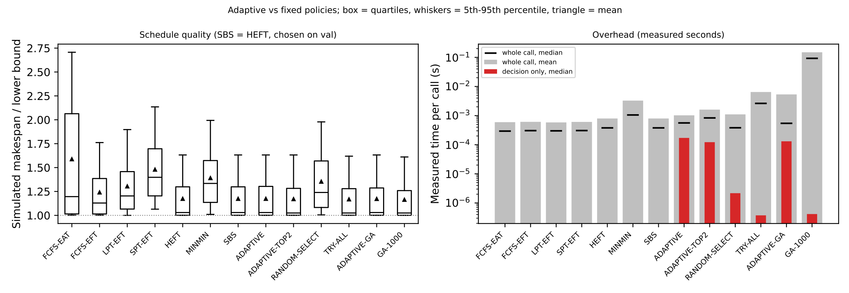  Figure 5. S03 — Adaptive vs fixed policies: simulated makespan / lower bound (left) and measured time per call (right, seconds, log; mean, median and decision part). Source: results/figures/20261017T083329Z-s03_final-b8e5be9a/g8_adaptive_vs_fixed.{pdf,svg,csv}. | 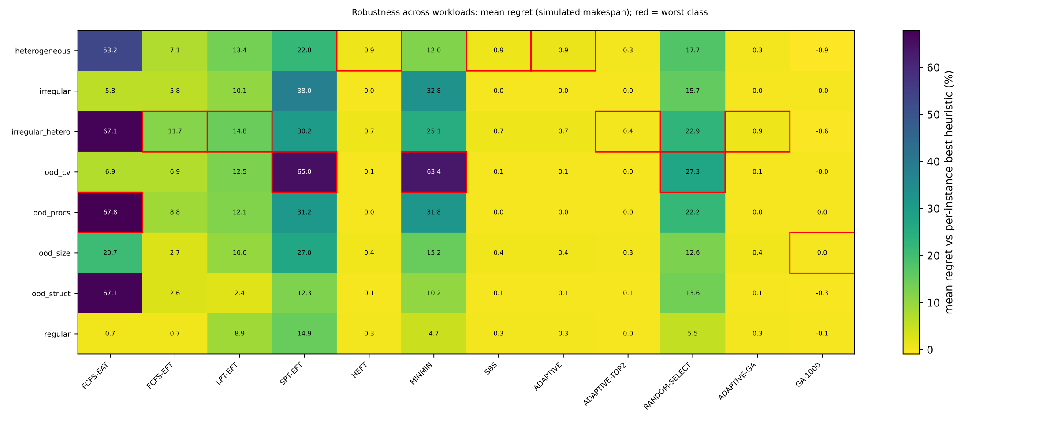  Figure 6. S03 — Robustness across workloads: mean regret (%) vs the per-instance best heuristic, workload class / unseen-workload set × policy; red box = worst class per policy. Source: results/figures/20261017T083329Z-s03_final-b8e5be9a/g9_regret_heatmap.{pdf,svg,csv}.

7.5 S02 — Reinforcement-learning scheduling
All three training seeds learned on validation data (each beat its own untrained network with a CI below 0 and beat FCFS-EAT), in about 16 minutes and 48,000 episodes each, without the predeclared behaviour-cloning fallback (Figure 7). On held-out test_id, RL improved on the conventional heuristic by about 18% (ρ vs FCFS-EAT 0.822, CI 0.802–0.841) but trailed HEFT by 0.97% (Table 6). This is the case where statistical and practical conclusions must be kept apart: the difference from HEFT is statistically significant (p = 6.8e-6; RL worse on 226 of 360), and the predeclared practical verdict is "matches", because the whole CI (1.0034–1.0160) lies inside the ±2% equivalence band fixed before testing. It does not lie below 1, so "improves" is not met. H2 is supported in its "matches" form only, and seed-dependently: seeds 0 and 1 have CIs including 1 (ρ 0.999 and 1.002), seed 2 is 2.8% worse.
Pattern: RL outperformed HEFT with 2 processors (ρ = 0.973) and for the heterogeneous class (0.984), but failed as the number of processors increased (ρ = 1.039 for m = 8). Outside the distribution, it generalised to larger DAGs (ood_size, ρ = 0.983) and greater work variance (ood_cv), but not to more processors (ood_procs, ρ = 1.034) or fork-join structure (ood_struct, ρ = 1.038), which partially validates H2b. Deleting the HEFT features dropped the performance by 3.7 points for ρ from the same seed: the policy is based on the HEFT’s features. The inference cost was ~50–140 µs per action, 12-18 times the HEFT’s schedule cost, in addition to one-off training.
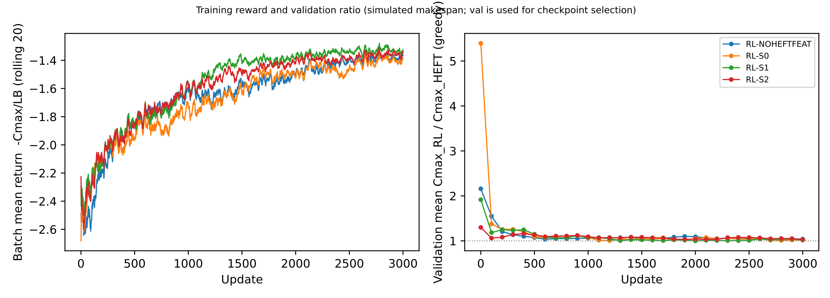
Figure 7. S02 — Training reward (batch mean −Cmax/LB, rolling 20 updates) and validation ρ = Cmax_RL / Cmax_HEFT vs updates for the three seeds and the ablation (validation chose the checkpoints). Source: results/figures/20261017T115054Z-s02_final-898ee9e1/g4_training_curves.{pdf,svg,csv}.
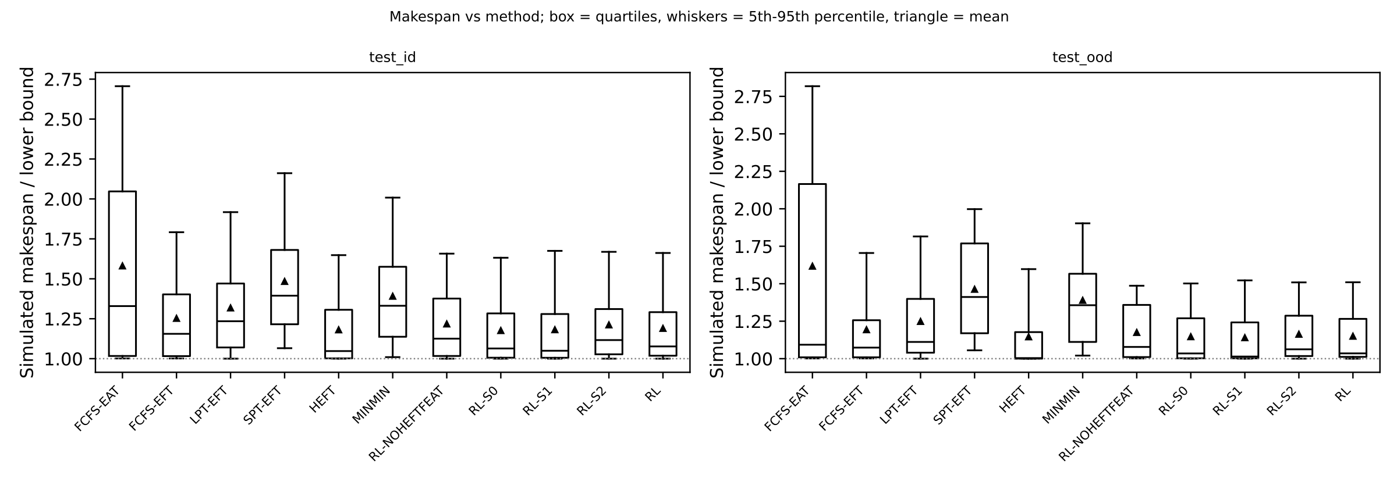  Figure 8. S02 — Makespan vs method: simulated makespan / lower bound on test_id and test_ood (box = quartiles, whiskers = 5th–95th percentile, triangle = mean). Source: results/figures/20261017T115054Z-s02_final-898ee9e1/g5_makespan_by_method.{pdf,svg,csv}. | 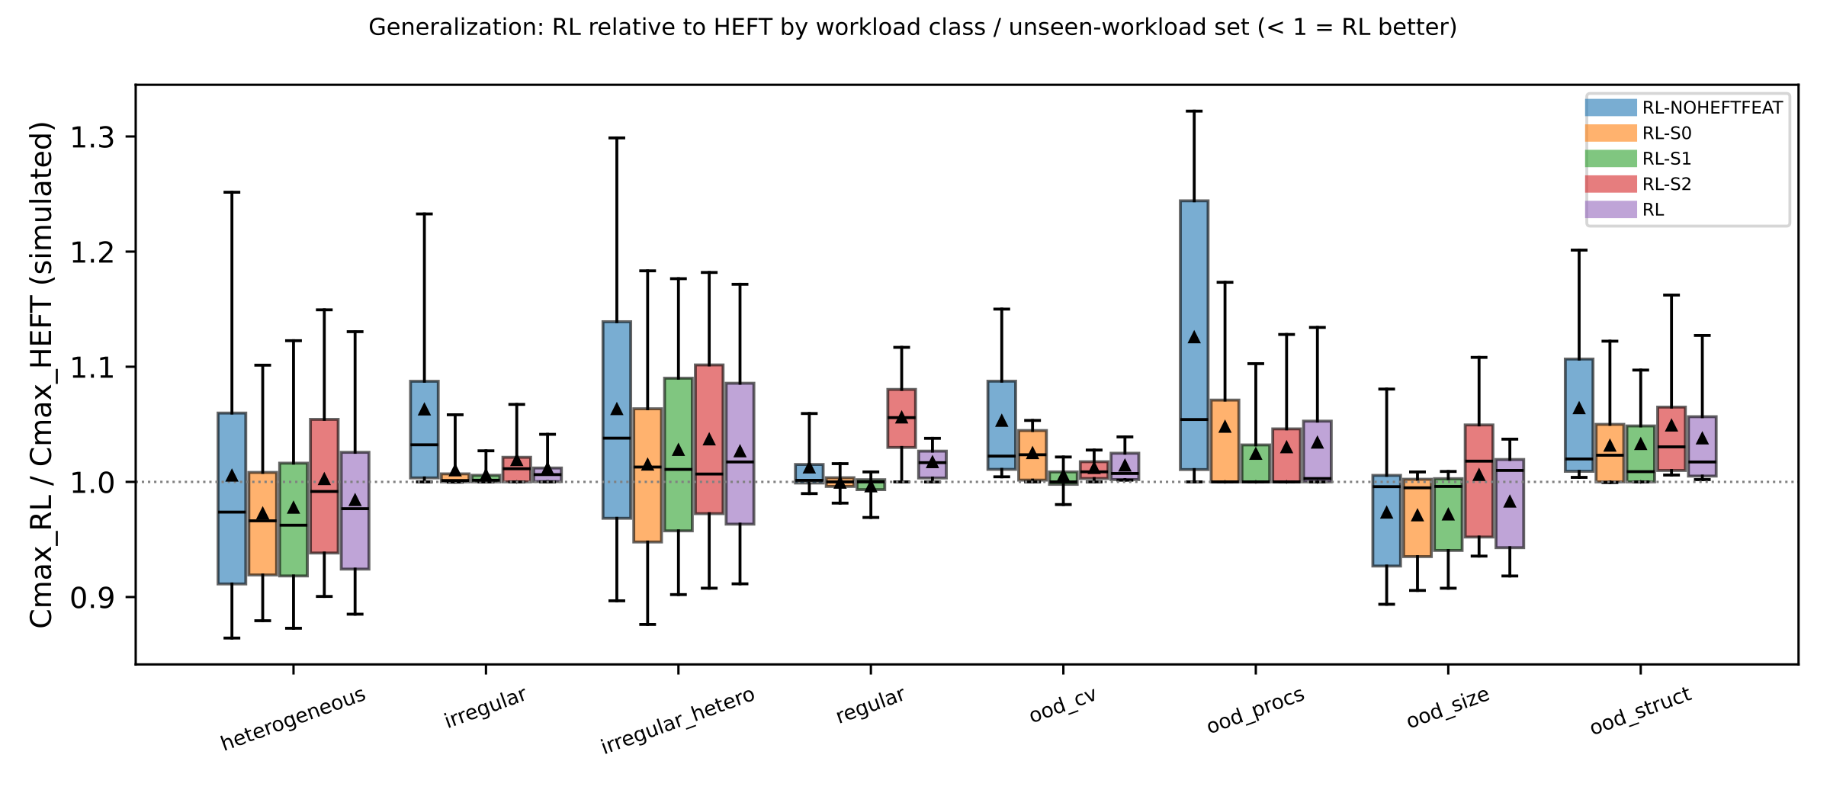  Figure 9. S02 — Generalization: ρ = Cmax_RL / Cmax_HEFT per instance by workload class and unseen-workload set (< 1 = RL better). Source: results/figures/20261017T115054Z-s02_final-898ee9e1/g6_rho_by_group.{pdf,svg,csv}.

7.6 Scalability
All makespans are simulated ones on test_id unless otherwise stated, obtained from master.csv and the corresponding tables. Resource count. Simulated speedup increases with m, yet efficiency decreases: HEFT 1.91 / 3.30 / 5.30 speedup and 0.95 / 0.82 / 0.66 efficiency at m = 2 / 4 / 8 (GA 1.98 / 3.34 / 5.32; FCFS-EAT 1.67 / 2.79 / 4.12) because of the restricted parallelism of the DAGs. The margin of improvement compared to the optimal heuristic becomes smaller as m grows, and all three approaches comply with this tendency: the margin of improvement of the GA to the best heuristic is 2.59 / 1.04 / 0.35%; the margin of the headroom of the oracle over SBS which could have been used by S03 (TRY-ALL over HEFT) is 0.96 / 0.31 / 0.09%; the ratio of RL to HEFT degrades from 0.973 to 1.017 and 1.039, and to 1.034 on the unseen 16-processors setting. Problem size. The Cmax/LB of HEFT grows relatively slowly with n (1.144 / 1.180 / 1.217 at n = 50 / 100 / 200), whereas the margin of improvement of the GA to the best heuristic is decreasing (1.98 / 1.08 / 0.91%) and the optimization time increases from 0.25 s to 3.7 s (n = 50 → 400). The ratio of RL to HEFT is 1.014 / 1.010 / 1.005 and 0.983 for the unknown n = 400. The decision time measured for S03 increases from 0.10 to 0.19 ms as n increases from 50 to 200, while RL costs 50-140 µs per decision. Hence, the higher is the size of the DAGs, the more expensive is the overhead cost compared to its benefits, and more processors give all algorithms less room to outperform HEFT. Efficiency degrades faster on real threads (§7.8): HEFT 0.96 / 0.79 / 0.42 for m = 2 / 4 / 8 and 1ms tasks.

7.7 Comparative discussion
All three methods agree in that in these cases, HEFT is close to the upper boundary of what inexpensive techniques can achieve, and any improvement over it required additional scheduling time. The choice of heuristics could only do 0.45% better than HEFT and lost all of it; the learned constructive strategy achieved HEFT quality within 1% but at 16 times higher cost; only search (S01) was able to come under HEFT, achieving about 1–3% better but at three orders of magnitude more time. These results confirm the explanations given in the literature regarding HEFT dominance – high-quality schedules with low scheduling cost [2] – and provide the basis for critical interpretation of the advantages claimed for learning and adaptation [8]–[10], [13]: they were achieved with stochastic task durations, dynamic cluster size, task rule switching or different classes of problems, none of which is present in our model. Furthermore, the controls of S01 suggest being cautious in interpreting seeded GA advances [6] as confirmation of evolutionary search: here hill climbing with the same seed values performed equally, and a smaller representation better. Execution measurement (§7.8) provides the following two observations: the GA’s slight edge applies to real threads, cumulatively, as well as the fact that when decision latency is included, the adaptive approaches lose more as tasks become smaller (ADAPTIVE +0.8% end-to-end on 1 ms tasks, +27% on 10 µs; TRY-ALL +10% to ×4.2). This backs up H4 in its measured formulation, based on three different task sizes on one host.

7.8 Measured execution with C++/OpenMP
The replay is provided in Figure 10 and Table 8; all figures are wall-clock seconds on the M4 except those which are specified to be simulated. The repetition noise (coefficient of variation over 10 replays) was 1.9% at 1 ms tasks and 3.5% at 10 µs, similar to the differences under test of 0.5-2%. M1: the GA scheduling was 1.6% faster than HEFT’s scheduling (simulated 1.8%), discernable in the overall but tied within noise in 240 out of 360 cases; it was the same as the simulation result at m=2 (0.964 vs 0.964) and zero at m=8 (0.999). M2: ADAPTIVE used HEFT’s schedule in 342 cases; with the added decision time in Python, it was 0.8% slower overall. M3: the OpenMP task runtime was 19% slower than the static HEFT schedule, and faster on approximately half of the instances only at m = 8. Speedup saturated after four threads (HEFT 1.93 / 3.15 / 3.39) due to the fact that 39–51% of the threads at m = 8 (39% at 1 ms tasks) executed 1.3× slower than calibrated (consistent with efficiency cores; observed from timing, not placement), increasing the waiting due to dependencies to 19–28% of thread time. With the ≈ 8% serial calibration adjustment removed, the simulation matched the measured time within 3% at m ≤ 4 for tasks of 100 µs or longer, underestimating it 1.5–2.4× at m = 8.
Table 8. measured comparisons at 1 ms mean task (primary: M1–M3, Holm) and selected descriptive ratios; ratio = geometric mean over the 360 instances of per-instance medians (< 1 favours the method); win / tie / loss uses a per-instance noise band. Source: results/derived/20261018T015324Z-omp_exec_final-9c4c1f9b/comparisons.csv.
Comparison | Measured ratio | 95% CI | Simulated | win / tie / loss | Holm p
M1 GA vs HEFT | 0.984 | 0.980 – 0.988 | 0.982 | 115 / 240 / 5 | 2.3e-20
M2 ADAPTIVE vs HEFT, incl. decision time | 1.008 | 1.006 – 1.011 | 1.000 | 12 / 239 / 109 | 1.2e-18
M3 OpenMP tasks vs static HEFT | 1.188 | 1.160 – 1.216 | — | 60 / 66 / 234 | 6.1e-31
GA-KEYS-EFT vs HEFT | 0.961 | 0.955 – 0.966 | 0.957 | 191 / 159 / 10 | —
RL-S0 vs HEFT | 0.999 | 0.991 – 1.006 | 0.997 | 102 / 163 / 95 | —
TRY-ALL vs HEFT, incl. decision time | 1.103 | 1.095 – 1.112 | 0.995 | 2 / 46 / 312 | —

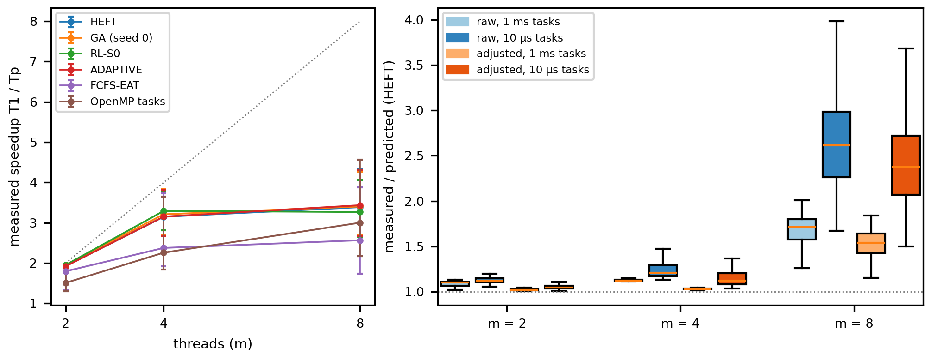
Figure 10. Measured execution (C++/OpenMP, Apple M4, mains power; wall-clock seconds). Left: measured speedup T1 / Tp vs threads at 1 ms mean task, median and IQR over the 360 test_id instances (T1: all tasks on one thread); dotted = ideal. Right: measured / predicted time of the HEFT schedule by thread count and mean task size, raw (nominal µs per sim_tu) and calibration-adjusted (measured serial seconds per sim_tu); 1 = simulator exact. Report view drawn from the saved plotted CSVs (no values recomputed). Source: results/figures/20261018T015324Z-omp_exec_final-9c4c1f9b/{md1_speedup_vs_threads,md2_simulator_gap}.{pdf,svg,csv}.

8. Limitations and threats to validity
- Simulation and one measured host. The quality results are simulated makespans (no communication cost, exact cost estimates, free dispatch). The replay runs a synthetic compute kernel (no memory traffic, no data on edges; hetero emulated by iteration counts) on one unpinned Apple M4, so its m = 8 results reflect this core mix; raw gaps include an ≈ 8% serial calibration offset; M2 adds Python decision times measured in another process; the replay's host records at start and end were lost to a driver defect (manifest reconstructed from recomputable values, docs/MD_ACCEPTANCE_REPORT.md §2).
- One synthetic generator. HEFT's near-dominance may be a property of this generator (no communication, the cost model used). Communication-heavy DAGs or real task traces could leave more room for selection and learning.
- Measurement. Time scheduling is done using wall time in one laptop; S01 and S03 have used battery power (84% to 15% in S01), so their times may be different when using mains power. Outliers in timing were identified and retained: S01 130 out of 14,850 rows (0.9%; median 1.35x group median, maximum 86x), S03 448 out of 17,550 (2.6%; median 2.84x, maximum 212x), S02 23 out of 13,500 (0.2%; median 1.81x, maximum 2.4x). In S03, almost all outliers depend on which policy the run uses, not noise: 83% of ADAPTIVE-GA outliers are runs that use GA (5% of runs), and all RANDOM-SELECT outliers use MINMIN (17% of runs). The lower rate in S02 corresponds to mains power usage, but the different methods of campaign make power usage not a singular factor. Simulated makespans are unaffected by power status (heuristic re-runs produce the same results).
- Statistics. Population for S01 was not predetermined, while the population for S02 is already determined in the approved plan instead of the initial methodology. Three RL seeds determine training variance only approximately. OOD cells contain 10 to 40 cases (ood_cv 10).
- Design-induced effects. Seeded approaches will never beat their seeds, since seed vs. approach comparison is irrelevant. RL training finished within the allocated budget while return was increasing; no hyperparameter search was performed.
- Scope and inputs. One student covered all three sub-problems — pending faculty approval. The S03 objective "use findings from Batches 1–3 and 7" is not met: those findings were unavailable; features were chosen from those batches' topics only, and no findings were invented.
- Literature. Full texts were read for [1], [4], [8], [12], [13] and partly for [2], [3], [5], [9]; [6], [7], [10], [16] were checked at abstract level and [11], [14], [15] at metadata level.

9. Conclusion and future research directions
On a shared, validated simulator with identical held-out workloads: evolutionary search reduced simulated makespan below the best heuristic by a small, consistent margin (1.17%) at ~10³× the scheduling time, with an equal-budget hill climber nearly as good and a keys-only GA better; adaptive selection among six heuristics did not improve on the best fixed policy (−0.016%, p = 0.78); reinforcement learning clearly improved on FCFS (~18%) and matched HEFT within the predeclared ±2% band while trailing it by a statistically significant 1%. So: yes, AI-based scheduling improves over a conventional fixed policy; no, it did not improve over a strong fixed policy without paying substantially more scheduling time. Executed with OpenMP on real threads, the GA's simulated gain held in aggregate (1.6%) but not per instance or at eight threads, and decision overhead made adaptive selection slower end-to-end.
Future directions:
- Communication-aware and stochastic models — add data-transfer costs and duration noise, where the reviewed RL work reports its advantages [9], and re-test whether HEFT's dominance persists.
- Heterogeneity-aware execution — model the host's performance and efficiency cores (or pin threads where the OS allows), add memory traffic and data movement to the kernel, and repeat the replay on other machines.
- Cheaper search — keys-only or hybrid representations, and compiled fitness evaluation, to move the GA's quality–time trade-off; and S03 selection between a heuristic and a short search, labelled by an explicit time budget.
- Better RL state — graph-neural encoders and longer or tuned training (on validation data), with the ablation showing how much is learned beyond HEFT's features.
- Workload diversity for selection — workload classes where no single heuristic dominates, and the Batches 1–3 and 7 findings once available.

10. References
[1] Y.-K. Kwok and I. Ahmad, "Static scheduling algorithms for allocating directed task graphs to multiprocessors," ACM Computing Surveys, vol. 31, pp. 406–471, 1999, doi: 10.1145/344588.344618.
[2] H. Topcuoglu, S. Hariri, and M.-Y. Wu, "Performance-effective and low-complexity task scheduling for heterogeneous computing," IEEE Transactions on Parallel and Distributed Systems, vol. 13, pp. 260–274, 2002, doi: 10.1109/71.993206.
[3] T. D. Braun et al., "A comparison of eleven static heuristics for mapping a class of independent tasks onto heterogeneous distributed computing systems," Journal of Parallel and Distributed Computing, vol. 61, pp. 810–837, 2001, doi: 10.1006/jpdc.2000.1714.
[4] E. Hou, N. Ansari, and H. Ren, "A genetic algorithm for multiprocessor scheduling," IEEE Transactions on Parallel and Distributed Systems, vol. 5, pp. 113–120, 1994, doi: 10.1109/71.265940.
[5] J. C. Bean, "Genetic algorithms and random keys for sequencing and optimization," ORSA Journal on Computing, vol. 6, pp. 154–160, 1994, doi: 10.1287/ijoc.6.2.154.
[6] M. Sulaiman, Z. Halim, M. Lebbah, M. Waqas, and S. Tu, "An evolutionary computing-based efficient hybrid task scheduling approach for heterogeneous computing environment," Journal of Grid Computing, vol. 19, no. 1, Art. 11, 2021, doi: 10.1007/s10723-021-09552-4.
[7] J. Jiang, Z. Sun, R. Lu, L. Pan, and Z. Peng, "Real relative encoding genetic algorithm for workflow scheduling in heterogeneous distributed computing systems," IEEE Transactions on Parallel and Distributed Systems, vol. 36, no. 1, pp. 1–14, 2025, doi: 10.1109/TPDS.2024.3492210.
[8] H. Mao, M. Schwarzkopf, S. B. Venkatakrishnan, Z. Meng, and M. Alizadeh, "Learning scheduling algorithms for data processing clusters," in Proc. ACM SIGCOMM, 2019, pp. 270–288, doi: 10.1145/3341302.3342080.
[9] N. Grinsztajn, O. Beaumont, E. Jeannot, and P. Preux, "READYS: A reinforcement learning based strategy for heterogeneous dynamic scheduling," in Proc. IEEE Int. Conf. Cluster Computing (CLUSTER), 2021, pp. 70–81, doi: 10.1109/Cluster48925.2021.00031.
[10] A. Zhadan et al., "Multi-agent reinforcement learning-based adaptive heterogeneous DAG scheduling," ACM Transactions on Intelligent Systems and Technology, vol. 14, no. 5, pp. 1–26, 2023, doi: 10.1145/3610300.
[11] J. R. Rice, "The algorithm selection problem," Advances in Computers, vol. 15, pp. 65–118, 1976, doi: 10.1016/S0065-2458(08)60520-3.
[12] P. Kerschke, H. H. Hoos, F. Neumann, and H. Trautmann, "Automated algorithm selection: Survey and perspectives," Evolutionary Computation, vol. 27, no. 1, pp. 3–45, 2019, doi: 10.1162/evco_a_00242.
[13] A. Uzunoglu, C. Gahm, and A. Tuma, "Machine learning based algorithm selection and genetic algorithms for serial-batch scheduling," Computers & Operations Research, vol. 173, Art. 106827, 2025, doi: 10.1016/j.cor.2024.106827.
[14] S. Holm, "A simple sequentially rejective multiple test procedure," Scandinavian Journal of Statistics, vol. 6, pp. 65–70, 1979, doi: 10.2307/4615733.
[15] F. Wilcoxon, "Individual comparisons by ranking methods," Biometrics Bulletin, vol. 1, no. 6, p. 80, 1945, doi: 10.2307/3001968.
[16] B. Efron and R. Tibshirani, "Bootstrap methods for standard errors, confidence intervals, and other measures of statistical accuracy," Statistical Science, vol. 1, no. 1, pp. 54–75, 1986, doi: 10.1214/ss/1177013815.

