**CSPE43-ADVANCED DATA STRUCTURES AND ALGORITHMS**

**PROJECT**

Submitted by

Pranav Sharma- 106122092

Yuvraj- 106122145

Under the guidance of

Prof. Nithya

Department of Computer Science and Engineering

**Performance comparison of A* Algorithm using different Heaps**

Abstract: A priority queue is one of the most indispensable abstract data types, particularly in graph algorithms like the A* algorithm, which is pivotal in pathfinding tasks, gaming, and robotics, among others. Over the years, various implementations of priority queues have emerged. Among the most potent ones are those grounded in the heap data structure, enabling insertions and removals in O(log n) time. With specialised heaps like Binomial heaps, inserts can be achieved in amortised O(1) time, potentially reducing the time complexity of algorithms utilising priority queues. In this project, we concentrate on three priority queue implementations: leftist heap, binomial queue, and min-max heap, investigating their suitability within the context of an A* algorithm implemented in the C++ programming language.

*Keywords*: A* algorithm; binomial heap; leftist heap; min-max heap

**INTRODUCTION**

Unlike Dijkstra's algorithm, which focuses solely on finding the shortest path between two nodes in a graph, the A* algorithm incorporates heuristic information to guide its search more efficiently. A* is widely used in various applications, including pathfinding in video games, robotics, and navigation systems like Google Maps.

The A* algorithm builds upon the concepts of Dijkstra's algorithm by introducing a heuristic function that estimates the cost of reaching the goal from any given node. This heuristic guides the algorithm to explore paths more likely to lead to the goal, allowing it to find the optimal path more quickly.

Combining the benefits of both breadth-first search (BFS) and greedy best-first search and the ideas of Dijkstra's algorithm, A* efficiently explores the search space while guaranteeing optimality under certain conditions. Its time complexity depends on the heuristic function used, but in practice, it often outperforms Dijkstra's algorithm, especially in domains where the heuristic provides meaningful guidance.

Research Design

For this research, a combination of experimental and quantitative approaches have be employed.

*Experimental Approach:*

* We Implemented the A* algorithm using different priority queue data structures, namely min-max heap, leftist heap, and binomial heap.
* Conducted experiments by running the implemented algorithms on various datasets representing different scenarios (varying numbers of nodes and edges) multiple times to capture variability.
* Recorded the runtime of each algorithm execution.
* Analysed the output generated by each algorithm, including the optimal path found and the number of nodes expanded.

*Quantitative Analysis:*

* + - Quantified the runtime performance of each algorithm using appropriate metrics such as average run time.
    - Measured the impact of changes in the input dataset (number of nodes, number of edges) on the runtime of each algorithm.

METHODOLOGY:

The methodology involves implementing three different heap structures—leftist heap, binomial heap, and min-max heap—and generating datasets in adjacency matrices, with each node represented by its (x, y) coordinates using a custom generator function. Subsequently, the A* algorithm is implemented using the different priority queues generated from the heap structures. The performance of these algorithms is compared based on runtime on four matrices: number of nodes, density of the graph, space and time complexity, and variable heuristic weight in the algorithm. Graphs are generated to facilitate better visualisation of the comparative analysis. The output observation about the efficiency of the heap in the algorithm will be made.

Top of Form

**ALGORITHMS EMPLOYED**

**Algorithm for a priority queue using a binomial heap:**

*1. Initialization:*

- Create an empty binomial heap to store the priority queue elements.

- Maintain a pointer to the minimum node in the heap.

*2. Insertion Operation:*

- Create a new binomial heap with a single node containing the value to be inserted.

- Merge this new heap with the main heap using the binomial heap merge operation.

- Update the pointer to the minimum node if necessary.

*3. Extract-Min Operation*:

- Find the root node with the minimum value in the binomial heap (the pointer to the minimum node).

- Remove this minimum node from the heap.

- Create a new binomial heap with the children of the removed minimum node.

- Merge this new heap with the main heap using the binomial heap merge operation.

- Update the pointer to the minimum node if necessary.

*4. Merge Operation (Binomial Heap Merge):*

- Initialize a temporary heap to hold the merged result.

- Traverse both binomial heaps simultaneously, starting with the smallest degree.

- Merge trees of the same degree by linking them according to the binomial heap merge rule:

- If two trees have the same degree, merge them and combine into a single tree with a higher degree.

- Keep track of the carry (if any) while merging trees of the same degree.

- After merging, if there is a carry, add it to the result heap.

- Update the pointer to the minimum node if necessary.

*5.Get-Min Operation*:

- Return the value of the root node of the binomial heap (the minimum node).

*6.Delete Operation (Decrease-Key followed by Extract-Min):*

- Decrease the key of the node to be deleted to a very small value (negative infinity).

- Perform the Extract-Min operation to remove this node from the heap.

**Pseudo-code for priority queue using binomial heap.**

Class Node:

value

degree

child

sibling

parent

Class BinomialHeap:

head // Pointer to the minimum node in the heap

Function BinomialHeap():

head = None

Function insert(value):

newHeap = new BinomialHeap()

newHeap.head = new Node(value)

self.head = mergeHeaps(self.head, newHeap.head)

Function extractMin():

if head is None:

return None

prev = None

curr = self.head

minNode = self.head

while curr.sibling is not None:

if curr.sibling.value < minNode.value:

prev = curr

minNode = curr.sibling

curr = curr.sibling

if prev is not None:

prev.sibling = minNode.sibling

else:

self.head = minNode.sibling

childHeap = new BinomialHeap()

childHeap.head = reverse(minNode.child)

self.head = mergeHeaps(self.head, childHeap.head)

return minNode.value

Function reverse(node):

if node.sibling is None:

return node

else:

nextNode = node.sibling

node.sibling = None

newHead = reverse(nextNode)

nextNode.sibling = node

return newHead

Function mergeHeaps(h1, h2):

if h1 is None:

return h2

elif h2 is None:

return h1

else:

if h1.degree <= h2.degree:

merged = merge(h1, h2)

return merged

else:

merged = merge(h2, h1)

return merged

Function merge(h1, h2):

if h1.sibling is None:

h1.sibling = h2

return h1

elif h1.sibling.degree < h2.degree:

h1.sibling = merge(h1.sibling, h2)

return h1

else:

nextSibling = h1.sibling

h1.sibling = h2

h2.sibling = nextSibling

return h2

Function getMin():

if head is None:

return None

else:

return head.value

Function delete(value):

// Decrease the key to negative infinity

decreaseKey(value, float('-inf'))

// Extract the minimum node

extractMin()

Function decreaseKey(oldValue, newValue):

// Find the node with oldValue and update its value to newValue

// Maintain heap properties

**Algorithm for priority queue using a height-balanced leftist heap**

*1. Define the Node Structure:*

First, you'll need a structure to represent each node in the heap. This structure typically contains the value (priority) of the element, pointers to the left and right child nodes, and the rank or "s-value" (which indicates the shortest distance to a null node).

*2. Initialize the Heap:*

Start by creating an empty heap. This means initially setting the root node to null.

*3. Insertion Operation:*

- To insert a new element into the heap, create a node with the given priority value.

- Merge this new node with the existing heap. During the merge operation, compare the new node's priority with the priority of the root node.

- If the new node has a higher priority, swap it with the root node.

- After the swap, recursively merge the child subtree (either left or right child, depending on which one got swapped) with the remaining heap.

- Update each node's rank (s-value) in the merged subtree after the merge operation.

*4. Merge Operation:*

- The merge operation is used during insertion and when merging two heaps.

- Compare the roots of the two heaps. The heap with the higher priority root becomes the new root of the merged heap.

- Recursively merge the child subtree of the smaller priority heap with the larger priority heap.

- After merging, update each node's rank (s-value) in the merged subtree.

*5. Deletion Operation:*

- To delete the element with the highest priority (root node), remove the root node and merge its left and right subtrees.

- The resulting merged subtree becomes the new heap.

*6. Get Highest Priority Element:*

- The highest priority element is always at the root of the heap.

*7. Empty Check:*

- Check if the heap is empty by examining whether the root node is null.

8. Complexity:

- Insertion and deletion operations in a height-balanced leftist heap typically have logarithmic time complexity O(log n), where n is the number of elements in the heap.

- Merging two heaps also has logarithmic time complexity.

**Pseudo-code for priority queue using height-balanced leftist heap**

// Node structure for the heap

struct Node:

value

left_child

right_child

rank (s-value)

// Initialize an empty heap

heap_root = null

// Function to merge two heaps

function merge(heap1, heap2):

if heap1 == null:

return heap2

if heap2 == null:

return heap1

// Compare priorities of root nodes

if heap1.value < heap2.value:

// Swap heaps to maintain leftist property

swap(heap1, heap2)

// Merge right child of heap1 with heap2

heap1.right_child = merge(heap1.right_child, heap2)

// Update rank (s-value)

if heap1.left_child == null or heap1.left_child.rank < heap1.right_child.rank:

swap(heap1.left_child, heap1.right_child)

// Update rank of heap1

heap1.rank = heap1.right_child.rank + 1

return heap1

// Function to insert an element into the priority queue

function insert(value):

new_node = Node(value)

heap_root = merge(heap_root, new_node)

// Function to delete the element with highest priority

function delete_max():

if heap_root == null:

return "Heap is empty"

max_value = heap_root.value

heap_root = merge(heap_root.left_child, heap_root.right_child)

return max_value

// Function to get the element with highest priority without removing it

function get_max():

if heap_root == null:

return "Heap is empty"

return heap_root.value

// Function to check if the priority queue is empty

function is_empty():

return heap_root == null

**Algorithm for a priority queue using a min-max heap:**

*1. Min-Max Heap Structure:*

- A min-max heap is a binary heap where each node at an even level (root at level 0, its children at level 1, and so on) is a minimum element, and each node at an odd level is a maximum element.

- The root of the heap is the overall minimum element.

- Elements are added to the heap by maintaining the min-max property.

- The heap is implemented using an array.

*2. Operations:*

- `insert(value)`: Add a new element to the heap while maintaining the min-max property.

- `deleteMin()`: Remove and return the minimum element from the heap.

- `deleteMax()`: Remove and return the maximum element from the heap.

- `peekMin()`: Return the minimum element without removing it.

- `peekMax()`: Return the maximum element without removing it.

- `isEmpty()`: Check if the heap is empty.

*3. Algorithm Steps:*

- Insertion:

1. Add the new element at the end of the array.

2. Perform a bottom-up bubble-up operation:

- If the new element is at an even level (min level), compare it with its parent (odd level).

- If the new element is smaller than its parent, swap them.

- If the new element is at an odd level (max level), compare it with its parent (even level).

- If the new element is larger than its parent, swap them.

- Continue this process until the heap property is restored.

- Deletion:

- For deleting the minimum element (`deleteMin()`):

1. Replace the root (minimum element) with the last element in the array.

2. Perform a top-down, trickle-down operation:

- Compare the new root with its children (both direct and indirect) and swap with the smaller child (for min level) or larger child (for max level) if necessary.

- Continue this process until the heap property is restored.

- For deleting the maximum element (`deleteMax()`):

1. Replace the root (maximum element at odd level) with the last element in the array.

2. Perform a top-down, trickle-down operation:

- Compare the new root with its children (both direct and indirect) and swap with the larger child (for max level) or smaller child (for min level) if necessary.

- Continue this process until the heap property is restored.

- Peeking:

- To peek at the minimum element (`peekMin()`), return the root of the heap.

- To peek at the maximum element (`peekMax()`), return the maximum element at the second level (first odd level) of the heap.

- Empty Check:

- To check if the heap is empty (`isEmpty()`), check if the array representing the heap has no elements.

**Pseudo-code for priority queue using min-max heap**

Class MinMaxHeapPriorityQueue:

Data:

heap: array to store the min-max heap

Method: insert(value):

// Add the new element to the end of the heap

heap.append(value)

index = heap.size() - 1

bubbleUp(index)

Method: deleteMin():

if heap.isEmpty():

return null

minElement = heap[0]

// Replace the root with the last element

heap[0] = heap.removeLast()

trickleDown(0)

return minElement

Method: deleteMax():

if heap.isEmpty():

return null

maxElementIndex = findMaxElementIndex()

maxElement = heap[maxElementIndex]

// Replace the max element with the last element

heap[maxElementIndex] = heap.removeLast()

trickleDown(maxElementIndex)

return maxElement

Method: peekMin():

if heap.isEmpty():

return null

return heap[0]

Method: peekMax():

if heap.isEmpty():

return null

maxElementIndex = findMaxElementIndex()

return heap[maxElementIndex]

Method: isEmpty():

return heap.isEmpty()

Method: bubbleUp(index):

parentIndex = (index - 1) / 2

if isMinLevel(index):

if heap[index] < heap[parentIndex]:

swap(index, parentIndex)

bubbleUpMin(parentIndex)

else:

if heap[index] > heap[parentIndex]:

swap(index, parentIndex)

bubbleUpMax(parentIndex)

Method: bubbleUpMin(index):

grandparentIndex = (index - 1) / 4

if grandparentIndex >= 0 and heap[index] < heap[grandparentIndex]:

swap(index, grandparentIndex)

bubbleUpMin(grandparentIndex)

Method: bubbleUpMax(index):

grandparentIndex = (index - 1) / 4

if grandparentIndex >= 0 and heap[index] > heap[grandparentIndex]:

swap(index, grandparentIndex)

bubbleUpMax(grandparentIndex)

Method: trickleDown(index):

if isMinLevel(index):

trickleDownMin(index)

else:

trickleDownMax(index)

Method: trickleDownMin(index):

leftChild = 2 * index + 1

rightChild = 2 * index + 2

smallest = index

if leftChild < heap.size() and heap[leftChild] < heap[smallest]:

smallest = leftChild

if rightChild < heap.size() and heap[rightChild] < heap[smallest]:

smallest = rightChild

if smallest != index:

swap(index, smallest)

trickleDownMin(smallest)

Method: trickleDownMax(index):

leftChild = 2 * index + 1

rightChild = 2 * index + 2

largest = index

if leftChild < heap.size() and heap[leftChild] > heap[largest]:

largest = leftChild

if rightChild < heap.size() and heap[rightChild] > heap[largest]:

largest = rightChild

if largest != index:

swap(index, largest)

trickleDownMax(largest)

Method: isMinLevel(index):

height = floor(log2(index + 1))

return height % 2 == 0

Method: findMaxElementIndex():

maxElementIndex = 1

for i in range(2, heap.size()):

if heap[i] > heap[maxElementIndex]:

maxElementIndex = i

return maxElementIndex

Method: swap(index1, index2):

temp = heap[index1]

heap[index1] = heap[index2]

heap[index2] = temp

**A* algorithm for pathfinding:**

1. Initialize two lists: openList and closedList. The openList will contain nodes to be evaluated, and the closedList will contain already evaluated nodes.

2. Add the starting node to the openList.

3. Loop until the openList is empty:

a. Select the node with the lowest f-score (f = g + h) from the openList. If nodes have equal f-scores, prioritise the one with the lowest h-score (heuristic).

b. Move the selected node from the open list to the closed list.

c. Generate the neighbouring nodes (adjacent nodes) of the selected node.

d. For each neighbouring node:

i. If it is in the closedList or is impassable, skip it.

ii. If it is not in the openList, add it to the openList and set its parent to the selected node. Calculate its g-score (the cost to reach this node from the start node) and h-score (heuristic estimate of the cost to reach the goal from this node).

iii. If it is already in the openList, check if the path to this node through the current node is shorter than its current path. If so, update its parent and recalculate its g-score.

e. Stop the loop if the goal node is added to the closedList (goal reached).

4. If the openList is empty and the goal node is not in the closedList, there is no path from the start node to the goal.

**Pseudo-code for A* algorithm for pathfinding**

function A*(startNode, goalNode)

// Initialize open and closed lists

openList := empty priority queue

closedList := empty set

// Add start node to open list

add startNode to openList with priority 0

while openList is not empty

// Select node with lowest f-score from open list

currentNode := node with lowest f-score in openList

remove currentNode from openList

add currentNode to closedList

if currentNode is goalNode

// Path found

return reconstructPath(startNode, goalNode)

// Generate neighboring nodes

neighbors := getNeighbors(currentNode)

for each neighbor in neighbors

if neighbor is impassable or neighbor is in closedList

continue

// Calculate tentative g-score for neighbor

tentativeGScore := currentNode.g + distance(currentNode, neighbor)

if neighbor is not in openList or tentativeGScore < neighbor.g

// Update neighbor's parent and g-score

neighbor.parent := currentNode

neighbor.g := tentativeGScore

neighbor.f := neighbor.g + heuristicCostEstimate(neighbor, goalNode)

if neighbor is not in openList

add neighbor to openList with priority neighbor.f

// No path found

return null

function reconstructPath(startNode, goalNode)

path := empty list

currentNode := goalNode

while currentNode is not null

add currentNode to path

currentNode := currentNode.parent

reverse path

return path

Data Analysis Procedures

The data analysis procedures for addressing the research questions involving the A* algorithm and various heap implementations can be outlined as follows:

**Data Generation and Preparation:**

* Used the custom generator function to create datasets representing graphs with a specified number of nodes.
* Generated random coordinates for each node within the range of the 1st quadrant.
* Construct complete graphs using Euclidean distance as edge weights.
* Randomly delete edges while ensuring graph connectivity.

**Visualisation:**

* Utilized online graph visualisation tools like https://graphonline.ru/en/ to visualise the generated graphs.
* Verified graph connectivity and observe the structure of the graph.

**Algorithm Implementation:**

* Implemented the A* algorithm using different priority queue implementations (e.g., binary heap, Fibonacci heap).
* Applied the A* algorithm to find the most optimal path in the generated graphs.

1. Comparison with Dijkstra's Algorithm:
   * Applied Dijkstra's algorithm to the same dataset to find the shortest path.
   * Compared the path generated by Dijkstra's algorithm with the one obtained from the A* algorithm.
   * Calculated and compared both algorithms' cost (path length) to assess their performance.
2. Runtime Analysis:
   * Measured and recorded the runtime of the A* algorithm with different heap implementations.
   * Compared the runtime performance of each heap implementation (e.g., binary heap, leftist heap, min_max heap).

**Data Interpretation:**

* Interpreted the analysis results to conclude the efficiency and effectiveness of different heap implementations in the A* algorithm.

Consider Limitations/Assumptions

1. **Reliance on Randomly Generated Datasets:** The methodology relies on randomly generated datasets for graph creation, introducing variability but potentially lacking representation of real-world scenarios due to the randomness inherent in the process.
2. **Lack of Diversity in Generated Datasets:** While random generation allows for variability, the datasets may not capture all possible real-world scenarios, potentially limiting the generalizability of the findings to practical applications.
3. **Quality of Heuristic Function:** The effectiveness of the A* algorithm heavily depends on the quality of the heuristic function used. The heuristic distance must never overestimate the true costs to ensure accurate pathfinding and optimal solutions.
4. **Memory Overhead of Advanced Heap Implementations:** Some advanced heap implementations, such as leftist heaps and min-max heaps, may have higher memory overhead compared to simpler heap structures. This increased memory footprint can impact the scalability and efficiency of the algorithm, particularly for large datasets or memory-constrained environments.
5. **Admissibility and Consistency of Heuristic:** The heuristic function must satisfy admissibility (never overestimating true costs) and consistency (satisfying the triangle inequality) properties for the A* algorithm to guarantee optimality. Violations of these properties may compromise the algorithm's performance and optimality, leading to suboptimal pathfinding results.
6. **Algorithm Configuration Sensitivity:** The performance of the A* algorithm and heap implementations may be sensitive to algorithm configuration parameters such as the choice of heuristic function, heap structure, or tie-breaking strategies. Inadequate configuration or parameter tuning may lead to suboptimal performance or unexpected behaviour in pathfinding tasks.

To mitigate the limitations outlined, several strategies will be employed to enhance the validity and reliability of the results. First, regarding the quality of the heuristic function,

rigorous measures will be taken to ensure that the heuristic distance consistently underestimates the true costs by employing Euclidean distance calculations. This approach minimises the risk of overestimation and maintains the optimality of the A* algorithm's pathfinding solutions.

Second, to address the potential lack of diversity in randomly generated datasets, the custom generator function will be carefully designed to produce datasets that mimic real-world scenarios as closely as possible. This includes incorporating features such as varying node densities and edge weights to capture a wide range of graph structures and complexities.

Acknowledging the limitations inherent in our project, it is crucial to recognise that the absence of a perfect heuristic function may impact the runtime performance of the A* algorithm. Despite our efforts to employ Euclidean distance calculations and ensure underestimation of heuristic distances, the inherent complexity of real-world scenarios may still pose challenges that affect algorithmic efficiency. Additionally, the unavailability of preprocessed real-world datasets restricts our ability to implement and test the algorithm in realistic environments fully.

Flowchart

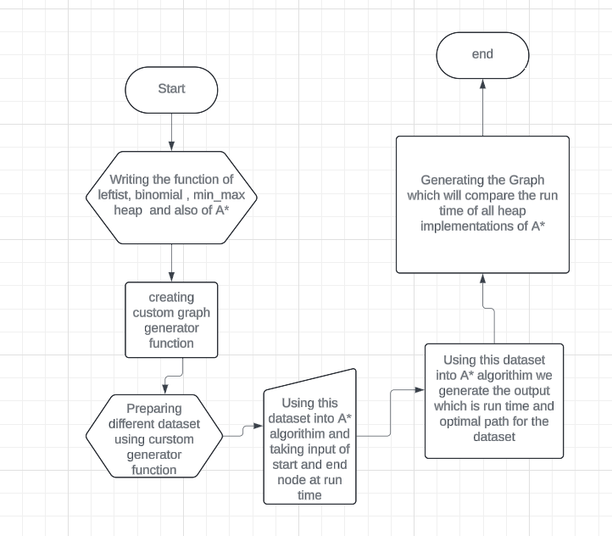

Justifying Choices:

The chosen methodology for this research, which involves implementing the A* algorithm with different priority queue implementations (leftist heap, binomial heap, and min-max heap) and evaluating their performance on various datasets, is justified based on several factors.

* Firstly, the A* algorithm is a widely used and well-established pathfinding algorithm known for its efficiency and optimality under certain conditions. By implementing A* with different priority queue implementations, we can assess the impact of heap structures on algorithmic performance, providing valuable insights into the effectiveness of various data structures in pathfinding tasks.
* Secondly, including leftist heap, binomial heap, and min-max heap implementations allows for a comprehensive comparison of heap structures with differing characteristics. While leftist heaps offer advantages such as improved merge operations, binomial heaps provide better space efficiency, and min-max heaps offer enhanced support for range queries. By evaluating these heap implementations in the context of the A* algorithm, we can elucidate their strengths, weaknesses, and suitability for pathfinding applications.
* Furthermore, custom-generated datasets enable the exploration of a wide range of graph structures and complexities, offering insights into algorithm performance across diverse scenarios. By systematically varying parameters such as the number of nodes, density of the graph, and heuristic weight, we can assess how different factors influence algorithmic efficiency and identify optimal configurations for practical use.
* Moreover, the proposed methodology builds upon existing research by extending the analysis beyond traditional binary heaps to include more advanced heap structures. This contributes to advancing knowledge in the field by providing a nuanced understanding of heap-based data structures and their impact on algorithmic performance.

Thus, our chosen methodology offers a systematic and rigorous approach to addressing the research questions by evaluating the performance of the A* algorithm with different priority queue implementations on custom-generated datasets. By building upon existing research and leveraging diverse heap structures and dataset configurations, this research contributes to advancing knowledge in pathfinding algorithms. It informs the development of more efficient and effective solutions for real-world applications.

**Results and Analysis**

**1. For dense graph :** time unit is microsecond

The graph generated for n=10 and n=20 are

***N=10 graph generated***

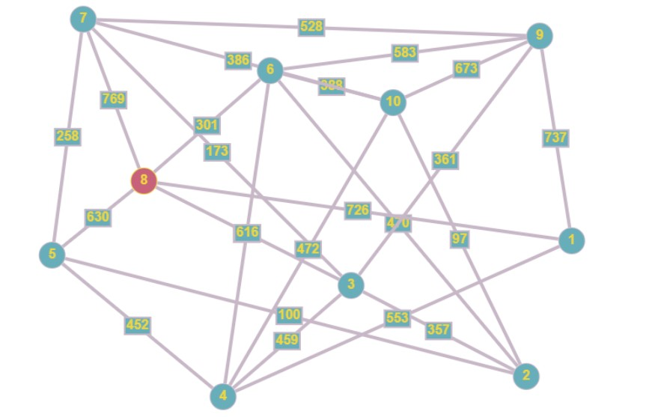

**N=20 graph generated**

**Comparison of Run time are:**

**2.Comparison based on Time Complexity**

* 1. A* using Binomial Heap: **O((|V| + |E|) log |V|)**
  2. A* using Height balanced Leftist Heap: **approximately O((|E| + |V|)log |V|))**
  3. A* using Min-Max Heap: **O((|E| + |V|) log |V|)**

Where |E| is the number of nodes and |V| is the number of edges in the graph

**Comparison based on Space Complexity**

* 1. A* using Binomial Heap: **O(|V|)**
  2. A* using Height balanced Leftist Heap: **O(|V|)**
  3. A* using Min-Max Heap: **O(|V|)**

Where |E| is the number of nodes and |V| is number of edges in graph

**3.Comparison based on Variable Complexity**

We had used variable heuristic weight = 1 in the normal graph

Now changing the Variable heuristic weight parameter = 2.3

**Table:** time unit is microsecond

The graph generated for n=10 and n=20 are

***N=10 graph generated***

**N=20 graph generated**

**Comparison of Run time are:**

* 1. **For sparse graph :** time unit is microsecond

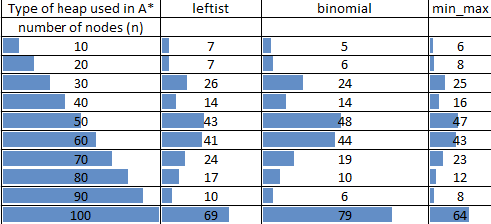

The sparse graph generated for n=10 and n=20 are

***N=10 graph generated***

**N=20 graph generated**

**Comparison of Run time are:**

**Conclusion**

The comparative study analysis yields several key inferences regarding the implementations of different types of heaps in the A* algorithm for pathfinding. The binomial Heap Implementation showcases notable advantages such as efficient merge operations and space efficiency. Binomial heaps are particularly beneficial for scenarios requiring frequent merging of heaps, as seen in graph algorithms like A*. They also excel in memory-constrained environments due to their space efficiency, making them suitable for pathfinding in resource-constrained environments and multi-agent pathfinding scenarios. For instance, in autonomous drone navigation, where memory optimization is crucial, a binomial heap implementation can efficiently manage priority queues while conserving memory resources.

Moving on to the Leftist Heap Implementation, its advantages lie in shorter path lengths during merge operations and fast insertion/deletion operations. These qualities make leftist heaps ideal for applications where minimizing path length and quick updates to the priority queue are essential. Real-time navigation and traffic management systems benefit from A* with a leftist heap implementation, ensuring fast route calculations and optimal route planning for vehicles and emergency services. For example, implementing A* with a leftist heap in ride-sharing platforms can lead to efficient pathfinding, reducing wait times and travel distances for passengers and drivers.

Next, the Min-Max Heap Implementation offers support for range queries and balanced performance for minimum and maximum element operations. These features are advantageous in scenarios requiring range-based queries and balanced operations. In-game AI pathfinding and supply chain logistics, A* with a min-max heap implementation can efficiently navigate dynamic environments and optimize routes based on changing conditions and constraints. For instance, in e-commerce delivery routing, using A* with a min-max heap can facilitate quick adjustments to delivery routes based on real-time traffic conditions and delivery priorities.

In summary, the choice of priority queue implementation in the A* algorithm for pathfinding depends on the specific requirements and constraints of the application. Binomial heaps are suitable for resource-constrained environments; leftist heaps excel in scenarios requiring fast updates and shorter path lengths, while min-max heaps are versatile in supporting range queries and balanced operations. Each implementation has strengths and can be effectively applied in various real-life scenarios to optimize pathfinding and navigation tasks.