DIFFUSION WORKSHEET

Name-__________________________________ Score-___________________

Grade-__________________________________ Date-____________________

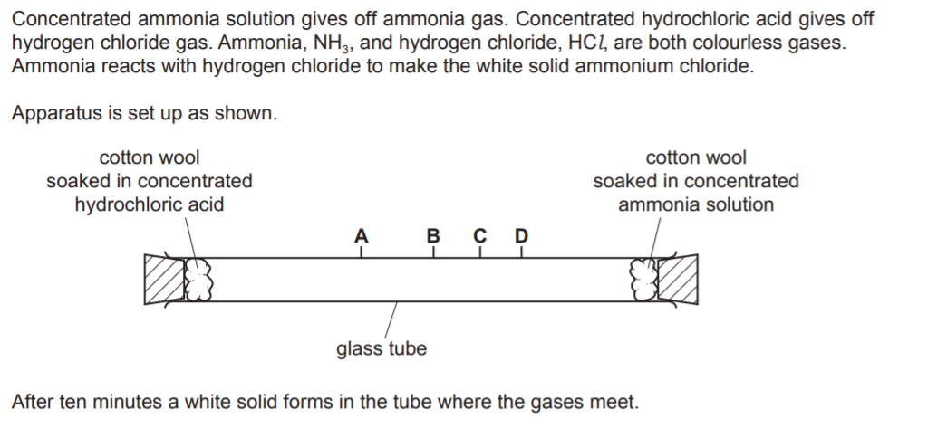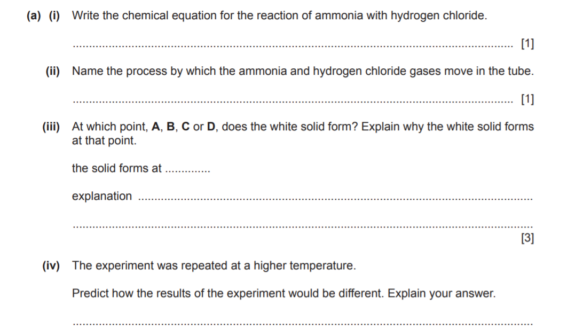

___________________________________________________________________________________________________________________________________________________________________________________________________________________________________________________[3]

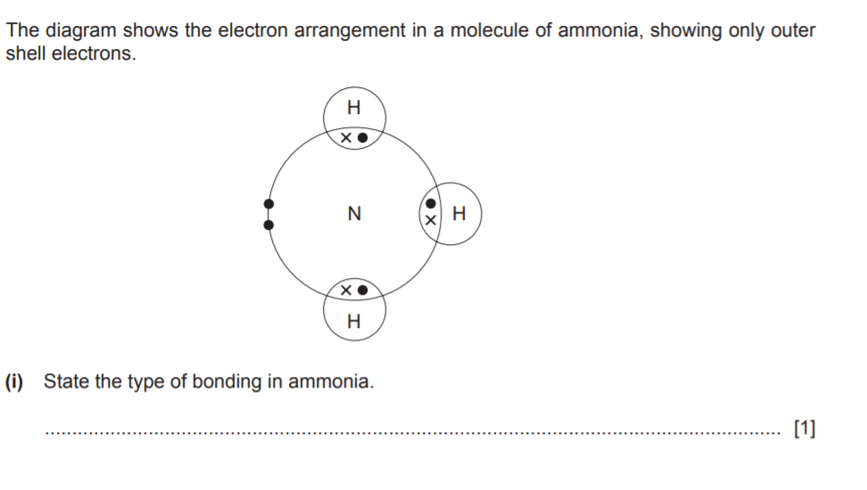

(ii) Draw the orbital diagram of hydrogen chloride molecule. [3]

|  |
| --- |
|  |