Game Design Document

Fill up the following document

1. Write the title of your project.

To the Top multiplayer

1. What is the goal of the game?

To climb to the top of a mountain

1. Write a brief story of your game.

You are an amateur backpacker who is travelling up a mountain, which has many boosts on it. A boost may be to float upwards for a couple of seconds. Another could be to not be able to fall back down the mounatain. There will be 2 players and first to the top wins. Collect as many coins as you can as well

1. Which are the playing characters of this game?

* Playing characters are the ones who respond to the user based on the input from the user.
* Cars, monkeys, dinos, wizards, etc., are the playing characters in the game.

|  |  |  |
| --- | --- | --- |
| Number | Character Name | What can this character do? |
| 1 | Player 1 | Respond to player controls and climb up the mountain |
| 2 | Player 2 | Respond to player controls and climb up the mountain |
| 3 | Player 3 | Respond to player controls and climb up the mountain |
| 4 | Player 4 | Respond to player controls and climb up the mountain |
| 5 |  |  |
| 6 |  |  |
| 7 |  |  |
| 8 |  |  |

1. Which are the Non-Playing Characters of this game?

* Non-Playing characters are the ones that don't have an action or behavior when the user interacts with the game.
* Hurdles, stones, bananas, coins, etc., are non-playing characters in the game.

|  |  |  |
| --- | --- | --- |
| Number | Character Name | What can this character do? |
| 1 | Mountain | A large image streching beyond the screen length that progressively gets steeper. Get to the top to win |
| 2 | Tree | An obstacle to block your path |
| 3 | Rock | An obstacle to block your path |
| 4 | Floatation boost | Temporarily makes you float up the mountain once being touched for 5 seconds |
| 5 | Anti-gravity boost | Makes you unable to fall of the mountain for 10 seconds |
| 6 | Fighter Boost | Gives you the ability to push people of the mountain, but you can get pushed of as well. |
| 7 | Coins | Extra bonuses to collect on your way |
| 8 |  |  |

Draw your imagination of this game. What does this game look like?

* Draw the game either on your computer or on paper.
* Add images of the game scenes to show each of the playing and non-playing characters at least once.

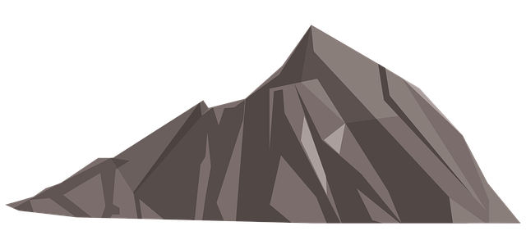

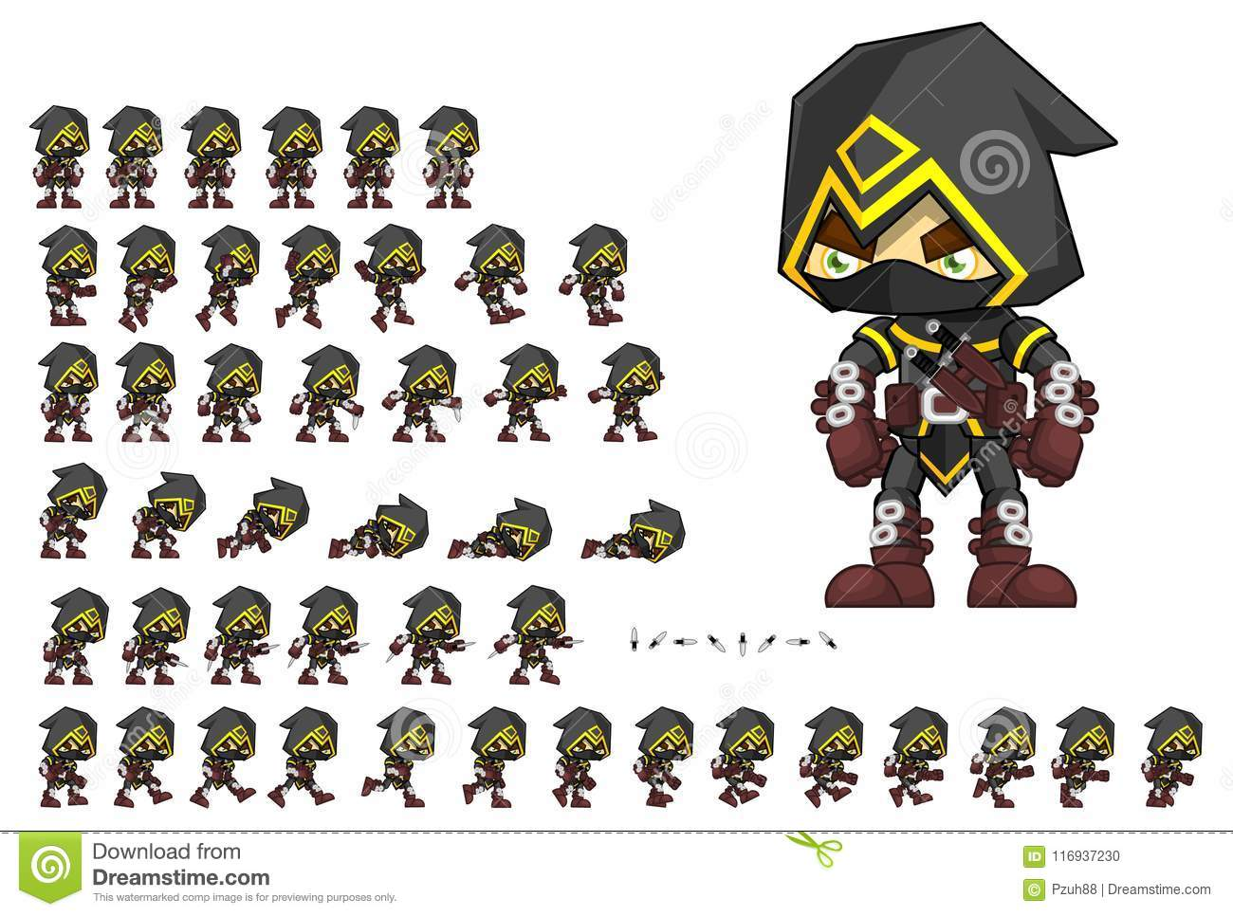

How do you plan to make your game engaging?

By adding a multiplayer format so friends can play together, and also make the game quite challenging, to market this is as a rage game, which are quite popular at the moment, but the multiplayer aspect makes it unique.