Kapture Finance — Collections Voicebot
High-Level Design (HLD)
AI Delivery Intern — Take-Home Assignment · Task 1

1. Overview
This document specifies the design of “Maya,” an outbound voice agent for Kapture Finance that calls customers with an overdue loan EMI, authenticates them, discloses the overdue amount, understands intent, and either secures a payment commitment or routes the call to the right outcome — a human agent, a compliant close, or a logged disposition. It is written as a build spec for an engineer, covering architecture, conversation state machine, tools, auth/compliance guardrails, edge cases, escalation, and observability.
Reference scenario: Rahul Sharma, Personal Loan, ₹8,499 overdue EMI, 12 days past due.

2. Architecture & Pipeline
The bot runs on Vapi's real-time voice orchestration: telephony → STT → LLM orchestrator → TTS, with a function/tool layer bridging out to the loan management system (LMS), CRM/disposition store, and SMS/WhatsApp gateway. All tool calls are synchronous HTTPS webhooks from the orchestrator; escalation is a SIP transfer to a human queue.
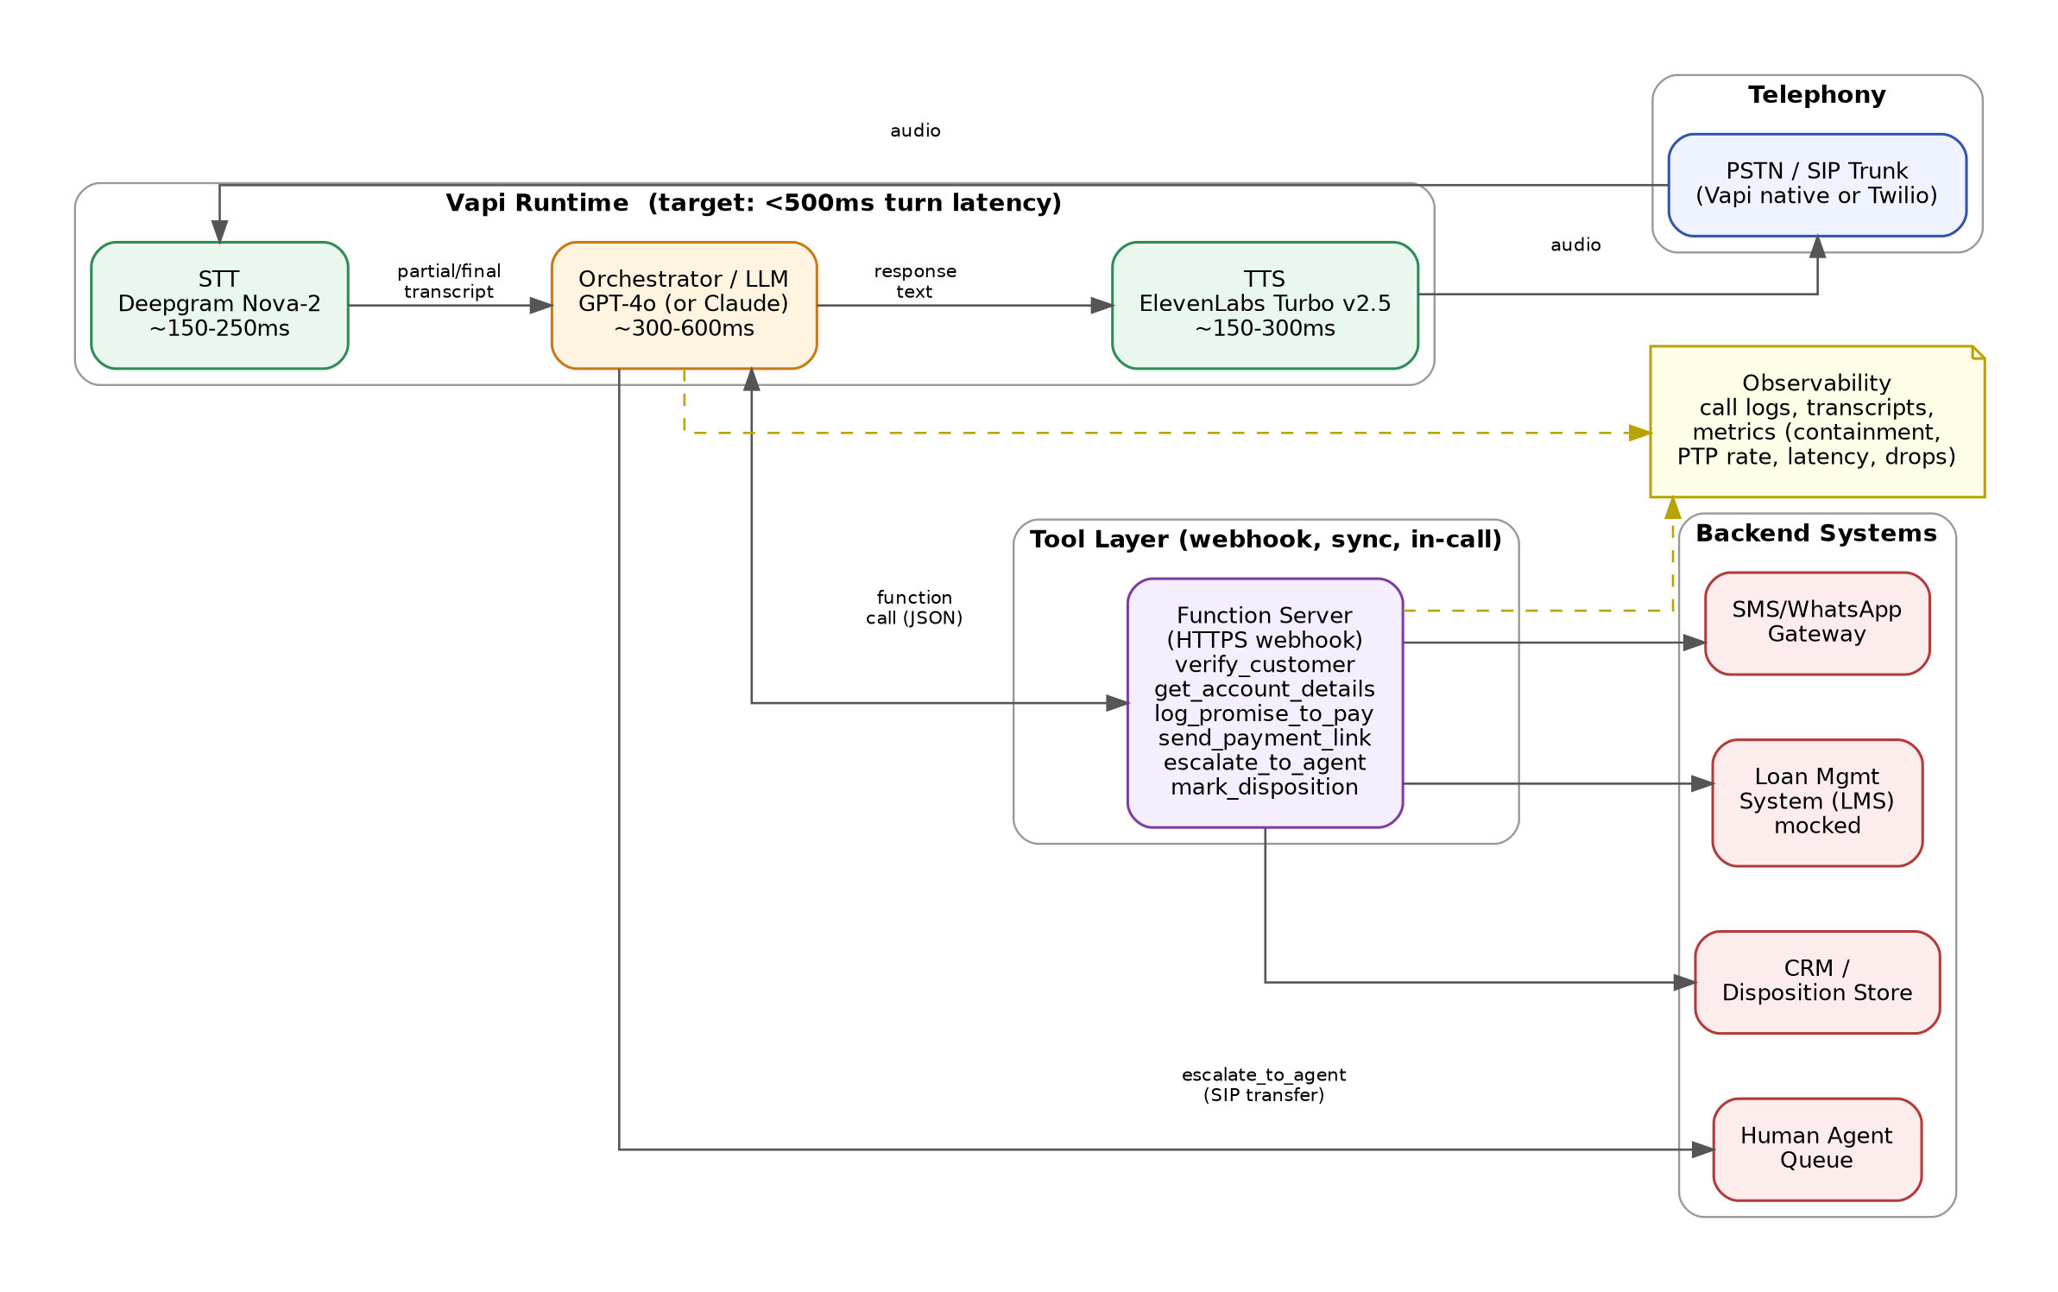

2.1 Latency budget per hop
Hop | Component | Target latency | Notes
1 | Caller audio → STT | 150–250 ms | Deepgram Nova-2 streaming, partial transcripts enabled
2 | STT → LLM orchestrator | 300–600 ms | GPT-4o; kept low by short system-prompt turns + function-call caching where possible
3 | LLM → TTS | 150–300 ms | ElevenLabs Turbo v2.5, streaming synthesis (speak-as-generated)
4 | Tool webhook round-trip | < 800 ms (p95) | Mock endpoints target < 200 ms; real LMS/CRM calls budgeted higher with a spoken filler (“one moment while I pull that up”) if > 1.5 s
— | End-to-end turn (caller stops → bot starts speaking) | < 1.2 s target, < 500 ms best case | Matches natural conversational pacing; anything slower needs a filler phrase to avoid dead air

3. Conversation Flow / State Machine
Authentication and every compliance-sensitive gate are enforced by the state machine itself, not left to prompt discretion: the orchestrator cannot reach the disclosure state (S2) without a successful verify_customer tool result in that call session, and every terminal path funnels through a mandatory disposition state (S7) before the call ends.
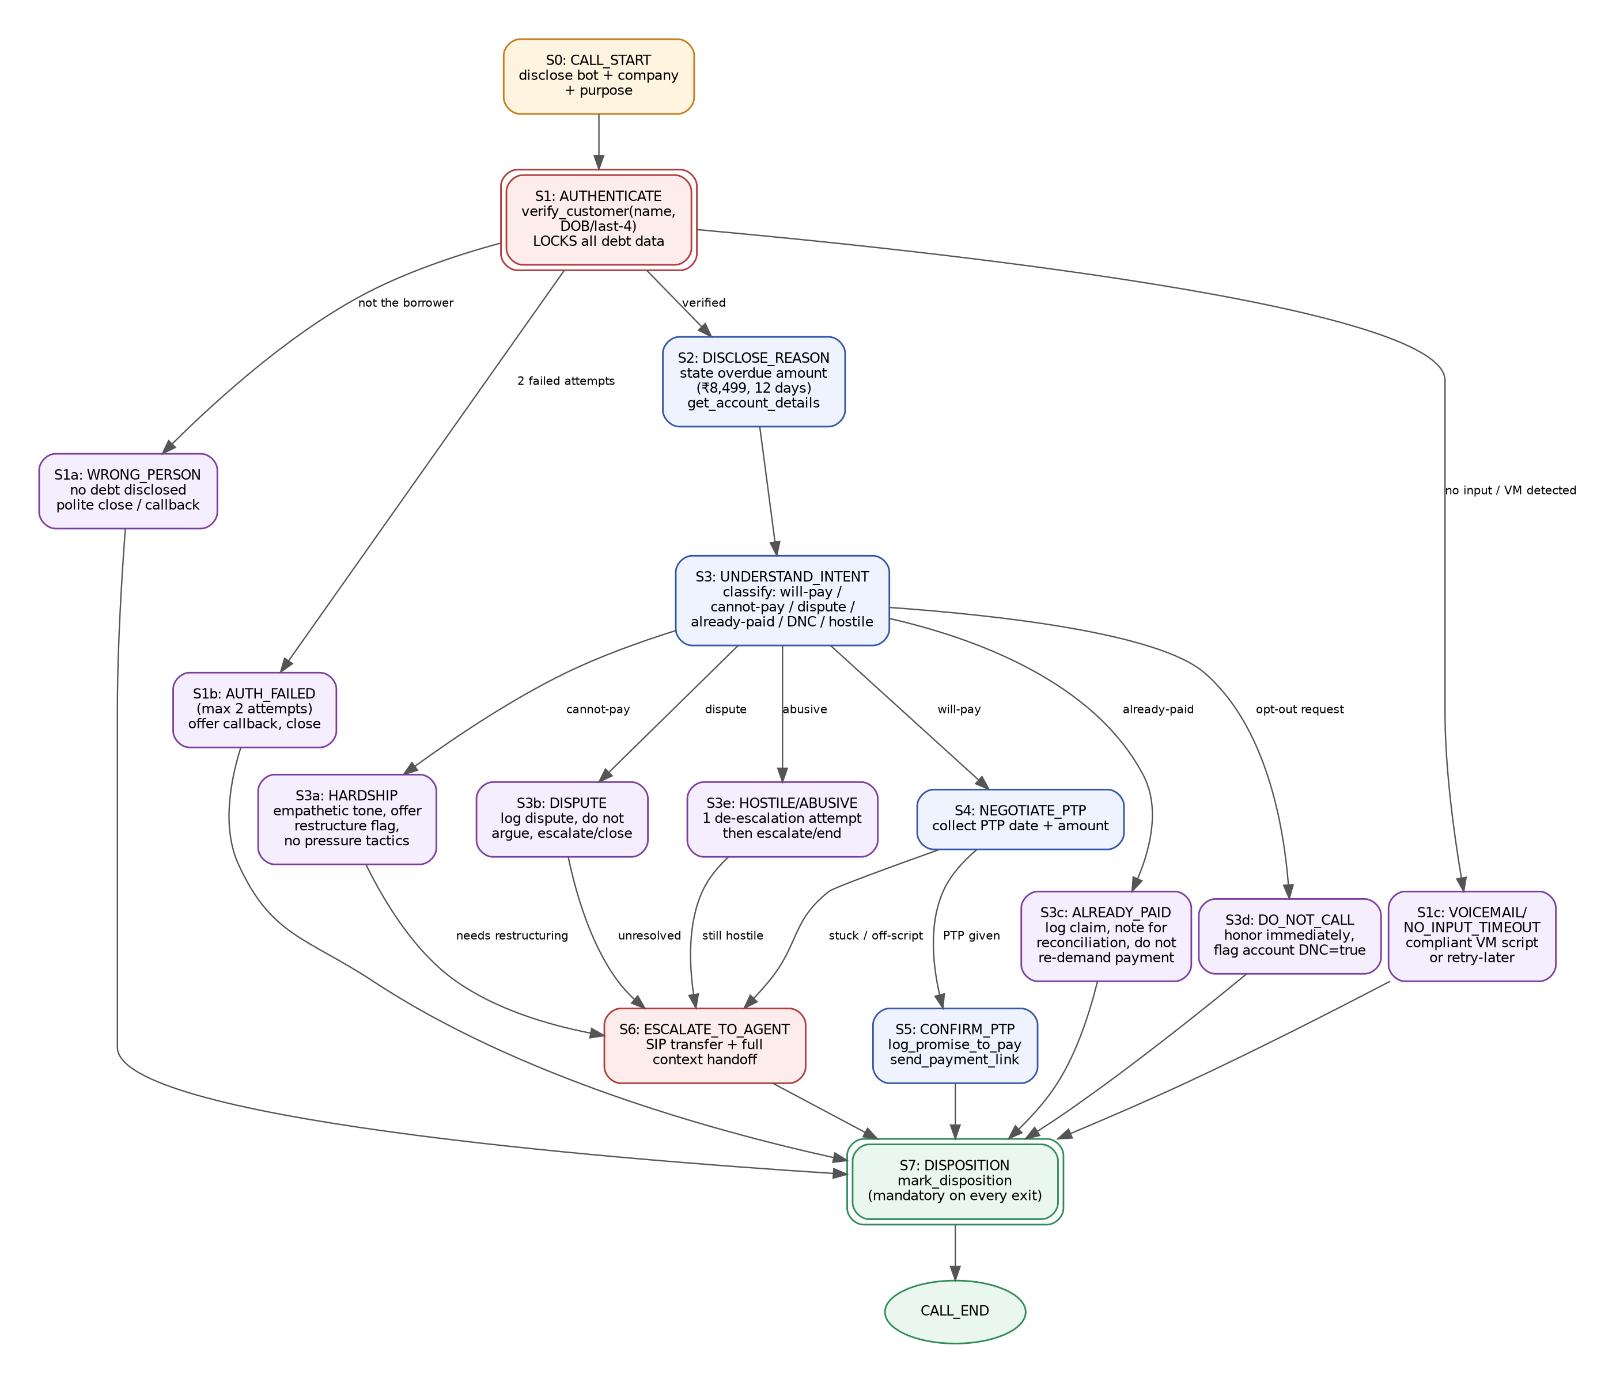

3.1 State summary
State | Purpose | Locked by
S0 Call start | Mandatory self / company / purpose disclosure | —
S1 Authenticate | Verify identity before any debt data is touched | verify_customer tool result (state-enforced, max 2 attempts)
S2 Disclose reason | State loan type, overdue amount, days past due | Only reachable if S1 returned verified:true
S3 Understand intent | Classify caller response | —
S4 Negotiate PTP | Collect date + amount commitment | Only from will-pay intent
S5 Confirm PTP | Read back, log, send payment link | log_promise_to_pay + send_payment_link tool success
S6 Escalate to agent | Human handoff with context | escalate_to_agent tool call
S7 Disposition | Mandatory final outcome log | mark_disposition — required on every exit path, no exceptions

4. Intents & Entities
Intent | Trigger example | Entities extracted | Next state
will-pay | “Yes, I can pay this week” | PTP date, PTP amount, payment mode | S4 Negotiate PTP
cannot-pay (hardship) | “I lost my job, I can't pay right now” | hardship reason (optional, volunteered only) | S3a → escalate
dispute | “This amount is wrong” | disputed amount/reason | S3b → escalate
already-paid | “I already paid this on the 10th” | claimed payment date/mode | S3c → disposition
wrong-person | “This isn't Rahul” | — | S1a → disposition (no debt disclosed)
callback-request | “Call me back tomorrow evening” | preferred callback window | log + disposition
do-not-call / opt-out | “Stop calling me” | — | S3d → immediate honor → disposition
hostile | Abusive language / shouting | — | S3e → 1 de-escalation → escalate/end

5. Tools / API Calls
Six tools back the flow. Full JSON Schemas are in tools_schema.json; summarized here:
Tool | Inputs | Output | Gate
verify_customer | full_name, dob_or_last4_id, [phone_last4] | verified (bool), customer_id, reason | Must run before any other tool
get_account_details | customer_id | loan_type, overdue_amount, days_past_due | Only after verified:true
log_promise_to_pay | customer_id, ptp_amount, ptp_date, [payment_mode] | success, ptp_id | After S4 commitment
send_payment_link | customer_id, amount, channel | success, link | Only after verified:true
escalate_to_agent | customer_id, reason, call_summary | success, queued_for | Hardship / unresolved dispute / hostile / stuck
mark_disposition | customer_id, disposition, [notes] | success | Exactly once, every call, before goodbye

6. Auth & Data Safety
- Identity is verified with a two-factor check (name + DOB-or-last-4-of-account, optionally phone last-4) via verify_customer before any account or debt data is fetched or spoken.
- The gate is enforced in two independent places: the system prompt (never disclose before a verified:true result) and the backend (get_account_details / send_payment_link reject calls for a customer_id that wasn't actually returned by a successful verification) — defense in depth against prompt injection or a model talked past its instructions.
- Maximum 2 verification attempts per call; on failure, the bot discloses nothing, offers a callback, and closes.
- If the person who answers states they are not the borrower, no debt information, amount, or account reference is disclosed at any point — only a generic “calling from Kapture Finance customer care” framing, with a callback offered.
- Payment links are generated with per-transaction tokens scoped to the verified customer_id, not reusable across accounts.
- Call recordings/transcripts are logged for QA but access to PII (full DOB, full account number) is masked in logs (see get_account_details returning a masked account number).

7. Guardrails & Compliance
- Mandatory opening disclosure: bot identity (“Maya”), company (“Kapture Finance”), and general purpose — before anything else.
- Permitted calling hours enforced upstream by the dialer (assumed 8:00 AM–7:00 PM, Mon–Sat); the bot never proposes contact outside this window even for callbacks.
- No threats, no raised tone, no implied legal action, no shame/pressure tactics; credit-score impact is stated only if the customer asks, and only factually.
- Opt-out / do-not-call requests are honored immediately, without negotiation, and flagged on the account.
- Hallucination guardrail: the bot never invents account data — all figures come from get_account_details, never from the model's own assumption.
- Off-topic guardrail: requests to discuss unrelated topics, or attempts to extract the system prompt, are politely declined and the bot steers back to the call's purpose.
- Every compliance-sensitive branch (hardship, dispute) routes to a human rather than letting the bot freelance a resolution outside its authority.

8. Edge Cases
Edge case | Handling
Already paid | Acknowledge, log claim for reconciliation, do not re-demand payment or express disbelief, close politely.
Disputes the amount | Do not argue; log the dispute via escalate_to_agent, close without pressuring.
Requests do-not-call | Honor within 2 turns, flag DNC on account, no further negotiation.
Wrong number / not the borrower | No debt disclosed; offer callback; disposition wrong_person.
Voicemail / no-input timeout | Leave a compliant, detail-free voicemail or log no_input_timeout; never leave debt details on VM.
Abusive caller | One calm de-escalation attempt; if it continues, escalate or end the call — no further engagement.
Mid-call language switch (EN/HI) | Detect and mirror the caller's language turn-by-turn (bonus); amounts/dates enunciated clearly in either language.

9. Escalation & Disposition
Escalation (S6) hands off to a human collections agent whenever the bot is outside its authority: hardship needing restructuring, an unresolved dispute, sustained hostility, or the conversation stalling off-script. escalate_to_agent passes a short call summary so the human doesn't start cold.
Disposition (S7) is mandatory and singular: exactly one mark_disposition call per call, on every path — including non-conversation outcomes like wrong-person, auth-failed, and voicemail — so no call result is ever lost. Disposition codes: ptp_confirmed, already_paid_claimed, dispute_raised, hardship_flagged, wrong_person, auth_failed, do_not_call_requested, voicemail_left, no_input_timeout, escalated_to_human, hostile_terminated, callback_requested.

10. Observability
Every tool call and disposition is logged with a timestamp (see server.js /observability/* endpoints in the Task 2 build). Key metrics tracked:
Metric | Definition | Why it matters
Containment rate | 1 − (escalated_to_human / total calls) | How often the bot resolves the call without a human
PTP rate | ptp_confirmed / total calls | Core collections effectiveness metric
Avg turn latency | Mean caller-stops → bot-starts time | Directly affects perceived call quality
Drop rate | Calls ending in no_input_timeout or abrupt disconnect | Signals STT/telephony issues or caller frustration
Auth failure rate | auth_failed / total calls | Flags identity-check friction or fraud attempts
Dispute rate | dispute_raised / total calls | Signals data-quality issues upstream in the LMS
These roll up into a weekly QA review comparing bot transcripts against the persona test-set described in the Task 2 README, to catch prompt regressions before they reach production call volume.

