**Admin Panel:**

The Django admin application can use your models to automatically build a site area that you can use to create, view, update, and delete records. This can save you a lot of time during development, making it very easy to test your models and get a feel for whether you have the right data.

Creating an admin panel in Django is quite straightforward and powerful due to Django's built-in admin interface.

**Steps to Create an Admin Panel in Django:**

**Step 1:-** Create a Django App

If you haven't already, create a Django app using the command line:

**django-admin startapp yourappname**

**Step 2:-** Define Models

In your app's **models.py** file, define the models you want to manage via the admin panel:

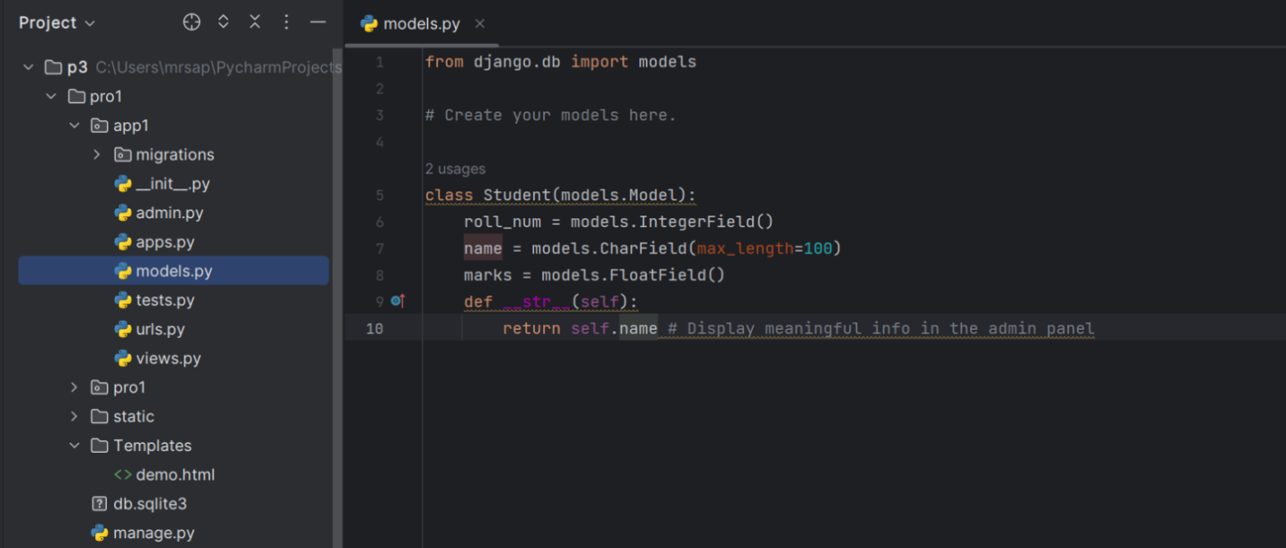

Enter command in Terminal:

**py manage.py makemigrations**

**py manage.py migrate**

**Step3: -** Register Models in Admin Panel

In the app's **admin.py** file, register your models to make them accessible in the admin panel:

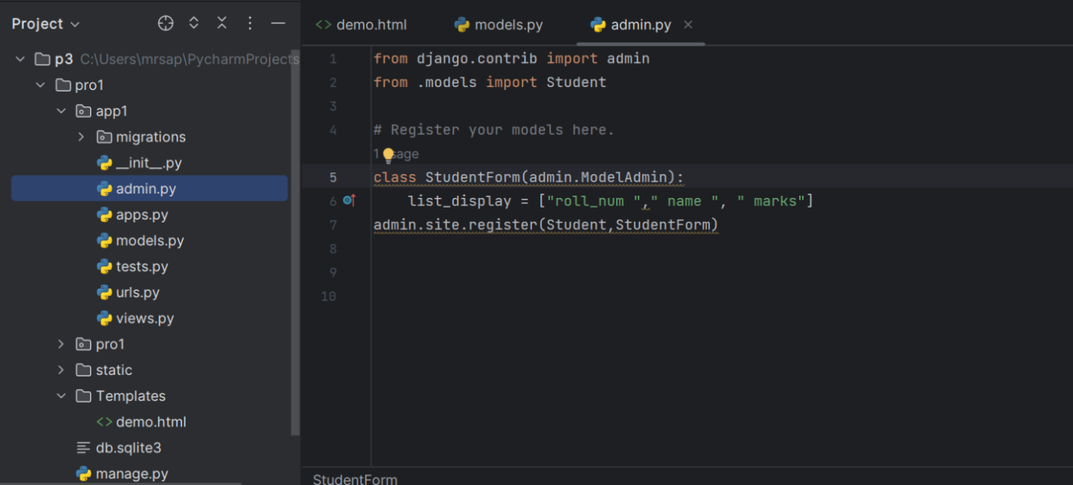

**list_display** to control which fields are displayed on the change list page of the admin. If you don't set list_display, the admin site will display a single column that displays the __str__() representation of each object.

The Django admin is an automatically-generated user interface for Django models. The **register function** is used to add models to the Django admin so that data for those models can be created, deleted, updated and queried through the user interface.

**@admin.register(model_nm)**

**admin.site.register(model_nm,admin_nm)**

**Step 4:-** Create Superuser

Run the following command to create a superuser who can access the admin panel:

**python manage.py createsuperuser**

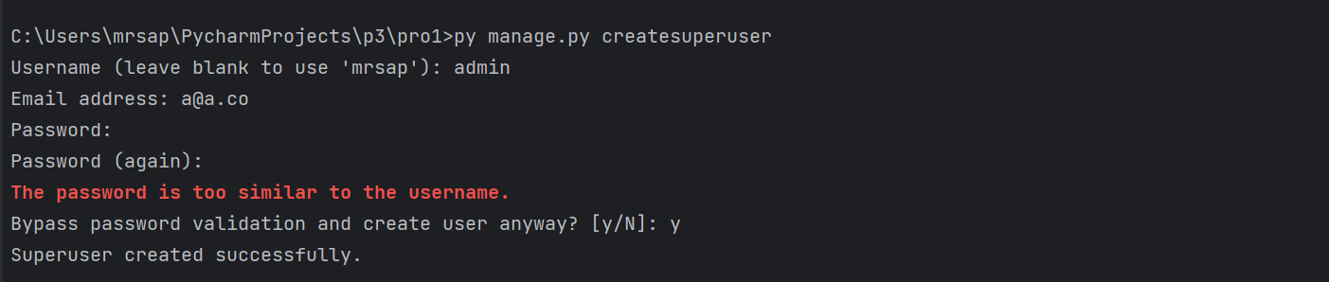

**Step 5:-** Start Development Server

**python manage.py runserver**

**Step 6:-** Access Admin Panel

Go to **http://127.0.0.1:8000/admin/** in your browser and log in using the superuser credentials created earlier.

You should now see the registered model(s) listed in the admin panel. You can add, edit, and delete instances of these models via the web interface.

