**Template inheritance**

Template inheritance allows you to build a base “skeleton” template that contains all the common elements of your site and defines **blocks** that child templates can override.

Let’s look at template inheritance by starting with an example:

**Step 1:-** Create new html file inside templates directory by the name base / layout.html.

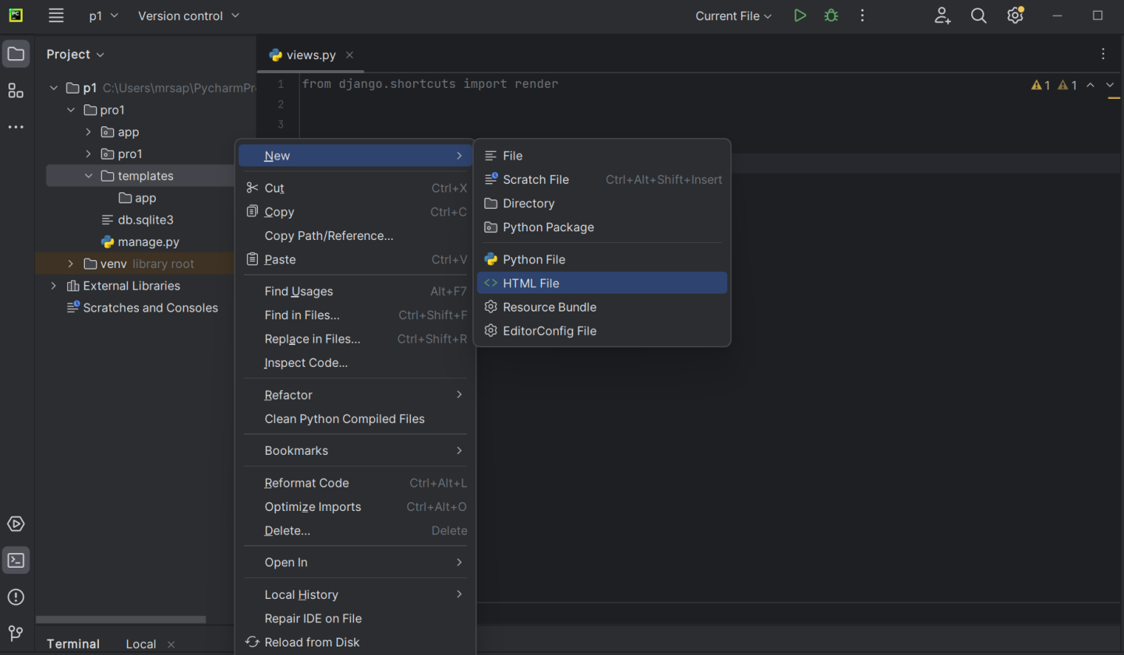

**# base.html**

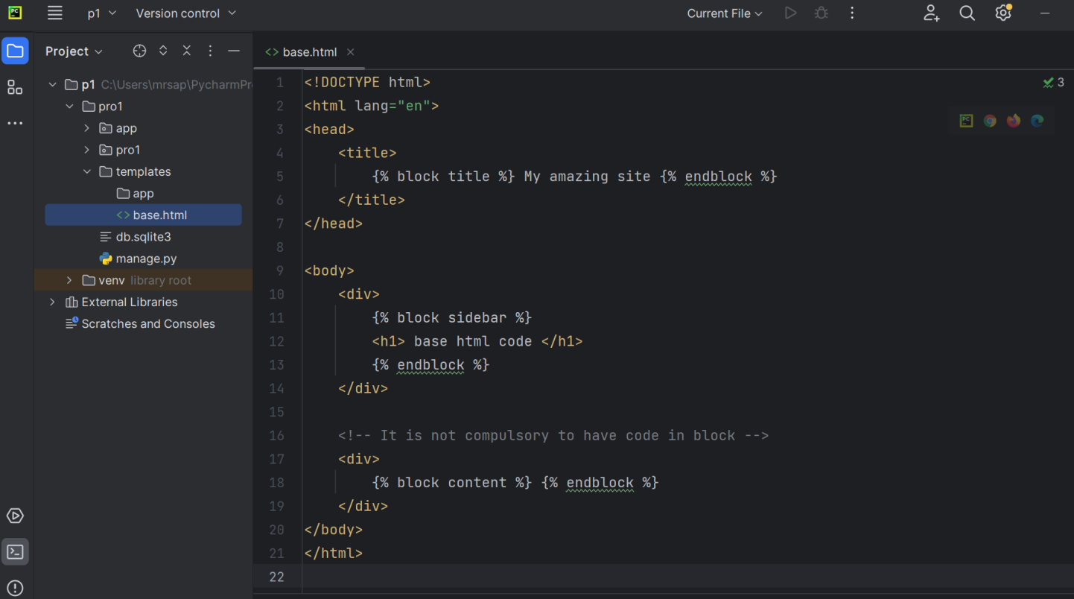

It’s the job of “child” templates to fill the empty blocks with content.

In this example, the [block](https://docs.djangoproject.com/en/5.0/ref/templates/builtins/#std-templatetag-block) tag defines three blocks that child templates can fill in. All the [block](https://docs.djangoproject.com/en/5.0/ref/templates/builtins/#std-templatetag-block) tag does is to tell the template engine that a child template may override those portions of the template.

**Note :**

* We can override only those blocks which are defined in parent template.
* It is not necessary to override all blocks of parent
* If you use [**{% extends “ parent.html file ” %}**](https://docs.djangoproject.com/en/5.0/ref/templates/builtins/#std-templatetag-extends) in a template, it must be the first template tag in that template. Template inheritance won’t work, otherwise.

**Step 2:-** Create child template inside app directory in templates

A child template might look like this: **# child.html**

The [extends](https://docs.djangoproject.com/en/5.0/ref/templates/builtins/#std-templatetag-extends) tag is the key here. It tells the template engine that this template “extends” another template. When the template system evaluates this template, first it locates the parent – in this case, “base.html”.

At that point, the template engine will notice the three [block](https://docs.djangoproject.com/en/5.0/ref/templates/builtins/#std-templatetag-block) tags in base.html and replace those blocks with the contents of the child template. Depending on the value the output might look like:

**# child.html**

Note that since the child template didn’t define the first div block, the value from the parent template is used instead. Content within a {% block %} tag in a parent template is always used as a fallback