PRANAV SALUNKHE

ELEX DOMAIN, 46

TASK - Control speed of motor using Potentiometer. Print Real-Time PWM value on Serial Monitor.

Components – 1. DC motor

2. Potentiometer

3. Arduino Uno

4. L293D

Code –

#define pot A5

#define m1 13

#define m2 12

#define en 9

int potVal = 0;

void setup() {

pinMode(m1, OUTPUT);

pinMode(m2, OUTPUT);

pinMode(en, OUTPUT);

Serial.begin(9600);

digitalWrite(m1, HIGH);

digitalWrite(m2, LOW);

}

void loop() {

potVal=analogRead(pot);

analogWrite(en, potVal/4);

Serial.print("| Pot - ");

Serial.print(potVal);

Serial.print(" | PWM - ");

Serial.print(potVal/4);

Serial.println(" |");

}

**Output**

Circuit

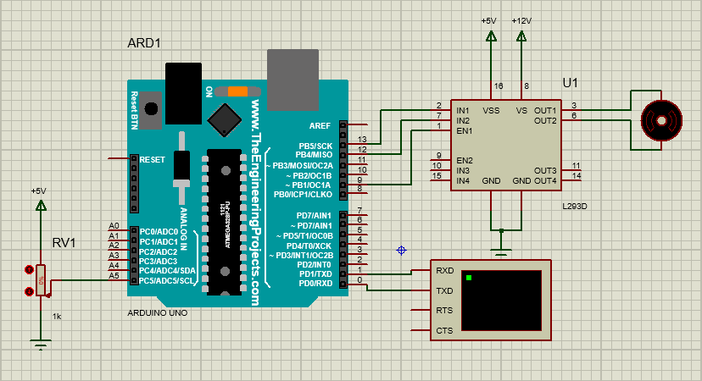

Serial Monitor

