Valmo Advocate
Partner support that resolves, not tickets.
Problem-first briefing — architecture, end state, data layer, engineering, bandwidth, build-vs-buy, and costs at scale

Audience: Seniormost leadership + AI Services
Status: Working demo, production designed
Scale modelled: 10,000 captains + 1–2 lakh pilots
Replaces: Kapture ₹4.8 Cr/yr

At a glance — where we are, and the one decision
The hard, novel part is built and running: an AI reasons the conversation, but no rupee can move except through deterministic, verified, constitution-bound code. What remains is integration, scale, and operations — every gap already sits behind an adapter or a config key. The one real decision is who staffs the finish and the run.
- Built today — one engine: stateful agentic loop, trust spine + adversarial verifier, SOP Compiler, L3 platform, KT, audit/CPD, governance conformance, auth, durable state.
- To finish (in-house): ~9 people for ~6 months (lean 4–5 for ~9). The critical path is access, not code.
- Run cost at scale: ₹3.53 Cr/yr (software + infra + LLM + voice) for 160k partners — below the ₹4.8 Cr Kapture licence it replaces.
- The call: Hybrid — keep the brain in-house; buy the staffing for the body (plumbing, scale, 24×7 ops). Build the hard part; buy the hands.
We are ahead on development — a real engine plus deep domain modelling. A vendor's real advantage is sustained capacity — a standing team makes updates, bugs, and round-the-clock ops easier. The gap is not capability; it is bandwidth.

1 · The problem — people are the engine, software is a filing cabinet
Today a partner raises an issue; a human reads it, gathers data, interprets the SOP, decides, and types a reply. Kapture merely records it — ₹4.8 Cr/year in licence alone, before the far larger L1 agent salary pool, and a partner still waits days for a wrong ₹1,240 debit.
- It doesn't scale — headcount grows with cases.
- It isn't consistent — the same issue resolves differently depending on who picks it up.
- It isn't owned — the functional teams whose processes cause the debit don't feel the SLA.
The opportunity: make the platform the engine, resolve inside the conversation in seconds, and hand functional teams a finished verdict to approve. This document is explicit throughout about what is built and demonstrable today versus what is designed but not built — every 'not built' item is an access/provisioning or scale item, not an engine to invent.

2 · Current architecture + the gaps
A request travels top-to-bottom. In the diagram, solid blue = built and demonstrable today; dashed amber = designed but not built (each behind an adapter or config key already in the tree).
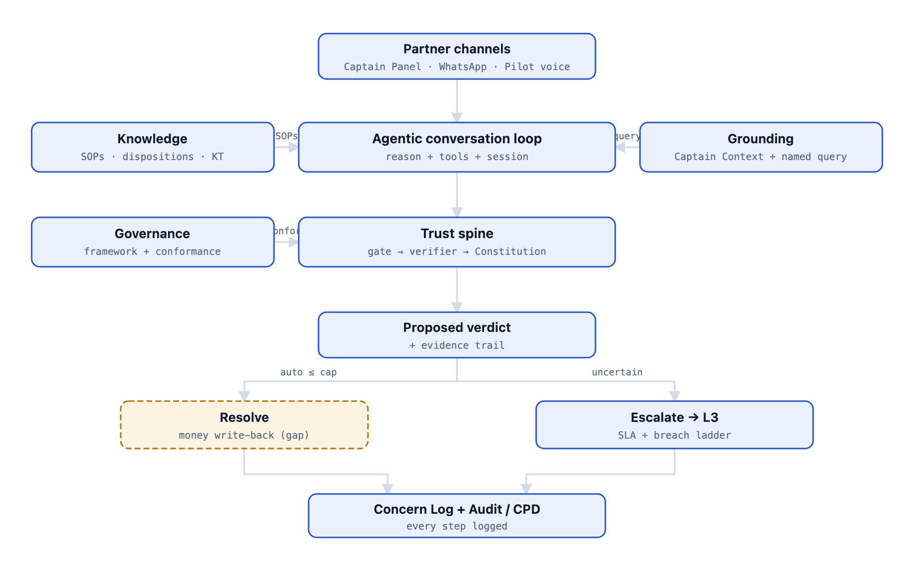
The connected request path. The model reasons; deterministic tools carry every guarantee. Money moves only via the verdict path, after the trust spine.

The gaps, and what each unblocks
- Live Meesho DB / Metabase + read-replica — real facts under every resolution; adds zero LLM cost (infra-only ~₹15–40k/mo).
- Redis cache — sub-second multi-turn at 10k concurrency. Postgres + pgvector — durability + a home for embeddings. Embeddings retrieval — finds the right SOP even when words don't match.
- Kafka / event stream — genuinely proactive protection at scale without polling per-captain.
- Real money write-back — the core promise (resolve in-conversation); highest-risk, behind finance sign-off, ships last.
- WhatsApp outbound + mobile voice — reach partners where they are (needs a Meta account + voice keys).
- Calibration, autonomy control, OTel tracing — the safety + audit layer that must land before unattended action.

3 · The end state — functional teams own it; the platform does the work
The inversion in one line: teams stop working cases; they approve verdicts. We ingest a team's SOPs and their 'brain' once; from then on the platform grounds each case, runs the checks, the trust gate, the verifier and conformance, and hands the owning team a finished, evidence-backed verdict scheduled into their queue. Their entire job is a one-click approve or reject.
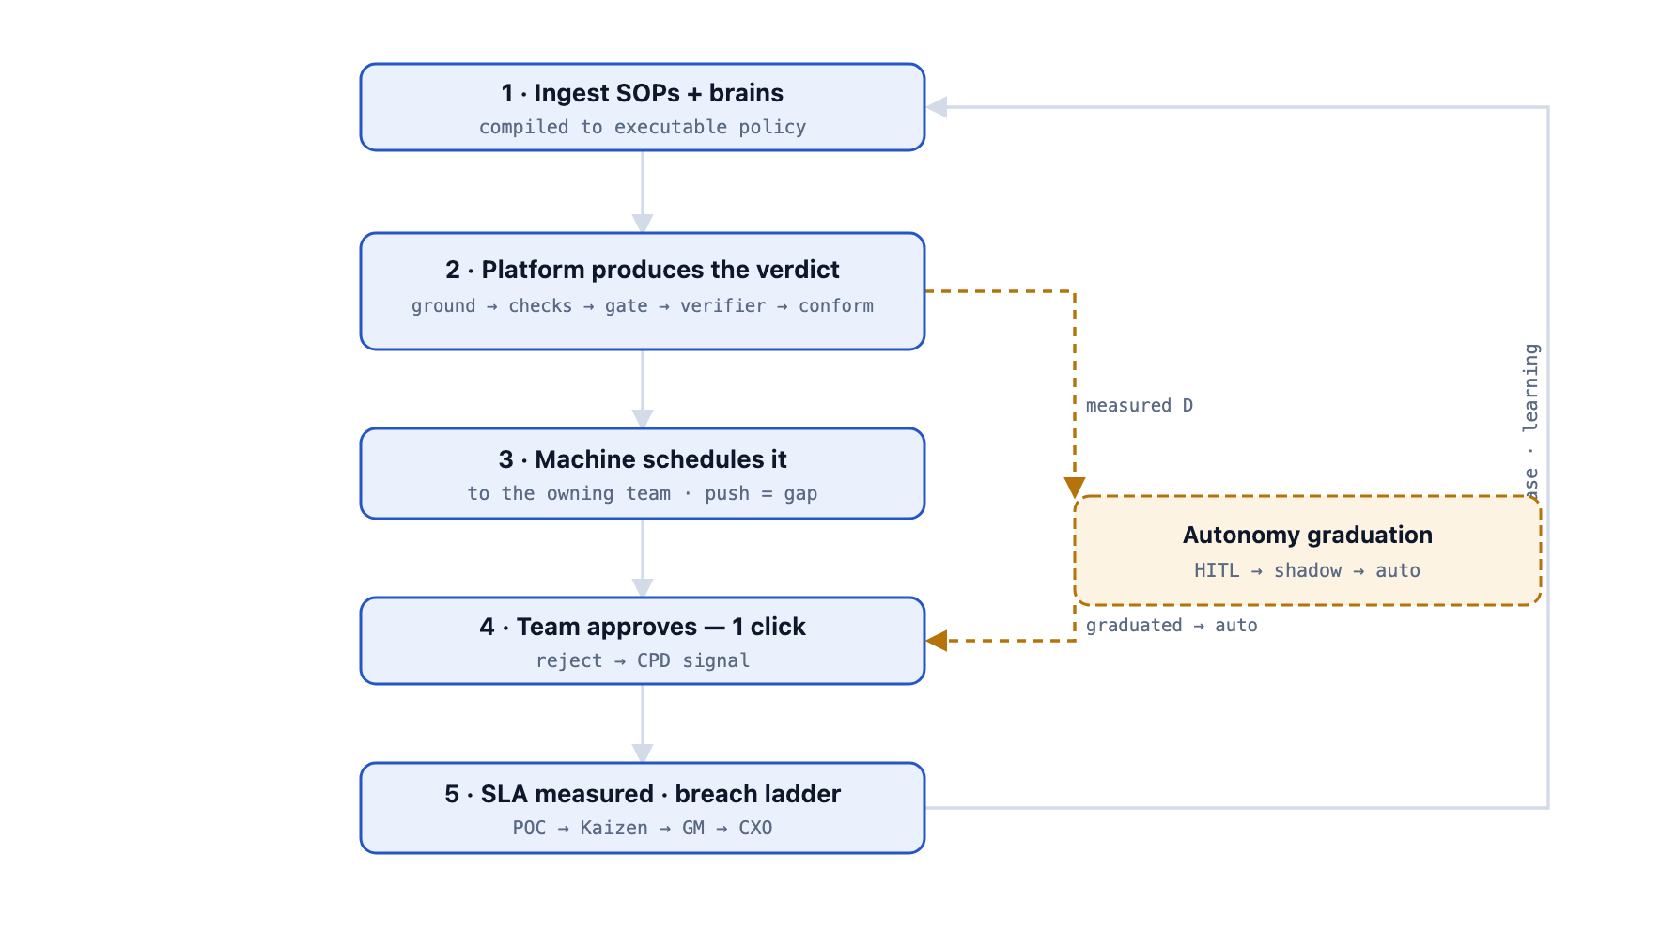
The one proven money-path chain, generalised to every team. The loop feeds learning back; autonomy is earned per disposition (designed; safe primitives exist).

Who owns what
- Support (us) owns the platform + guardrails — the engine, trust spine, compilers, audit, RBAC, SLA machinery, and the invariants (money never moves without checks + a cap + an agreeing verifier; every verdict cites evidence; everything logged immutably). We watch over and empower.
- Functional teams own outcomes + metrics — their SOPs and brain (they author; we compile), their queue, SLA, breach count, CSAT, and the approve/reject decision. They never build, integrate, or operate anything.
Economic shape: headcount grows with approvals, not cases — and approvals shrink as dispositions graduate to auto. That bends the ₹4.8 Cr/yr curve down while resolution moves from days to seconds. It scales to many teams and both tenants (captains + FEs) with no new engine code.

4 · The data layer — fast, cheap, safe over a 55 TB database
The load-bearing rule: the LLM reasons over data but never touches the database. It selects a pre-approved named query from a whitelist; deterministic code runs it; rows come back tagged with their source. This kills the three failure modes of 'let the AI query the DB' — latency, runaway token cost, and a SQL/prompt-injection surface.
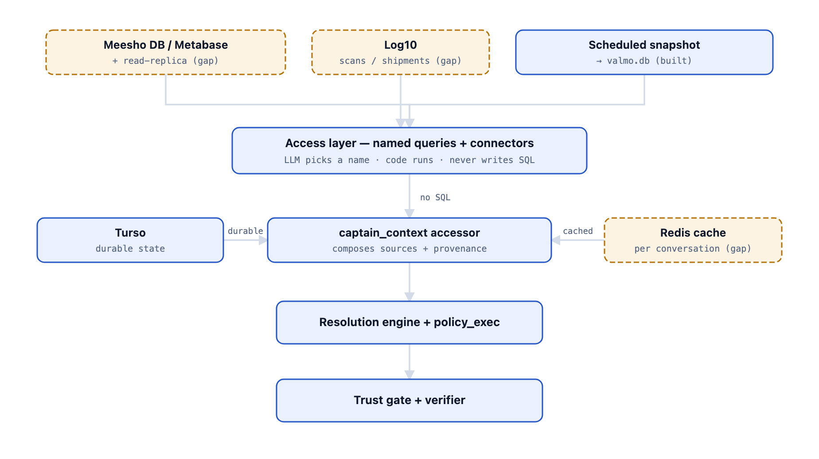
The LLM selects a whitelisted named query; deterministic code runs it. PII names are dropped at the snapshot boundary; the live role is SELECT-only, least-privilege, entity-scoped.
- Source — Meesho DB root via Metabase (the already-audited window) against a dedicated read-replica; Log10 for scans; a scheduled snapshot for disputes (running today as valmo.db).
- Querying — whitelisted, parameterized named queries only. A named query hits an index (~ms) and adds zero LLM cost. Each new data need = a new named query the SOP declares — reviewable, never free-form SQL.
- Pipelines — hot-path queries cached in Redis per conversation; the proactive monitor feeds a CDC-refreshed read-model (never polls per-captain); disputes read the Metabase→SQLite snapshot.
- PII — names dropped at the snapshot boundary; the live role is SELECT-only, least-privilege, entity-scoped; every read is a loggable event. Getting access is a narrow, inspectable ask — which cards, which columns.

5 · Where this lives — two front doors, one brain
One engine reaches two very different populations. Captains (DC staff, literate, at a screen) get an embedded widget in the Captain Panel. Pilots / FEs (1–2 lakh drivers, often low-literacy, hands full, patchy network) get a voice-first assistant in the mobile app — a Siri-esque wake word, spoken Hinglish, almost no reading.
- Captain widget — a tab inside the tool they already live in, no new login. Built: streaming React UI, SSE, Bearer-token RBAC. Gap: iframe embed + login-scoped SSO handoff.
- Pilot voice assistant — Built: the listen→think→speak loop, multi-language, a reactive visualiser. Gap (the vendor scope): on-device wake word (Porcupine), native mobile SDK, streaming Sarvam Indic STT/TTS, true barge-in, offline handling, and an IVR fallback for no-app pilots.
- Both are thin transports over the same engine and procedures; each tenant has separate SOPs + data (captain vs FE), shared everything else. Accessibility for low-literacy pilots is the primary design constraint: voice default, everything spoken back, a human floor always reachable.

6 · The engineering — intelligence in the model, guarantees in the code
The demo proves the hard part: an LLM runs the conversation, but every guarantee lives in deterministic code the model cannot talk its way around. Production wraps that core in infrastructure to run for 10k+ partners concurrently, safely, and observably.

The money-decision sequence — four independent gates before a rupee moves
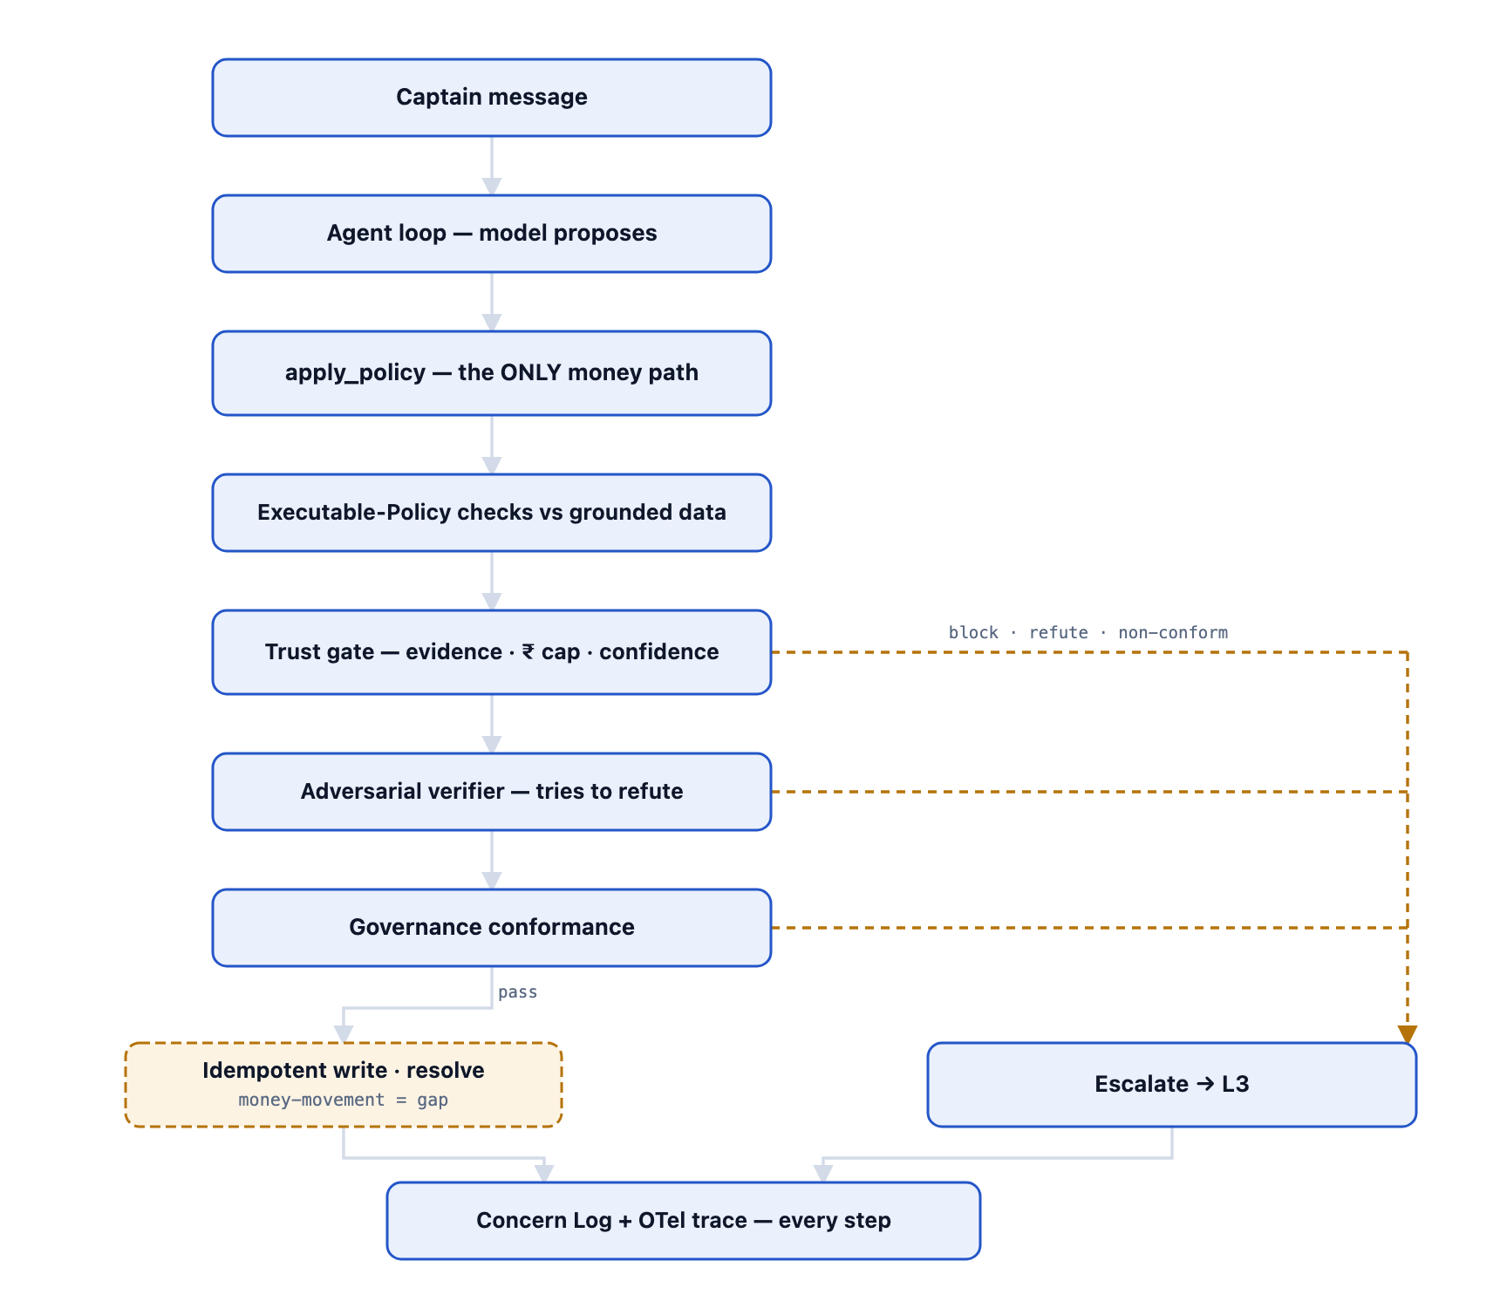
The model only reasons; code decides. Any gate blocking, the verifier refuting, or a non-conformant verdict diverts to a human-worked escalation — never an auto-pay. Calibration + OTel tracing are the gaps here.
- Agentic loop + 5-tool contract — bounded (6 steps); apply_policy is the sole money path.
- Trust spine — grounded generation · policy-as-code caps (evidence + ₹ cap) · calibrated confidence (recalibration job = gap) · fail-closed adversarial verifier · 9-principle Partner Constitution.
- SOP Compiler + a generic check-interpreter (the key remaining build) so a new SOP needs a named query but zero new executor code.
- Scale substrate — Postgres + pgvector, Redis, Kafka, embeddings behind the unchanged retrieve() contract; multi-tenancy (captains vs FEs, shared spine).
- Observability + eval — OTel (one trace_id) + deterministic replay; golden-set regression gate, LLM-as-judge, shadow eval, canary + auto-rollback — the gate for any autonomy.
- Safety — per-disposition kill-switches + feature flags; keep-warm + autoscale; money write-back with idempotency + exactly-once, human-in-loop until earned.

7 · Engineering bandwidth — a finishing job, not a rebuild
The demo is a working ~12k-line system. What remains is integration, hardening, and the autonomy/eval wraps — every gap behind a seam. Comfortable: ~9 people (7 eng + EM/PM + designer) for ~6 months. Lean: 4–5 for ~8–9. Headcount buys calendar time on the code — not the three things that gate go-live.

Phases
- Phase 1 · Data layer + persistence (6–8 wk) — MetabaseProvider on a read-replica, Postgres/pgvector, real embeddings, the generic check-interpreter; soak-tested at load.
- Phase 2 · Governance-approval + L3 at scale (6 wk) — real Valmo bands + severity scorer, conformance gate end-to-end, notifications/breach-ladder wired, ops control tower.
- Phase 3 · Pilot voice + mobile (8 wk) — server Whisper/Sarvam voice, WhatsApp outbound live, pilot app + in-chat attachments, controlled cohort.
- Phase 4 · Autonomy + eval + observability (8–10 wk) — eval harness, OTel + replay, measured D per disposition, kill-switches, and last (highest-risk) real money write-back.

The real critical path — access, not code (open in the same week you fund the team)
- A scoped, PII-aware, SELECT-only Meesho-DB read-role — gates all of Phase 1.
- Finance sign-off for money movement + per-disposition ₹ caps — gates Phase 4 (ships last regardless).
- Functional-team owners to author/approve SOPs + confirm their bands — gates Phase 2 and resolution quality.
- A Meta / WhatsApp Business account (own lead time — start in Phase 1) + a security/compliance review.

8 · If we hand this to AI Services — buy the staffing, not the brain
If we engage a vendor, the single most important decision is to stop them rebuilding the crown jewels — that work is done, and it is where the differentiation and safety live. Hand them the plumbing, scale, and 24×7 ops behind our contracts.

(A) Crown jewels — hand over, do NOT rebuild
- SOP Compiler + ExecutablePolicy model + policy_exec.
- Agentic loop + the 5-tool contract (apply_policy = sole money path).
- Trust spine — gate, adversarial verifier, Partner Constitution.
- Disposition/knowledge model + KT engine + blueprints.
- Governance framework + conformance loop; L3 platform; Concern Log + audit/CPD; provider registry (model independence).

(B) What they still engineer
- Live data integration (Metabase replica, Log10, event stream).
- Scale infra — Postgres/pgvector, Redis, Kafka.
- Pilot mobile app + production voice (wake word, Sarvam, IVR).
- Observability (OTel) + eval harness; security/compliance (PII, residency, SSO) + money write-back; ops hardening + 24×7 on-call.

(C) The call — Hybrid
Boundary rule: if a task changes how the AI reasons or stays safe, it is a crown jewel — keep control. If it changes what the engine connects to, how it scales, or who watches it at 3 a.m., it is a services team's natural home. Every integration is already behind an adapter, so this seam is real.
- Keep fully in-house — choose when we can guarantee a standing 3–5 person team + on-call. Watch-out: fails the moment bandwidth is borrowed, not dedicated.
- Hybrid (recommended) — vendor builds the body behind our contracts and runs 24×7 ops; we keep the AI/trust IP. Needs a hard IP boundary + code-review rights over anything touching reasoning/trust.
- Hand off fully — not recommended; high risk they weaken the trust spine and create IP/lock-in exposure.
We are ahead on dev; their advantage is a standing team. The gap is capacity, not capability. One-line call: we built the hard part — buy the staffing, not the brain.

9 · Costs at scale — every line, to the paisa
Bottoms-up monthly model of the TECHNOLOGY run cost for 10,000 captains + ~1.5 lakh pilots (separate SOPs/data, shared engine). Software + infra + LLM + voice: ₹29.4 L/mo → ₹3.53 Cr/yr — for 160k partners, at or below the ₹4.8 Cr Kapture licence. On technology alone the sensible range is ₹2.5 Cr (lean) → ₹4.3 Cr (comfortable) per year. Engineering-personnel cost is deliberately left as a placeholder for leadership to set — the team is sized in Section 7 (~9 comfortable / 4–5 lean); the compensation figure is yours to fill in.
Line item | Basis (per-unit × volume) | ₹/month | ₹/year
LLM INFERENCE
Captains — conversational tier (cheap: Groq Llama 3.3 70B / OSS) | 63,750 LLM concerns/mo (75k concerns × 85% invoke LLM) × 5 turns × ~1.5 agentic round-trips × 4,000 in / 350 out tok = 1,912.5M in / 167.3M out. Prompt-cache factor 0.5 on input (stable system+tools+SOP prefix) → 956M billed in. @ ₹51/M in, ₹68/M out (Groq $0.59/$0.79). | ₹0.60L | ₹7.2L
FE pilots — conversational tier (cheap: Groq/OSS) | 382,500 LLM concerns/mo (450k × 85%) × 4 turns × ~1.5 round-trips × 4,000 in / 350 out = 9,180M in / 803M out; cache 0.5 → 4,590M billed in. @ ₹51/M in, ₹68/M out. | ₹2.89L | ₹34.7L
Money path — apply_policy reasoning + adversarial verifier (premium: Claude Opus 4.8) | 76,500 money/redress concerns/mo (30% of captain + 15% of FE LLM concerns) × 2 premium calls (policy reasoning + independent skeptic) × 6,000 in / 700 out = 918M in / 107M out; cache 0.8 → 734M billed in. @ ₹430/M in, ₹2,150/M out (Opus 4.8 $5/$25). | ₹5.46L | ₹65.5L
SOP Compiler (premium, authoring-time) | ~200 SOP compiles/mo (new + revised, captain + FE sets) × 15,000 in / 4,000 out; Opus 4.8 tier. | ₹3.0k | ₹0.36L
EMBEDDINGS
Disposition/SOP retrieval embeddings | ~270M tok/mo (2 query embeds/concern × 300 tok over 446k LLM concerns + corpus re-embeds of ~1,000 chunks) @ ₹5.16/M (Voyage-3 $0.06/M). | ₹1.9k | ₹0.23L
VOICE (PILOT FES)
STT — Sarvam Saarika (Indic ASR), per-minute | 405,000 FE voice concerns/mo (90% of 450k) × 3 min inbound speech = 1,215,000 min @ ₹0.50/min. | ₹6.08L | ₹72.9L
TTS — Sarvam Bulbul (Indic voice), per-minute | 405,000 voice concerns × 2 min spoken output = 810,000 min @ ₹1.20/min (~₹15 / 1,000 chars, ~900 chars/min). | ₹9.72L | ₹1.17Cr
MESSAGING
WhatsApp Business (captain channel) | ~115,000 utility/template msgs/mo (resolution notices + proactive nudges outside the 24h window) @ ₹0.16/msg. User-initiated service conversations are free (Meta, India). | ₹0.18L | ₹2.2L
DATA LAYER
Meesho DB read replica (parameterized queries via Metabase) | Managed Postgres read replica sized for ~17.5k concerns/day of indexed parameterized reads + hot-path lookups. Adds ZERO LLM cost (model never issues SQL). | ₹0.45L | ₹5.4L
Metabase hosting | Self-hosted on a small instance (or Metabase Cloud) for the named-query card layer + refresh scheduling. | ₹0.12L | ₹1.44L
Redis — Captain-Context cache | Managed HA Redis caching assembled Captain Context per conversation (ms reads, avoids re-querying the replica each turn). | ₹0.20L | ₹2.4L
CDC / materialized-view refresh jobs | Scheduled compute keeping the read-model / monitor feed warm (never per-captain polling at 10k). | ₹0.12L | ₹1.44L
COMPUTE
Keep-warm min-instances + autoscale (FastAPI API) | Cloud Run-equiv: min 4 always-on (2 vCPU / 4 GB) to kill cold-starts + autoscale to ~20 at 10k peak concurrency; SSE streaming holds connections, so I/O-bound concurrency is high per instance. | ₹1.60L | ₹19.2L
Worker / consumer fleet (proactive monitor + async jobs) | Always-on consumers for the event-stream monitor (cheap rule filter first, LLM only on a fired risk) + async escalation/CPD jobs. | ₹0.40L | ₹4.8L
DATABASE
Postgres + pgvector (Concern Log, decisions, immutable audit, policies, vectors) | Production managed Postgres w/ pgvector + read replica + PITR/backups. Vector store lives here — no separate managed vector DB. | ₹0.55L | ₹6.6L
STORAGE
Object storage (attachments + voice recordings) | ~405k FE voice recordings × ~1.5 MB (~600 GB/mo growth) + captain evidence attachments (~50 GB/mo); S3-equiv @ ~₹1.8/GB-mo + requests, year-1 average stored. | ₹0.15L | ₹1.8L
OBSERVABILITY
Logging + tracing + metrics (OTel, one trace_id/concern) | 525k concerns/mo each with a full execution trace + logs + metrics; managed (Grafana Cloud / Log10 / Datadog-equiv). | ₹0.70L | ₹8.4L
SECURITY
Secrets manager + KMS | Managed secret store (API keys, DB tokens, auth secret) + KMS envelope encryption. | ₹0.04L | ₹0.48L
EDGE
CDN (frontend assets + API edge) | Cloudflare/CloudFront-equiv for the React widget + edge caching. | ₹0.08L | ₹0.96L
[TOTAL] Technology run cost (personnel excluded) | Sum of every technology line above · recommended default config | ₹29.4L | ₹3.53Cr
ENGINEERING PERSONNEL — SET BY LEADERSHIP
Engineering team — headcount × compensation | Sizing in Section 7: ~9 (comfortable) or 4–5 (lean); compensation per your bands. | [ ] | [ ]
[SCENARIO] Lean — tech only | Groq/OSS conversation + Sonnet-5 verifier + self-hosted Whisper STT + trimmed observability (technology only). | ₹21.1L | ₹2.5Cr
[SCENARIO] Comfortable — tech only | Premium Haiku conversation + Opus verifier + managed Sarvam voice + full observability + headroom (technology only). | ₹35.5L | ₹4.3Cr
[BASELINE] Kapture CRM being replaced (reference) | Confirmed ₹1.2 Cr/quarter × 4 = ₹4.8 Cr/yr. CRM LICENSE only — does NOT include the L1 human-agent workforce that answers tickets. | ₹40.0L | ₹4.8Cr

Where the money goes
- Not the reasoning engine — voice is 54% of technology spend. The conversational LLM tier is just ₹3.5 L/mo combined for ~446k concerns, because ~70% of traffic runs on a free/OSS model — and money still cannot move on that tier. Halve voice (self-host Whisper for STT), halve the tech bill.
- The gpt-5.5 warning: the live demo runs gpt-5.5 on every tier. Shipping that unchanged would take the conversational line from ~₹3.5 L to ~₹14.2 L/mo (~4×). The risk-split tiering is a models.yaml config change, no rewrite.
- Why the honest number is favourable: the ₹4.8 Cr Kapture figure is a licence only — it excludes the L1 agent workforce that in-conversation resolution displaces. Our run cost sits at/below the licence while covering ~16× more partners and absorbing voice for 150k drivers.

Assumptions (adjust any — the totals move with it)
- FX: $1 ≈ ₹86 (2026).
- Captains: 10,000 base, treated as 10,000 peak concurrency; ~0.25 concerns/captain/day → ~2,500 concerns/day → ~75,000/month.
- FE/pilot drivers: 150,000 (midpoint of the stated 1–2 lakh); ~0.10 concerns/driver/day → ~15,000 concerns/day → ~450,000/month. Combined ~525,000 concerns/month.
- LLM-invocation split: 15% of concerns resolved fully by cache / deterministic data-query with a templated reply (no tokens); 85% invoke the conversational LLM.
- Turns per concern: captains 5, FE 4 (stateful multi-turn slot-filling). Each user-turn averages ~1.5 model round-trips (the agentic tool loop: search_sops / get_captain_context / run_data_query, then compose).
- Tokens per conversational round-trip: ~4,000 input (system prompt + tools schema + retrieved SOP chunks + conversation history + pulled data rows) / ~350 output.
- Prompt-caching: stable system+tools+SOP prefix cached across turns → effective input factor 0.5 on conversation, 0.8 on the money path (evidence varies more). Cache reads bill ~0.1× input.
- Tier mix (money-touching): 30% of captain concerns are action/redress (money path), 15% of FE concerns. Money concerns run 2 premium calls each (apply_policy reasoning + adversarial verifier), ~6,000 in / 700 out each.
- Model tiers: conversational = Groq Llama 3.3 70B / OSS (₹51/₹68 per M) as the recommended cheap default, or Claude Haiku 4.5 (₹86/₹430) as the premium conversational option; money path / verifier / SOP-compile = Claude Opus 4.8 (₹430/₹2,150 per M), with Sonnet 5 (₹258/₹1,290) as the cheaper verifier for the lean scenario.
- Model-tier note: the live demo runs OpenAI gpt-5.5 on EVERY tier. At GPT-5-class pricing (~$1.25/$10 per M), running gpt-5.5 on the conversation tier instead of Groq/OSS would cost ~₹14.2L/mo vs ~₹3.5L/mo — roughly 4×. This is exactly why the production plan reserves premium models for the money path only.
- Voice (FE pilots only): 90% of FE concerns are voice via the mobile app; ~3 min inbound speech (STT) + ~2 min spoken output (TTS) per voice concern. Captains default to WhatsApp text (in-app voice optional). Sarvam pricing est.: STT ₹0.50/min, TTS ₹1.20/min (~₹15 per 1,000 chars).
- Sensitivity — captain voice: if 30% of captain concerns also go voice, add ~₹1.2L/mo. Not in the base model.
- WhatsApp: user-initiated service conversations are free (Meta India); only ~115,000 outbound utility/template messages/mo bill at ₹0.16.
- Embeddings can be self-hosted (BGE/E5) at effectively compute-only cost; modelled here on managed Voyage-3 (₹5.16/M) as the conservative case.
- Engineering-personnel cost is not modelled here — headcount sizing is in Section 7 (~9 comfortable / 4–5 lean); compensation is left to leadership's own bands.
- Object-storage figure is a year-1 average; voice-recording retention grows the line in later years — set an explicit retention policy.
- All 'live' cost lines (Sarvam voice, Meesho DB replica/Metabase, WhatsApp outbound, money-movement) are for the DESIGNED production build, not current demo spend — the demo uses browser Web Speech, canned/SQLite data, echoed WhatsApp, and idempotent no-op writes.

Recommendation — fund the team, clear the access, keep the brain
1. Adopt the end state: functional teams approve; the platform does the checks, reviews and verdicts.
2. Staff comfortable through Phases 1–2 (~9 people), then taper toward lean. In the same week, open the five non-engineering tracks — data read-role, finance sign-off, team owners, Meta account, security review — because those, not code, gate go-live.
3. Choose Hybrid: keep the engine + trust + governance IP in-house; hand the vendor the plumbing, scale, and 24×7 ops behind our contracts.
4. Approve the data layer: a scoped, PII-aware, SELECT-only read-role on a Meesho DB replica via Metabase — the single most important unblock, and a narrow, inspectable ask.
The hard, novel part exists and works — an agent that reasons but cannot move money except through deterministic, verified, constitution-bound code. The remaining build is integration and hardening, not invention. The ask is capacity and access.

