**Topic ----------------- create Table, DML , subquery and joins**

31. Practice creating following tables

MySQL syntax:

create table mydept_DBDA

(

deptid int primary key,

dname varchar(20) not null unique,

dloc varchar(20)

)

Oracle syntax:

create table mydept_DBDA

(

deptid number primary key,

dname varchar2(20) not null unique,

dloc varchar2(20)

)

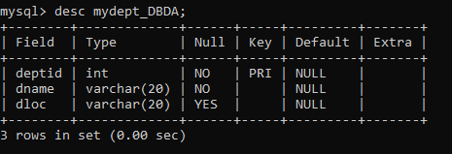

insert into mydept_DBDA values(30,'Purchase','Mumbai');

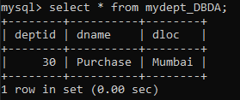

MySql syntax:

create table myemployee

(

empno int primary key,

fname varchar(15) not null,

mname varchar(15),

lname varchar(15) not null,

sal float(9,2) check(sal >=1000),

doj date,

passportnum varchar(15) unique,

deptno int,

constraint fk_deptno foreign key(deptno) references mydept_DBDA(deptid) on

delete set null

on update cascade

)

Oracle syntax:

create table myemployee

(

empno number(5) primary key,

fname varchar2(15) not null,

mname varchar2(15),

lname varchar2(15) not null,

sal number(9,2) check(sal >=1000),

doj date default sysdate,

passportnum varchar2(15) unique,

deptno number constraint fk_deptno references mydept_DBDA(deptid) on delete

cascade

)

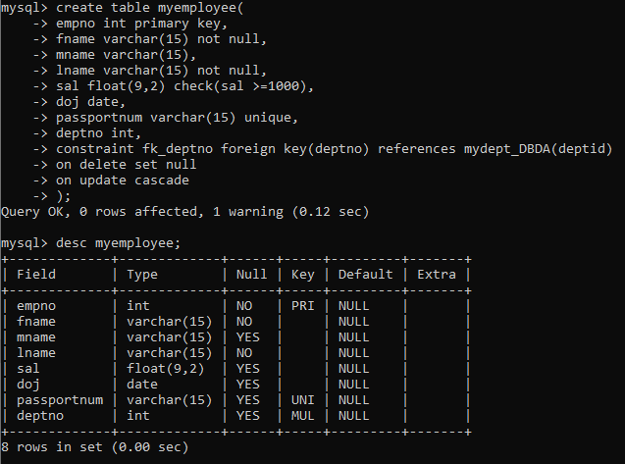

32. Create following tables Student, Course

Student (sid,sname) ---------------- sid ---primary key  
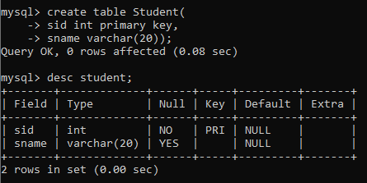

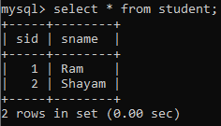

Course(cid,cname)-------------- cid ---primary key

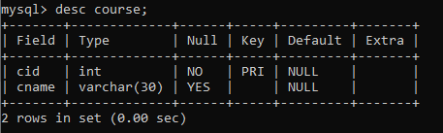

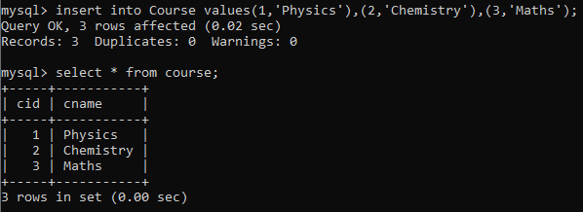

Marks(studid,courseid,marks)

Sample data for marks table

studid,courseid,marks

1 1 99

1 3 98

2 1 95

2 2 97

create table marks(

studid number,

courseid number,

marks number,

constraint pk primary key(studid,courseid),

constraint fk_sid foreign key (studid) references student(sid) on delete cascade,

constraint fk_cid foreign key (courseid) references course(cid)

)

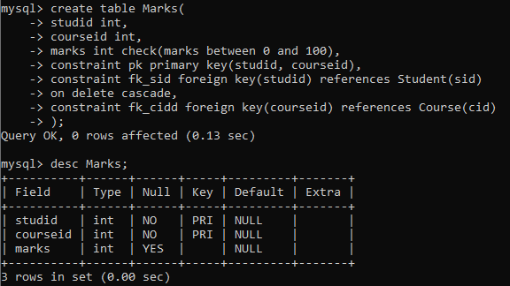

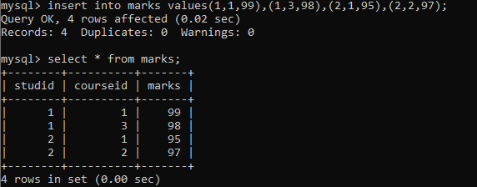

33. Create empty table emp10 with table structure same as emp table.

create table emp10 as

(

select *

from emp

where 1=2;

)

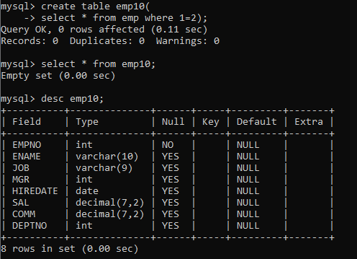

34. Solve following using alter table

add primary key constraint on emp,dept,salgrade

emp ----→ empno

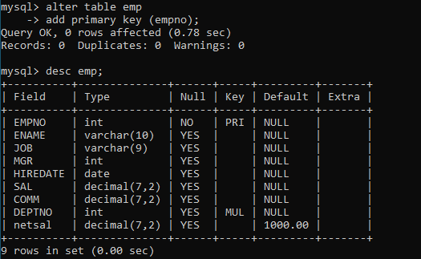

dept---→ deptno

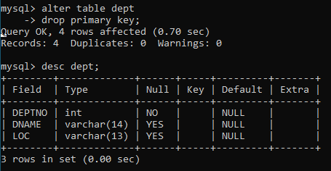

salgrade---→ grade

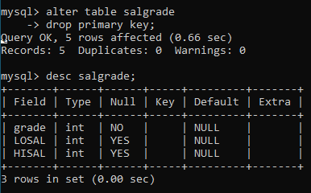

add foreign key constraint in emp

deptno --->> dept(deptno)

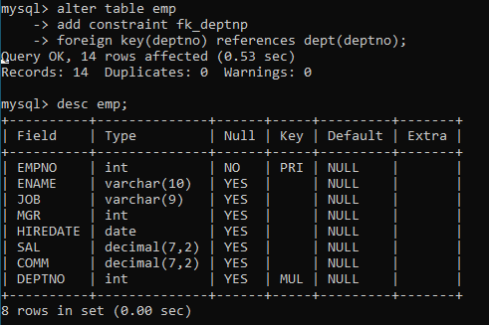

add new column in emp table netsal with constraint default 1000

