1. Display all suppliers who stays in state either in California

Or Texas or Arkansas

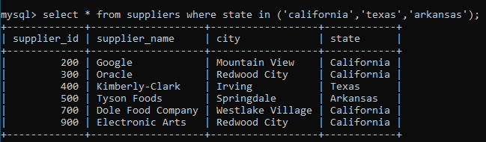

2. List all suppliers who does not stay in Springdale.

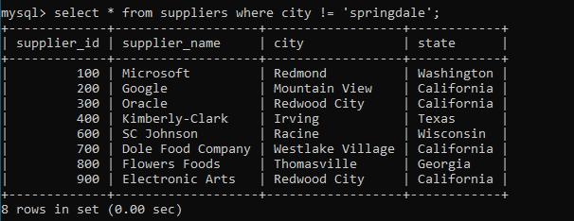

3. Find order­_id and customer_id for orders place on date 18-feb-16

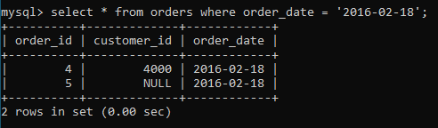

4. Find order_id and customer_id for orders place on Feb 2016

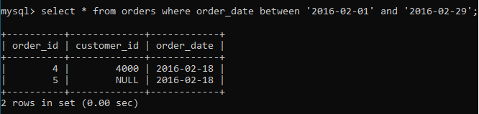

5. Find all customers with name 'Reynolds', or Anderson

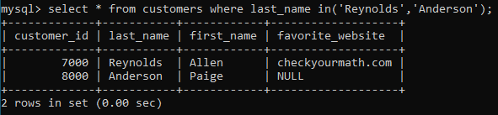

6. Find all suppliers with supplier_id >=200 and <=700

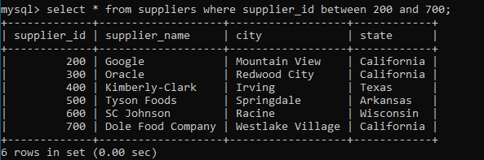

7. Find all customers for whom favorite_website is not given

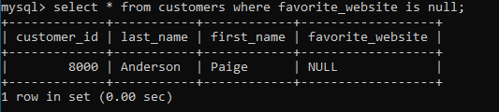

8. Find all customers for whom favorite_website is given

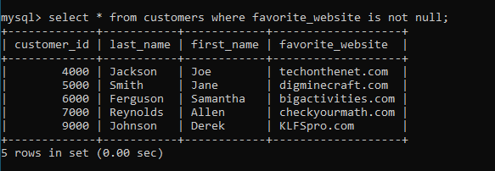

9. Find all suppliers with supplier_id is not >=200 and not <=700

