**View, Indexes Assignment**

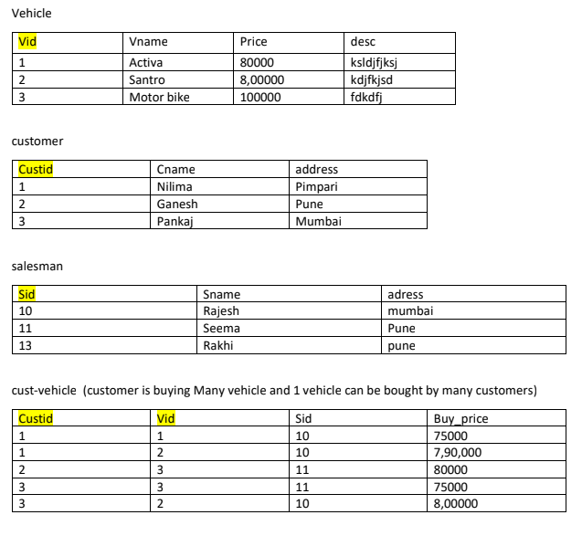

1. create all given tables

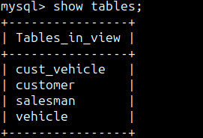

2. create index on vehicle table based on price

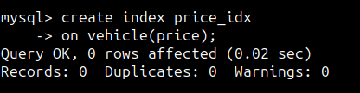

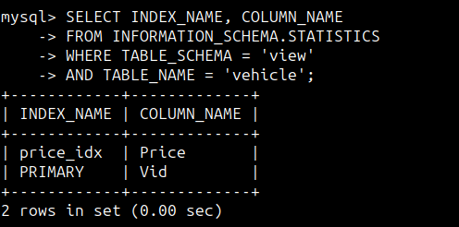

3. find all customer name,vehicle name, salesman name, discount earn by all customer

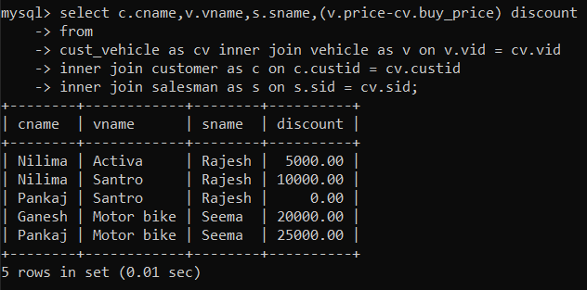

4. find all customer name,vehicle name,salesman name for all salesman who stays in pune

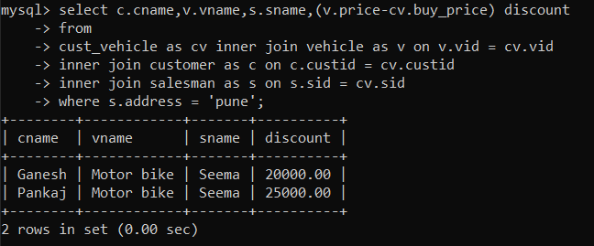

5. find how many customers bought motor bike

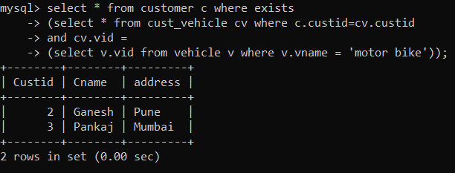

6. create a view find_discount which displays output

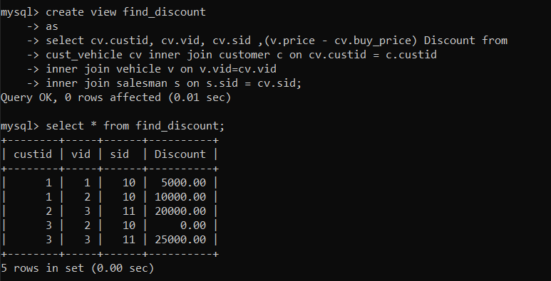

7. find all customer name, vehicle name, salesman name, discount earn by all customer

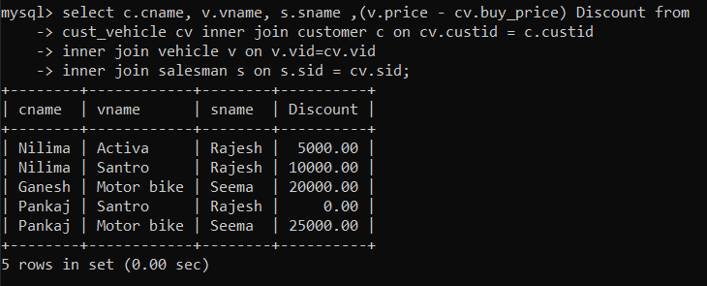

8. create view my_hr to display empno,ename,job,comm for all employees who earn

Commission

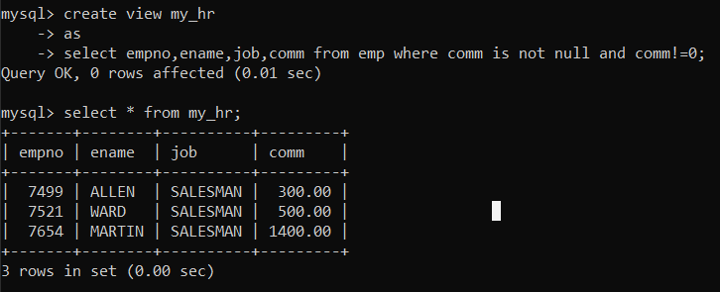

9. create view mger30 to display all employees from department 30

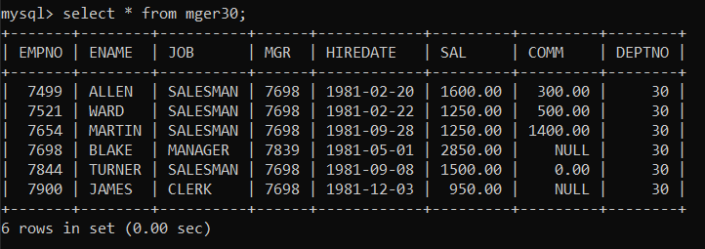

10. insert 3 employees in view mger30 check whether insertion is possible

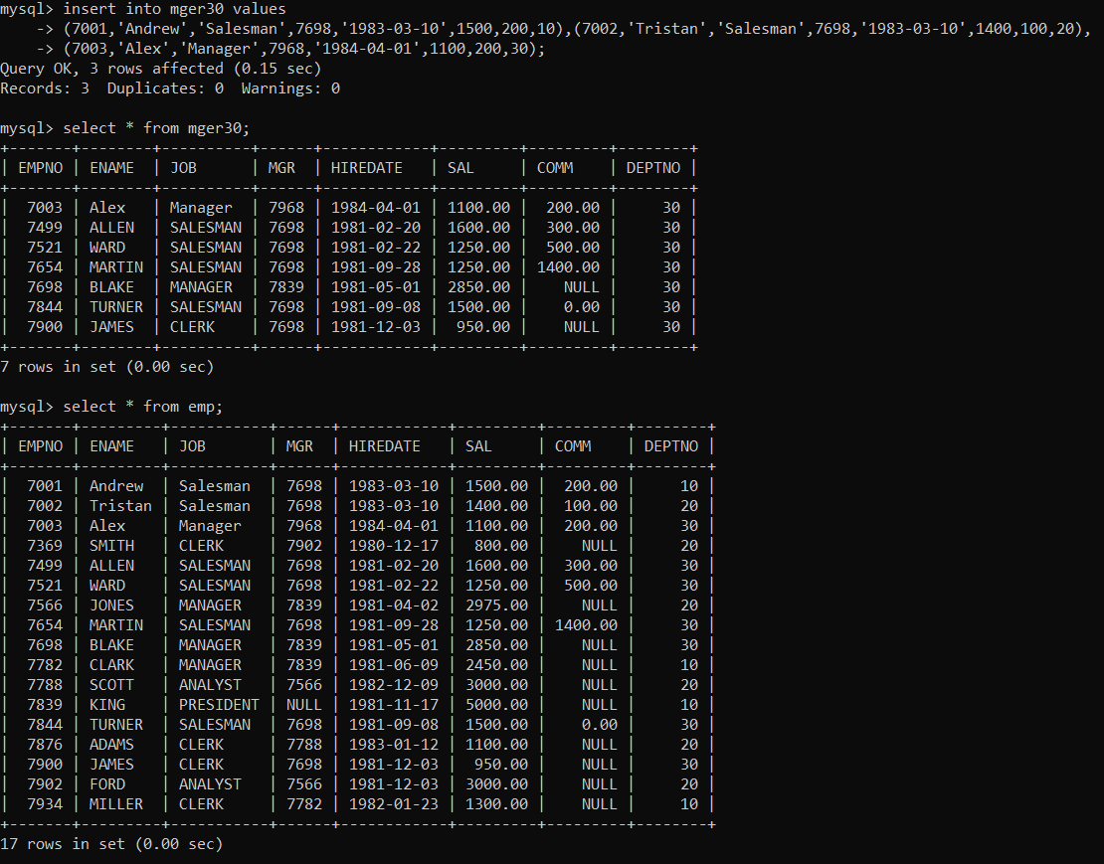

11. insert 3 records in dept and display all records from mger30

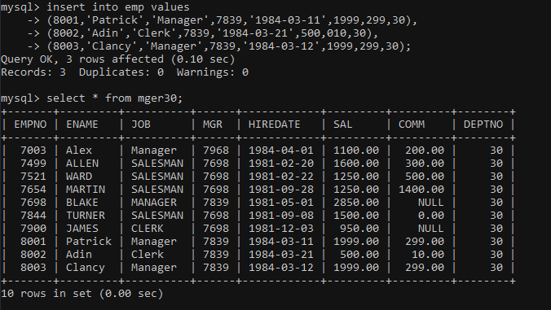

12. use rollback command check what happens

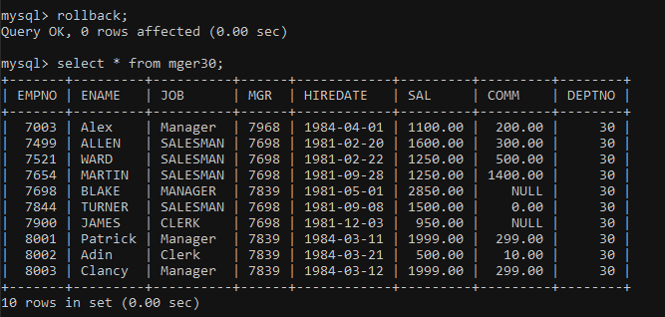

13. do the following

insert row in emp with empno 100

insert row in emp with empno 101

insert row in emp with empno 102

add savepoint A

insert row in emp with empno 103

insert row in emp with empno 104

insert row in emp with empno 105

add savepoint B

delete emp with empno 100

delete emp with emp no 104

rollback upto svaepoint B

check what all records will appear in employee table

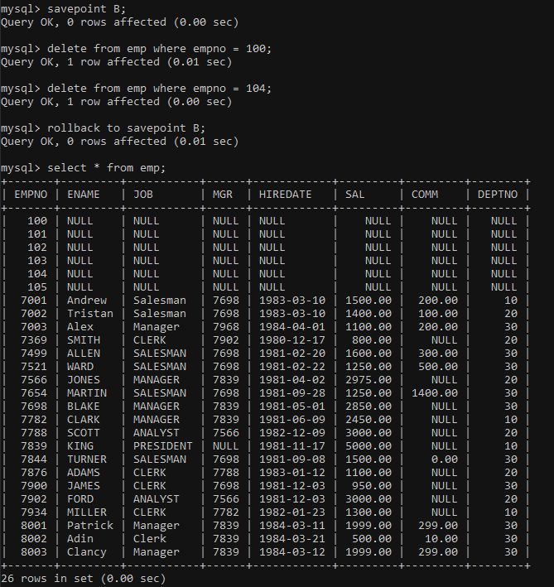

rollback upto A

check what all records will appear in employee table

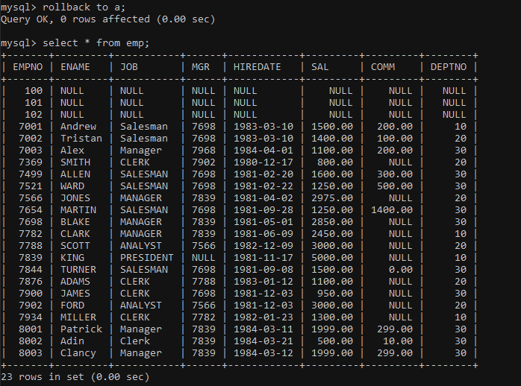

commit all changes

check what all records will appear in employee table

check whether you can roll back the contents.

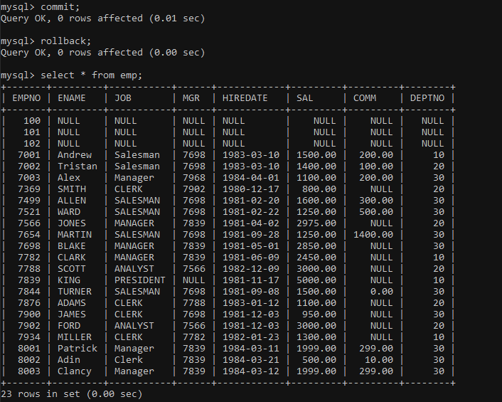

14. create a procedure getMin(deptno,minsal) to find minimum salary of given table.

