**MINI PROJECT ON**

**On**

**ANGANWADI MANAGEMENT SYSTEM**

***Submitted By***

Monali Chalwadikar T150028511

Pranav Chandaliya T150028512

Nidhi Patil T150028556

***In partial fulfillment for the third year***

***Software Laboratory I [SL-I]***

**of**

**Bachelor of Engineering**

**of**

**Savitribai Phule Pune University**

**IN**



**Maharashtra Institute of Technology, Pune**

**Department of Information Technology**

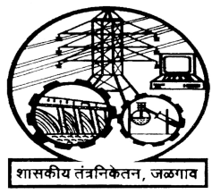**2018-19**

**MINI PROJECT REPORT**

**ON**

**ANGANWADI MANAGEMENT SYSTEM**

**Submitted By**

**T150028511: Monali Chalwadikar**

**T150028512: Pranav Chandaliya**

**T150028556: Nidhi Ptil**

**Guided by**

**Mrs. Sheetal Girase**

**Mrs. Varsha Naik**

**Department of Information Technology**



**Certificate**

This is to certify that,

T150028511: Monali Chalwadikar

T150028512: Pranav Chandaliya

T150028556: Nidhi Patil

have successfully completed miniproject entitled “ANGANWADI MANAGEMEN SYSTEM”in partial fulfillment of the requirements for the Software Laboratory I for the degree of Bachelor of Engineering in Department of Information Technology of Savitribai Phule Pune University, Pune during the academic year 2018-19.

**Mrs. Sheetal Girase Mrs. Sumedha Sirsikar**

Assistant Professor Head

Department of IT Department of IT

Signature of External Examiner-

Date: -

Place: -

**Acknowledgement**

We have taken efforts in these projects. However, it would not have been possible without Kind support and help of many individuals. We would like to extend our sincere thanks to all of them.

We are highly indebted and sincerely thanks **Mrs.Varsha Powar**,ma’am and lab teacher for her guidance and constant supervision as well as for providing necessary information regarding the topic & also for her support in completing the work.

We would like to express our gratitude towards **Mrs.Sheetal Girase**,ma’am DMSL project coordinator for her co-operation and encouragement which help us in completion of this project.

Our thanks and appreciations also go to our parents, colleagues, friends and people who have knowingly helped us out with their abilities.

Monali Chalwadikar[T150028511]

Pranav Chandaliya[T150028512]

NidhiPatil[T150028556]

**Table of Contents**

|  |  |  |  |
| --- | --- | --- | --- |
| 1 | **Project Overview** | |  |
|  | 1.1 | Project statement | 1 |
|  | 1.2 | Project Introduction | 2 |
| 2 | **Requirement Statement** | | 3 |
|  |  |  |  |
| 3 | **System Requirement Specification** | |  |
|  | 3.1 | Design Specifications |  |
|  |  | 3.1.1 Entity-Relationship Diagram | 4 |
|  |  | 3.1.2 Schema Diagram | 5 |
|  | 3.2 | Software & Hardware requirements | 6 |
|  | 3.3 | Scheduling chart | 7 |
|  |  |  |  |
| 4 | **Functional Specifications** | |  |
|  | 4.1 | Interactions | 8 |
|  | 4.2 | Graphical User Interfaces | 9-16 |
|  |  |  |  |
| 5 | **Test Case Design: Input Validation** | |  |
|  | 5.1 | Test Cases | 17-22 |
| 6 | **Scope and References** | | 23 |
| 7 | **Conclusion** | | 24 |

**CHAPTER: 1**

**Project Overview**

**1.1 PROBLEM STATEMENT**

Anganwadi Management system is main platform that focuses on total development of children. To improve the nutritional and health status of children of age group 6 months-6years.

An Anganwadi Management System keeps track of the list of children, nursing women, pregnant women, teachers, DPO, mukhya sevika’s, doctor’s, and anganwadi’s.

* Anganwadi are classified on the basis of zip code, state, city where anganwadi number is unique.
* Student takes admission in Anganwadi. The head of the anganwadi registers the details of anganwadi members like pregnant women, nursing women and children and a new member id is generated every time a new student is registered.Head registers the gender of baby,date of delivery for nursing women and month of pregnancy for pregnant women.Head also maintains records for these members.
* Each anganwadi will have exactly one head. On the basis of anganwadi requirements, head submits requirement list to DPO.The requirement list contains furniture requirements and cereals needed by anganwadi.
* Teacher’s will be assigned to each anganwadi. Anganwadi teacher is female selected from locality.  Every anganwadi teachers are supervised by one mukhya sevika .Mukhya sevika assigns teachers to anganwadi and keeps track of teachers.
* Each anganwadi will have doctors appointed and each doctor have a unique id generated.Doctors will conduct health check ups of children, nursing women and pregnant women. Doctors will maintain the health reports of each member in the anganwadi with th help of member id and anganwadi id.
* Mukhya sevika adds teacher, head and doctors and maintain record of them.
* DPO will be dealing with each anganwadi requirement and fulfills the requirements that are submitted by head. DPO adds AWC’s and mukhya sevika’s and keeps track of them.

**1.2 Project Introduction**

There are many anganwadi centers available in our country. They should be managed very well as in anganwadi there is provision of supplementary nutrition for children 6 months to 6 years of age and for pregnant and nursing women. Pregnant mothers, infant and young children are especially vulnerable to infection hence utmost care should be taken at all stages of managing supplementary nutrition. Information about this system is recorded manually. All data is either stored on paper or in a bulky registers. When admin wants to see the data of some anganwadi then it becomes very time consuming process to go through all registers. Searching facility is not easy in the current system. It takes too much data for storage.

The system developed has solutions for many problems faced. The system provides the features like easy to understand and view information. All the data is stored in the computer. The different stake holders can access the information. The information can be updated easily. With the help of project all stake holders of project can manage members under them and keep record of them.With the help of system developed the head of the anganwadi can request for requirements to DPO and he can fulfill the requirements.Doctors can have a health report online instead of going through bunch of papers.

**Chapter: 2**

**Requirement Statement**

Anganwadi Management system is main platform that focuses on total development of children. To improve the nutritional and health status of children of age group 6 months-6years.

An Anganwadi Management System keeps track of the list of children, nursing women, pregnant women, teachers, DPO, mukhya sevika’s, doctor’s, and anganwadi’s.

* Anganwadi are classified on the basis of zip code, state, city where anganwadi number is unique.
* Student takes admission in Anganwadi. The head of the anganwadi registers the details of anganwadi members like pregnant women, nursing women and children and a new member id is generated every time a new student is registered.Head registers the gender of baby,date of delivery for nursing women and month of pregnancy for pregnant women.Head also maintains records for these members.
* Each anganwadi will have exactly one head. On the basis of anganwadi requirements, head submits requirement list to DPO.The requirement list contains furniture requirements and cereals needed by anganwadi.
* Teacher’s will be assigned to each anganwadi. Anganwadi teacher is female selected from locality.  Every anganwadi teachers are supervised by one mukhya sevika .Mukhya sevika assigns teachers to anganwadi and keeps track of teachers.
* Each anganwadi will have doctors appointed and each doctor have a unique id generated.Doctors will conduct health check ups of children, nursing women and pregnant women. Doctors will maintain the health reports of each member in the anganwadi with th help of member id and anganwadi id.
* Mukhya sevika adds teacher, head and doctors and maintain record of them.
* DPO will be dealing with each anganwadi requirement and fulfills the requirements that are submitted by head. DPO adds AWC’s and mukhya sevika’s and keeps track of them.

**Chapter: 3**

**System Requirement Specification**

**3.1 Design Specifications**

A **design specification** is a detailed document providing information about a designed product or process. For example, the design specification must include all necessary drawings, dimensions, that will be needed, etc. It may also give specific examples of how the design should be executed, helping others work properly

**3.1.1 Entity-Relationship Diagram**

An Entity Relationship (ER) Diagram is a type of flowchart that illustrates how “entities” such as people, objects or concepts relate to each other within a system. ER Diagrams are most often used to design or debug relational databases in the fields of software engineering. Also known as ERDs or ER Models, they use a defined set of symbols such as rectangles, diamonds, ovals and connecting lines to depict the interconnectedness of entities, relationships and their attributes. They mirror grammatical structure, with entities as nouns and relationships as verbs.

**3.1.2 Schema Diagram**

In database terms, a schema the organization and structure of a database. A schema contains schema objects, which could be [tables](https://database.guide/what-is-a-table/), [columns](https://database.guide/what-is-a-column/), data types, [relationships](https://database.guide/what-is-a-relationship/), [primary keys](https://database.guide/what-is-a-primary-key/), [foreign keys](https://database.guide/what-is-a-foreign-key/), etc.A database schema can be represented in a visual diagram, which shows the database objects and their relationship with each other.

**3.2 Software and Hardware Requirements**

Requirement analysis help the software engineer to better understand the problem they will work

to solve. It includes the set of tasks that lead to an understanding: -

1. What customer wants exactly?

2. What is the information proposed by the system?

3. What function the systems perform?

4. What is the behavior of the system?

**HARDWARE REQUIREMENTS:**

* Processor: Pentium(R) Dual-core CPU
* Hard Disk: 40GB
* RAM: 256 MB or more

**SOFTWARE REQUIREMENTS:**

* Operating System: Windows 10, Windows 8, Windows 7.
* Language: Java Runtime Environment, Net beans 8.0.2 (front end)
* Database: MS SQL Server

**Assumptions and Dependencies**

**The assumptions are: -**

* The coding should be error free
* Pregnant women and nursing women should have aadhar card.
* The system should have more storage capacity and provide fast access to the

database

* The system should provide search facility and support quick transactions
* Teacher’s should be above the age of 18.
* Appllicant must have basic knowledge of interacting with a computer.

**The dependencies are: -**

* The specific hardware and software due to which the product will be run.
* Based on listed requirements and specification the project will be developed

and run.

* The end users should have proper understanding of the product.
* The information of all the users must be stored in a database that is accessible

by the Sukanya Samruddhi Yojana Application.

**Chapter: 4**

**Functional Specifications**

**4.1 Interactions (Use case diagram)**

**4.2 Graphical User Interfaces**

**4.2.1 User selection page**

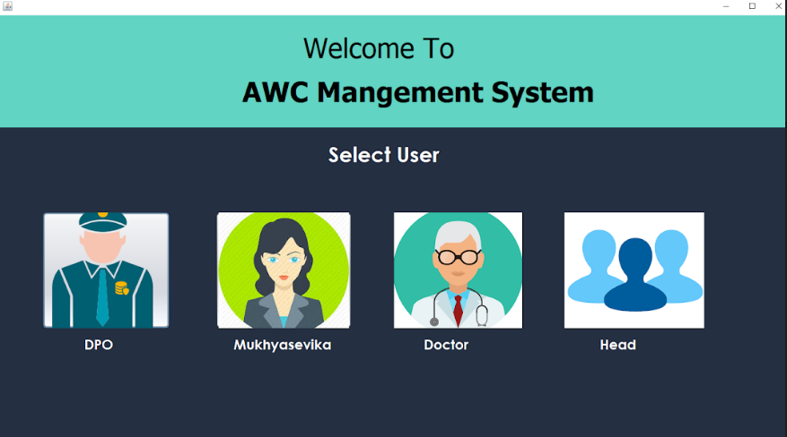

The four user among these users have to select one option as needed

**4.2.2 Login Page**

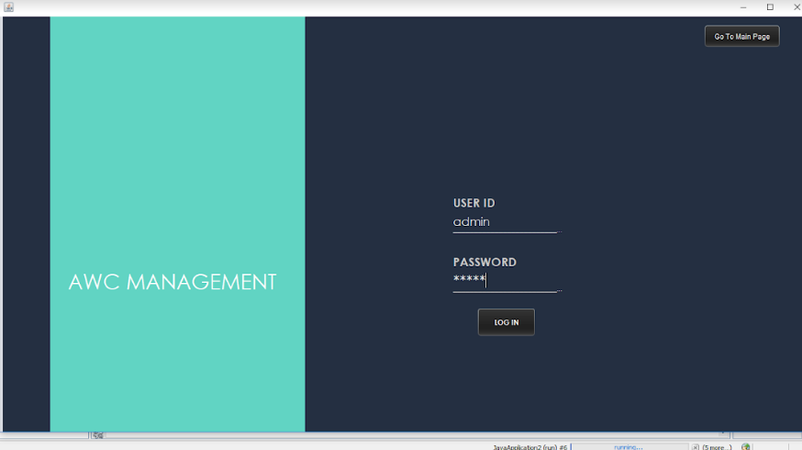

Each Member clicks on the appropriate button and gets into login page. Each stake holder has a different username and login on the basis of which they are differentiated. On entering correct username and password each member gets into its respective account.

**4.2.3 DPO Account**

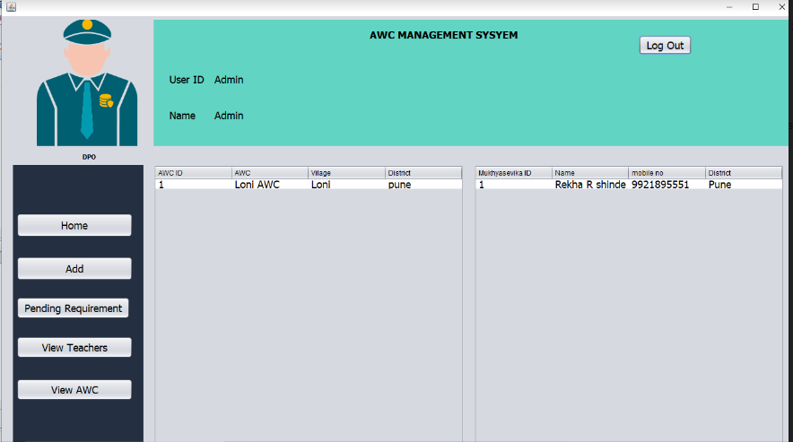

Once the DPO enters correct password and username software takes him/her to his/her respective account.Where he gets options like Home button,Add button.Pending requirements, View teacher and view awc. And home button contains list of awc’s and mukhya sevika’s already present.

**4.2.4 Add Button**

Add button is used to add new AWC’s or mukhya Sevika’s.

**4.2.5 Pending Requirement Button**

Pending Requirement list show the requirements that are pending to be fulfilled of an anganwadi.

**4.2.6 View Teachers**

Shows the list of already present teachers.

**4.2.7 View AWC’s**

When the awc id entered in search box displays the information of awc present.

**4.2.8 Mukhya sevika’s account**

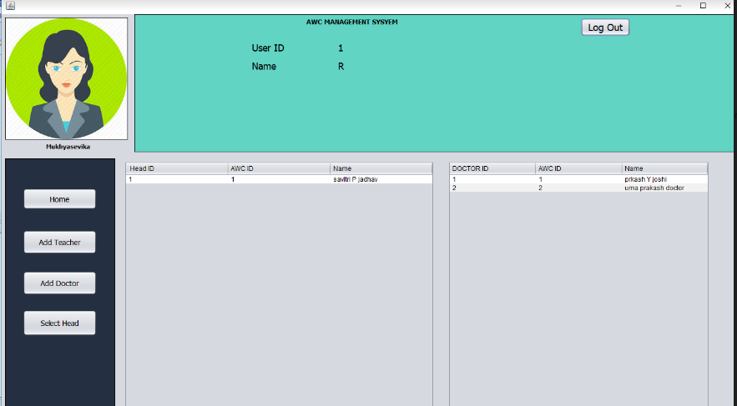

Once the Mukhya Sevika enters correct password and username software takes her to her respective account.Where he gets options like Home button,Add teacher.Add doctor and select head. And home button contains list of teachers and doctors already present.

**4.2.9 Add Teacher button**

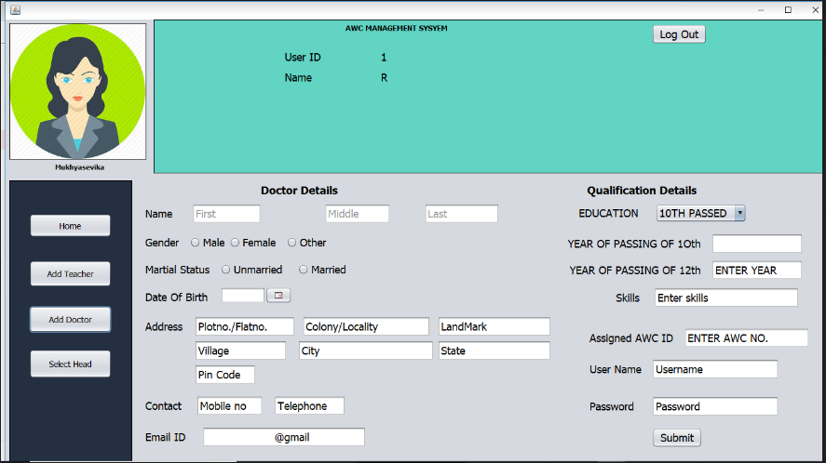

Add teacher button enables mukhya sevika to add a teacher to a anganwadi.

**4.2.10 Add Doctor Form**

Add doctor button enables mukhya sevika to add a doctor.

**4.2.11 Select Head**

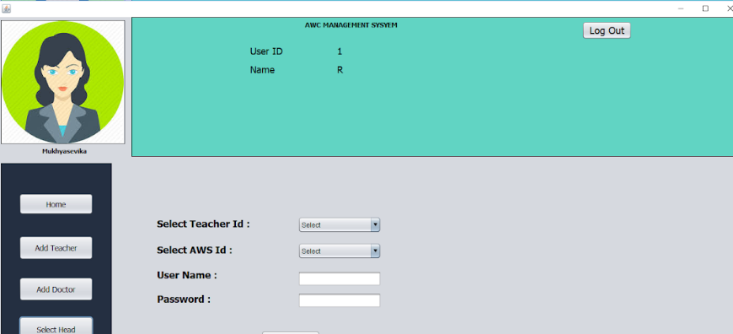

Mukhya sevika is able to select head for particular anganwadi.

**4.2.12 Doctor’s Home Page**

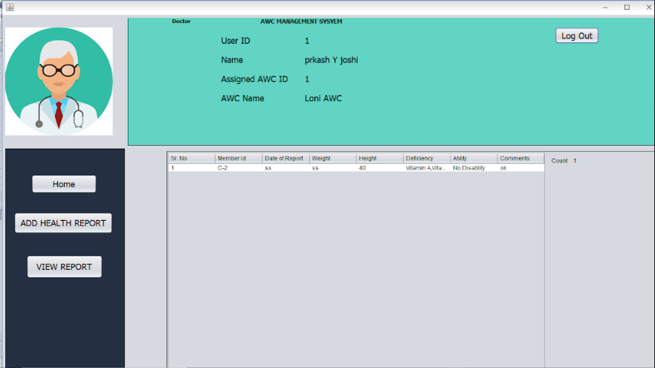

Once the Doctor enters correct password and username software takes him/her to his/her respective account.Where he gets options like Home button,Add health report and View report. And home button contains list of health reports already present.

**4.2.13 Add Health Report**

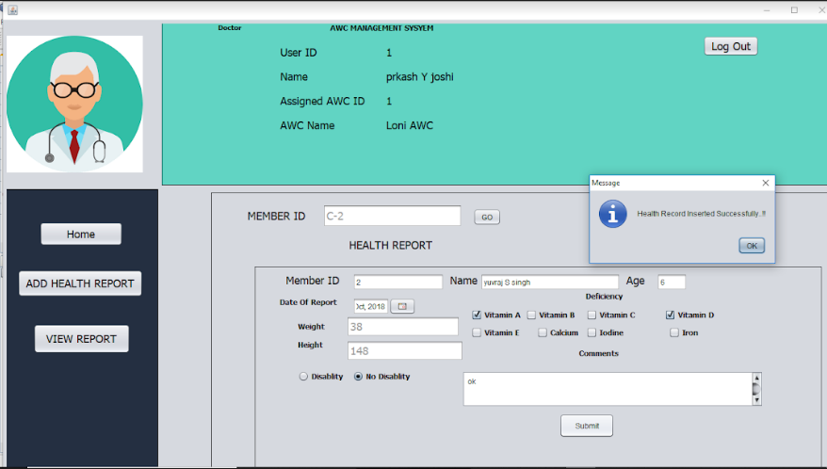

Add health report option enables doctor to add report of a particular member.

**4.2.14 View report**

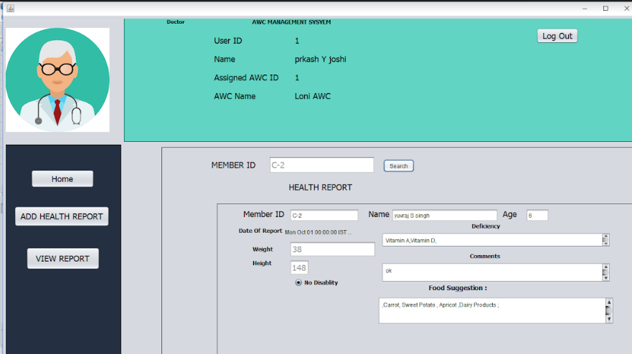

View report helps doctor to view report of particular member by searching its id.

**4.2.15 Head Account**

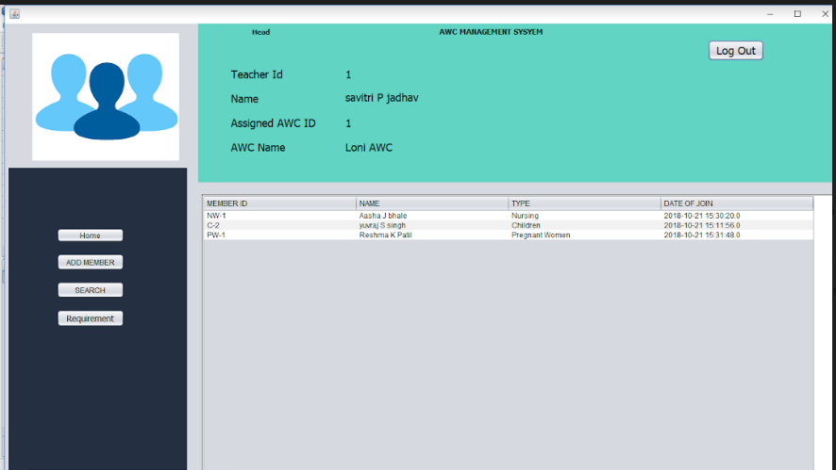

Once the Head enters correct password and username software takes him/her to his/her respective account.Where he gets options like Home button,Add button. requirements, Search. And home button contains list of members like children,pregnant women and women already present.

**4.2.15 Add Member form(Children,Pregnant Women and Nursing Women)**

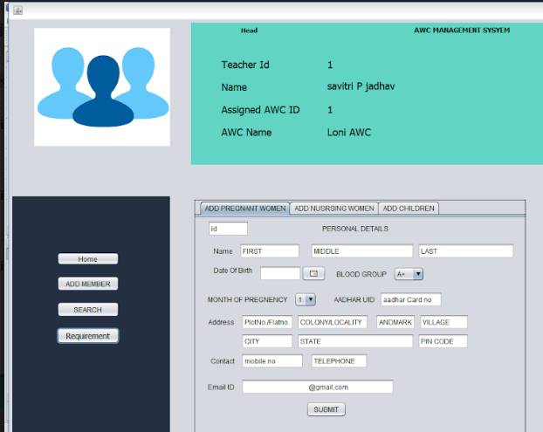

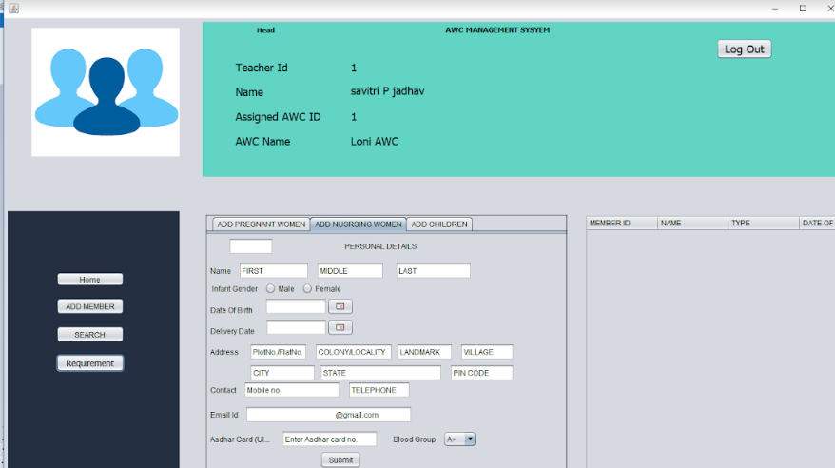

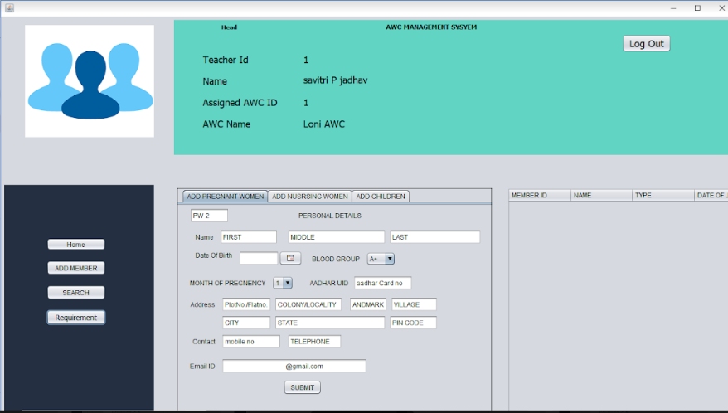

Head is able to add new members like children,pregnant women and nursing women.

**4.2.16. Search Button**

Head can enter member id to search.

**4.2.17. Requirement button**

Head fills the requirement form and sends it to DPO.

**CHAPTER: 5**

**Testing**

Tests are the individual tests specified in a test plan document. Each test is typically described by

* An initial system state.
* A set of actions to be performed.
* The expected results of the test.

Testing as a Continuous Process:

All testing follows a pre-planned process, which is agreed to. All tests consider not only a nominal system condition but also address anomalous and recovery aspects of the system. The system is tested in a stressed environment, nominally in excess of 150 percent of its rated capacities. All test products (test cases, data, tools, configuration, and criteria) are documented in

a software description document. Every test shall be described in traceable procedures and have pass-fail criteria included.

|  |  |  |  |  |  |  |
| --- | --- | --- | --- | --- | --- | --- |
| Test Case ID | Objective | Case | Procedure | Expected Result | Actual Result | Status |
| 1.) User selection page |  |  |  |  |  |  |
| 1.1.Login Page for DPO | To test login page for DPO takes in DPO’s account | 1.)  2.)  3.) | Enter valid username and password  Enter invalid username & password  Enter either invalid username or password | Entered username & password should be accepted and DPO home should be shown.  Error message shown for invalid entry  Error message shown for invalid entry | Same as expected  Same as expected  Error massage not shown | PASS  PASS  FAIL |
| 1.2.Login Page for Mukhya sevika | To test login page for Mukhya sevika takes in Mukhya sevika’s account. | 1.)  2.)  3.) | Enter valid username and password  Enter invalid username & password  Enter either invalid username or password | Entered username & password should be accepted and DPO home should be shown.  Error message shown for invalid entry  Error message shown for invalid entry | Same as expected  Same as expected  Same as expected | PASS  PASS  PASS |
| 1.3.Login Page for Doctor | To test login page for Doctor takes in Doctor’s account | 1.)  2.)  3.) | Enter valid username and password  Enter invalid username & password  Enter either invalid username or password | Entered username & password should be accepted and DPO home should be shown.  Error message shown for invalid entry  Error message shown for invalid entry | Same as expected  Same as expected  Same as expected | PASS  PASS  PASS |
| 1.4.Login Page for Head | To test login page for head takes in Head account | 1.)  2.)  3.) | Enter valid username and password  Enter invalid username & password  Enter either invalid username or password | Entered username & password should be accepted and DPO home should be shown.  Error message shown for invalid entry  Error message shown for invalid entry  . | Same as expected  Same as expected  Same as expected | PASS  PASS  PASS |
| 2.) DPO ACCOUNT |  |  |  |  |  |  |
| 2.1 DPO home page | To test DPO home page contains already present awc’s and mukhya sevika.  To test DPO home page contains already present awc’s and mukhya sevika’s | 1.)  2.) | Click on to home button  Click on to the home button | List of already present anganwadis and mukhya sevika’s are displayed  List of already present anganwadis and mukhya sevika’s are not displayed | Same as expected  Not as expected | PASS  FAIL |
| 2.2.Add button | To test add button displays form to add awc and mukhya sevika | 1.)  2.) | Click on to the add button  Make entries in registration form. | Form for registration of awc and mukhya sevika should open  Anganwadi and mukhya sevika should be registered successfully | Same as expected  Same as expected | PASS  PASS |
| 2.3 Pending requirement button | To test whether pending requirements are shown correctly. | 1.) | a)click on the pending requirement button | Displays pending requirement list of anganwadis | Same as expected | PASS |
| 3.) Mukhya sevika’s account |  |  |  |  |  |  |
| 3.1. Mukhya sevika’s home page | a) To test mukhya sevika home page contains already registered teachers and doctors | 1.) | Click on the home button | List of already present teachers and doctors are displayed | Same as expected | PASS |
| 3.2.Add Teacher button | To test whether add teacher button opens registration page | 1.) | Click on Add teacher button | Form registration for teacher opens | Same as expected | PASS |
| 3.3.Add Doctor | To test whether add doctor button opens registration page | 1.) | Click on Add doctor button | Form registration for doctor opens | Same as expected | PASS |
| 3.4.Select Head | To test select head button use to select head . | 1.) | Click on to select head and select teacher as head and enter password and username | Head selection should be done successfully | Same as expected | PASS |
| 4.Doctors’s Account | | | | | |  |
| 4.1.Doctor’s Home Page | Test to see doctor’s home page | 1) | Click on home page | List of students available in Anganwadi should be visible | Same as expected | PASS |
| 4.2 Add Report | Test to see registration of health report of member | 1)  2) | Click on add report and fill the form and select submit.  Click on add report and fill the form by giving already present member id and submit. | To successfully register the report of member.  To display message report already registered. | Same as expected.  Same as expected. | PASS  PASS |
| 4.3 View Report | To test view report shows the report of already registered member | 1)  2) | Click on view report and enter the member id.  Click on view report and enter member id not present | To display the report of member.  To display error message. | Same as expected.  Same as expected. | PASS  PASS |
| 5.Head home page | | | | | |  |
| 5.1 .Head home page | To test if home page of head contains already present members. | 1) | Click on the home page to view list of already present members. | Displays table with member information. | Same as expected | PASS |
| 5.2. Add member button | To test if member is added successfully | 1)  2)  3) | Click on the add children button. Add child information and click submit.  Click on the add pregnant women button. Add pregnant women information and click submit.  Click on the add nursing women button. Add nursing women information and click submit. | Child’s information should be successfully registered.  Pregnant women information should be successfully registered.  Nursing women information should be successfully registered. | Same as expected  Same as expected  Same as expected | PASS  PASS  PASS |
| 5.3. Search button | To test search button searches member. | 1) | Enter member id and click on search. | Member searched information is successfully displayed. | Same as expected | PASS |
| 5.4.Requirement button | To test requirement button opens requirement form. | 1) | Enter requirements and click on submit. | Requirements are successfully registered. | Same as expected | PASS |

**Chapter: 6**

**Scope and References**

1. It can be implemented using android so it will be easy for accessing from everywhere

2. We can  connect it to a web server so that officers can look after the data without visiting the

anganwadi

3. Making it visible to the public so the common person and government will get to know the

utilization of the money done by each anganwadi.

4. The project can be easily implemented under various situations. We can add

new features as and when we require, making reusability possible as there is

flexibility in all the modules.

5. The language used for developing the project is Java, MYSQL as it is quite

advantageous in terms of performance, tools available, cross platform compatibility,

libraries, cost (freely available), and development process.

Books:

* Database System Concepts by Avi Silberschatz, Henry F. Korth, S.Sudarshan
* Software Requirements and Specifications: A Lexicon of Practice,Principles and Prejudices (ACM Press) by Michael Jackson.
* Java Programming for Beginners by Daniel Lorig.

Websites:

* <https://www.slideshare.net/RojaRani15/anganwadi-management-system>
* <https://issuu.com/surajbaadkar/docs/aanganwadi_management_system>
* <http://nipccd.nic.in/syllabi/eaw.pdf>

**Chapter: 7**

**Conclusion**

This project presents the Anganwadi Management System, a system that aims to outdo the problems associated with the current Anganwadi Centers (AWC’s).

The information generated by this system is basically the rearrangement of community data which until now was kept in huge duty registers.By having a system, we have streamlined the current process made it more reliable and convenient to not only registered members but also in getting the results of the entire process. Our system also brings transparency to stakeholders about the members in AWC’s.

The software holds a promise to deliver unbiased, real time, statistical data which will be consistent information to all the stakeholders and interested parties. Also the results, stats and trends shown by this system will bring lot of attention improving and involvement of stakeholders.