Software Requirements Specification For HospiLite HMS

Version: 1.0
Author: Pranav Dalvi
Date: 10 March 2024

Copyright (c) 2024 Pranav Dalvi.
Permission is granted to copy, distribute and/or modify this document
under the terms of the GNU Free Documentation License, Version 1.3
or any later version published by the Free Software Foundation;
with no Invariant Sections, no Front-Cover Texts, and no Back-Cover Texts.
A copy of the license is included in the section entitled "GNU
Free Documentation License".

Table of Contents
1. Introduction 2
1.1 Purpose 2
1.2 Scope 2
1.2.1 Patient Management: 2
1.2.2 Appointment Scheduling: 3
1.2.3 Billing and Invoicing: 3
1.2.4 Staff Management: 3
1.2.5 Reporting and Analytics: 3
1.3 Definitions, Acronyms And Abbreviations 3
1.4 References 3
1.5 Overview 4
2. Overall Description 4
2.1 Product Perspective 4
2.2 Entity-Relationship Diagram 5

1. Introduction

1.1 Purpose
The purpose of the HospiLite project is to provide a comprehensive Hospital Management System (HMS) implemented in PHP utilizing the Model-View-Controller (MVC) architectural pattern. This project aims to serve as a practical learning exercise for individuals interested in acquiring skills in PHP programming, web development, and software engineering principles. By working on the development of HospiLite, participants will gain hands-on experience in designing, developing, and deploying a functional web-based application tailored for managing various aspects of hospital operations efficiently.
Moreover, beyond the educational aspect, HospiLite intends to offer a practical solution for healthcare facilities to streamline their administrative tasks, enhance patient care, and improve overall operational efficiency. By offering features such as patient management, appointment scheduling, billing, and reporting functionalities, HospiLite aims to simplify the complexities of hospital management, thereby contributing to the optimization of healthcare services delivery.

1.2 Scope
The scope of the HospiLite project encompasses the design, development, and deployment of a Hospital Management System (HMS) implemented in PHP utilizing the Model-View-Controller (MVC) architectural pattern. The system aims to provide a comprehensive suite of functionalities tailored to meet the diverse needs of healthcare facilities, including hospitals, clinics, and medical centers.

1.2.1 Patient Management:
- Registration of new patients.
- Updating patient information.
- Viewing patient history and medical records.
- Assigning unique identifiers to patients for easy identification.

1.2.2 Appointment Scheduling:
- Scheduling appointments for patients with doctors and specialists.
- Managing appointment slots, availability, and cancellations.
- Sending reminders to patients about upcoming appointments.

1.2.3 Billing and Invoicing:
- Generating invoices for medical services rendered.
- Recording payments and managing billing history.
- Providing detailed billing statements to patients.

1.2.4 Staff Management:
- Managing information about doctors, clerk, and administrative staff.
- Assigning roles, responsibilities, and access permissions.
- Tracking staff schedules and availability.

1.2.5 Reporting and Analytics:
- Generating various reports for administrative and analytical purposes.
- Analyzing trends in patient visits, treatments, and revenue.
- Providing insights to support decision-making and resource allocation.

1.3 Definitions, Acronyms And Abbreviations
HMS | Hospital Management System
HospiLite | Name of the HMS software
ERD | Entity-Relationship Diagram

1.4 References
Web publication system.pdf
https://www.cse.msu.edu/~cse435/Handouts/SRSExample-webapp.doc

1.5 Overview
The next chapter, the Overall Description section, of this document gives an overview of the functionality of the product.
The third chapter, Requirements Specification section, of this document is written primarily for the developers and describes in technical terms and requirement of the product.
The software is intended to give user-friendly experience due to which it modification and refinement of the system will still be in progress.

2. Overall Description

2.1 Product Perspective
Tool used: draw.io
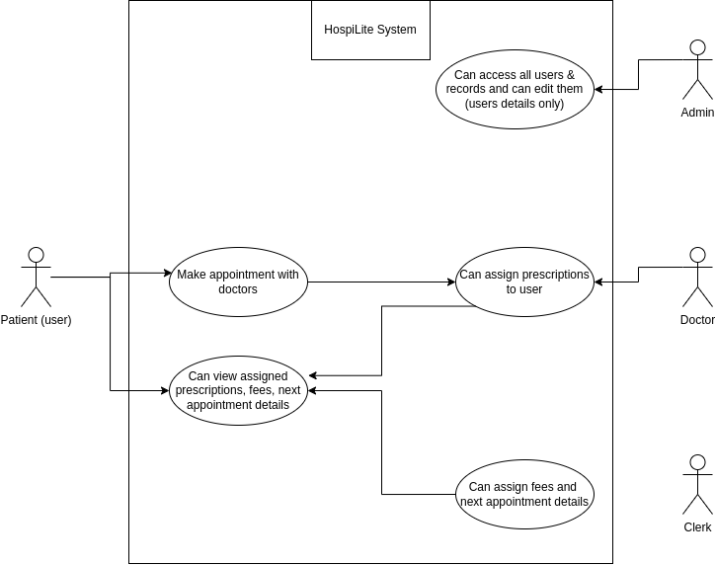

The system has 4 main actors Patient(User), Doctor, Clerk and Admin where patient can create his account and can create appointments, Doctor can view appointment according to his speciality and can assign prescriptions to the patient and Clerk can assign fees and next appointment date (if needed) to the patient.

2.2 Entity-Relationship Diagram
Tool used: draw.io
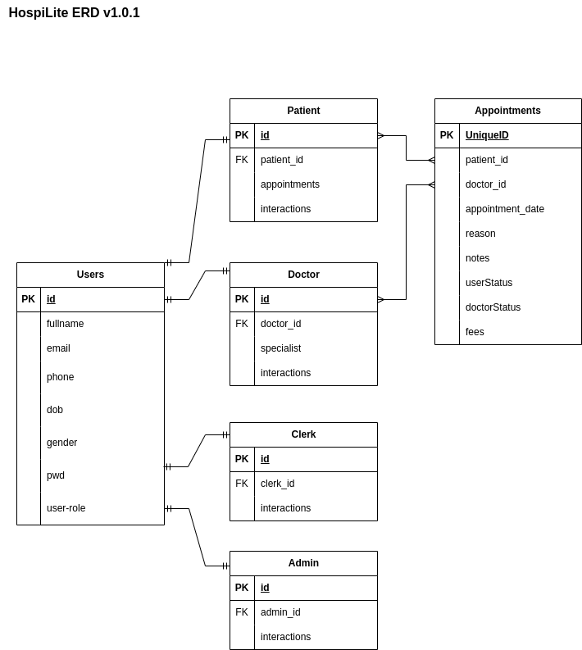

HospiLite uses SQL DB where our aim is to keep same user auth system for end-users and for hospital-staff. Patient Records may contain all the medical reports of the patient and overall interaction on the website, Doctor Records may contain his/her area of specialization and data of his/her interaction with the patient and his overall interaction on the website, Clerk Records may contain his/her interactions with patient and overall interaction on the website.

