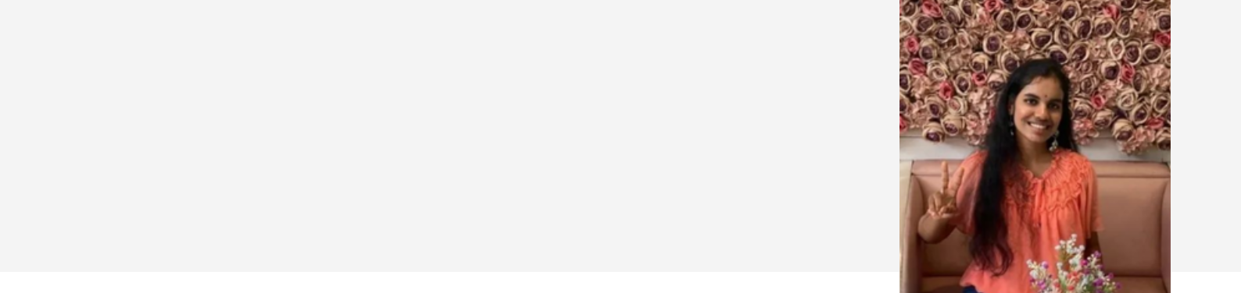**VARSHA KOTIPALLI**

**STUDENT/CONTENT** **WRITER**

**CONTACT**

9561387199

varshak.4008@gmail.com

Pune,Maharashtra,India

https://varsha-kss.github.io/ My_Portfolio/

**SKILLS**

Content Writing

Public speaking

Designing

Front-end web development

Research

Team Management

Strong Communication

**EDUCATION**

**SCHOOLING**

1. International0 School,Vallabhnagar Pune

2009-2021

**BACHELOR OF ENGINEERING (CSE)**

D.Y Patil College of Engineering,0 Akurdi Pune

2022-2025

**PROFILE**

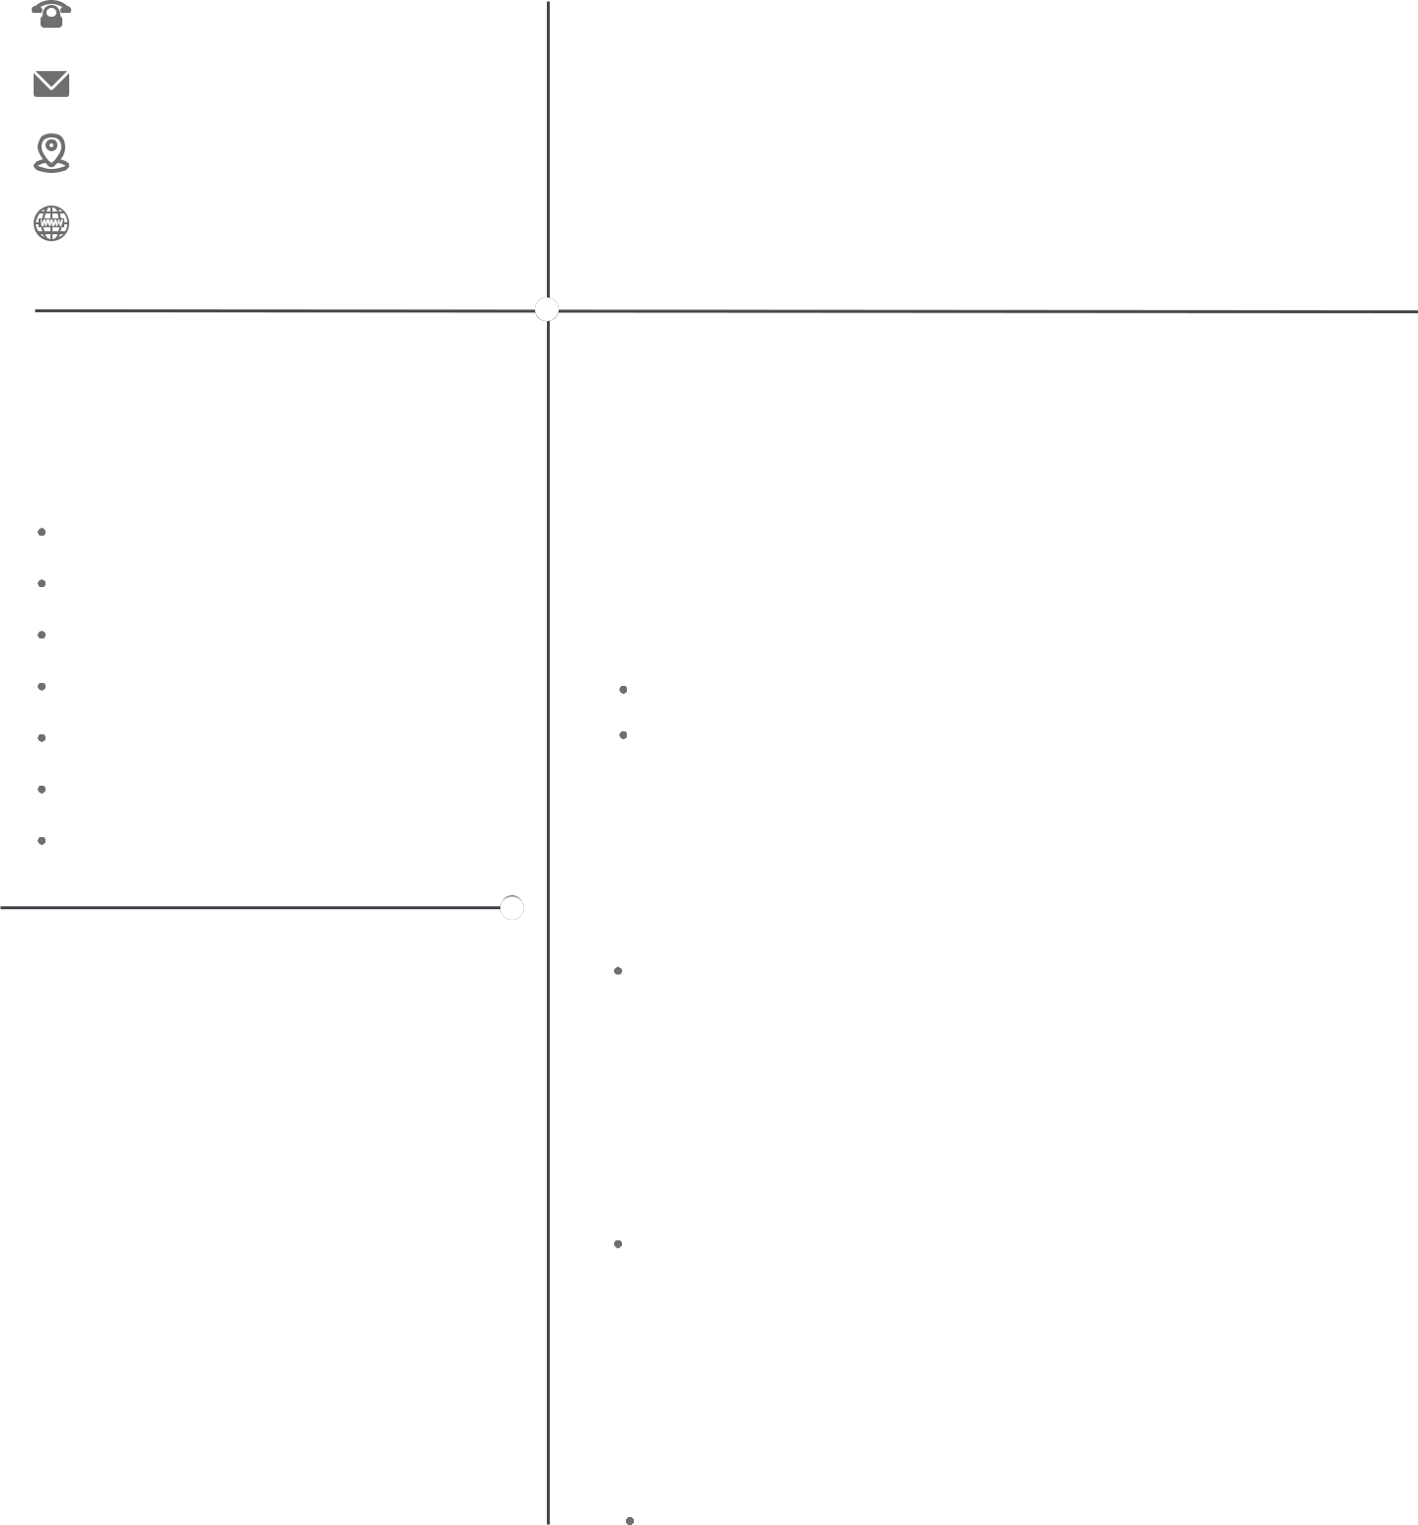

HI, I am a passionate learner currently pursuing my Bachelors of0 Engineering in Computer Science. I am also a front-end web developer0 in love with content writing and a knack for extra curriculars.

**EXPERIENCE**

**INTEL STUDENTS AI CLUB DYPCOE**

Content Writer

2022-present

wrote many technology related articles on the club"s medium page.

Helped in managing the club events.

**COLLEGE MAGAZINE WRITER AND0 EDITOR DYPCOE**

2022-present

Currently working in the English Literature Dept of college0 magazine to represent it in sppu annual competition.

**GDSC PR COORDINATOR DYPCOE**

2022-present

Responsible for drafting the WhatsApp messages and Instagram0 content for the club's events.

**SCHOOL MAGAZINE TEAM**

2018-2020

Worked in the school magazine team and wrote various articles0 and stories for it.