
Architecture
CyberSignal: how the pieces fit, the design decisions and trade-offs, the rule-versus-LLM split and the cost model
Live app: https://cybersignal-web.vercel.app Code: https://github.com/PranavKatyayen/cybersignal

How the pieces fit
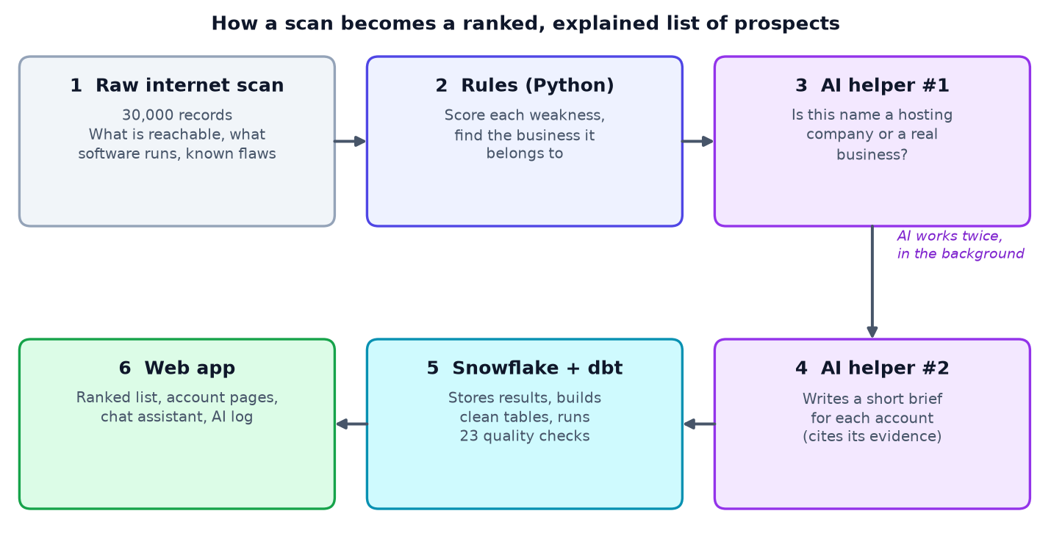
Figure 1. The pipeline from raw scan to the web app
A 30,000-record scan sample is scored and attributed by Python rules (app/backend/pipeline). Where no business domain was seen, a small model decides whether the organization name is a hosting company or a real business. A larger model then writes one cited brief per account, offline. Results are loaded into Snowflake (RAW), dbt builds staging views, one intermediate view (tiers and rank) and two mart tables under 23 tests, and a Next.js app on Vercel reads the marts. Only the chat calls a model live. The sample yields 417 accounts from 477 scored assets.

Rule versus LLM split
Job | Rule or LLM | Why
Score every asset and account | Rules | Stable and explainable; a prompt edit must never reorder a sales list
Drop honeypots, and ISP or hosting machines (hostnames that embed the IP address, plus a known-host list) | Rules | Exact and free
Business or hosting company, when only an organization name exists | Small LLM, behind two caches | Messy names need judgement
Account brief and opening question | Larger LLM; code checks citations and falls back to a safe template | Language is where AI helps, and fabrication risk is highest here
Chat: understand the question | Small LLM proposes filters; code validates them against whitelists | The model never writes SQL
Chat: fetch accounts | Fixed, parameterised SQL | Safe by construction
Chat: write the answer | Larger LLM, only over the returned rows | Grounded and refusable

The rule: rules decide anything that changes a ranking; the LLM is used only for judgement or language, and never sets a score.

Key decisions and trade-offs
- Score first, attribute second. The only step that can cost an LLM call runs on records that already have findings, cutting model calls by about 70%.
- Briefs are generated offline, once per account, resumable and keyed by findings and prompt version. Pages never wait on a model and cost is accounts times one call. The trade-off is that briefs go stale until regenerated.
- One LLM client for every call (llm_client.py): Gemini, Groq or Anthropic behind one interface, retries with backoff, per-provider throttling, JSON validation, and a trace of every request and response with provider, model, prompt version, latency, tokens and cost. It is more code, but it is what makes evals, cost and debugging possible.
- Prompts and skills are versioned files (prompts/<skill>/vN.md, skills/*/SKILL.md). A new version becomes the default only if its eval improves.
- Chat safety. The model proposes filters; code validates them; fixed SQL runs; the answer may use only the returned rows; input is capped and rate limited (in serverless this is a speed bump, not a guarantee).
- Snowflake and dbt in layers. RAW as loaded, STAGING tidy, ANALYTICS marts read by the app, and the tier thresholds in one dbt model.
- Free tiers throughout (Gemini, Groq, Vercel, a Snowflake trial), so building cost $0.

Evals and traces
Skill | Labelled set | Measures | v1 to v2
org_classification | 25 hand-labelled names | Accuracy, precision and recall per class | 80% to 92%
risk_narrative | 23 real accounts | Citation validity, top-finding coverage, invented CVEs or ports, unsupported claims, perspective | Unsupported claims 56.5% to 100%; perspective 78.3% to 100%
chat_assistant | 12 fixed questions | Correct filters, no invented accounts or CVEs, refuses off-topic | All checks pass

Every harness bypasses caches, saves results/<version>_<provider>_<model>.json and can diff against an earlier run. Every LLM call is logged in full; the Traces page filters by skill, prompt version, provider, model and status and compares v1 with v2.

Cost model (tokens x volume x frequency)
Cost per call = (input tokens x input price + output tokens x output price) / 1,000,000, using tokens measured from the trace log and published prices.
Task | Model | Tokens in / out | Cost per call
Organization classification | small tier (gemini-3.5-flash-lite) | 371 / 40 | $0.00021
Sales brief | writing tier (gemini-3.1-flash-lite) | 531 / 101 | $0.00028
Sales brief | writing tier (gemini-3.5-flash-lite) | 562 / 136 | $0.00051
Chat question (2 calls, estimate) | flash-lite | about 1,500 / 300 | about $0.0024

Model choice per task: a cheap small model for the narrow classification decision, a stronger one for writing, where invented facts matter. On the free tier both map to flash-lite models because larger free models have tiny quotas; in production the writing tier would move to a stronger model.
This dataset: about $0.25 at paid rates; billed $0 on free tiers. The Traces page shows both numbers.
Production estimate (a daily scan of this size, 20% new organization names a day, 500 chat questions a day): briefs 417 x $0.00051 = $0.21, classification about 45 x $0.00021 = $0.01, chat 500 x $0.0024 = $1.20, so about $1.40 a day, $43 a month. Ceiling: $60 a month, with a hard stop if one day passes 3x expected (about $4.30). Every trace record carries its cost, so the check is a sum over one day.

Known limitations
- One snapshot: no trend claims anywhere.
- The score measures need, not fit or intent, and every CVE counts the same 40 points (CVSS severity is in the data but unused).
- A few ISP or hosting names can remain (for example megared.net.mx) when their machine names do not contain the IP.
- Evals are small, v2 prompts were written after seeing v1's failures on the same sets, and the brief check is keyword-based; a held-out set and an LLM judge are next.
- Chat prompts live in code, and chat calls are logged to Vercel's runtime logs rather than the trace file.
- The Snowflake trial ends around mid-October 2026, and free LLM tiers have daily caps.

