Neural Recommender System
Epoch Spring Camp 2026 — Take Home Assignment 3

1. Approach
The goal of this assignment was to build a recommender system that predicts whether a user will interact with a given item, using implicit feedback data. Each row in the dataset represents a positive interaction between a user and an item. Since no explicit negative feedback exists, negative samples were generated by randomly pairing users with items they had not interacted with.
Three models were implemented and compared: Matrix Factorization (MF) as the baseline, an MLP-based neural recommender, and Neural Matrix Factorization (NeuMF) as the bonus task combining both approaches. All models were evaluated using Hit@10 — the fraction of test interactions where the correct item appeared in the top 10 ranked recommendations against 100 randomly sampled negatives.

2. Model Descriptions

Matrix Factorization (MF)
Users and items are each represented as learned embedding vectors. The interaction score is computed as the dot product of the user and item embeddings, passed through a sigmoid activation to produce a probability between 0 and 1. This is a linear model — it can only capture linear relationships between users and items.

MLP-Based Recommender
Users and items again have separate embedding layers. Instead of a dot product, the two embeddings are concatenated and passed through a three-layer MLP with ReLU activations, with a final sigmoid output. This allows the model to learn complex, non-linear interaction patterns.

Neural Matrix Factorization (NeuMF) — Bonus
NeuMF combines both approaches using separate embedding tables for each path. The MF path computes a dot product; the MLP path concatenates and passes through linear layers. The outputs of both paths are combined using torch.stack and passed through a final linear layer with sigmoid. Separate embeddings are used for each path to allow them to specialize independently.

3. Key Design Choices
- Binary Cross Entropy (BCE) loss was used since this is a binary classification problem — label 1 for interactions, label 0 for sampled negatives.
- Sigmoid activation on the final layer ensures model output is a probability between 0 and 1, compatible with BCE.
- Adam optimizer with lr=0.001 was used for all models — it adapts learning rates per parameter and converges faster than plain SGD.
- ReLU activations in MLP and NeuMF introduce non-linearity, allowing the model to capture complex user-item relationships.
- Negative sampling ratio (num_neg) was varied from 1 to 4. Higher ratios give the model more negative examples to learn from, improving discrimination.

4. Results
Model | emb_dim | Epochs | num_neg | Hit@10
MF | 50 | 10 | 1 | 0.094
MLP | 50 | 10 | 1 | 0.517
NeuMF | 50 | 10 | 1 | 0.509
MF | 100 | 20 | 2 | 0.147
MLP | 100 | 20 | 2 | 0.595
NeuMF | 100 | 20 | 2 | 0.611
MF | 200 | 30 | 4 | 0.254
MLP | 200 | 30 | 4 | 0.815
NeuMF | 200 | 30 | 4 | 0.800

5. Observations and Analysis
- MLP consistently outperforms MF by 4-5x across all configurations. This confirms that non-linear interaction modeling captures user behavior far better than a simple dot product.
- MF shows limited improvement even with larger embeddings and more epochs — the fundamental bottleneck is the linear dot product, not capacity.
- NeuMF beats MLP at moderate capacity (emb_dim=100): 0.611 vs 0.595. Combining linear and non-linear signals helps when each path is somewhat capacity-limited.
- At high capacity (emb_dim=200), MLP alone beats NeuMF: 0.815 vs 0.800. With enough parameters, the MLP can model all patterns independently, and the MF path adds minimal signal.
- All models improve with larger embedding dimensions, more epochs, and more negative samples, showing that both model capacity and training data quality matter.
- NeuMF shows a sharper initial loss drop compared to MLP, suggesting the combined architecture finds a good solution faster in early epochs.

6. Beyond the Basics
- Implemented the NeuMF bonus task combining MF and MLP paths with separate embeddings.
- Ran systematic experiments across three hyperparameter configurations to analyze the effect of embedding size, training duration, and negative sampling ratio.
- Analyzed why NeuMF wins at lower capacity but loses to MLP at higher capacity — connecting the observation to model capacity theory.
- Added loss curve plots for all three models across all configurations to visualize training behavior.

7. When to Use Each Model
Based on the experimental results and training behavior observed:

Use MF when:
- The dataset is very large and speed is the priority — MF is the simplest and fastest to train.
- User-item interactions are relatively straightforward and linear similarity is sufficient.
- Compute resources are limited — MF has far fewer parameters than MLP or NeuMF.

Use MLP when:
- User behavior is complex and non-linear — as seen in these experiments, MLP outperformed MF by 4-5x across all configurations.
- Sufficient compute and data are available — MLP needs more capacity to realize its advantage.
- At high capacity (emb_dim=200), MLP achieved the best overall score of 0.815, outperforming even NeuMF.

Use NeuMF when:
- Resources are moderate — NeuMF showed faster early convergence than MLP (sharper initial loss drop), making it efficient at lower epoch counts.
- At moderate capacity (emb_dim=100), NeuMF outperformed MLP (0.611 vs 0.595) by combining linear and non-linear signals.
- When training time is limited — NeuMF's MF path provides useful signal in early epochs before the MLP path has fully converged, giving a head start.
- However, at high capacity NeuMF is overtaken by MLP — the MLP alone becomes powerful enough to model all patterns, making the MF path redundant.

Loss Curves
emb_dim=50, epochs=10, num_neg=1
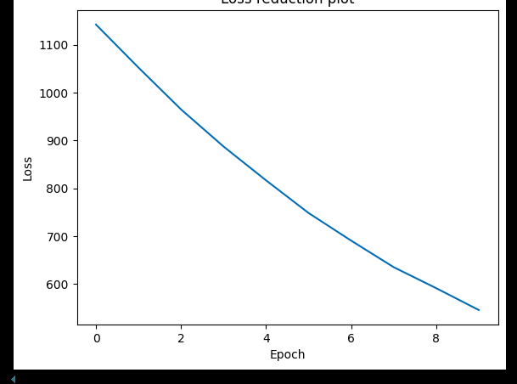  MF | 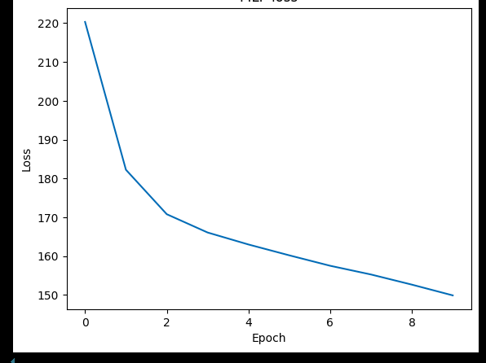  MLP | 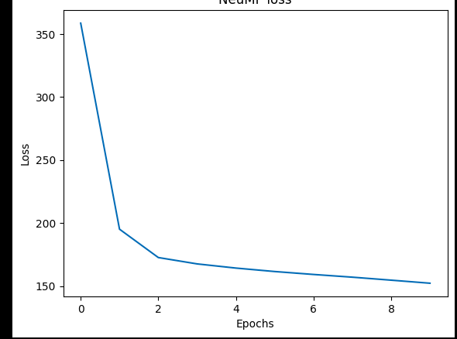  NeuMF

emb_dim=100, epochs=20, num_neg=2
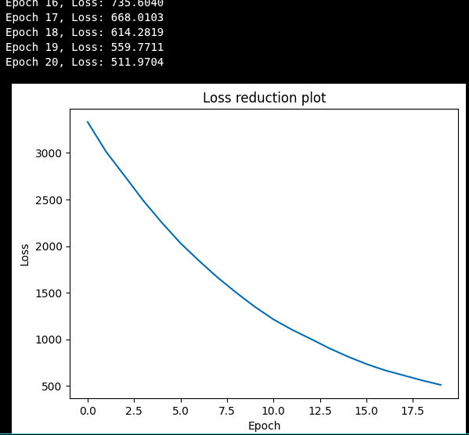  MF | 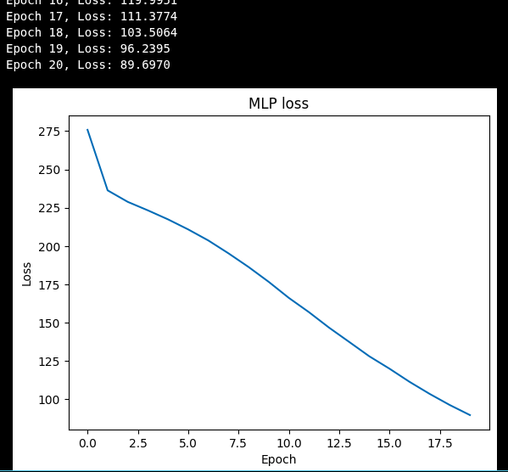  MLP | 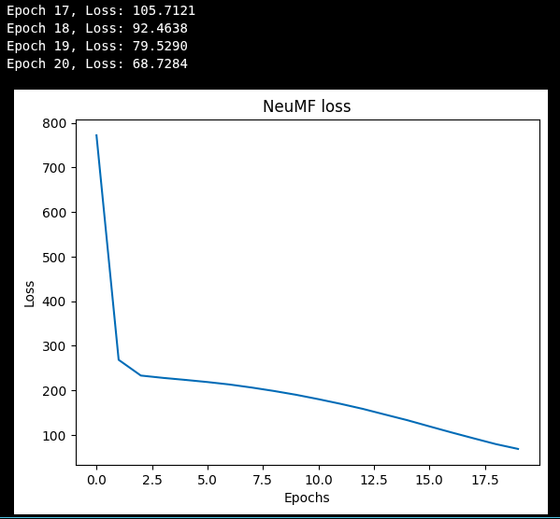  NeuMF

emb_dim=200, epochs=30, num_neg=4
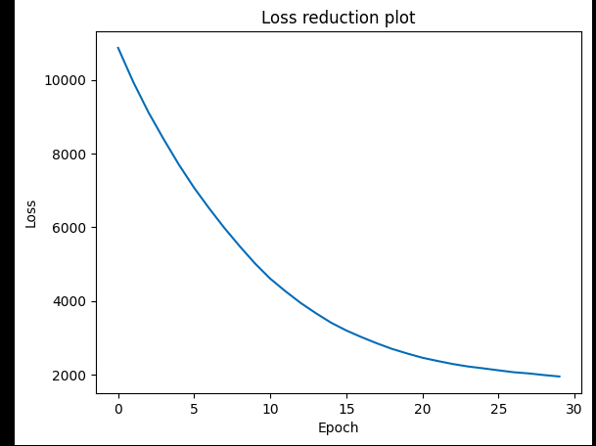  MF | 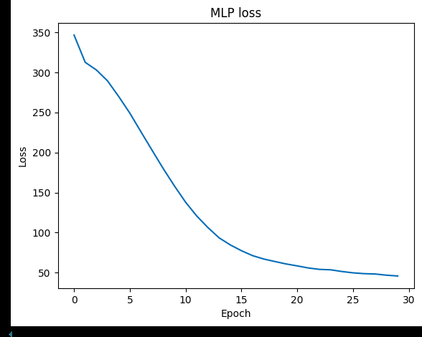  MLP | 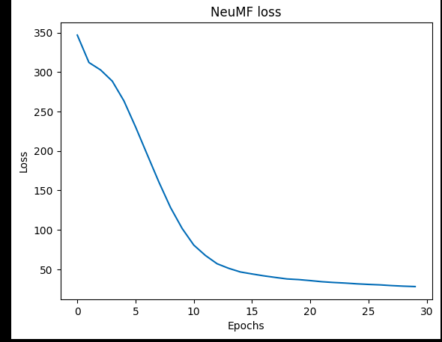  NeuMF

