San Jose State University

Department of Electrical Engineering

EE104, Spring 2022, Pham

Laboratory Assignment 5

# Objectives

This lab gives you opportunities to create the models for different real-world scenarios for the car manufacturing industry, electrical engineering industry, and process capacity modeling.

# Grading

Refer to the section **Python Programming** for grading criteria.

# Bibliography

Refer to the lecture notes for sample programs.

# Requirements

## 1 - Numerical Integration - HIC

Help your colleague from the mechanical department to design a car airbag to meet the Head Injury Criterion (HIC).  You can choose to at least match the Mercedes Benz HIC = 310 or the 1995 Audi 8 HIC = 142.

* <https://www.intmath.com/applications-integration/hic-head-injury-criterion.php>
* <https://www.intmath.com/applications-integration/hic-part2.php>

## 2 - Differential Equation – ER Modeling

Model a hospital ER (Emergency Room) with a general ERU (ER Unit) and an ICU (Intensive Care Unit) specializing in COVID-19 treatment with ventilation equipment.

For ER, the variables can be Number of Nurses, Number of Doctor, Number of beds, available slots for diagnosis equipment such as X-ray machine, CT Scanners, Number of Patients coming into the ER, Number of Patients being discharged vs being transferred to the ICU, death rate, etc. Your model should have at the minimum 3 variables.

For ICU specializing in COVID-19 treatment, again the variables can be Number of Nurses, Number of Doctor, Number of beds, Number of ventilators, Number of Patients coming into the ER, Number of Patients being discharged vs being transferred to the ICU, death rate, etc. Your model should have at the minimum 3 variables.

You will turn in your model along with different scenarios and graphs, including a graph that shows both ER & ICU being saturated and the values of your program variables that cause that condition to occur.

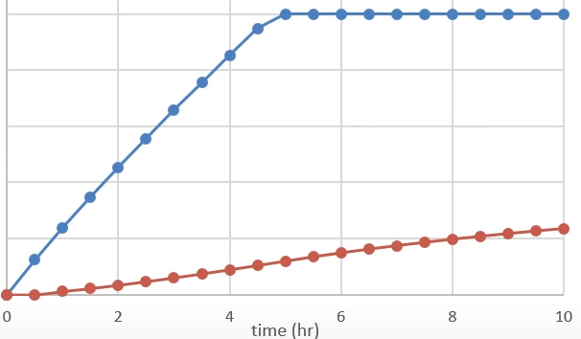

You can leverage the concept and code from this lecture below and provide your own model for the ERU and the ICU. In the model below, the Water Tank 1 can be your ERU and Water Tank 2 can be your ICU. <http://apmonitor.com/che263/index.php/Main/PythonDynamicSim>

## 3 - Python hardware programming

Design a digital safe box.

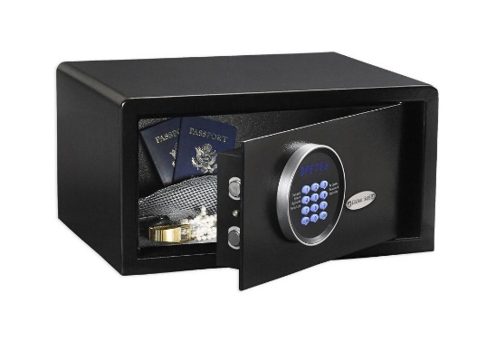You will use the PYNQ-Z2 board to design a digital safe box. You will be provided with a sample 3-digit unlock program with the sample code to generate your own FSM, test waveform generator, and the board wiring diagram. You will also have a sample program to translate the user secrete code to ASCII equivalent.

Your job is to write one single python program. The Python program will ask for 2-character alphanumeric secret code. Use your firstName + lastName as secret code for this lab, such as CP, BB, CB, etc. and it will give out the ASCII equivalent sequence. For example, CP=6780 and that will be the digit sequence 6-7-8-0 to unlock the safe box. The same program will cycle through different keypad entry sequence, but the lock will only open when user enters the right sequence (i.e. 6-7-8-0) as in this example. The program will output input and output waveforms in the following format. The waveform bellow shows the lock opens when the user enters the correct sequence 1-0-6:

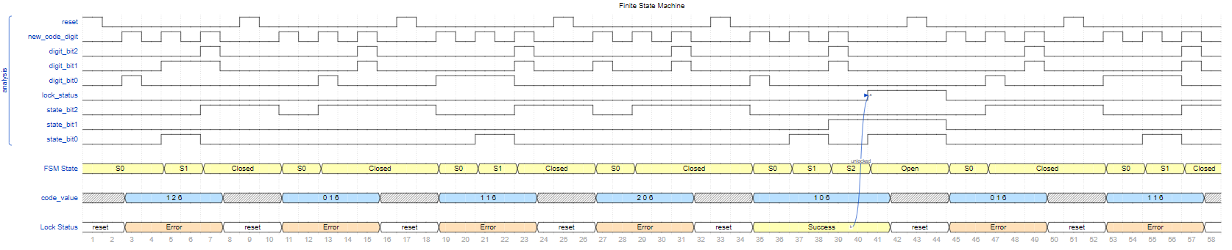

For waveform generation, we use Wavedrome. Check out <https://wavedrom.com/> for tutorial, online editor, source codes, etc.

# Python Programming

#### Lab Submission

Once you learn the process and the code associate with each step in the process, you will be able to customize the program to do the followings.

|  |  |  |
| --- | --- | --- |
| **Program or Requirement** | **Use Case** | **Earned Score / Max Score** |
| README file & Documentation | README: README is a brief user guide so that the user can install the proper python packages and knows how to execute your program. The README file can contain sample screenshots with explanation. (5 points)  Documentation: Explain your ER model that includes ERU and ICU (5 points) | _____ / 10 |
| Numerical Integration - HIC | Car airbag modeling. Being able to explain the HIC equation that you are using and explain why your answer is the best. | _____ / 10 |
| Differential Equation – ER Modeling with 3+ variables | Production capacity modeling  ERU 20/40  ICU 20/40 | _____ / 40 |
| Python hardware programming | Hotel Safe Box - Digital Lock  Turn in the source code along with the HTML file by exporting your Jupyter executed program or automatically generated when you execute from the Linux command line. Make sure you take a picture of your board with proper wiring, and proper documentation update in your source code to reflect any new changes. | _____ / 40 |
|  | **TOTAL** | **100%** |

That’s all for this lab. Hopefully you found it useful and increase your interest in the Python world! See you in the next lab.

# Laboratory Hand-In Requirements

Once you have completed a working design, prepare for the submission process. You are required to demonstrate a working design. You are also required to submit an archive of your project in the form of a ZIP file. Use 7-Zip option to create the ZIP file. Name the archive lab#_yourlastname_yourfirstname.zip. Refer to Lab 1 for detail instructions.

You will submit your zip file to the instructor through Canvas by the due date and time. If the class will be on campus, then you will expect to demonstrate in the classroom. If we ever have to go back to an online mode, turn in your archive to Canvas along with a narrated video capturing the screen of your computer running your program demonstration. If your program is not completely functional by the due date, you should demonstrate and turn in what you have accomplished to receive partial credit. See the syllabus for the late penalty guideline