Power readings for insole project

ADC, IMU, and BLE turned on (FSRs are also connected to the ADC)
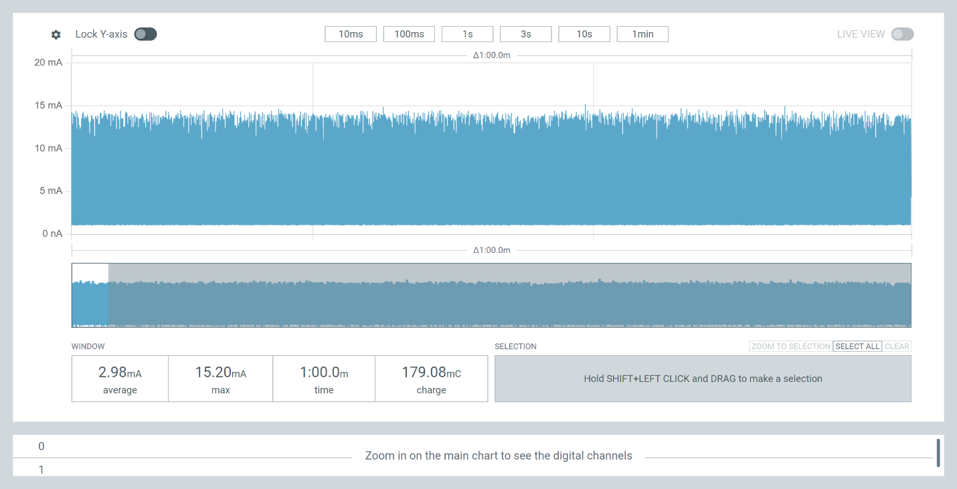
Without extra mass

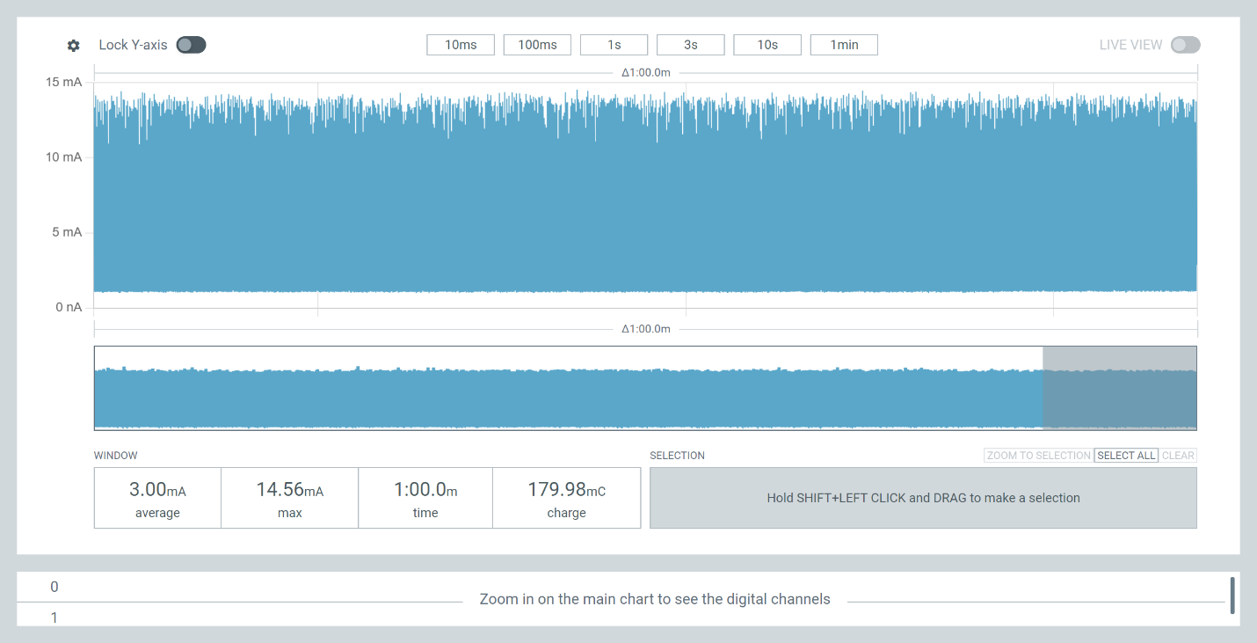
With paint bucket
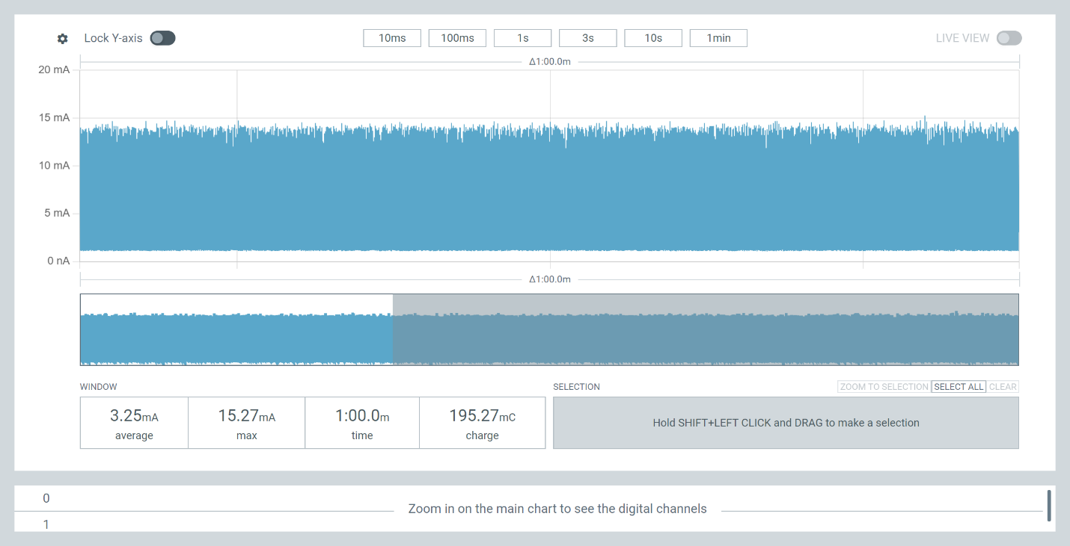
Right foot, sitting
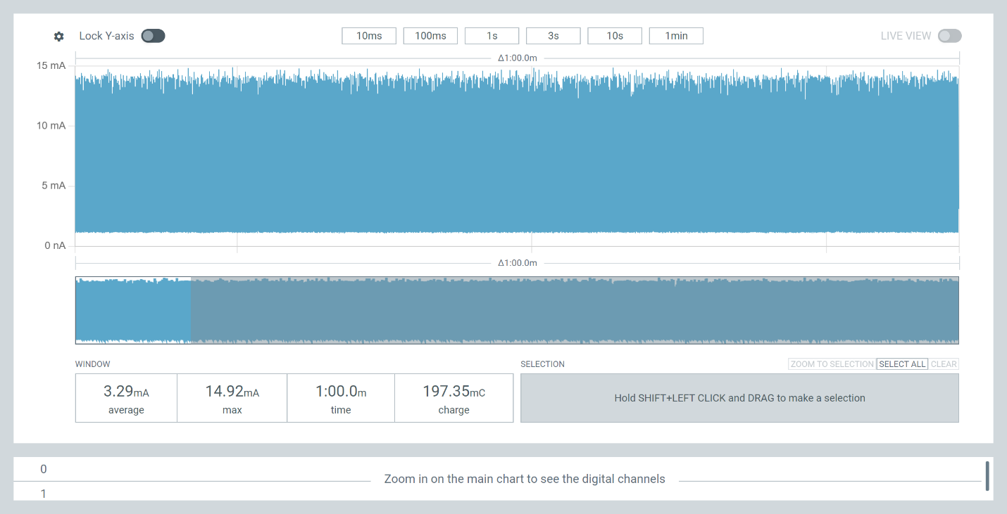
Right foot, leaning

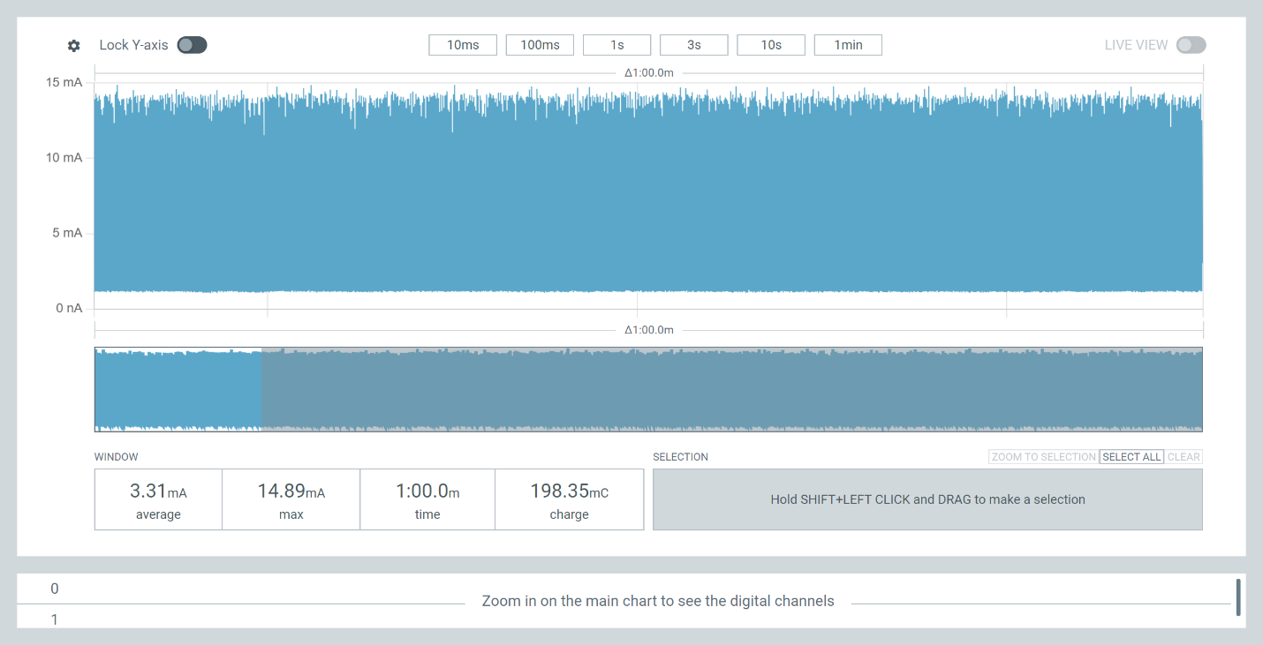
Right foot, standing

Boundary case
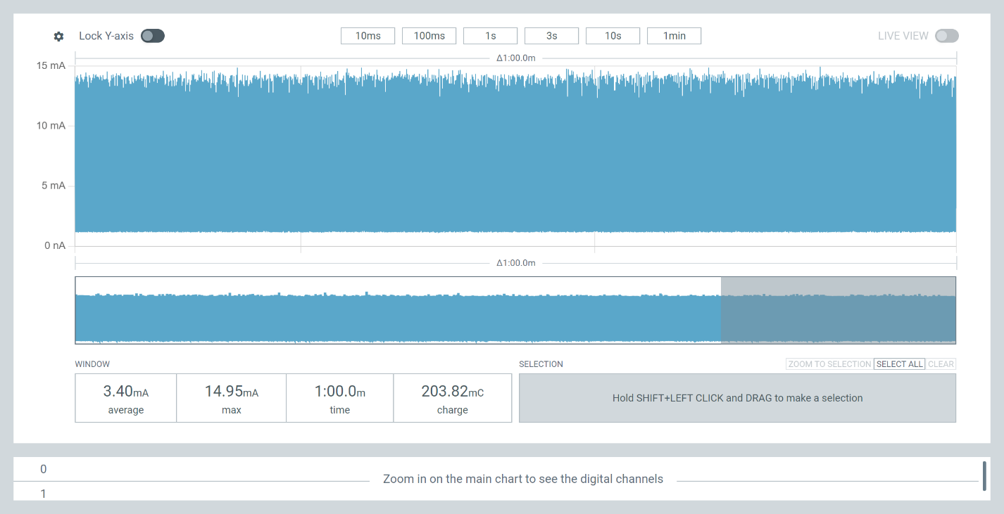
Replace FSR to ADC connection with 150Ohms (equivalent to behavior of FSR with large amount of pressure from figure)

Test | Average Current (mA) | Maximum Current (mA) | Average Power (mW) | Maximum Power (mW)
No weight | 2.98 | 15.20
Weight (paint bucket) | 3.00 | 14.56
Right foot, sitting | 3.25 | 15.27
Right foot, leaning | 3.29 | 14.89
Right foot, standing | 3.31 | 14.69
Replaced FSR with 150Ohm | 3.40 | 14.95

Test | Average Current (mA) | Maximum Current (mA) | Average Power (mW) | Maximum Power (mW)
No weight | 2.98 | 15.2 | 11.026 | 56.24
Weight (paint bucket) | 3 | 14.56 | 11.1 | 53.872
Right foot, sitting | 3.25 | 15.27 | 12.025 | 56.499
Right foot, leaning | 3.29 | 14.89 | 12.173 | 55.093
Right foot, standing | 3.31 | 14.69 | 12.247 | 54.353
Replaced FSR with 150Ohm | 3.4 | 14.95 | 12.58 | 55.315

Change voltage source to 4200mV

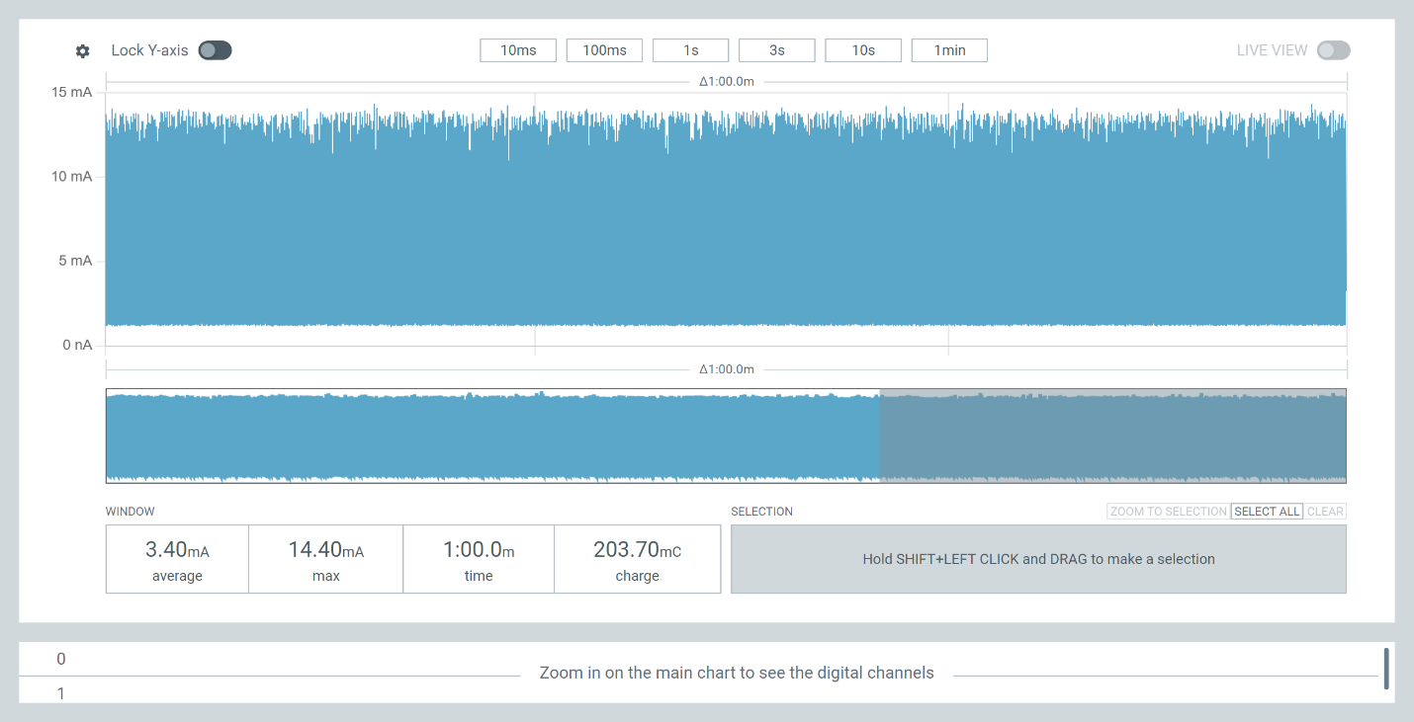
Replace FSR to ADC connection with 150Ohms (equivalent to behavior of FSR with large amount of pressure from figure)

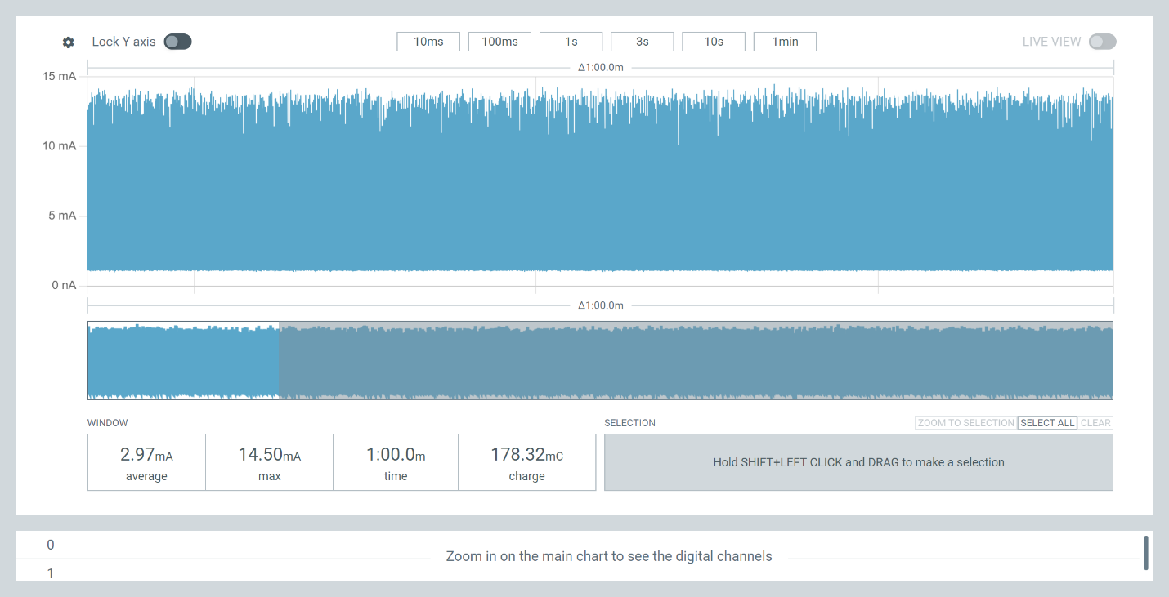
Without extra mass
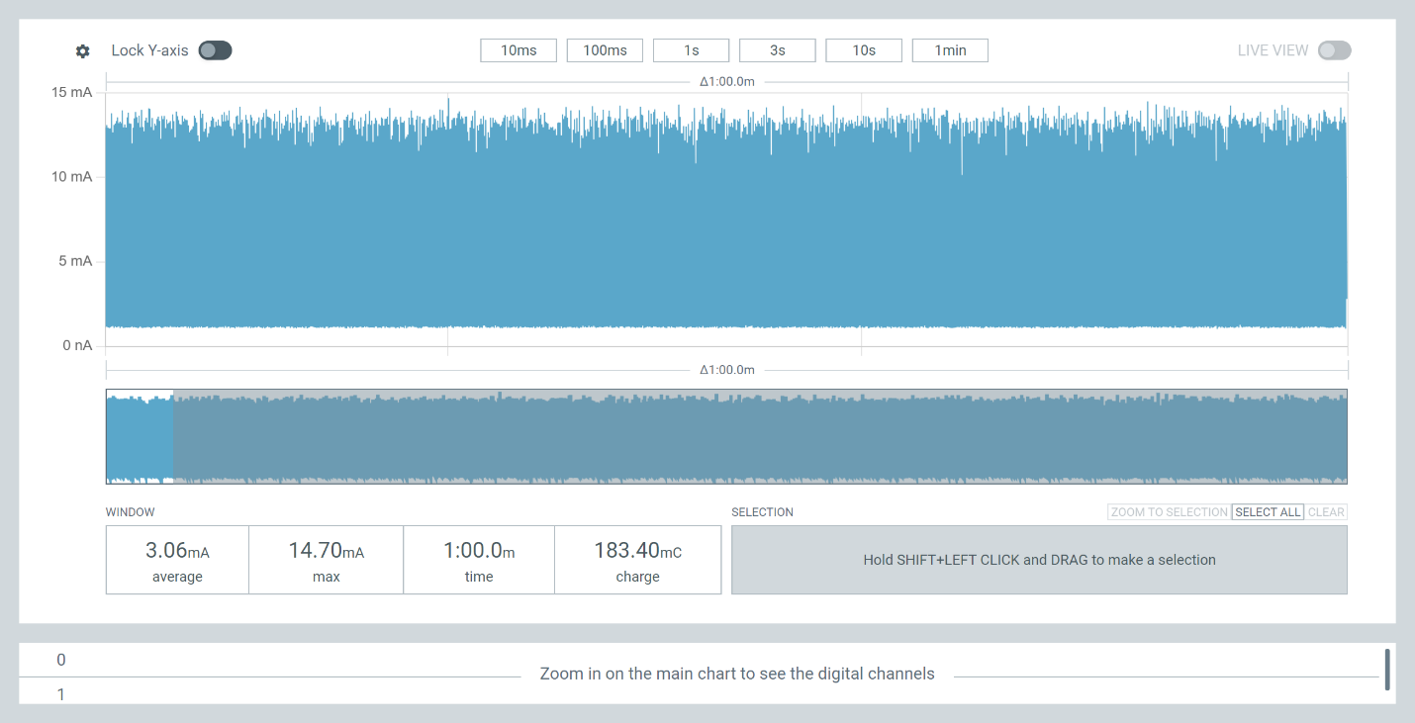
With mass (1Gal of White Distilled Vineagar)

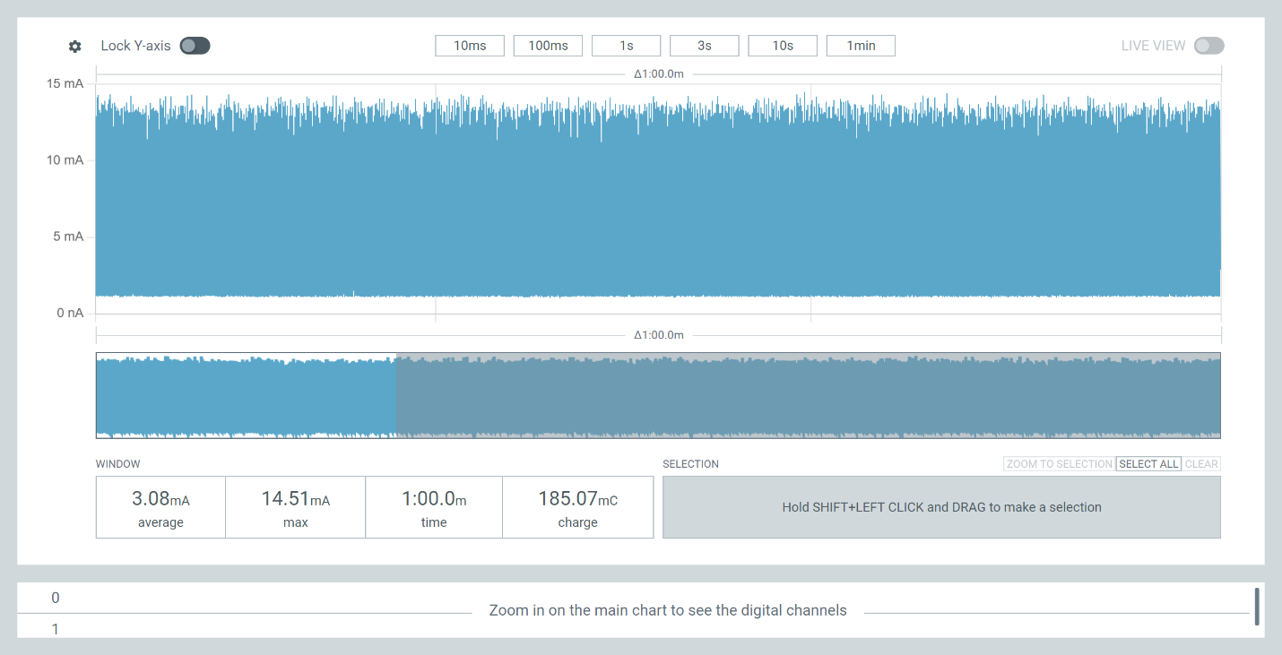
Right foot sitting

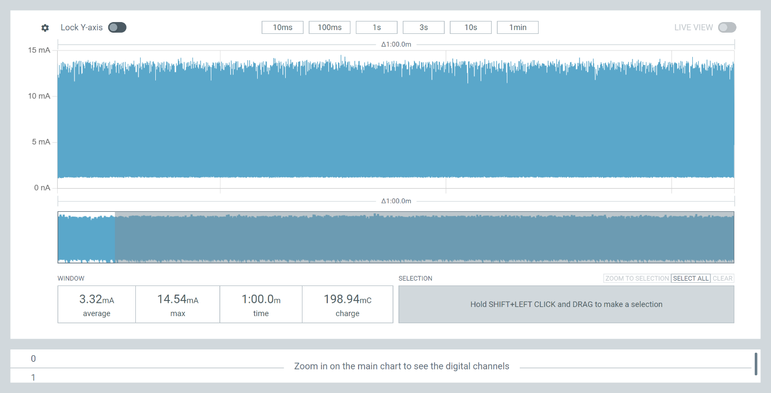
Right foot standing
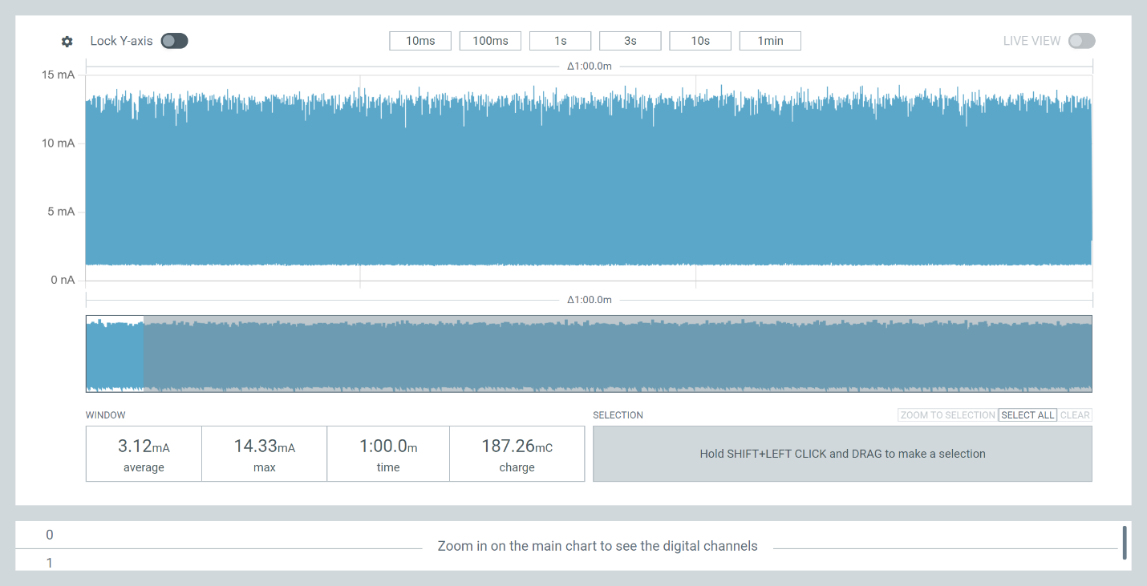
Right foot leaning

